James Howe 53290287

The scene contains a robot who moves a tray with a teapot and cup between two tables spaced apart from one another. There is a bounding wall that cannot be passed through which has a security camera that watches over the room. This security camera also emits a red spotlight in its field of view to show where it is looking. There are also all 7 Dragon Balls (from the hit anime/manga series Dragon Ball) collected and spinning in the centre of the scene ready to summon the legendary wish giving dragon Shenron (not shown in the scene). The robot also has a planar shadow that comes from a light placed over the centre of the scene.

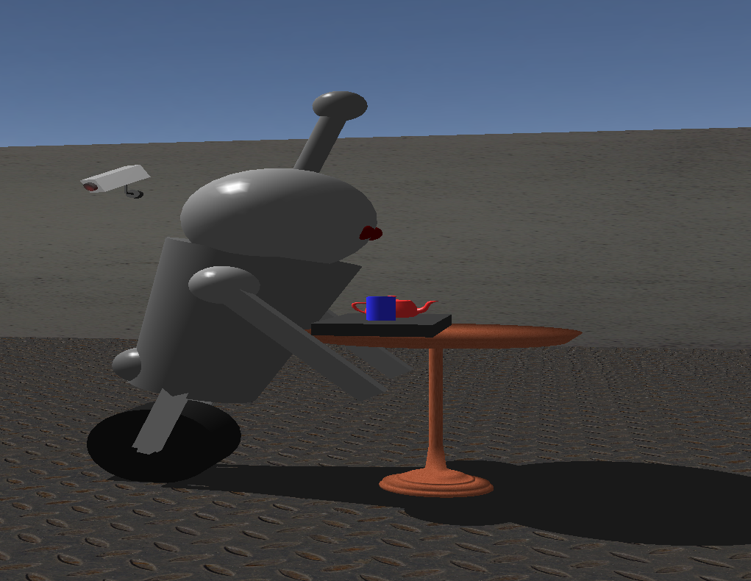
The robot leans over to pick up and put down the tray.

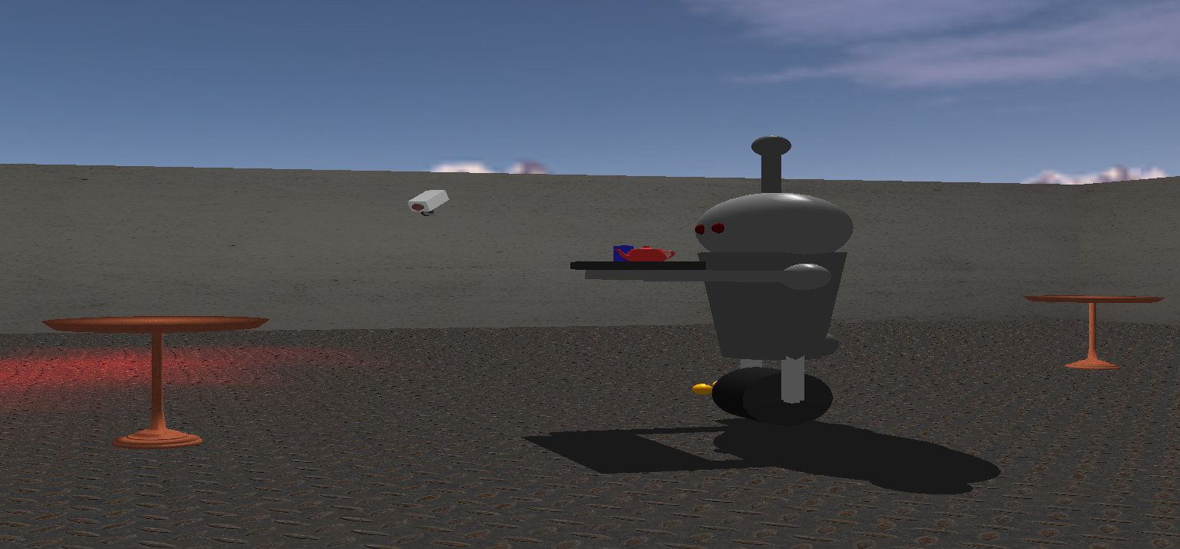

The robot delivers the tray between the tables.

The robot is made of three parts, one being the wheel it stands on, one being its body and head and the final one being its arms. The wheel was made using a cylinder that was rotated on its side and two disks that close off the ends. The main body of the robot is a cylinder that has the top radius of 0.75 and a bottom radius of 0.5. This cylinder sits on the wheel using two rectangles (cubes that were transformed to be tall and narrow). The robot’s head is a sphere that has been scaled up 1.5 times in the x axis only, with an antenna on top made of a narrow cylinder with a small sphere on top. The arms are simply two spheres that act as shoulders with long, thin rectangles as the arms

The security camera is also made of two separate components. The base that connects the camera to the wall is a cylinder with two rectangles to give the body of the camera space to rotate away from the wall. The main body is a rectangle with a cylinder that was closed using a disk which rotates between -75 degrees and 75 degrees in the x axis. The camera is tilted down 30 degrees on the z axis to give it the impression of looking down from the wall instead of straight ahead. There is also a spotlight that moves along with the camera and is positioned to look out from the lens at a 30 degree angle to the floor.

The Dragon Balls and tray are both simple models built from the solid primitives. The Dragon Balls are just spheres with a radius of 0.25, coloured orange and each has a different () texture for the number of stars on them. The tray is simply a flat rectangle with a cylinder and teapot sitting on top of it.

A planar shadow was added to the robot using the light that was placed over the centre of the scene. This shadow was done by making a matrix which projected the points of the robot down onto the ground and giving it a dark grey colour to give it the effect of a shadow.

A skybox was added around the scene by making a cube with sides 500 units long and texturing it using supplied skybox textures. Although the bounds of the scene block vision of it, the skybox does include a matching top and bottom.

Collision detection was added to ensure that the user could not leave the bounding wall of the scene, but it has not been implemented for the robot or the tables so the user can pass through them. The wall detection was added by making a limit on how close to the wall the user can get so that they cannot pass through the wall or clip the view camera through the wall.

The scene is only interacted with using the arrow keys. The up arrow moves the camera forward, the down arrow moves the camera backwards, the left arrow pans the camera left and the right arrow pans the camera right.

A table was created as a surface of revolution, with the relevant x and y coordinates shown here.
This table was then textured using a simple wooden texture.

The wood, wall and floor textures were all sourced from www.textures.com.
The skybox texture used was one of the ones supplied on learn.
The Dragon Ball star textures were made by me.

