**2022 MCM**

**2022年MCM**

**Problem C: Trading Strategies**

**问题C:交易策略**





**Background**

**背景**

Market traders buy and sell volatile assets frequently, with a goal to maximize their total return. There is usually a commission for each purchase and sale. Two such assets are gold and bitcoin.

市场交易者经常买入和卖出波动性很大的资产，目标是实现总回报最大化。每笔买卖通常都有佣金。其中两种资产是黄金和比特币。

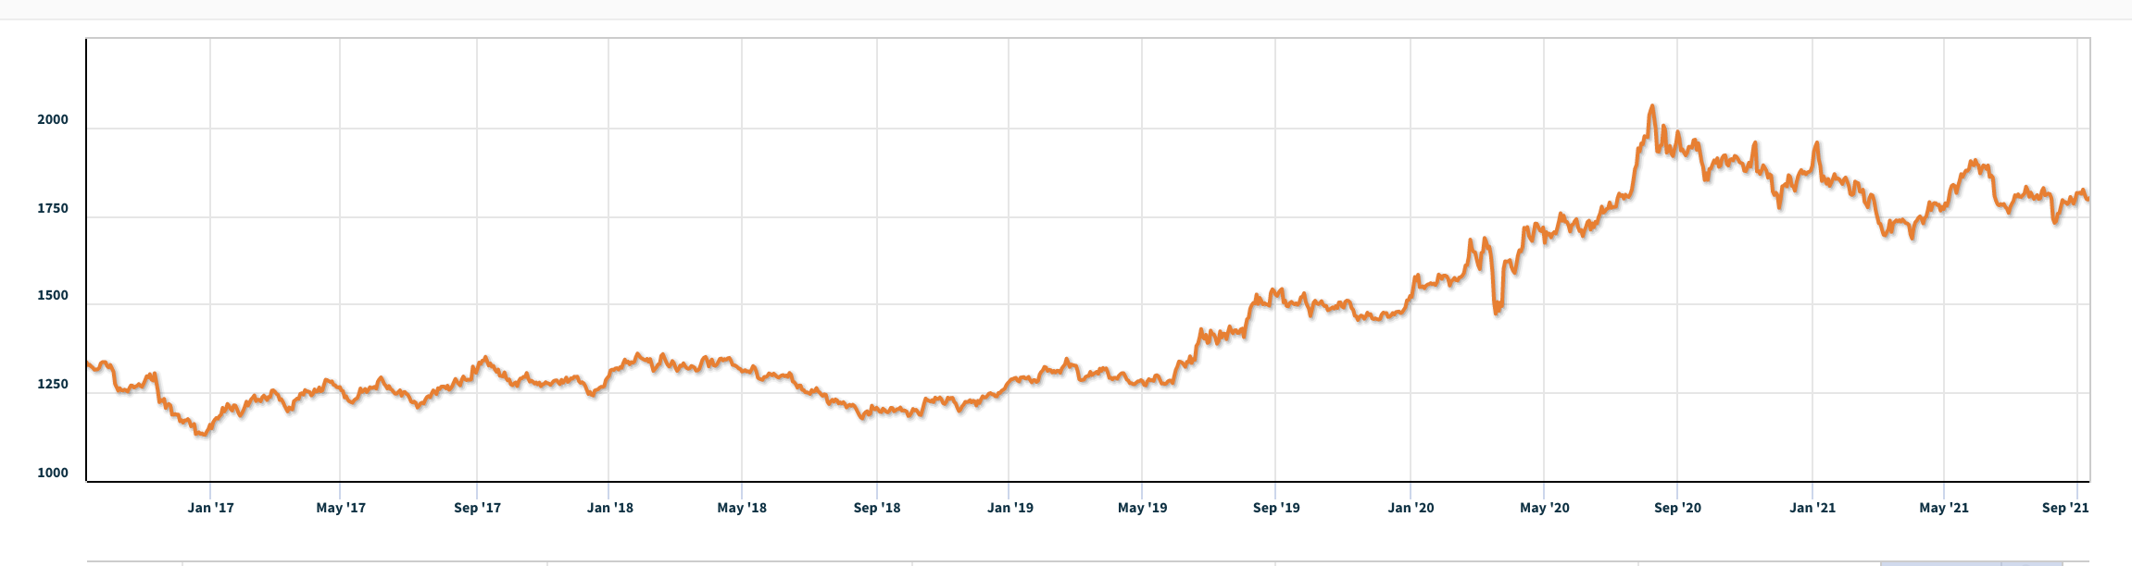



**Figure 1:** Gold daily prices, U.S. dollars per troy ounce. Source: London Bullion Market Association, 9/11/2021

图1:黄金日价格，美元/金衡盎司。资料来源:伦敦金银市场协会，2021年9月11日

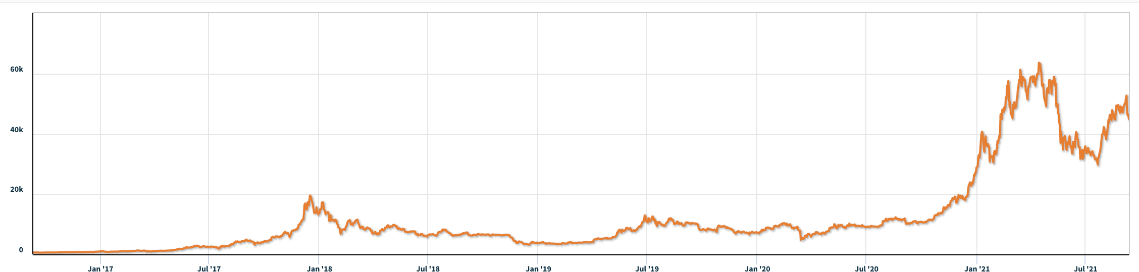



**Figure 2:** Bitcoin daily prices, U.S. dollars per bitcoin. Source: NASDAQ, 9/11/2021

图2:比特币每日价格，单位为美元/比特币。资料来源:NASDAQ，9/11/2021

**Requirement**

**要求**

You have been asked by a trader to develop a model that uses **only** the past stream of daily prices to date to determine each day if the trader should buy, hold, or sell their assets in their portfolio.

一位交易员要求你开发一个模型，它只使用迄今为止的过往每日价格流，来确定该交易员每天应该买入、持有还是卖出其投资组合中的资产。

You will start with $1000 on 9/11/2016. You will use the five-year trading period, from 9/11/2016 to 9/10/2021. On each trading day, the trader will have a portfolio consisting of cash, gold, and bitcoin [C, G, B] in U.S. dollars, troy ounces, and bitcoins, respectively. The initial state is [1000, 0, 0]. The commission for each transaction (purchase or sale) costs α% of the amount traded. Assume αgold = 1% and αbitcoin = 2%. There is no cost to hold an asset.

你将从2016年9月11日的1000美元开始。您将使用从2016年9月11日到2021年9月10日的五年交易期。在每个交易日，交易员都有一个由现金、黄金和比特币[C，G，B]组成的投资组合，分别以美元、金衡盎司和比特币表示。初始状态为[1000，0，0]。每笔交易(购买或销售)的佣金成本为交易金额的α%。假设αgold = 1%，α比特币= 2%。持有一项资产是没有成本的。

Note that bitcoin can be traded every day, but gold is only traded on days the market is open, as reflected in the pricing data files LBMA-GOLD.csv and BCHAIN-MKPRU.csv. Your model should account for this trading schedule.

请注意，比特币可以每天进行交易，但黄金只在市场开放的日子进行交易，这一点反映在定价数据文件LBMA-GOLD.csv和BCHAIN-MKPRU.csv中。您的模型应该考虑到此交易计划。

**To develop your model, you may only use the data in the two spreadsheets provided:**

**要开发模型，您只能使用提供的两个电子表格中的数据:**

LBMA-GOLD.csv and BCHAIN-MKPRU.csv.

LBMA-GOLD.csv和BCHAIN-MKPRU.csv。

* Develop a model that gives the best daily trading strategy **based only on price data up to that day.** How much is the initial $1000 investment worth on 9/10/2021 using your model and strategy?
* 建立一个模型，只根据当天的价格数据给出最佳的每日交易策略。按照你的模式和策略，在9/10/2021上最初的1000美元投资值多少钱？
* Present evidence that your model provides the best strategy.
* 提供证据证明你的模型提供了最好的策略。
* Determine how sensitive the strategy is to transaction costs. How do transaction costs affect the strategy and results?
* 确定策略对交易成本的敏感度。交易成本如何影响战略和结果？
* Communicate your strategy, model, and results to the trader in a memorandum of at most two pages.
* 在一份最多两页的备忘录中向交易者传达你的策略、模型和结果。

Your PDF solution of no more than 25 total pages should include:

总页数不超过25页的PDF解决方案应包括:

* One-page Summary Sheet.
* 一页的总结表。
* Table of Contents.
* 目录。
* Your complete solution.
* 你的完整解决方案。
* One- to two-page Memorandum.
* 一至两页的备忘录。
* Reference List.
* 参考清单。

Note: The MCM has a 25-page limit. All aspects of your submission count toward the 25-page limit (Summary Sheet, Table of Contents, Reference List, and any Appendices). You must cite the sources for your ideas, images, and any other materials used in your report.

注:MCM有一个25页的限制。你提交的所有方面都达到了25页的限制(汇总表、目录、参考列表和任何附录)。你必须为你的想法、图像和你的报告中使用的任何其他材料引用来源。

**Attachments**

**附件**

THE TWO DATA FILES PROVIDED CONTAIN THE ONLY DATA YOU SHOULD USE FOR THIS PROBLEM.

所提供的两个数据文件仅包含应用于此问题的数据。

1. LBMA-GOLD.csv
2. LBMA-GOLD.csv
3. BCHAIN-MKPRU.csv
4. BCHAIN-MKPRU.csv

**Data Descriptions**

**数据说明**

1. LBMA-GOLD.csv
2. LBMA-GOLD.csv

* **Date**: The date in mm-dd-yyyy (month-day-year) format.
* 日期:年月日格式的日期。
* **USD (PM)**: The closing price of a troy ounce of gold in U.S. dollars on the indicated date.
* USD (PM):在指定日期以美元为单位的金衡盎司的收盘价。

1. BCHAIN-MKPRU.csv
2. BCHAIN-MKPRU.csv

* **Date**: The date in mm-dd-yyyy (month-day-year) format.
* 日期:年月日格式的日期。
* **Value**: The price in U.S. dollars of a single bitcoin on the indicated date.
* Value:指定日期的单一比特币价格(以美元为单位)。