|  |  |  |
| --- | --- | --- |
| **Problem Chosen** C | **2022 MCM/ICM Summary Sheet** | **Team Control Number** 2222182 |

Type Your Paper Title HERE

【细节待修改】Market traders buy and sell volatile assets frequently, with a goal to maximize their total return. Traders are always looking to increase their returns by predicting asset ups and downs and minimizing the risk (lower returns or even bankruptcy) when investing. Gold and Bitcoin are two representative assets. In this paper, we use the attached data to predict the possible best investment scenarios, use the regret level as evidence to validate the strategy, adjust the commission to test the sensitivity of the scenarios to the cost, and write the model decision as a memo to the trader.

In this paper, we introduce a multi-stage fuzzy investment method, by analyzing the characteristics of gold and bitcoin, we decide to invest in stages, the investment decision is mainly based on the price data before the trading day (schedule LBMA-GOLD.csv, BCHAIN-MKPRU.csv), each investment change or maintain the current asset ratio (C,G,B), in order to achieve the purpose of reducing losses and increasing returns The result: investing $1000 on 9/11/2016 will result in $62,211 on 9/10/2021.

To ensure that the evidence is convincing, the degree of regret is used here as reliable evaluation evidence.

The sensitivity of the strategy to the transaction cost is analyzed by constantly adjusting the commission percentage. The transaction cost is mainly the commission charged for each purchase or sale of bitcoin or gold (αgold = 1%, αbitcoin = 2%). For this reason, we adjusted the commission ratio and reduced it to (αgold = 0.1%, αbitcoin = 0.2% αgold = 0.01%, αbitcoin = 0.02%) respectively, concluding that the reduction in transaction costs allowed for higher returns on upfront decisions, a higher percentage of bitcoins invested, and a small increase in final wealth.

Last but not least, we summarize the suggestions and write a memorandum to the trader to communicate our strategy, model, and results.

**Key Words**: TODO

现在还没有完成的：

1. 图片和表格的题注
2. 所有标为xxx的（例如：Figure xxx shows the result of xxxx）
3. 总结和备忘录
4. 参考文献和附录

Content

1. Introduction 2

1.1 Background 2

1.2 Problem Analysis 2

2. Assumptions and Justifications 3

3. Notations 3

4. Model Construction and Resolution 4

4.1 Subtitle预处理 4

4.2 Subtitle数据分析 5

4.3 Subtitle参数说明和问题描述 6

4.4 Subtitle参数量化 6

4.5 Subtitle确定约束条件 7

4.6 Subtitle博弈模型确定 8

4.7 Model Resolution 9

4.8 Subtitle运算结果 10

5. Model Analysis 13

5.1 Model Demonstration 13

5.2 Sensitive Analysis 15

5.3 Strengths and Weakness 16

6. Conclusion 16

7. Memorandum 16

References 16

Appendix A 17

Appendix B 17

目录需要更新，选中-右键-更新域。

关于提交论文前对论文页眉的修改：

1. Page后面的第1个数字不需要修改，表“当前页码”，它是正常自动变化设置的。
2. 总页数需要论文完成后手工修改；总页数不应该包含Summary页数；

所以上面页眉的总页数应该减去1才是正确的页数。例如，本文档页眉的“3”应该改为“2”，表明正文只有2页。

# Introduction

## Background

Nowadays, market investment is one of the most important means to realize wealth appreciation. Through the purchase or sale of various assets in the market, investors can obtain different returns. In order to maximize the total return to investors, we can optimize the investment strategy and decide the amount and proportion of assets to be bought or sold based on market conditions.

Different assets have different risks, rewards and trading rules. Generally speaking, gold is less risky and less profitable; while bitcoin has higher risks and higher returns. The commission cost per transaction costs % of the amount traded. Usually, is smaller than . 为了方便起见，下文中所有的资产比例指的都是将资产折合为美元后的价值比例。

## Problem Analysis

First of all, we note that this is a personal investment and the amount of investment is small, so the strategy should be in line with the market mechanism to reduce risks and increase returns.

As for gold trading, its price is affected by both short-term and long-term factors. Short-term factors, which are uncertain and contingent, let gold price fall more than its recent increase, so it is not recommended to invest in short-term timing. The medium and long-term timing model is influenced by the Federal Reserve’s monetary policy the characteristics of economic cycle. These economic data can be made out obviously after their occurrence, but are hard to predict in advance.

Therefore, under the complex and unpredictable driving factors, it is recommended to allocate gold assets for a long time. In this way, no matter how time or market influencing factors changes, we can finally obtain long-term benefits. The price of such strategy is only to give up some band benefits that are difficult to grasp in the short term. We do not recommend that individual investors to take risks for this return. Therefore, for gold trading, we recommend maintaining long-term allocation of small positions, i.e. 5 % ~ 10 % of the position.（这部分写法有问题）

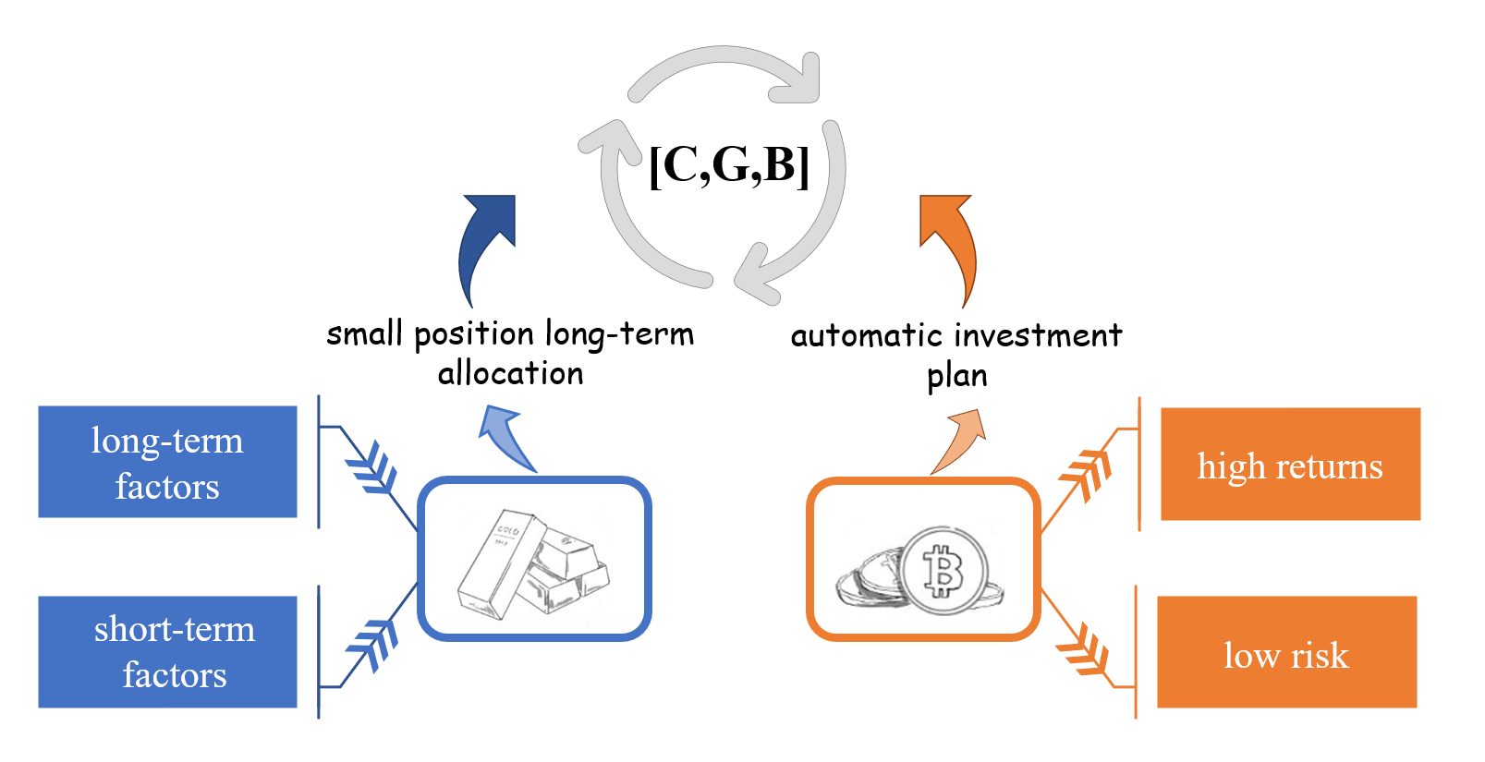 For bitcoin transactions, we prefer the automatic investment plan. In the stock market, automatic investment plan has been proved to be a suitable strategy for most people. By buying a certain amount of stock regularly, you can get the same or even higher returns with the market level with less time and energy cost. Since bitcoin's price change is also volatile, we think the automatic investment plan apply equally to bitcoin. By timing purchase, we can effectively smooth out the price volatility, reduce holding costs and halve risk.

Figure 1. Gold and bitcoin

In a word, securities returns, which can only be estimated according to limited information, can be considered as fuzzy variables rather than just random variables. Since the trapezoidal fuzzy【这里引用xxx】 number has been shown to be an appropriate measure of security returns, we decide to establish a multi-stage decision-making model, which helps us to regularly change the proportion of holding assets and reduce trading in other time to reduce risks and improve returns.

To verify the sensitivity of the model to transaction costs, we let the transaction cost changes in a certain range. The sensitivity of the model is captured by the change in the transaction amount at each stage and the final return.

In actual financial activities, considering investors are '**bounded rationality**', investors' psychological factors will affect their investment behavior. Therefore, we introduce specific measures of traders’ regret psychology to prove that our model is the best model. When other conditions are the same, the lower the degree of traders’ regret is, the more satisfied the decision is and the more successful the model is.

# Assumptions and Justifications

1. **There is no limit to the maximum and minimum transaction amount.**

To simplify the model, we assume that the minimum amount per transaction is 0, with no upper limit. And no debit or credit occurs. This applies to transactions of both gold and bitcoin.

1. **Traders make their decisions to purchase or sell based only on data from attachment, which are independent from people and circumstances around them.**

When people make decisions to buy or sell, they usually receive many factors, such as the evaluation from people around them, the current situation of life, and the news on the Internet. In this question, when making a trading decision, only the attached data matters with no other factors.

1. **Investors are more concerned about downside risks.**

When studying the psychology of investor regret, we find that the intensity of emotions is greater about loss than gain【这里引用xxx】.这里有何作用？

# Notations

Table 1 shows the notations commonly used in this paper and their description.

Table 1. Notations

|  |  |
| --- | --- |
| Notations | Description |
|  | Initial assets owned by investors |
|  | An investment period |
|  | Total wealth at the end of period |
|  | Fuzzy yield of risky assets in period |
|  | The semi-variance of |
|  | Investment amount to asset on period |
|  | Investment amount to risk-free asset on period |
|  | The upper bound constraint of risk asset on period |
|  | The lower bound constraint of risk asset on period |

# Model Construction and Resolution

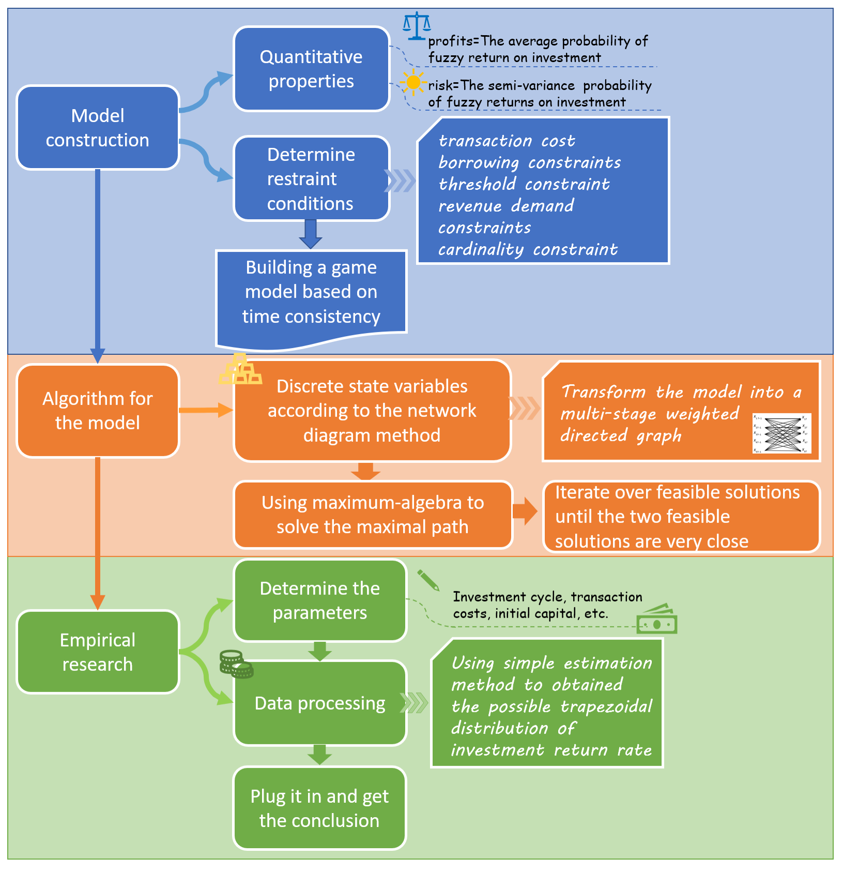Based on the analysis above,（那里的分析？） with the '**time inconsistency**' of investment strategy brought into model construction, a **multi-stage** **mean semi-variance fuzzy portfolio** model is proposed. It is based on transaction cost, loan constraint, threshold constraint, revenue demand and cardinality constraint, and the optimal investment strategy of time consistency is studied. Due to transaction cost, revenue demand and cardinality constraints, the model provides a **mixed-integer semi-closed-loop dynamic optimization with path-dependence** to solve this problem. As for details, we’ll use the discrete approximate iterative algorithm is to obtain the optimal time-consistent investment strategy in the following paper. Figure 2 is the flowchart of this process.

Figure 2. Model construction

## Subtitle预处理

Before data analysis and decision making, we must ensure its quality, which determines the prediction and generalization ability of the model. In order to ensure the accuracy, integrity and credibility of the data, we preprocess the data based on the attachments given: *BCHAIN-MKPRU.csv* and *LBMA-GOLD.csv*. We analyze the data in the table and delete useless data, supplement data that may be missing, and finally retain the revised data.

After analysis, we found that there is no illogicality data such as negative data, text or outliers in both files, so there is no need to delete any（没有就不需要写出来）.

In order to make the data smoother（为什么要平滑？）, we choose the mean interpolation method to supplement the data. For each incomplete item, the mean value of price on the day before and after the missing data day is supplemented into it. Table 2 shows the price data inserted into *LBMA-GOLD.csv*.

Table 2. Data inserted into file

|  |  |  |  |  |  |  |  |  |  |  |
| --- | --- | --- | --- | --- | --- | --- | --- | --- | --- | --- |
| **Date** | **12/30/16** | **12/23/16** | **12/22/17** | **12/29/17** | **12/24/18** | **12/31/18** | **12/24/19** | **12/31/19** | **12/24/20** | **12/31/20** |
| **Price** | **1132.98** | **1148.45** | **1272** | **1301.5** | **1263.1** | **1281** | **1469.8** | **1521** | **1874.65** | **1915.4** |

## Subtitle数据分析（这里有何作用？）

Focusing on gold and bitcoin, we mainly analyze their trading risks and correlation of price trends in this part.

With the development of market investment, people are more inclined to trade rationally and reduce risks while obtaining greater expected returns. Portfolio investment is a common way to avoid risks in investment management. By selecting different investment portfolios, we can maximize returns and minimize risks.

By introduce coefficient【这里引用xxx】，we can study the dynamic correlation between gold and bitcoin in the market. DCC-GARCH model is widely used in this field. Its general form is:

where is the conditional revenue rate of *k* kinds of assets, is the set of collected information, is the conditional covariance matrix, is the dynamic conditional correlation index matrix, is the covariance matrix and is the unconditional covariance matrix of standardized residual. andare positive parameters which meet +.

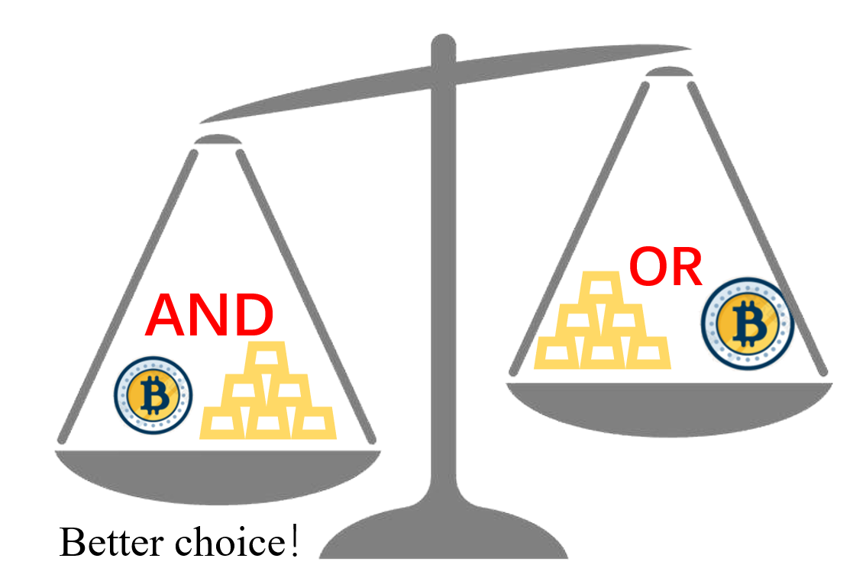Through this model, we establish a single variable GARCH (1,1) model for the return ratio series of bitcoin and gold, and draw the conclusion that the dynamic correlation between bitcoin and gold is characterized by remarkable persistence. The details are not important to the main problem we want to solve, so we omitted them in this paper. In short, it is supposed to invest both gold and bitcoin to gain more return while lower the risks.

Figure 3. Investment choice

As for volatility, it describes the uncertainty of asset returns, which is used to reflect the risk level of financial assets. According to how volatility changes, assets can be devided into assets with different risks. Common types include high-risk assets, mid-risk assets, and risk-free assets.

Unlike gold and bitcoin, the U.S. dollars is affected by many factors and is largely controlled, so its value holds for a long time, and the volatility is very low. It can be considered as a risk-free asset. As for gold, its price and volatility changes more violent than U.S. dollar but less violent than bitcoin. Thus, gold can be considered as a mid-risk asset and bitcoin can 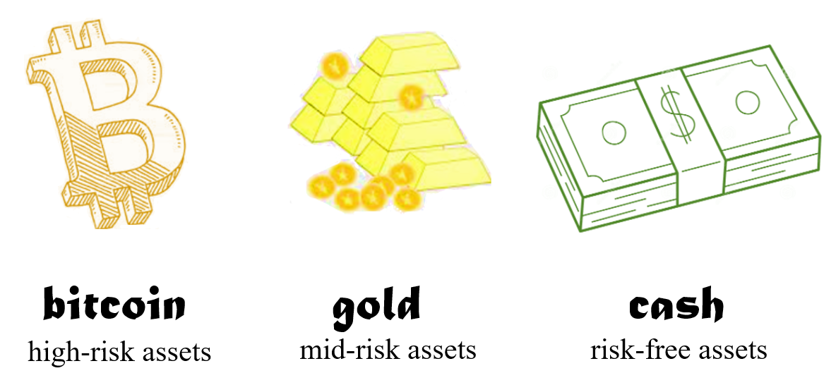be considered as a high-risk asset, as Figure 4 shows.

Figure 4. Risks of assets

## Subtitle参数说明和问题描述

Assume that there are kinds of risk assets and 1 kind of risk-free asset for investors to choose. His initial wealth is . Letstand for investment period, with stages. At the first stage of investment stage, the investor can only invest with . The asset portfolios changes at the beginning of eachstage and investment last for stages.

Let stand for the fuzzy yield of risky assets in period , and . Set as the total wealth at the end of period . In period , set as the semi-variance of , as the investment in asset , as the investment in risk-free asset , and as the upper and lower bound constraint of risk asset on period .

Let .

## Subtitle参数量化

The securities market is a complex system with dynamic changes. It is difficult for people to obtain the overall information of the random distribution of securities returns. We can only estimate the return according to the historical information of securities. Thus, securities returns can be considered as fuzzy variables rather than random variables. In addition, considering the uncertainty of market environment, trapezoidal fuzzy number is often used to measure the yield of securities. Many scholars have discussed the fuzzy portfolio optimization problem deeply, such as Carlsson[xxx], Anne Trefethen[xxx], Zhang Peng and Zhang Weiguo[xxx], etc. 这里引用xxx

The return and risk of asset portfolios are measured by the possibilistic mean value and the possibilistic standard semi-variance of asset fuzzy return, respectively. Clearly, the whole process is self-financing, as investors did not add additional funds during this period. Record the return rate of risk assets as , where

In period , the possibilistic mean value of the assets can be calculated as:

Assuming the transaction cost is % in this paper. Obviously, the transaction cost of asset in periodis , and the total cost of the asset portfolio is :

Then, the net income ratio of asset portfolio by the end of period is:

and the total wealth held by investor by the end of period is:

where .

## Subtitle确定约束条件

The threshold constraint of multi-stage portfolio is:

where and as the upper and lower bound constraint of .

Set the lower bound constrain of proportion of investment ratio on risk-free assets to be , then the borrowing constraints of risk-free assets in period is:

According to formula xxx(13), the semi-variance of asset portfolio is:

where its standard semi-variance is . Assume that is a semi-positive definite matrix.

The cardinality constraint is:

where is the maximum number of risk-free assets, and

## Subtitle博弈模型确定

The traditional multi-stage mean-standard semi-variance portfolio optimization model only considers the expected value of end-of-period wealth and standard semi-variance. In the real world, however, investors care not only about the expected value and standard semi-variance of end-of-period wealth, but also about which during the investment period. In other words, the expectation and the semi-variance of the portfolio are different in the period. Therefore, this paper uses standard semi-variance to measure risk. Set the weight coefficient and risk preference coefficient .

Time-consistent strategy means when , the optimal policies based on these two stages are the same. Few scholars have studied the time consistency of the multi-stage mean-standard semi-variance portfolio model with transaction costs, borrowing constraints, threshold constraints, income demand and cardinality constraints. In this paper, we restate this problem as a game problem. In this part, we will study the optimal strategy of generalized multi-stage mean-quasi-semi-variance fuzzy portfolio model with time consistency under multiple realistic constraints.

According to Bjork and Murguci’s research, a definition based on non-cooperative game was given:

**Definition 1.** Consider a fixed control law . Set . can be any control variable. For any , if is the same time-consistent strategy, then it comes the following result:

Such time-consistent law is called the **perfect nash equilibrium strategy** of sub-game. Under a non-cooperative game frame, assume that a gamer starts at position. According to Definition xxx, since he follows strategy , he can only choose strategy to maximize .

The following formula xxx shows a common equivalent transformation in time- consistent strategy:

In actual investment, we can easily conclude the following conditions:

* Expected return should be maximized;
* Investment to risk-free assets is a must;
* The number of assets is no more than ;
* The end-of-period wealth are supposed to be larger than

Thus, base on formula xxx, formula xxx, formula xxx, formula xxx, formula xxx, formula xxx and the conclusions above, we can get the following strategy model:

This is a mixed-integer semi-closed-loop dynamic optimization model with path-dependence.

这里需要小结一下模型的特点，以及大概的求解思路。

## Model Resolution

In this part, we will use discrete approximate iterative algorithm[xxx] to solve this problem. First, discretize the state variables based on network graph methods. Through this way, we can turn the model into a multi-stage weighted directed graph. Next, solve the maximum path by the maximum algebraic method. Here we can get the feasible solution. Finally, based on the feasible solution, keep iterating until the last 2 solutions are very close.

The details are as follows:

1. Disperse the interval into four equations. Therefore, discrete state variable at stage can be obtained. ().
2. 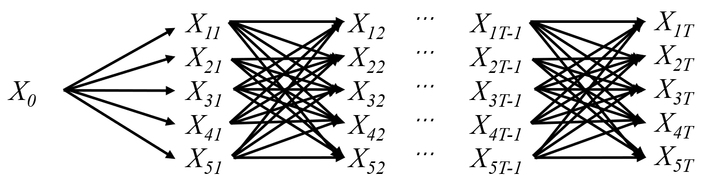Let stand for the multi-stage weighted directed graph. Solve the edges of .Build the graph as Figure 5 shows.

Figure 5.Multi-stage weighted directed graph

1. Based on discrete approximate iterative algorithm[xxx], get the longest path of after the first iteration:

where

1. Keep iteration. The -th iteration can be described as follows:

Let the longest path of the -th iteration be . The best solution to the longest path in Figure xxx is also the feasible solution to the multi-stage mean semi-variance fuzzy portfolio model. Based on this, disperse the variables from stage 1 to stage into four equations, as the following steps shows.

1. Disperse and , and into two internal structure which are the same. The 5 disperse points of , which are and can be solved.
2. Based on , disperse the variables from stage 3 to stage into 5 disperse points in the same way. The weight of stage can also be easily solved.
3. The longest path of -th iteration and another feasible solution can be calculated :

where .

If , the longest path is the approximate solution to our model. Else, keep iterating until it does.

## Subtitle运算结果

Here, based on the data in the attachment and the model above, we figure it out that how much the initial investment worth on 9/10/2021.

The first thing needs doing is clearing parameters:

* According to historical data on closing prices of gold and bitcoin from 09/11/2016 to 09/10/2021, we consider a month as a cycle of 60 months, that is, 60 stages. Thus, .
* Initial wealth .
* To ensure that investment is profitable, the ultimate wealth should be greater than the initial wealth. So .
* There are 2 kinds of risk assets(gold, bitcoin) and 1 kind of risk-free asset(cash), thus, .
* Set stand for gold and stand for bitcoin. The transaction costs of gold and bitcoin are .
* Since there will be no additional funds in the investment process, that is, no borrowings or arrears, the lower bound of the risk-free asset investment ratio is 0. Also, the amount of transactions in the period is less than or equal to the total wealth in period . Thus, , .
* Due to threshold constraints, the position of gold should be kept between 5 % and 10 %. Thus, .

The model described by formula xxx can be embodied as follows:

Formula xxx is the wealth we hope to achieve, formula xxx(a) corresponds to the iterative process, formula xxx(b) corresponds to profit demand, formula xxx(c) corresponds to the self-financing process, formula xxx(d) corresponds to the product category and formula xxx(e) corresponds to the threshold constraint of gold.

Solve it according to the method in Section 4.7 and get the trapezoidal distribution of the probability of return on assets in each period.

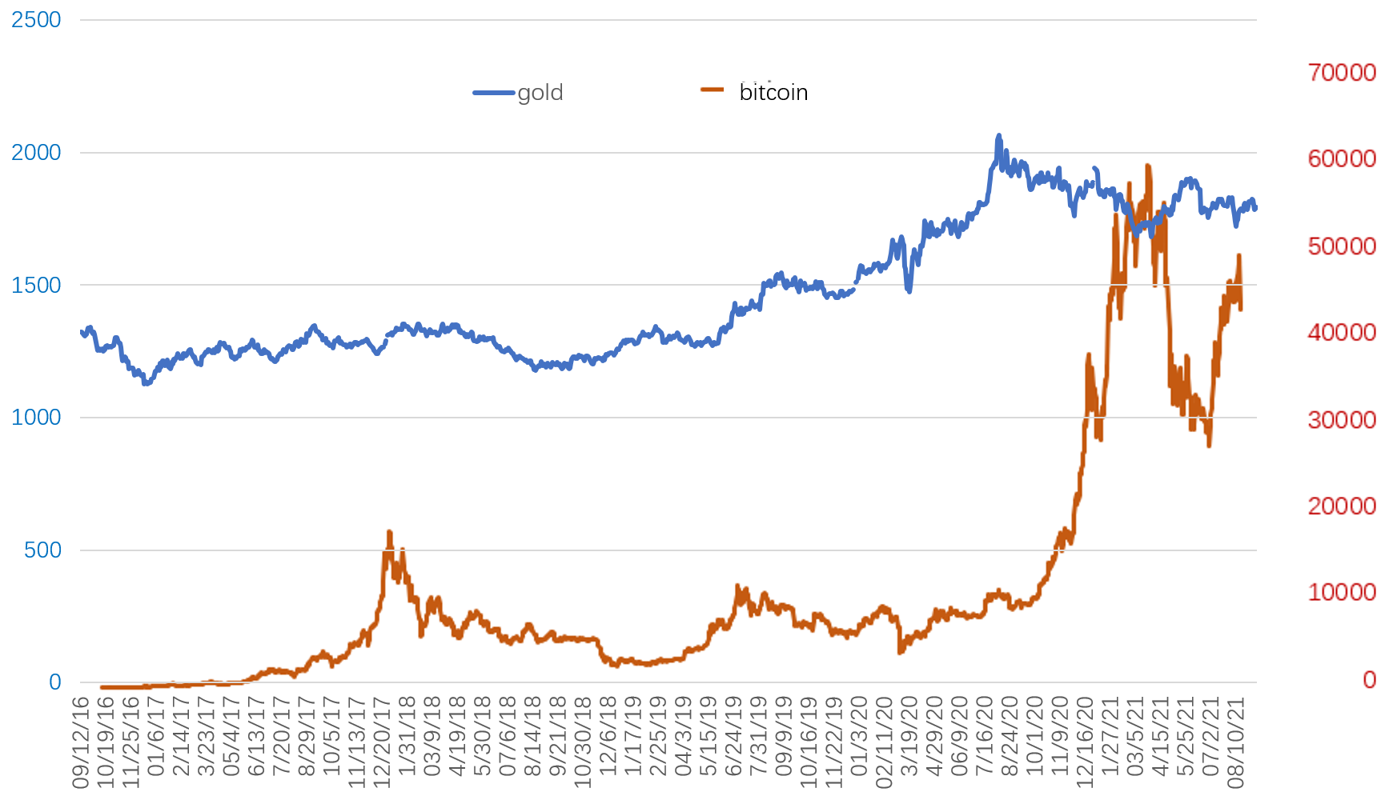To better understand the transaction in each period, the price charts of gold and bitcoin are shown below as Figure xxx shows. Visualize the results of the model as the following Figure xxx, xxx and xxx show.

Figure 6. Daily price of gold and bitcoin

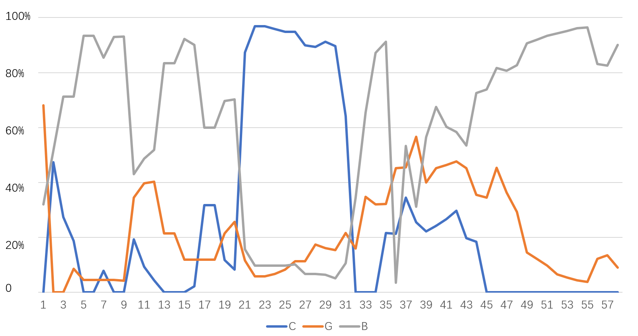Figure xxx shows the proportion of assets in total wealth at the end of each period. Blue, orange and gray lines represent cash, gold and bitcoin, respectively. We find that in periods 1 to 5 and 30 to 35, bitcoin is bought rapidly and massively. This is because the model judges that the price of bitcoin will continue to increase during this period and in the next several period, and the risk of decline in the short term is small, so a large number of purchases are made. In period 20 to 22, although we suffer some losses, the rapid sell-off of large amounts of gold and bitcoin helps us avoid the continuing decline. In period 34 and 35, most bitcoins are promptly and decisively sold, and gold, whose return is more stable, was invested. This further ensures the income when avoiding risks. In period 36 to 60, the slow purchase of bitcoin is due to its relatively low valuation caused by the rapid decline before. At this time, increasing the purchase is conducive to grasping the subsequent upward trend. Also, it is worth attention that although it is less likely to continue to fall after falling, that is, the risk is less, the model still suggest us to buy slowly to share the risk.

Figure 7.Proportion of assets in each period

The reasons and details of other transactions are similar to the above analysis, so they are not described too much here.

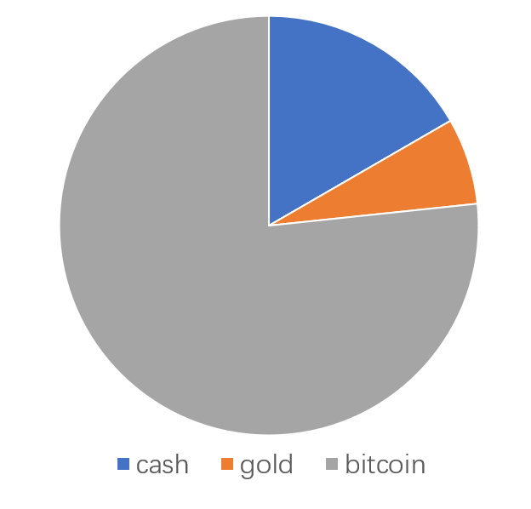In order to more intuitively feel the key investment assets in different periods, count the assets with the highest proportion in each period, and call this asset the "champion" of this period. Count the "champion" times of the three assets. Bitcoin wins "champions" for 46 times, gold wins 10 times and cash wins 4 times. Their "champion times" ratio is shown in Figure xxx.

Figure 8."Champion times" ratio

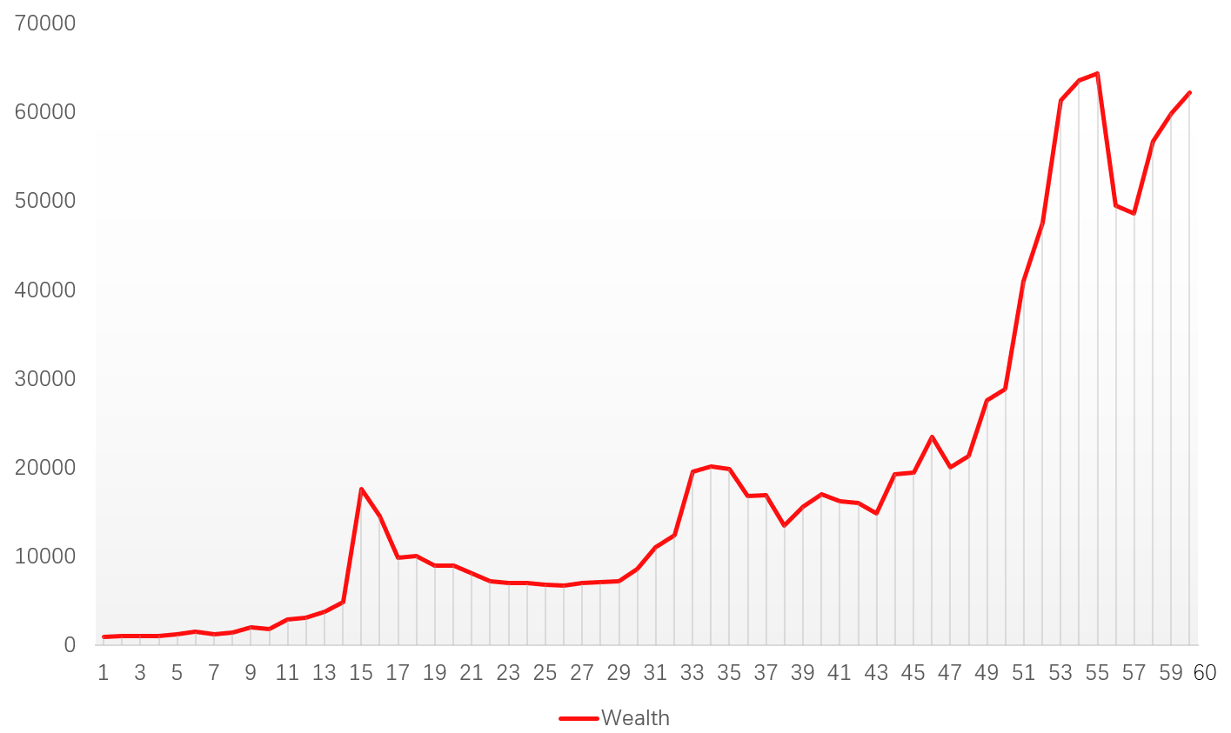

Figure xxx shows us our wealth intuitively. It can be found that the strategy based on the model helps us invest better, which means getting higher returns while avoiding risks. For example, in period 15 to 20 and 53 to 57, the market environment is quite unfavorable. Although there are losses, they are kept to a level that is far less than the market decline. And in period 46 to 55, we also keep up with the pace of market profits, obtained quite reliable income.

At the same time, it should be noted that compared with the losses in period 15 to 20 and 53 to 57, although the decline of the market in the latter is much larger than that in the former, the decline caused by investment based on the model is not much different. This shows that with the increase of historical data, the model’s resistance to sudden market deterioration continues to increase. If more historical data are available, the stronger our ability to predict and bear risks, the more radical strategies can be adopted to achieve higher returns.

Figure 9. Total wealth

In a nutshell, by 09/10/2021, the initial $1000 finally reaches assets equivalent to **$62211**. The rate of return has reached an impressive 100%

# Model Analysis

## Model Demonstration

In actual financial activities, considering that investors are "bounded rational", investors' psychological factors will affect their investment behavior. In investment decision-making, any portfolio in the market is an alternative, and investors will compare the expected returns and risks of different portfolios, when investors have an unlimited number of alternative portfolios. This part compares the investor's portfolio with the portfolio that is likely to receive the maximum return, to get the investor's "**regret value**" when the return is not optimal. Similarly, compare the investor's portfolio with the portfolio that is likely to have the least risk, to get the "regret value" when the portfolio does not meet the minimum risk. Because of "regret aversion" psychology, it is difficult for investors to maximize wealth and minimize risk from the perspective of absolute rationality when making investment decisions. Otherwise, they add regret psychology into investment decisions, hoping that the investment results will not bring regret to themselves.

We introduce regret psychology into the demonstration of the rationality of the model, which shows that the decision made by our model for different types of investors makes the degree of regret of investors lower than other choices, and makes investors more satisfied, that is, our model is more successful.

Due to the irrational behavior of investors in the process of investment, such as chasing up and down, overconfidence and regret aversion, many traditional portfolio models cannot explain the anomalies in financial markets well. Therefore, a large number of scholars began to develop and improve portfolio theory from the perspective of investor behavior. Chorus C.G proposed a **Generalized Random Regret Minimization** model in 2014. Based on Chorus's model, this part describes the investor's regret psychology from the perspective of return and risk.

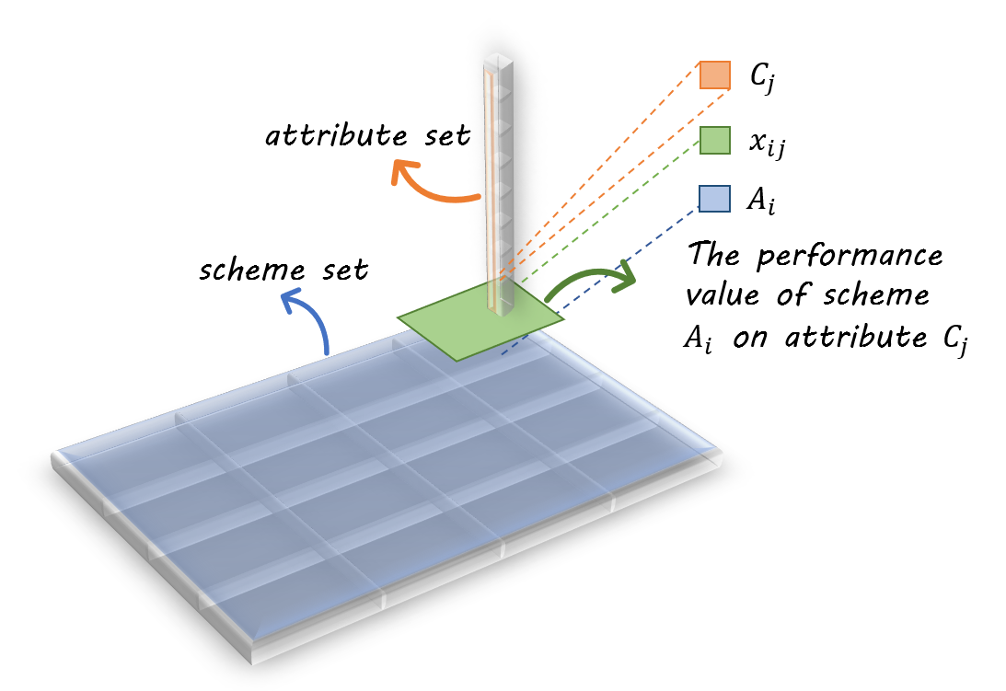Assume that there are feasible schemes. is the set of schemes. is the set of attributes. is the performance value of scheme on attribute . Performance values of different schemes can be compared under the same attribute.

Figure 10. Performance value

In the financial market, investors use the initial wealth to invest. If the final wealth is less than the maximum wealth available, investors may regret. This kind of regret value can be calculated as follows:

where is max available yield rate, is the actual yield, is the investor’s degree of regret and is the investor’s sensitivity to yield rate.

In the process of investment, investors hope to reduce the risk by diversifying investment. If the portfolio risk is greater than the minimum risk that investors can bear, investors will regret to do so. This kind of regret value can be calculated as follows:

where is the lowest acceptable risk, is the actual risk, is the investor’s degree of regret and is the investor’s sensitivity to risks.

Usually, the higher the expected return of an investor, the greater the risk he is willing to take. Thus, investor’s sensitivity to yield rate and risks can be considered as nearly negative correlation. Let

If , then the investor is more sensitive to yield. If , then the investor is more sensitive to risks. Otherwise, the investor is equally sensitive to yield and risks. The total regret value is:

In this paper, cash is considered as risk-free asset, gold is considered as mid-risk asset and bitcoin is considered as high-risk asset, according to their fluctuation. Investors are divided into conservative investors, normal investors and radical investors, according their investment style.

As for conservative investors, . As for normal investors, . As for racial investors, .

According to the model, we can get an investment proposal. Next, we will explore the regret value of investors with different styles when investing based on this proposal. The score is used to measure the success of the model, and the results are compared with the results of *equal proportional investment*[1].

【图片】

## Sensitive Analysis

When transaction costs fluctuate, the investment decisions given by the model will also be affected. When transaction costs rise, even if the investment phase remains unchanged, trades will be reduced or even stopped in some stages; when transaction costs fall, trades rise in some stages.

Therefore, we can change transaction costs and then observe the changes in investment suggestions given by the model. In this way, the sensitivity of the model to transaction costs is explored. We set three pairs of transaction costs of gold and bitcoin: and , and , and . Here are the results of our model.

When and , the result is clearly displayed in 4.8.

When and , Table xxx shows the proportion of assets [C,G,B] and the total wealth in different period.

Table 3. Total wealth and proportion of assets

|  |  |  |  |  |
| --- | --- | --- | --- | --- |
| Period | [C,G,B] | | |  |
| Cash | Gold | Bitcoin |
| 1 | 0 | 680 | 320 | 998 |
| 2 | 317 | 0 | 683 | 1067 |
| 3 | 160 | 91 | 749 | 1069 |
| 4 | 0 | 43 | 957 | 1157 |
| 5 | 0 | 43 | 957 | 1157 |
| … | | | | |
| 60 | 0 | 46 | 954 | 63157 |

When and , Table xxx shows the proportion of assets [C,G,B] and the total wealth .

Table 4. Total wealth and proportion of assets

|  |  |  |  |  |
| --- | --- | --- | --- | --- |
| Period | [C,G,B] | | |  |
| Cash | Gold | Bitcoin |
| 1 | 0 | 680 | 320 | 998 |
| 2 | 317 | 0 | 683 | 1067 |
| 3 | 160 | 91 | 749 | 1069 |
| 4 | 0 | 43 | 957 | 1157 |
| 5 | 0 | 43 | 957 | 1157 |
| … | | | | |
| 60 | 0 | 46 | 954 | 63157 |

We can clearly see that with the increase of transaction cost, the transaction amount and times in most of the stages are gradually decreasing. From this, we can draw the conclusion that our model is very sensitive to transaction cost.

## Strengths and Weakness

**Strengths:**

* **Comprehensiveness**. What our model takes into account are not only returns, but also risks investors to take when investing. It takes as little risk as possible while making the investor's return as large as possible.
* **Innovativeness**. Introduce a specific measure of investor regret psychology to demonstrate the superiority of the model, and use it to measure the success of the model.
* **Applicability**. Theoretically, in the absence of major international events, the model can continuously update itself over long periods of time and is highly applicable.

**Weakness:**

* Because the risks taken investors are considered, the decisions proposed are on the conservative side, which may cause investors to miss out on certain gains.
* The decision is mainly influenced by the price data without taking other factors into account such as international situation, policy implications, etc. The factors are relatively homogeneous and may lead to results that differ from the actual optimal ones.

# Conclusion

TODO

# Memorandum

//TODO

这里打算放个封面什么的

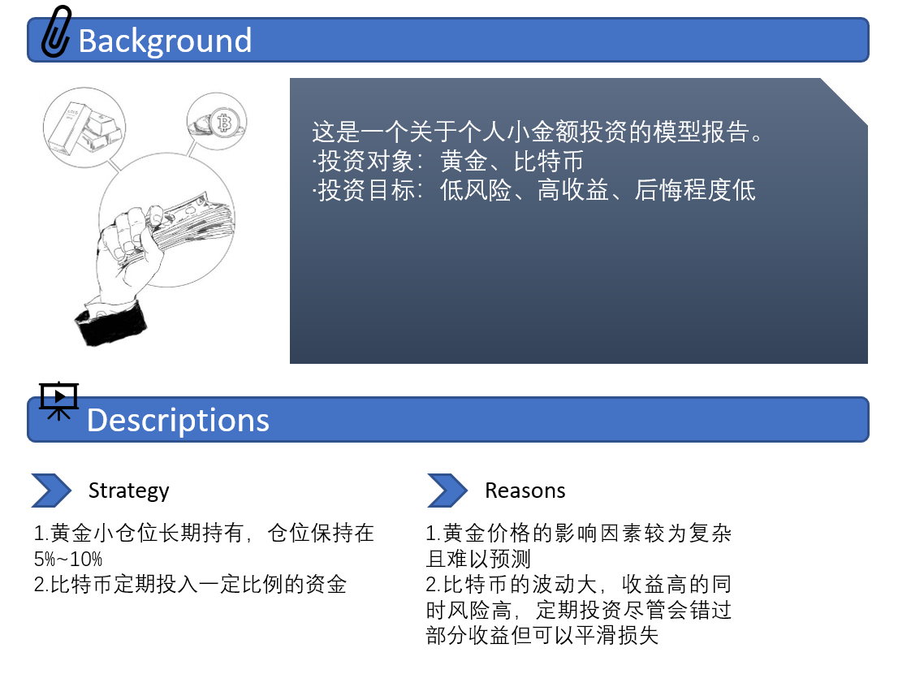

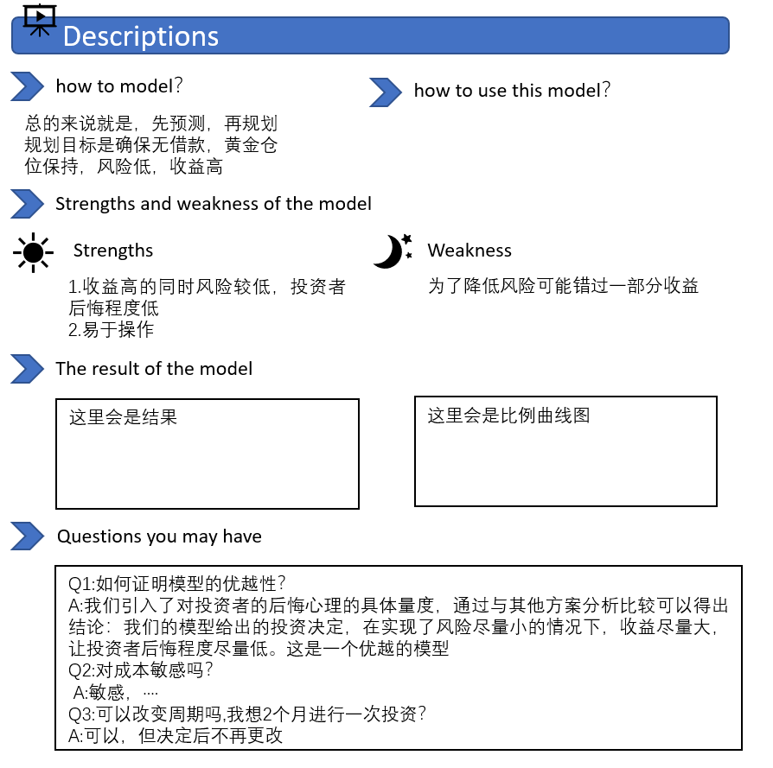

# References

1. Vercher E, BermUdez J D. A Posibilistic Mcan-Downside Risk-Skewness Model f-or Efficient Portfolio Selection[J]. IEEE Transactions On Fuzzy Systems, 2013.3:585—595.
2. Test
3. test
4. test
5. test
6. stest
7. test
8. test

# Appendix A

# Appendix B

|  |  |  |  |  |  |  |  |  |  |
| --- | --- | --- | --- | --- | --- | --- | --- | --- | --- |
| Period | [C, G, B] | | |  | Period | [C, G, B] | | |  |
| Cash | Gold | Bitcoin | Cash | Gold | Bitcoin |
| 1 | 0 | 680 | 320 | 959 | 31 | 533 | 179 | 286 | 11025 |
| 2 | 478 | 0 | 522 | 1044 | 32 | 350 | 126 | 522 | 12368 |
| 3 | 277 | 0 | 723 | 1059 | 33 | 0 | 128 | 872 | 19531 |
| 4 | 190 | 86 | 724 | 1089 | 34 | 0 | 259 | 741 | 20097 |
| 5 | 0 | 45 | 955 | 1243 | 35 | 0 | 259 | 741 | 19864 |
| 6 | 0 | 45 | 955 | 1512 | 36 | 179 | 376 | 445 | 16778 |
| 7 | 79 | 46 | 875 | 1263 | 37 | 177 | 374 | 449 | 16878 |
| 8 | 0 | 46 | 954 | 1439 | 38 | 345 | 466 | 209 | 13524 |
| 9 | 0 | 44 | 956 | 2074 | 39 | 282 | 326 | 252 | 15994 |
| 10 | 219 | 392 | 489 | 1856 | 40 | 163 | 335 | 502 | 17005 |
| 11 | 95 | 407 | 498 | 2892 | 41 | 184 | 355 | 461 | 16221 |
| 12 | 44 | 419 | 537 | 3110 | 42 | 202 | 359 | 439 | 15997 |
| 13 | 0 | 204 | 796 | 3765 | 43 | 231 | 352 | 417 | 14851 |
| 14 | 0 | 204 | 796 | 4869 | 44 | 154 | 277 | 568 | 19264 |
| 15 | 0 | 108 | 892 | 17597 | 45 | 156 | 274 | 570 | 19452 |
| 16 | 20 | 113 | 867 | 14556 | 46 | 0 | 356 | 644 | 23517 |
| 17 | 306 | 114 | 579 | 9877 | 47 | 0 | 344 | 656 | 20001 |
| 18 | 306 | 114 | 579 | 10013 | 48 | 0 | 261 | 739 | 21356 |
| 19 | 113 | 208 | 679 | 8992 | 49 | 0 | 137 | 862 | 27567 |
| 20 | 79 | 245 | 676 | 9015 | 50 | 0 | 117 | 883 | 28859 |
| 21 | 763 | 101 | 136 | 8113 | 51 | 0 | 94 | 906 | 41005 |
| 22 | 862 | 51 | 86 | 7235 | 52 | 0 | 65 | 935 | 47598 |
| 23 | 862 | 51 | 86 | 6997 | 53 | 0 | 54 | 946 | 61357 |
| 24 | 852 | 61 | 86 | 7004 | 54 | 0 | 38 | 962 | 63571 |
| 25 | 833 | 75 | 92 | 6841 | 55 | 0 | 35 | 965 | 64401 |
| 26 | 841 | 100 | 59 | 6755 | 56 | 0 | 127 | 873 | 49560 |
| 27 | 841 | 100 | 59 | 6998 | 57 | 0 | 139 | 861 | 48650 |
| 28 | 791 | 152 | 56 | 7112 | 58 | 0 | 99 | 901 | 56751 |
| 29 | 890 | 157 | 53 | 7199 | 59 | 0 | 79 | 921 | 59934 |
| 30 | 882 | 161 | 57 | 8549 | 60 | 0 | 64 | 936 | 62211 |

1. equal proportional investment means purchasing at on 09/11/2016.