问题分析

首先我们注意到这是一项个人投资，且投资金额较少，因此我们作出的投资决策应符合市场普遍规律以降低风险、提高收益。

First of all, we note that this is a personal investment and the amount of investment is small, so the strategy should be in line with the market mechanism to reduce risks and increase returns.

首先，金价格既受短期因素影响，也受长期因素影响，而短期的因素又不确定，比如随机出现的一些因素，包括突发的一些局势问题等都会影响黄金价格，所以不建议进行短期择时投资。中长期择时模型有两个驱动因素，一个是美联储货币政策，从政策的时间尺度，可以大概知道货币政策对黄金在什么阶段会有什么影响。同时第二个因素取决于每一次经济周期本身的特点。回过头来，可以比较明显地判断出来，但这些经济数据很难提前去预测的。

First of all, gold price is affected by both short-term and long-term factors. Short-term uncertain factors, such as contingent economic issues, let gold price fall more than its recent increase, so it is not recommended to invest in short-term timing. The medium and long-term timing model has two driving factors. One is the Federal Reserve’s monetary policy. From the time scale of the policy, we can probably infer how monetary policy affects gold at what stage. The other factor depends on the characteristics of each economic cycle. These economic data can be made out obviously after their occurrence, but are hard to predict in advance.

所以在复杂的驱动因素下，每个因素下又有不可测驱动力的情况下，建议大家长期配置，这样不管时间怎么变、不同的时间阶段背后的因子怎么变，我们最终可以获得长期的收益，最终只是放弃一些短期可能有，也可能没有的波段性的收益，这些收益我们不建议个人投资者去参与这些短期的波动。因此，对于黄金交易我们建议保持小仓位长期配置，即5%~10%

Therefore, under the complex and unpredictable driving factors, it is recommended to allocate gold assets for a long time. In this way, no matter how time changes or how the market influencing factors are at different time stages, we can finally obtain long-term benefits. The price of such strategy is only to give up some band benefits that are difficult to grasp in the short term. We do not recommend that individual investors take risks for this return. Therefore, for gold trading, we recommend maintaining long-term allocation of small positions, namely 5 % ~ 10 % of the position.

而对于比特币交易，我们要始终注意我们是小金额个人投资。在股票领域，定投已经被证明是一种适合普通人的操作策略。通过定期买入一定量的股票，只要投入较少的时间、精力，就可以获得与市场水平持平甚至更高的收益。因为比特币的价格波动同样剧烈，风险和收益都较高，我们认为定投同样适用于比特币。通过定时分批买入，能够有效的平滑掉价格的剧烈波动，降低持有成本，平坦风险。

For Bitcoin transactions, we should also attach attention to the fact that we are small personal investments. In the stock market, automatic investment plan has been proved to be a suitable strategy for ordinary people. By buying a certain amount of stock regularly, you can get the same or even higher returns with the market level with less time and energy cost. Since Bitcoin's price change is also volatile, with high risk and high return, we think the automatic investment plan apply equally to Bitcoin. By timing purchase, we can effectively smooth out the price volatility, reduce holding costs and halve risk.

综上所述，我们决定建立多阶段决策模型，定期改变持有资产比例，其余时间保持比例，停止交易以降低风险，提高收益。

Thus, we decide to establish a multi-stage decision-making model, which helps us to regularly change the proportion of holding assets and reduce trading in other time to reduce risks and improve returns.

在实际金融活动中，考虑到投资者是“有限理性的”，投资者的心理因素会影响其投资行为.因此我们引入交易员对“后悔”心理的具体量度以证明我们的模型是最佳模型。其他条件相同时，交易员后悔程度越低，模型所提供的决策越使交易员满意，模型越成功。

In actual financial activities, considering investors are 'bounded rationality', investors' psychological factors will affect their investment behavior. Therefore, we introduce specific measures of traders’ regret psychology to prove that our model is the best model. When other conditions are the same, the lower the degree of traders’ regret is, the more satisfied the decision is and the more successful the model is.

**模型的建立**

【模型建立的部分】本文将投资策略的“时间非一致性”纳入研究框架，提出具有交易成本、借款约束、阈值约束、收益需求和基数约束的多阶段均值-标准半方差模糊投资组合模型，并研究其时间一致性的最优投资策略。由于存在交易成本、收益需求和基数约束，该模型是一个具有路径依赖性的混合整数半闭环动态优化问题。本文运用离散近似迭代算法求出其最优时间一致的投资策略。

Based on the analysis above, with the '**time inconsistency**' of investment strategy brought into model construction, a **multi-stage** **mean semi-variance fuzzy portfolio** model is proposed. It is based on transaction cost, loan constraint, threshold constraint, revenue demand and cardinality constraint, and the optimal investment strategy of time consistency is studied. Due to transaction cost, revenue demand and cardinality constraints, the model provides a mixed-integer semi-closed-loop dynamic optimization with path-dependence to solve this problem. As for details, we’ll use the discrete approximate iterative algorithm is to obtain the optimal time-consistent investment strategy in the following paper.

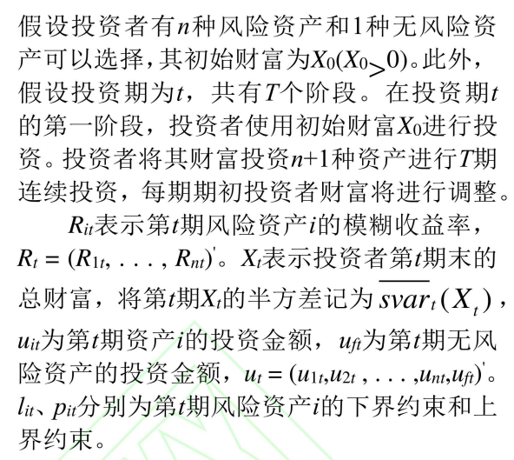1.问题描述

Assume that there are $n$ kinds of risk assets and 1 kind of risk-free asset for investors to choose. His initial wealth is $X_{0}$. Let $t$ stand for investment period, with $T$ stages. At the first stage of investment stage, the investor can only invest with $X_{0}$. The asset portfolios changes at the beginning of eachstage and investment last for $T$ stages.

Let $R_{it}$ stand for the fuzzy yield of risky assets $i$ in period $t$, and $R_{t}={\left(R_{1t},R_{2t},…R_{nt}\right)}^{'}$. Set $X_{t}$ as the total wealth at the end of period $t$. In period $t$, set $\overline{svar}\left(X_{t}\right)$ as the semi-variance of $X_{t}$, $u_{it}$ as the investment in asset $i$, $u_{ft}$ as the investment in risk-free asset $i$, $l_{it}$ and $p_{it}$ as the upper and lower bound constraint of risk asset $i$ on period $t$. Let $u_{t}={\left(u_{1t}, u_{2t}, …,u_{nt}, u_{ft}\right)}^{'}$.

2.量化参数

[参数建立的部分】证券市场是一个动态变化的复杂系统，人们难以获得证券收益随机分布的总体信息，只能根据证券历史信息对随机收益的参数或概率分布进行经验估计，证券收益可以被认为是模糊变量而不仅仅是随机变量。另外，考虑到市场环境的不确定性，梯形模糊数常被用于度量证券收益率。已有众多学者对模糊投资组合优化问题深入探讨，如，Carlsson等[14]、金秀等[15]、Zhang Peng和Zhang Weiguo[16]，Zhang Weiguo等[17]。

The securities market is a complex system with dynamic changes. It is difficult for people to obtain the overall information of the random distribution of securities returns. We can only estimate the return according to the historical information of securities. Thus, securities returns can be considered as fuzzy variables rather than random variables. In addition, considering the uncertainty of market environment, trapezoidal fuzzy number is often used to measure the yield of securities. Many scholars have discussed the fuzzy portfolio optimization problem deeply, such as Carlsson , Anne Trefethen, Zhang Peng and Zhang Weiguo , etc. 这里引用xxx

资产组合的收益和风险分别用资产模糊收益的期望和可能性标准半方差来度量。显然，投资过程都是自融资，因为投资者在选择投资组合期间没有追加额外的资金。记风险资产的收益率Rit= (ait, bit, αit , βit) (i= 1, 2, . . . , n; t = 1, 2, . . . , T)为梯形模糊数。

The return and risk of asset portfolios are measured by the possibilistic mean value and the possibilistic standard semi-variance of asset fuzzy return, respectively. Clearly, the whole process is self-financing, as investors did not add additional funds during this period. Record the return rate of risk assets as $R_{it}$, where $R_{it}=\left(a_{it}, b_{it}, α_{it},β_{it}\right).$

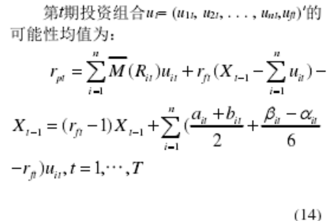

In period $t$, the possibilistic mean value $r_{pt}$ of the assets $u_{t}=\left(u_{1t}, u_{2t}, …u_{nt}, u_{ft}\right)$ can be calculated as:

$${ r}_{pt}= \sum_{i=1}^{n}{\overline{M}\left(R_{it}\right)u_{it}+r_{ft}(X_{t-1}-}\sum_{i=1}^{n}{u_{it}})-X_{t-1}=\left(r_{fi}-1\right)X_{t-1}+\sum{\left(\frac{a_{it}+b_{it}}{2}+\frac{β_{it}-α_{it}}{6}-r_{ft}\right)u_{it}, t=1,2,…,T}$$

本文的交易成本即为佣金成本。每笔的佣金成本是交易金额的百分之阿尔法。则资产i在第t期的交易成本为 百分之欧美噶*uit，投资组合ut=（u1t,u2t,u3t,````,unt,uft）在第t期的总交易成本为：【Ω改成γ】

Ct=(求和符号)欧美噶*（uit）(i从1到n)，t=1,```T

Assuming the transaction cost is $γ$% in this paper. Obviously, the transaction cost of asset $i$ in period $t$ is $u_{it}×γ\%$, and the total cost of the asset portfolio $u_{t}=(u_{1t},u_{2t},…,u_{nt},u_{ft})$ is :

$$C_{t}= \sum_{i=1}^{n}{u_{it}×γ, }t=1,2,…,T$$

则投资组合xt在第t期的净收益率为：

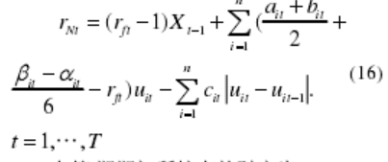（c那啥换成欧美噶的公式）

在t期期末所持有的财富为

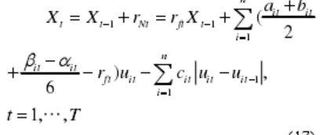

（c那啥换成欧美噶的公式）

Then, the net income ratio of asset portfolio $X_{t}$ by the end of period $t$ is:

$$r_{Nt}=(r_{ft}-1)X_{t-1}+\sum_{i=1}^{n}{\left(\frac{a_{it}+b_{it}}{2}+\frac{β_{it}-α_{it}}{6}-r_{ft}\right)u_{it}}-\sum_{i=1}^{n}{γ_{it}\left|u_{it}\right|}$$

and the total wealth held by investor by the end of period $t$ is:

$$X_{t}=r_{Nt}+X_{t-1}=r_{ft}X_{t-1}+\sum_{i=1}^{n}{\left(\frac{a_{it}+b_{it}}{2}+\frac{β_{it}-α_{it}}{6}-r_{ft}\right)u_{it}}-\sum_{i=1}^{n}{γ_{it}\left|u_{it}\right|}$$

3.确定约束条件

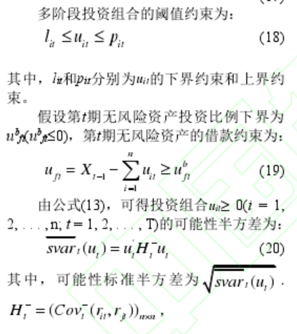

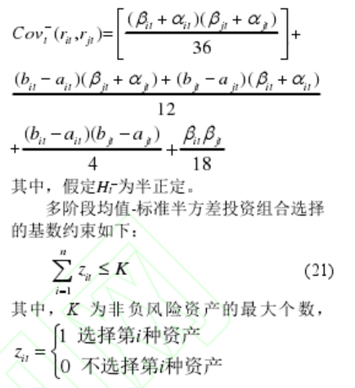

4.确定博弈模型

传统的多阶段均值-标准半方差投资组合优化模型只考虑了期末财富的期望值和标准半方差。然而，在现实世界中，投资者不仅关心期末财富的期望值和标准半方差，还关心投资期中的财富期望值和标准半方差。换句话说，投资组合的期望值和半方差在t期是不同的。因此，本文采用标准半方差来度量风险。因此假设有权系数wt>0，风险偏好系数ηt >0,(t = 1, … , T)

目前还未有学者研究具有交易成本、借款约束、阈值约束、收益需求和基数约束的多阶段均值-标准半方差投资组合模型的时间一致性问题。在本文中，我们将该问题重新表述为一个博弈问题。在本节中，我们将研究多重现实约束下具有时间一致性的广义多阶段均值-准半方差模糊投资组合模型的最优策略。

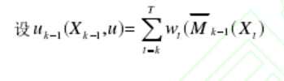

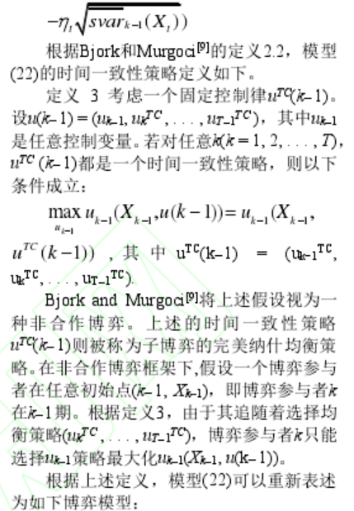

根据上述定义，我们建立如下博弈模型：式23、24抄上去

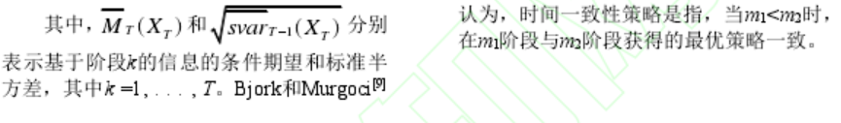

因此，依据式25（抄上去）可将式23、24转化为式27（抄上去）

模型(27)是一个具有路径依赖性的混合整数半闭环动态优化问题。

**模型的求解**

全部照抄

**实证结果**

1.确定参数

根据附件所给黄金与比特币从XXX到XXX的收盘价的历史数据，我们将一个月视为一个周期，共60个阶段，即T=60。初始财富X0=1000$，其财富可在每期期初进行调整。投资者有两种风险投资（黄金、比特币）和1种无风险资产(现金)可以选择，即n=2。i=1，鸟事黄金，i=2表示比特币。佣金抽取比例 欧美噶1=0.01，欧美噶2=0.02，下界为 ，下界为

2.数据处理

利用 Vercher 和BermUdez[19]的简单估计方法处理数据，可得到各期资产收益率的可能性梯形分布。

来个图

3.结论

（表格最好，举几期）

最后加上最后的资产