**Data Communications (CSE4060)**

**Homework #2 (Ch.7 - Ch.12)**

20161637 장호영

**1) Calculate the bandwidth of the light for the following wavelength ranges (assume a propagation speed of 2 m)? You can use the formula f = c / λ to find the corresponding frequency for each wave length**

a) 1000 to 1200 nm : (2 x 10⁸ /1000 x 10⁹) - (2 x 10⁸ / 1200 x 10⁹) = **33THz**

b) 1000 to 1400 nm : (2 x 10⁸ /1000 x 10⁹) - (2 x 10⁸ / 1400 x 10⁹) = **57THz**

**2) A path in a digital circuit-switched network has a data rate of 1 Mbps. The exchange of 1000 bits is required for the setup and teardown phases. The distance between two parties is 5000 km. Answer the following questions if the propagation speed is 2 m:**

**total delay = delay for setup and teardown + propagation delay + transmission delay**

**propagation delay = 3 x 5000/2 x 10⁸ = 75ms , trasmission delay = 3 x 1000/1000 = 3 ms**

a. What is the total delay if 1000 bits of data are exchanged during the data transfer phase?

78 + 25 + 1 = **104ms**

b. What is the total delay if 100,000 bits of data are exchanged during the data-transfer phase?

78 + 25 + 100 = **203 ms**

c. What is the total delay if 1,000,000 bits of data are exchanged during the data-transfer phase?

78 + 25 + 1000 = **1103 ms**

d. Find the delay per 1000 bits of data for each of the above cases and compare them. What can you infer?

위로 미루어 추정했을 때, 한번의 setup과 tear down phase로 더 많은 데이터를 보내는 c가 가장 비율이 좋다. 생각보다 setup과 tear down에서 많은 딜레이가 존재하므로 생성했을 때 많은 데이터를 보내는 것이 더 유리할 것이라고 추론된다.

**3) In below Figure,**

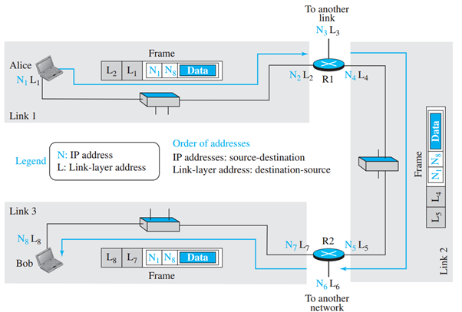

a) assume Link 2 is broken. How can Alice communicate with Bob?

**주어진 그림에서 보았을 때, 다른 라우터를 통해 R2를 갈 수 있는 경로가 없으므로 새로운 라우팅이 되기 전까지는 communication이 힘들 것 같다.**

b) show the process of frame change in routers R1 and R2.

**L2 L1 N1 N8 -> L5 L4 N1 N8**

**L5 L4 N1 N8 -> L8 L7 N1 N8 로 프레임이 변하게 된다.**

**4) What is the maximum effect of a 2-ms burst of noise on data transmitted at the following rates? We have (vulnerable bits) = (data rate) × (burst duration).**

a) 1500 bps – 1500 x 2 x = **3bits**



b) 12 kbps – 12000 x 2 x = **24bits**



c) 100 kbps – 100000 x 2 x = **200bits**



d) 100 Mbps – 100000000 x 2 x = **200000bits**



**5) What is the Hamming distance for each of the following codewords?**

**-> exclusive or 연산을 하면 hamming distance를 구할 수 있다.**

1) *d*(10000, 00000) -> 10000 따라서, **1**

2) *d*(10101, 10000) -> 00101 따라서, **2**

3) *d*(00000, 11111) -> 11111 따라서, **5**

4) *d*(00000, 00000) -> 00000 따라서, **0**

**6) In below Figure, show what happens in each of the following cases:**

i) The sender is at the ready state and an error-free ACK arrives.

**sender가 타이머를 멈추고 저장된 프레임을 버리고 상위 레이어로부터 새로운 패킷을 받을 준비를 한다.**

ii) The sender is at the blocking state and a time-out occurs.

**sender는 저장된 프레임을 복사하여 다시 보내고, 타이머를 다시 시작한다.**

iii) The sender is at the ready state and a time-out occurs.

**이런 경우는 발생하지 않는다. 타이머가 돌아가는 기간 동안에는 sender는 ready 상태가 아니라 blocking 상태에 있다.**

iv) The receiver is in the ready state and a packet comes from the network layer.

**receiver는 ready 상태에 있고 패킷이 네트워크 레이어에서 온다.**

v) The receiver is in the ready state and a corrupted frame arrives.

**receiver가 준비된 상태이고 corrupt된 프레임이 도착하면 프레임을 없앤다.**

vi) The receiver is in the ready state and an acknowledgment arrives.

**에러없는 프레임이 도착하면 프레임 속의 메시지가 네트워크 레이어로 전달되고 ACK가 전달되며**  **receiver는 다음 프레임 받을 준비를 한다.**

**7) A multiple access network with a large number of stations can be analyzed using the Poisson distribution. When there is a limited number of stations in a network, we need to use another approach for this analysis. In a network with *N* stations, we assume that each station has a frame to send during the frame transmission time () with probability *p*. In such a network, a station is successful in sending its frame if the station has a frame to send during the vulnerable time and no other station has a frame to send during this period of time.**

a. Find the probability that a station in a pure Aloha network can successfully send a frame during the vulnerable time.

**vulnerable time 동안 N-1 station이 보낼 프레임이 없다면**



b. Find the probability that a station in a slotted Aloha network can successfully send a frame during the vulnerable time.

