**Data Communications (CSE4060)**

**Homework #6 ( - Ch.30)**

1. Below figure shows a router using FIFO queuing at the input port. The arrival and required service times for seven packets are shown below; $t_{i}$ means that the packet has arrived or departed *i* ms after a reference time. The values of required service times are also shown in ms. We assume the transmission time is negligible.

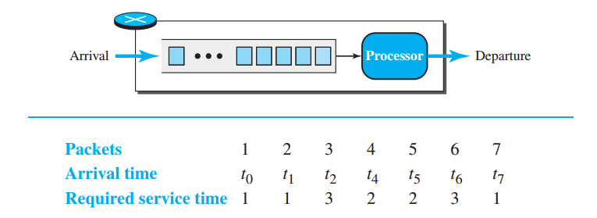

1. Using time lines, show the arrival time, the process duration, and the departure time for each packet. Also show the contents of the queue at the beginning of each millisecond.
2. For each packet, find the time spent in the router and the departure delay with respect to the previously departed packet.
3. If all packets belong to the same application program, determine whether the router creates jitter for the packets.

2. To regulate its output flow, a router implements a weighted queueing scheme with three queues at the output port. The packets are classified and stored in one of these queues before being transmitted. The weights assigned to queues are w = 3, w = 2, and w = 1 (3/6, 2/6, and 1/6). The contents of each queue at time $t_{0}$ are shown in below Figure. Assume packets are all the same size and that transmission time for each is 1 $μ$ s.

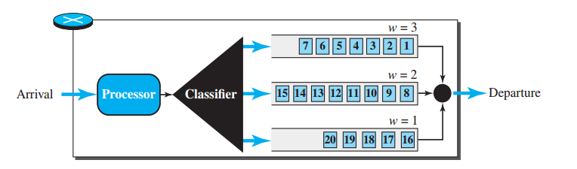

1. Using a time line, show the departure time for each packet.
2. Show the contents of the queues after 5, 10, 15, and 20 μs.
3. Find the departure delay of each packet with respect to the previous packet in the class w = 3. Has queuing created jitter in this class?
4. Find the departure delay of each packet with respect to the previous packet in the class w = 2. Has queuing created jitter in this class?
5. Find the departure delay of each packet with respect to the previous packet in the class w = 1. Has queuing created jitter in this class?

3. An output interface in a switch is designed using the leaky bucket algorithm to send 8000 bytes/s (tick). If the following frames are received in sequence, show the frames that are sent during each second.  
❑ Frames 1, 2, 3, 4: 4000 bytes each  
❑ Frames 5, 6, 7: 3200 bytes each  
❑ Frames 8, 9: 400 bytes each  
❑ Frames 10, 11, 12: 2000 bytes each