Fall 2024 MSE 760 Lab1 Assignment Report

University of Wisconsin-Madison

Electronic Structure and Lattice Constant of Diamond

Jiahui Yang

October 08, 2024

**Abstract**

This report details the computational analysis of the face-centered cubic diamond structure, with a focus on the electronic structure and optimization of the lattice constant. Utilizing norm-conserving pseudopotentials and the Quantum ESPRESSO software, systematic studies were conducted to determine total energy convergence with respect to k-point density and wavefunction cutoff. The lattice constant was optimized by fitting the total energy calculations to the Murnaghan equation of state. Comparative analyses were performed against experimental lattice constants and electronic band structures to benchmark the accuracy of the computational methods. Moreover, the band structure and density of states for diamond were computed and analyzed, providing insights into the directness and size of the band gap. These findings contribute to a deeper understanding of diamond’s electronic properties, with implications for both theoretical and practical applications.

Link to Lab1 Assignment GitHub repo:

<https://github.com/jhyang13/UWMadison_MSE760/tree/main/lab_assignment1>

**Contents**

1. Abstract--------------------------------------------------------------------------------------------2

2. Introduction and Methods-----------------------------------------------------------------------4

3. Results and Discussions-------------------------------------------------------------------------

4. Conclusions--------------------------------------------------------------------------------------

5. References-----------------------------------------------------------------------------------------

**General information**

1. Name: Jiahui Yang
2. Email: [jyang753@wisc.edu](mailto:jyang753@wisc.edu)
3. Home Department: Mechanical Engineering
4. Status: PhD Student

**Introduction and Methods**

During our class on Parallel Reduction example, it dawned on us pretty fast how parallel computing could be a game-changer for array-related tasks.

**Results and Discussions**

1. **Build the structure of diamond (similar to silicon, only different lattice constant)**

Both diamond and silicon have a face-centered cubic structure with a two-atom basis per unit cell. However, the lattice constants for these two materials differ: diamond has an experimental lattice constant of 3.567 Å, while silicon's experimental lattice constant is 5.431 Å.

Though their atomic arrangements are nearly identical, the lattice constant must be adjusted to reflect the smaller atomic spacing in diamond. The diamond structure can be described as a face-centered cubic Bravais lattice with two carbon atoms per unit cell. The carbon atoms are located at fractional coordinates C(0.00, 0.00, 0.00) and C(0.25, 0.25, 0.25) relative to the unit cell. The crystal structure remains the same as silicon, but the smaller lattice constant for diamond results in closer atomic spacing and higher bond strength. This difference significantly impacts physical properties such as hardness, electronic band structure, and thermal conductivity.

In Quantum ESPRESSO simulations, the lattice constant is expressed in atomic units (a.u.), where 1 a.u. = 0.529177 Å. For diamond, the lattice constant in atomic units is:



The diamond structure is simulated in Quantum ESPRESSO by defining the crystal structure, atomic positions, and relevant calculation parameters. Below is the input file (scf.in) for a self-consistent field (SCF) calculation:

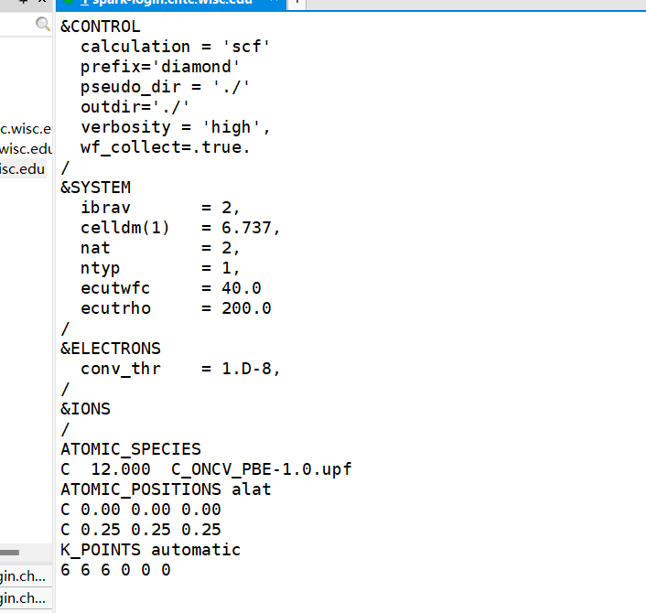

Explanation of Input Parameters:

* **ibrav = 2:** This specifies the face-centered cubic structure.
* **celldm(1) = 6.737:** Defines the lattice constant in atomic units (6.737 a.u.), which corresponds to 3.567 Å in real space, the experimental lattice constant of diamond.
* **nat = 2:** Indicates there are two atoms per unit cell.
* **ntyp = 1:** Specifies that there is only one type of atom in this system, which is carbon.
* **ecutwfc = 40.0:** This defines the cutoff energy for the wavefunctions, a typical value for density functional theory (DFT) calculations using pseudopotentials.
* **ATOMIC_POSITIONS alat:** This defines the positions of the two carbon atoms in the unit cell, where the fractional coordinates (0.00, 0.00, 0.00) and (0.25, 0.25, 0.25) represent the standard diamond structure.
* **K_POINTS {automatic}:** Specifies the k-point grid for sampling the Brillouin zone. The 6x6x6 grid is commonly used for well-converged total energy calculations, providing a good balance between accuracy and computational cost.

1. **Total energy convergence as a function of k-point**

To analyze the total energy convergence as a function of the k-point grid, a series of SCF calculations were performed using Quantum ESPRESSO for the diamond structure. The objective was to determine how the total energy stabilizes as the k-point grid becomes denser, which is crucial for ensuring both accuracy and computational efficiency. The k-point grid was varied across several values: 2x2x2, 4x4x4, 6x6x6, 8x8x8, 10x10x10, and 12x12x12. These grids sample the Brillouin zone with increasing density, capturing more detailed electronic information. For each k-point grid, an SCF calculation was performed using the same input parameters for the diamond structure. The key parameters used in the calculations were as follows: ibrav = 2 (face-centered cubic structure for diamond), celldm(1) = 6.737 (lattice constant corresponding to 3.567 Å), nat = 2 (two carbon atoms per unit cell), ecutwfc = 40.0 Ry (wavefunction cutoff energy), and ecutrho = 200.0 Ry (charge density cutoff energy). After each calculation, the total energy was extracted from the output file. The total energy value, typically found after the SCF cycle has converged, was recorded. The energy is expressed in Rydbergs (Ry).

The table below summarizes the total energy values as a function of the k-point grid size:

|  |  |
| --- | --- |
| **K-point Grid** | **Total Energy (Ry)** |
| 2x2x2 | -22.48872467 |
| 4x4x4 | -22.71537462 |
| 6x6x6 | -22.72504724 |
| 8x8x8 | -22.72624239 |
| 10x10x10 | -22.72572244 |
| 12x12x12 | -22.72603218 |

The total energy values obtained for different k-point grids show that as the k-point grid density increases, the total energy gradually converges. From the initial 2x2x2 grid to the 4x4x4 grid, there is a significant decrease in the total energy, indicating that the 2x2x2 grid is too sparse for an accurate calculation. As the grid becomes denser from 6x6x6 to 12x12x12, the changes in total energy become minimal. The difference in total energy between the 6x6x6 grid and the 8x8x8 grid is only 0.0012 Ry, while the total energy difference between the 10x10x10 and 12x12x12 grids is negligible, at approximately 0.0003 Ry. This suggests that by the **8x8x8 grid**, the total energy has nearly converged, and further increasing the k-point density results in diminishing returns in terms of energy accuracy.

1. **Total energy convergence as a function of wavefunction cutoff**

The wavefunction cutoff energy (ecutwfc) was varied across several values: 20 Ry, 30 Ry, 40 Ry, 50 Ry, and 60 Ry. These values were selected to observe how the total energy stabilizes as the cutoff energy increases, capturing the convergence behavior of the system. For each ecutwfc value, a SCF calculation was performed using Quantum ESPRESSO with the same input parameters, except for the variable cutoff energy. The charge density cutoff energy (ecutrho) was fixed at 200 Ry across all calculations. For each SCF calculation, the total energy was extracted from the output file (scf.out). The total energy values were recorded in Rydberg units (Ry) after the SCF cycle converged. The total energies for each ecutwfc value were compared to determine the cutoff energy at which the total energy converges, indicating that further increases in ecutwfc provide minimal improvements in accuracy.

The table below summarizes the total energy values for the diamond structure as a function of the wavefunction cutoff energy:

|  |  |
| --- | --- |
| **Wavefunction Cutoff (Ry)** | **Total Energy (Ry)** |
| 20 | -22.23041550 |
| 30 | -22.56722077 |
| 40 | -22.72624239 |
| 50 | -22.77118584 |
| 60 | -22.78351676 |
| 70 | -22.78696639 |
| 80 | -22.78735266 |

The total energy decreases as the wavefunction cutoff increases, showing clear convergence. At 20 Ry, the energy is -22.2304 Ry, much higher than subsequent values, indicating insufficient accuracy. Increasing to 30 Ry results in a significant drop to -22.5672 Ry. By 40 Ry, the energy is -22.7262 Ry, but changes become minimal beyond this. The difference between 50 Ry and 60 Ry is just 0.0123 Ry, and between 70 Ry and 80 Ry, it narrows further to 0.0004 Ry, indicating the total energy has effectively converged by **70 Ry**.

1. **Optimize the lattice constant by total energy fitting to Murnaghan equation of state**
2. **Find experimental results of diamond structure and compare**
3. **Compute band structure of diamond and compare with experimental band structure**
4. **Compute the density of states of diamond**

**Conclusions**

**References**

[1] Sheik, S.S., Aggarwal, S.K., Poddar, A., Balakrishnan, N. and Sekar, K., 2004. A fast pattern matching algorithm. Journal of chemical information and computer sciences, 44(4), pp.1251-1256.