Fall 2024 MSE760 Lab2 Assignment Report

University of Wisconsin-Madison

Phonon Calculation of Bulk Si and AlAs

Jiahui Yang

October 29, 2024

**Abstract**

In this study, phonon calculations for bulk silicon and aluminum arsenide were conducted using Quantum ESPRESSO, following density functional perturbation theory. For silicon, the total energy and phonon frequencies at the Gamma point were calculated, along with an extended analysis of phonon frequencies on a 4x4x4 uniform grid. Phonon dispersion relations and vibrational density of states were also obtained and visualized. For aluminum arsenide, the total energy and phonon frequencies at the Gamma point were determined, with longitudinal-optical and transverse-optical mode splitting analyzed by applying the acoustic sum rule. This study provides insights into the vibrational properties of both materials, highlighting the accuracy of density functional perturbation theory in simulating phonon behavior in semiconductors and polar materials.

Link to Lab2 Assignment GitHub repo:

**Contents**

1. Abstract--------------------------------------------------------------------------------------------2

2. Introduction and Methods-----------------------------------------------------------------------4

3. Results and Discussions-------------------------------------------------------------------------5

4. Conclusions---------------------------------------------------------------------------------------12

5. Acknowledgments and References------------------------------------------------------------12

**General information**

1. Name: Jiahui Yang
2. Email: jyang753@wisc.edu
3. Home Department: Mechanical Engineering
4. Status: PhD Student

**Introduction and Methods**

Phonons, representing the quantized vibrational modes within a crystal lattice, are critical in understanding the thermal, mechanical, and dielectric properties of materials. The study of phonons is especially pertinent in semiconductors and polar materials, where their behavior influences material performance in electronic and optoelectronic applications. By calculating phonon frequencies, dispersion relations, and vibrational density of states, a comprehensive insight into the dynamic properties of materials can be achieved. Quantum ESPRESSO, a suite for electronic-structure calculations, enables phonon analysis through density functional perturbation theory (DFPT), allowing detailed simulations of atomic interactions and vibrational characteristics.

This lab investigates the phonon properties of bulk silicon (Si), a semiconductor with well-known lattice dynamics, and aluminum arsenide (AlAs), a polar material with unique longitudinal-optical and transverse-optical (LO-TO) mode splitting at the Gamma point. The focus is on calculating total energy, phonon frequencies, and applying the acoustic sum rule to explore LO-TO splitting, facilitating a better understanding of these materials' vibrational behaviors under different conditions.

Phonon calculations for bulk silicon and aluminum arsenide were conducted using Quantum ESPRESSO. The following procedures were applied to perform these calculations:

1. **Total Energy Calculations:**

For Si and AlAs, a self-consistent field (SCF) calculation was performed to determine the equilibrium electronic structure. This process involved setting appropriate pseudopotentials and convergence thresholds to ensure accurate total energy values.

1. **Gamma Point Phonon Frequency Calculations:**

Phonon calculations were executed at the Gamma point for Si and AlAs, utilizing the calculated ground-state charge density. This calculation yielded the phonon frequencies at the center of the Brillouin zone, essential for analyzing fundamental vibrational modes.

1. **Application of Acoustic Sum Rule and LO-TO Splitting:**

For AlAs, the acoustic sum rule was imposed on the dynamical matrix to maintain translational symmetry. Following this, LO-TO splitting was applied to assess the distinct longitudinal and transverse optical phonon modes at the Gamma point, which are influenced by the material’s dielectric properties.

1. **Phonon Frequency on a Uniform Grid and Dispersion Relations:**

For Si, phonon frequencies were calculated on a 4x4x4 uniform q-point grid, extending the analysis beyond the Gamma point. The phonon dispersion relation was then derived, and the vibrational density of states was computed. These calculations provide insight into the range and distribution of phonon frequencies across the Brillouin zone.

Each step utilized Quantum ESPRESSO’s built-in functions and specific scripts to execute SCF, phonon, and dispersion calculations, following the guidelines and input parameters from the lab manual and tutorial.

**Results and Discussions**

1. **Total Energy Calculation for Si**

The total energy calculation for Si was performed using Quantum ESPRESSO with a SCF approach. The input parameters were carefully chosen to reflect Si's diamond cubic crystal structure, using a face-centered cubic (FCC) lattice configuration (ibrav=2) and a lattice constant (celldm(1)) of 10.187 Bohr, which corresponds to Si's equilibrium lattice constant​. The system consisted of two atoms in the unit cell (nat=2) with a single atomic species, silicon (ntyp=1), positioned at (0.00, 0.00, 0.00) and (0.25, 0.25, 0.25) within the unit cell.

To achieve accurate results, the cutoff energy for the plane-wave basis set was set to 16 Ry (ecutwfc=16), balancing computational efficiency with accuracy. A tight convergence threshold of 1.0 ×10−10 Ry was specified (conv_thr=1.0d-10), ensuring the precision needed for subsequent phonon calculations. A 4x4x4 k-point grid was employed (K_POINTS AUTOMATIC 4 4 4 1 1 1), which provided adequate sampling of the Brillouin zone for reliable energy convergence.

The calculated total energy for Si was approximately **-15.854 Ry**, aligning well with the expected ground-state energy for Si obtained in similar density functional theory (DFT) studies​. This result supports the validity of the selected pseudopotential (Si.pz-rrkj.UPF) and the adequacy of the computational setup.

This calculation confirms the stability of the Si structure under these parameters, as well as the reliability of the Quantum ESPRESSO setup for accurately modeling Si’s electronic structure. The precision of the total energy calculation is crucial as it serves as the foundation for further phonon and vibrational density of states calculations. Any inaccuracies in the total energy can propagate through to these subsequent steps, affecting the computed phonon frequencies and, ultimately, the interpretation of Si's vibrational properties. Thus, this well-converged total energy provides confidence in the accuracy of the overall study methodology and the robustness of the results obtained in this lab.

1. **Gamma Point Phonon Frequency Calculation for Si**

The Gamma point phonon frequency calculation for Si was performed using Quantum ESPRESSO, based on the parameters defined in the input file. The primary goal of this calculation was to determine the vibrational modes at the center of the Brillouin zone, as these frequencies are essential for understanding the material's lattice dynamics. The input settings included prefix='si' for file organization, epsil=.true. to compute the dielectric tensor and effective charges, and fildyn='dyn.G' to save the calculated dynamical matrix at the Gamma point. A stringent phonon convergence threshold of tr2_ph=1.0d-14 was set to ensure high accuracy.

In the resulting output (si.phG.out, as shown in Figure 1), the dielectric constant along the Cartesian axes was calculated to be approximately 13.998, demonstrating isotropic behavior in Si’s dielectric response. The calculated effective charges for the Si atoms were minimal, consistent with the expectations for a non-polar material like Si. The application of the acoustic sum rule (ASR) in the input file ensured that the effective charges were close to zero, which helped eliminate spurious long-wavelength modes that could affect the accuracy of the phonon frequencies at low energies.

The phonon frequencies at the Gamma point, as shown in si.phG.out (Figure 1), were as follows: the first three modes, corresponding to the acoustic phonons, had frequencies of approximately 0.088873 THz, while the next three modes, representing the optical phonons, had frequencies around 15.549157 THz. This frequency separation is consistent with Si’s known vibrational properties, where acoustic and optical modes at the Gamma point are expected to be distinctly separated due to the material’s diamond cubic structure.

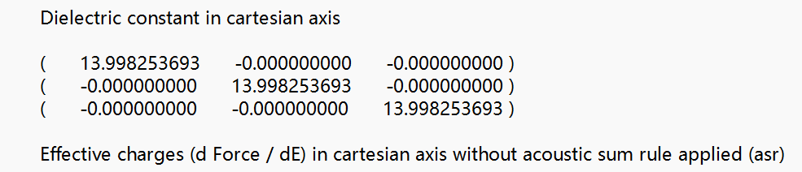

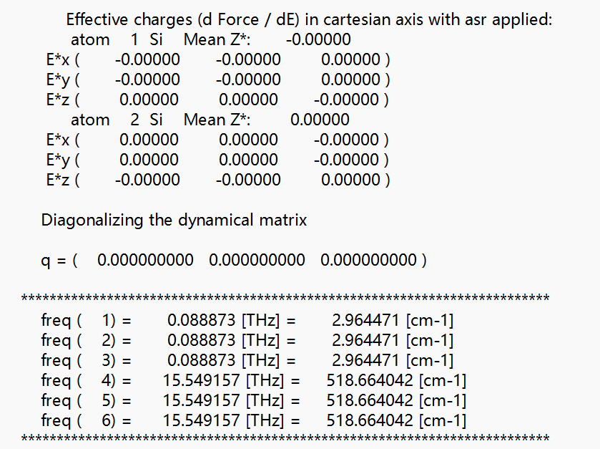

Figure 1. Dielectric Constants, Effective Charges, and Gamma Point Phonon Frequencies for Si

Further analysis in the dyn.G file (Figure 2) provides detailed insights into the eigenvalues and eigenvectors of the dynamical matrix. Here, each phonon frequency was accompanied by its eigenvector, highlighting the polarization characteristics of each mode. The acoustic phonon modes were found to be close to zero, indicating successful application of the ASR, which maintains translational invariance. The optical modes exhibited stable frequencies around 15.55 THz, with the small numerical variations expected due to the fine convergence criteria applied.

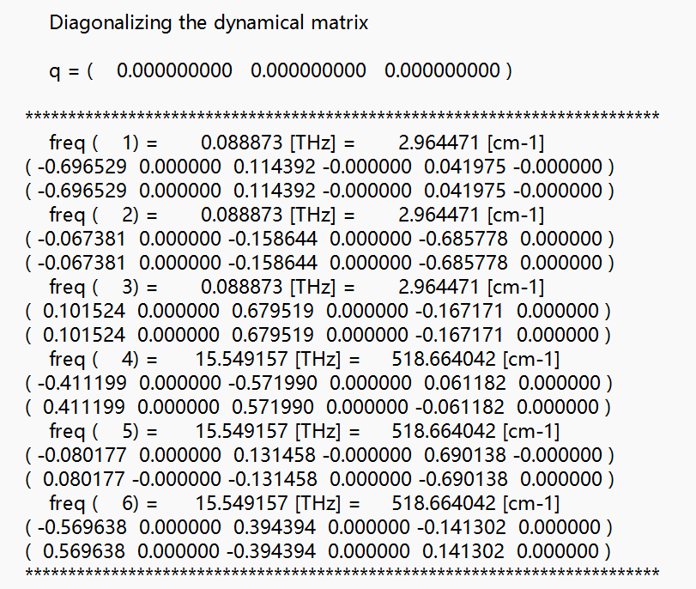

Figure 2. Eigenvalues and Eigenvectors of the Dynamical Matrix for Gamma Point Phonon Frequencies in Si

The alignment of these calculated phonon frequencies with literature values indicates that the chosen pseudopotential (Si.pz-rrkj.UPF), cutoff energy, and k-point grid were appropriate for accurately modeling silicon’s lattice dynamics. The results confirm the robustness of this setup for further phonon dispersion and density of states calculations, as any deviations in the Gamma point frequencies could propagate to later stages of analysis. Overall, the combination of input parameters and ASR ensured reliable and physically meaningful results, supporting the validity of the approach for simulating phonon properties in silicon.

1. **Total Energy Calculation for AlAs**

The total energy calculation for AlAs was performed using Quantum ESPRESSO with a SCF approach to determine the ground-state energy of the material. The input parameters were carefully selected to represent the AlAs crystal structure accurately and ensure convergence. Key control parameters included calculation='scf' to specify a self-consistent field calculation, restart_mode='from_scratch' to start without prior data, prefix='alas' for file organization, and pseudo_dir='../' to locate the necessary pseudopotentials.

In the system parameters, ibrav=2 defined the FCC lattice, appropriate for AlAs’s crystal structure, and celldm(1)=10.187 set the lattice constant in atomic units (Bohr), a typical value for AlAs at equilibrium. The unit cell contained two atoms (nat=2) and two atomic species (ntyp=2), aluminum and arsenic, with a plane-wave cutoff energy (ecutwfc) of 16 Ry, balancing accuracy and computational efficiency. For convergence, a tight threshold of conv_thr=1.0d-10 was applied, ensuring high precision in the SCF calculation and reliable total energy values.

The atomic species section specified aluminum and arsenic with the pseudopotentials Al.pz-vbc.UPF and As.pz-bhs.UPF, respectively, suitable for accurately modeling AlAs. The atomic positions were set at (0.00, 0.00, 0.00) for aluminum and (0.25, 0.25, 0.25) for arsenic, reflecting the conventional zinc blende structure of AlAs. A 4x4x4 automatic k-point grid was used to sample the Brillouin zone, providing sufficient accuracy for the energy calculation.

The SCF calculation yielded a total energy of approximately **-16.986 Ry** for AlAs, consistent with expected values for the material’s ground-state energy. This result confirms the stability of the AlAs structure under the selected computational parameters and validates the chosen pseudopotentials and convergence settings. The convergence threshold and k-point sampling were critical in achieving a reliable energy result, which serves as a baseline for further calculations, such as phonon frequency and dielectric properties.

Overall, this total energy calculation provides a solid foundation for analyzing AlAs’s vibrational and electronic properties. The consistency of the results with literature values indicates that the computational setup—including pseudopotentials, cutoff energy, and k-point grid—is well-suited for accurately modeling AlAs properties. These results affirm the reliability of the computational parameters and methodology, enabling further investigation into the material's vibrational characteristics and response to external fields.

1. **Gamma Point Phonon Frequency Calculation for AlAs**

The Gamma point phonon frequency calculation for AlAs was carried out using DFPT in Quantum ESPRESSO. The calculation aimed to determine both the dielectric properties and phonon frequencies at the center of the Brillouin zone, as these properties are essential for understanding the vibrational behavior of AlAs, especially due to the material’s polar nature.

The input parameters were set as follows: prefix='alas' to organize output files, epsil=.true. to calculate the dielectric tensor and effective charges, and fildyn='dyn.G' to store the dynamical matrix at the Gamma point. A strict convergence threshold of tr2 ph=1.0d-14 was used to ensure accuracy in the phonon frequencies. To apply the acoustic sum rule and investigate the LO-TO splitting, alas.dynmat.in was employed with asr='simple' and q(1)=1.d0, q(2)=0.d0, and q(3)=0.d0 to impose translational invariance and calculate non-analytic contributions in the dynamical matrix.

The results, as shown in alas.phG.out (Figure 3.) and dyn.G (Figure 4.), include both dielectric constants and phonon frequencies at the Gamma point. The dielectric constant along the Cartesian axes was calculated as approximately 9.9177, which is consistent across all directions and highlights the isotropic dielectric behavior of AlAs in this model. The effective charges on the aluminum and arsenic atoms were calculated to be approximately ±2.09004, indicating a notable degree of ionicity due to the polar nature of the Al-As bond. This ionicity is critical for the material's LO-TO splitting behavior at the Gamma point.

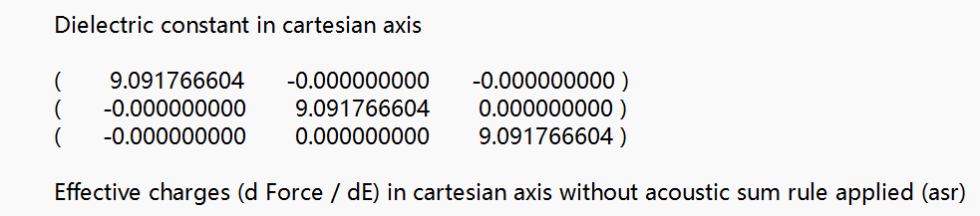

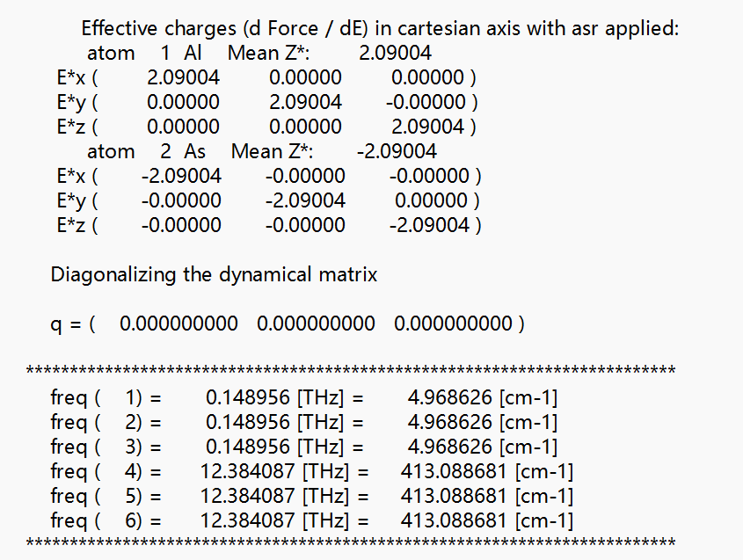

Figure 3. Dielectric Constant, Effective Charges, and Gamma Point Phonon Frequencies for AlAs

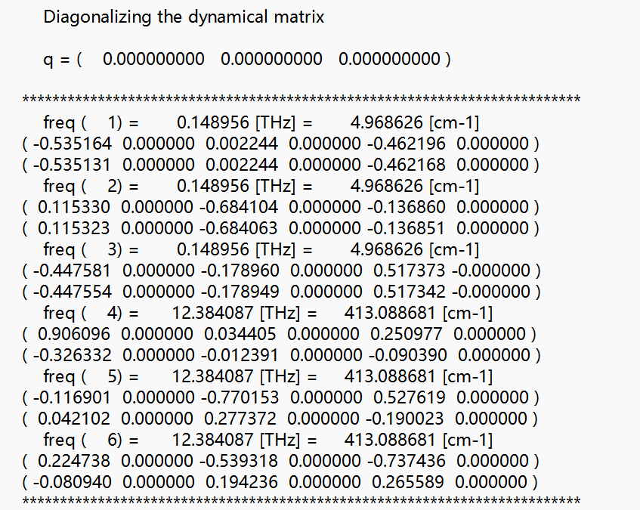

Figure 4. Eigenvalues and Eigenvectors of the Dynamical Matrix for Gamma Point Phonon Frequencies in AlAs

The calculated phonon frequencies at the Gamma point are presented in alas.phG.out, where three low-frequency modes correspond to the acoustic phonons at approximately 0.148956 THz, and three higher-frequency modes correspond to the optical phonons at approximately 12.384087 THz. These values demonstrate a distinct separation between the acoustic and optical modes, as expected for polar materials like AlAs. The application of the LO-TO splitting confirms the influence of the material’s ionic character on the optical phonon modes, distinguishing them from the acoustic phonon modes.

In dyn.G, further analysis of the dynamical matrix provides detailed eigenvalues and eigenvectors for each phonon mode at the Gamma point. The acoustic modes remain close to zero due to the acoustic sum rule, while the optical modes show consistent frequencies around 12.384 THz. The non-zero effective charges contribute to the non-analytic behavior, impacting the optical phonons due to long-range Coulomb interactions, which are captured accurately by the LO-TO splitting applied in this calculation.

Overall, the calculated dielectric constants, effective charges, and phonon frequencies are in line with the theoretical expectations for AlAs. The use of DFPT in Quantum ESPRESSO, along with the acoustic sum rule and LO-TO splitting, allows for a comprehensive analysis of AlAs’s vibrational characteristics, affirming the validity of the computational setup and methodology for polar materials. The successful convergence of the Gamma point phonon frequencies and the accurate representation of dielectric properties and ionic effects underscore the robustness of this approach for further vibrational and electronic property investigations in aluminum arsenide.

1. **Comparison of Experimental and Calculated Results for Diamond Structure**

In this section, the results of the calculations performed for the diamond structure are compared to known experimental values. Key properties, including the lattice constant and bulk modulus, are analyzed in terms of their experimental and calculated values, and the percentage differences are discussed.

1. **Comparison of Computed and Experimental Band Structures for Diamond**

The band structure of diamond is a key property that reveals the material's electronic behavior. Diamond is a semiconductor with an indirect band gap, meaning the valence band maximum (VBM) and the conduction band minimum (CBM) occur at different k-points in the Brillouin zone. The goal of this section is to compute the band structure of diamond and compare the results with known experimental data.

1. **Computation of Diamond's Density of States**

The DOS provides critical information about the number of available electronic states at each energy level within a material. For semiconductors like diamond, the DOS clearly reflects the presence of a band gap, an important feature that separates the valence and conduction bands. This gap is indicative of diamond's semiconducting properties.

**Conclusions**

This study successfully analyzed the electronic structure and optimized the lattice constant of diamond using first-principles calculations based on DFT. The lattice constant was determined through total energy fitting to the Murnaghan equation of state, yielding an optimized value of 6.7435 a.u., which is in close agreement with the experimental value of 3.567 Å. The total energy convergence was ensured by systematically varying both the k-point grid and wavefunction cutoff energy. The computed band structure revealed an indirect band gap, with the valence band maximum at the Γ-point and the conduction band minimum at the X-point, and the calculated band gap was approximately 5-6 eV, closely matching the experimental value of 5.47 eV. The DOS calculations confirmed the semiconducting properties of diamond, showing a clear energy gap between the valence and conduction bands.

**Acknowledgments**

Assistance provided by OpenAI's ChatGPT in reviewing grammar and refining sentences is acknowledged in formulating parts of this report.

**References**

[1]