**Molecular Dynamics Lab**

Jiahui Yang, Mechanical Engineering

**Molecular Dynamics (MD) Module Problems**

During this exercise we will get hands on experience running various molecular dynamics simulations using the Large-scale Atomic/Molecular Massively Parallel Simulator (LAMMPS) Molecular Dynamics code. In doing so we will explore issues of equilibration, estimating error, and determining thermodynamic quantities such as melting temperature, latent heat, and thermal expansion. This lab will focus on Aluminum (Al) as described by an Embedded Atom Method (EAM) interatomic potential. The specific parts of the lab are:

***1 Equilibration 1***

*1.1 Equilibration Time 1*

*1.2 Error Estimation 2*

*1.3 Extrapolating Error Estimation 3*

***2 Heating and Cooling 4***

*2.1 Solidification/Melting 4*

*2.2 Latent Heat 4*

*2.3 Specific Heat 4*

*2.4 Thermal Expansion 5*

*2.5 Confirming the Clausius-Clapeyron Equation (More challenging) 5*

The first concept we will address is that of equilibration. Equilibration is the process of letting the systems reach thermodynamic equilibrium. Equilibration is needed at the start of a Molecular Dynamics simulation when initial atom positions and velocities must be input by the user and may not represent the final thermodynamic conditions. Equilibration is also neededwhen one changes parameters in a system during or between runs, e.g., taking a step in temperature. In general, it is usually necessary to let the system equilibrate from the start of a run before extracting any materials information related to equilibrium properties. During the first exercise we will explore how long this equilibration can take, and how to asses when a system has reached equilibrium.

# Equilibration

Here we explore how long it takes to reach equilibrium conditions of volume, temperature, pressure, and total energy when we take a temperature step. We use solid fcc aluminum as the example.

## Equilibration Time

Using the script file EquilRun.txt perform an equilibration run for 10000 steps with a step size of 0.001 picoseconds. Set the temperature to 700 K and the initial lattice parameter to 4.04525 Angstroms. To set these parameters look for the “Parameters for Exercise 1:” section near the top of the file. After “equal” for each variable enter the number for the variable. For example: variable AlLattice equal ###

To execute the run use the following command from the terminal (note: for mac and linux you will omit the .exe and % portions)

% run_lammps

Do this in the directly with the *.in file. See the README in the home directory on the cluster for more information and updates on this.

Before proceeding with the data analysis below I recommend you skip to Problem 1.2. Setup and start the run there before proceeding with the analysis here as that run will take several minutes to run and you won’t have to wait if you start it now.

Several output files will be generated from the run. The key one we’re interested in right now is npteqfile.txt. This is a space delimited file with columns for Time Step, Temperature (K), Pressure (bar), Volume (A3), and Total Energy (eV/atom). Use Excel’s text to columns feature if you are unsure of how to get the data imported properly.

Using the output npteqfile.txt file plot the system volume, temperature, pressure, and total energy against the timestep. Based on each of these parameters estimate where the system appears to enter equilibrium. **Record the timestep and total simulation time for each property in** Table 1**. Also copy your four plots into the space below Table 1. Remember to include axis titles and units and make sure the plot shows the data points and not just a fit line.**

## Error Estimation

Next, we’ll look at how to extract system properties and precision estimates (error bars) from our MD equilibration run. Note that this is precision, not accuracy, and a precise value can still be incorrect due to, e.g., errors in the potential.

Using the same input files and settings from Problem 1.1 set the number of steps to run to one million instead of ten thousand. Note that this run could take several minutes so I recommend setting this up to run in a separate directory while you work on the plotting and analysis in Problem 1.1.

Using the file npteqfile_averages.txt generated during the same MD run we have the same system properties from part 1.1 in 1000 step block averages over the simulation time. Starting after equilibration steps (let us all start from block 3 (i.e., ignore the first 2 block averages) to be consistent) calculate the Standard Error in the Mean for Volume per atom and Energy per atom as a function of how many blocks we include in the average. **Fill in these values in Table 2 for number of blocks included (5, 10, 100, 500, 900).** Remember that the equation for Standard Error in the Mean for uncorrelated data is:

$σ_{m}=\frac{σ}{\sqrt{N}}$

Where $σ_{m}$ is the Standard Error in the Mean, $σ$ is the standard deviation in the block averages, and $N$ is the number of blocks used to generate the standard deviation.

**Also include a plot of the Standard Error in the Mean for both Volume per atom and Energy per atom for every block number (it should range 1-998).** **Remember to include axis titles and units and make sure the plot shows the data points and not just a fit line.**

Note that the energy output in the npteq files are already given in units eV/atom. Convert these to meV/atom to give more readable values. Also, the volume is given in cubic Angstroms (Å) per cell. Please convert it to Å3/atom by dividing by the number of atoms in the simulation (32). By representing values per atom you can easily compare across different system sizes.

NOTE: An easy way to set up the standard deviations for these various numbers of blocks in excel is to sort the data by TimeStep from largest to smallest, then generate the standard deviation for the full TimeStep range. Next extend that standard deviation formula down to the bottom of the dataset. This works because excel automatically ignores empty cells, so as the formula includes more and more empty cells toward the bottom of the dataset the standard deviation is being calculated based only the first few blocks, ignoring everything below.

## Extrapolating Error Estimation

Now we have an idea about how precise our values of Energy per atom and Volume per atom are in our system. However, what if we wanted to know how precise we could be after 100, 200, or maybe 1,000 blocks? For our current system it may be trivially easy to just increase the step count in the run and do the analysis again. However, for more complex systems and calculations that take more time this may not be practical. Let’s take advantage of what we know about the functional form of the standard error in the mean and see how well we can extrapolate. Recall that the standard error in the mean takes the form:

$σ_{m}=\frac{σ}{\sqrt{N}}$

Taking advantage of logarithms, we could also write this equation as $$log \left(σ_{m}\right) = log \left(σ\right) -0.5*log⁡(N)$$

Now we have a linear equation with respect to number of blocks included in analysis.   
  
Take the log of the Standard Error in the Mean for Volume and Energy that you calculated previously. **For block numbers 100-998 plot these values against each other and fit a line through the data. Fill in Table 3 with the slope values that you find for Volume and Energy. Also copy below your log plot(s). Please plot these two data sets in one figure. Remember to include axis titles and units and make sure the plot shows the data points and not just a fit line. Make sure you include at least 2 significant figures in the slope.**

# Heating and Cooling

In this part of the lab, we will use MD to calculate properties for a series of temperatures for Al and show how we can extract a number of very useful thermodynamics properties.

## Solidification/Melting

We will now explore solidification/melting of our aluminum solid. To do this we’ll perform an MD run in which we ramp the temperature from 900K to 1400K in 25K intervals. Then we will ramp the temperature back down using the same process. At each temperature we will perform an equilibration run using the equilibration settings determined earlier in the lab (holding for 2,000 time steps), and then a production run to extract the system properties. Solidification/melting is a first-order phase transition which requires nucleation of the new phase. As this process is stochastic and takes time, the simulation will typically not actually solidify (melt) until below (above) the true melting temperature, and effect called hysteresis. In some cases the system may not go through the phase transition at all during the run time of the simulation.

Open the script file Ramp.txt and set the initial and final temperature, and the temperature step in the same way you set the variables in Problem 1. Then Run the script file using the usual submit command.

Open the prall.txt file using excel to see the overall output of the run. You may also notice additional files generated for each temperature step. We won’t look in detail at these, but they have all the detailed results for each temperature step. **Plot system volume per atom vs temperature and system total energy per atom vs temperature for the ramp up and ramp down and copy those plots below Table 4.** Again, remember to normalize your data per atom. Also split the ramp up and ramp down into different series on your plots. Use these plots identify the melting temperature from the heating and cooling data and enter the results in **Table 4**.

## Latent Heat

The latent heat is the enthalpy change in the system at fixed temperature during a phase transition. For a liquid to solid transition this is called the “latent heat of fusion”. Use the data determined in Problem 2.1 to estimate the latent heat of fusion under both the heating and cooling conditions and enter them in **Table 5**.

## Specific Heat

The specific heat of a material captures the way internal energy changes with temperature and is defined as

$$c_{P}={\left(\frac{∂U}{∂T}\right)}_{P,N}$$

A simple expression for the specific heat is the formula $c_{P}=A+BT$. Determine this expression from your solid phase heating data by fitting to a quadratic and differentiating and enter the values in **Table 6**.

## Thermal Expansion

The thermal expansion coefficient of a material captures the way volume changes with temperature and is defined as

$$α={\frac{1}{V}\left(\frac{∂V}{∂T}\right)}_{P,N}$$

Using the volume vs. temperature data you obtained in Problem 2.1 calculate α for the solid phase of the Al from the heating curve. To find α fit V(T) to a linear function of T, differentiate, and then divide by your average V over the temperature range as V(T) changes a small amount. Enter the data in **Table 7**.

## Confirming the Clausius-Clapeyron Equation (More challenging)

The Clausius-Clapeyron equation states

$${\left(\frac{∂P}{∂T}\right)}_{CC}=\left(\frac{∆S}{∆V}\right)$$

The left side is the partial derivative of function *P*(*T*) along the coexistence curve of two phases, i.e., how much you need to change pressure for a small change in temperature to keep the two phases in equilibrium. The right-side is the change in entropy (*S*) and volume (*V*) between the two phases. All values are evaluated at the same *P*, *T* in the equation. Rearranging this equation gives

$$∆S=∆V{\left(\frac{∂P}{∂T}\right)}_{CC}$$

This $∆S$ value is called the entropy of melting (or freezing, depending on the sign) when the coexistence is between the solid and liquid. To explore this approach to getting $∆S\left(P_{0},T_{m}\right)$ please calculate $∆V\left(P_{0},T_{m}\right)$ and ${\left(\frac{∂P}{∂T}\right)}_{CC,\left(P_{0},T_{m}\right) }$, where $\left(P_{0},T_{m}\right)$ denotes that they are all to be evaluated at standard pressure $P_{0}=1 atm$ and $T_{m}$ = the predicted melting temperature of Al. To calculate ${\left(\frac{∂P}{∂T}\right)}_{CC }$ please determine $T_{m}\left(P\right)$ for at least 6 values of *P* from 0 to 100 GPa (1 GPa = 109 Pa) and fit it and differentiate. Note that you will need to extend the range of temperatures, e.g. to 2000k. Focus only on melting from heating as kinetics of freezing is slow and stochastic and has a lot of hysteresis. You will observe clearer trends from a larger system size, e.g., 500 atoms, so consider trying that (although not required). Then compare this value of $∆S$ to the value found by calculating $∆S$ from the condition of thermal equilibrium between the two phases on the coexistence curve, which requires that $∆S\left(P_{0},T_{m}\right) =\frac{∆H\left(P_{0},T_{m}\right) }{T_{m}}$. Please enter the relevant data in Table 8.

**Problem 1**

**Problem 1.1**

**Table 1:** Estimate the time steps and total simulation time to equilibrate the following system properties for Aluminum. Fill in after running the EquilRun.txt script using LAAMPS to complete Problem 1.1. Include below your plots of Temperature, Pressure, Volume, and Total Energy vs Time Step. On the volume plot normalize the total volume to volume per atom by dividing by the number of atoms in our simulation (32).

|  |  |  |
| --- | --- | --- |
| System Property | Time Steps to Equil | Simulation Time to Equil (picosecond) |
| Temperature (K) | 4000 | 4 |
| Pressure (bar) | 4000 | 4 |
| Volume (Angstrom3) | 3000 | 3 |
| Total Energy (eV/atom) | 3000 | 3 |

**Temperature vs Timestep**

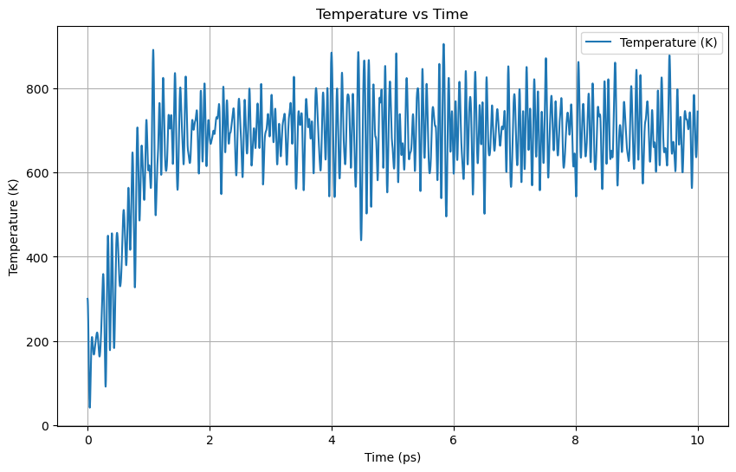

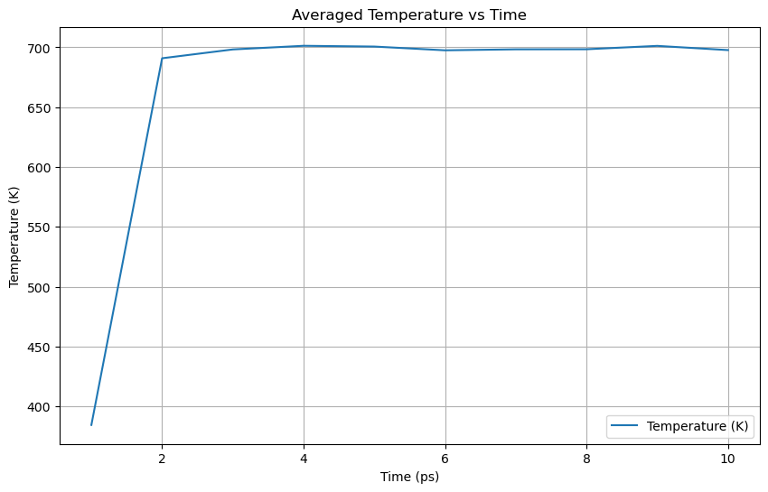

**Pressure vs Timestep**

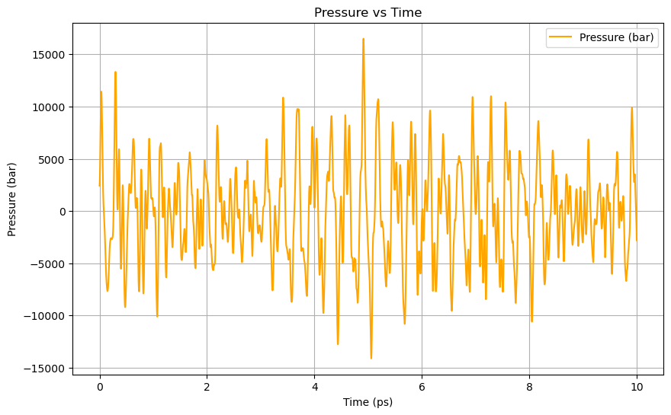

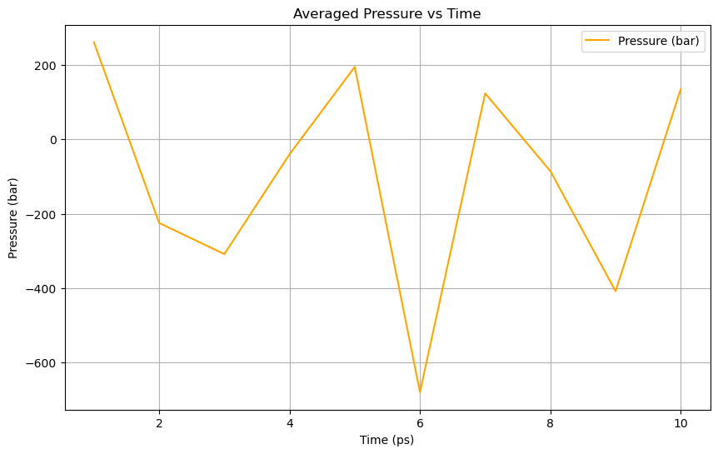

**Volume per atom vs Timestep**

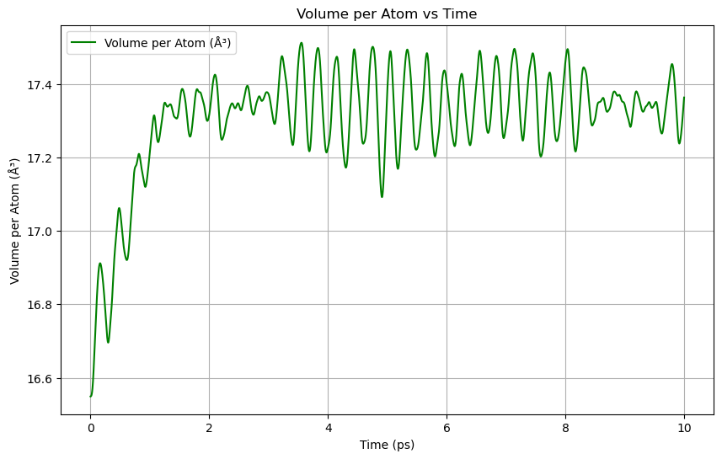

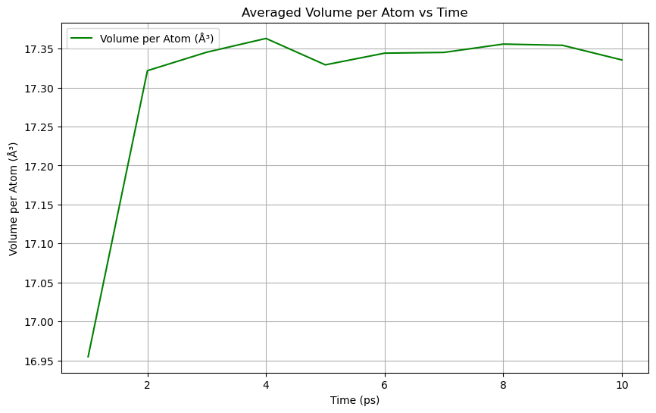

**Total Energy per atom vs Timestep**

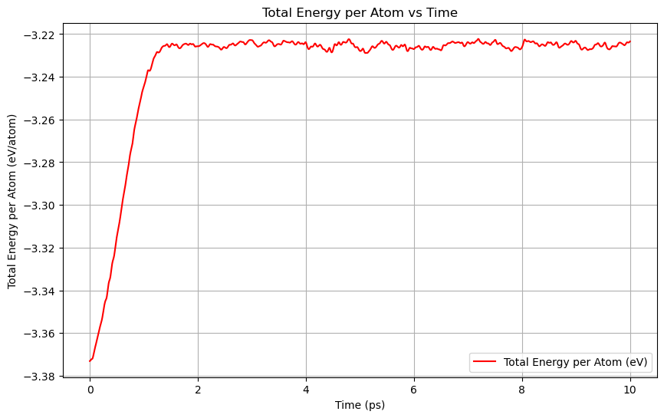

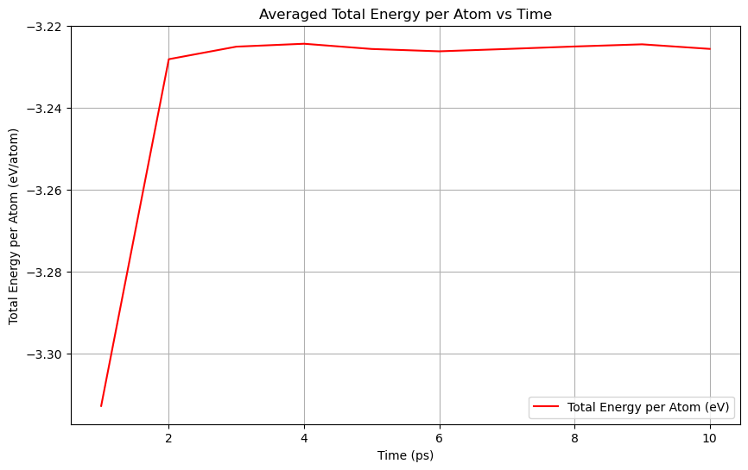

Data from npteqfile.txt is plotted using code from problem_1-1.ipynb.

**Problem 1.2**

**Table 2:** Calculate the Standard Error in the Mean for Temperature and Energy of the system as a function of number of blocks included in the calculation. Also calculate the total simulation time for each corresponding number of blocks. Fill in the individual values for when the number of blocks are 5, 10, 100, 500, and 900 to complete Problem 1.2.

|  |  |  |  |
| --- | --- | --- | --- |
| Number of Blocks | Simulation Time (picosecond) | Standard Error in the Mean Volume (A3/atom) | Standard Error in the Mean Energy (eV/atom) |
| 5 |  |  |  |
| 10 |  |  |  |
| 100 |  |  |  |
| 500 |  |  |  |
| 900 |  |  |  |

**Standard Error in Mean Volume vs Number of Blocks**

**Standard Error in Mean Energy vs Number of Blocks**

**Problem 1.3**

**Table 3:** Plot the log of Standard Error in the Mean for Volume and Energy against the number of blocks included in the calculation. Do this for the range 100-998 under which we might expect to see a linear relationship emerge. Record the slopes of the linear fit for Volume and Energy to complete Problem 1.3.

|  |  |  |
| --- | --- | --- |
|  | Volume | Energy |
| Linear fit slope |  |  |

**Standard Error in the Mean for Volume and Energy vs Number of Blocks**

1. Based on these values have we done enough steps in this equilibration run to be able to accurately extrapolate our volume precision? How about Energy?

Answer: ???.

**Problem 2**

**Problem 2.1**

**Table 4**: Plot average energy per atom against temperature and identify the melting temperature from the heating and cooling data to complete Problem 2.1. If the system did not go through a transition just give a bound (e.g., on cooling Tmelt < 900K)

|  |  |
| --- | --- |
| Ramp | Tmelt (K) |
| Heating |  |
| Cooling |  |

**Volume vs Temperature:**

**Energy vs Temperature:**

1. How large is the hysteresis between ramping up and cooling down and how might we reduce this? If you have a bound in the above Table 4 just take the bound values to estimate the bound on the hysteresis (e.g., hysteresis is > 180K) and discuss ways to reduce this.

Answer: ???

1. Compare our calculated melting temperatures values (if you only have one value then use that one) to experimental values. Lets use an experimental value of 933K [https://www.engineeringtoolbox.com/melting-temperature-metals-d_860.html]. What are our percent errors vs. experiment? What might lead to these errors? For the melting temperature, use the average of the heating and cooling values.

Answer: ???

**Problem 2.2**

**Table 5:** From the energy curves in Problem 2.1 estimate the latent heat of fusion for the heating and cooling runs to complete Problem 2.2 (if you only have a transition on heating or on cooling just use that value and say “Not Available” for the other).

|  |  |
| --- | --- |
| Ramp | Latent Heat (eV/atom) |
| Heating |  |
| Cooling |  |

1. Compare our calculated latent heat values to the experimental value of 10.79 kJ/mol. [https://www.nuclear-power.net/aluminum-specific-heat-latent-heat-vaporization-fusion/] Use the heating run values to be concrete. What are our percent errors vs. experiment?

Answer: ???

**Problem 2.3**

**Table 6:** From the heating energy curve in Problem 2.1 estimate a specific heat of the form A + BT by fitting a quadratic equation and taking the derivative ***across the range of solid temperatures***(do not include the liquid as the fit must include only one phase). Enter the values here to complete Problem 2.3

|  |  |
| --- | --- |
| Specific Heat Coefficient Label | Value (J/mol or J/mol/K) |
| A |  |
| B |  |

1. Use our calculated values of A and B to predict the specific heat at 900K. Compare this specific heat prediction, not the values o A and B, with experimental values from Dehoff. What is our percent error in predicting specific heat at this temperature?   
     
   Note that Dehoff fits a more complete equation of the form Cp = A + BT + C/T2 + DT2 with values A=31.38, B=-1.64E-2, C=-3.60E5, D=2.08E-5. Units are in J/mol. [Dehoff, Thermodynamics in Materials Science].

Answer: ???

**Problem 2.4**

**Table 7:** Plot the volume per atom against temperature and use the LINEST function in excel to fit lines to estimate thermal expansion coefficients. We’ll use the heating curve to estimate the solid linear thermal expansion coefficient, and the cooling curve to estimate the liquid linear thermal expansion coefficient. Make sure to fit only the solid phase region on heating and the liquid phase region on cooling.

Note that the values obtained will be volumetric thermal expansion. To approximate linear values we can divide our values by 3.   
  
We’re using the linest function because it provides a nice way to also get error bars on these numbers. Using the array functionality the second row of each fit will give the error. Include these errors in your answers. These provide the answer to Problem 2.4.

|  |  |  |
| --- | --- | --- |
| Ramp | Solid Linear Thermal Expansion coefficient (m/(m-K)=1/K) | Liquid Linear Thermal Expansion coefficient (m/(m-K)=1/K) |
| Up |  | Leave Blank |
| Down | Leave Blank |  |

1. Compare our thermal expansion coefficients with experimental data for solid phase (2.23e-5 (m/(m-K)=1/K)) [https://www.engineeringtoolbox.com/linear-expansion-coefficients-d_95.html]. What scale error are we getting? 5%, 10%, Factor of 2, Factor of 10?

Answer: ???

**Problem 2.5**

**Table 8:** Values of relevant terms in the determination of $∆S\left(P_{0},T_{m}\right)$. Please use the provided SI units.

|  |  |
| --- | --- |
| Tm (K) |  |
| P,T values for finding ${\left(\frac{∂P}{∂T}\right)}_{CC,\left(P_{0},T_{m}\right) }$, | |
| *P* (Pa) | $T_{m}$ (K) |
|  |  |
|  |  |
|  |  |
|  |  |
|  |  |
|  |  |
| Key Values | |
| $${\left(\frac{∂P}{∂T}\right)}_{CC,\left(P_{0},T_{m}\right) }$$ (Pa/K) |  |
| $∆S=∆V{\left(\frac{∂P}{∂T}\right)}_{CC}$ (eV/(K atom)) |  |
| $T_{m}$ (K) |  |
| $∆H\left(P_{0},T_{m}\right)$ (eV/atom) |  |
| $∆S\left(P_{0},T_{m}\right) =\frac{∆H\left(P_{0},T_{m}\right) }{T_{m}}$ (eV/(K atom)) |  |

1. Compare $∆S=∆V{\left(\frac{∂P}{∂T}\right)}_{CC}$ and $∆S\left(P_{0},T_{m}\right) =\frac{∆H\left(P_{0},T_{m}\right) }{T_{m}}$? What is the percent error difference and what might give rise to this difference? How do these values compare to experimental value of 9.28 J/(mol-K) and what might be the source of the errors?

Answer: ???