**Setup Environment to use Software on CHTC**

1. Log into your CHTC account:
   1. Follow instructions here:

<https://chtc.cs.wisc.edu/uw-research-computing/connecting>

1. Add environment variables and spack initialization to .bashrc:

export SPACK_USER_CONFIG_PATH="/home/groups/mse_course_ping/programs/.spack"

. /home/groups/mse_course_ping/programs/spack/share/spack/setup-env.sh

spack load python@3.11.7

export PYTHONPATH= /home/groups/mse_course_ping/programs/py-libs/lib/python3.11/site-packages/:$PYTHONPATH

* 1. One way to do this is to run the following commands:

*vim ~/.bashrc*

This will open a screen that looks like:

* 1. Then use press “j” or the down arrow to move cursor down, repeat until the cursor is below the “# User specific aliases and functions” section. Note: cursor will start likely start at top right corner.
  2. Once the cursor is in the correct place type “i” to enter insert mode. Once in insert mode you can copy and paste these two line:

export SPACK_USER_CONFIG_PATH="/home/groups/mse_course_ping/programs/.spack"

. /home/groups/mse_course_ping/programs/spack/share/spack/setup-env.sh

spack load python@3.11.7

export PYTHONPATH=/home/groups/mse_course_ping/programs/py-libs/lib/python3.11/site-packages/:$PYTHONPATH

* 1. Then press “esc” to escape insert mode. Your screen should look like this:

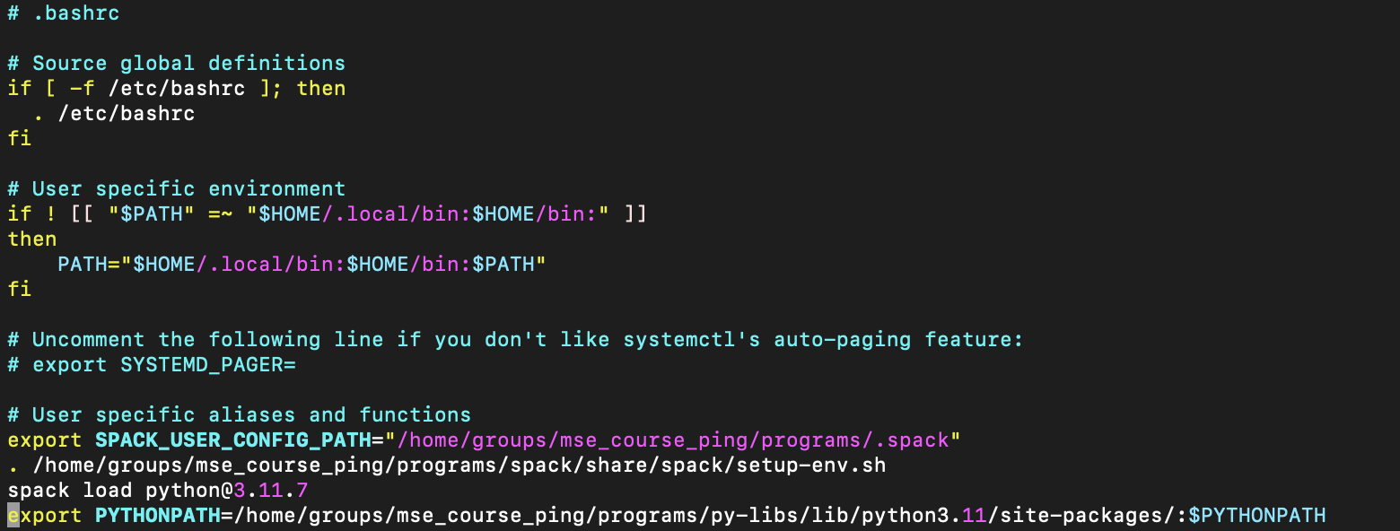

* 1. Then type “:wq” and press enter to save (w) and quit (q) vim.

1. Now you need to source your .bashrc which you can do via the command:

*source ~/.bashrc*

NOTE: This happens every time you login so you don’t need to repeat these steps in the future. Your .bashrc is sourced when you log in.