**Installing Quantum ESPRESSO (Windows Version)**

This tutorial offers a step-by-step guide for installing Quantum ESPRESSO on Windows. If you have a CHTC account, it is preferable to use that, but this guide is also helpful if you need to run the simulations on your personal laptop.

**Step 1: Download the .exe installer from the following link, or find an .exe installer from other reliable online sources.**

<https://winmostar.com/wm/cygwin_wm/packages/qe-5.2.1-64bit-mpich2.exe>

The original resources for .exe installer:

<https://winmostar.com/en/manual_en/installation/QE_install_manual_en_win.pdf>

**Step 2: Run the .exe installer.**

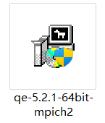

**Step 3: Ensure that the MPI library is installed, preferably MPICH2, as the current .exe version of Quantum ESPRESSO does not support other MPI libraries. You can download MPICH2 from the following link and run the .exe installer.**

<http://www.mpich.org/static/downloads/1.4.1p1/mpich2-1.4.1p1-win-x86-64.msi>

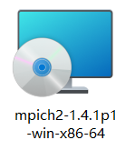

**Step 4: If you encounter the installation prompt shown in the following screenshot, please check the .NET Framework activation status or download .NET Framework 3.5.**

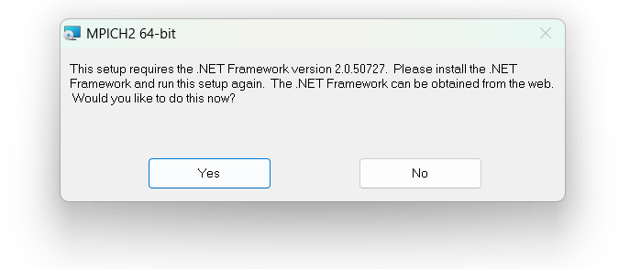

**Make sure it is properly activated:**

* Open "Control Panel" > "Programs" > "Turn Windows features on or off"
* Ensure that .NET Framework 3.5 (including .NET 2.0 and 3.0) is checked and activated.

(Sorry, the screenshot below is in Chinese : (((((((

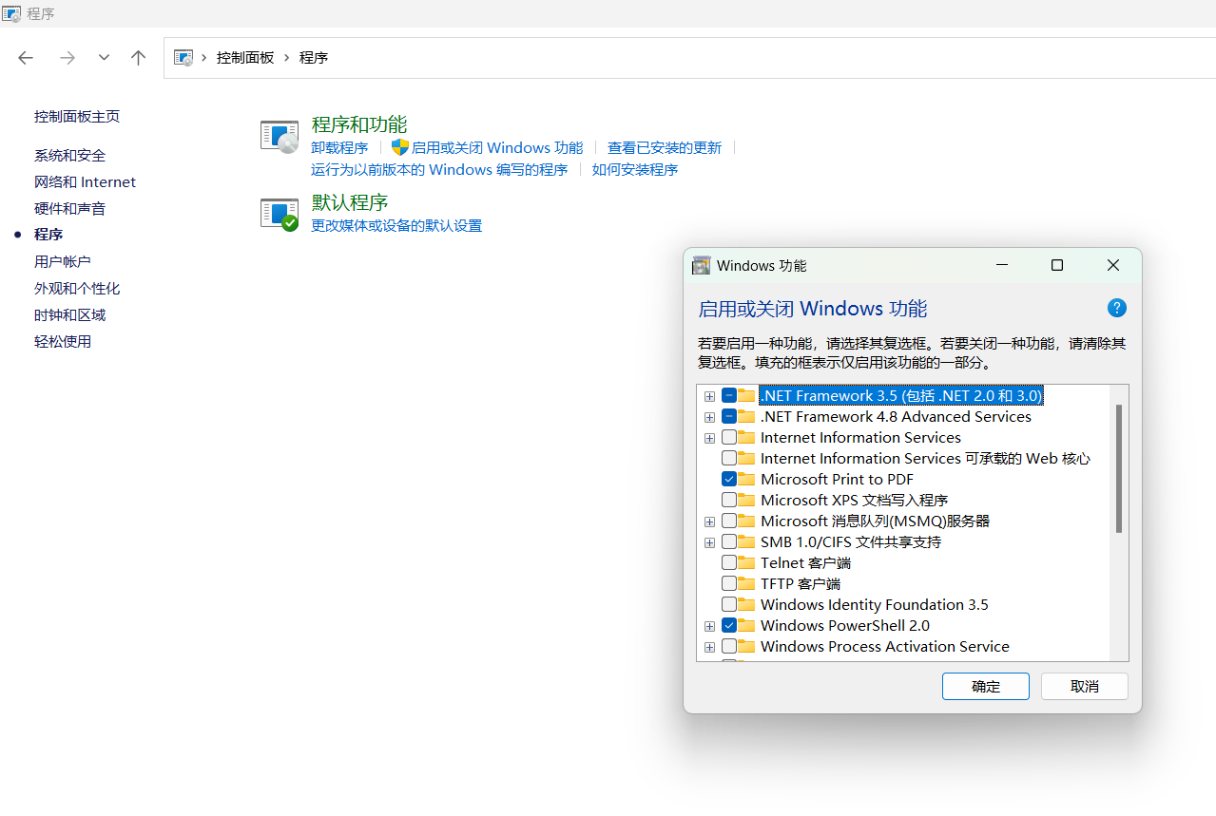

**Step 5: Add the address of the Quantum ESPRESSO `bin` folder as an environment variable.**

* Copy the address of the `bin` folder; in my case, it is:

D:\quantum_espresso\Quantum ESPRESSO 64-bit 5.2.1-mpich2\bin

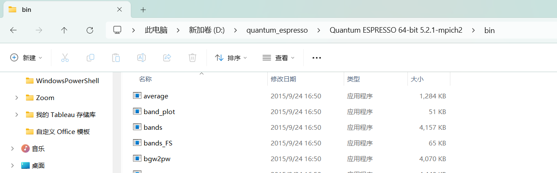

* Go to "Advanced System Settings" and "Environment Variables," then add the address to the `Path` under either "User Variables" or "System Variables."

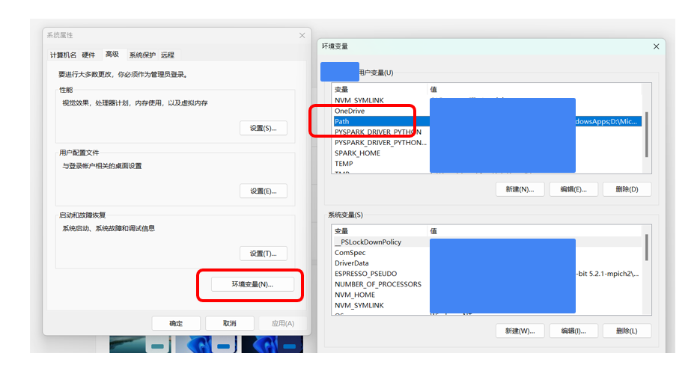

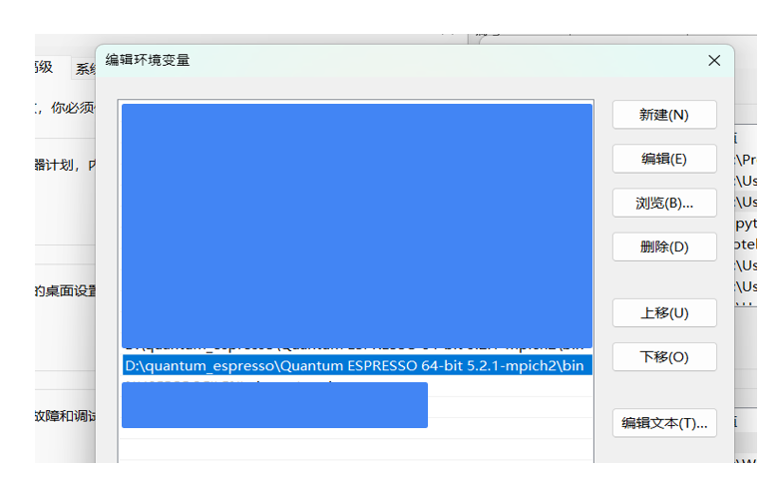

**Step 6: Open the Windows Command Prompt and input *pw.exe*. If QE and MPICH2 have been successfully installed, activated, and added to the environment variables, it should run as shown in the screenshot below.**

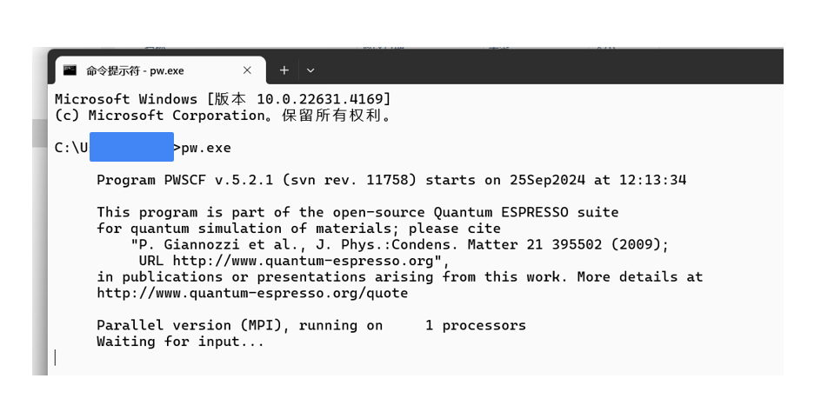

**Acknowledgements**

This tutorial is specifically designed for use in MSE 760 at UW-Madison. If you have any questions or suggestions, please feel free to contact Jiahui Yang at [jyang753@wisc.edu](mailto:jyang753@wisc.edu).