1. **Change the current directory to a subdirectory called somedir.**

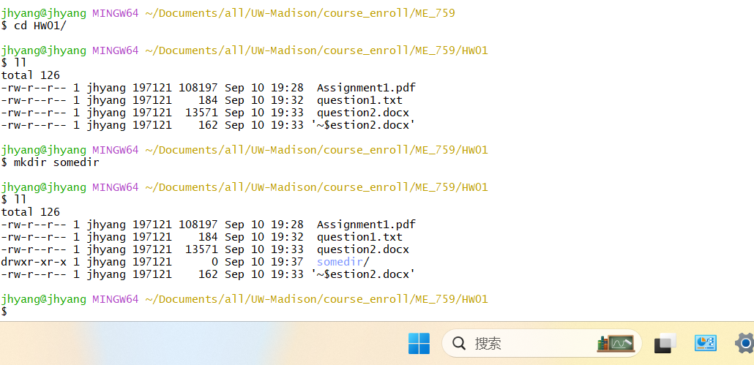

1. **Print out to the terminal the contents of a file called sometext.txt. The file exists in the current directory.**

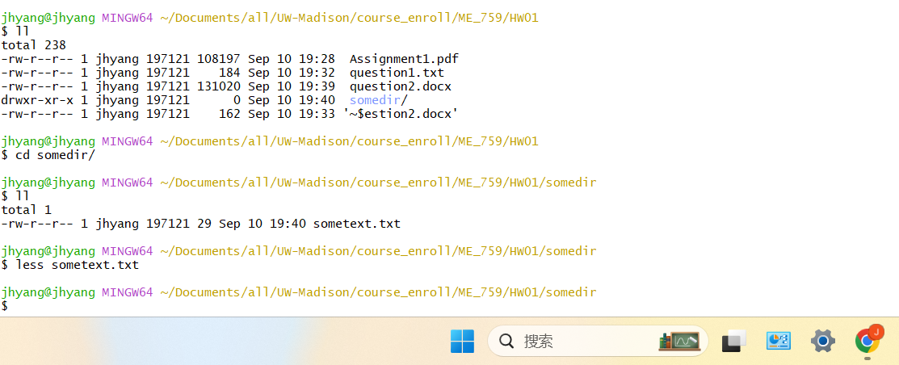



1. **Print out to the terminal the last 5 lines of a plain text file called sometext.txt. The file exists in the current directory.**

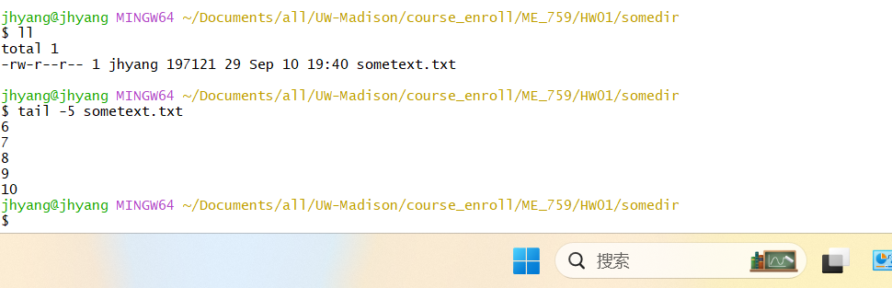

1. **Print out to the terminal the last 5 lines of each file that ends in the extension .txt and lives in the current directory.**

d.sh file is the script to complete question d)

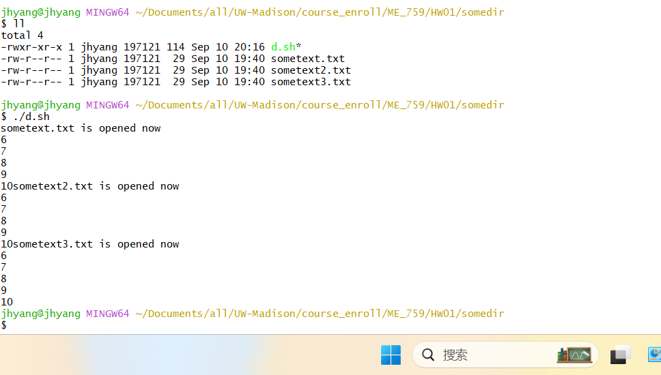

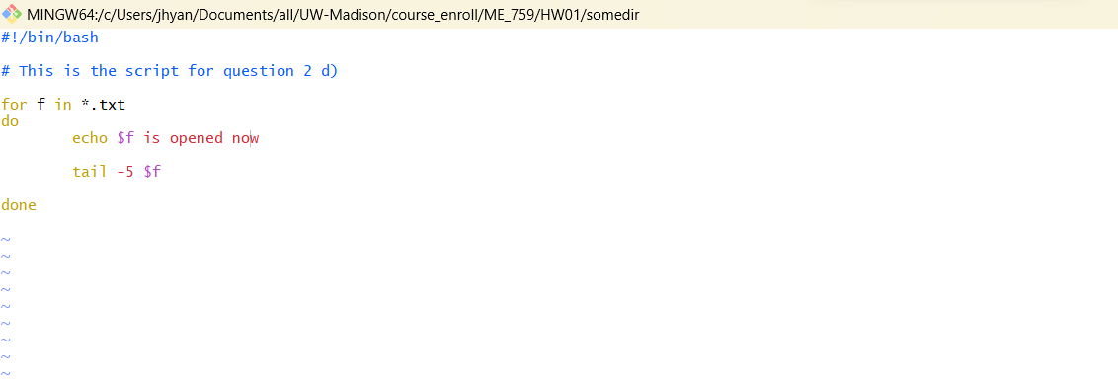

1. **Write a for loop which prints each integer from 0 to 6 (including 0 and 6).**

for.sh file is the script to complete question e)

