1. **Are there any modules loaded (module list) when you log in on Euler?**

According to the screenshot down below, there is no modules loaded when I logged into Euler.

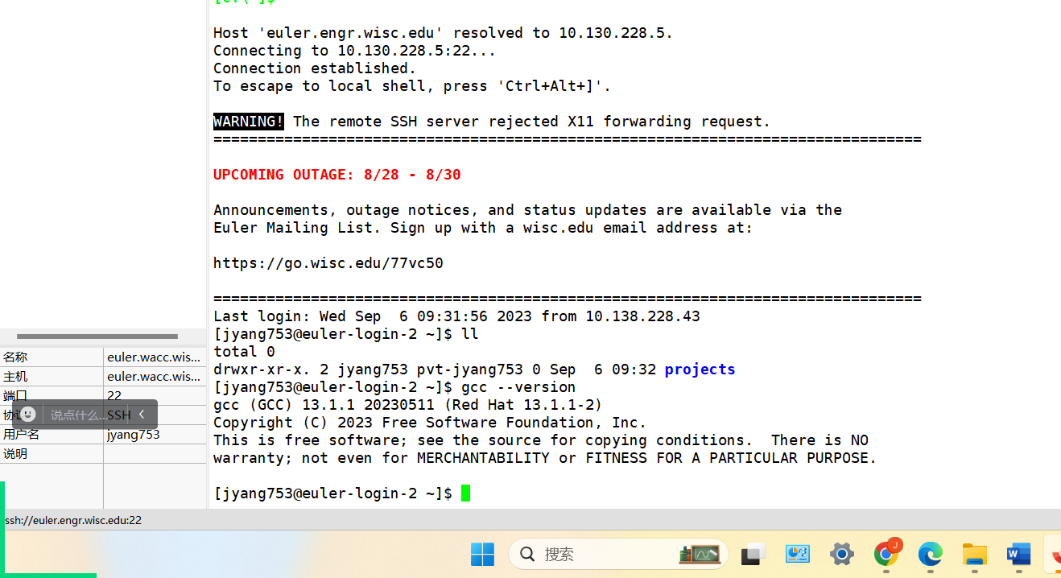

1. **What version (version number) of gcc is available to you without loading any modules?**

Command line:

gcc --version

gcc (GCC) 13.1.1 20230511 (Red Hat 13.1.1-2)

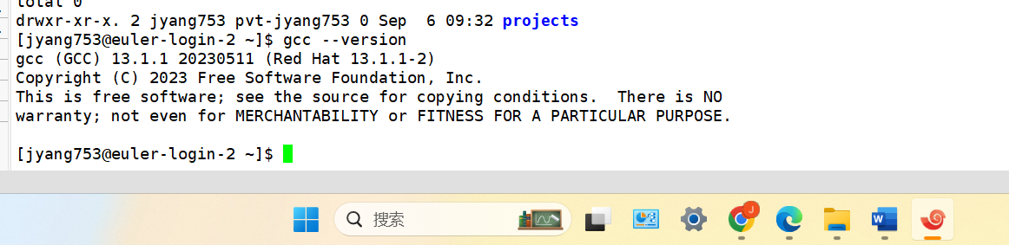

1. **List all cuda modules available on Euler?**

Command line:

module avail nvidia/cuda

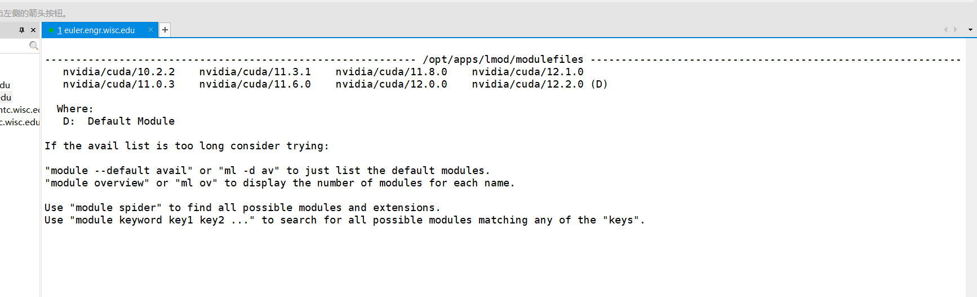

1. **List one other piece of software that has a module on Euler and write one sentence about what it does. (If you aren’t familiar with any of the other software, google one up and write a sentence about it.)**

Command line:

module avail intel

intel: Intel Compilers and Libraries

