**HW04 Task1**

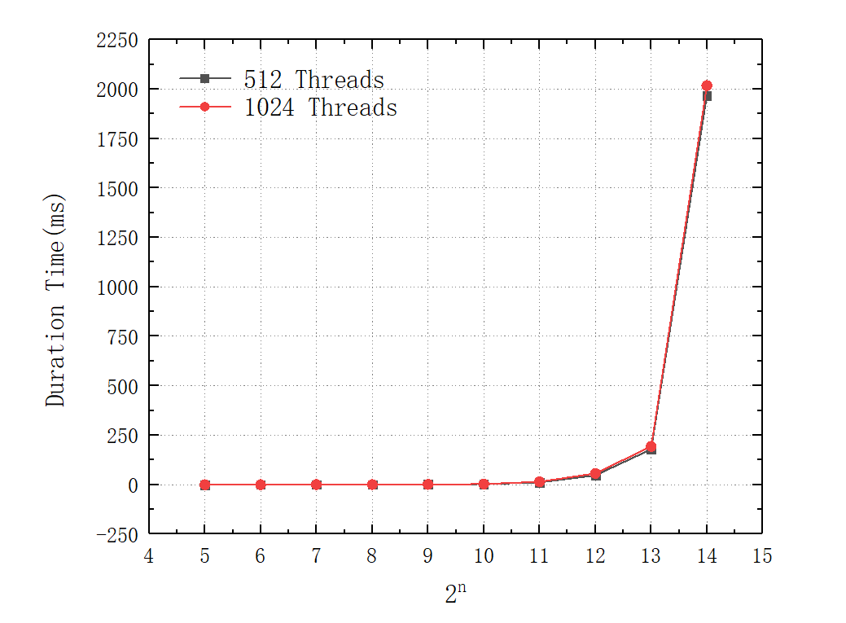

**HW02 Task1**

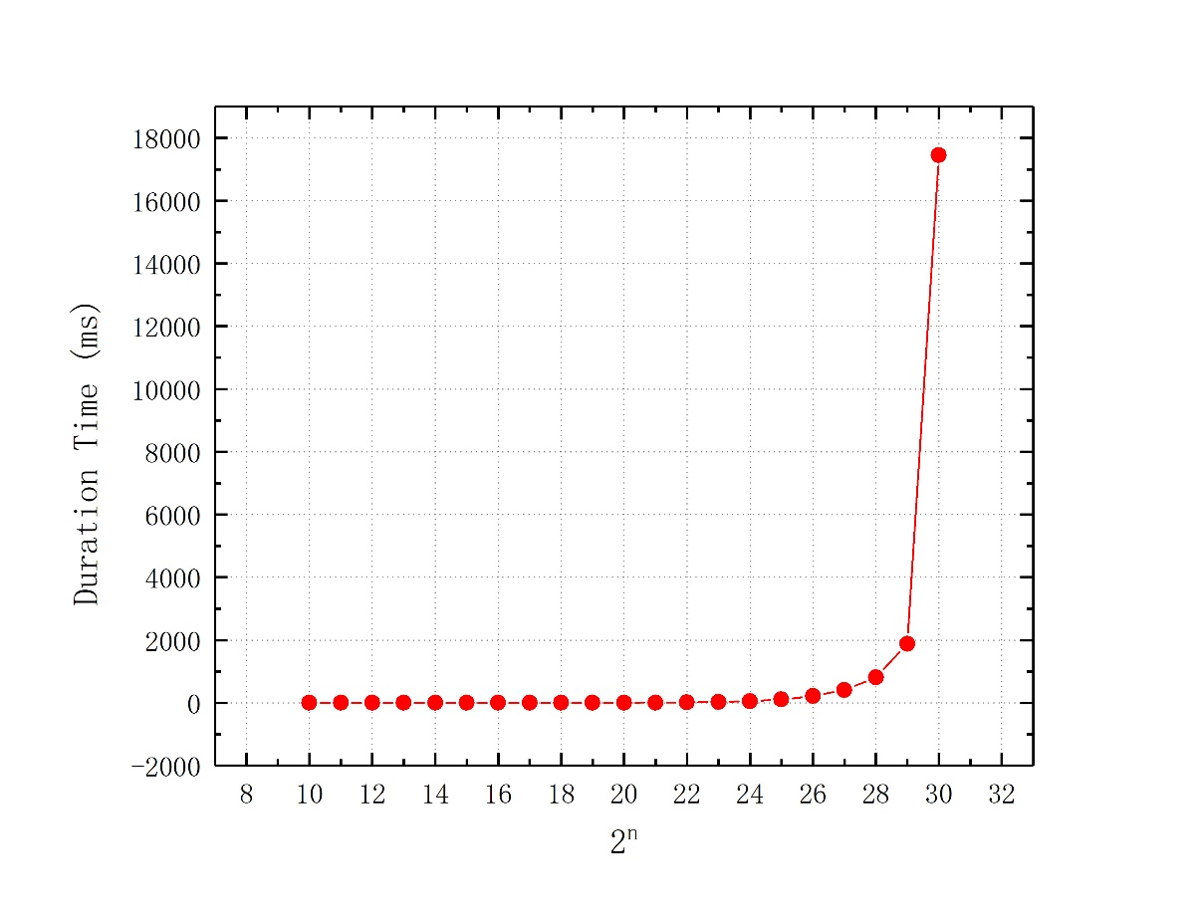

In small-scale problems, the performance difference between CPU and GPU may be relatively small. However, as the problem size increases, the performance advantage of the GPU is likely to become more pronounced. Typically, smaller thread block sizes, such as 16, may be more effective for small-scale problems, while larger thread block sizes, such as 1024, may be more effective for large-scale problems. In this comparison, I used two relatively large thread block sizes, and as a result, not much difference is evident. The graph below provides substantial evidence of how thread block size can impact performance.

**HW04 Task1 Plus**

