**HW04 Task2**

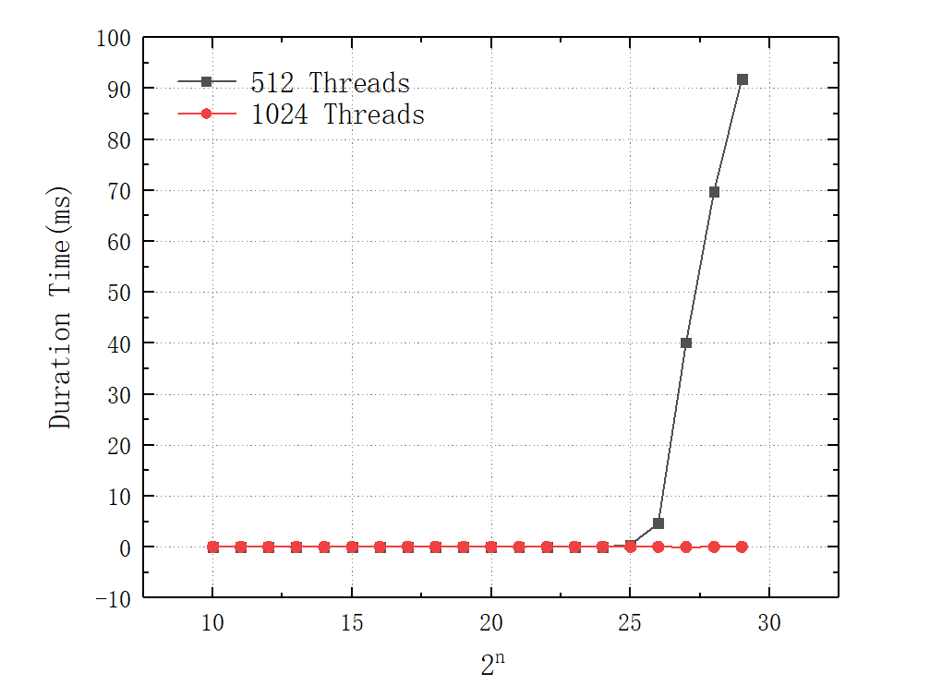

Again, in the case of smaller-scale problems, the performance gap between CPUs and GPUs may be relatively marginal. However, as the problem size increases, the performance advantages of utilizing a GPU are expected to become increasingly evident. For larger-scale problems, employing larger thread block sizes, like 1024, may prove to be more effective, while for smaller-scale problems, smaller thread block sizes, such as 128, could be more efficient.