**CZ3005**

**LAB_02**

**[ TS5 ]**

**Park, Jee Hyun**

**N1603000D**

**Exercise 1:**

1. **Translate the natural language statements above describing the dealing within the Smart Phone industry in to First Order Logic, (FOL).**

**[ natural language statement ]**

SumSum, a competitor of Appy, developed some nice smart phone technology called Galactica-S3, all of which was stolen by Stevey, who is a Boss. It is unethical for a Boss to steal business from rival companies. A competitor of Appy is a rival. Smart phone technology is a business.

**[ FOL statements ]**

company(sumsum).

company(appy).

tech(galactica_s3).

competitor(sumsum, appy).

developer(sumsum, galactica_s3).

stolen(galactica_s3, stevey).

boss(stevey).

∀X,Y,Z boss(X) ∧ business(Y) ∧ rival(Z) ∧ stolen(Y, X) ⇒ unethical(X).

∀X competitor(X, appy) ⇒ rival(X).

∀X tech(X) ⇒ business(X).

1. **Write these FOL statements as Prolog clauses.**

**[ prolog clauses ]**

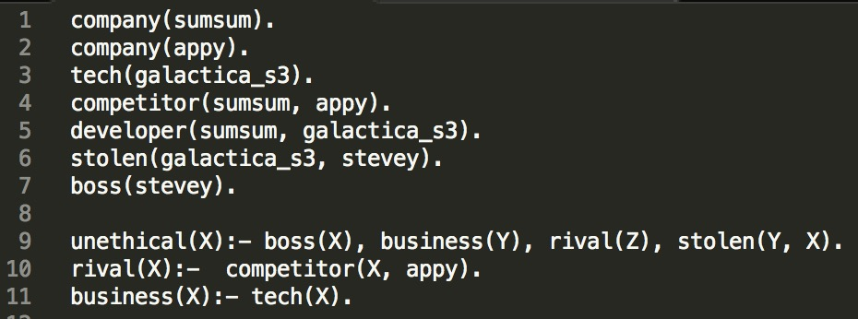

1. **Using the prolog search engine, prove that Stevey is unethical. Show a trace of your proof.**

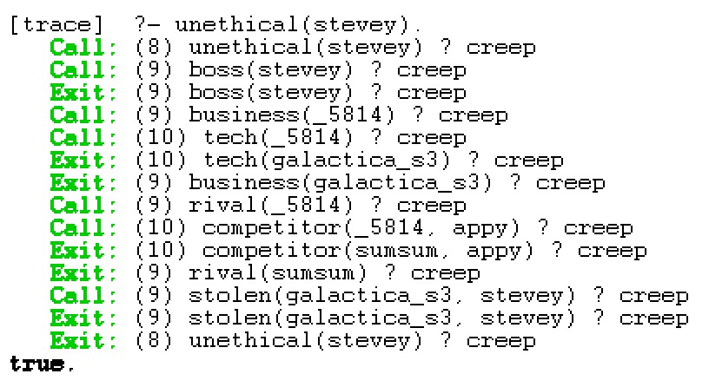

**Exercise 2:**

1. **Define their relations and rules in a prolog rule base. Hence, define the old Royal succession rule. Using this old succession rule determine the line of succession based on the information given. Do a trace to show your results.**

**[ knowledges & rules ]**

* 1. 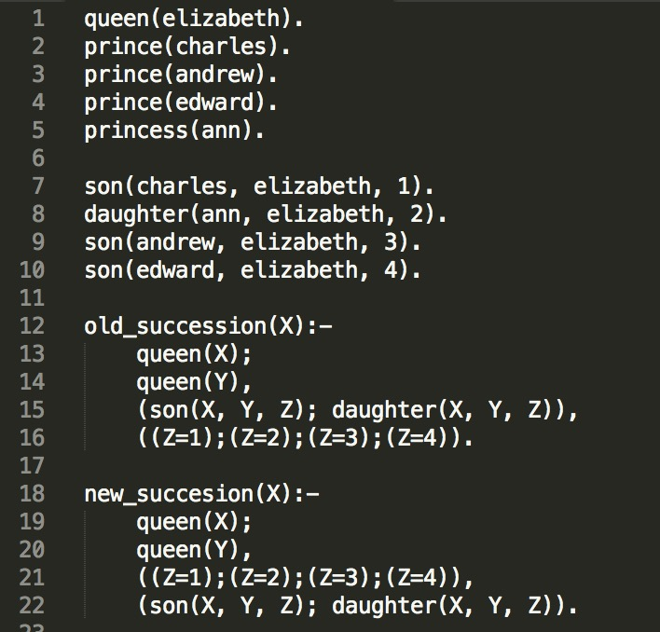
  2. **[ trace result ]**
  3. 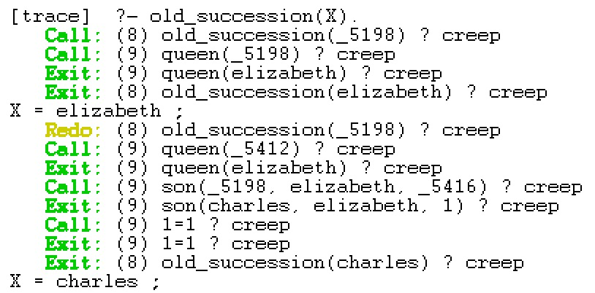

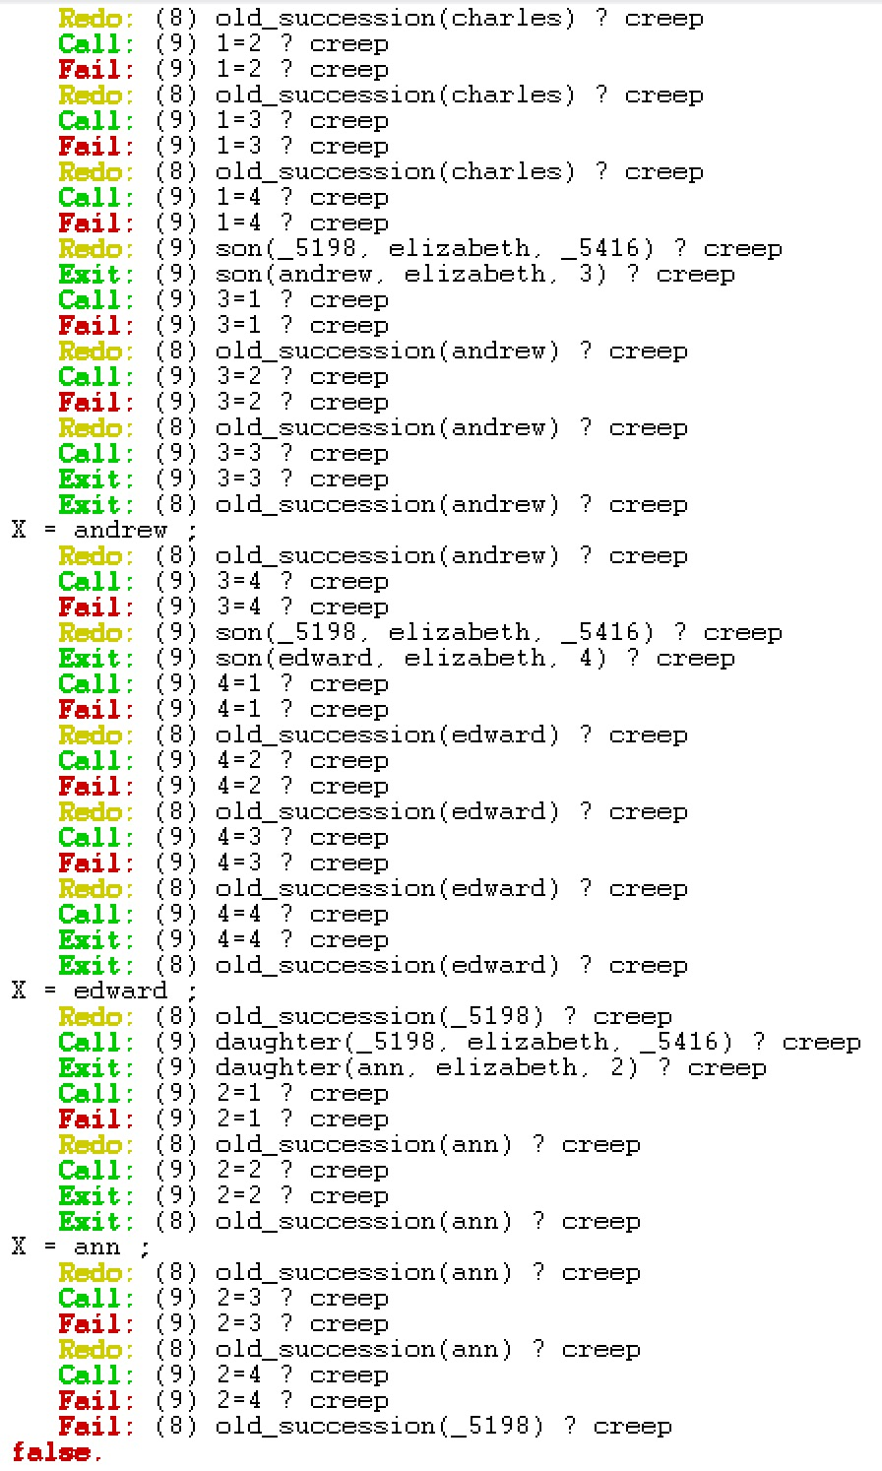

1. **Recently, the Royal succession rule has been modified. The throne is now passed down according to the order of birth irrespective of gender. Modify your rules and prolog knowledge base to handle the new succession rule. Explain the necessary changes to the knowledge needed to represent the new information. Use this new succession rule to determine the new line of succession based on the same knowledge given. Show your results using a trace.**

**[ trace result ]**

