**REPORT**

**SALES MANAGEMENT**

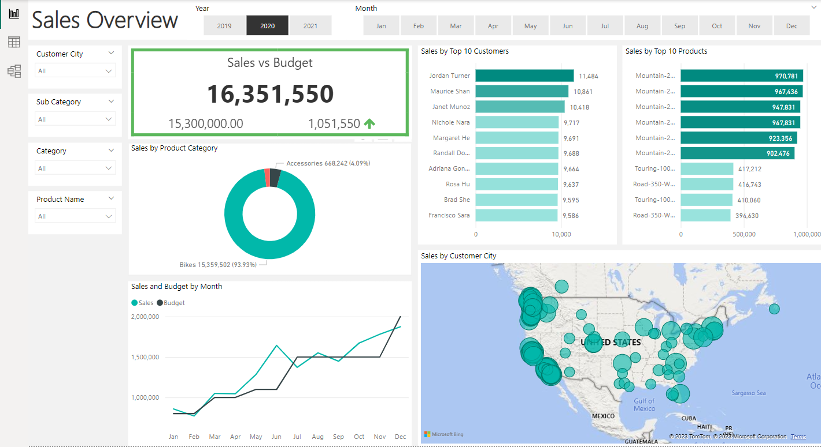

**Business Request & User Stories**

The business request for this data analyst project was an executive sales report for sales managers. Based on the request that was made from the business we following user stories were defined to fulfill delivery and ensure that acceptance criteria’s were maintained throughout the project.

|  |  |  |  |  |
| --- | --- | --- | --- | --- |
| **No #** | **As a (role)** | **I want (request / demand)** | **So that I (user value)** | **Acceptance Criteria** |
| **1** | Sales Manager | To get a dashboard overview of internet sales | Can follow better which customers and products sells the best | A Power BI dashboard which updates data once a day |
| **2** | Sales Representative | A detailed overview of Internet Sales per Customers | Can follow up my customers that buys the most and who we can sell ore to | A Power BI dashboard which allows me to filter data for each customer |
| **3** | Sales Representative | A detailed overview of Internet Sales per Products | Can follow up my Products that sells the most | A Power BI dashboard which allows me to filter data for each Product |
| **4** | Sales Manager | A dashboard overview of internet sales | Follow sales over time against budget | A Power Bi dashboard with graphs and KPIs comparing against budget. |

**Data Cleaning & Transformation (SQL)**

To construct the essential data model for conducting analysis and meeting the business requirements outlined in the user stories, we extracted the following tables using SQL. An additional data source, the sales budget, was initially in Excel format and was subsequently integrated into the data model during a later stage of the process.

The following SQL statements were employed to cleanse and reshape the required data.

**DIM_CALENDAR:**

-- Cleansed DIM_Date Table --

SELECT

  [DateKey],

  [FullDateAlternateKey] AS Date,

  --[DayNumberOfWeek],

  [EnglishDayNameOfWeek] AS Day,

  --[SpanishDayNameOfWeek],

  --[FrenchDayNameOfWeek],

  --[DayNumberOfMonth],

  --[DayNumberOfYear],

  --[WeekNumberOfYear],

  [EnglishMonthName] AS Month,

  Left([EnglishMonthName], 3) AS MonthShort,   -- Useful for front end date navigation and front end graphs.

  --[SpanishMonthName],

  --[FrenchMonthName],

  [MonthNumberOfYear] AS MonthNo,

  [CalendarQuarter] AS Quarter,

  [CalendarYear] AS Year --[CalendarSemester],

  --[FiscalQuarter],

  --[FiscalYear],

  --[FiscalSemester]

FROM

 [AdventureWorksDW2019].[dbo].[DimDate]

WHERE

  CalendarYear >= 2019

**DIM_CUSTOMERS:**

-- Cleansed DIM_Customers Table --

SELECT

  c.customerkey AS CustomerKey,

  --      ,[GeographyKey]

  --      ,[CustomerAlternateKey]

  --      ,[Title]

  c.firstname AS [First Name],

  --      ,[MiddleName]

  c.lastname AS [Last Name],

  c.firstname + ' ' + lastname AS [Full Name],

  -- Combined First and Last Name

  --      ,[NameStyle]

  --      ,[BirthDate]

  --      ,[MaritalStatus]

  --      ,[Suffix]

  CASE c.gender WHEN 'M' THEN 'Male' WHEN 'F' THEN 'Female' END AS Gender,

  --      ,[EmailAddress]

  --      ,[YearlyIncome]

  --      ,[TotalChildren]

  --      ,[NumberChildrenAtHome]

  --      ,[EnglishEducation]

  --      ,[SpanishEducation]

  --      ,[FrenchEducation]

  --      ,[EnglishOccupation]

  --      ,[SpanishOccupation]

  --      ,[FrenchOccupation]

  --      ,[HouseOwnerFlag]

  --      ,[NumberCarsOwned]

  --      ,[AddressLine1]

  --      ,[AddressLine2]

  --      ,[Phone]

  c.datefirstpurchase AS DateFirstPurchase,

  --      ,[CommuteDistance]

  g.city AS [Customer City] -- Joined in Customer City from Geography Table

FROM

  [AdventureWorksDW2019].[dbo].[DimCustomer] as c

  LEFT JOIN dbo.dimgeography AS g ON g.geographykey = c.geographykey

ORDER BY

  CustomerKey ASC -- Ordered List by CustomerKey

**DIM_PRODUCTS:**

-- Cleansed DIM_Products Table --

SELECT

  p.[ProductKey],

  p.[ProductAlternateKey] AS ProductItemCode,

  --      ,[ProductSubcategoryKey],

  --      ,[WeightUnitMeasureCode]

  --      ,[SizeUnitMeasureCode]

  p.[EnglishProductName] AS [Product Name],

  ps.EnglishProductSubcategoryName AS [Sub Category], -- Joined in from Sub Category Table

  pc.EnglishProductCategoryName AS [Product Category], -- Joined in from Category Table

  --      ,[SpanishProductName]

  --      ,[FrenchProductName]

  --      ,[StandardCost]

  --      ,[FinishedGoodsFlag]

  p.[Color] AS [Product Color],

  --      ,[SafetyStockLevel]

  --      ,[ReorderPoint]

  --      ,[ListPrice]

  p.[Size] AS [Product Size],

  --      ,[SizeRange]

  --      ,[Weight]

  --      ,[DaysToManufacture]

  p.[ProductLine] AS [Product Line],

  --     ,[DealerPrice]

  --      ,[Class]

  --      ,[Style]

  p.[ModelName] AS [Product Model Name],

  --      ,[LargePhoto]

  p.[EnglishDescription] AS [Product Description],

  --      ,[FrenchDescription]

  --      ,[ChineseDescription]

  --      ,[ArabicDescription]

  --      ,[HebrewDescription]

  --      ,[ThaiDescription]

  --      ,[GermanDescription]

  --      ,[JapaneseDescription]

  --      ,[TurkishDescription]

  --      ,[StartDate],

  --      ,[EndDate],

  ISNULL (p.Status, 'Outdated') AS [Product Status]

FROM

  [AdventureWorksDW2019].[dbo].[DimProduct] as p

  LEFT JOIN dbo.DimProductSubcategory AS ps ON ps.ProductSubcategoryKey = p.ProductSubcategoryKey

  LEFT JOIN dbo.DimProductCategory AS pc ON ps.ProductCategoryKey = pc.ProductCategoryKey

order by

  p.ProductKey asc

**FACT_INTERNET SALES:**

-- Cleansed FACT_InternetSales Table --

SELECT

  [ProductKey],

  [OrderDateKey],

  [DueDateKey],

  [ShipDateKey],

  [CustomerKey],

  --  ,[PromotionKey]

  --  ,[CurrencyKey]

  --  ,[SalesTerritoryKey]

  [SalesOrderNumber],

  --  [SalesOrderLineNumber],

  --  ,[RevisionNumber]

  --  ,[OrderQuantity],

  --  ,[UnitPrice],

  --  ,[ExtendedAmount]

  --  ,[UnitPriceDiscountPct]

  --  ,[DiscountAmount]

  --  ,[ProductStandardCost]

  --  ,[TotalProductCost]

  [SalesAmount] --  ,[TaxAmt]

  --  ,[Freight]

  --  ,[CarrierTrackingNumber]

  --  ,[CustomerPONumber]

  --  ,[OrderDate]

  --  ,[DueDate]

  --  ,[ShipDate]

FROM

  [AdventureWorksDW2019].[dbo].[FactInternetSales]

WHERE

  LEFT (OrderDateKey, 4) >= YEAR(GETDATE()) -2 -- Ensures we always only bring two years of date from extraction.

ORDER BY

  OrderDateKey ASC

**DATA MODEL**

