Self Accessment：
- More than 3 years experience in embedded software field.
- Proficient in C and C++ programming.
- Solid algorithm foundation, good understanding inside WINOWS and LINUX.
- Keen to the new technological things.
- a quick learner.

Specific Skills：
- [1] Linux device driver & application development
- [2] Good understanding of SPI, I2C, CAN Bus standard.
- [3] Can understand hardware schematic design and datasheet.
- [4] Familiar with live555 streaming media library framework.
- [5] Have certain reverse engineering ability.
- [6] Fluent English for professional communication.

Working Experience：
July 2011— September 2014： Cheng Du JiuZhou Electronics co.ltd
Position： Embedded software engineer
Job Description： Embedded software development
- [1] Linux Device Driver Development
- [2] Linux Application Development
- [3] uc-OS II application development。

Project & Achievement：
- Project ID： 1
- Project Name： Intelligent Lighting System Based On CAN Bus
- Project Time： October 2013- September 2014
- Project Description：
The intelligent lighting system is an intelligent solution for home lighting system, the schematic representation of the system is mainly like this:
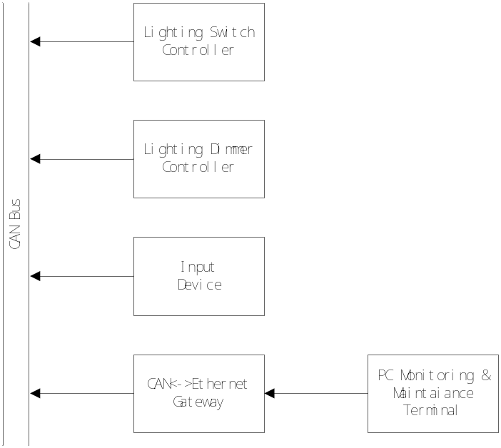
From this picture, you can see there are 4 different categories of devices connected by CAN bus. They are Lighting switch controller, Lighting Dimmer Controller, Input Devices, CAN<->Ethernet Gateway.
Lighting switch controller is used to turn on/off the light. You can control manually or from other devices via can bus. It have multiple control channels (4~16), the number of channels depends on the specific model.
Lighting dimmer controller is not only used to simply turn on /off light, it can adjust the brightness of the bulb light. This is mainly implemented by adjusting the power output of AC power. It have multiple control channels (4~12).
Input device is a special device, it support both digital input or analog signal input (0~24V).it is used to control other devices according to the input status of its channels. The way it is used to control other device is called rules. rule is composed of trigger condition and action it asks other devices to take .for example, if the content of the rule is like this: when Voltage level of AI channel 0 is below 10V, Lighting switch controller 0 should turn on. the input device will do what the rules illustrates, if the Voltage level of AI channel 0 is really below 10V, it will send a control frame data to Lighting switch controller.
Can<->Ethernet gateway mainly acts as a bridge between the can bus and network. so the PC or smart phones can get to access the CAN network to control devices or do configuration and maintenance work with the supporting of corresponding software.
- Project Achievement：

I’m in charge of software for these devices, currently, it has been finished.

- Project ID： 2
- Project Name： Intelligent Traceable Scale On Linux Platform
Project Time： Nov 2012- September 2014
- Project Description：
- The previous product is based on LPC17XX MCU, its system resource is limited,，for the further development of the product, we began to design new hardware platform based on Cortex-A8,and the Linux was chosen as the OS on board. A big challenge we confronted is that the old product source code is a mature code, how to transplant it to new platform with low cost. Finally I propose a strategy and been accepted. The whole system can be divided into three parts as shown below:
Application Logic
OS
System Call

In these parts, Application logic does need to rewritten in migration, however, the system calls changes dynamically with hardware and OS. To eliminate these differences, we added a abstraction layer as shown below. It provides a unified interface for upper application logic, so for further development, we don’t need to care about the OS specifics, only to implement the logic itself.

Transactional Logic
OS
System Call
Abstraction Layer
In the project, every hardware device should be supported by the Linux device driver; I have finished the character device below:
(1) Weight sensor device driver using I2C Bus.
(2) Key pad device driver.
- Project Achievement：
I have been awarded as outstanding employee in 2013 for this project.

- Project ID： 3
- Project Name： Linux Stream Media Player Based On live555 media library
Project Time： May 2013 -September 2013
- Project Description：
- the project is part of video surveillance project, the video format supports MPEG2，MPEG4 and H.264. It is used to transform network video stream into real-time video frame. Because embedded media server use live555 as framework. So the client also uses live555 library to transform the network steam. we also uses mature video processing library ffmpeg to decoding stream into video frame and audio stream, and write video frame into framebuffer.

- Project ID： 4
- Project Name: Intelligent Traceable Scale
- Project Time: April 2012 - September 2014
- Project Description:
Currently, food security problem has aroused public interest. To solve this problem, it’s best to put the whole food production process under surveillance, Including production, distribution, and retail. This system was proposed by the government, through this system, every citizen can query the food production information. It can ensure it is traceable if the security problem occurs. Intelligent traceable scale is one solution for these. It is used in farm market or super-market. Our Intelligent traceable scale can exchange data with central server via Ethernet, Wifi, GPRS, CDMA. Food traceability information was download to every traceable scale. When citizens buy any food, the note the scale print has 1D,2D barcode . These barcode have traceable information, every citizen can query information on government website through these barcode.
- Project Achievement：
The project requirement is different with every city. I’m in charge of requirement from Nanjing, Yinchuan, and Urumqi. I have implemented the software to meet these cities’s requirement.

- Project ID： 5
- Project Name: Transplant of TCP/IP Stack Based on UIP
- Project Time: Nov.2011-Mar.2012
- Project Description:
Due to the Ethernet communication of our platform has not yet implemented, I have to transplant the TCP/IP stack to our hardware platform.UIP is chosen owning to its cuteness and flexibility. the Objective of our implementation is：
(1) Efficiency
(2) Low Delay
(3) Memory saving.
Our detailed Implementation is as follows:
(1) Double-buffer mechanism is introduced to enhance the efficiency.
(2) The key processes for sending and receiving are all done in the interrupt context ,so as to enhance efficiency further.
(3) The memory consumption of the buffer is highly configurable, it can be increased or decreased for actual need.
The whole TCP/IP protocol stack has been divided into multiple contexts. they are interrupt context, protocol context, and application context separately. Interrupt context works within the physical layer in OSI network reference model. It sends or receives raw data packages. Protocol context works within the network/transport layer in OSI reference model. Application context works within the application layer. The data exchanges between each context by buffer mechanism which is implemented using zero-copy technique, so as to greatly boost the transportation.

Project Id: 6
Project Name： Linux device driver development and transplant
Project Time： June 2011 – Nov 2011
Project Description：
On the basis of AM335X core, our company has designed new generation data transit server product. It can be used as a cache for the data from network or RS485, so as to reduce the load of upper-stream central data server. The cross-platform IDE QT is introduced to write the transaction logic of application, so as to guarantee the performance and rapid development of the application.
Additionally, the low-level operational details of hardware should be encapsulated in the form of linux driver, and the QT library should be fully integrated to the system. I’m in charge to transplant/develop following device drivers:
[1] ISL12022 real-timer driver
[2] RS485/RS232 Multiplexing serial driver
[3]4-channel Ethernet device driver
[4]Quad channel Ethernet device driver
Project Id: 7
Project Name：High voltage cable monitoring system
Project Time：July 2010 - January 2011
Project Description：
Voltage, Wind velocity, and wind direction signal acquisition, send the data via GSM.

Project Id: 8
Project Name： Real-time temperature monitoring system
Project Time： March 2008 - July 2008
Project Description：
Flexible data acquisition framework was designed for temperature data acquisition. To optimize the data transformation process, SSE2 instruction set was introduced to optimize the computing process.
Technique：in-memory database、SSE2 instruction optimization、low-pass filter algorithm

Education Background：
Sep 2004—June 2008 Xi’an technological university
Material Physics (Undergraduate)

2008年9月—2011年3月 Xi’an Technological University
Material Physics (Postgraduate)

Personal Information：
Name: Chen Ji
Sex： Male
Birth Date： July 2013
Place: Xi’an
Marriage Status： Not Married
Mobile： 15002823394
E-Mail： limitworld@163.com

