**Directory Structure**

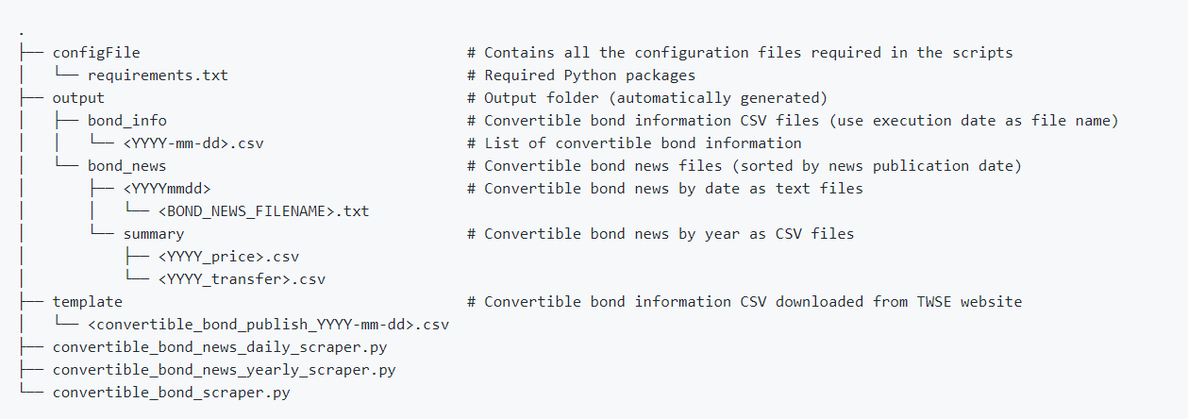

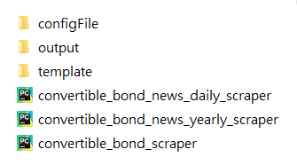

1. configFile



1. output

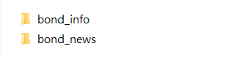

1. bond_info

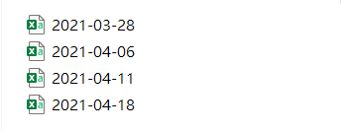

1. bond_news

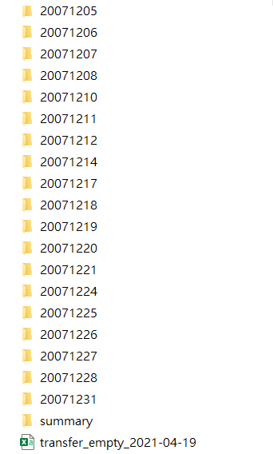

1. Each News Folder

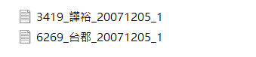

1. summary

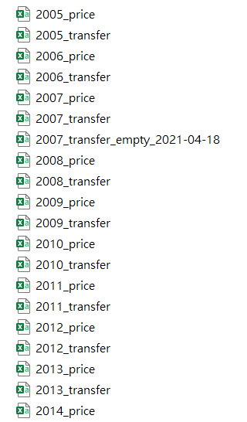

1. template

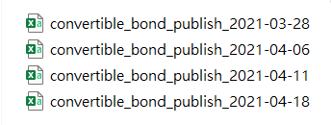

**Outputs**

1. Convertible Bond Information CSV File

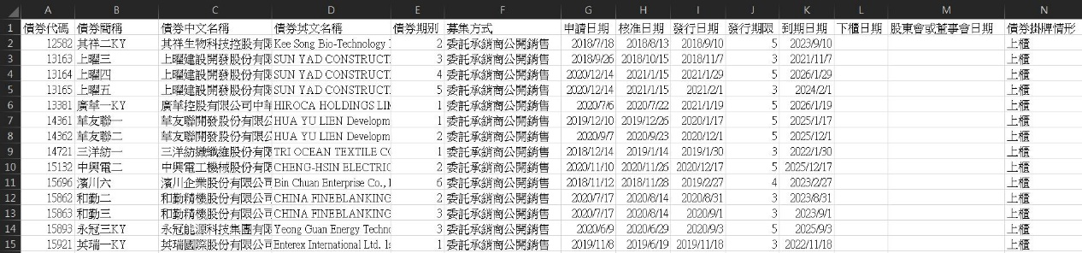

1. Convertible Bond News Text File

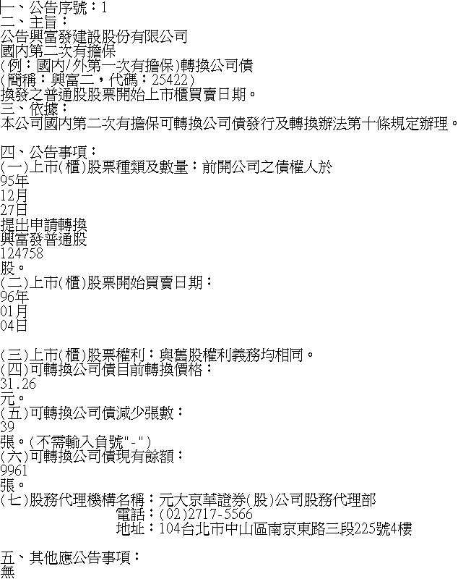

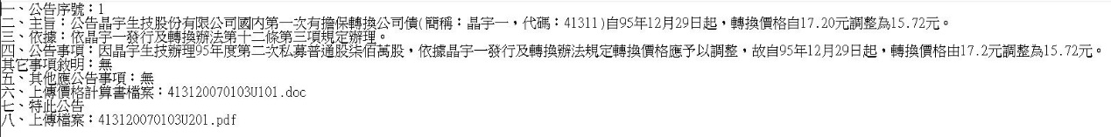

1. Convertible Bond News CSV File

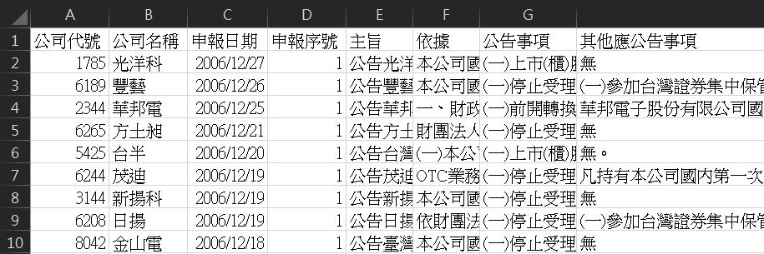

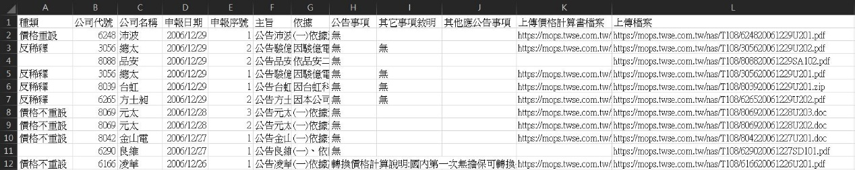

**How to Execute**

Enter the following codes in Windows Command Prompt:

1. Install packages

*pip install -r requirements.txt*

1. Run the script

*python convertible_bond_scraper.py*

*python convertible_bond_news_daily_scraper.py YYYY-MM-DD*

*python convertible_bond_news_yearly_scraper.py YYYY*