Random Taco Cookbook

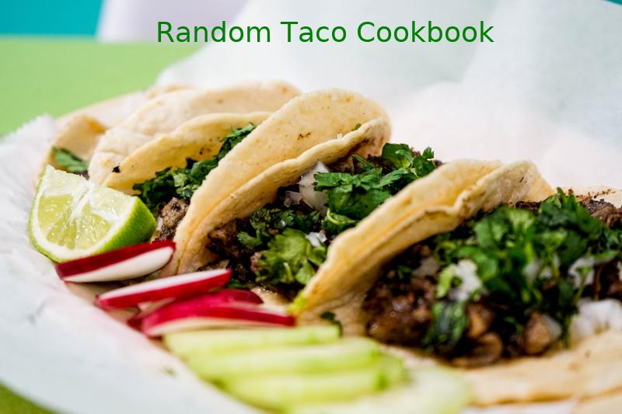

### Credits

* Taco image: Photo by Tai's Captures on Unsplash
* Source: https://taco-1150.herokuapp.com/random/?full_taco=true
* Code by: Adade Gbadoe

First Taco Recipe

### Mahi Mahi Rub

Mahi Mahi Rub  
==============  
  
A rub for Mahi Mahi, if fish tacos be what you're fancying:  
  
* 1 Part spicy chili powder  
* 1 Part salt  
* 1 Part ground cumin  
* 1/2 Part chopped cilantro  
* 1/2 Part cayenne  
* 1/2 Part pepper  
* 1/2 Part oregano  
* 1/2 Part onion powder  
* 1/2 Part garlic powder  
  
You choose your measurements and enjoy!

### Phoning it in Pico de Gallo

Phoning it in Pico de Gallo  
===========================  
  
_Super Quick & Easy Pico_  
  
  
* 1 pint grape tomatoes, quartered (make your kids do this part)  
* 3 tablespoons finely chopped white onion  
* Coarse salt  
* Squeeze of lime  
* As many finely chopped red (or green) jalapeños as you want (optional)  
  
Combine the tomatoes, cilantro and onion together in a bowl. Season to taste with salt and lime.  
  
Reserve some of this mixture for kids, and then add as much jalapeño as you like to the remaining mixture for the non wimps.

### Drunken Green Beans

Drunken Green Beans  
===================  
  
Green beans are fine. Green beans cooked in beer are better. Maybe even the best.  
  
* 1 Surly fist full of green beans  
* half a beer  
* quarter cup vegetable broth  
* 2 cloves garlic  
* 1 Tbsp olive oil  
* some salt, whatever  
  
First peel and dice the garlic and sauté it in the olive oil. Before it gets all burned and ruined, add the beer and vegetable broth.   
   
As the liquid comes to a boil, cut the green beans up. Add the green beans and a pinch of salt and let them simmer for about five minutes. If you like your beans on the softer side you can let it go a little longer. But the trick is to pull them right after the color starts to turn and you've just made a delicious addition to any taco.

### Taco de rajas poblanas

Taco de rajas poblanas  
======================  
  
* Bunch of poblano peppers  
* Onion  
* Tad of oil  
* Mexican crema or sour cream  
* *optionally*, fresh corn  
* *optionally*, queso Oaxaca or panela or fresco  
  
Start with 1 or more produce-section bags of Poblano peppers,  
it's handy if the bags are not totally full for a subsequent step.  
  
Place the Poblano peppers over an open flame, typically directly  
over a natural gas burner on a stove. Their skin will bubble and blister,  
rotate and rearrange them with tongs until the burns, bubbles, and  
blisters are evenly distributed around the chiles and you feel a tingle  
in your upper sinuses. Put the singed peppers back in the produce bags,  
then close the bags tightly to 'sweat' the chiles inside.  
  
While the chiles are sweating, sautee some onion slices in a pan.  
Optionally, add some pre-cooked whole kernels of corn when the onion is  
almost done.  
  
Take the chiles out of the bag. Their skin will be wilted and will come off  
in your fingers. Peel the outer layer of the chiles off and discard. Once  
the outer skin is removed, de-vein the rest and remove the seeds. Then  
cut the flesh into thinninsh strips.  
  
Add the chile strips (the 'rajas') back into the pan with the onion. Get it  
all hot and finish cooking any bits of chile that remain raw after the  
skin removal process. When it looks close to done, lower the cooking heat  
to a minimum and add the cream and cheese(s) and warm them for about 5 minutes.

### Hard Corn Shells (Traditional; US)

Hard Corn Shells (Traditional; US)  
======================  
  
Mistakenly thought by many to be traditionally Mexican, hard shells were actually popularized in the US in the mid-20th century.  
  
While they can certainly be made at home (if you have access to a deep-fryer), the best method of obtaining hard taco shells is to head to the grocery store.

Second Taco Recipe

### Packaged Seasonings

Packaged Seasonings  
==============  
  
Lest we be accused of snobbery, let's acknowledge that a taco is a taco, and taco night can be well-served by not having to think at all.  
  
Feel free to use the pre-packaged seasoning of your choice. When I'm in an old-school mood, I head straight for...  
  
* Old El Paso Taco Seasoning

### Pickled Vegetables

Pickled Vegetables  
==================  
  
__Whisk:__  
  
* 1/4 cup rice vinegar  
* 2 teaspoons sugar  
* 1 teaspoon soy sauce  
* 1 teaspoon fish sauce  
* Some red pepper flakes  
  
__Then toss in some sliced vegetables. Suggestions include:__  
  
* cucumbers  
* carrots  
* onions  
* radishes  
  
Mix, cover and chill in fridge for at least 30 minutes before using.

### Tomatoes (Traditional; US)

Tomatoes (Traditional; US)  
======================  
  
Adding a bit of coolness and moisture, tomatoes are a staple ingredient of the American taco. The better the tomato the more flavor they will impart, but even a sub-sandard grocery store tomato has a place in a traditional taco.  
  
* Tomatoes (diced)  
* Cherry Tomatoes (quartered)  
* Grape Tomatoes (sliced)

### Insane Garlic Ground Turkey

Insane Garlic Ground Turkey  
=========================  
  
While not particularly fancy, the insane garlic ground turkey is a crowd pleaser.  
  
Ground Turkey  
-----------  
  
* 2 pounds of ground turkey (preferably thigh meat)  
* Four yellow onions  
* Store-bought Taco Seasoning  
* More garlic than you can imagine (4-5 cloves)  
* Olive Oil  
  
1. Chop several onions into slices.  
2. In a large pan heat olive oil in a saucepan over high heat  
3. Cook onions on high heat until they are almost caramelized. (10 minutes)  
4. Reduce heat to medium.  
5. Add ground turkey making sure to stir meat to ensure adequate turkey / onion mixture.  
6. Cover and let turkey cook for 8 minutes.  
7. Mix taco seasoning using one cup of water for each packet of seasoning  
8. Add several cloves or garlic to pan. When in doubt with garlic always err on the side of too much.  
9. Cook uncovered until taco seasoning is reduced.  
10. Warn guests of impending garlic.  
  
Total cooking time: 30-40 minutes

### Hard Corn Shells (Traditional; US)

Hard Corn Shells (Traditional; US)  
======================  
  
Mistakenly thought by many to be traditionally Mexican, hard shells were actually popularized in the US in the mid-20th century.  
  
While they can certainly be made at home (if you have access to a deep-fryer), the best method of obtaining hard taco shells is to head to the grocery store.

Third Taco Recipe

### Universal Taco Seasoning

Universal Taco Seasoning  
========================  
  
I got tired of buying packets of store-bought taco seasoning, so I experimented with various spices and ratios until I landed on this recipe. I keep a jar of it in the cupboard at all times.  
  
* 6 tbsp chili powder  
* 4 tbsp cumin  
* 4 tbsp corn starch  
* 3 tbsp onion powder  
* 1 tbsp salt  
* 1 tbsp garlic powder  
* 4 tsp oregano (Mexican oregano, if you've got it)  
* 2 tsp crushed red pepper  
  
Combine in Mason jar and shake well to combine.  
  
This mix works well for chicken, pork and beef, destined for the grill, oven, slow cooker or stovetop. You could tweak it a bit to target a specific meat, but I like to have a base, universal mix around. Makes it super easy to turn leftover anything into delicious taco filling: Just chop up whatever it is, toss it into a skillet, sprinkle generously with seasoning, then add a bit of water and simmer to impart flavor.

### Salsa Sauce

Salsa Sauce  
============  
  
From What's Cookin' Cookbook: A Recipe Collection from the Schlaback Family  
  
* 14 c. tomatoes, chopped  
* 2 1/2 c. onions  
* 4 tsp. fresh garlic  
* 2 (4 oz.) canned green chilies  
* 1 tsp. garlic powder  
* 1 tsp. salt  
* 2 tsp. paprika  
* 1/2 tsp. ground cumin  
* 1/4 tsp. oregano  
* 1 tsp. chili powder  
* 1/2 c. vinegar  
* 1 Tbsp. brown sugar  
  
Mix and bring to a boil. Cook down 1 1/2 hours. Cold pack for 20 minutes.

### Potato Hash

Potato Hash  
===================  
  
* 6 or so small yukon gold poatoes   
* 4 green onion, chopped  
* 1/2 small can of green chiles  
* olive oil  
* coarse salt  
* 1/4t chili powder  
* dash cumin  
* 1/4t garlic powder  
* Nutrional yeast (optional)  
  
  
Peel and dice potatoes, throw in a pan with a 1/4 or so of water, cover and cook on medium-high until potatoes are soft.  
Once potatoes are soft, lower to medium heat add green onions, chiles, spices and olive oil. Cook until hash-like. BOOM.

### Better Than Powder Groundbeef

Did you grow up on Old El Paso ground beef taco seasonings?  
  
I'm sorry. So did I. They're terrible, right? Here's something better:  
  
Dice a half-onion, sautee and season liberally with salt, pepper, and ground cumin.  
  
Brown a pound of ground beef, seasoning liberally with ground cumin, salt, pepper. Add tabasco/other hot sauce if you like.  
  
When beef is browned, add a small jar of salsa (any kind! i like corn/black bean tomato salsa), and simmer for 5-10 minutes.  
  
Enjoy. Serve with crispy taco shells for nostalgia.

### Hard Corn Shells (Traditional; US)

Hard Corn Shells (Traditional; US)  
======================  
  
Mistakenly thought by many to be traditionally Mexican, hard shells were actually popularized in the US in the mid-20th century.  
  
While they can certainly be made at home (if you have access to a deep-fryer), the best method of obtaining hard taco shells is to head to the grocery store.