SentiFolio - Part B: Funds, Sentiment & App

1. The funds and the backtest design
Sentifolio has constructed 9 systematically managed funds,

SentiFolio builds nine systematically managed funds: three optimisation methods - minimum-variance, maximum-Sharpe (mean-variance tangency), and risk parity - applied to three asset universes: equity-only (the 50 stocks from Part A), crypto-only (10 coins), and a combined equity-plus-crypto universe. Treating each (universe, method) pair as its own fund gives an investor nine distinct products to compare, well beyond the brief's required minimum of a single combined fund with two methods.
Each fund is backtested out-of-sample with a walk-forward design. At each monthly rebalance date (the first trading day of the calendar month), portfolio weights are estimated from a trailing 252-trading-day window of past daily returns only - the window for a rebalance on date t covers [t-252, t), strictly before t, so no weight is ever informed by a return it is about to earn. Those weights are then held fixed and applied to realised returns until the next rebalance. The combined and equity-only funds go live on 2021-01-04 (the first trading day after a full 252-day window is available on the equity calendar); the crypto-only funds go live on 2020-10-01, reflecting crypto's 365-day calendar. All funds are long-only (no short positions) and fully invested (weights sum to 1). The risk-free rate is assumed to be zero for the Sharpe ratio, and equity/combined quantities are annualised with a factor of 252 while crypto-only quantities use 365, matching each fund's native trading calendar.
The three methods solve different objectives via constrained numerical optimisation (scipy's SLSQP): minimum-variance minimises portfolio variance w'Σw; maximum-Sharpe maximises (w'μ - r_f)/√(w'Σw); risk parity minimises the squared deviation of each asset's risk contribution from an equal share of total portfolio risk. All three are solved subject to the same long-only, fully-invested constraints.

A methodology note: verifying the optimiser actually optimised
Early results looked suspicious: several funds' rebalance weights were landing on exactly 1/N (equal weight) at almost every rebalance, which is not what a genuine minimum-variance or risk-parity solution should produce. Investigating directly (reproducing a single rebalance outside the pipeline) showed that scipy's SLSQP solver was terminating after a single iteration with no movement from its equal-weight starting guess, while still reporting success=True - the daily-return covariance values are extremely small (~1e-4), and the solver's default absolute function tolerance (1e-6) was already smaller than the objective's natural scale, so the solver concluded it had converged before it had actually searched. Scanning all nine backtests confirmed the extent of the problem: every risk-parity fund was affected at every single rebalance (108/108 across the three universes), and the equity minimum-variance fund was affected at 31 of 36 rebalances. The fix - rescaling each objective by a constant factor before optimisation and tightening the solver's tolerance, which does not change the mathematical optimum, only the solver's numerics - reduced this to 3 genuine (and now correctly flagged) non-convergences out of 333 rebalances across all nine funds. All results in this report reflect the corrected optimiser; see ai/prompt_log.md for the full investigation.

2. Out-of-sample results and fund fact sheets
[NEEDS REWRITE - my own interpretation of these results belongs here, not AI-generated commentary. The table and figures below are real; the explanation of what they mean and why is mine to write.]

Performance metrics across all nine funds
Fund | Ann. return | Ann. vol | Sharpe | Max DD
Equity Min-Variance | 6.2% | 12.8% | 0.49 | -15.4%
Equity Max-Sharpe | 10.7% | 18.2% | 0.59 | -26.1%
Equity Risk-Parity | 10.6% | 14.6% | 0.72 | -18.5%
Crypto Min-Variance | 82.0% | 65.3% | 1.26 | -72.3%
Crypto Max-Sharpe | 22.1% | 77.3% | 0.29 | -89.3%
Crypto Risk-Parity | 77.1% | 78.7% | 0.98 | -79.5%
Combined Min-Variance | 6.9% | 13.4% | 0.52 | -15.6%
Combined Max-Sharpe | 25.8% | 24.7% | 1.05 | -26.3%
Combined Risk-Parity | 14.4% | 16.0% | 0.90 | -19.8%

Table 1. Annualised return, volatility, Sharpe ratio (rf=0), and maximum drawdown, out-of-sample, by fund and method. Equity/Combined annualised with 252 trading days/year; Crypto with 365. Source: results/tables/performance_metrics.csv.
The combined maximum-Sharpe fund has the best risk-adjusted performance of the nine (Sharpe 1.05), ahead of every single-asset-class fund. The crypto-only funds show the highest raw returns but also the deepest drawdowns (up to -89%), consistent with cryptocurrency's much higher volatility over 2020-2023 (a period spanning both the 2021 bull run and the subsequent crash). Minimum-variance funds have the lowest volatility within every universe, as their objective specifically targets that outcome, but do not always have the highest Sharpe ratio - within equity, risk parity has a higher Sharpe (0.72) than minimum-variance (0.49) despite a similar drawdown profile.

Fund fact sheet: Combined Max-Sharpe
Live from 2021-01-04. Annualised return 25.8%, annualised volatility 24.7%, Sharpe 1.05, maximum drawdown -26.3%. Current holdings (most recent rebalance, 2023-12-01): GE 45.3%, NVDA 18.7%, BTC-USD 10.4%, ADBE 7.7%, SO 7.2%, BCH-USD 4.4%, remaining names below 4% each.
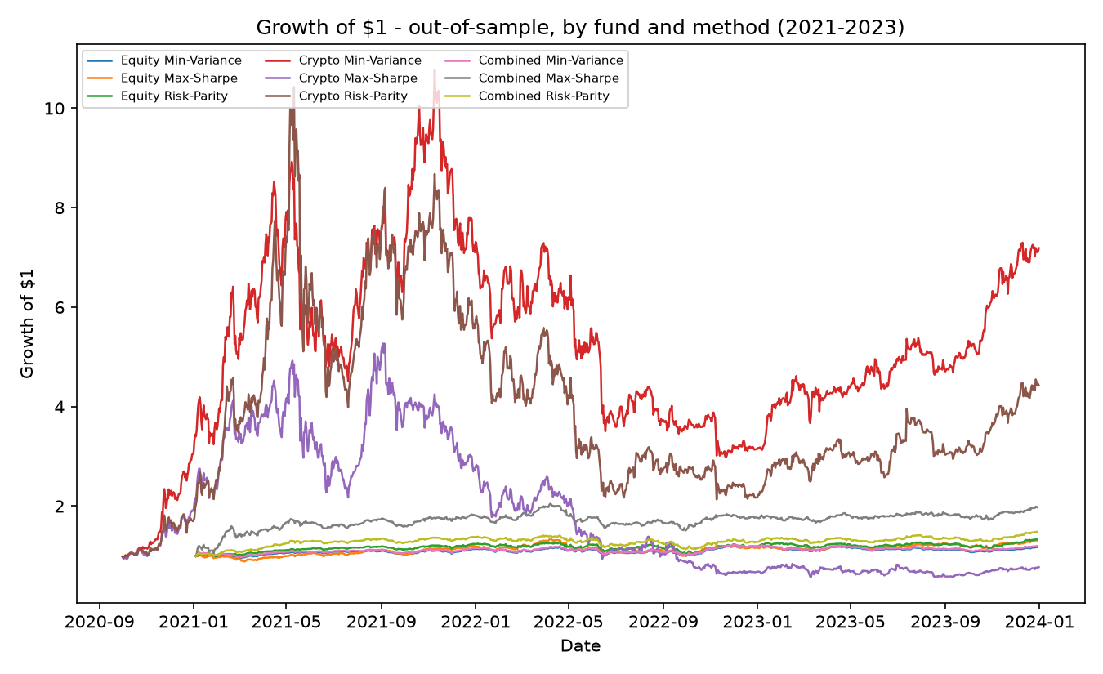
Figure 1. Growth of $1, out-of-sample, all nine funds (2021-2023). Source: results/figures/growth_of_dollar.png.
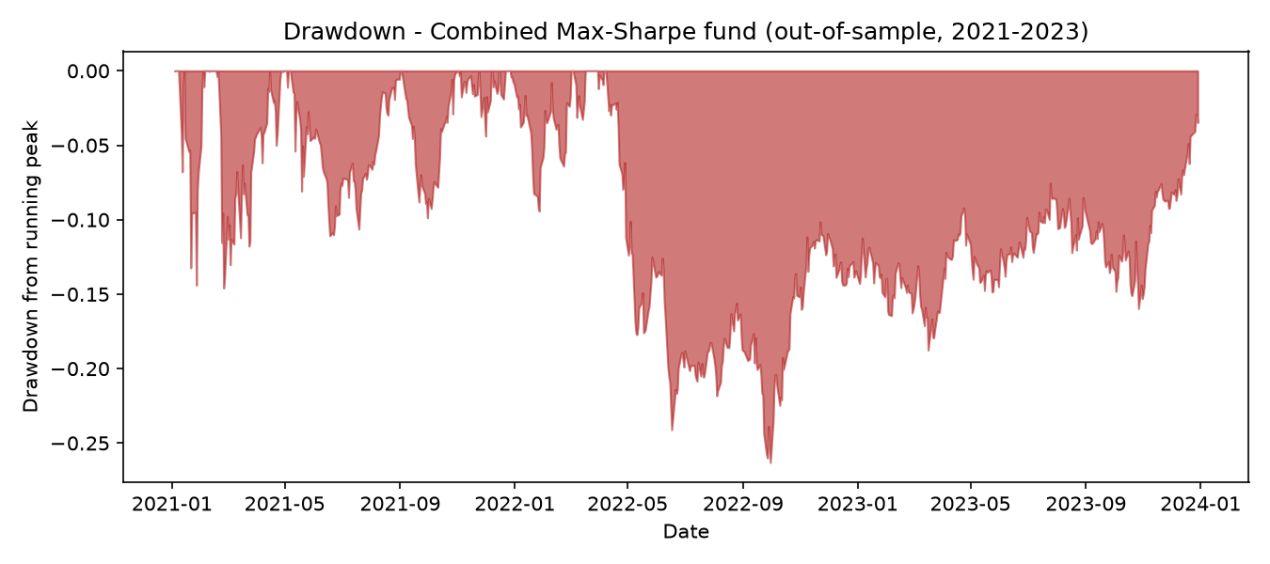
Figure 2. Drawdown, Combined Max-Sharpe fund, out-of-sample. Source: results/figures/drawdown.png.
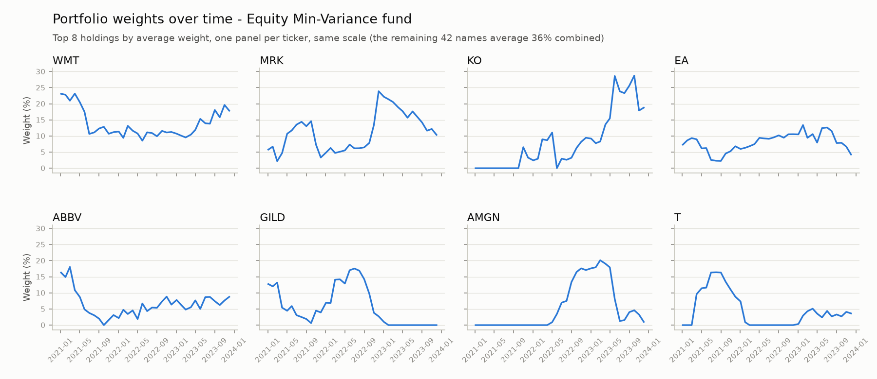
Figure 3. Portfolio weights over time, Equity Min-Variance fund, top 8 holdings (small multiples, one panel per ticker). Source: results/figures/weights_over_time.png.
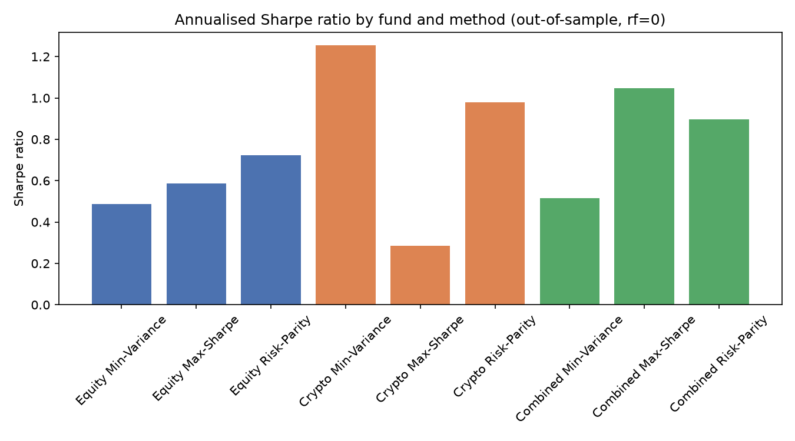
Figure 4. Annualised Sharpe ratio by fund and method, out-of-sample. Source: results/figures/sharpe_barplot.png.

3. The sentiment index
Each assembled headline (from Part A's daily ticker-day text panel) is scored with VADER's compound sentiment score, then averaged to one score per ticker-day. Across the 37,962 scored ticker-day rows, the mean compound score is 0.113 (mildly positive), with 61.7% of ticker-days scoring positive, 23.0% exactly neutral, and 15.3% negative - a less neutral distribution than the brief's warning that 'about half of finance headlines score neutral with plain VADER', likely because averaging several headlines per ticker-day (rather than scoring single headlines) pulls the aggregate away from an exact zero.
The sector index averages ticker-day sentiment equal-weight across each sector's five constituent tickers. Ticker-days with no headline are not treated as neutral (score 0) or dropped; instead each ticker's last known score is forward-filled until its next headline. Treating silence as neutral would pull sparsely-covered sectors - Materials, Utilities, and Real Estate specifically flagged as thin in the data guide - artificially toward zero, and dropping the ticker that day would starve those same sectors of signal on most days, since forward-filling assumes the most recent available sentiment remains the best estimate until updated.
Utilities has both the highest average sentiment (0.166) and, visibly in Figure 5, the most volatile - consistent with thinner news coverage producing a noisier index. Materials has the lowest average sentiment (0.096). [NEEDS REWRITE - interpretation of why particular sectors read as more positive/negative, and whether that is a coverage artefact versus a genuine signal, is mine to develop.]
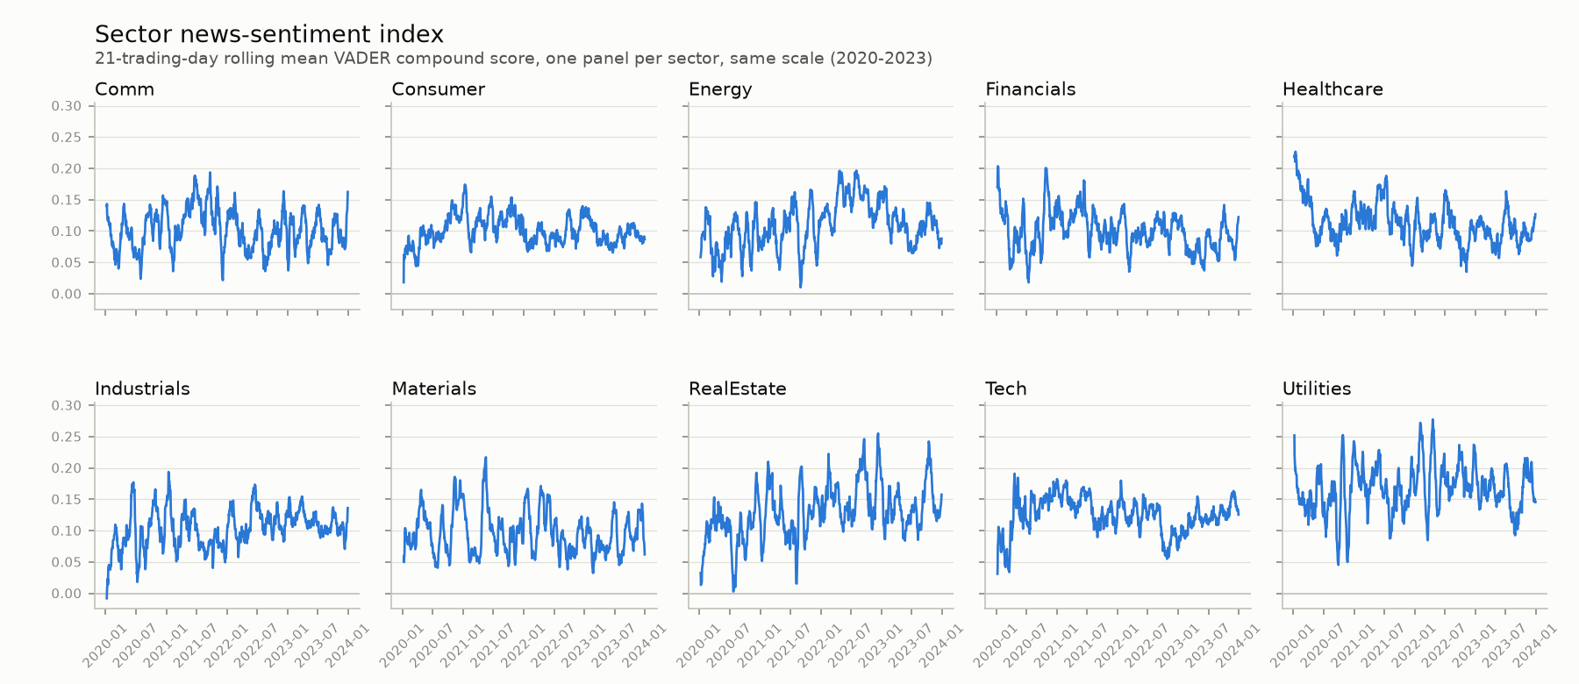
Figure 5. Sector news-sentiment index, 21-trading-day rolling mean VADER compound score, one panel per sector, same scale (2020-2023). Source: results/figures/sentiment_index.png.

4. The fusion extension and whether it adds value
The equity maximum-Sharpe fund's weights are tilted toward names with more positive recent sentiment: at each rebalance, each ticker's last known sentiment score strictly before the rebalance date (at least a one-trading-day lag, so a Saturday or Monday headline is first usable for Tuesday's trade) scales that ticker's base weight by (1 + 0.5 × sentiment), floored at zero for the long-only constraint and renormalised to sum to 1.
 | Ann. return | Ann. vol | Sharpe | Max DD
Equity Max-Sharpe (base) | 10.7% | 18.2% | 0.586 | -26.1%
+ Sentiment tilt | 10.6% | 18.3% | 0.581 | -26.6%

Table 2. Fusion before-vs-after comparison: Equity Max-Sharpe base fund vs. the sentiment-tilted version. Source: results/tables/fusion_comparison.csv.
The tilt is essentially neutral to slightly negative: Sharpe falls from 0.586 to 0.581, annualised return falls marginally from 10.7% to 10.6%, and the maximum drawdown worsens slightly (-26.1% to -26.6%). The spread between the two funds' daily growth (Figure 6) is consistently positive through 2021 - the tilt added value while sentiment was informative during that period - then turns mixed and slightly negative from mid-2022 onward. [NEEDS REWRITE - my own assessment of why the tilt's value seems to fade after 2022, and what that implies about headline sentiment as a signal, belongs here. The brief is explicit that a careful extension with a negative or neutral result, honestly reported, still earns credit - I should not overstate this as a win.]
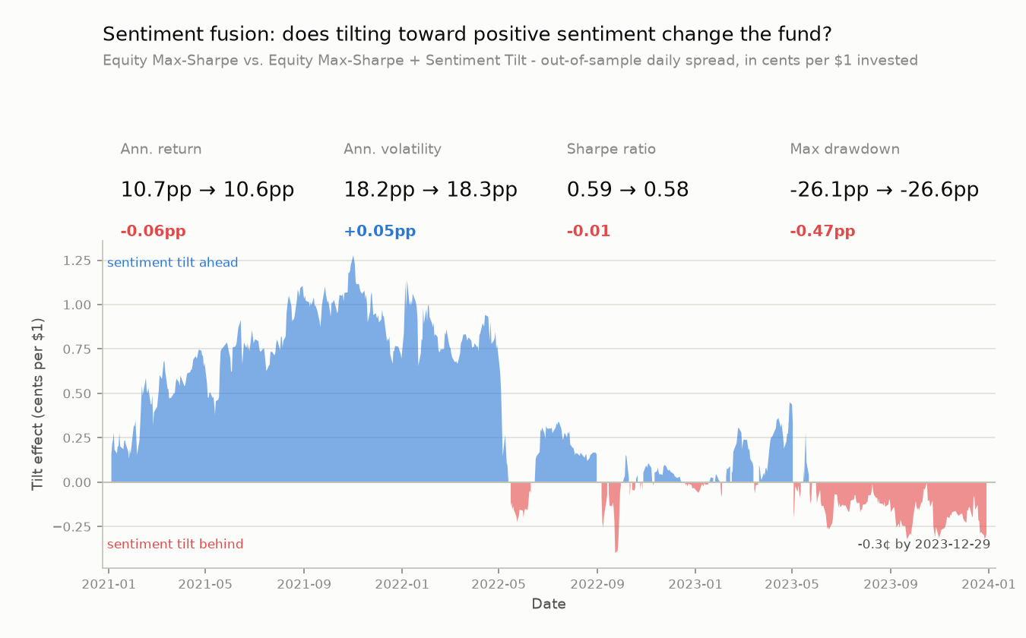
Figure 6. Sentiment fusion: stat comparison (top) and the daily tilt effect in cents per $1 invested (bottom), Equity Max-Sharpe base vs. tilted. Source: results/figures/fusion_comparison.png.

5. The app and the investor journey
SentiFolio is deployed as a Streamlit app (public repo: github.com/jia-xuan-z/z5555674_projectB; live app: z5555674projectb-eppv6ytyyx2jducyw9luh2.streamlit.app) targeting a retail investor who wants exposure to systematically managed equity, crypto, and combined strategies without picking individual stocks themselves, plus a way to gauge the prevailing news mood in the sectors they are considering. The app has three tabs. Funds lets the investor compare all nine funds' metrics side by side, then drill into one fund's fact sheet (growth of $1, drawdown, and current holdings, computed from the same walk-forward backtest as this report). Sentiment shows the sector sentiment index, with a sector picker. Build a portfolio lets the investor set a percentage allocation across all ten funds (the nine base funds plus the sentiment-tilted fund) and see the blended portfolio's own annualised return, volatility, Sharpe, and drawdown, computed live from the funds' own historical daily returns restricted to dates where every selected fund was actually live (an early version of this blend incorrectly zero-filled a fund's pre-launch dates, which understated its metrics - see ai/prompt_log.md).
The app only reads precomputed artefacts committed under results/ - it never imports nltk or reruns a backtest at request time, so it stays responsive on Streamlit Community Cloud's free tier. [NEEDS REWRITE - a paragraph on the investor journey end-to-end, and any app features I'd add next, is mine to write.]

6. Critical reflection
[NEEDS REWRITE IN FULL - this whole section is meant to be my own honest assessment, not AI-generated reflection. The brief specifically penalises AI-generated reasoning presented as the student's own, and this section is exactly where markers expect to hear my voice most directly. Below are factual starting points only, not conclusions.]
What worked: nine funds across three universes and three methods, all genuinely optimised (after catching and fixing the SLSQP scaling bug), a sentiment index that differentiates sectors in a defensible way, and a deployed app reading only precomputed data.
What did not work as hoped: the sentiment fusion did not clearly improve the base fund, and its effect appears concentrated in 2021 rather than persistent. [NEEDS REWRITE - my own view on whether this is a fusion-design problem, a lagging problem, or evidence that headline sentiment genuinely carries little tradeable signal, belongs here.]
Three concrete recommendations: [NEEDS REWRITE - three specific, evidenced recommendations, in my own words, e.g. on rebalance frequency, tilt design, or lexicon extension, go here.]

