Reference-country composition and age-standardized PCOS-attributed infertility contrasts: China and 18 G20 countries, 1990–2023
XX Author¹, XX Author², XX Corresponding Author^{1,*}
¹XX Department, XX Institution, XX City, XX Country, XX Postal code
²XX Department, XX Institution, XX City, XX Country, XX Postal code
*Correspondence: XX email; ORCID: XX
30 October 2026
Running title: PCOS infertility and reference composition

Abstract
STUDY QUESTION: How did changing within-age reference-country population shares contribute to the 1990–2023 change in China’s age-standardized PCOS-attributed total-infertility rate difference from an 18-country pooled reference?
SUMMARY ANSWER: In the GBD point estimates, changing reference-country shares accounted for +88.65 per 100,000 females of the +151.54 change in China’s total-infertility rate difference (58.5% of the signed net change).
WHAT IS KNOWN ALREADY: GBD studies describe PCOS-attributed infertility burden and trends. Fixed age-standardization weights still permit country composition within each reference age group to change.
STUDY DESIGN, SIZE, DURATION: This exploratory ecological analysis covered China and 18 other sovereign G20 countries, females aged 15–49 in seven age groups, and 34 years, 1990–2023.
PARTICIPANTS/MATERIALS, SETTING, METHODS: GBD 2023 prevalence counts and matched female populations yielded age-specific rates, which were standardized using fixed weights normalized over ages 15–49. The primary estimand was the 1990–2023 change in China’s total PCOS-attributed infertility rate difference from the contemporaneous population-pooled reference. A Kitagawa-type decomposition separated Chinese rates, reference-country rates and within-age country shares. UN WPP 2024 replaced shares only. Alternative benchmarks, country exclusions, age restrictions, endpoints and annual chaining examined the sensitivity of the comparison.
MAIN RESULTS AND THE ROLE OF CHANCE: China’s total rate rose from 333.56 to 605.08 and the reference rate from 606.48 to 726.45 per 100,000. Their difference narrowed from -272.92 to -121.38. The respective rate and composition components were +271.51 - 208.62 + 88.65 = +151.54 (rounded). UN shares gave +86.76 for composition and +150.69 overall. The 2023 secondary-infertility difference was +2.16 with contemporaneous GBD shares, -47.99 with fixed-1990 shares and -127.89 with equal-country weights. Results are derived point estimates; jointly aligned posterior draws were not obtained for interval propagation.
LIMITATIONS, REASONS FOR CAUTION: Joint posterior uncertainty in component magnitudes and near-zero differences remains unquantified. The 58.5% value is a signed accounting ratio, not a causal or case-attributable fraction. The selected G20 comparison does not represent the world or a clinically matched population.
WIDER IMPLICATIONS OF THE FINDINGS: International reproductive-health comparisons should specify the reference population and report absolute rate and composition components alongside net differences. Contemporary and fixed-composition benchmarks answer complementary monitoring questions; a narrowing difference alone does not indicate a reduction in infertility burden.
FUNDING: XX: verified funding sources and funder roles to be completed by the authors at submission.
DISCLOSURES: XX: author-specific disclosures to be completed at submission.
TRIAL REGISTRATION NUMBER: Not applicable; this is a secondary analysis of aggregate estimates, not a clinical trial.
Keywords: Polycystic Ovary Syndrome; Infertility, Female; Prevalence; Age Distribution; Population Dynamics.

Introduction
Polycystic ovary syndrome (PCOS) affects reproductive health and requires care tailored to the individual (Teede et al., 2023). Population monitoring complements this clinical perspective by describing national trajectories in PCOS-attributed infertility. In the Global Burden of Disease (GBD) study, this outcome is a modeled cause-specific infertility impairment expressed in the general female population (GBD 2023 Collaborators, 2025). Interpreting a national trajectory against a pooled international population requires an explicit definition of that reference.
Liu and colleagues quantified GBD 2019 PCOS-attributed infertility prevalence, disability and geographical trends (Liu et al., 2024). Liang and colleagues analysed GBD 2021 burden, trends and the contributions of population growth, ageing and epidemiological change to burden counts (Liang et al., 2025); another study examined China and worldwide trajectories (Liang, 2026). These studies establish the burden context. The present analysis addresses a different estimand: the change in a national-versus-pooled-reference rate difference, allowing country shares to vary within each age group while the age standard remains fixed (Supplementary Table S9). Its contribution is the empirical interpretation of this comparison using an established decomposition, rather than a new decomposition method.
A contemporaneous population pool represents the country mix at each date. A redistribution of population shares toward countries with lower age-specific rates can lower the pooled rate even when country-specific rates are unchanged. Age standardization fixes the age mix, but not this within-age country mix. Consequently, a smaller absolute gap between the national and pooled-reference rates need not reflect a decline in the national rate. We quantified the 1990–2023 change in China’s total PCOS-attributed infertility rate difference from the population-pooled reference of 18 other sovereign G20 countries, allocating that change to Chinese rates, reference-country rates and reference-country shares. Secondary questions concern demographic-source choice, infertility subtypes and fixed-1990 or equal-country benchmarks.

Materials and methods

Design, data and outcome
This ecological secondary analysis used GBD 2023 Results Tool exports obtained on 25 October 2026 (Institute for Health Metrics and Evaluation, 2026). We analysed females aged 15–49 in seven five-year age groups during 1990–2023. The fixed set comprised 19 sovereign G20 countries, with China excluded from the reference. The 18 reference countries were Argentina, Australia, Brazil, Canada, France, Germany, India, Indonesia, Italy, Japan, Republic of Korea, Mexico, Russian Federation, Saudi Arabia, South Africa, Türkiye, United Kingdom and United States of America. The G20 was established in 1999; we applied this country set retrospectively across the study years. The European Union and African Union were excluded as additional units to avoid overlapping country populations (Australian Government, 2026). This fixed country set defines the international benchmark for the analysis; it is neither a sample representative of the world nor a clinically matched control group.
We selected prevalence (measure 5), PCOS (cause 605), total infertility (impairment 198), primary infertility (220) and secondary infertility (221). Endometriosis (607) was retained as a supplementary comparator. The GBD 2023 household-survey framework identifies primary infertility using absence of a livebirth, desire for a child, union duration of at least five years and no current contraception. Its secondary definition requires a livebirth more than five years earlier and the corresponding union, fertility-intention and contraception conditions. The modeling process combines these survey envelopes with sex- and cause-attribution evidence, including clinical sources, and expresses the final rates among all females in each age group (GBD 2023 Collaborators, 2025). Supplementary data distinguish these quantities from clinical 12-month infertility definitions and from PCOS prevalence itself.
For country $c$, age $a$, year $t$ and infertility type $k$, let $N_{c,a,t,k}$ denote modeled infertility cases and $P_{c,a,t}$ the matched GBD female population. Age-specific prevalence per 100,000 is $r_{c,a,t,k}={10}^{5}N_{c,a,t,k}/P_{c,a,t}$. We checked unique complete cells, finite nonnegative values, primary-plus-secondary additivity and agreement with separately exported endpoint Rate values. Input specifications and hashes are retained in the reproducibility archive.

Annual contrasts and the primary period change
Let $R$ be the set of 18 reference countries; the labels $CHN$ and $R$ denote China and the pooled reference. We used the seven published six-decimal age weights reproduced by Chen and colleagues (Chen et al., 2026), normalized them to sum to one over ages 15–49 and held them fixed. Supplementary Methods report the weight vector, its source limitations and the numerical rounding check.
sc,a,t=Pc,a,tj∈R​Pj,a,t, AR,t,k=a​wac∈R​sc,a,trc,a,t,k, (1)
ACHN,t,k=a​warCHN,a,t,k, Dt,k=ACHN,t,k−AR,t,k. (2)
Here $w_{a}$ sums to one, and $s_{c,a,t}$ sums to one over reference countries within each age and year. Pooling within age precedes standardization. The annual rate difference is $D_{t,k}$; its period change is $ΔD_{k}(t_{0},t_{1})=D_{t_{1},k}−D_{t_{0},k}$. The primary estimand is $ΔD_{total}(1990,2023)$ under contemporaneous GBD shares. Subtype and alternative-reference analyses address secondary estimands. All rates are restricted-age standardized rates per 100,000 females.

Symmetric decomposition of the period change
For endpoints $t_{0}$ and $t_{1}$, the symmetric product identity of Kitagawa-type accounting gives (Kitagawa, 1955):
$ΔD_{k}(t_{0},t_{1})=X_{k}+Q_{k}+S_{k},$ (3)
Xk=a​wa(rCHN,a,t1,k−rCHN,a,t0,k), (4)
Qk=−a​wac∈R​sc,a,t0+sc,a,t12(rc,a,t1,k−rc,a,t0,k), (5)
Sk=−a​wac∈R​rc,a,t0,k+rc,a,t1,k2(sc,a,t1−sc,a,t0). (6)
$X_{k}$, $Q_{k}$ and $S_{k}$ allocate the period change to Chinese rates, reference-country rates and reference-country shares, respectively. Each uses the same endpoints, subtype and population-source specification. Averaging the two replacement orders splits the product interaction symmetrically, giving an exact identity before rounding. Positive components raise the signed China-minus-reference difference. For a difference that remains negative at both endpoints, a positive net change indicates a smaller absolute gap.
The identity is additive across ages and types. The share component is zero if shares are unchanged; it also vanishes when the countries’ mean endpoint rates are identical within age, because share changes sum to zero. These algebraic properties clarify the role of composition. Its estimated magnitude in the GBD data is reported separately below.
We report absolute components before the ratio $100S_{k}/ΔD_{k}(t_{0},t_{1})$. Its signed net denominator contains cancellation between components and can approach zero; ratios can consequently exceed 100% or change sign. This accounting ratio is distinct from a fraction of women, cases or disease causation. The primary- and secondary-infertility contributions add to the total change. Each subtype contribution can itself be separated into rate and country-share components; subtype percentages and composition percentages should therefore not be added to one another.

Population sources and benchmark definitions
UN WPP 2024 supplied historical mid-year female population estimates for the same 4,522 country–age–year cells (United Nations, 2024). Values in thousands were converted to persons; projections from 2024 onward were excluded. Only the within-age reference shares were replaced. GBD cases continued to use matched GBD population denominators, and the age standard remained fixed.
Current-year shares compare China with the contemporaneous pooled population. Fixed-1990 shares hold the reference’s 1990 within-age country mix constant while country rates vary. Equal-country weights compare China with the arithmetic mean of 18 country rates within age. These benchmarks specify different reference populations and therefore different descriptive estimands, rather than competing estimates of one identical target. The contemporary pool is the primary benchmark because the primary question compares China with the reference population represented at each date. The fixed-1990 benchmark instead isolates a comparison under a constant country mix. Its endpoint difference from the contemporary benchmark is not, in general, equal to the symmetric share component, which averages rates at both endpoints (Supplementary Methods).

Structural sensitivity and posterior uncertainty
We examined both population sources, exclusion of each reference country in turn, ages 20–49 with renormalized age weights, 1990 or 2010 start years, and 2021, 2022 or 2023 endpoints. Adjacent-year decompositions were also summed over 1990–2023 to assess sensitivity to the decomposition path. Supplementary Methods provide a separate age-weight rounding check and the endometriosis endpoint analyses. These analyses assess specification and numerical sensitivity, not posterior uncertainty.
The study exports contain point estimates and marginal uncertainty limits, but no posterior draws with verified joint alignment across the inputs needed for the analysis. We therefore report the derived contrasts, components and ratios as descriptive point estimates conditional on the supplied GBD outputs, without propagated uncertainty intervals or significance tests. Marginal limits alone do not determine joint uncertainty, and independent simulation or resampling the selected countries would introduce additional assumptions rather than recover the GBD posterior dependence. A draw-based analysis would require recomputing the complete pooling and decomposition within each verified joint draw, with particular care for ratios whose net-change denominator approaches zero.

Computational reproducibility
The analyses were exploratory and were not preregistered. Python and base R implementations were used to cross-check the core calculations. The source manifest, code and aggregate results are identified by the immutable analytical snapshot (PCOS research workspace, 2026). Supplementary Methods provide the recorded software versions, execution commands, notation map, numerical checks and GATHER reporting map (Stevens et al., 2016). Numerical agreement between implementations checks computation; it does not independently validate the modeled disease estimates.

Ethical approval
Public aggregate GBD estimates and UN demographic data were analysed without individual participant records. XX: institutional ethics-review applicability or exemption determination to be confirmed by the responsible author. No ethics approval number is asserted.

Use of artificial intelligence
AI assistance in code development, analysis checks, drafting and technical editing is disclosed in Acknowledgements. Scientific verification and final approval remain the responsibility of the human authors.

Results

Coverage and PCOS contrasts
The PCOS analysis comprised 13,566 country–age–year–type records covering 19 countries, seven age groups, 34 years and three infertility categories. These are model-output records, not independent participant observations. Each population source covered 4,522 country–age–year cells. Completeness, subtype additivity, endpoint rate reconstruction and numerical agreement between the R and Python implementations were checked; the corresponding results, including those for the supplementary endometriosis analysis, are reported in Supplementary Methods.
China’s PCOS-attributed total infertility standardized rate increased from 333.56 to 605.08 per 100,000, while the population-pooled reference increased from 606.48 to 726.45 (Table 1; Figure 1). The difference changed from -272.92 to -121.38 and the ratio from 0.550 to 0.833. The narrower negative difference therefore accompanied increases in both standardized rates, rather than a fall in the Chinese rate. Subtype-specific trajectories are shown in Figure 2.
Table 1. PCOS-attributed infertility rates and contrasts under contemporary GBD population shares.
Type | Year | China | Reference | Difference | Ratio
Total | 1990 | 333.56 | 606.48 | -272.92 | 0.550
Total | 2023 | 605.08 | 726.45 | -121.38 | 0.833
Primary | 1990 | 44.70 | 214.64 | -169.94 | 0.208
Primary | 2023 | 97.35 | 220.89 | -123.54 | 0.441
Secondary | 1990 | 288.86 | 391.84 | -102.98 | 0.737
Secondary | 2023 | 507.72 | 505.56 | +2.16 | 1.004
Rates and differences are per 100,000 females, standardized within ages 15–49. Difference is China minus reference; ratio is China divided by reference. Calculations precede rounding, so displayed values may not add or subtract exactly. All values are model point estimates without propagated posterior intervals.

Rate and reference-composition components
The 1990–2023 change in the total contrast was
$\underset{X}{\underbrace{+271.51}} \underset{Q}{\underbrace{−208.62}} \underset{S}{\underbrace{+88.65}}=\underset{ΔD}{\underbrace{+151.54}} \text{per 100,000},$ (7)
with displayed rounding (Table 2; Figure 3). Chinese rate changes and reference-share changes moved the signed difference upward, while reference-country rate changes offset them. The country-share term was 58.5% of the signed net change; this denominator is smaller because positive and negative terms cancel.
The country-share component was +88.11 ending in 2021 and +86.74 ending in 2022. The annual-chained component was +87.11 (57.5%). Across 18 country exclusions and restriction to ages 20–49, the GBD 1990–2023 country-share ratio ranged from 39.8% to 67.9% (Supplementary data, Table S2 and Figure S3). The share component remained positive across these specifications. Excluding India gave +56.16 per 100,000 (39.8% of the net change), whereas excluding the Russian Federation gave +110.34 (67.9%). Each exclusion changes and renormalizes the reference population; these differences are not country-specific causal contributions.
Secondary infertility contributed +105.14 and primary infertility +46.40 to the +151.54 total change. The secondary contribution was 69.4% of the signed net change. Its country-share component was +56.81, compared with +31.84 for primary infertility. The 69.4% subtype contribution and the 58.5% country-share contribution are different partitions of the same total change and should not be added. In the age-specific decomposition, the largest positive total-infertility share components were +23.76 at ages 40–44 and +20.42 at ages 35–39; the component at ages 15–19 was -2.27 (Supplementary Table S3). These are contributions to the standardized comparison, not estimates of individual age-specific infertility risk.
Table 2. Symmetric PCOS contrast-change decomposition, 1990–2023, by population source.
Type | Shares | China rates $X$ | Ref. rates $Q$ | Ref. shares $S$ | Net $ΔD$
Total | GBD | +271.51 | -208.62 | +88.65 | +151.54
Total | UN WPP | +271.51 | -207.59 | +86.76 | +150.69
Primary | GBD | +52.65 | -38.09 | +31.84 | +46.40
Primary | UN WPP | +52.65 | -37.75 | +30.13 | +45.02
Secondary | GBD | +218.86 | -170.53 | +56.81 | +105.14
Secondary | UN WPP | +218.86 | -169.83 | +56.64 | +105.67
All contributions are per 100,000 females, with fixed standard age weights. Components sum before rounding. UN changes country shares only. Positive and negative components may cancel; percentages use the signed net denominator defined in Methods.

Population sources and benchmark definitions
UN weighting gave a total contrast change of +150.69, decomposed as +271.51 from Chinese rates, -207.59 from reference rates and +86.76 from country shares (57.6%; Figure 4). The 2023 total difference was -122.62, compared with -121.38 under GBD shares. Mean total-variation distance between the two within-age reference-share vectors was 1.32 percentage points in 2023 and 1.13 over all years. The reference-share components and total changes were similar under the two population sources. Because both specifications retain the same GBD disease rates, this agreement concerns demographic weighting rather than independent disease-rate validation.
Under contemporary GBD shares, the 2023 primary PCOS difference was -123.54 and the secondary difference was +2.16 per 100,000. Holding the GBD country shares at their 1990 values changed the secondary difference to -47.99; equal-country weighting gave -127.89 (Table 3; Figure 5). The corresponding UN values were +2.26, -48.34 and -127.89. The disease rates and age weights are unchanged within each comparison. Thus, the positive secondary-infertility point difference under contemporary shares is benchmark-dependent; its sign alone does not establish a reliable population ranking.
Table 3. Benchmark definition changes the 2023 PCOS secondary infertility contrast.
Population source | Benchmark | Reference rate | China minus reference
GBD | Current-year shares | 505.56 | +2.16
GBD | Fixed-1990 shares | 555.71 | -47.99
GBD | Equal countries | 635.61 | -127.89
UN WPP | Current-year shares | 505.46 | +2.26
UN WPP | Fixed-1990 shares | 556.06 | -48.34
UN WPP | Equal countries | 635.61 | -127.89
China’s standardized rate is 507.72 per 100,000 throughout. Country weights are applied within each age; the same GBD disease rates and age standard are used. Equal-country rows are identical by construction. Each row represents a different benchmark definition.

Discussion
Reference-country composition made a substantial contribution to the narrowing PCOS-attributed infertility contrast between China and the pooled reference. With a fixed age standard, the 1990–2023 signed rate difference increased by +151.54 per 100,000: +271.51 from Chinese rates, -208.62 from reference-country rates and +88.65 from changing reference-country shares. The close +86.76 share component under UN populations supports stability to this demographic-source substitution. Both China’s and the reference’s total modeled rates rose, so the narrower contrast describes their relative trajectories alongside the changing population mix.
The contribution is an empirical demonstration of how reference construction changes the interpretation of reproductive-health comparisons, complementing geographical burden and trend studies (Liu et al., 2024; Liang et al., 2025; Liang, 2026). Fixing age weights does not fix the country mix within each age group. An established symmetric decomposition expresses this composition component in the same units as the rate difference and makes it distinguishable from changes in Chinese and reference-country rates. The findings concern the specified country pool and period, rather than a new decomposition theory or a universal percentage contribution.
For monitoring, the benchmark should match the question. Contemporary pooling compares China with the population represented by the 18-country pool at each date; a fixed historical composition supports comparison over time without changes in that country mix; equal-country weighting instead gives each country equal influence. These are complementary descriptive targets, not a hierarchy of correct and incorrect weights. Reporting the contemporary and fixed-composition contrasts together would make benchmark dependence visible, as illustrated by secondary infertility in 2023. Absolute components should accompany any percentages because opposing rate components reduce the signed net denominator. The 39.8%–67.9% range across the specified GBD age and country-exclusion scenarios describes sensitivity to those choices, not posterior uncertainty.
Clinical interpretation also depends on the outcome and denominator. In the 2020 Chinese community survey, Yang and colleagues used Rotterdam PCOS ascertainment among married Han women aged 20–49 and reported infertility characteristics among PCOS participants (Yang et al., 2022). The present analysis instead concerns GBD cause-attributed infertility among all females aged 15–49. These definitions and populations serve different purposes (Supplementary Table S11). The clinical guideline provides the diagnostic and care context (Teede et al., 2023); the aggregate comparison does not identify individual transitions between infertility categories or effects of diagnosis, treatment or service provision.
The principal limitation is unquantified joint posterior uncertainty: the precision of the absolute components, the 58.5% ratio and near-zero differences remains unknown. Structural sensitivity analyses cannot replace that uncertainty assessment. Additional limits include heterogeneous upstream evidence and modeled cause attribution, possible shared population inputs between GBD and UN, exploratory analytical choices and the purposively selected G20 country set. The published age weights were not independently matched to an official full-precision IHME vector. However, the rounding envelopes reported in Supplementary Table S8 are narrow and address numerical precision only; they do not establish the provenance of the age standard or the validity of the disease estimates. The results describe this G20 comparison, not the world or a matched clinical control population.
In this descriptive analysis, reference-country composition accounted for +88.65 per 100,000 of the +151.54 change in the modeled China-minus-reference difference. The narrower difference coexisted with increasing infertility rates in China and the reference pool. Reporting absolute rate and composition components, together with clearly defined alternative benchmarks, would distinguish these patterns without interpreting benchmark convergence as improved reproductive health.

Authors’ roles
XX: verified author-by-author contributions to design, execution, analysis, drafting and critical discussion, final approval and accountability to be supplied at submission.

Acknowledgements
We acknowledge the GBD data providers and collaborators and the United Nations Population Division. XX: additional acknowledgements, if applicable.
OpenAI ChatGPT and Codex assisted code development, analysis checks, drafting and technical editing, including revisions on 30 October 2026. No synthetic observations or posterior draws were substituted for study data. The documented Codex session on 29 October 2026 recorded the model identifier gpt-6.1-sol; model identifiers for other sessions were not independently verified. Human authors retain responsibility for the study. XX: the authors must complete and confirm their review of AI-assisted text, code, numerical outputs and references, approve the final manuscript, and supply any tool/version details required by the target journal from their own records before submission.

Funding
XX: verified sponsors, grants and funder roles, or an author-approved no-specific-funding statement, to be supplied at submission.

Disclosures
XX: author-specific financial, personal and professional disclosures to be supplied at submission.

Data availability
The executable Python and R workflow, aggregate derived results, query specifications and checksums are available in the immutable public research snapshot (PCOS research workspace, 2026). The snapshot identifies the analysis underlying the present article and is distinct from the manuscript version. Licensed original GBD 2023 extracts were accessed through the GBD Results Tool on 25 October 2026 (Institute for Health Metrics and Evaluation, 2026); the query dimensions, export identifiers and SHA-256 hashes needed to identify them are recorded in the snapshot’s input manifest. These originals and country–age source-cell extracts are retained in the private research archive and are excluded from the public repository. UN WPP 2024 population data are identified by the exact source product and file in the reference list (United Nations, 2024); the attributed 4,522-row subset and its source manifest are included in the immutable snapshot. No hospital data were used.

Supplementary data
Supplementary Methods, Tables S1–S11 and Figures S1–S7 accompany the article. These include the numerical sensitivity results, literature and outcome-definition comparisons, and a GATHER reporting map. The public reproducibility repository contains code, aggregate derived results, source specifications, a complete annual subtype CSV and execution instructions; licensed GBD originals and restricted country–age source cells are excluded.

References
Australian Government Department of Foreign Affairs and Trade. The G20. Accessed 30 October 2026. https://www.dfat.gov.au/trade/organisations/g20.
Chen S, Yang X, Jiang S, Lin Y, Huang L, Chen H, Zheng J, Xie Y, Kuang Z. Burden and temporal trends of female-specific cancers in China: a systematic analysis of the 2023 global burden of disease study. PLOS One. 2026;21:e0351539. Supplemental table of reproduced GBD standard population. doi:10.1371/journal.pone.0351539.
GBD 2023 Disease and Injury and Risk Factor Collaborators. Burden of 375 diseases and injuries, risk-attributable burden of 88 risk factors, and healthy life expectancy in 204 countries and territories, including 660 subnational locations, 1990–2023: a systematic analysis for the Global Burden of Disease Study 2023. Lancet. 2025;406(10513):1873–1922. doi:10.1016/S0140-6736(25)01637-X. Includes Supplementary Appendix 1, infertility methods.
[dataset] Institute for Health Metrics and Evaluation. GBD 2023 prevalence and matched female-population extracts for China and 18 other G20 countries, 1990–2023. GBD Results Tool; extracts accessed 25 October 2026. https://vizhub.healthdata.org/gbd-results/. Release: GBD 2023; export identifiers 1b13e337, 916826fb, 416daf73 and 76c5523c. Query specifications and input hashes are provided in the versioned research snapshot listed below. Access is subject to IHME terms.
Kitagawa EM. Components of a difference between two rates. J Am Stat Assoc. 1955;50(272):1168–1194. doi:10.1080/01621459.1955.10501299.
Liang Q. Trend analysis of the burden of PCOS and related infertility in China and worldwide between 1990 and 2021. Reprod Biomed Online. 2026;52(2):105239. Published online 2 September 2025. doi:10.1016/j.rbmo.2025.105239.
Liang Y, Zhong K, Huang Z, Shi W, Ou Y. Global, regional, and national burden of infertility attributable to polycystic ovary syndrome, 1990–2021: results from the Global Burden of Disease Study 2021. Front Public Health. 2025;13:1693486. doi:10.3389/fpubh.2025.1693486.
Liu X, Zhang J, Wang S. Global, regional, and national burden of infertility attributable to PCOS, 1990–2019. Hum Reprod. 2024;39:108–118. doi:10.1093/humrep/dead241.
[dataset] PCOS research workspace. Analysis code, query manifests and aggregate derived results for GBD 2023 infertility comparisons. GitHub; 2026. Immutable revision 1abf337d9f23cc69292e03cd581b6a1557e6effe. https://github.com/jiabao1314/PCOS/tree/1abf337d9f23cc69292e03cd581b6a1557e6effe/PCOS_Revision_2026-10-29. Includes the Python/R workflow, input manifest, aggregate results and attributed UN population subset; restricted GBD originals are excluded.
Stevens GA, Alkema L, Black RE, Boerma JT, Collins GS, Ezzati M, Grove JT, Hogan DR, Hogan MC, Horton R, et al. Guidelines for Accurate and Transparent Health Estimates Reporting: the GATHER statement. PLOS Med. 2016;13:e1002056. doi:10.1371/journal.pmed.1002056.
Teede HJ, Tay CT, Laven JJE, Dokras A, Moran LJ, Piltonen TT, Costello MF, Boivin J, Redman LM, Boyle JA, et al. Recommendations from the 2023 International Evidence-based Guideline for the Assessment and Management of Polycystic Ovary Syndrome. J Clin Endocrinol Metab. 2023;108:2447–2469. doi:10.1210/clinem/dgad463.
[dataset] United Nations, Department of Economic and Social Affairs, Population Division. World Population Prospects 2024, Online Edition: population by five-year age group and sex, medium variant, midyear. United Nations; 2024. Source file: WPP2024_PopulationByAge5GroupSex_Medium.csv.gz. https://population.un.org/wpp/assets/Excel%20Files/1_Indicator%20(Standard)/CSV_FILES/WPP2024_PopulationByAge5GroupSex_Medium.csv.gz. Historical estimates through 2023 only were selected. Creative Commons Attribution 3.0 IGO.
Yang R, Li Q, Zhou Z, et al. Changes in the prevalence of polycystic ovary syndrome in China over the past decade. Lancet Reg Health West Pac. 2022;25:100494. doi:10.1016/j.lanwpc.2022.100494.
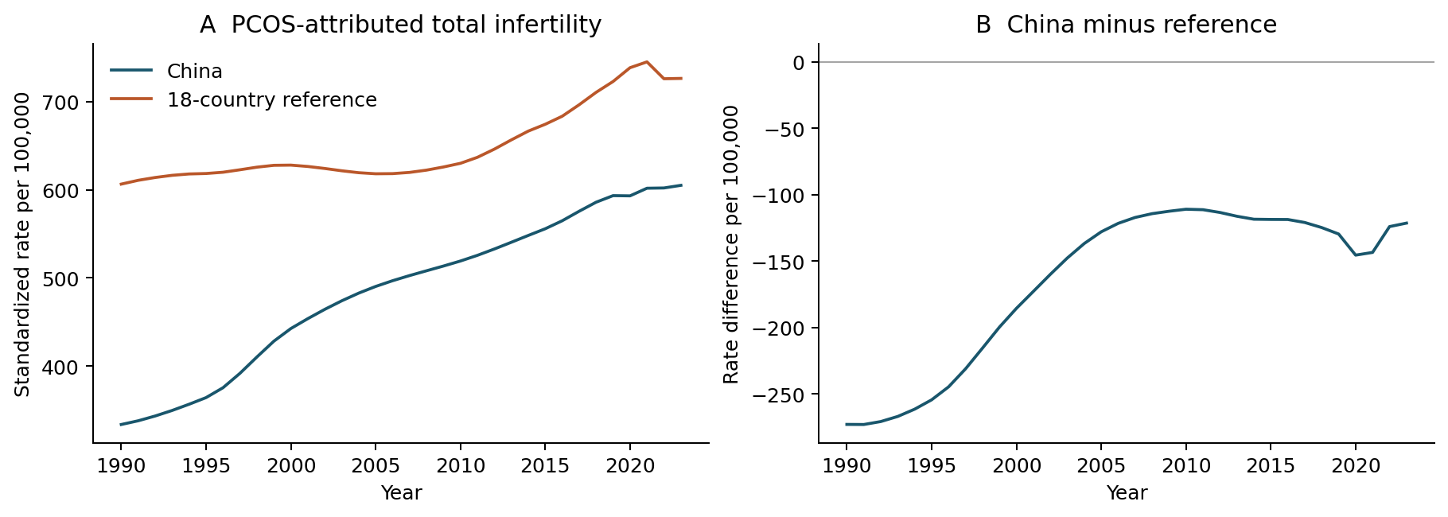
Figure 1. PCOS-attributed total infertility rates and China-minus-reference differences. The reference pools the 18 countries within age before fixed-age standardization. Both national and reference modeled rates increase. All values are point estimates without propagated GBD uncertainty.
Alt text: Two-panel line plot. China and the population-pooled reference both increase from 1990 to 2023; the China-minus-reference difference remains negative and narrows from minus 272.92 to minus 121.38 per 100,000.
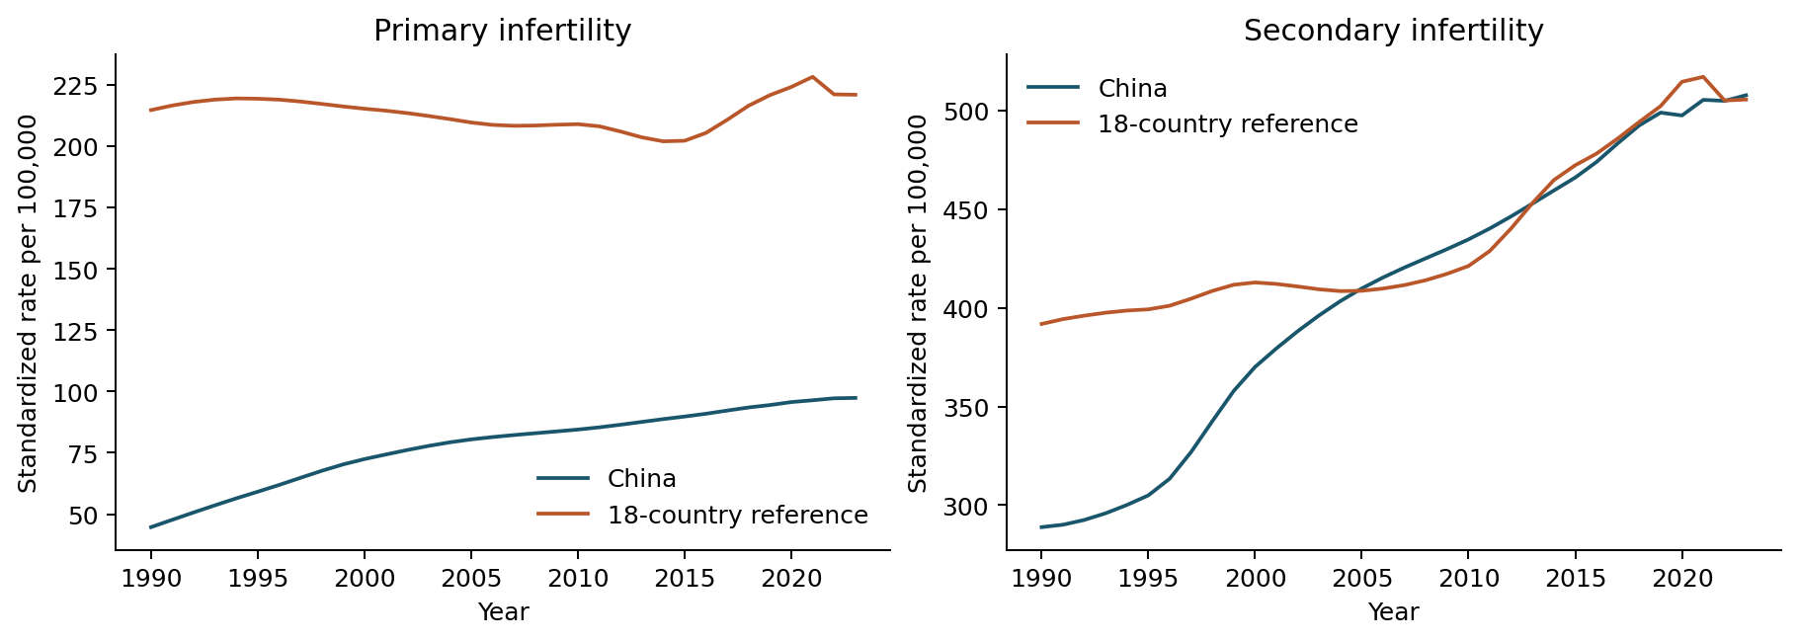
Figure 2. PCOS-attributed primary and secondary infertility trajectories. The same population-pooled GBD reference and age standard are used. The categories do not track individual transitions.
Alt text: Primary and secondary PCOS-attributed infertility trajectories. The primary contrast remains negative; the secondary contrast approaches zero and is plus 2.16 per 100,000 in 2023 under contemporary GBD reference shares.
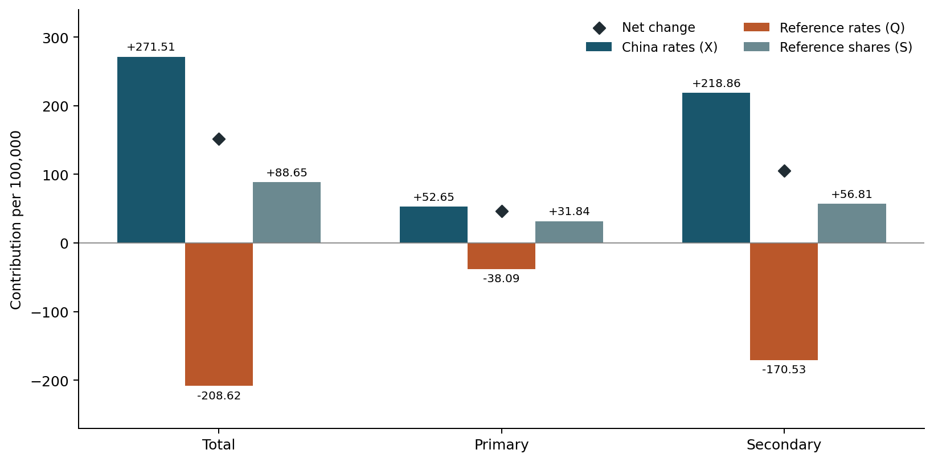
Figure 3. Absolute symmetric components of changing PCOS contrasts, 1990–2023. China-rate, reference-rate and reference-share components add to the diamond-marked net changes before rounding. Components with opposing signs cancel; their percentages of the net are descriptive accounting ratios.
Alt text: Bars separate Chinese rate, reference rate and reference share components by infertility type, with diamonds for net changes. For total infertility the components are plus 271.51, minus 208.62 and plus 88.65 per 100,000.
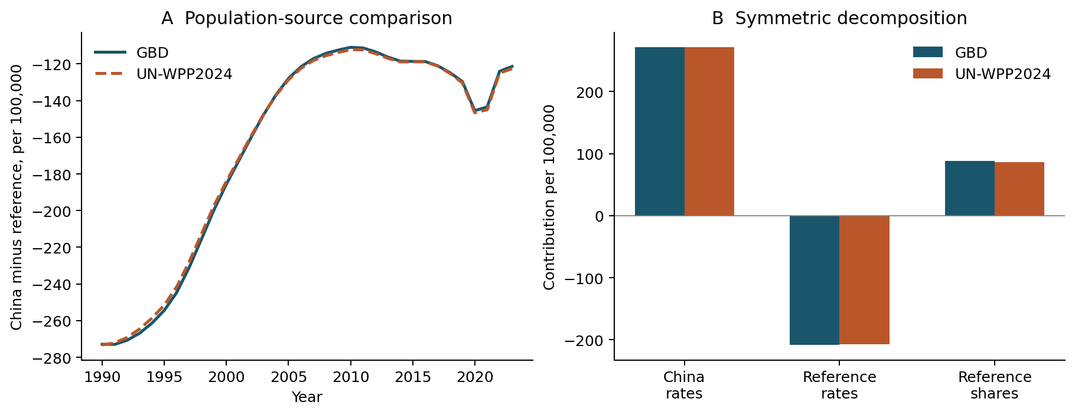
Figure 4. Alternative demographic-source weighting of the PCOS comparison. Panel A shows annual total-infertility differences; panel B shows endpoint decomposition components. Only within-age reference-country shares change between GBD and UN scenarios; disease rates and age weights remain fixed.
Alt text: Annual differences and endpoint components under GBD and UN shares are close. For total infertility, the share component is plus 88.65 with GBD and plus 86.76 with UN; disease rates are held fixed.
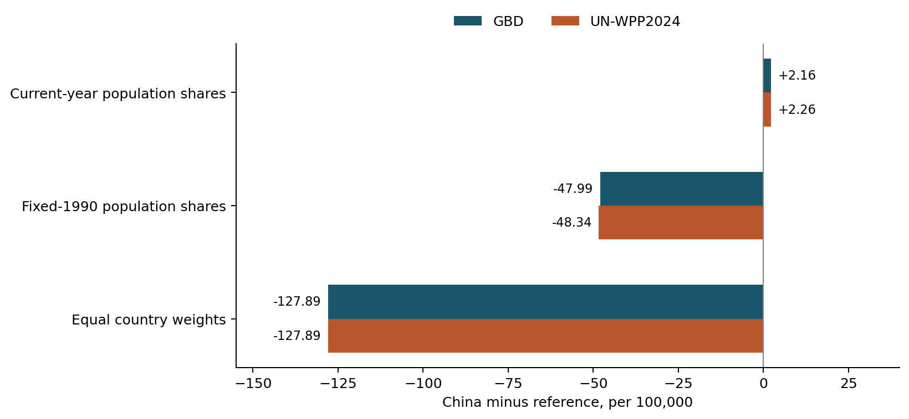
Figure 5. Benchmark dependence of the 2023 PCOS secondary-infertility difference. Current-year, fixed-1990 and equal-country reference weights answer different comparison questions. Bars show point estimates under GBD or UN population shares. Equal-country values coincide by construction; no bar represents a confidence interval.
Alt text: Benchmark bars for secondary infertility in 2023. The GBD difference is plus 2.16 with current shares, minus 47.99 with 1990 shares and minus 127.89 with equal-country weights; UN scenarios show the same sign pattern.

本轮9项修正核对索引
2026年10月31日生成。本索引供作者和老师审阅，不属于论文正文。正文蓝字与既有标色TeX和PDF对应；文末逐项列出修改前后，点击“定位正文”可跳转。
本索引中红色删除线表示原文，蓝色表示修订后；这是可编辑字体标记，不是Word修订模式。原统计结果、图表、公式和XX保持不变。

FIX-01 绝对差距表述
老师稿第3页 定位正文
原文
Consequently, a smaller national-versus-pool difference need not reflect a decline in the national rate.
修订后
Consequently, a smaller absolute gap between the national and pooled-reference rates need not reflect a decline in the national rate.
核对说明：有符号D增大，绝对差距缩小。

FIX-02 摘要主估计目标
老师稿第1页 定位正文
原文
How did changing reference-country population shares contribute to China’s PCOS-attributed infertility rate difference from an 18-country pool during 1990–2023?
修订后
How did changing within-age reference-country population shares contribute to the 1990–2023 change in China’s age-standardized PCOS-attributed total-infertility rate difference from an 18-country pooled reference?
核对说明：明确主估计目标；其余摘要栏目不改。

FIX-03 人口来源比较表述
老师稿第10页 定位正文
原文
The share and net-change components were close under this population-source substitution.
修订后
The reference-share components and total changes were similar under the two population sources.
核对说明：净变化是分量之和。

修正核对索引 第2页

FIX-04 AI会话版本与作者核查
老师稿第12页 定位正文
原文
OpenAI ChatGPT and Codex assisted code development, analysis checks, drafting and technical editing, including revisions on 30 October 2026. No synthetic observations or posterior draws were substituted for study data. Human authors retain responsibility for the study. XX: the authors must complete and confirm their review of AI-assisted text, code, numerical outputs and references, approve the final manuscript, and supply any tool/version details required by the target journal from their own records before submission.
修订后
OpenAI ChatGPT and Codex assisted code development, analysis checks, drafting and technical editing, including revisions on 30 October 2026. No synthetic observations or posterior draws were substituted for study data. The documented Codex session on 29 October 2026 recorded the model identifier gpt-6.1-sol; model identifiers for other sessions were not independently verified. Human authors retain responsibility for the study. XX: the authors must complete and confirm their review of AI-assisted text, code, numerical outputs and references, approve the final manuscript, and supply any tool/version details required by the target journal from their own records before submission.
核对说明：恢复已保存且仅对应2026-10-29会话的版本；作者核查仍待确认。

修正核对索引 第3页

FIX-05 删除未引用文献
老师稿第14页 定位正文
原文
Xu Y, Jia Y, Li Q, Jiang H, Xiong Y, Liang W, Liu X, Huang Y, Zou K, Sun X, et al. Global, regional, and national burden of endometriosis, PCOS, and unexplained infertility and their attribution to infertility, 1990–2021: Global Burden of Disease Study 2021. J Evid Based Med. 2025;18:e70100. doi:10.1111/jebm.70100.
修订后
删除此未被Blue K正文引用的文献条目；未新增替代引文或研究主张。
核对说明：Blue K无正文引用；删除游离条目，不新增疾病或方法主张。

FIX-06 公开库与私人原始输入
老师稿第13页 定位正文
原文
The reproducibility archive contains code, aggregate results, source specifications, a complete annual subtype CSV and execution instructions; licensed GBD originals and restricted source cells are excluded.
修订后
The public reproducibility repository contains code, aggregate derived results, source specifications, a complete annual subtype CSV and execution instructions; licensed GBD originals and restricted country–age source cells are excluded.
核对说明：区分公开库与私人FULL_PRIVATE原始输入。

修正核对索引 第4页

FIX-07 2020年中国调查口径
老师稿第11页 定位正文
原文
Yang and colleagues’ Chinese community survey used Rotterdam PCOS ascertainment among married Han women aged 20–49
修订后
In the 2020 Chinese community survey, Yang and colleagues used Rotterdam PCOS ascertainment among married Han women aged 20–49
核对说明：原论文2020组对应20--49岁；保留Yang2022引文。

FIX-08 两处限定用语
老师稿第9页 定位正文
原文
In the existing age-specific decomposition
修订后
In the age-specific decomposition
核对说明：去除工作记录用语。
老师稿第11–12页 定位正文
原文
the economically selected reference-country set
修订后
the purposively selected G20 country set
核对说明：准确描述固定G20集合，不改变国家或权重。

FIX-09 清稿与审阅标记
老师稿第1页 定位正文
原文
Editorial revision: blue text marks additions or replacements relative to the supplied 30 October 2026 source. Numerical results and plotted data have not been re-estimated.
修订后
clean论文正文移出上述内部编辑说明；本轮审阅稿仅标示这9项修正，老师原始蓝字稿和所有旧版本另行保留。此项不改变科学正文。
核对说明：独立clean稿和审阅记录，不投稿。

