# SRAM封装说明文档

1024X8_lay_retest_inline:

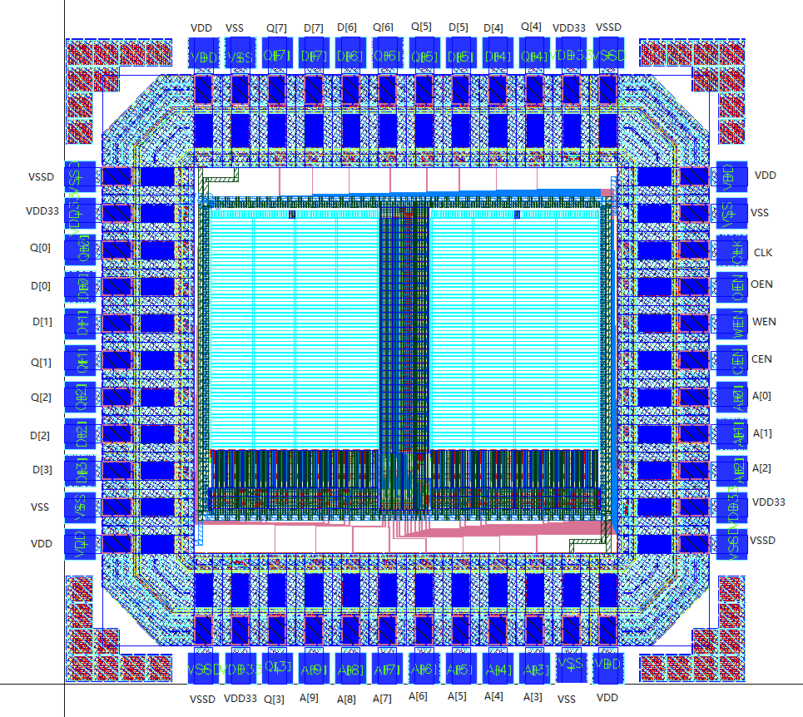

（0,0）

图1 芯片PAD floorplan

芯片的芯片面积为：1487.66um×1407.66um；PAD尺寸为：65um×65um PAD pitch：80um

|  |  |  |  |  |
| --- | --- | --- | --- | --- |
| 封装  序号 | 芯片PAD序号 | PAD  名称 | PAD中心  X坐标 | PAD中心  Y坐标 |
| 1 | 1 | VSSD | 303.795 | 34.5 |
| 2 | 2 | VDD33 | 383.775 | 34.5 |
| 3 | 3 | Q[3] | 463.715 | 34.5 |
| 4 | 4 | A[9] | 543.715 | 34.5 |
| 5 | 5 | A[8] | 623.715 | 34.5 |
| 6 | 6 | A[7] | 703.715 | 34.5 |
| 7 | 7 | A[6] | 783.715 | 34.5 |
| 8 | 8 | A[5] | 863.715 | 34.5 |
| 9 | 9 | A[4] | 943.715 | 34.5 |
| 10 | 10 | A[3] | 1023.715 | 34.5 |
| 11 | 11 | VSS | 1103.945 | 34.525 |
| 12 | 12 | VDD | 1183.715 | 34.5 |
| 13 | NC | NC | NC | NC |
| 14 | 13 | VSSD | 1453.160 | 303.795 |
| 15 | 14 | VDD33 | 1453.160 | 383.775 |
| 16 | 15 | A[2] | 1453.160 | 463.715 |
| 17 | 16 | A[1] | 1453.160 | 547.715 |
| 18 | 17 | A[0] | 1453.160 | 623.715 |
| 19 | 18 | CEN | 1453.160 | 703.715 |
| 20 | 19 | WEN | 1453.160 | 783.715 |
| 21 | 20 | OEN | 1453.160 | 863.715 |
| 22 | 21 | CLK | 1453.160 | 943.715 |
| 23 | 22 | VSS | 1453.135 | 1023.945 |
| 24 | 23 | VDD | 1453.160 | 1103.715 |
| 25 | 24 | VSSD | 1183.865 | 1373.160 |
| 26 | 25 | VDD33 | 1103.885 | 1373.160 |
| 27 | 26 | Q[4] | 1023.945 | 1373.160 |
| 28 | 27 | D[4] | 943.945 | 1373.160 |
| 29 | 28 | D[5] | 863.945 | 1373.160 |
| 30 | 29 | Q[5] | 783.945 | 1373.160 |
| 31 | 30 | Q[6] | 703.945 | 1373.160 |
| 32 | 31 | D[6] | 623.945 | 1373.160 |
| 33 | 32 | D[7] | 543.945 | 1373.160 |
| 34 | 33 | Q[7] | 463.945 | 1373.160 |
| 35 | 34 | VSS | 383.715 | 1373.135 |
| 36 | 35 | VDD | 303.945 | 1373.160 |
| 37 | 36 | VSSD | 34.5 | 1103.865 |
| 38 | 37 | VDD33 | 34.5 | 1023.885 |
| 39 | 38 | Q[0] | 34.5 | 943.945 |
| 40 | 39 | D[0] | 34.5 | 863.945 |
| 41 | 40 | D[1] | 34.5 | 783.945 |
| 42 | 41 | Q[1] | 34.5 | 703.945 |
| 43 | 42 | Q[2] | 34.5 | 623.945 |
| 44 | 43 | D[2] | 34.5 | 543.945 |
| 45 | 44 | D[3] | 34.5 | 463.945 |
| 46 | 45 | VSS | 34.525 | 383.715 |
| 47 | 46 | VDD | 34.5 | 303.945 |
| 48 | NC | NC | NC | NC |

注明：这里的XY坐标是相对于图1芯片的左下角坐标为（0,0）而言。

芯片的外围在流片时添加了dummy，加dummy的芯片面积为芯片面积2.2mmx2.2mm，因此芯片的左下角坐标相对于加dummy后左下角有个偏差，偏差距离为X方向为356.17，Y方向为396.17，如下图：

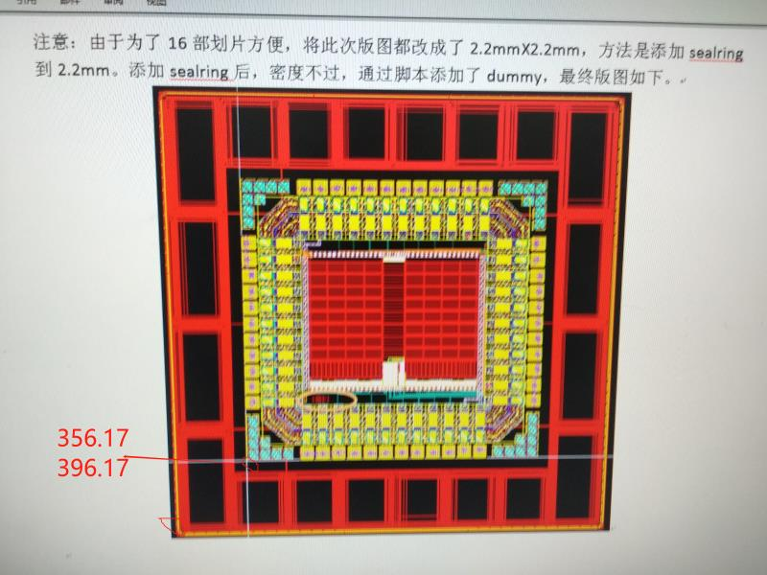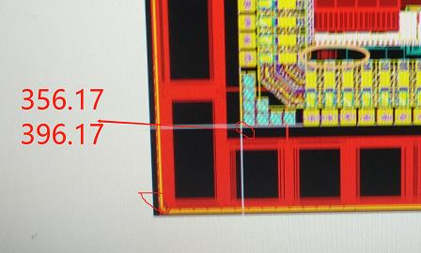

版标如下图，为T18004.

