数据集:

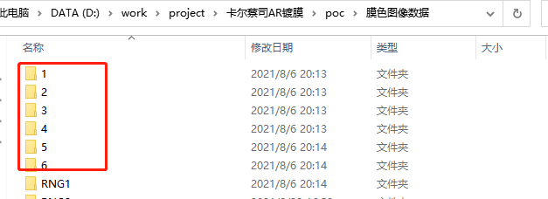

6个文件夹, 全绿膜数据

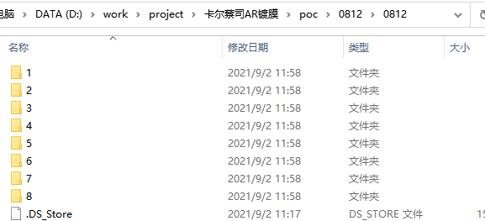

8个文件夹, 1为绿膜数据, 2~7为蓝膜数据. 其中, 文件夹3中包含蓝绿模糊数据:

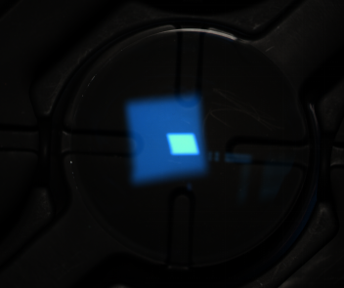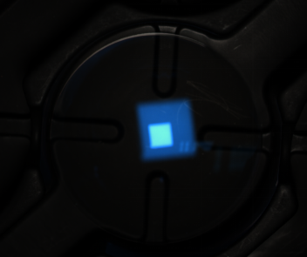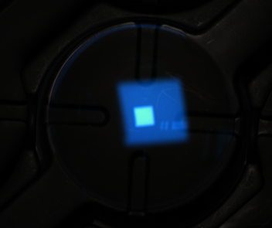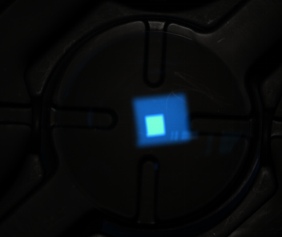

希望多采集此类数据, 目前只有5张, 且需要蔡司给一个XYZ值可接受误差范围.

因为光源不同, 则Xn, Yn, Zn不同, 导致通过XYZ值计算得到的LAB值误差不同..

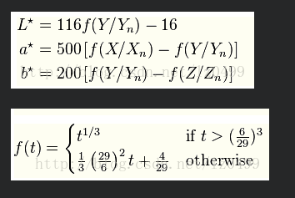

Xn Yn Zn不同, 可能导致f(t)函数会选择的分段区间不同, lab计算结果则发生改变.

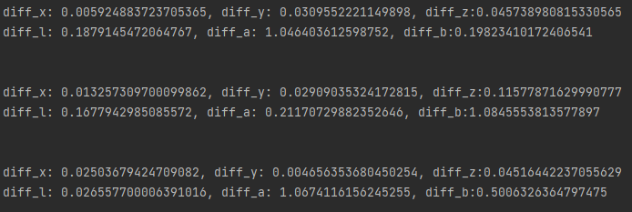

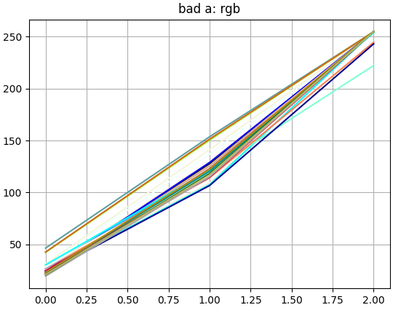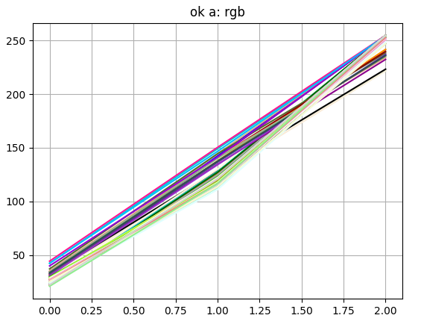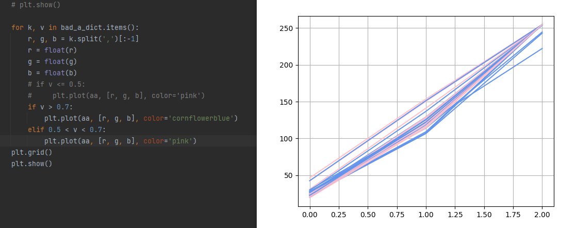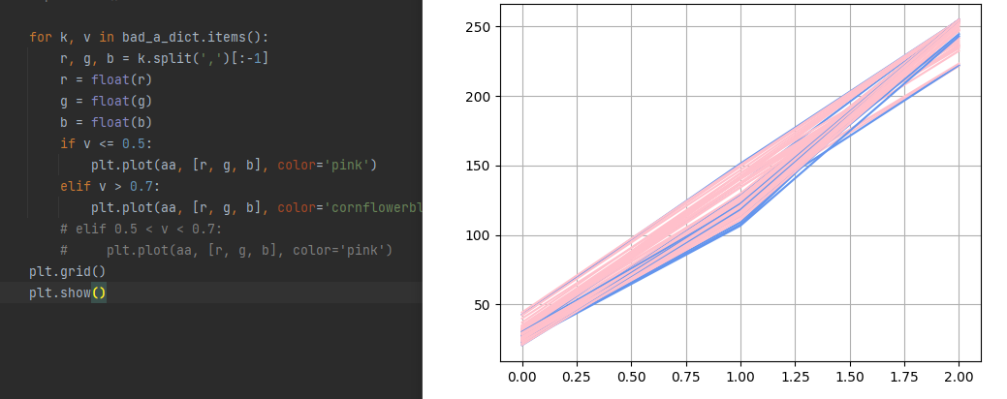

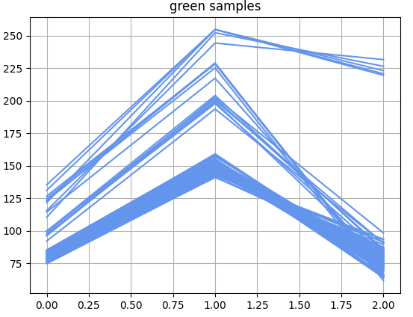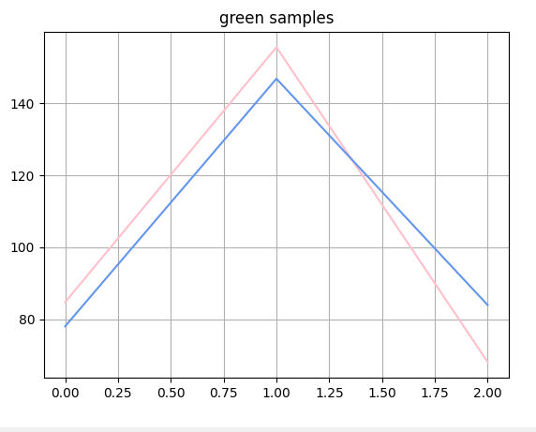

蓝膜数据, 矫正B值.

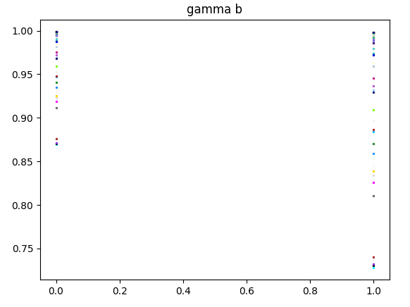

蓝膜数据, rgb均做gamma矫正:

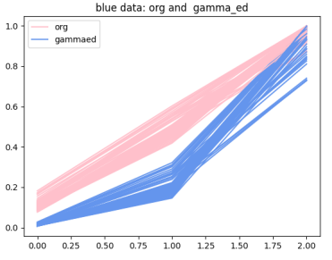

L, a, b 三个值的模型拟合情况:

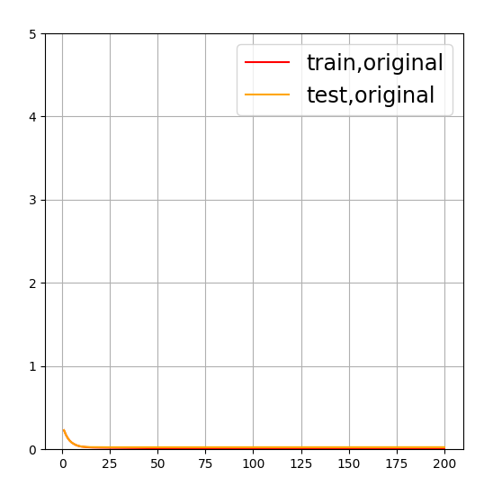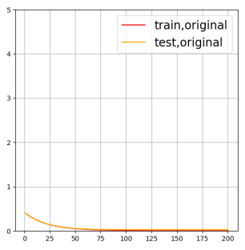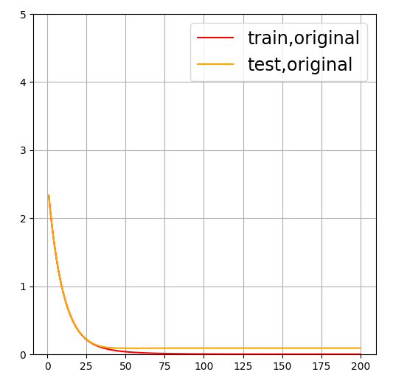

企业微信截图_16306644241136

目前的实验情况:

绿膜数据, 直接rgb2lab 120/133

蓝膜数据, rgb2xyz2lab, 且rgb值均做gamma矫正. 89/96

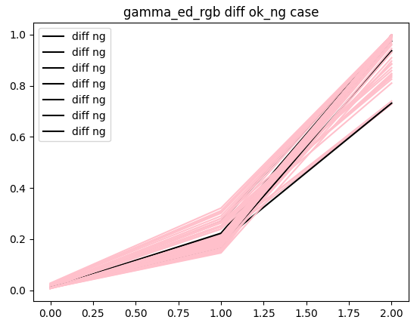

dir\_name: 22\_7

rgb: ['27.79476502082094', '120.23914336704343', '222.22129684711481']

real lab: [8.26, -6.73, -16.27], pred lab: [8.11767469939344, -5.739489135199449, -16.509841200477954]

diff\_l: 0.14232530060655968, diff\_a: 0.9905108648005516, diff\_b:0.23984120047795443

dir\_name: 23\_7

rgb: ['31.06305770374777', '141.1885782272457', '254.73944080904224']

real lab: [9.42, -7.15, -17.61], pred lab: [9.321393389107278, -6.637529649033441, -17.805260916809384]

diff\_l: 0.09860661089272149, diff\_a: 0.5124703509665594, diff\_b:0.19526091680938507

dir\_name: 24\_18

rgb: ['23.87626412849494', '125.71445568114218', '254.78346222486616']

real lab: [7.51, -2.44, -20.84], pred lab: [7.543156184434, -1.933699802842595, -20.85840371746437]

diff\_l: 0.03315618443400048, diff\_a: 0.506300197157405, diff\_b:0.018403717464369862

dir\_name: 24\_19

rgb: ['26.37061273051755', '129.96014277215943', '254.7531231409875']

real lab: [7.94, -3.94, -19.17], pred lab: [7.940438910352, -3.2822651252053388, -19.22029775545032]

diff\_l: 0.00043891035199994377, diff\_a: 0.6577348747946612, diff\_b:0.05029775545031967

dir\_name: 27\_18

rgb: ['24.997025580011897', '114.9619274241523', '254.50505651397978']

real lab: [7.48, 0.57, -20.65], pred lab: [7.4833755972404, 1.082169485786419, -20.617047264214104]

diff\_l: 0.003375597240399486, diff\_a: 0.5121694857864191, diff\_b:0.032952735785894305

dir\_name: 27\_5

rgb: ['26.30755502676978', '114.55562165377751', '252.06543723973826']

real lab: [7.59, 0.7, -19.94], pred lab: [7.58141782697, 0.18209567605620425, -19.916588751476038]

diff\_l: 0.008582173029999751, diff\_a: 0.5179043239437957, diff\_b:0.02341124852396348

dir\_name: 28\_16

rgb: ['26.287923854848305', '117.13920285544319', '247.80368828078525']

real lab: [7.48, -1.79, -19.41], pred lab: [7.493093212576401, -1.2656740041268877, -19.396941176156435]

diff\_l: 0.013093212576400504, diff\_a: 0.5243259958731123, diff\_b:0.013058823843564937

L A B all diff in 0.5: 89, all data size: 96

基本还是a值, 差一点点..

<https://blog.csdn.net/lz0499/article/details/77345166>

绿膜数据 gamma 矫正实验:

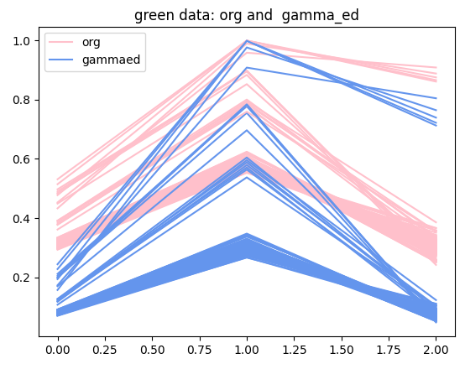

Lab三个值上的拟合情况:

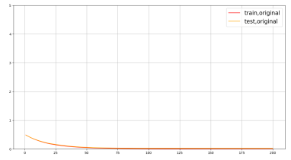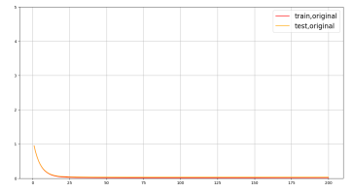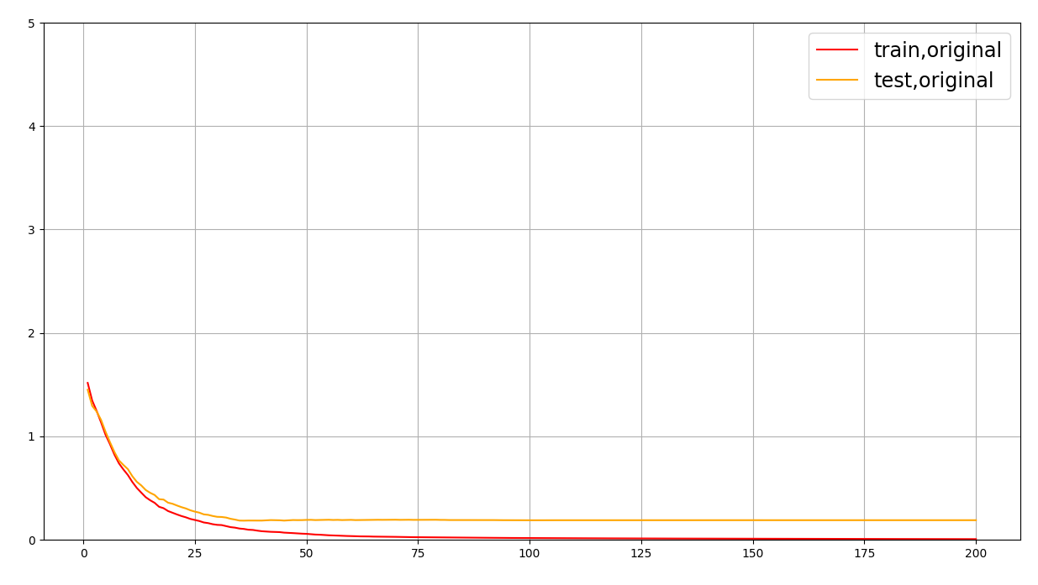

data: 6\_8, diff l: 0.15551168520834047, diff a: 0.7497804644630435, diff b: 0.03650049493650309

data: 23\_5, diff l: 0.0338879512097634, diff a: 0.5938901399174006, diff b: 0.06858605115302652

蓝绿膜数据均开启gamma矫正, 均rgb2xyz2lab

131/133 89/96

蓝绿膜数据均开启gamma矫正, 均rgb2lab **有点容易过拟合**..