基于 ArcGIS 制作排放清单
Make Emission Inventory Based on ArcGIS
目录
一 、空间分配依据文件 1
二、 MEIC 网格和 CMAQ 网格相交 5
三、 MEIC 总量核算 7
四、 空间分配 11
五、 运行 ISAT.M 19
六、注意事项 21

思路：1.生成准备文件 2.将 MEIC 的 0.25°*0.25°的网格和CMAQ网格相交(因为两者网格大小不同） 3.计算每个MEIC网格中污染物的量 4.根据空间分配依据计算每个CMAQ网格内的污染物的量 5. 运行 ISAT.M生成可输入模型的nc文件
Train of thought: 1.Generate a preparation file.2. Intersect the 0.25° x 0.25° MEIC grid with the CMAQ grid (because the grid sizes are different). 3. Calculate the amount of pollutants in each MEIC grid 4. Calculate the amount of pollutants in each CMAQ grid according to space allocation 5. Run ISAT.M to generate a nc file that can input the model

一 、空间分配依据文件
ⅠBasis for space allocation of emission inventory

农业源排放清单依据 “农田”数据
工业源排放清单依据 “工矿”数据
电力源排放清单依据 “城镇”数据
交通源排放清单依据 “路网”数据
居民源排放清单依据 “人口”数据
The agriculture source emission inventory is based on "field" data
The industry source emission inventory is based on "industrial and mine" data
The power source emission inventory is based on "town" data
The transport source emission inventory is based on "road network" data
The resident source emission inventory is based on "population" data

1. 数据来源: 中科院 2020 年 1km 土地利用栅格数据（需要注册账号，会员可下载2023年数据 https://www.resdc.cn/Datalist1.aspx?FieldTyepID=1,3） 2019年和2021年人口数据也可从此下载
1. Data source: Raster data of land utilization of the Chinese Academy of Sciences in 2020 1 km (need to register account, members can download data in 2023, https://www.resdc.cn/Datalist1.aspx?FieldTyepID=1,3) , population data in 2019 and 2021 can also be downloaded
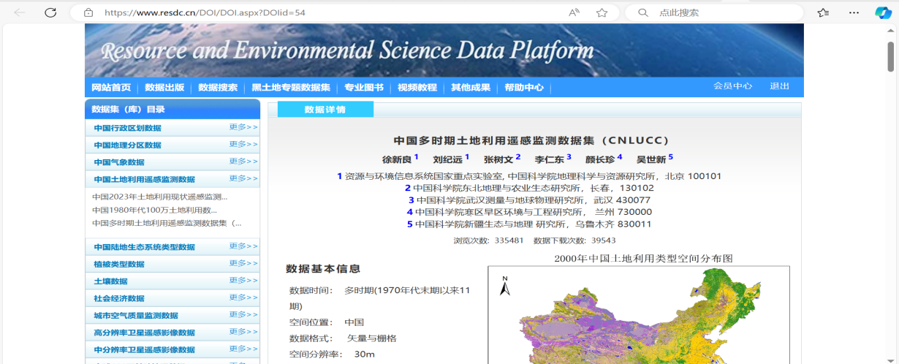

- 将土地利用栅格数据转面（转换工具-由栅格转出-栅格转面），得到 shp 文件。
2. Turn the land use grid data to get the shp file.
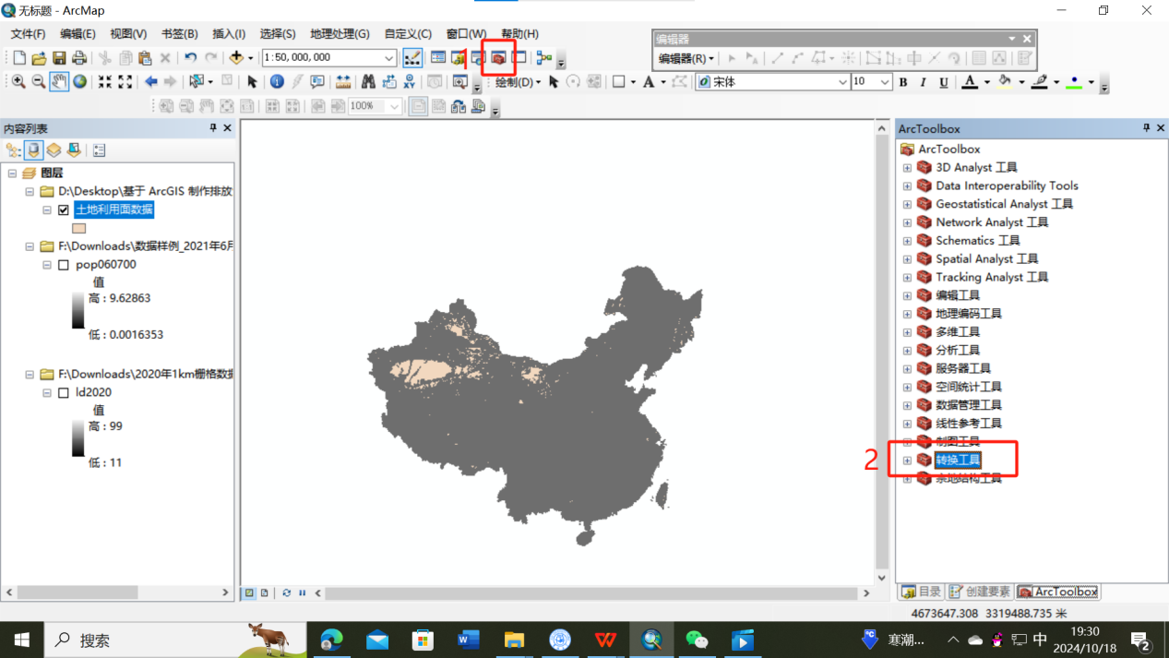
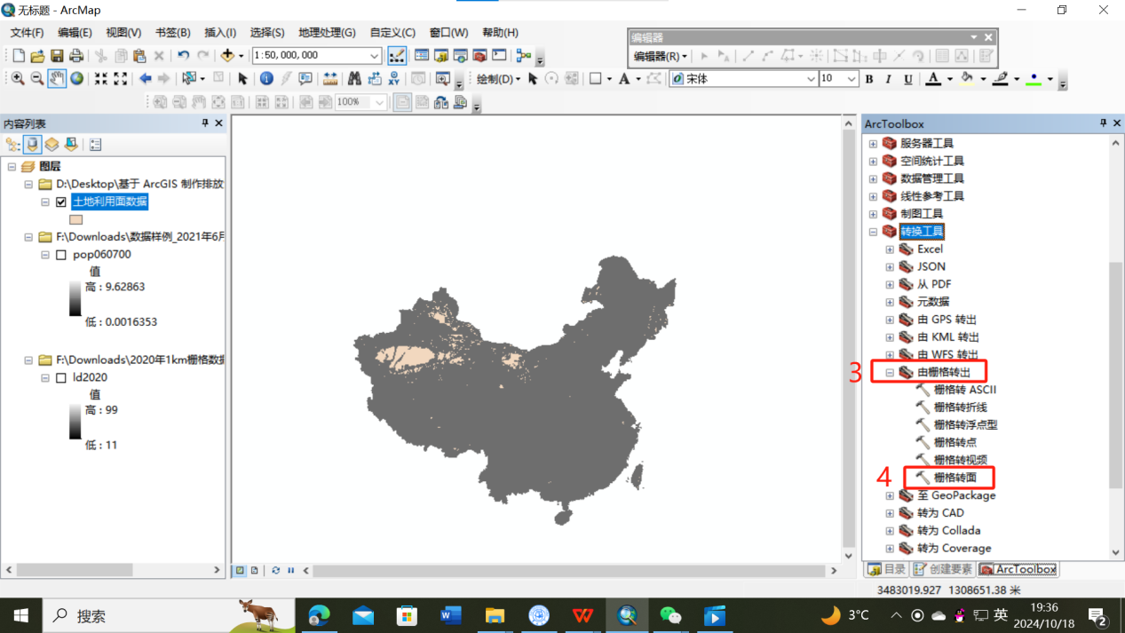
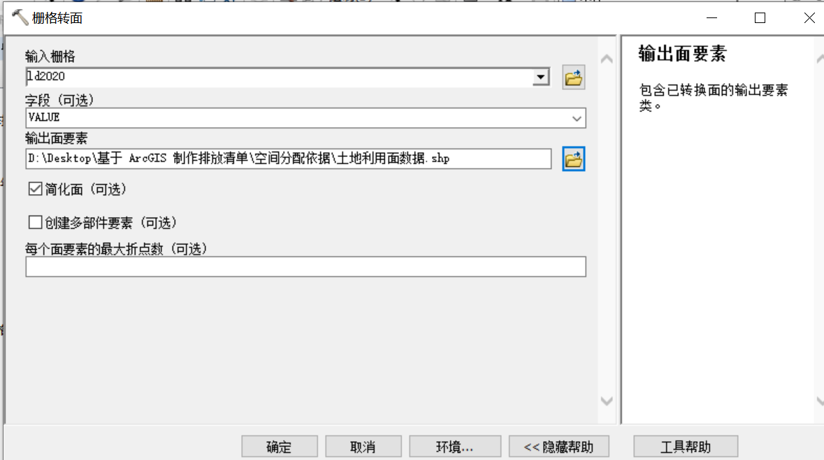
- 农业源：打开属性表，按属性选择，将农田（土地利用类型 11 和 12）选择出来，导出数据，生成“农田.shp”。
3. Agriculture source: Open the attribute table, select the field (land use types 11 and 12), export the data, and generate "field.shp".
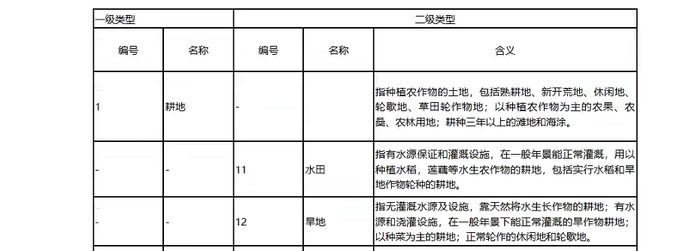

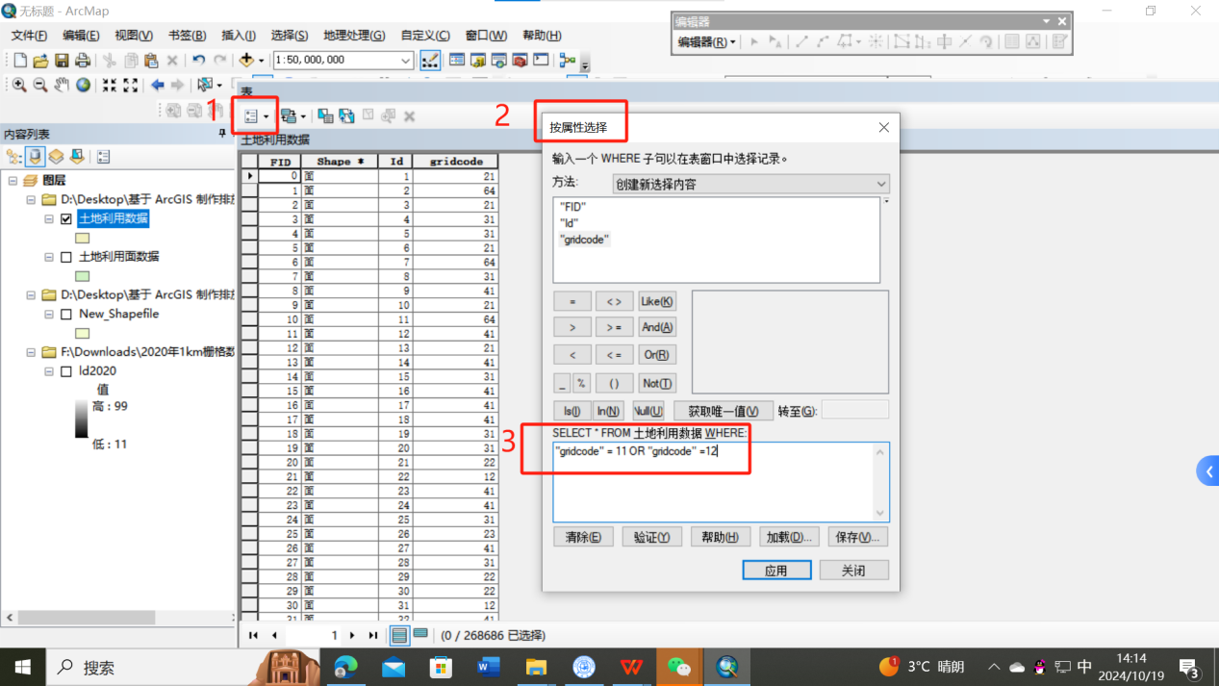

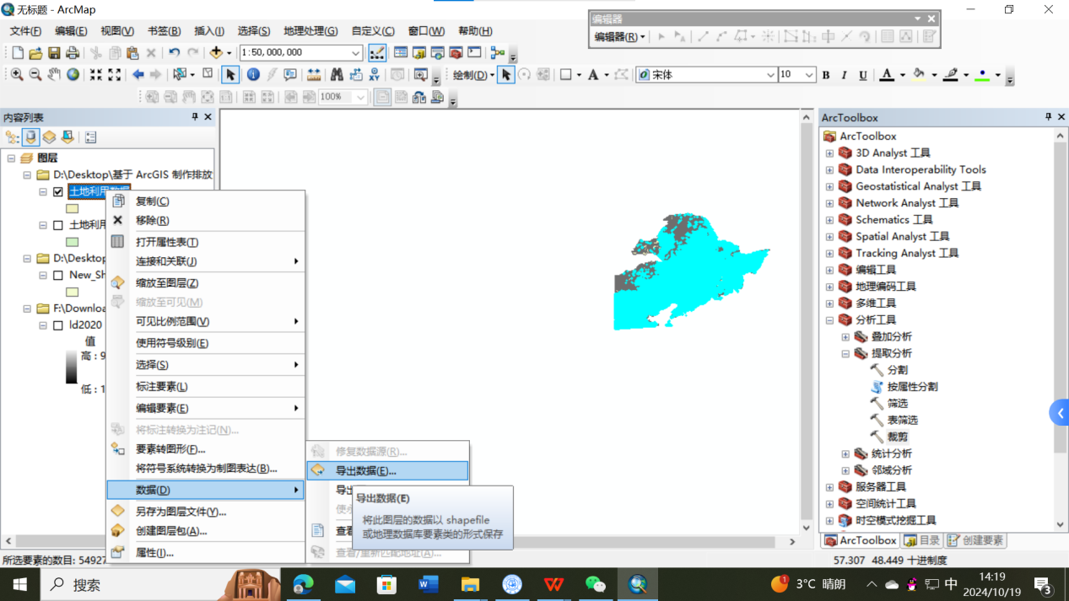

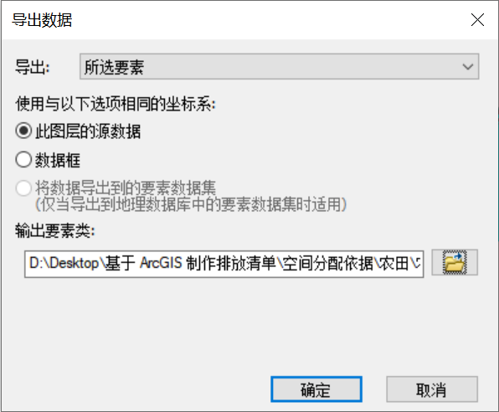
- 工业源：打开属性表，按属性选择，将工矿（土地利用类型 53）选择出来，导出数据，生成“工矿.shp”。
4. Industry source: Open the property table, select the industrial and mineral (land use type 53), export the data, and generate "industrial and mineral.shp".
5. 电力源：打开属性表，按属性选择，将城镇（土地利用类型 51）选择出来，导出数据，生成“城镇.shp”。
5. Power source: Open the property table, select the town (land use type 51), export the data, and generate "town.shp".
- 交通源：路网文件“gis_osm_roads_free_1.shp”。
6. Transport source: road network file "gis_osm_roads_free_1.shp".
- 居民源：将人口栅格数据进行栅格转点，得到“POP2021.shp”。
7. Resident source: The population grid data is converted to the grid point to obtain "POP2021.shp".

- MEIC 网格和 CMAQ 网格相交
Ⅱ MEIC mesh and CMAQ mesh intersect
- 打开 ISAT2019，利用“NC转网格“功能，制作 MEIC网格 shp 文件。
1. Open ISAT2019 and use the "NC to grid" function to make the MEIC grid shp file.
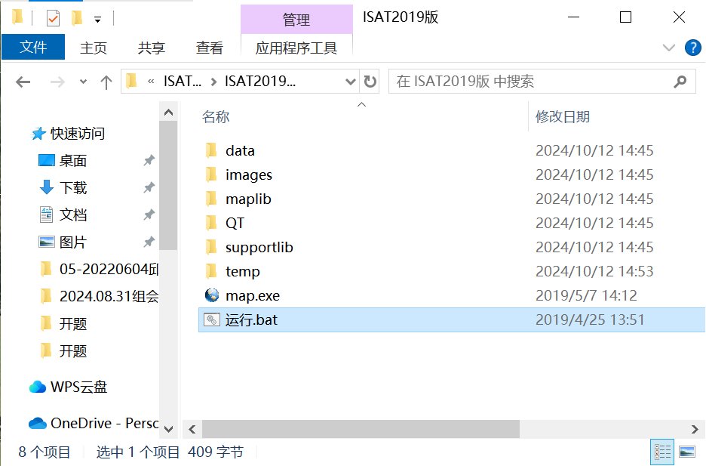

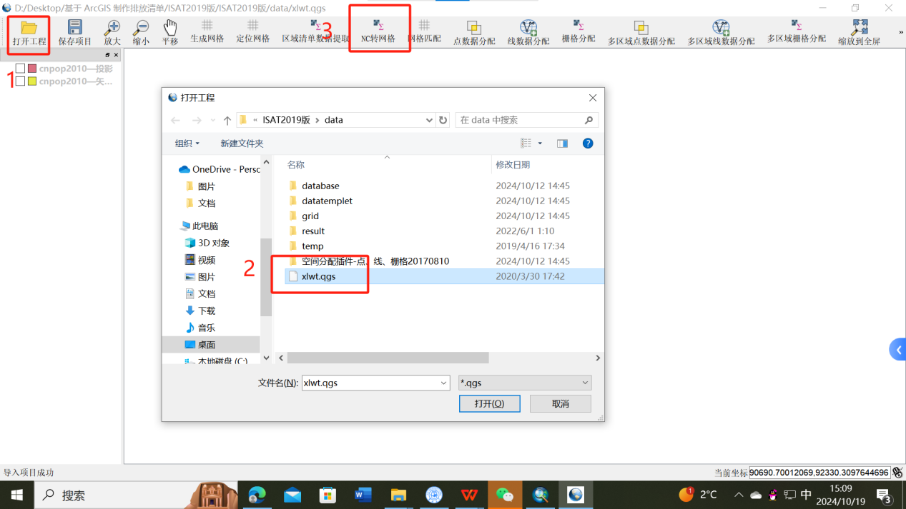
“NC 转网格”的输入数据为 MEIC 数据任一 nc 文件，选择何种行业、何种污染物对结果没有影响。
The input data of "NC to grid" is any nc file of MEIC data, and the selected industry and pollutant have no influence on the result.
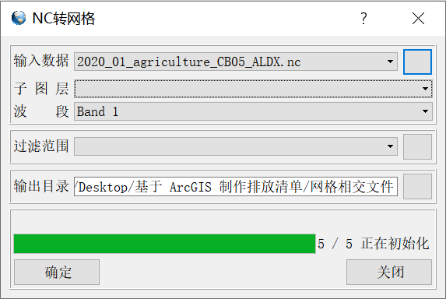
生成文件名为““xxxxxx——矢量化.shp，即 MEIC 网格的 shp 文件。
The generated file name is "xxxxxx" - vectorized.shp, that is, the shp file of the MEIC grid.
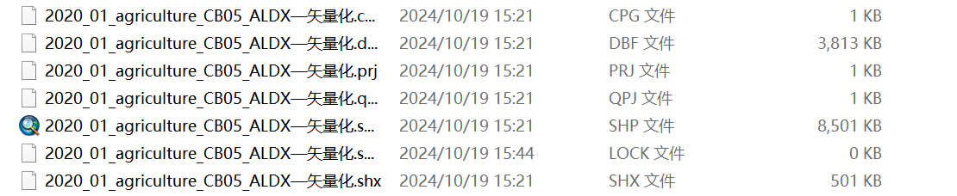
- 重新打开 ArcGIS，依次加载 CMAQ网格和 MEIC 矢量化网格。（涉及到投影坐标系转换，建议按此方法载入文件）
2. Open ArcGIS again and load the CMAQ grid and MEIC vectorized grid in sequence. (When it comes to projection coordinate system conversion, it is recommended to load the file in this way)
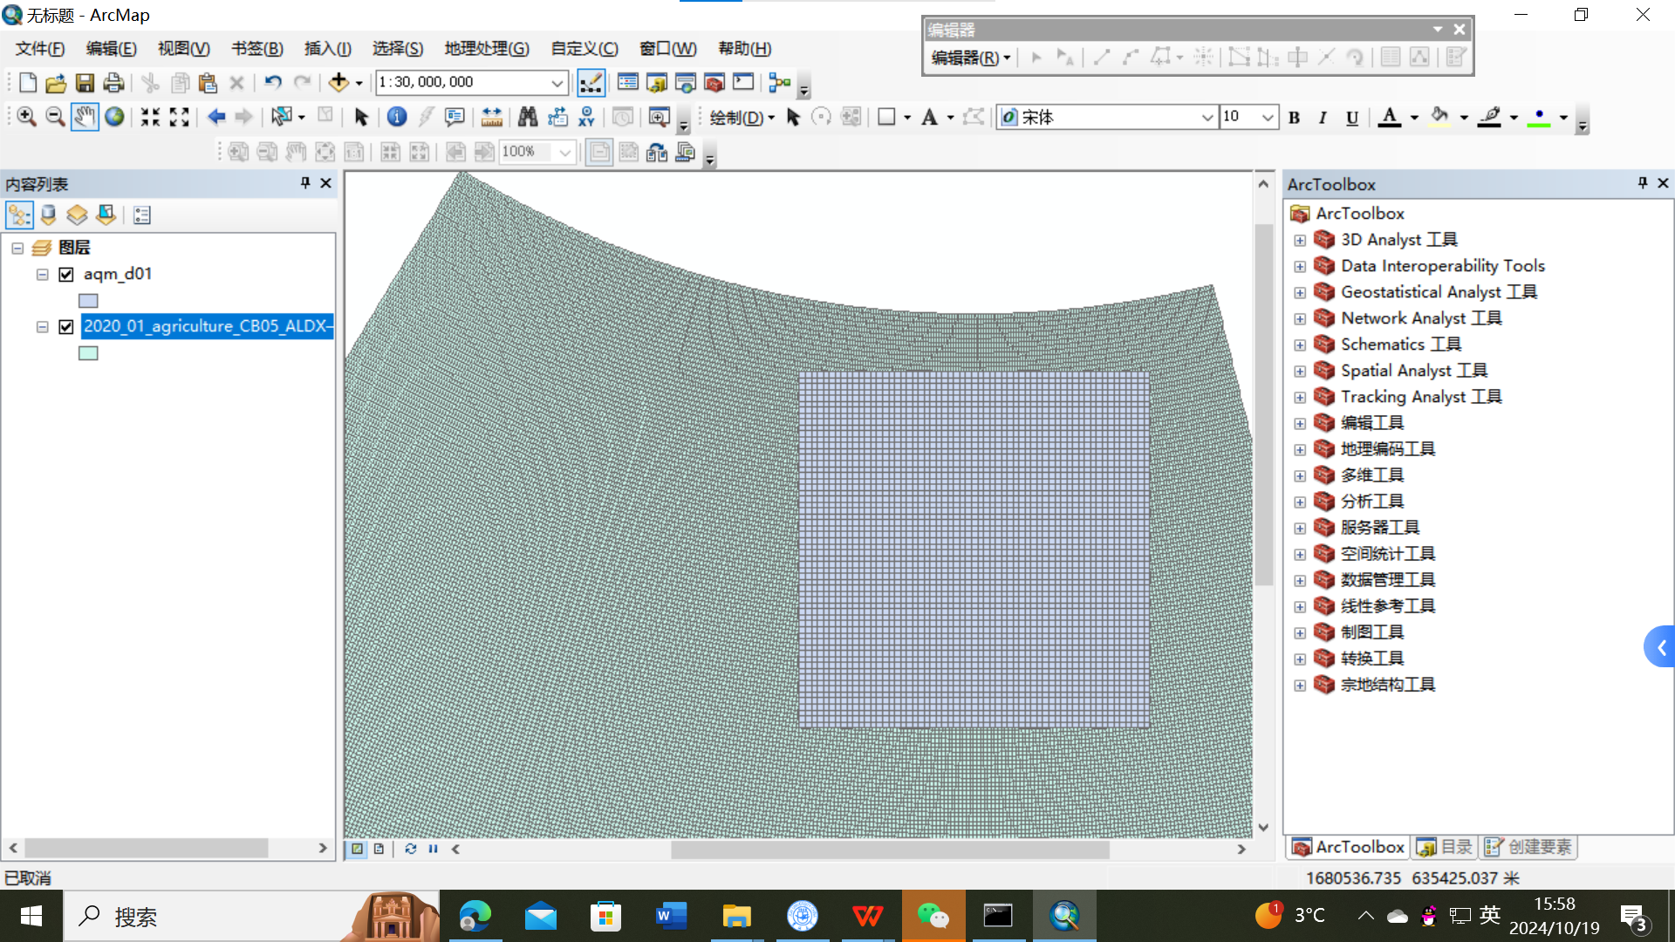

- 计算每个MEIC网格面积

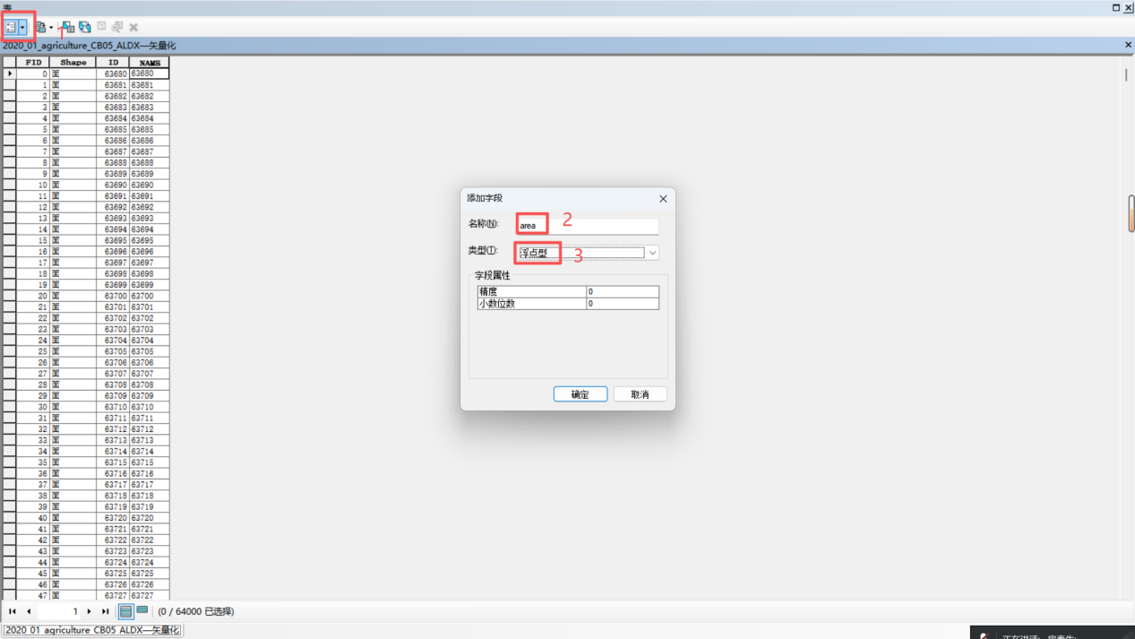

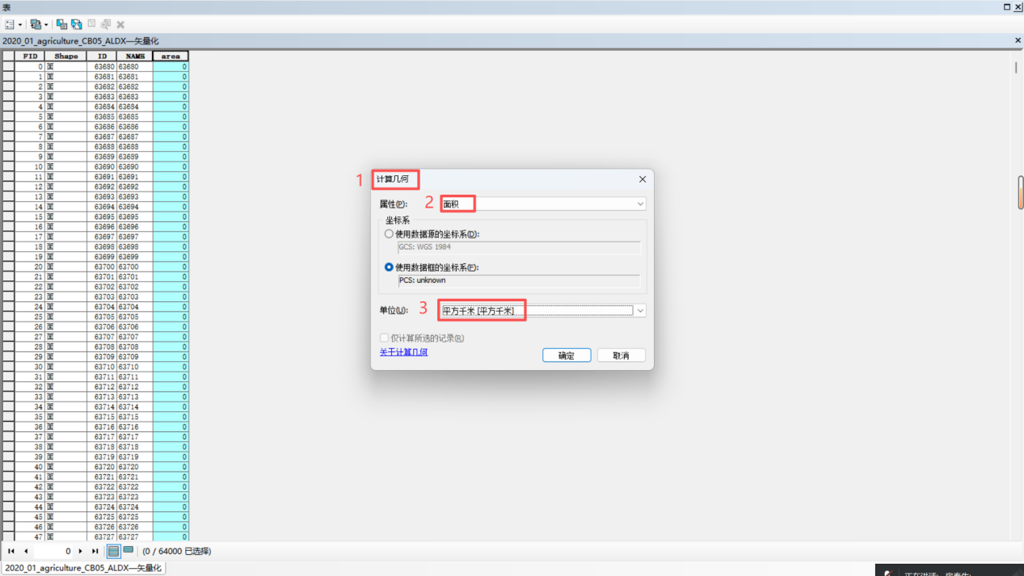

- 地理处理-相交，得到“xiangj_d01.shp”。
4. Geographical treatment - intersection, get "xiangj_d01.shp".
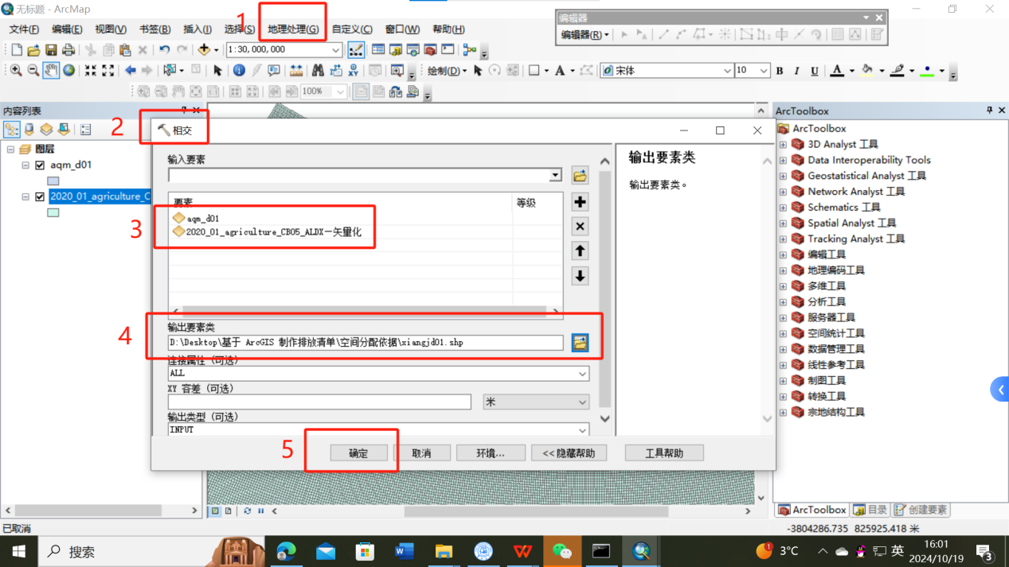
红色网格为 MEIC 的 0.25°网格，蓝色网格为 CMAQ网格。黄色网格为两个网格相交后
的小碎格，xiangj_d01.shp 的属性表里每一行都是一个小碎格。
The red grid is the 0.25° grid of MEIC, and the blue grid is the CMAQ grid. The yellow grid is after the two grids intersect. Each row in the xiangj_d01.shp property table is a small grid.
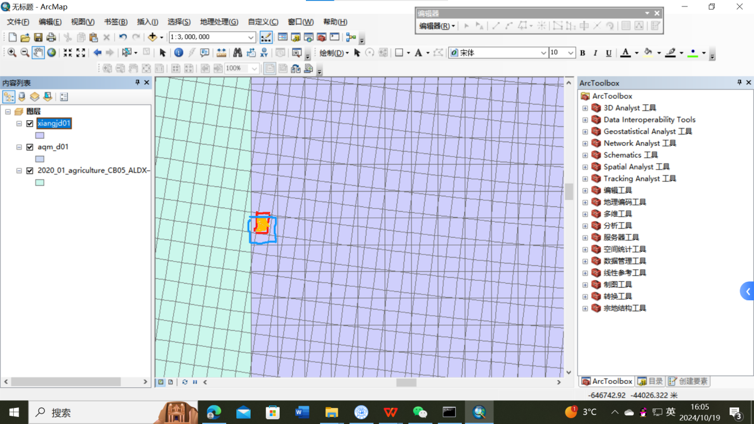

- MEIC 总量核算
Ⅲ Total MEIC accounting
思路：判断每一个 MEIC 网格是否全部落在模拟区域内，比如边界上的 MEIC 网格则不是完整的，此时需要根据面积大小计算边界上的 MEIC 小网格的污染物总量。
Idea: To determine whether all of each MEIC grid falls in the simulation area, for example, the MEIC grid on the boundary is not complete, then the total amount of pollutants in the MEIC grid on the boundary needs to be calculated according to the area size.

1.计算相交后的每个小网格的面积
1. Calculate the area of each small grid after intersecting
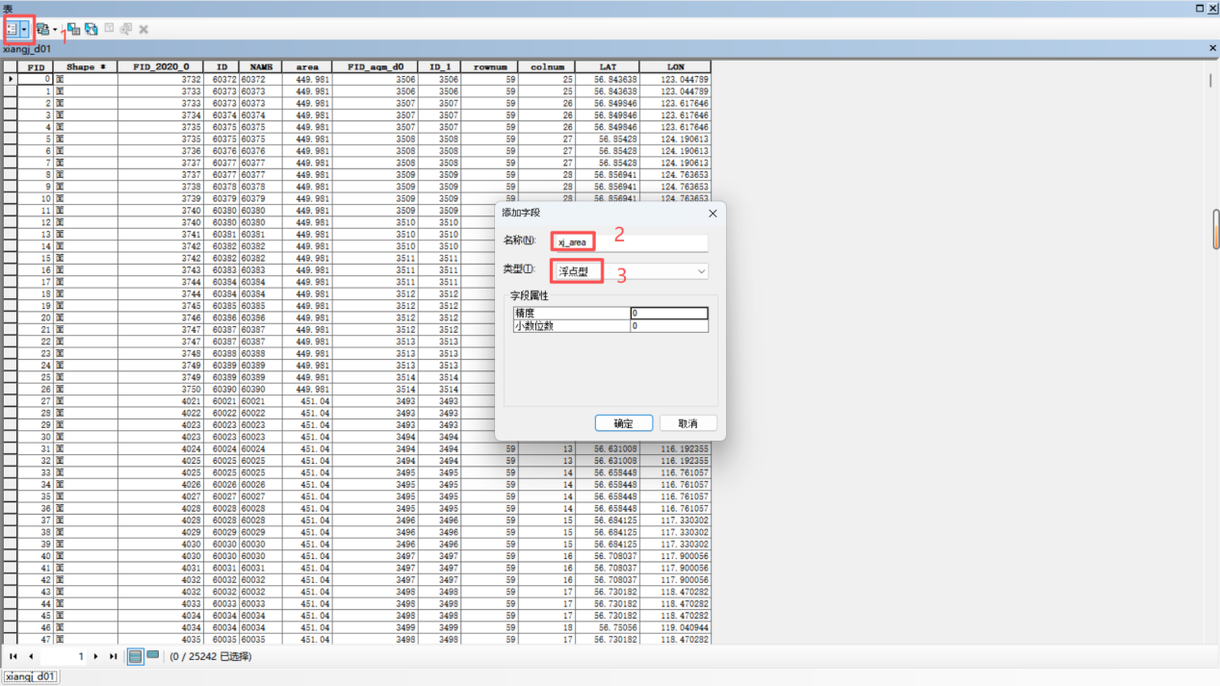

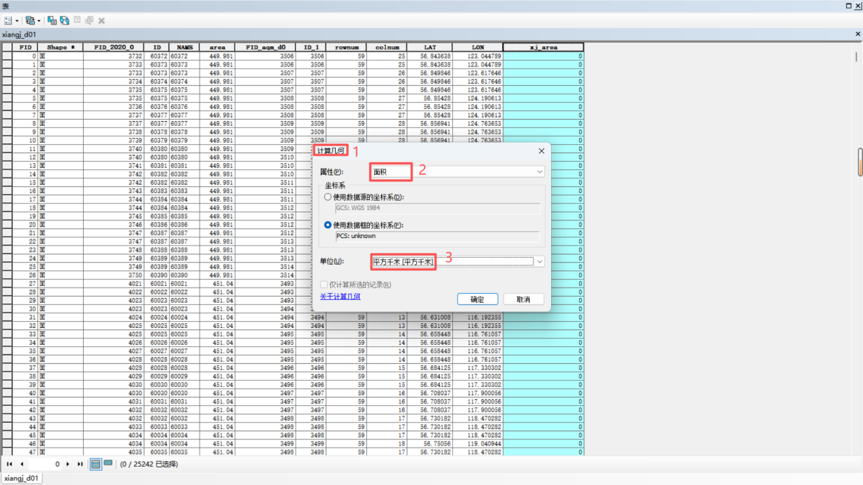

2.计算每个小网格的面积占其归属的完整的MEIC网格面积的比例

2. Calculate the proportion of the area of each small mesh to the area of the complete MEIC mesh to which it belongs

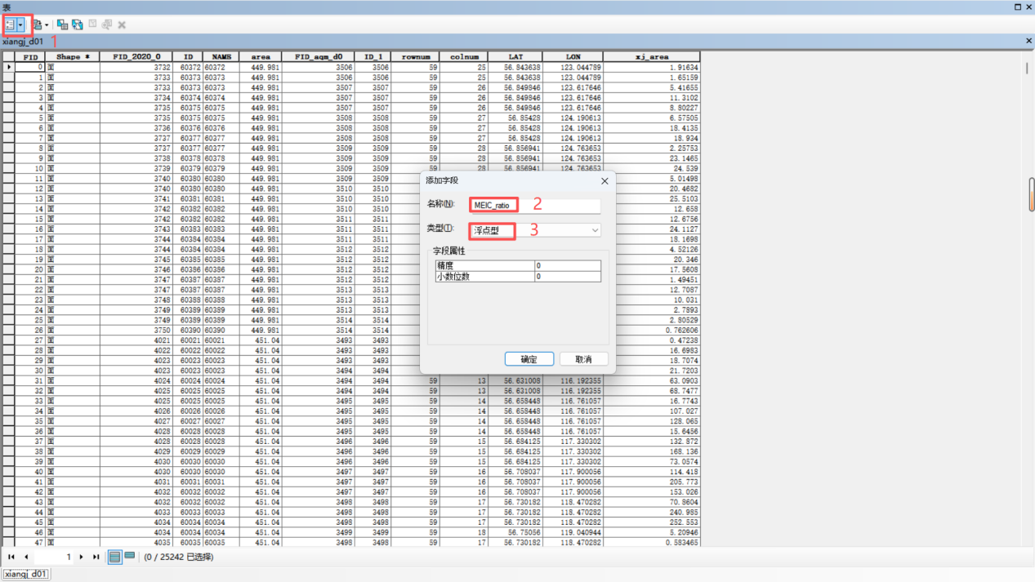

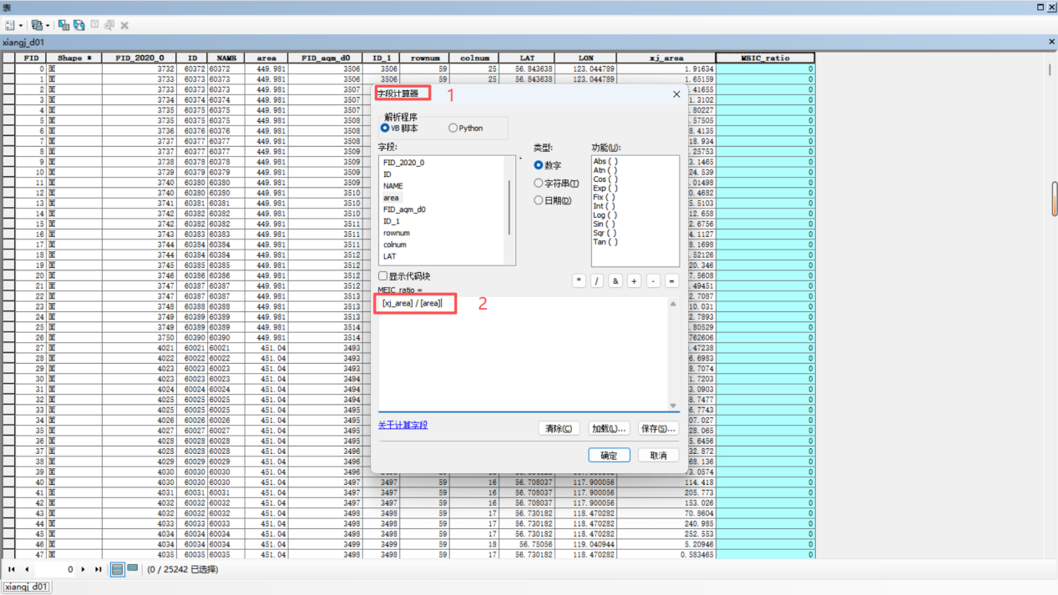

3.将归属同一个MEIC网格的小网格的比例汇总起来，得到每个MEIC网格被相交操作分割后的剩余面积的占比

3. Summarize the proportion of small meshes belonging to the same MEIC mesh to obtain the proportion of the remaining area of each MEIC mesh after being divided by the intersection operation
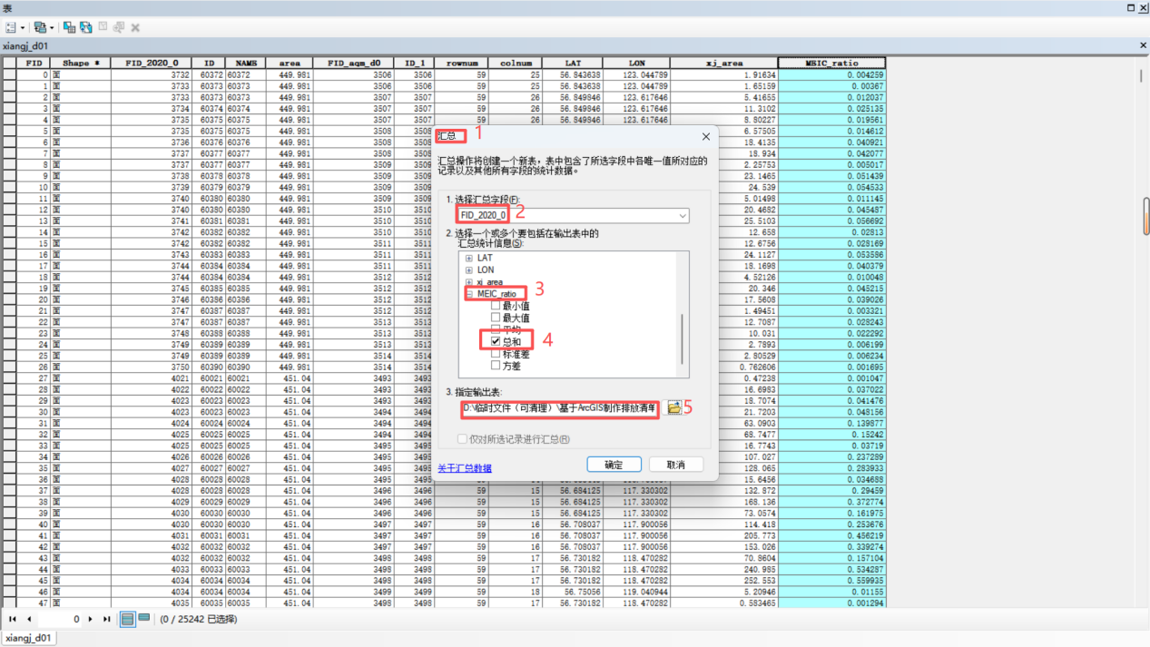

4. 提取 MEIC 网格数据，将“FID_2020_0”列另存为 grid.csv 文件，运行程序
readmeic_department.py。此程序根据 MEIC 网格 ID 提取污染物相应数值。运行时间较长，需要等待 1-2 分钟。
4. Extract MEIC grid data, save the "FID_2020_0" column as grid.csv file, and run the program readmeic_department.py. This program extracts the corresponding pollutant values based on the MEIC grid ID. It takes 1-2 minutes to run.
注意：MEIC 官方数据不同版本对 PM2.5,PM10,PMcoarse 公布种类不同，如原始数据里是PMcoarse，则需要自行计算 PM10 (即PM2.5+PMcoarse)。
Note: Different versions of MEIC official data release different types of PM2.5,PM10 and PMcoarse. If the original data is PMcoarse, you need to calculate PM10 (i.e. PM2.5+PMcoarse).
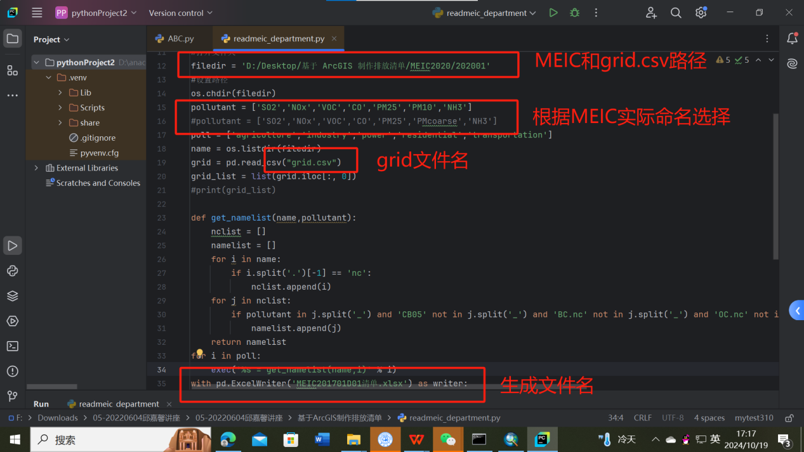
生成文件是按部门统计的总量。
The generated files are the total amount counted by department.
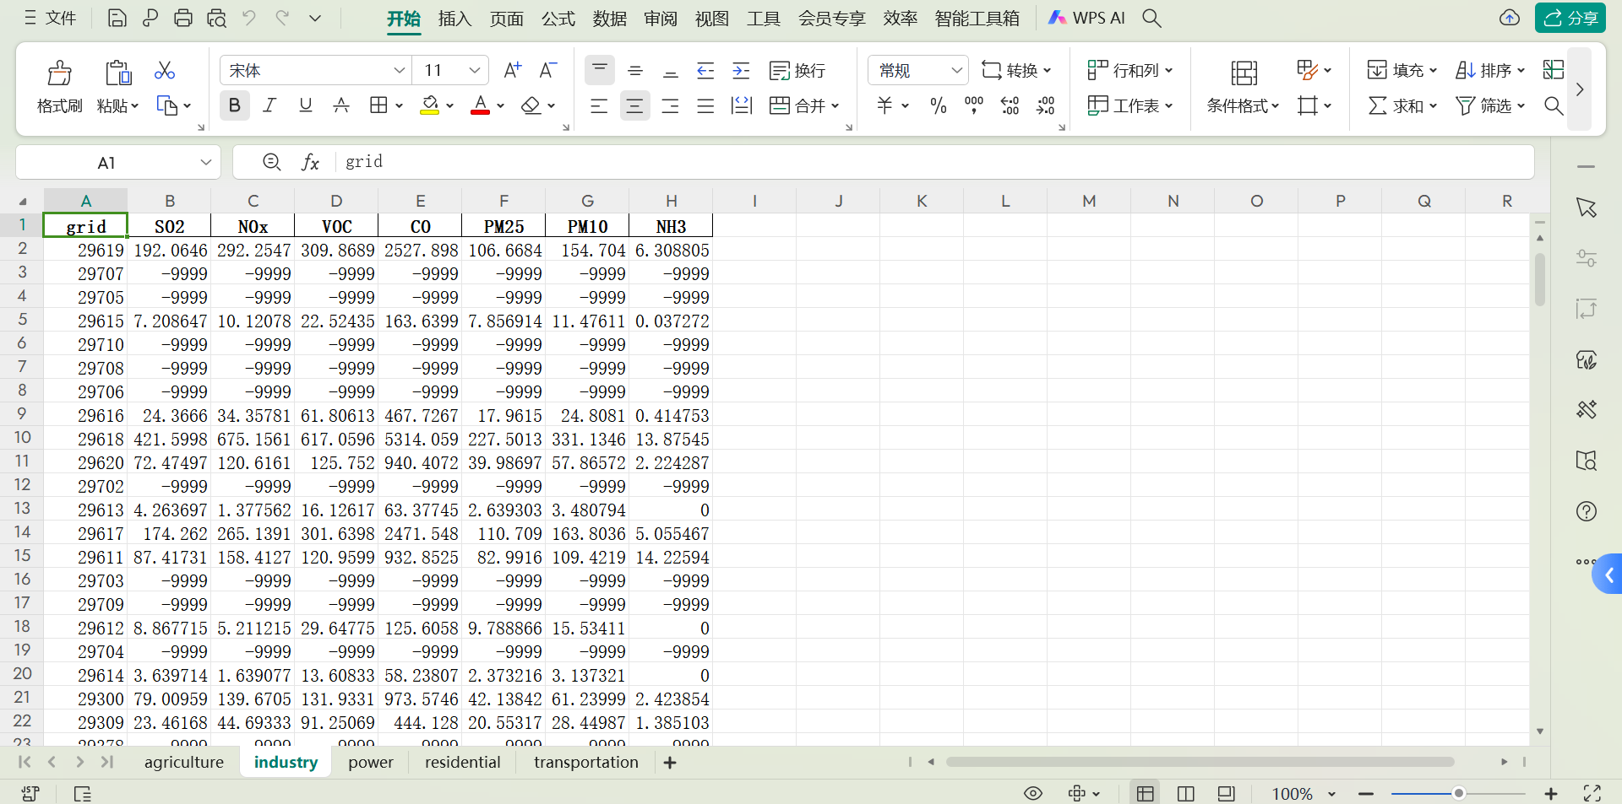
5.根据面积占比，计算出 MEIC 数据实际总量。用 ratio 列乘上一步求出的总量，即为空间分配时所用的实际总量。
5. Calculate the actual total amount of MEIC data according to the area proportion. The ratio column is multiplied by the total amount obtained in the previous step, which is the actual total amount used in space allocation.
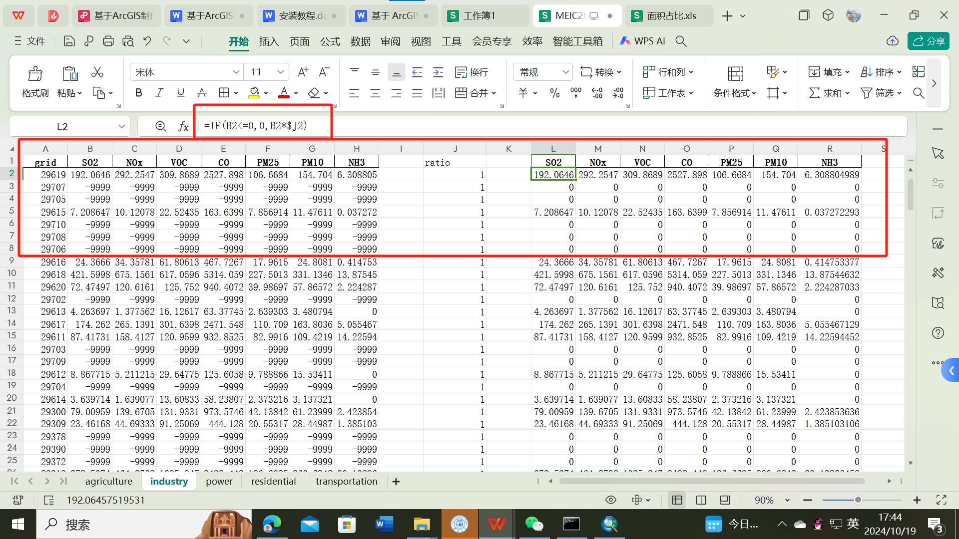

- 空间分配
Ⅳ Space allocation
1. 农业源清单
(1) 将农田.shp 与 “CMAQ 和 MEIC 相交网格”进行相交，相当于把农田分散进每个小碎格里面。对字段 area-计算几何，计算每个小碎格里农田的面积。
1. Agriculture source list
(1) The intersection of the field.shp with the "CMAQ and MEIC intersection grid" is equivalent to scattering the field into each small fragment. For the area- calculate the geometry, and calculate the area of each small field.
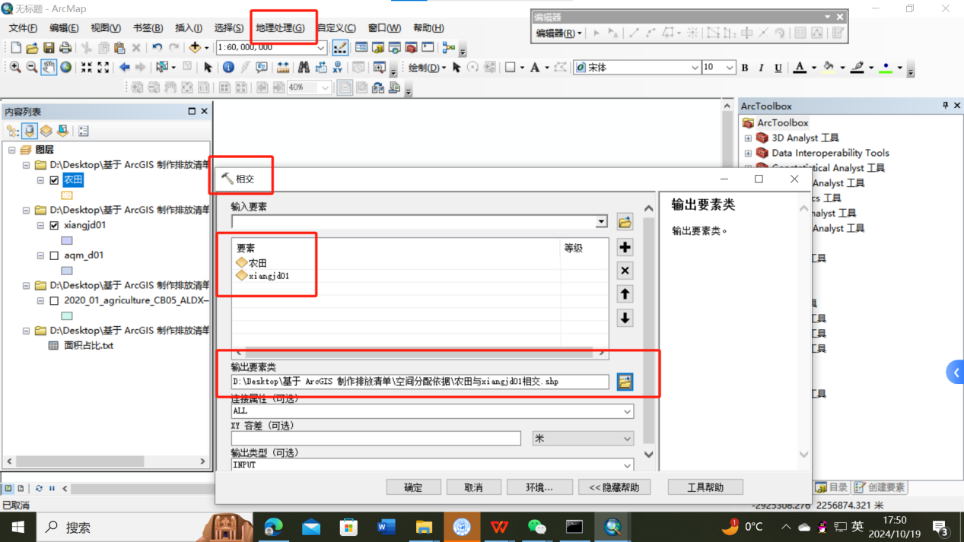

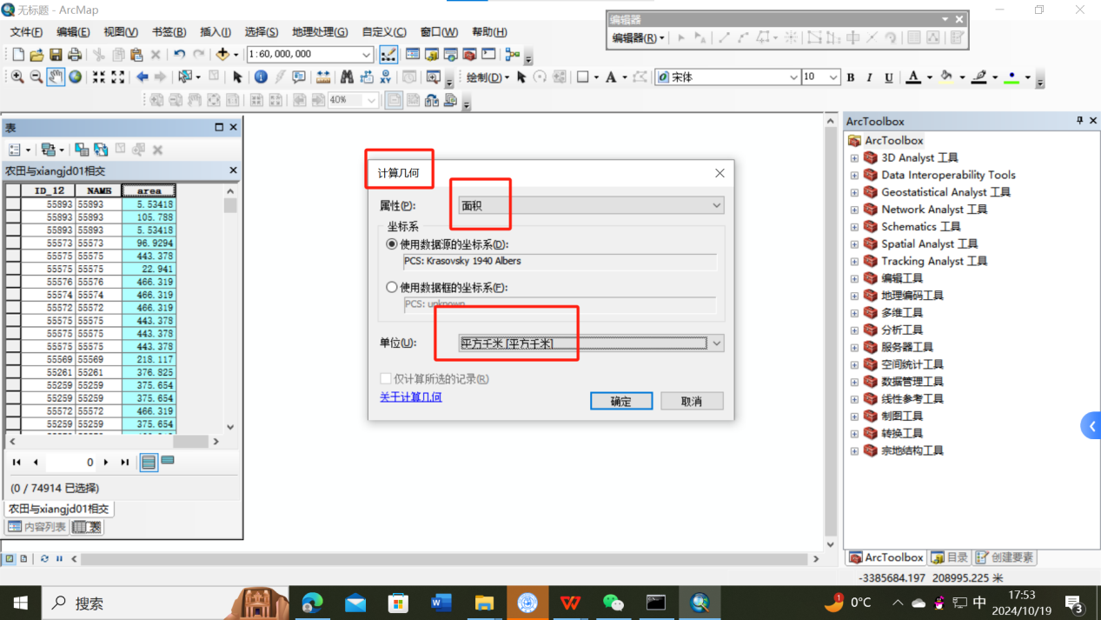
- 按 MEIC 网格 ID（FID_2020_0）汇总农田面积。
(2) Summarize field area according to MEIC grid ID (FID_2020_0).
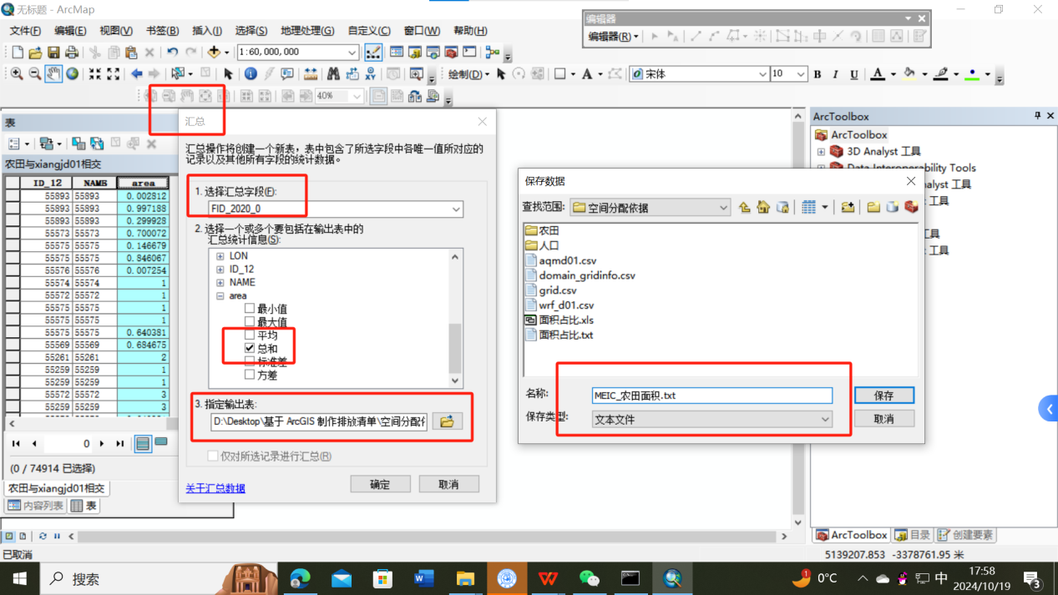
- 将”农田与网格相交”的图层连接上农田面积总和。根据 FID_2020_0 连接。（area是每个小碎格里农田的面积，sum_area是每个MEIC网格里农田的总面积)
(3) Connect the layer of "field intersects with grid" to the sum of field area. Connect according to FID_2020_0. (area is the area of each small field, sum_area is the total area of the field in each MEIC grid)
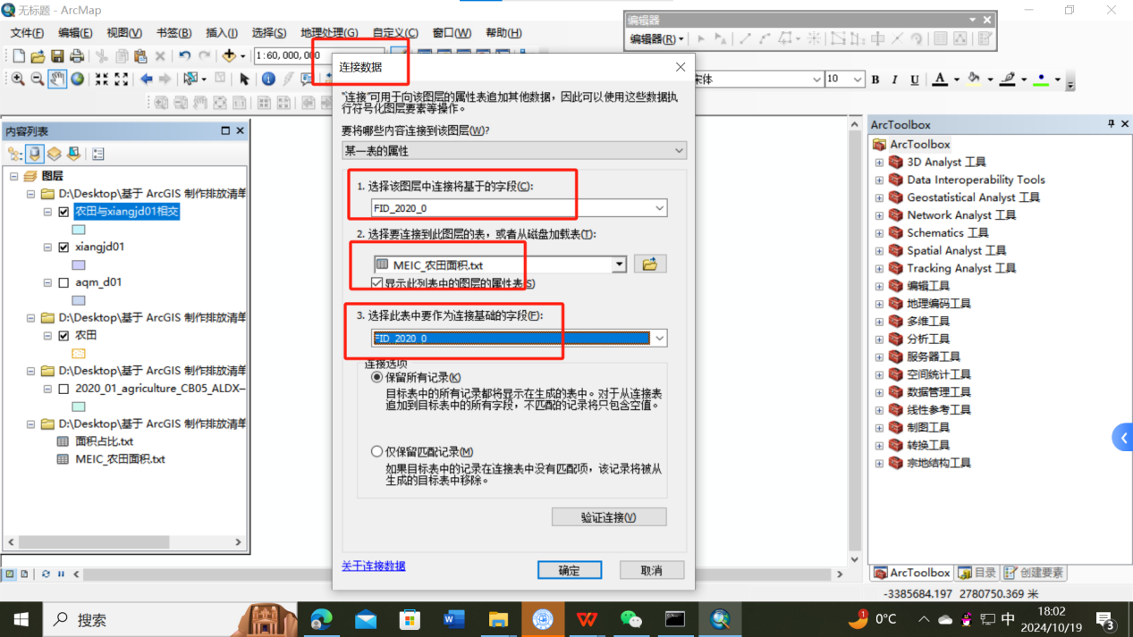

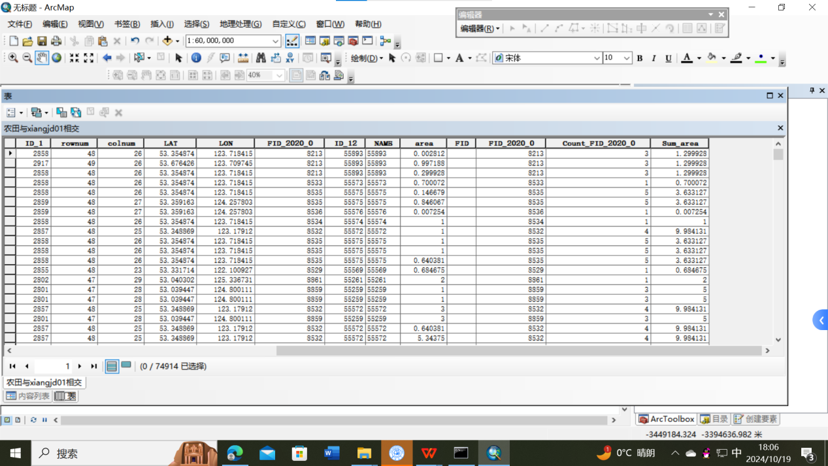
- 在农田和网格相交的属性表中，添加字段 ratio_农，用字段计算器计算比例。得到每个 MEIC 网格中若干的农田面积占比。
(4) Add the ratio_agriculture to the property table where field and grid intersect, and calculate the proportion with the calculator. The proportion of field area in each MEIC grid is obtained.
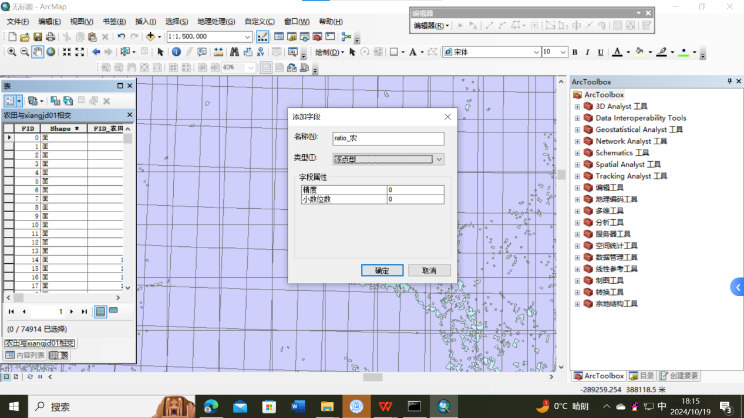

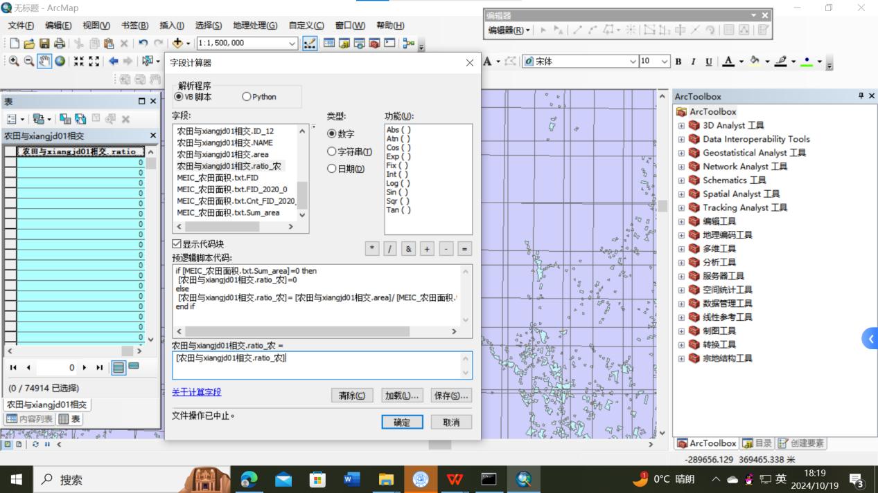
- 将 MEIC 的农业源污染物表格（提前准备好的，必须是.xls 格式）连接到图层中，用FID_2020_0 和 grid 连接。
(5) Connect MEIC's agricultural source pollutant table (prepared in advance, must be in.xls format) to the layer with FID_2020_0 and grid.
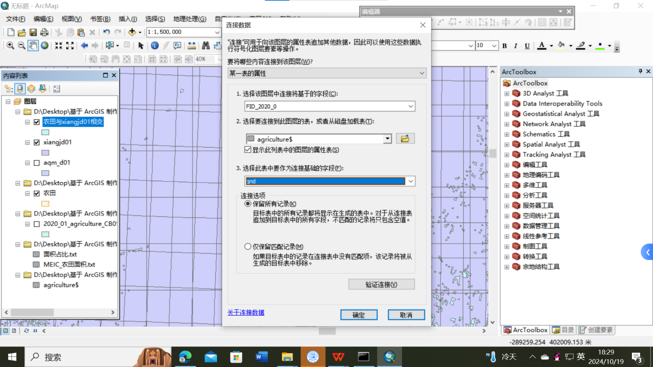

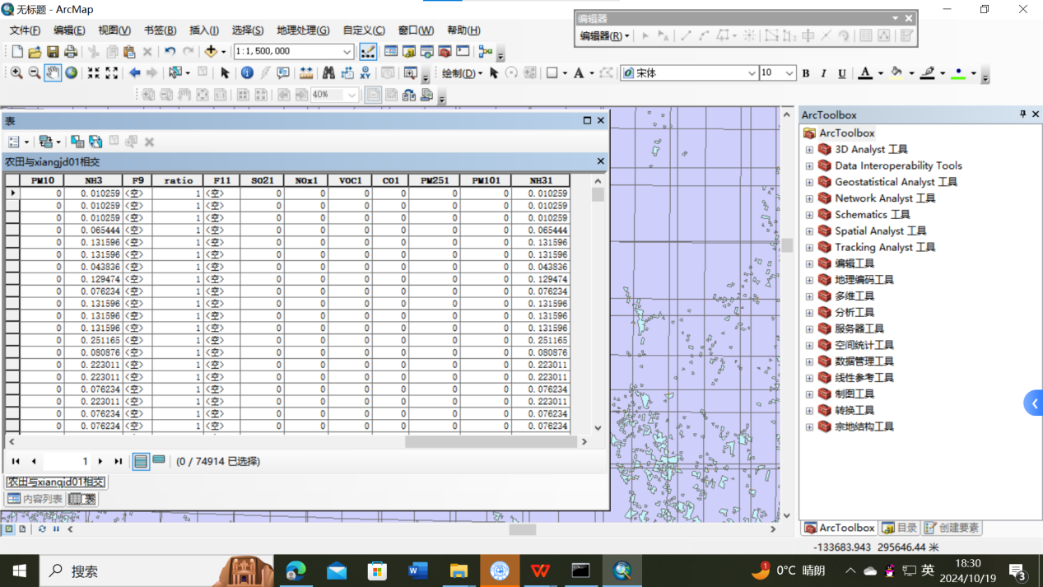
- 新建字段 nh3_农田，将 ratio_农与 nh31 相乘，得到每块农田的 nh3 的排放量。
(6) Create a new field nh3_ field, multiply ratio_ agriculture and nh31, and get the nh3 emission of each field.
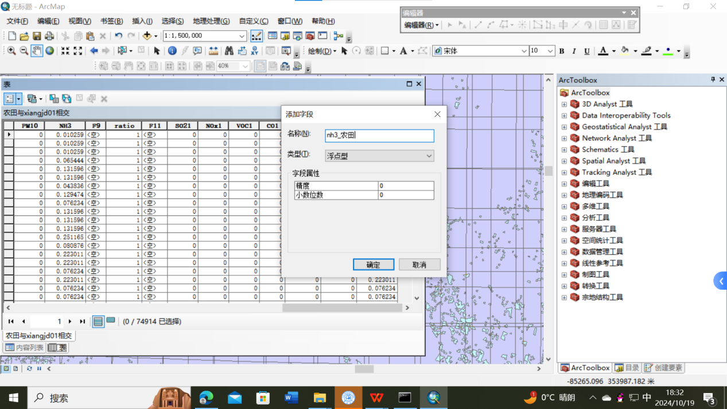

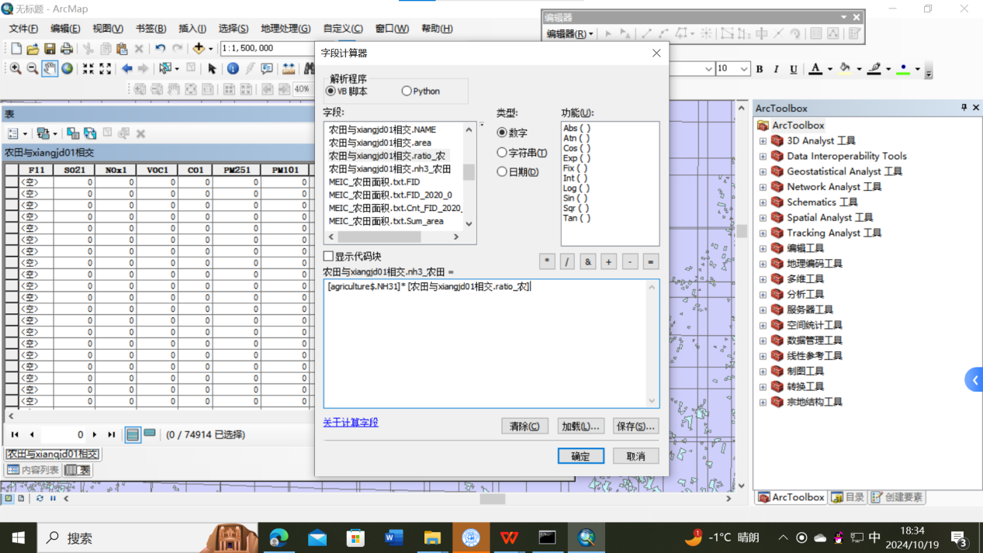
- 根据 CMAQ 网格 FID_aqm_d01 汇总每个 CMAQ 网格的污染物排放量,输出 txt 文件。
(7) Summarize the pollutant emissions of each CMAQ grid according to CMAQ grid FID_aqm_d01 and output txt file.
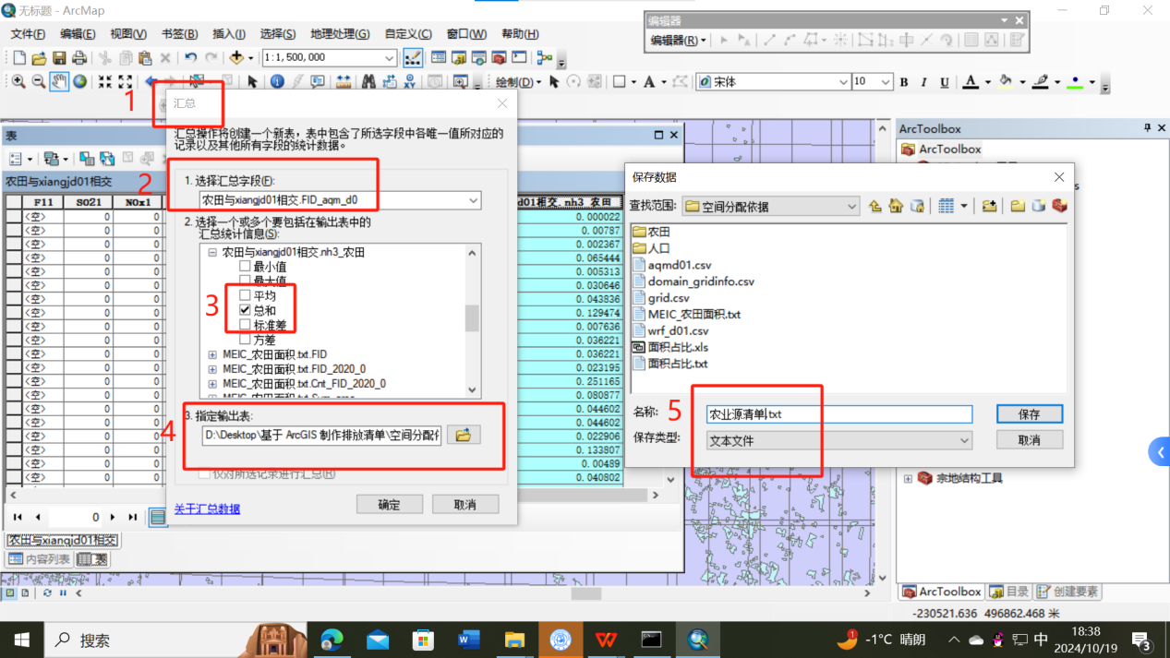
- 将上一步生成的农业源清单.txt 连接到 cmaq 网格上。导出 txt 格式，即农业源清单d01。
(8) Connect the agriculture source listing.txt generated in the previous step to the cmaq grid. Export txt format, namely agriculture source list d01.
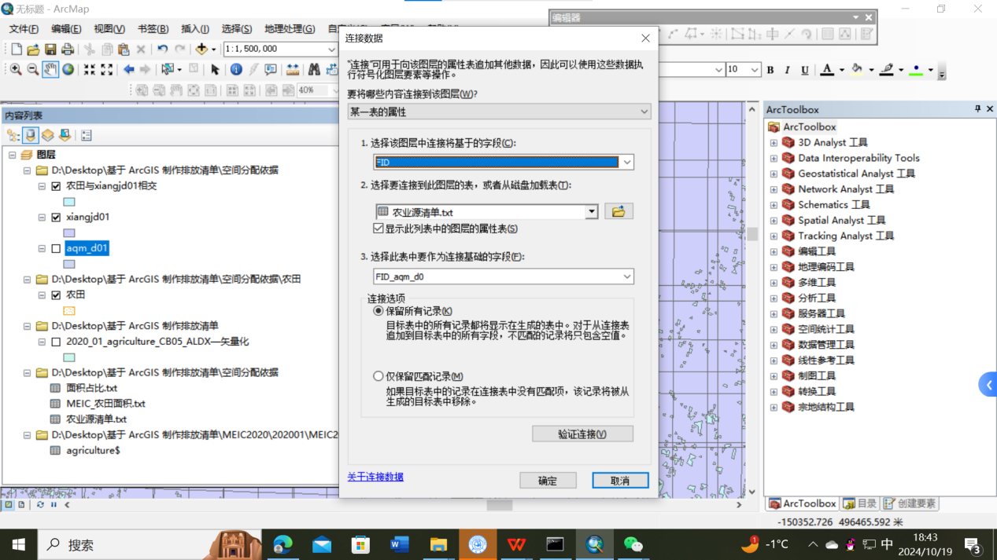
- 通过属性-符号系统-数量-分级色彩，查看分配结果。
(9) View the distribution result through the attribute - symbol system - quantity - graded color.
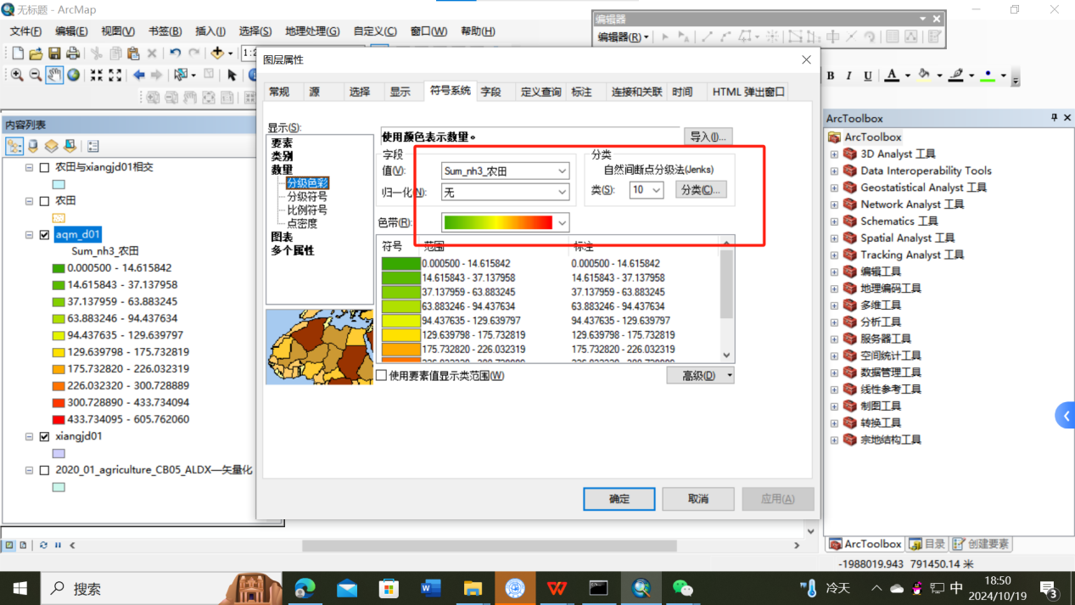

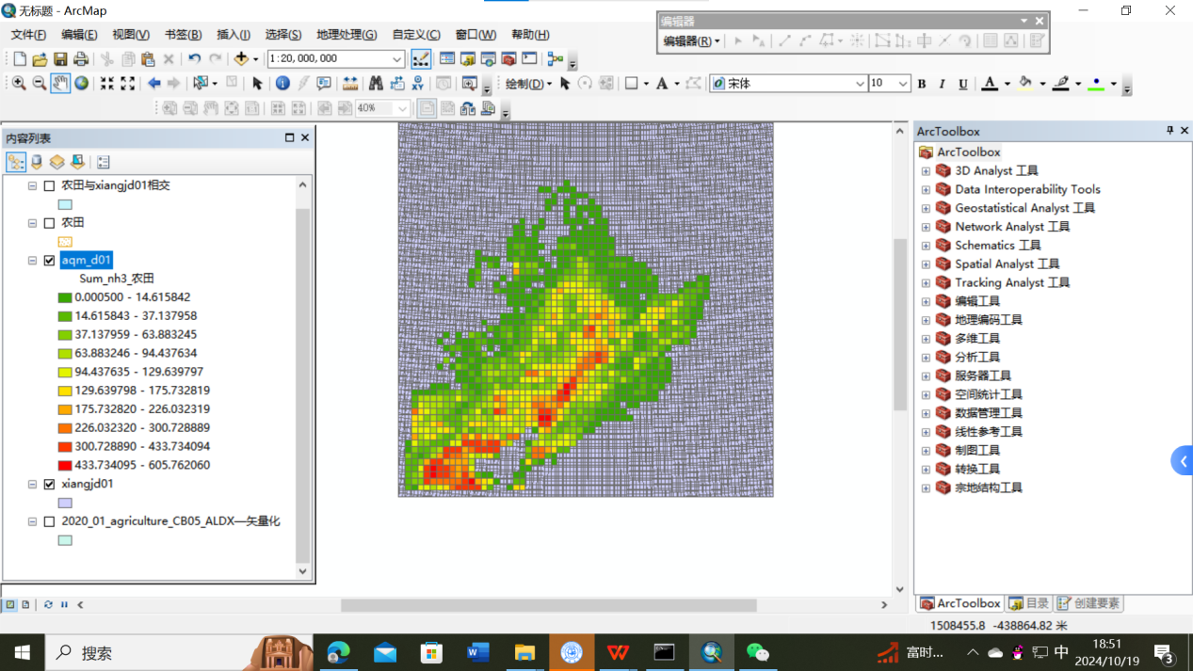
2.工业源清单
2. Industry source list
同农业源分配过程。空间分配依据文件为“工矿.shp”
Same as agriculture source allocation process. The space is allocated according to the file "Mining.shp".
- 电力源清单
3. Power source list
同农业源分配过程。空间分配依据文件为“城镇.shp”
Same as agriculture source allocation process. The space is allocated according to the file "Town.shp"
- 居民源清单
4. Resident source list
(1) 将人口栅格数据转点（转换工具-由栅格转出-栅格转点），得到 shp 文件。
(1) The population grid data transfer point to get the shp file.
(2) 将xiangj_d01.shp 和POP2021.shp 进行空间连接。(第四步）
分析工具-叠加分析-空间连接
(2) xiangj_d01.shp and POP2021.shp will be connected in space. (Step Ⅳ)
Analysis Tools - Overlay Analysis - Spatial connection
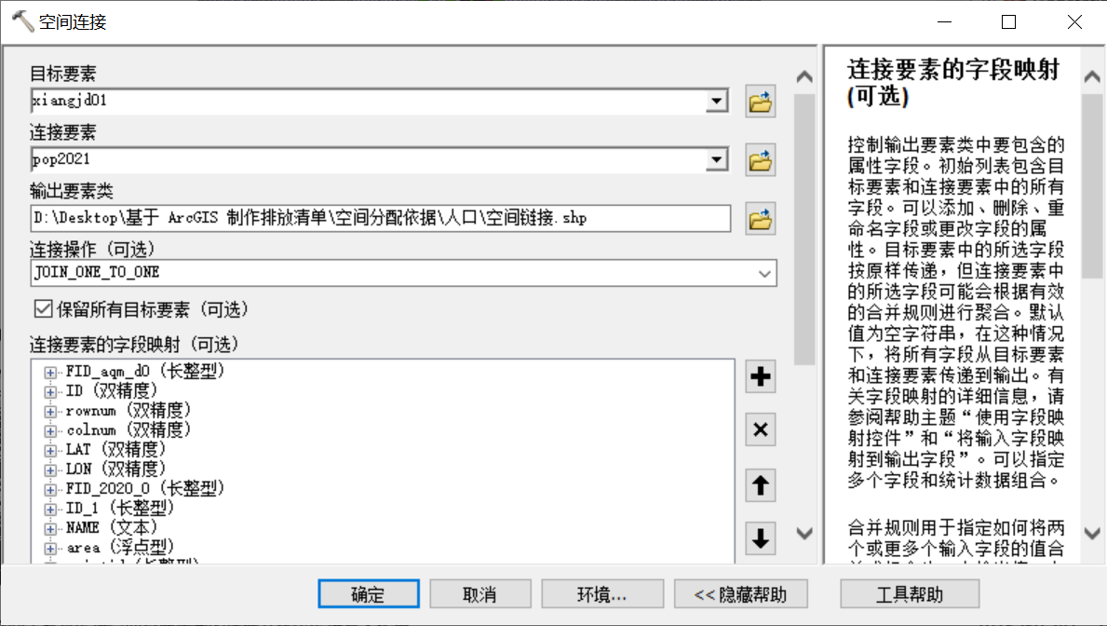
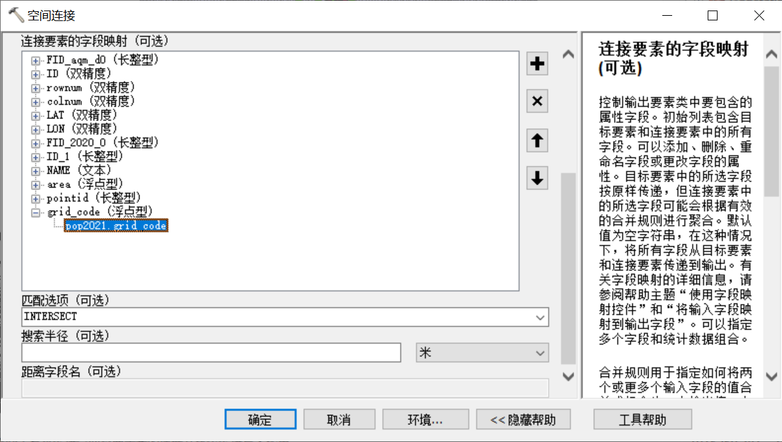
- 其余步骤与农业源一样。
(3) The remaining steps are the same as for agriculture sources.
5. 交通源清单
5. Transport source list
(1) “MEIC 和 CMAQ 相交”后的网格与路网相交。（第四步）
(1) The grid of “MEIC and CMAQ intersect” intersects with the road network. (Step Ⅳ)
(2) 新建字段 length，计算几何-计算长度。
(2) Create a new field length, calculate geometry - calculate length.
(3) 其余步骤与农业源一样。
(3) The remaining steps are the same as for agricultural sources.

- 运行 ISAT.M
Ⅴ Run ISAT.M
1. 将空间分配后的清单文件整理为 ISAT.M 要求的 csv 格式（注意经纬度不要放反，污染物的列标题必须小写，按此表格模板中污染物顺序，空的地方填0），并放在以下位置。
1. Arrange the list file after space allocation into the csv format required by ISAT.M (note that the latitude and longitude must not be reversed, the column headings of pollutants must be lowercase, according to the order of pollutants in the table template，fill in the blanks with 0 ), and put it in the following position.
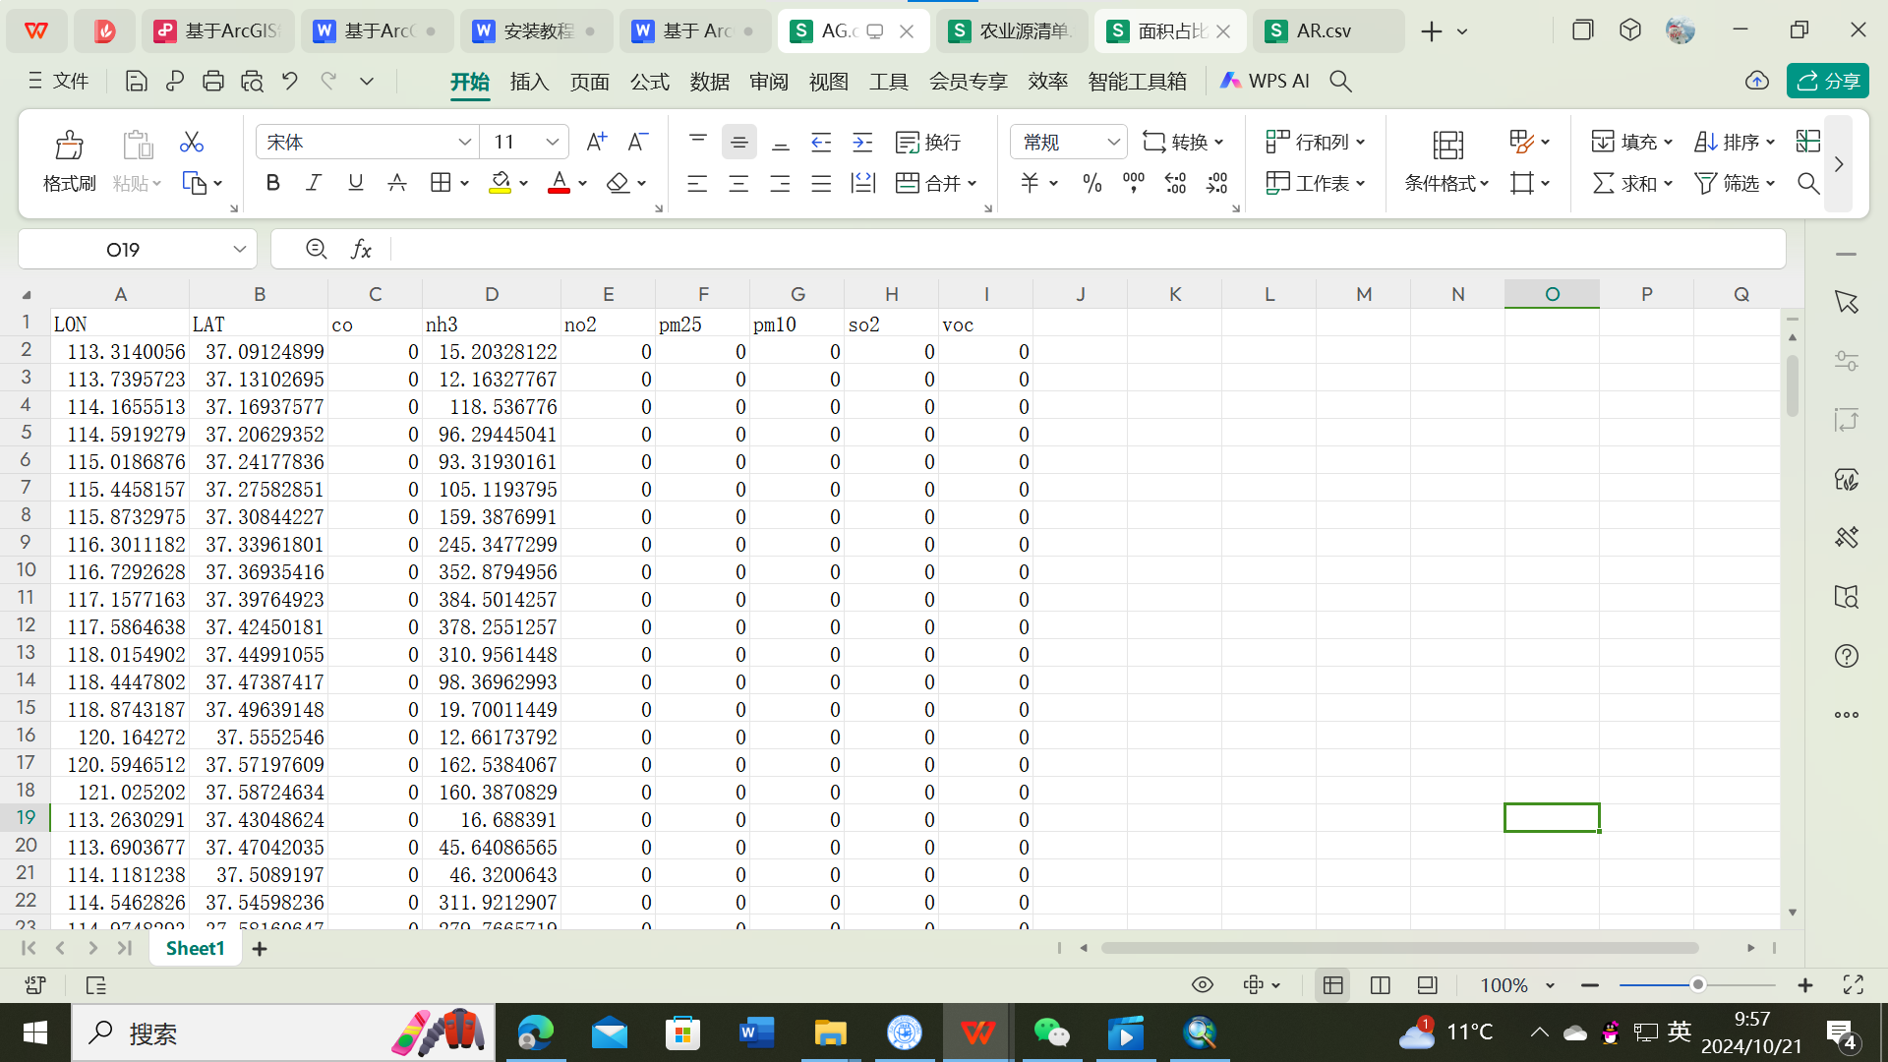

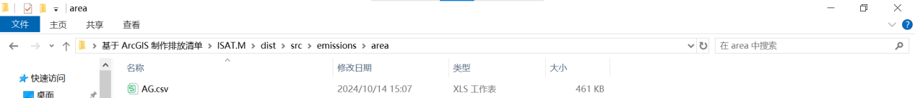
- 修改以下文件，如生成 d01 层清单时，输入的清单 csv 文件有 3541行数据，则这个文件修改为 3541 行“1”。d02 和d03 层也根据行数修改。在生成不同层的清单nc文件时此表格需要修改“1”的总行数。（减排时可以修改这里）
2. Modify the following file. For example, if the entered list csv file contains 3541 lines of data when the layer d01 list is generated, change the file to 3541 lines of 1. The d02 and d03 layers are also modified based on the number of rows. This table needs to change the total number of rows of "1" when generating the manifest nc file of different layers. (You can modify this when reducing emissions)
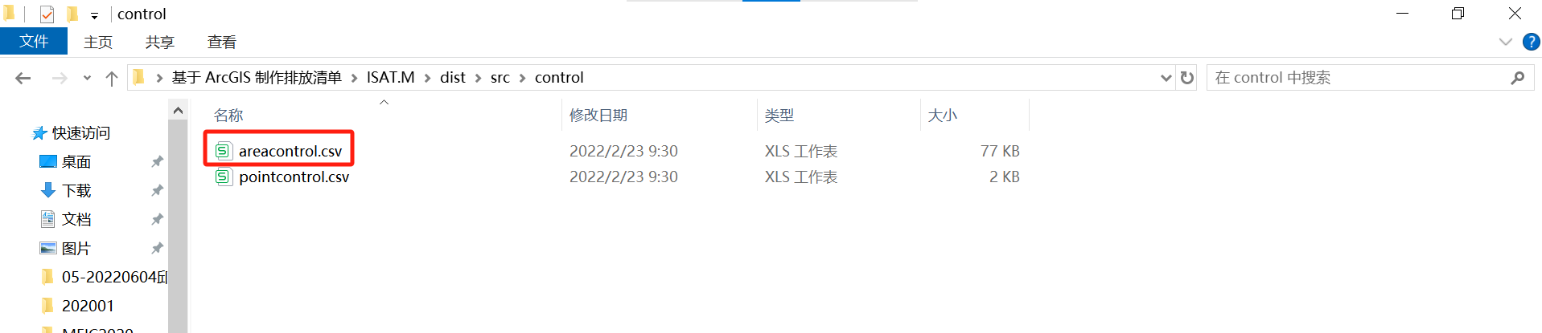
- 将 mcip 生成的 GRIDCRO2D 文件复制到 met 文件夹下。
3. Copy the GRIDCRO2D file generated by mcip to the met folder.
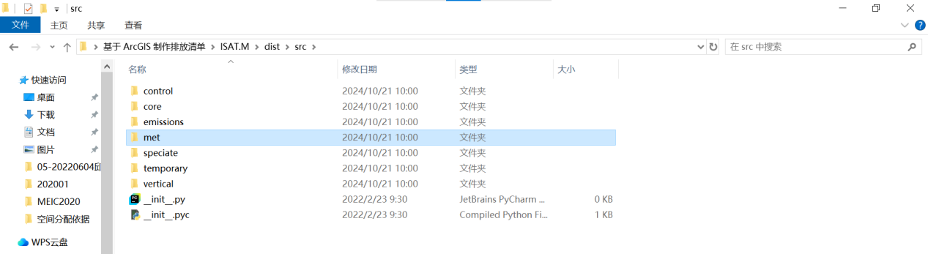
4. 按要求修改 ini 文件（用 txt 打开），保存，双击运行“area_ inlinenew.exe”,跳出cmd对话框，若运行完毕则生成清单后自动关闭。否则报错后自动关闭对话框。
农业命名为 AG，居民命名为 AR，工业命名为 IN，电力命名为 PP，交通命名为 TR
4. Modify the ini file as required (open it with txt), save it, double-click area_inlinenew. exe, and the cmd dialog box is displayed. If the running is complete, the source list is generated and automatically closed. Otherwise, the dialog box is automatically closed after an error is reported.
Agriculture is named AG, resident is named AR, Industry is named IN, Power is named PP, transport is named TR
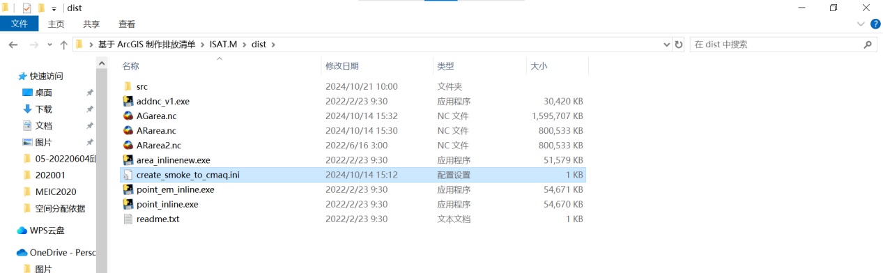

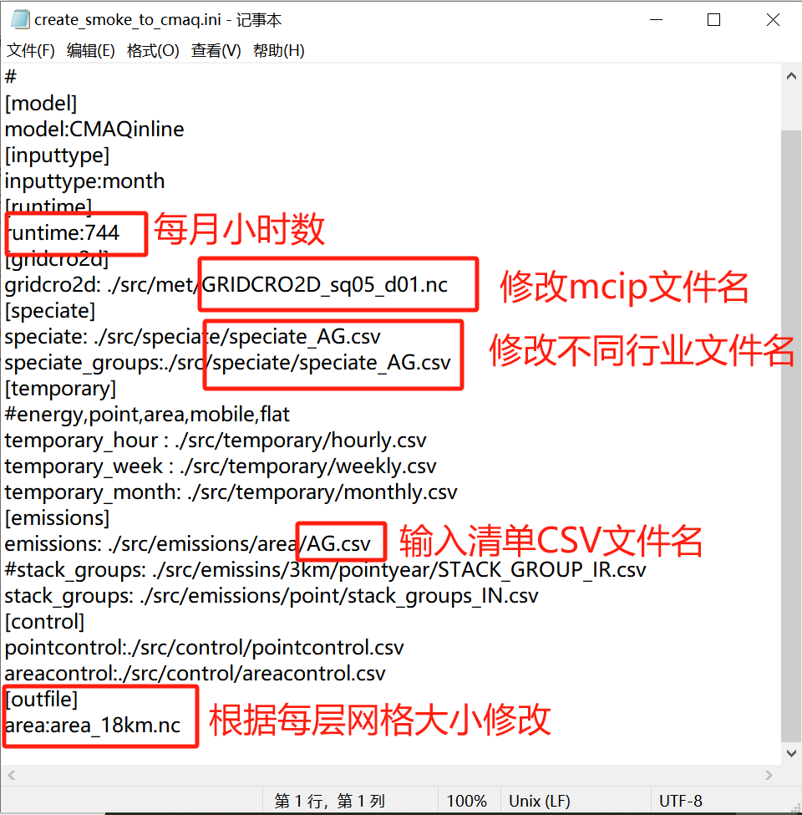

六、注意事项
制作清单完成后按以下步骤检查最终输入 ISAT.M 的 csv 文件和生成的 nc 文件。
1. 电力行业的 NH3 是 0，注意不要有空值。
2. 每个网格的 PM2.5 都应该小于 PM10，检查一下是否有异常情况。
3. 分配前MEIC202001文件和分配后AG文件分别整理一下总量，正常情况应该是分配后污染物总量略有下降，但不会有数量级上的变化。
4. nc 文件用 Panoply 软件打开，查看属性表的 SDATE，是否正确，如果不正确则是 ISAT.M运行时指定 met 文件名出现错误，气象文件对应不上。
5. 用 Panoply 软件打开，查看 nc 文件格式是否正确，是否有数值。
Ⅵ Matters needing attention
After making the list, follow the following steps to check the csv file and the generated nc file of the final input ISAT.M.
1. NH3 of the power industry is 0, pay attention to no empty value.
2. The PM2.5 of each grid should be less than PM10, check to see if there are any abnormalities.
3. The total amount of the MEIC202001 file before distribution and the AG file after distribution should be sorted out respectively. Normally, the total amount of pollutants should be slightly decreased after distribution, but there will be no changes of orders of magnitude.
4. Use the Panoply software to open the nc file and check whether the SDATE of the attribute table is correct. If the sdate is incorrect, the met file name specified during the ISAT.M operation is incorrect, and the weather file does not correspond to it.
5. Use the Panoply software to open the nc file and check whether the format of the nc file is correct and whether there is a value.

