**IST 263 Project Milestone 6 – First Draft Using CSS**

**Name**: Jiachen Li

**Description:**  
Please paste your project description from Project Milestone 1 here.

l plan to create a 3 pages travel guide website showcasing my hometown’s unique charm to attract visitors. The site will feature the town’s history, culture, local cuisine, and recommended travel routes. The first page introduces the city’s historical background and cultural heritage, the second page explores local dishes and markets, and the third page highlights must see attractions with suggested itineraries.

**What is the url of the page you choose to work on for this part?**

<https://jiachenli011.github.io/ist263/project/project6/>

**Paste a screen shot of the wireframe you created for this page below.**

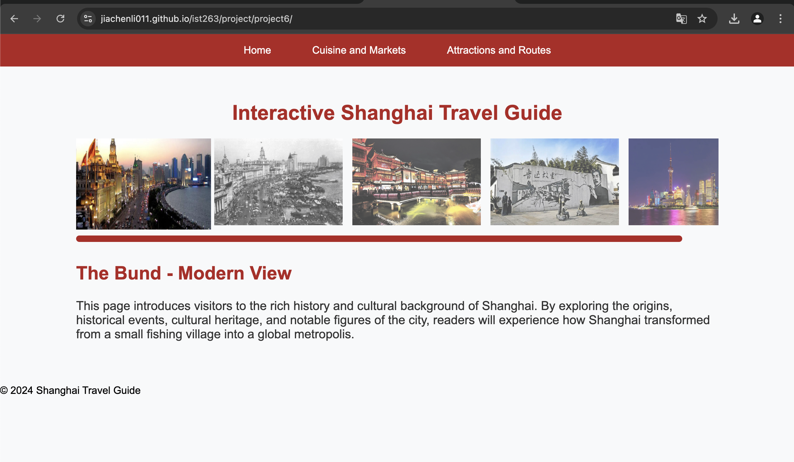

**Provide the URL of the WAVE checker for this page below.**

[**https://wave.webaim.org/report#/https://jiachenli011.github.io/ist263/project/project6/**](https://wave.webaim.org/report#/https://jiachenli011.github.io/ist263/project/project6/)

**Provide the URL of the HTML validator for you page below.**

[**https://html5.validator.nu/?doc=https%3A%2F%2Fjiachenli011.github.io%2Fist263%2Fproject%2Fproject6%2F**](https://html5.validator.nu/?doc=https%3A%2F%2Fjiachenli011.github.io%2Fist263%2Fproject%2Fproject6%2F)**.**

**If something went wrong in this part, describe what happened and how you can fix it moving forward.   
Examples of problems could be, page isn’t responsive, page doesn’t look like wireframe, etc.**