IST 363

# Lab 02

## Lab Corrections

1. 20/20 <https://jiachenli011.github.io/ist363/lab01/lab01.html>

## warmup

You may not use artificial intelligence to answer the questions below.

### Review Transitions

* 1. There are 3 properties. ‘Width’ for control the value of width, which means animation will change width value. ‘0.3s’ property is for how long the animation takes, and it means the animation will take 0.3s to complete. ‘ease’ is used for animation time, and ease is set as the default time value. Animation slower at the beginning and the end, and faster in the middle.
  2. Pseudo class ‘::after’ use for insert a custom underline, and here we use this because of we want to use a underline animation.

### Your turn Transitions

1. <https://codepen.io/jiachenli011/pen/ZYzVWgZ>

### Review keyframes

1. 1. Because we need a consistent speed for loading animation. ‘ease’ will cause the animation faster in the middle, and slower in beginning and end.
   2. Because ‘linear’ will play at same speed from beginning to end.(according to the comments in the link below the animation-timing-function: linear; line 10)
   3. l think ‘ease-out’ maybe would useful because it will cause the animation has a slow end. It may have a perfect performance in some animations.
   4. I think we can use percentage to replace ‘to’ and ‘from’, like form -> 0% and to -> 100%.

### Your Turn keyframe

1. <https://codepen.io/jiachenli011/pen/EaYGyYx>

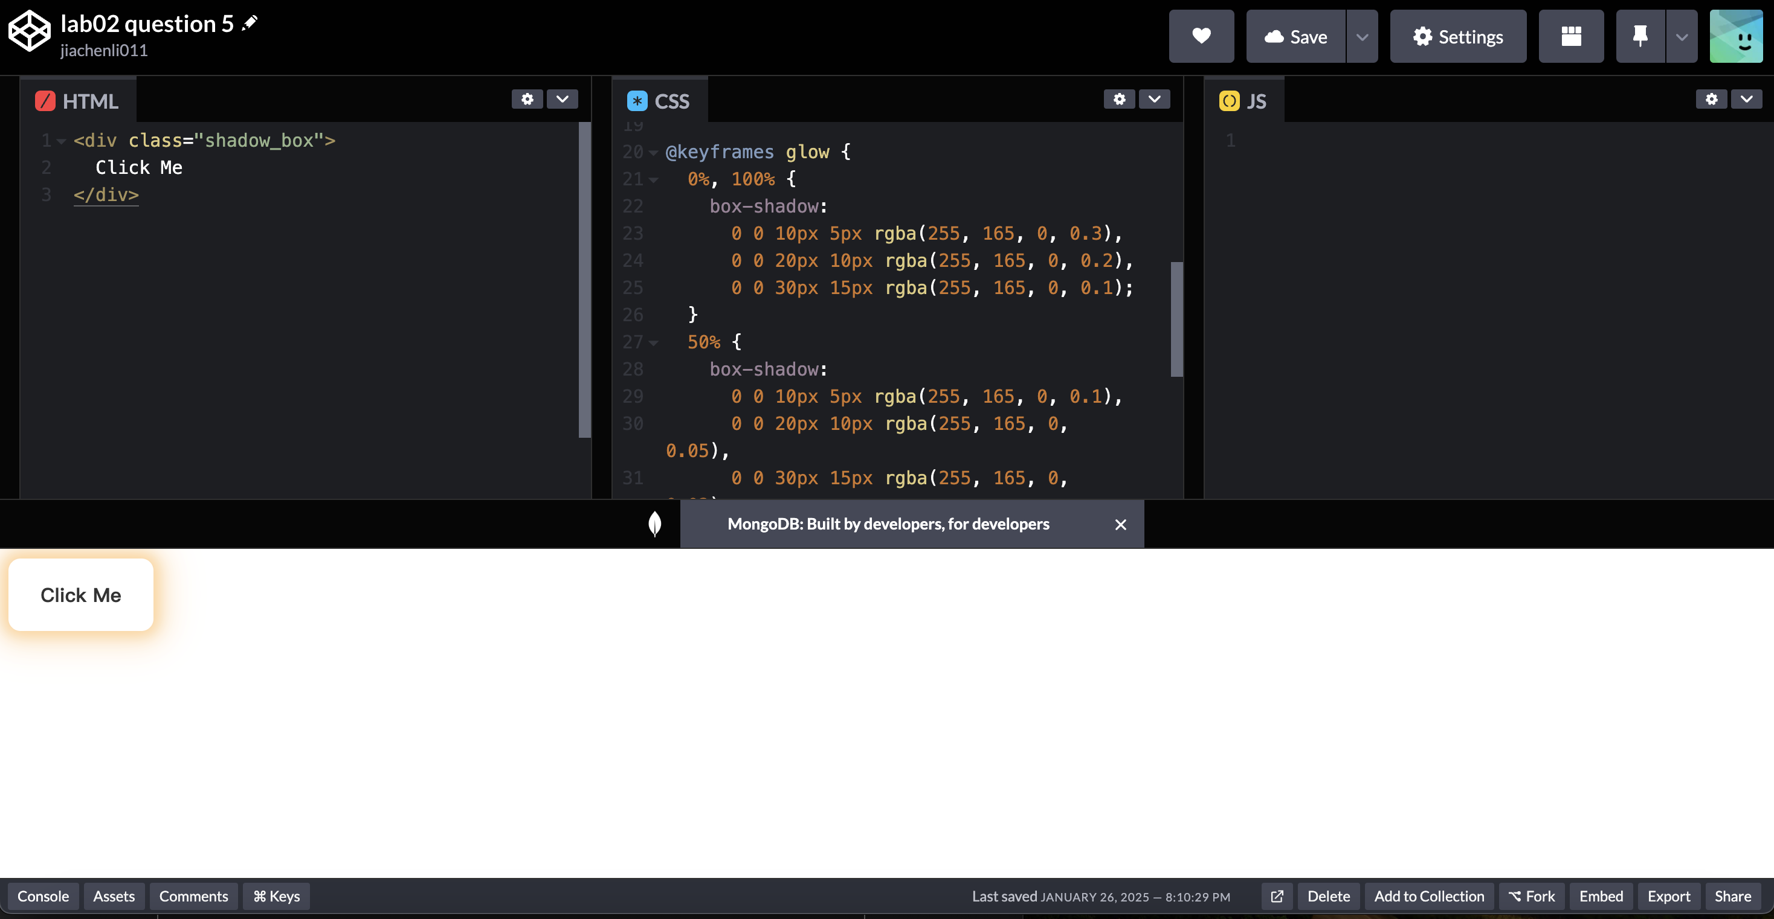

## Animated Page

1. <https://jiachenli011.github.io/ist363/lab02/lab02.html>

## challenge ANimated gifs

1. [https://jiachenli011.github.io/ist363/lab02/my_first_gif.gif](https://jiachenli011.github.io/ist363/lab02/my_first_gif.gifl)