*Control Systems ZJU-UIUC Institute*

# Lab #3:

Lab Report

# Digital Simulation of a Closed-Loop System

Reported By: Jiadong Hong, Di Wu

Lab TA: Yunze Shi

### Exercise 1

|  |  |  |  |  |  |  |
| --- | --- | --- | --- | --- | --- | --- |
|  | **Calculated Value in Prelab** | | | **Experimental Data** | | |
| **Controller** | ***Mp*** | ***tr*[s]** | ***ts*[s]** | ***Mp*** | ***tr*[s]** | ***ts*[s]** |
| **#1** | 49.8% | 0.052 | 0.400 | 49.8% | 0.046 | 0.393 |
| **#2** | 2.84% | 0.180 | 0.400 | 2.84% | 0.268 | 0.315 |
| **#3** | 2.84% | 0.052 | 0.097 | 3.20% | 0.067 | 0.087 |

Table 1: Comparison of system characteristics between calculated value in prelab and experimental data

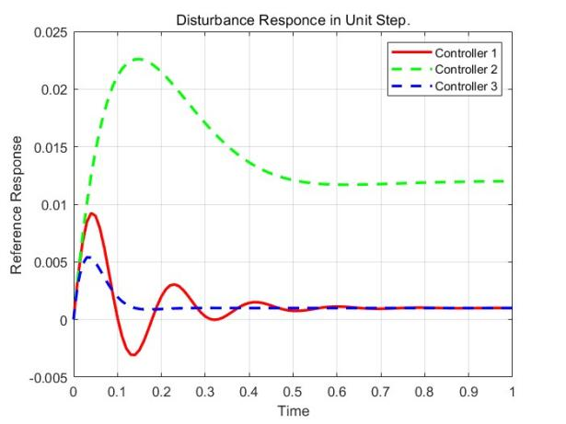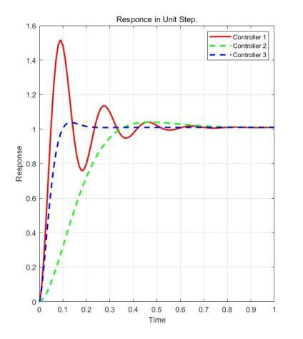

Figure 1: Disturbance Response

We can find that Controller #3 met the specifications. It responds quickly to step inputs and is not affected by disturbances.

For Controller #1, the dumping coefficient 𝜁 is about 0.217 which is much less than 0.75. For Controller #2, steady-state tape speed 𝜔*ss* is 0.12 rad/s which is larger than 0.11 rad/s.

### Exercise 2

### The system can be represented in *s*-domain,

QQ截图20231116193846

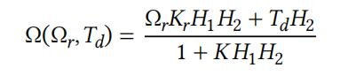

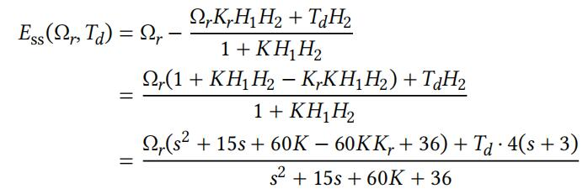Then, the steady-state error could be represented as,

So the *s*-domain steady-state error is,

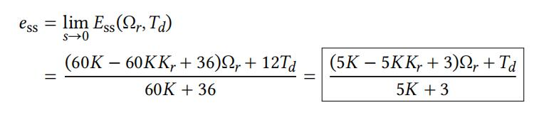

### Exercise 3

We have the polynomials that,

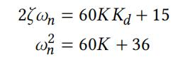

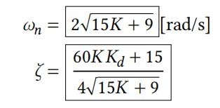The result is solved as,

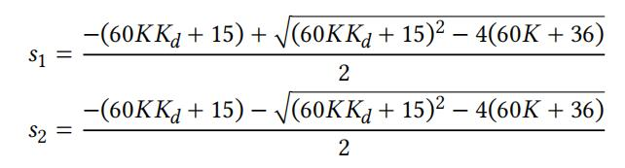According to the specifications of Controller 3, we have poles,

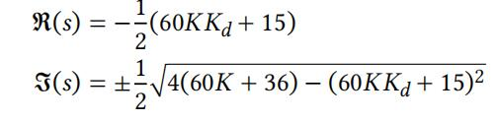The negative value shows that there is no RHP poles and we can fine the real and imaginary part of *s*1, *s*2,

And the relationship can be described as,

QQ截图20231116195746

With larger *Kd*, real part and absolute value of imaginary part will both increase. The dominant pole will converge to zero. And the figure will then get farther away from the origin of the poles. This can be seen in the figure

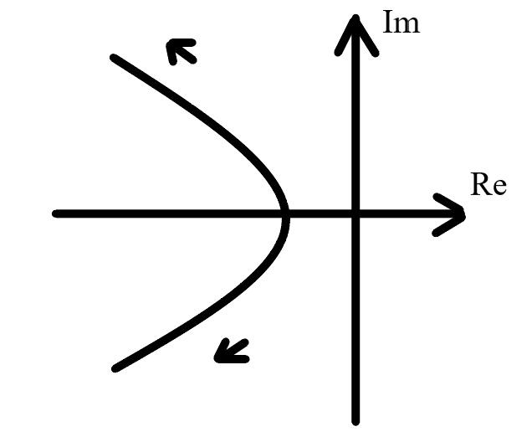 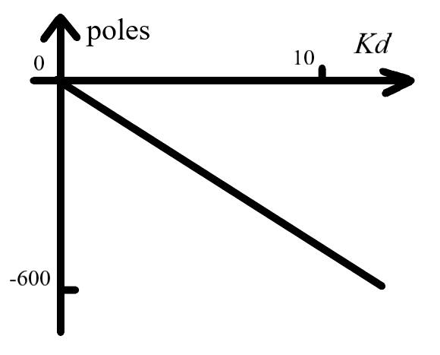

Figure 2: The track of poles