Project 1 Report

1. The difficulty for me is to write the offset function of the mid point. I spend a lot of time to figure out the normalizing process. At first, I calculate the length of the vector and project each coordinate to the vector. Then I find out the class, STVector3 has the normalizing function. We can easily use p.Normalize() to calculate it. The last step is to multiply each coordinate with radius to get the correct position of the point.
2. All my screenshots are in /data/images folder.

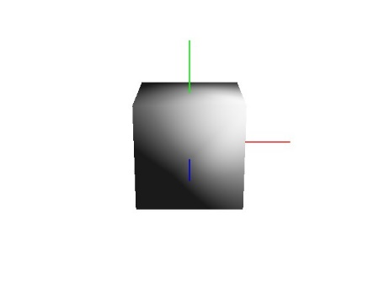 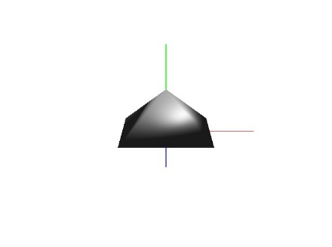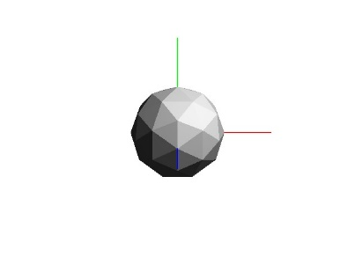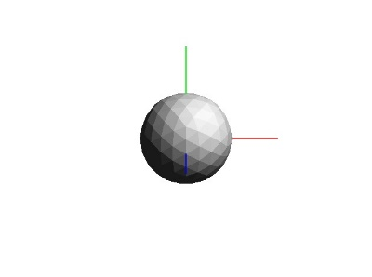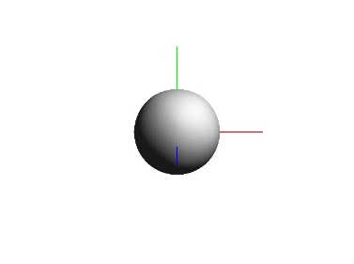

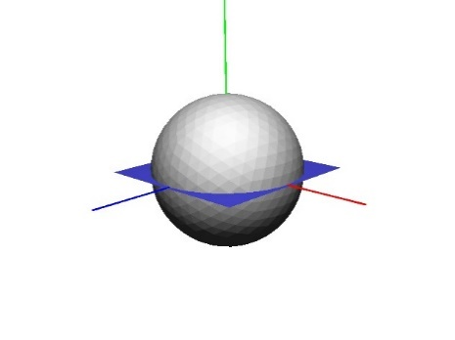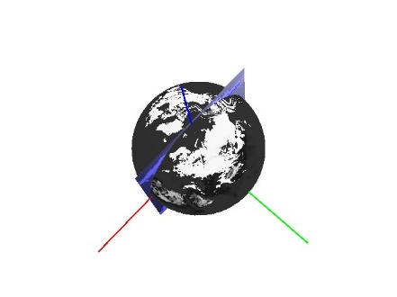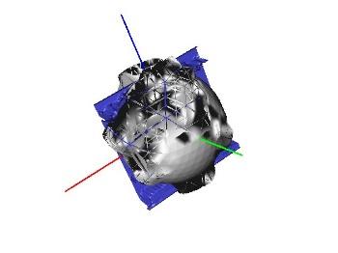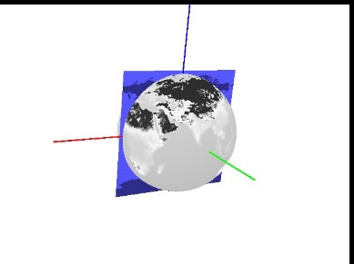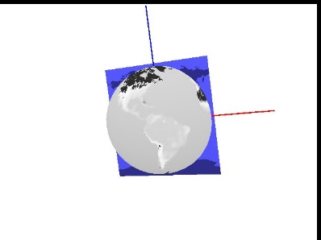

1. I test my code under virtual box. Everything runs ok. If you want to test subdivision loop, please start from level 1.
2. The subdivision loop part has a bug. If you start from level 3 to loop the subdivision, the code would crash. However, if you start from level 1, everything is perfect.

Another thing is that the subdivision function doesn’t work because one line code is missing. I reported this bug to Dr. Corey. She fixed this bug.