Software Project Management Project
Semester Project, SS 2026
Group 1

iGEO Internet of Moving Things Planning Report

Authors
Nguyen, Hieu
Wang, Jingru
Dinesha Shyamala, Prasad
Yi, Jiahao
Sun, Teng
Guo, Ziyu

Prepared for Software Project Management (SPM)

1: Project Management Foundations, Stakeholder Analysis, and Decision Analysis

Project Definition
TOMI Automobiles plans to extend the GEO car line with iGEO, a decoupled Internet of Moving Things (IoMT) platform. The project introduces dedicated IoMT hardware, a dedicated in-car display, a hosting application for software modules, and two demonstration modules: Drive to Welcoming Home (WH) and Smart Commercials (SC). The system is deliberately separated from core driving and safety-critical vehicle functions.
The planning objective of this report is to turn the project description into a manageable project plan that covers scope, stakeholders, supplier selection, work breakdown, effort estimation, schedule dependencies, and human resource planning.

Project Scope
- Design a modular IoMT platform for the GEO product line without influencing driving-critical behavior.
- Select suitable iGEO IoMT hardware and display components and justify the choices.
- Develop or outsource the hosting application and its GUI for module deployment, activation, deactivation, and configuration.
- Deliver two exemplary modules: WH for smart-home arrival automation and SC for location-based commercial notifications.
- Integrate iGEO Cloud, smart-home devices, garage devices, SMS notification, and retail cloud services through controlled interfaces.

Business Goals
- Strengthen TOMI's innovation image in the emerging Internet of Moving Things market.
- Increase the attractiveness of the GEO line for young, connected, and tech-oriented customers.
- Differentiate TOMI from slower-moving automotive competitors through software-enabled customer experience.
- Explore future monetization potential through contextual offers while avoiding intrusive user experience.
- Maintain customer trust by treating safety, security, and privacy as visible product qualities.

Project Goals
- Complete the iGEO project within the one-year window from 2023-06-01 to 2024-05-31.
- Keep total implementation cost below EUR 1,000,000.
- Keep all IoMT software and hardware decoupled from GEO driving-control systems.
- Provide a user-friendly display and GUI for module management and configuration.
- Demonstrate working WH and SC modules with security, privacy, integration, and usability validation.

Critical Success Factors
- Clear, validated requirements and strict scope control for the hosting platform and both modules.
- A supplier decision that balances safety, process maturity, IoT competence, cost, and collaboration.
- A modular architecture that supports future IoMT modules without redesigning the platform.
- Robust security/privacy design for location data, home access, garage access, and user profiles.
- Early stakeholder involvement, especially from Finance, IT, Architecture, Sales, and Product Line Management.

Assumptions and Constraints
Type | Item
Assumption | Users accept controlled use of location, profile, and smart-home data when convenience and privacy controls are clear.
Assumption | External IoT and retail services provide stable APIs or protocols for integration.
Assumption | The selected supplier can provide hardware/display support within the one-year schedule.
Constraint | Budget is capped at EUR 1,000,000.
Constraint | The project must finish within one year, from 2023-06-01 to 2024-05-31.
Constraint | IoMT features must not control or endanger driving-critical car functions.
Constraint | TOMI has limited internal capacity, so hardware/display and hosting application work are partly outsourced.

Stakeholders
Stakeholder | Role | Attitude | Reasoning
George Wein | Project Manager | Supportive | Initiated the idea and owns coordination after project approval.
Tom Wards | CTO | Supportive but cautious | Wants innovation but insists on security, safety, testing, and clear requirements.
Jim Becker | Executive Marketing | Supportive with price concern | Sees campaign potential but worries about affordability.
Julia Andersen | Finance and Controlling Director | Skeptical | Concerned about development cost, profit per unit, and financial risk.
Peter Scofield | Executive IT | Skeptical | Concerned about security, privacy, media risk, and IT capacity.
Anne Smith | Lead IT Architect | Hidden supportive | Believes separation architecture can work but avoids conflict with Peter.
Jane Wilson | Sales Manager | Interested | Needs customer segments and target regions for sales planning.
Jim Bucksley | Developer | Supportive | Likes the concept and sees lower risk because core car functions are untouched.
David Renegan | Developer | Cautiously supportive | Likes the idea but knows requirements will be difficult.
John Burton | GEO Product Line Manager | Supportive | Sees alignment with the GEO product strategy.
Jonathan Newman | TEO Product Line Manager | Hidden opposed | Privately believes the features distract from the driving experience and create requirement risk.

Socio-Diagram and Stakeholder Relations
The socio-diagram focuses on attitudes and informal influence. Green relations indicate support or constructive cooperation, yellow relations indicate caution or political pressure, and red/dashed relations indicate open or hidden resistance.
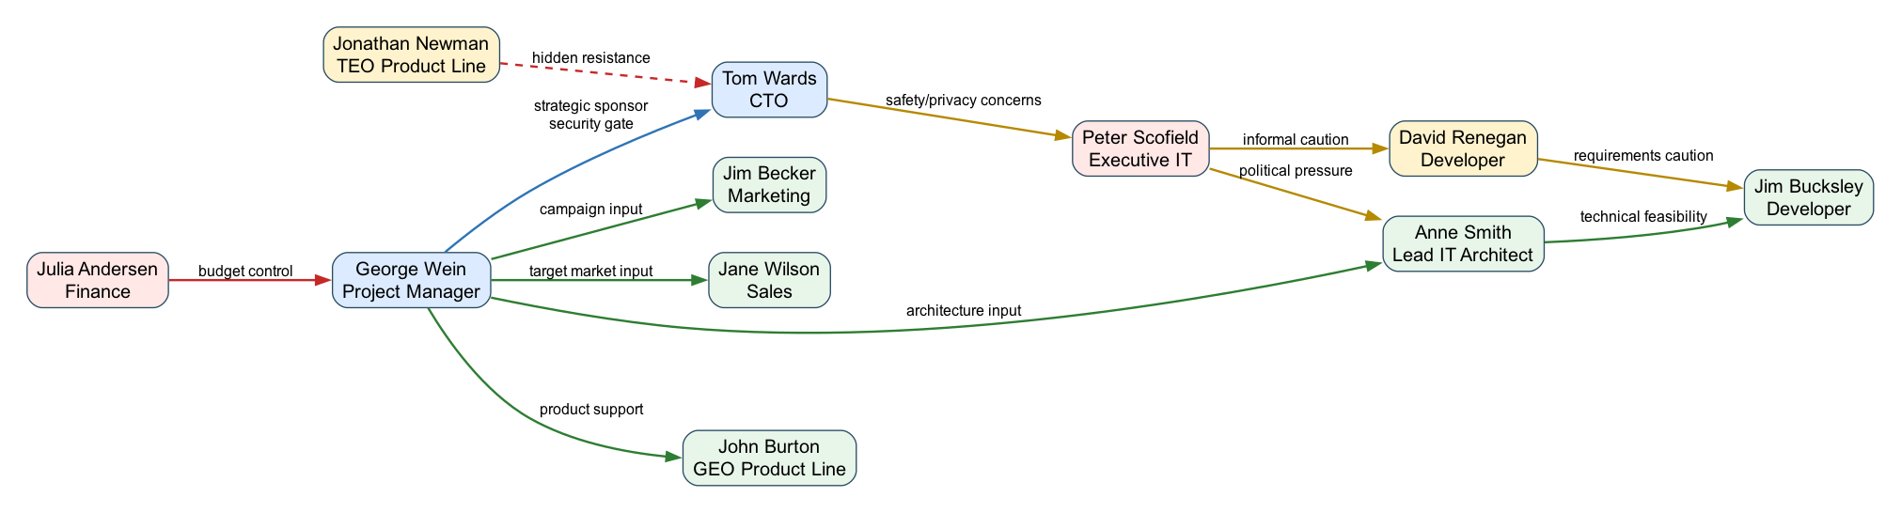
Figure 1: Socio-diagram of the iGEO stakeholder environment.
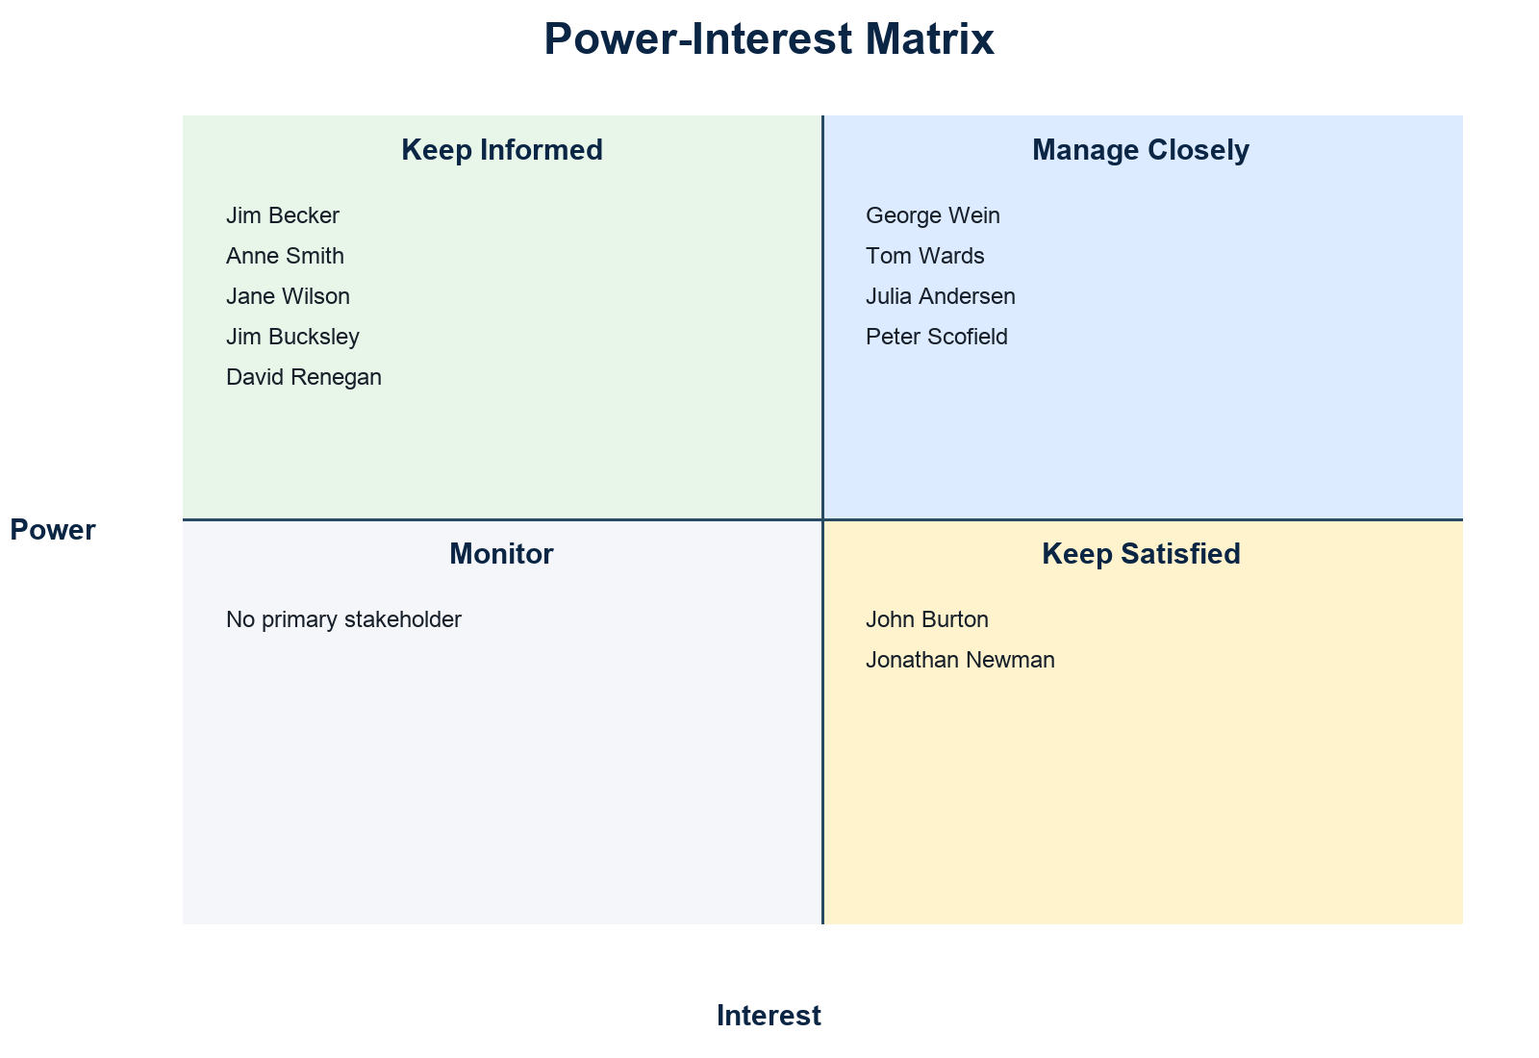
Figure 2: Power-interest matrix derived from stakeholder attitude and influence.

Stakeholder Involvement Counter Actions
Stakeholder Group | Risk | Counter Action
Finance and IT skeptics | Budget, security, privacy, and capacity concerns may slow approval. | Use monthly risk and cost reviews; show security architecture and cost forecast early.
Hidden opponents | Jonathan Newman may influence Tom informally against the project. | Address driving-experience concerns explicitly and frame iGEO as optional, decoupled, and non-safety-critical.
Technical contributors | Developers and architecture may underestimate requirement complexity. | Run structured requirement reviews and trace requirements to use cases and test cases.
Marketing and sales | Commercial value may remain vague. | Define target customer assumptions, price sensitivity, and user acceptance criteria before launch.
Supportive sponsors | Innovation enthusiasm may create scope creep. | Keep a controlled backlog and require change impact analysis for new modules or features.

Supplier Selection Criteria
The supplier criteria are limited to five decision criteria, as required by the task. They emphasize the concerns raised by TOMI stakeholders and the information available in the supplier profile.
Criterion | Rationale
Safety/security and reputation | The project handles location, home, garage, and personal profile data; reputation risk is repeatedly raised by CTO and IT.
Automotive/IoT technical capability | The supplier must support smart-car and IoT integration, including reliable hardware/display choices.
Process maturity and quality assurance | Testing, deployment, and change handling are key concerns for TOMI.
Cost and commercial fit | The project is capped at EUR 1,000,000 and affordability is a marketing concern.
Flexibility and collaboration | Requirements are likely to evolve, so supplier communication and change handling matter.

2: Work Breakdown Structure and Decision Analysis & Resolution

WBS First Version
The first WBS follows a broad functional decomposition. It is useful for orientation but still contains overlap and missing work that must be corrected.

WBS First Version Diagram
Figure 3: WBS version 1.

WBS Validation and Error Solving
Rule | Violation in Version 1 | Resolution for Version 2
Disjunction Rule | Hardware/display procurement appeared under both supplier management and technical design. | Separate supplier decision/contracting from technical integration design.
Disjunction Rule | GUI design overlapped with WH and SC module work. | Move common GUI/UX responsibility to Hosting GUI and Module Configuration UI; keep WH/SC focused on module logic.
Completion Rule | Security/privacy validation was too implicit. | Add a dedicated verification work package for security, privacy, usability, and integration tests.
Completion Rule | Deployment and operational handover were missing. | Add a release, documentation, and handover work package.

WBS Final Version

WBS Final Version Diagram
Figure 4: WBS version 2 after validation.

Final WBS Work Packages
ID | Work Package | Description
WP1 | Project initiation and stakeholder management | Kick off the project, align key stakeholders, define governance and communication routines.
WP2 | Requirements engineering | Elicit, document, prioritize, and validate functional and non-functional requirements.
WP3 | Supplier evaluation and contracting | Define criteria, evaluate FunIOT/ProfCar, and onboard the chosen supplier.
WP4 | Architecture and safety separation design | Design the decoupled IoMT architecture and integration boundaries.
WP5 | Hardware/display selection and integration design | Select automotive-grade hardware/display options and define integration constraints.
WP6 | Hosting application backend | Implement deployment, enable/disable, compatibility checks, and lifecycle control.
WP7 | Hosting GUI and module configuration UI | Build user-facing GUI flows for module management and configuration.
WP8 | WH module implementation | Implement smart-home, lighting, climatization, garage, and notification behavior.
WP9 | SC module implementation | Implement commercial tag configuration, location-based offers, and notification display.
WP10 | Cloud and third-party integration | Integrate iGEO cloud, smart home devices, garage, SMS, and retail cloud interfaces.
WP11 | Verification, security, and usability testing | Run integration, acceptance, security/privacy, and display usability tests.
WP12 | Deployment, documentation, and handover | Prepare pilot release, operational documentation, training, and final handover.

Supplier Decision

Paired Comparison Analysis
The paired comparison ranks the five criteria before the grid analysis. Safety/security and technical capability dominate because failure would threaten customer trust and the project's feasibility. Cost is important but cannot compensate for a risky automotive IoMT supplier.
Pair | Preferred Criterion | Reason
Safety/security vs Technical capability | Safety/security | Stakeholders repeatedly treat safety and privacy as approval gates.
Safety/security vs Process maturity | Safety/security | Process matters, but reputation damage from a breach would be more severe.
Safety/security vs Cost | Safety/security | A cheaper supplier is not acceptable if security risk increases.
Safety/security vs Flexibility | Safety/security | Flexibility cannot replace secure automotive-grade behavior.
Technical capability vs Process maturity | Technical capability | The system needs proven IoT/smart-car competence first.
Technical capability vs Cost | Technical capability | Integration failure would be more expensive than a higher day rate.
Technical capability vs Flexibility | Technical capability | Technical fit is more decisive than change style.
Process maturity vs Cost | Process maturity | CMMI/ITIL/ISO-like maturity supports predictable delivery and testing.
Process maturity vs Flexibility | Process maturity | Controlled deployment is more important than informal adaptability.
Cost vs Flexibility | Cost | Within a fixed budget, commercial fit receives the remaining priority.

Criterion | Rank Weight
Safety/security and reputation | 5
Automotive/IoT technical capability | 4
Process maturity and quality assurance | 3
Cost and commercial fit | 2
Flexibility and collaboration | 1

Grid Analysis
Criterion | Weight | FunIOT Score | FunIOT Weighted | ProfCar Score | ProfCar Weighted
Safety/security and reputation | 5 | 4 | 20 | 7 | 35
Automotive/IoT technical capability | 4 | 6 | 24 | 9 | 36
Process maturity and quality assurance | 3 | 4 | 12 | 9 | 27
Cost and commercial fit | 2 | 9 | 18 | 4 | 8
Flexibility and collaboration | 1 | 9 | 9 | 5 | 5
Total |  |  | 83 |  | 111

Decision: ProfCar is selected with 111 weighted points compared with FunIOT's 83. FunIOT is attractive for cost and flexibility, but ProfCar better matches TOMI's security-sensitive automotive context due to stronger smart-car experience, larger engineering capacity, ISO certification, CMMI/ITIL experience, 5G capability, and longer warranty.

3: Planning Poker and Use Case Point Estimation Method

Planning Poker
The group used a Fibonacci-like scale of 1, 2, 3, 5, 8, 13, 20, and 40 points. The scale was chosen because the uncertainty between large work packages grows non-linearly and the gaps force discussion instead of false precision.
WP | Final Estimate | First-Round Range | Rationale
WP1 | 5 | 3-8 | Mostly coordination work; uncertainty comes from stakeholder availability.
WP2 | 8 | 5-13 | Requirements are described in the brief but stakeholder conflicts make validation harder.
WP3 | 8 | 5-13 | Supplier information is available, but criteria weighting and contract risk require discussion.
WP4 | 13 | 8-20 | Safety separation and modularity are central architectural concerns.
WP5 | 13 | 8-20 | Hardware/display choice depends on supplier data and user-facing usability constraints.
WP6 | 20 | 13-40 | The hosting app controls module lifecycle, compatibility checks, and deployment behavior.
WP7 | 13 | 8-20 | GUI complexity is moderate but must remain safe and simple while driving.
WP8 | 20 | 8-40 | WH touches smart home, garage, passenger identification, cancellation, and privacy flows.
WP9 | 13 | 8-20 | SC is smaller than WH but still needs location, preference, and retail integration.
WP10 | 20 | 13-40 | External APIs and device protocols increase uncertainty.
WP11 | 20 | 13-40 | Testing is broad because security, privacy, usability, and integration all matter.
WP12 | 8 | 5-13 | Release and handover are well understood but depend on prior acceptance results.

The hardest work package to estimate was WP8, the WH module. The first round ranged from 8 to 40 points because some members viewed it as ordinary feature coding, while others included passenger identification, smart-home device reliability, garage access, privacy, cancellation behavior, and error handling. The group selected 20 points after agreeing to treat WH as the most integration-heavy module.
The largest gap was therefore 32 points on WP8. WP10 and WP11 also produced large gaps because third-party integration and security/usability validation depend on supplier decisions and external device behavior.

Use Case Point Estimation
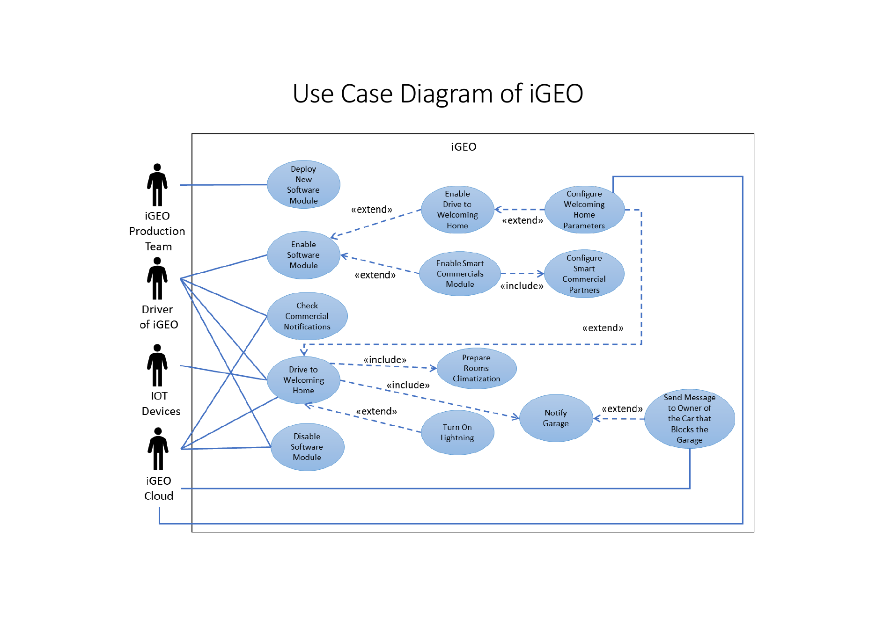
Figure 5: Provided use case diagram of iGEO.

Unadjusted Actor Weight (UAW)
Actor Type | Actors | Classification Rationale | Quantity | Weight | Subtotal
Simple | iGEO Cloud | Defined API used for profiles, configuration storage, and SMS forwarding. | 1 | 1 | 1
Average | IoT Devices at Smart Home; IoT Garage Device | External systems communicate through network/device protocols. | 2 | 2 | 4
Complex | Driver; iGEO Production Team | Human actors interact through graphical user interfaces. | 2 | 3 | 6

Total UAW = 11. Supermarket and retail cloud services are mentioned as preconditions but are not counted separately because they are not primary actors in the provided use cases.

Unadjusted Use Case Weight (UUCW)
Use Case | Transactions | Type | Weight
Deploy New Software Module | 4 | Average | 10
Enable Software Module | 3 | Simple | 5
Enable Drive to Welcoming Home Module | 3 | Simple | 5
Configure Welcoming Home Parameters | 4 | Average | 10
Drive to Welcoming Home | 5 | Average | 10
Prepare Rooms Climatization | 5 | Average | 10
Turn On Lightning | 5 | Average | 10
Notify Garage | 5 | Average | 10
Send Message to Owner of Blocking Car | 2 | Simple | 5
Enable Smart Commercial Module | 3 | Simple | 5
Configure Smart Commercial Parameters | 4 | Average | 10
Check Commercial Notification | 3 | Simple | 5
Disable Software Module | 6 | Average | 10

Use Case Type | Rule | Quantity | Weight | Subtotal
Simple | Up to 3 transactions | 5 | 5 | 25
Average | 4 to 7 transactions | 8 | 10 | 80
Complex | More than 7 transactions | 0 | 15 | 0

UUCW = 105. Therefore, UUCP = UAW + UUCW = 11 + 105 = 116.

Technical Complexity Factor
Factor | Description | Project Rationale | Weight | Score | Subtotal
T1 | Distributed solution | Vehicle hardware, cloud services, IoT home devices, garage devices, and retailer services cooperate. | 2 | 5 | 10
T2 | Performance objectives | Garage and in-car notifications should react quickly and predictably. | 1 | 4 | 4
T3 | End-user efficiency | Drivers need short, clear interaction flows while using the car. | 1 | 4 | 4
T4 | Complex internal processing | The WH module combines passenger identification, location, climatization, lighting, and garage logic. | 1 | 4 | 4
T5 | Reusable code/design | The hosting app must support future modules beyond WH and SC. | 1 | 4 | 4
T6 | Easy to install | Supplier and workshop installation should be repeatable across GEO vehicles. | 0.5 | 3 | 1.5
T7 | Easy to use | Usability is critical because the dedicated display is used in a driving context. | 0.5 | 5 | 2.5
T8 | Portable | A reusable IoMT platform may later be transferred to other TOMI product lines. | 2 | 3 | 6
T9 | Easy to change | Module configuration, supplier components, and cloud APIs may change after release. | 1 | 4 | 4
T10 | Concurrent users | Multiple drivers and profiles may use the same vehicle or cloud account over time. | 1 | 3 | 3
T11 | Special security features | Location, garage access, home devices, and personal profiles require strong protection. | 1 | 5 | 5
T12 | Third-party access | Smart home, garage, SMS, and retail services require third-party interfaces. | 1 | 4 | 4
T13 | Special training facilities | The system should be intuitive; only minimal handover guidance is expected. | 1 | 1 | 1

Technical Factor Total = 53.0. TCF = 0.6 + (0.01 x 53.0) = 1.13.

Environmental Complexity Factor
Factor | Description | Project Rationale | Weight | Impact | Subtotal
E1 | Familiar with software development process | The team is familiar with structured SPM methods but not with every automotive process. | 1.5 | 3 | 4.5
E2 | Application experience | The team has limited direct automotive IoMT domain experience. | 0.5 | 2 | 1.0
E3 | Object-oriented paradigm experience | The implementation assumptions use familiar object-oriented design concepts. | 1 | 4 | 4
E4 | Lead analyst capability | The analyst role is considered capable for an academic planning project. | 0.5 | 3 | 1.5
E5 | Motivation | The project is visible and relevant for exam admission, so motivation is high. | 1 | 5 | 5
E6 | Stable requirements | The brief is clear, but stakeholder concerns and supplier choices create some volatility. | 2 | 3 | 6
E7 | Part-time workers | The actual team members are students and can contribute only part-time. | -1 | 4 | -4
E8 | Difficulty of programming language | Typical implementation languages and APIs are familiar enough for the assumed team. | -1 | 2 | -2

Environmental Factor Total = 16.0. ECF = 1.4 + (-0.03 x 16.0) = 0.92.
Total Use Case Points: UCP = UUCP x TCF x ECF = 116 x 1.13 x 0.92 = 120.59.
Productivity factor: E1-E6 below 3 plus E7-E8 above 3 gives 2 risk factors, so PF = 20 person-hours/UCP. Estimated development effort = 120.59 x 20 = 2412 person-hours.

4: Project Scheduling

Activity Network Diagram and Critical Path
The activity network uses weeks as the time unit and includes all four precedence relationships: Finish-to-Start (FS), Start-to-Start (SS), Finish-to-Finish (FF), and Start-to-Finish (SF). The SF relationship is used for operational handover: support readiness cannot finish before pilot deployment preparation has started.
ID | Activity | Dur. | Predecessors | ES | EF | LS | LF | Float | Start | Finish
A1 | Project initiation and stakeholder alignment | 2 | - | 0 | 2 | 0 | 2 | 0 | 2023-06-01 | 2023-06-14
A2 | Requirements engineering | 6 | A1 FS | 2 | 8 | 2 | 8 | 0 | 2023-06-15 | 2023-07-26
A3 | Supplier criteria, evaluation, and contracting | 5 | A2 SS | 2 | 7 | 6 | 11 | 4 | 2023-06-15 | 2023-07-19
A4 | Architecture and safety separation concept | 5 | A2 FS | 8 | 13 | 8 | 13 | 0 | 2023-07-27 | 2023-08-30
A5 | Hardware/display selection and integration planning | 8 | A3 FS | 7 | 15 | 11 | 19 | 4 | 2023-07-20 | 2023-09-13
A6 | Hosting application implementation | 12 | A4 FS | 13 | 25 | 13 | 25 | 0 | 2023-08-31 | 2023-11-22
A7 | WH module implementation | 10 | A6 SS | 13 | 23 | 15 | 25 | 2 | 2023-08-31 | 2023-11-08
A8 | SC module implementation | 8 | A6 SS | 13 | 21 | 17 | 25 | 4 | 2023-08-31 | 2023-10-25
A9 | Cloud/API and display integration | 6 | A5 FS, A6 FF | 19 | 25 | 19 | 25 | 0 | 2023-10-12 | 2023-11-22
A10 | System integration testing | 6 | A7 FS, A8 FS, A9 FS | 25 | 31 | 25 | 31 | 0 | 2023-11-23 | 2024-01-03
A11 | Security, privacy, and usability validation | 5 | A10 SS, A10 FF | 26 | 31 | 26 | 31 | 0 | 2023-11-30 | 2024-01-03
A12 | Pilot deployment preparation | 4 | A10 FS, A11 FS | 31 | 35 | 31 | 35 | 0 | 2024-01-04 | 2024-01-31
A13 | Operations handover and support readiness | 3 | A12 SF | 28 | 31 | 32 | 35 | 4 | 2023-12-14 | 2024-01-03
A14 | Final release and project closure | 2 | A12 FS, A13 FS | 35 | 37 | 35 | 37 | 0 | 2024-02-01 | 2024-02-14

Critical path: A1 -> A2 -> A4 -> A6 -> A9 -> A10 -> A11 -> A12 -> A14. The calculated project duration is 37 weeks, leaving schedule buffer inside the one-year project window.
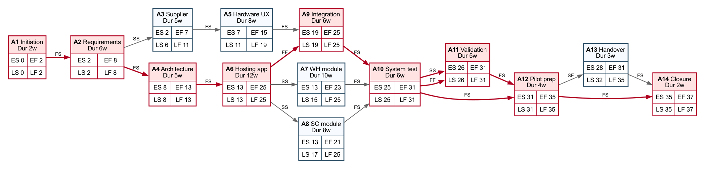
Figure 6: Activity network with ES/EF/LS/LF values. Red nodes are critical.

Gantt Chart
The Gantt chart translates the activity network into a calendar view from 2023-06-01. It shows the critical activities in red and non-critical activities in blue.
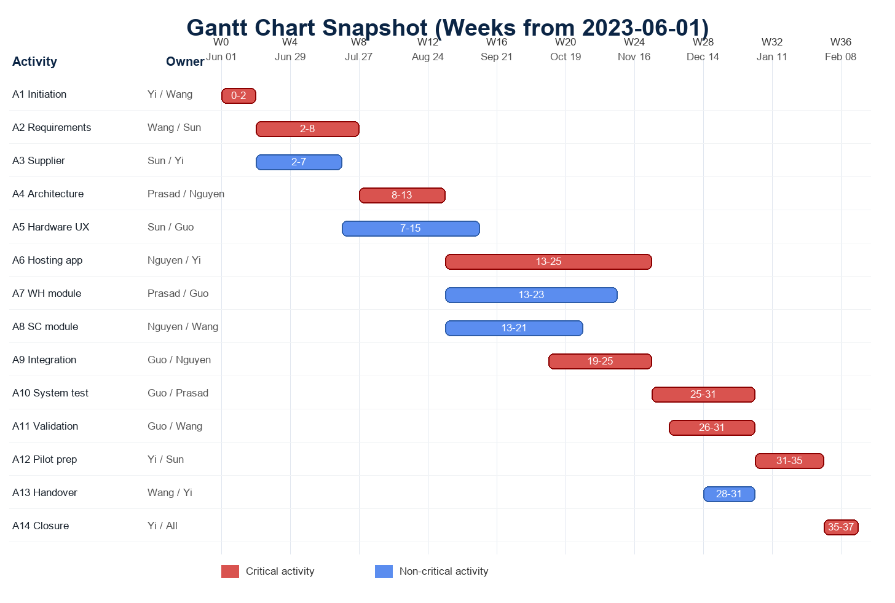
Figure 7: Gantt chart snapshot based on the activity network.

Resource and Skill Planning
Name | Working Time | PM | Req. | Arch. | Prog. | Security/Test | UX/Marketing | Docs
Nguyen, Hieu | 60% | 3 | 3 | 4 | 5 | 4 | 2 | 3
Wang, Jingru | 50% | 3 | 5 | 3 | 3 | 3 | 4 | 5
Dinesha Shyamala, Prasad | 60% | 3 | 3 | 5 | 5 | 4 | 2 | 3
Yi, Jiahao | 60% | 5 | 3 | 4 | 4 | 3 | 3 | 4
Sun, Teng | 50% | 4 | 4 | 2 | 2 | 2 | 5 | 4
Guo, Ziyu | 50% | 3 | 3 | 4 | 4 | 5 | 3 | 3

Activity | Primary Skills | Assigned Members | Capacity Note
A1 | PM, stakeholder management | Yi, Wang | Yi leads setup; Wang supports documentation and stakeholder records.
A2 | Requirements, documentation | Wang, Sun, Yi | Sun contributes market/supplier perspective; Yi resolves scope questions.
A3 | Supplier analysis, PM | Sun, Yi, Wang | Sun leads commercial criteria; Yi handles decision traceability.
A4 | Architecture, safety | Prasad, Nguyen, Guo | Architecture decisions reviewed with testing/security perspective.
A5 | Hardware/display, UX | Sun, Guo, Wang | Combines supplier information, usability concerns, and validation criteria.
A6 | Programming, architecture | Nguyen, Yi, Prasad | Main development effort; capacity protected from reporting tasks.
A7 | Programming, UX | Wang, Nguyen | GUI work aligned with module configuration needs.
A8 | Programming, integration | Prasad, Guo | WH receives strong integration and testing coverage.
A9 | Programming, integration | Nguyen, Wang | SC smaller than WH but still requires cloud/location logic.
A10 | Cloud/API integration | Guo, Nguyen, Prasad | Technical integration begins only after supplier-dependent work is stable.
A11 | Testing, security, usability | Guo, Prasad, Wang | Testing-heavy phase with usability and privacy review.
A12 | Deployment, documentation | Yi, Sun, Wang | Release package, stakeholder communication, and handover documents.
A13 | Operations readiness | Yi, Wang | Runs near pilot start to ensure support readiness.
A14 | Closure | All members | Final review and project closure are shared by the whole team.

Conclusion
The iGEO project is feasible if TOMI treats safety separation, supplier maturity, and stakeholder alignment as core management topics rather than late quality checks. The optimized WBS contains twelve work packages, ProfCar is selected as the preferred supplier, the Use Case Point estimate gives approximately 121 UCP and 2,412 person-hours of development effort, and the activity network produces a 37-week critical-path schedule within the one-year constraint.
The main residual risks are requirements volatility, security/privacy exposure, supplier dependency, and acceptance of the Smart Commercials module. These risks are addressed through early stakeholder involvement, controlled supplier selection, explicit security/privacy validation, and a pilot release before final handover.

