**Assignment 1**

**Problem 1:**

In this problem, a dataset of 60,000 records in which 10,000 records is test set is introduced. The dataset is available in keras and can be directly imported from keras.

Based on the model: <https://github.com/fchollet/keras/blob/master/examples/cifar10_cnn.py>, we built a MLP neural network and modified the following parameters to find out the changes.

**1. Number of epochs.**

Through 100 epochs the program plotted the curve of accuracy and loss. The team finds that no significant increase of performance is happening after 30 epochs (learning rate = 0.0001), and no there is an obvious overfitting issue rising before the 40th epoch. Thus though a little bit under-fitting, the team decided to put 30 epochs in the model.

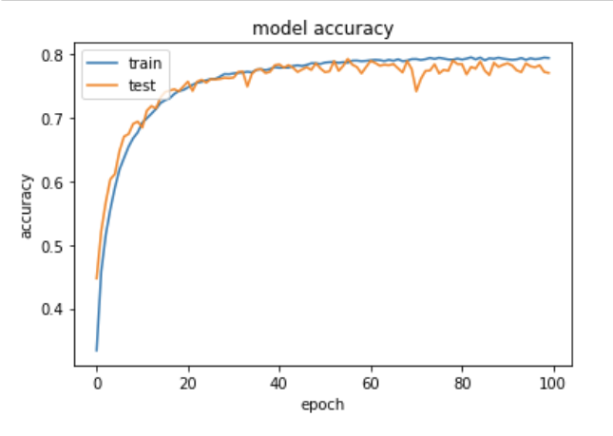 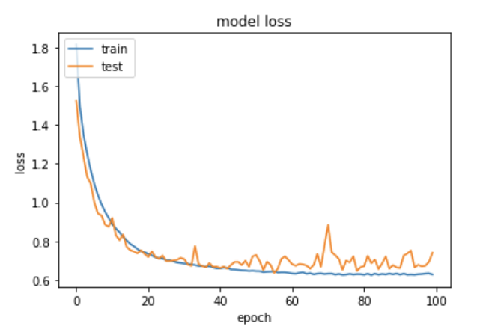

**2. Batch size**

A batch size indicates the amount of records to be involved in back propagation. Thus, too large a batch size decrease the efficiency of back propagation, while too small a batch size may slow down the process as a whole.

Under this very circumstance the team finds a tradeoff between the network performance and speed, using the following experiment:

When batch size is 32:

Test loss: 0.6967130443572999

Test accuracy: 0.7642

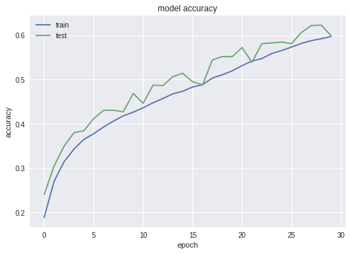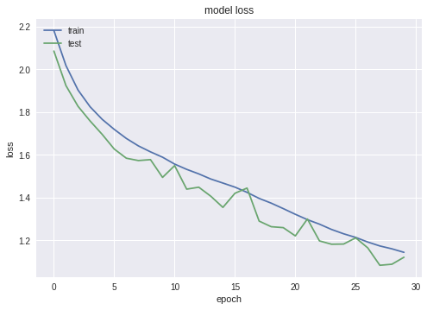

When batch size increased as 128:

Test loss: 0.799194857120514, Test accuracy: 0.7223

……

And when batch size increased to 256:

Test loss: 0.9514189182281494 Test accuracy: 0.6693

As for a batch size of 1024:

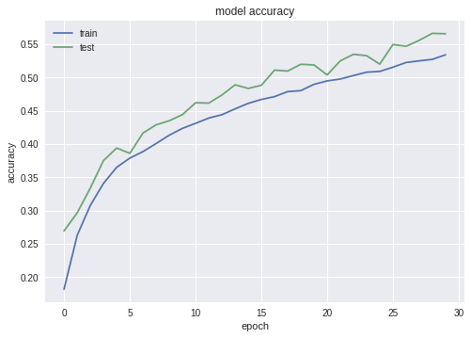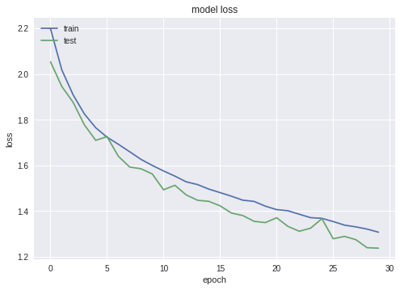

This leaves the model much fewer chances to improve itself, which leads an underfitting.

**3. Network configuration:**

The amount of layers and number of nodes together defines the complexity of a neural network. There is another trade off issue here between overfitting and underfitting when configuring the model.

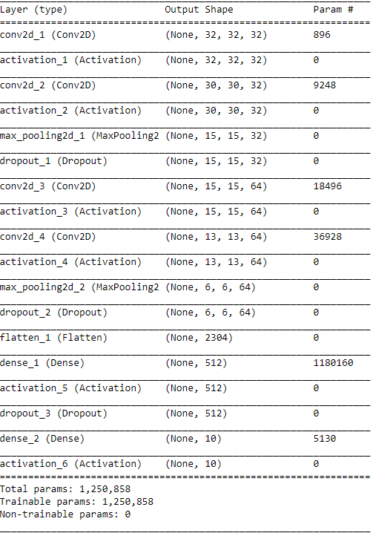

1. **Number of neurons in a layer:**

Keeping other parameters the same as above, and changing following layers’ neurons number: “conv2d_2” from 32 to 64, “conv2d_3”: 64 to 128, “conv2d_4”: 64 to 128, “dense_1”: 512 to 1024

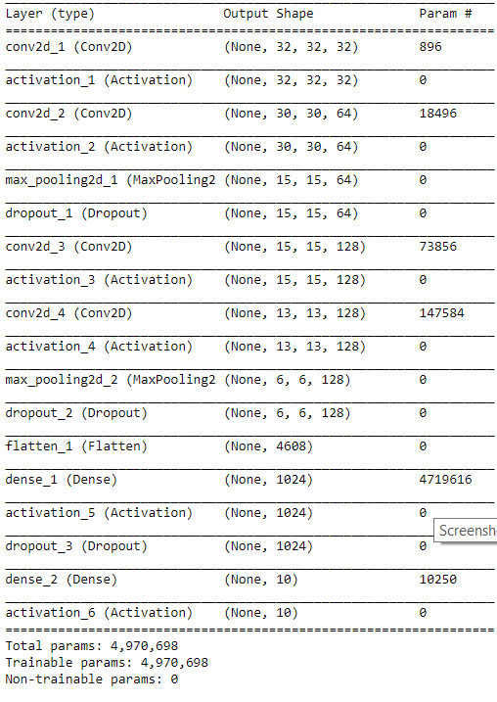

Test loss: 0.60612752037  
 Test accuracy: 0.8098

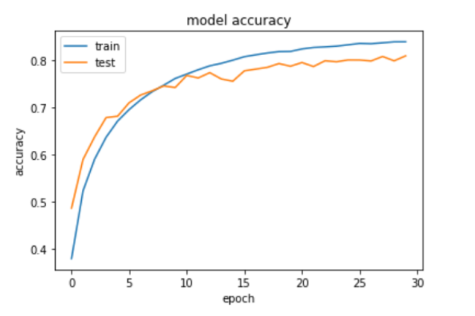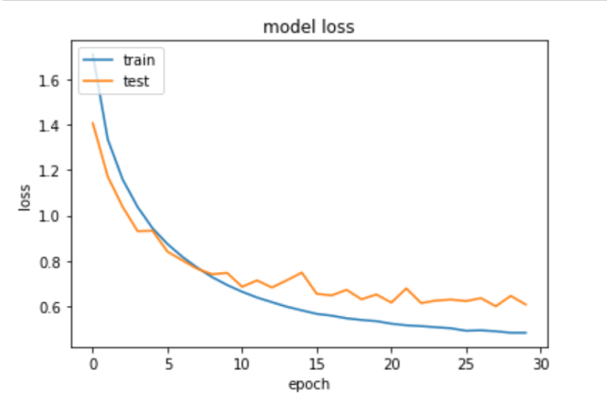

By adding neurons of each “conv2d” layer, we got a better accuracy and less loss. We assume that adding neurons improving the performance of MLP neural network.

1. **Number of layers:**

Keeping other parameters the same as above, and adding “conv2d_5”, “conv2d_6”, “max_pooling_2d_3”, “dropout_3” and “batch_normalization” layers after each conv2d layer.

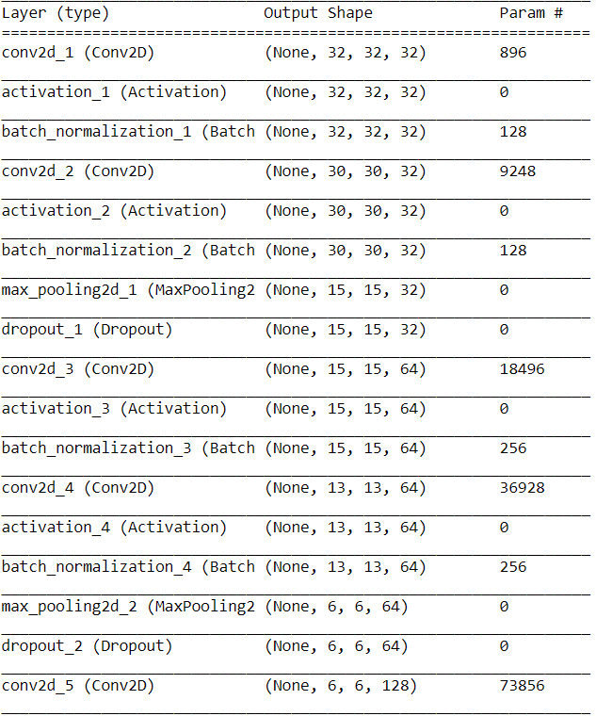

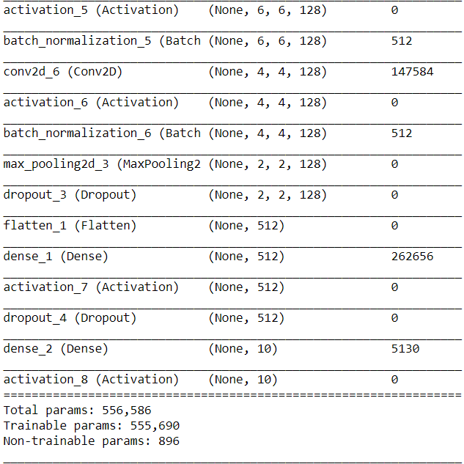

Test loss: 0.492332640553

Test accuracy: 0.8443

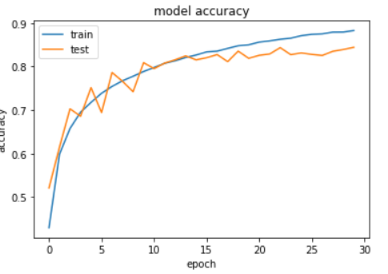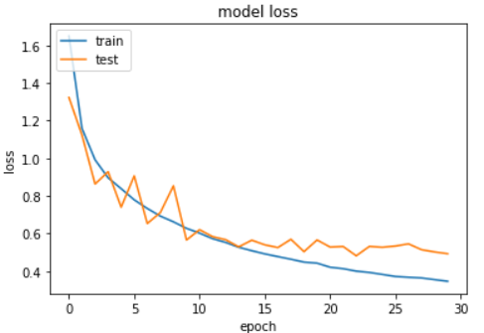

By adding more layers, we got the highest accuracy and the lowest loss; however, the model is kind of overfitting depending on the graphs above because the test loss (val_loss) is above the train loss from the epoch 15 to epoch 30.

**4. Learning rate**

A learning rate defines how much is the model changing the weight of each node according to the loss gradient. With a small learning rate the model may need many epochs to find its limit, for too large a learning rate is going to cause a failure in converging to the minimum loss.

By changing the learning rate from 0.001 to 0.01 we can see if the learning rate is too large, the gradient descent fails to converge and even deverge.

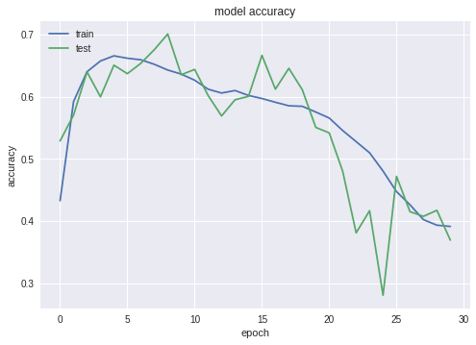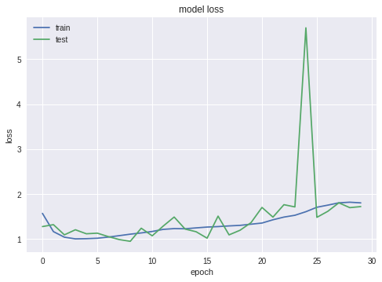

When adjusting the learning rate to a very small value(0.0001), the gradient descent can be very slow. The accuracy is less than learning rate at 0.001 that it may need more epochs to reach the same loss limit.

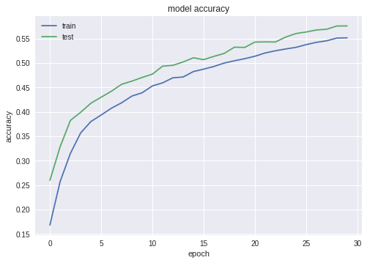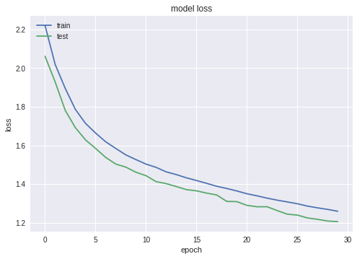

Overall the best learning rate is 0.001 for this model.

**5. Activation function**

Nodes in the network needs an activation function to trigger it and explain its way to influence the outputs. There are myriad of functions, amongst which there can be suitable ones or not for this specific problem.

The team tried the following functions: sigmoid, tanh, softplus, softmax, elu, selu.

1. **sigmoid**

Sigmoid function can compress the output into (0,1). But when implementing back propagation algorithm sigmoid function can easily cause saturation and gradient loss. After we replaced relu with sigmoid, the accuracy badly decreases and the loss is pretty high.

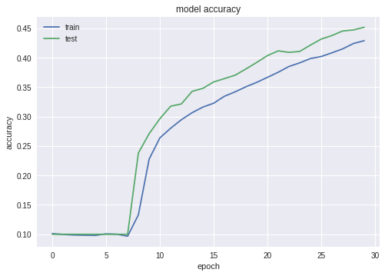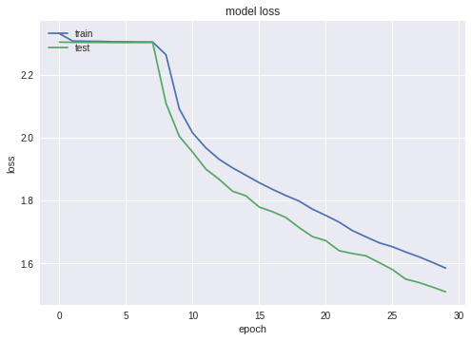

1. **tanh**

Tanh compresses output into an interval of [-1,1]. Unless sigmoid whose output is always positive, tanh is a zero-centered function, so the weights can be adjusted in all directions. Tanh shows a good performance in accuracy and loss.

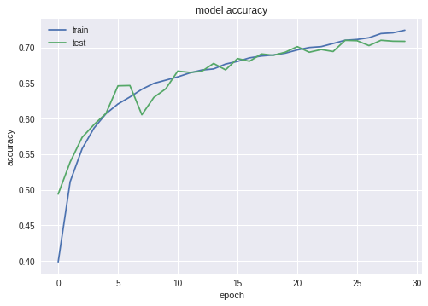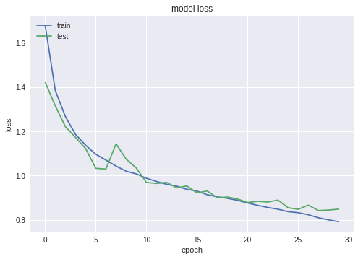

1. **softplus**

Softplus function is like smooth relu. Unlike relu rejects negative input, softplus can map all real number to positive output. However its derivative is always less than 1, so it has gradient loss problem too. For this model it shows now well with an accuracy just around 0.5.

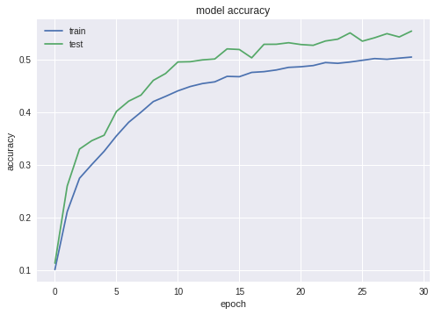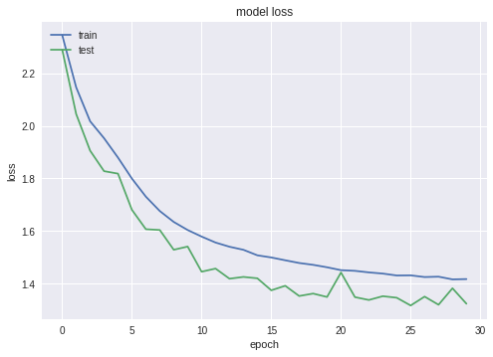

1. **softsign**

Softsign is kind of like tanh with symmetry at origin and output interval (-1,1). It performs as perfect as relu.

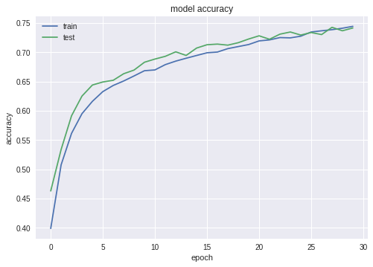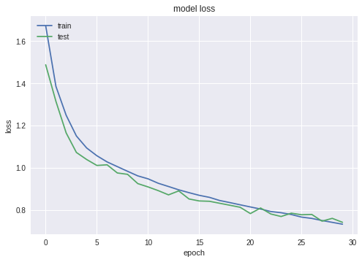

1. **elu**

Elu function is an enhanced version of relu. It introduces negative input with negative output. Elu brings the highest accuracy among all six tested activation functions.

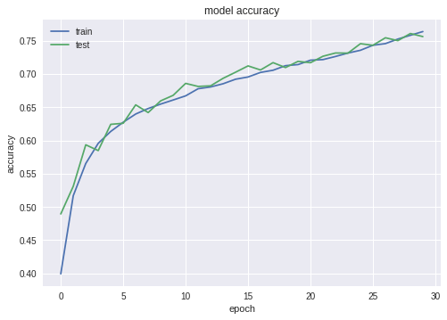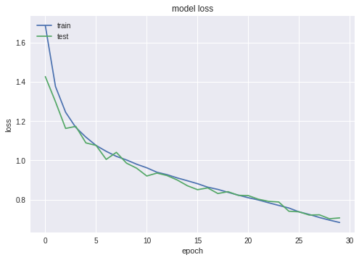

1. **selu**

Selu is a new variety of elu. They are similar on negative x half axis, while on positive x half axis the gradient of selu is larger than 1. For this model selu performs well on the training set, but validation set is overfitted.

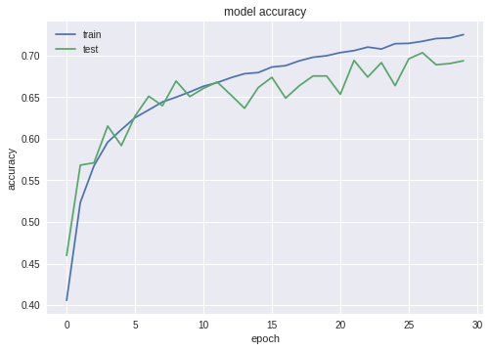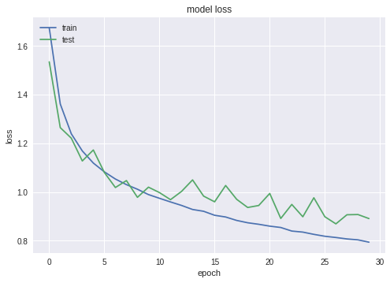

In general, elu and softsign do excellent job in this case, but relu is still the best choice, cause relu is the most simple and efficient activation function without too much complicated computation.

**6. Dropout rate**

Dropout is another regularization algorithm, that randomly cast a part of neurons out of the net according to a certain rate.

When I set dropout rate as 1…

Test loss: 1.8474201045036316

Test accuracy: 0.7192

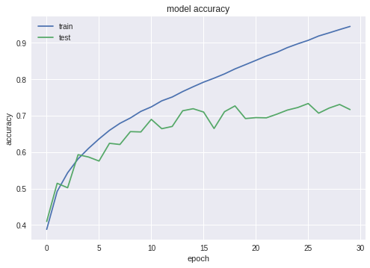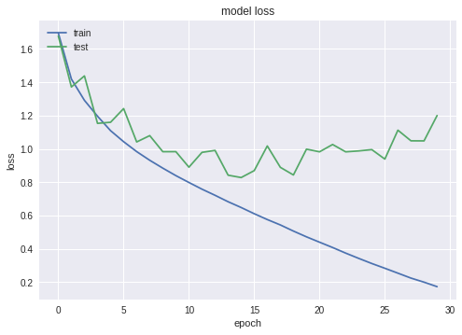

Nobody can stop the model being overfitted.

As for a dropout rate of (0.1,0.1,0.2):

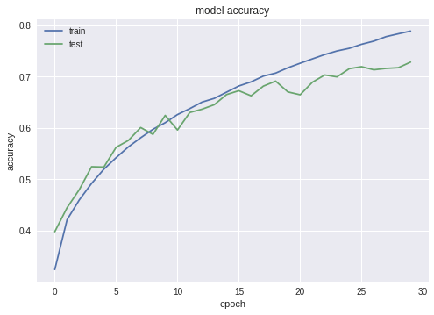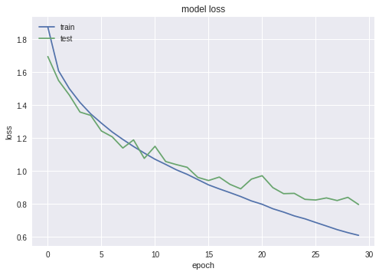

The model is overfitting after epochs.