NSC report

Jiahua Chen

2023-12-18

## Data Summary

### SInce December 2016, how many incidents involved an ebike in the U.S. and Canada?

NA indicates no response.

#### Raw count

| **ebike** | **US** | **Canada** |
| --- | --- | --- |
| Yes | 79 | 363 |
| No | 777 | 2391 |
| I don't know | 22 | 29 |
| NA | 539 | 771 |

#### Percentage: (sum across column)

| **ebike** | **US** | **Canada** |
| --- | --- | --- |
| Yes | 5.6 | 10.2 |
| No | 54.8 | 67.3 |
| I don't know | 1.6 | 0.8 |
| NA | 38.0 | 21.7 |

#### By country

Ebike vs Pedal Bike in the US

| **ebike** | **N** | **Percent** |
| --- | --- | --- |
| Yes | 79 | 5.58 |
| No | 777 | 54.83 |
| I don't know | 22 | 1.55 |
| NA | 539 | 38.04 |

Ebike vs Pedal Bike in Canada

| **ebike** | **N** | **Percent** |
| --- | --- | --- |
| Yes | 363 | 10.21 |
| No | 2391 | 67.28 |
| I don't know | 29 | 0.82 |
| NA | 771 | 21.69 |

## Gender vs Injury

### What are the gender of people who reported e-bike incidents?

#### Raw count

| **ebike** | **Female** | **Male** | **Other** | **Unknown** |
| --- | --- | --- | --- | --- |
| Yes | 119 | 140 | 8 | 175 |
| No | 677 | 1441 | 37 | 1013 |
| I don't know | 6 | 12 | 2 | 31 |
| NA | 131 | 226 | 3 | 950 |

#### Percentage

| **ebike** |  | **Female** | **Male** | **Other** | **Unknown** |
| --- | --- | --- | --- | --- | --- |
| Yes | % row | 26.9 | 31.7 | 1.8 | 39.6 |
| No | % row | 21.4 | 45.5 | 1.2 | 32.0 |
| I don't know | % row | 11.8 | 23.5 | 3.9 | 60.8 |
| NA | % row | 10.0 | 17.3 | 0.2 | 72.5 |

### What are the injury level by gender?

#### Raw count

| **ebike** | **gender** |  | **No injury** | **Injury no treatment** | **Injury with treatment** | **Unknown** |
| --- | --- | --- | --- | --- | --- | --- |
| Yes | Female | N | 95 | 14 | 10 | 0 |
|  | Male | N | 105 | 19 | 14 | 2 |
| No | Female | N | 501 | 64 | 100 | 12 |
|  | Male | N | 1113 | 148 | 173 | 7 |
| I don't know | Female | N | 5 | 0 | 1 | 0 |
|  | Male | N | 7 | 0 | 3 | 2 |
| NA | Female | N | 116 | 7 | 8 | 0 |
|  | Male | N | 196 | 11 | 19 | 0 |

#### Percentage

| **ebike** | **gender** |  | **No injury** | **Injury no treatment** | **Injury with treatment** | **Unknown** |
| --- | --- | --- | --- | --- | --- | --- |
| Yes | Female | % row | 79.8 | 11.8 | 8.4 | 0.0 |
|  | Male | % row | 75.0 | 13.6 | 10.0 | 1.4 |
| No | Female | % row | 74.0 | 9.5 | 14.8 | 1.8 |
|  | Male | % row | 77.2 | 10.3 | 12.0 | 0.5 |
| I don't know | Female | % row | 83.3 | 0.0 | 16.7 | 0.0 |
|  | Male | % row | 58.3 | 0.0 | 25.0 | 16.7 |
| NA | Female | % row | 88.5 | 5.3 | 6.1 | 0.0 |
|  | Male | % row | 86.7 | 4.9 | 8.4 | 0.0 |

#### Graph Visualization:

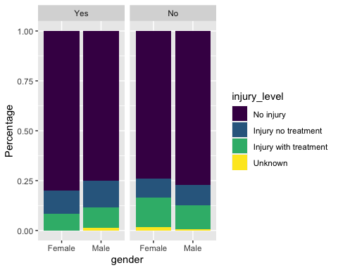

## Age vs Injury

### What are the ages of people who reported e-bike incidents?

#### Raw count

| **ebike** | **0-12** | **13-17** | **18-24** | **25-34** | **35-44** | **45-54** | **55-64** | **65-74** | **75+** |
| --- | --- | --- | --- | --- | --- | --- | --- | --- | --- |
| Yes | 0 | 2 | 9 | 64 | 92 | 36 | 32 | 5 | 2 |
| No | 3 | 17 | 132 | 638 | 533 | 297 | 217 | 74 | 4 |
| I don't know | 0 | 0 | 1 | 4 | 6 | 2 | 2 | 1 | 0 |
| NA | 0 | 1 | 19 | 94 | 105 | 34 | 42 | 11 | 1 |

#### Percentage

| **ebike** |  | **0-12** | **13-17** | **18-24** | **25-34** | **35-44** | **45-54** | **55-64** | **65-74** | **75+** |
| --- | --- | --- | --- | --- | --- | --- | --- | --- | --- | --- |
| Yes | % row | 0.0 | 0.5 | 2.0 | 14.5 | 20.8 | 8.1 | 7.2 | 1.1 | 0.5 |
| No | % row | 0.1 | 0.5 | 4.2 | 20.1 | 16.8 | 9.4 | 6.8 | 2.3 | 0.1 |
| I don't know | % row | 0.0 | 0.0 | 2.0 | 7.8 | 11.8 | 3.9 | 3.9 | 2.0 | 0.0 |
| NA | % row | 0.0 | 0.1 | 1.5 | 7.2 | 8.0 | 2.6 | 3.2 | 0.8 | 0.1 |

#### Graph Visualization

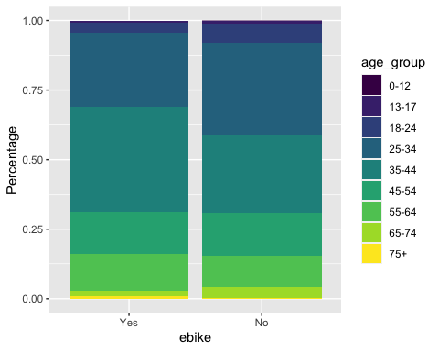

### What are the injury level by age?

#### **Raw count**

| **ebike** | **injury_level** | **0-12** | **13-17** | **18-24** | **25-34** | **35-44** | **45-54** | **55-64** | **65-74** | **75+** |
| --- | --- | --- | --- | --- | --- | --- | --- | --- | --- | --- |
| Yes | No injury | 0 | 2 | 5 | 52 | 75 | 27 | 21 | 3 | 2 |
|  | Injury no treatment | 0 | 0 | 2 | 8 | 12 | 4 | 4 | 1 | 0 |
|  | Injury with treatment | 0 | 0 | 2 | 4 | 4 | 5 | 6 | 1 | 0 |
| No | No injury | 1 | 8 | 86 | 500 | 431 | 220 | 171 | 48 | 0 |
|  | Injury no treatment | 1 | 5 | 23 | 63 | 47 | 25 | 19 | 6 | 2 |
|  | Injury with treatment | 1 | 4 | 22 | 67 | 50 | 51 | 26 | 20 | 2 |

#### Percentage

| **ebike** | **injury_level** |  | **0-12** | **13-17** | **18-24** | **25-34** | **35-44** | **45-54** | **55-64** | **65-74** | **75+** |
| --- | --- | --- | --- | --- | --- | --- | --- | --- | --- | --- | --- |
| Yes | Injury with treatment | % row | 0.0 | 0.0 | 5.6 | 11.1 | 11.1 | 13.9 | 16.7 | 2.8 | 0.0 |
|  | Injury no treatment | % row | 0.0 | 0.0 | 4.2 | 16.7 | 25.0 | 8.3 | 8.3 | 2.1 | 0.0 |
|  | No injury | % row | 0.0 | 0.6 | 1.4 | 14.8 | 21.3 | 7.7 | 6.0 | 0.9 | 0.6 |
|  | Unknown | % row | 0.0 | 0.0 | 0.0 | 0.0 | 16.7 | 0.0 | 16.7 | 0.0 | 0.0 |
| No | Injury with treatment | % row | 0.3 | 1.0 | 5.5 | 16.8 | 12.6 | 12.8 | 6.5 | 5.0 | 0.5 |
|  | Injury no treatment | % row | 0.3 | 1.6 | 7.5 | 20.5 | 15.3 | 8.1 | 6.2 | 2.0 | 0.7 |
|  | No injury | % row | 0.0 | 0.3 | 3.5 | 20.6 | 17.8 | 9.1 | 7.1 | 2.0 | 0.0 |
|  | Unknown | % row | 0.0 | 0.0 | 2.5 | 20.0 | 12.5 | 2.5 | 2.5 | 0.0 | 0.0 |
| I don't know | Injury with treatment | % row | 0.0 | 0.0 | 7.1 | 7.1 | 14.3 | 0.0 | 0.0 | 0.0 | 0.0 |
|  | Injury no treatment | % row | 0.0 | 0.0 | 0.0 | 0.0 | 0.0 | 0.0 | 0.0 | 0.0 | 0.0 |
|  | No injury | % row | 0.0 | 0.0 | 0.0 | 12.5 | 12.5 | 4.2 | 8.3 | 4.2 | 0.0 |
|  | Unknown | % row | 0.0 | 0.0 | 0.0 | 0.0 | 11.1 | 11.1 | 0.0 | 0.0 | 0.0 |
| NA | Injury with treatment | % row | 0.0 | 0.0 | 0.9 | 1.2 | 1.5 | 1.5 | 0.9 | 0.9 | 0.0 |
|  | Injury no treatment | % row | 0.0 | 0.0 | 0.0 | 4.2 | 3.5 | 0.0 | 3.5 | 0.0 | 0.0 |
|  | No injury | % row | 0.0 | 0.1 | 2.1 | 10.8 | 12.2 | 3.7 | 4.4 | 1.0 | 0.1 |
|  | Unknown | % row | 0.0 | 0.0 | 0.0 | 0.0 | 0.0 | 0.0 | 0.0 | 0.0 | 0.0 |

#### Graph Visualization

