State Diagram:

Interrupt/Exception:

26,50,51: Load INTV with the correct value. Load the User Stack Pointer (USP) with value in R6. Load the oldPSR register with PSR. Sets PSR to Supervisor Mode. Set EVENT = 0 to indicate interrupt. Clears the interrupt flag.

63: Same as 26, 50, 51 except EXCV is loaded, and EVENT is set to 1 to indicate exception.

59: Loads R6 with Supervisor Stack Pointer (SSP)

57: Subtracts R6 by 2 and loads into MAR

53: Loads MDR with oldPSR

52: Stores oldPSR into address defined by R6

54: Subtracts R6 by 2 and loads into MAR

55: Loads MDR with PC

56: Stores PC into address defined by R6

58: Loads MAR with INTV or EXCV depending on EVENT bit

60: Load value stored at that location

62: Load MDR into PC

RTI:

8: Load MAR with R6

36: Load value defined by R6

38: Load value from MDR into PC

39: Add R6 by 2 and load into MAR

40: Load value defined by R6

42: Load PSR with value from MDR

37: Load R6 with User Stack Pointer (USP)

41: Switch back to User Mode

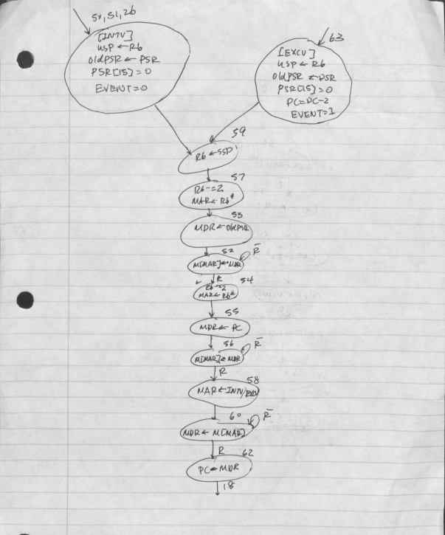

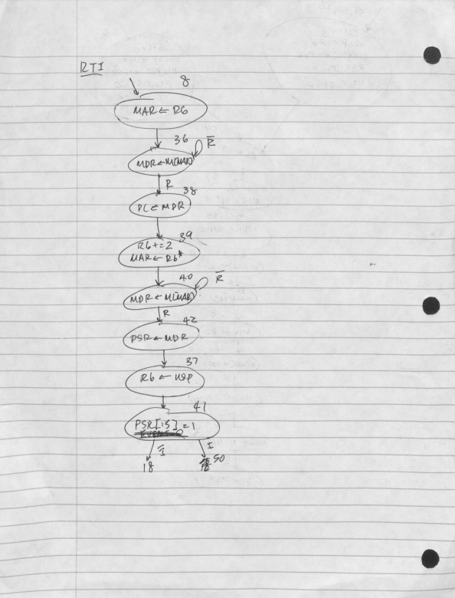

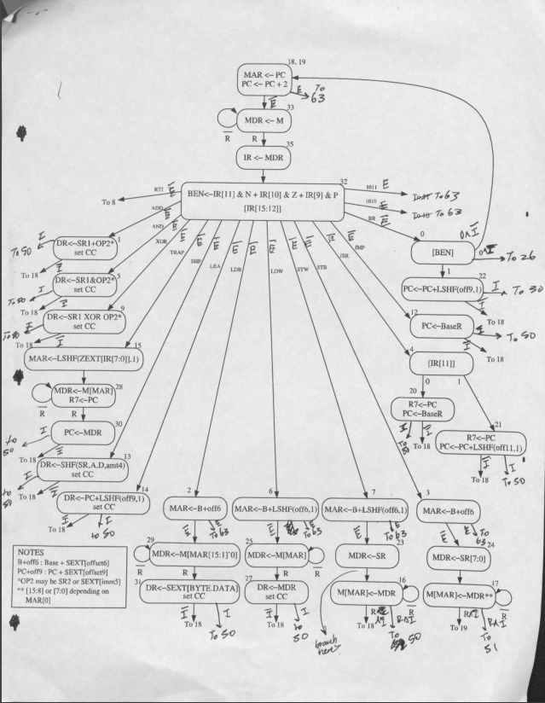

Datapath:

The GateStack structure is used to implement stack switching. It can output changes to the R6 register by passing in a +/- 2 to the SR1out. It’s also used to pass either the USP or SSP to the bus as needed, and only the USP ever needs to be loaded.

The additional -2 adder option into PCMUX is to handle exceptions.

The MARMUX2 structure is used for altering values from the vector table, before storing into the MAR.

The PSR structure is used for efficient saving of the old PSR before saving and to effectively either clear bit 15, set bit 15, or obtain data from the BUS.

The GateIE structure is used to pass appropriate EXCV or INTV values depending on the EVENT that has occurred. These registers are loaded by additional logic, which will be set by analyzing the current state of the machine.

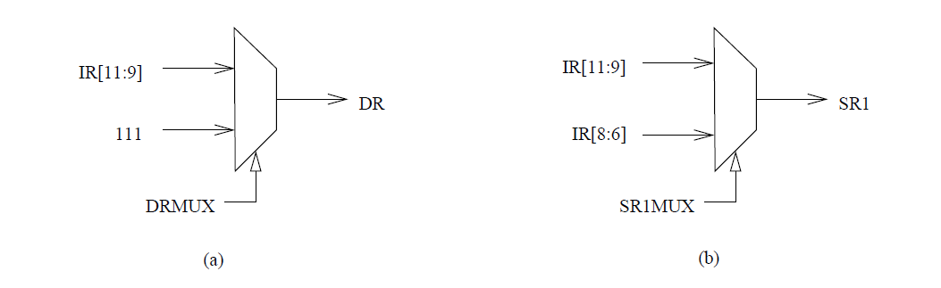

110

110

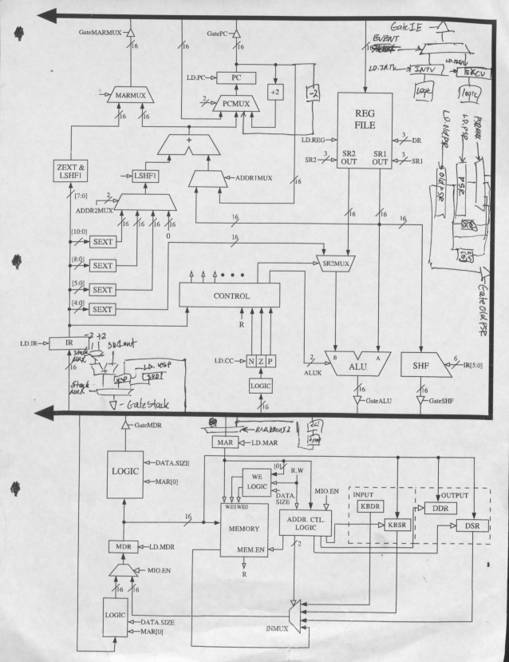

New Control Signals:

LD.EXCV, LD.PSR, LD.OLDPSR, LD.EVENT, and LD.USP are used to control when these registers are loaded.

INTFLAGCLR is used to clear the interrupt flag after entering states 50,51, or 26 to indicate that the interrupt is being handled.

CCUPDATE is used to update condition codes during the RTI instruction when PSR is loaded from the supervisor stack.

PCMUX has an additional possibility (3) to indicate PC = PC-2.

DRMUX can now have the destination register be set to R6 with value 2.

SR1MUX can now have the source register be set to R6 with value 2.

MARMUX2 is used to select what should be loaded into MAR

0: BUS

1: BUS << 1 + x200

PSRMUX is used to select which value will be loaded into the PSR.

0: update CC portion of PSR

1: clear PSR[15]

2: set PSR[15]

3: BUS

STACKADDRMUX is used to select which value to add to SR1, which should be R6

0: -2

1: +2

STACKMUX is used to select which value should be sent to the bus for stack switching

0: STACKADDR

1: USP

2: SSP

EVENTMUX is used to select what should be loaded into the EVENT register.

Microsequencer:

This was designed to simply exceptions, by sending all exceptions to the same state 63 (11111). This required an additional COND bit. There were specific combinations of condition bits meant to ensure which exceptions could occur where.

0110: unknown opcode

0111: protected or unaligned

1000: unaligned only

Other condition bits were used for interrupts.

0101: normal check of interrupt flag

0100: check for ready bit and interrupt flag for memory accesses

Additional logic is used for the BEN state 0 because it should only branch to state 26 if the branch isn’t taken. An additional MUX is also added in case IRD = 1 to handle unknown opcode exceptions.

