哈哈哈哈aaaaaaaaaaaaaaaaaaa

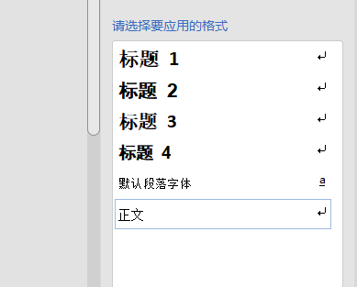bbbbbbb

Dasdasddasddasdasdada

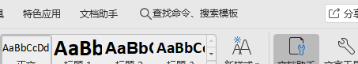

|  |  |  |
| --- | --- | --- |
| ddd | ddd | ddd |
| ccc |  | ddd |

aaaaaaaaaaaaaaaaavvvvvvvvvvvvvvvvvvvvvvv