**Analyzing US Insurance Market**

**Group 5**

**Roger Hung, Erin Cao, Henry Gao, Stella He, Jiajie Yuan, Robert Malongo**

# **Introduction**

Private single-payer model is a system in which a single public or quasi-public agency organizes health care financing, but the delivery remains largely in private hands. This model has been growing at a rapid rate and the US Federal government plans to shift more Medicare beneficiaries to this model.

There is a demand to select which companies are the best to partner with. In this case, we assist to find the best candidate to provide health insurance services in each state. In our proposal, we calculate the market share of major insurance companies and the Herfindahl-Hirschman Index (HHI) for each state.

Further, we investigate the benefit package offered by the major insurance companies and focus on the coverage of dental services. We provide a summary of the percentage of enrollees covered with preventive and comprehensive dental care.

There is a concern among the Congress that drug addiction has become a national crisis. We undertake this analysis in order to understand determine insurance companies that are more proactive in making sure their members are not on an unsafe dose of prescription opioids for a prolonged period. We report the weighted average of the *Use of Opioids at High Dosage****”*** (UOD) of the top ten companies with the largest market share in each state.

# 

# **Results and Discussions**

## **Question 1: Private single-payer Partner**

In order to find out the private single-payer partner, we divided our work into two stages——data preparation and data manipulation.

There are three things that we completed at the data preparation stage. Firstly, we reviewed the three relevant datasets, “CPSC_Enrollment_Info_2019_10”, “Montlhy_Report_By_Plan_2019_10” and “MajorInsuranceOrgs”, to get a better understanding of how messy the whole insurance market is and to identify the hierarchy in the market. Secondly, we cleaned the data by dropping the rows of our dataset where the number of enrolled beneficiaries is missing or the enrollment count is 10 or less. In addition, we filtered out the contracts with their names starting with “s”. Thirdly, we merged the two datasets, “CPSC_Enrollment_Info_2019_10” and “Montlhy_Report_By_Plan_2019_10” by state and plan ID columns to look for which insurance company is offering which contract. Based on prior data, we again merged the data with the “MajorInsuranceOrgs” dataset to keep only the big-name companies. However, since some of the names in “Organization.Marketing.Name” column couldn’t match with names provided in the “Organization Marketing Name” column in “MajorInsuranceOrgs” dataset but still possess some amount of enrollments, we decided, considering not to influence the total market share, to include those companies into our analysis as long as they hold high enough enrollments, which means we see those companies’ “Organization Marketing Name” as their major organization names.

The main goal at the data manipulation stage was to calculate the market share of the big-name companies in given states and to mark the top-4 states in terms of market concentration. Based on the analysis(the coding process is enclosed in the appendix), we discover that the top 4 states with the highest Herfindahl-Hirschman Index(HHI) among the 8 states assigned are South Dakota, Mississippi, New Jersey and South Carolina. Furthermore, for each of the four states, we came up with the company with the largest share, or “lion's share” of the market. They are Medica in South Dakota, UnitedHealthcare in South Carolina, Aetna Health Inc. in New Jersey, and Humana in Mississippi. The following figure and table demonstrate the Herfindahl-Hirschman Index we derived from the dataset and the market share that the four biggest players in the four states respectively.

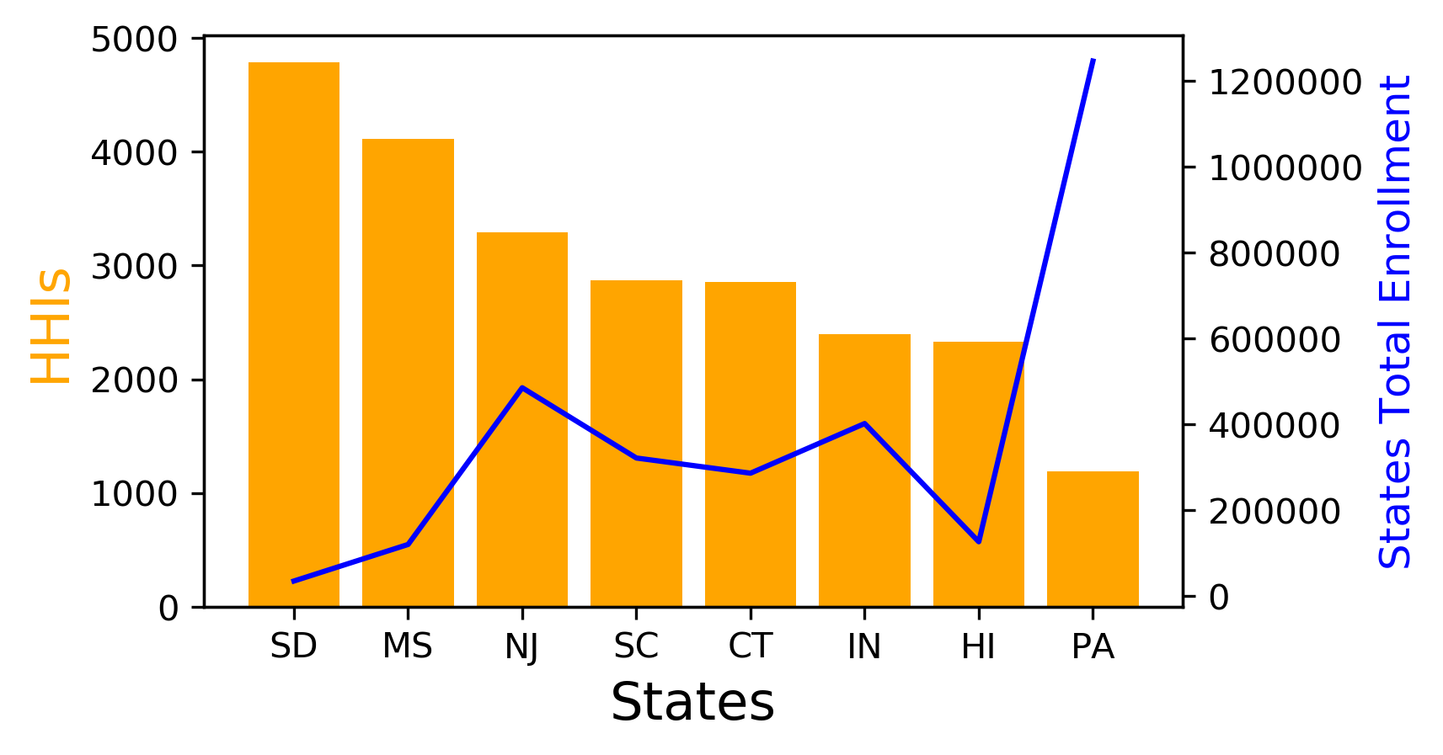

**Figure 1.1** HHIs and Total Enrollment in each state

From the figure, we could find the top 4 highest HHI states. Interestingly, we also noticed that Pennsylvania, despite having the lowest HHI, contains an outstanding high total enrollment. This phenomenon could be attributed to a more open market due to high enrollment, or demand, giving equal opportunities for insurance companies. On the contrary, in a highly concentrated marketplace like South Dakota, the enrollment turns out to be extremely low compared with the other states.

|  |  |  |  |
| --- | --- | --- | --- |
| **State** | **HHI** | **Company with largest share** | **Market Share** |
| SD | 4785 | Medica HealthCare | 64% |
| MS | 4116 | Humana | 59% |
| NJ | 3295 | Aetna Health Inc. | 45% |
| SC | 2866 | UnitedHealthcare | 41% |

**Table 1.1** Companies with the largest share in the market

As shown in the table, in states with higher HHI, in other words, a more concentrated marketplace, there exist companies with significant market share. To be more specific, the top 2 companies in each state listed above account for more than 70% of the total market share, causing the market more of an oligopoly or even duopoly[1]. Once a few businesses control the vast majority of the market division, they can easily influence the industry by colluding on prices or output. However, as the instruction requires us to look for a company that has 70% of the market share while the rest have the remaining 30% in a state, none of the companies in given states meet the criteria in our findings. The closest case would be Medica HealthCare in South Dakota, which accounts for 64% of the market share. Surprisingly, despite being the top 1 player in South Dakota, Medica HealthCare does not appear on the top 5 players list of any other given states. Further research revealed that South Dakota is one of the four primary service areas of Medica HealthCare, which may be a plausible explanation for this finding.

## 

## 

## **Question 2: Insurance Benefit Package**

In order to get useful features for question 2, we cleaned and manipulated the date based on three tables, which are pbp_b16_dental.csv, CPSC_Enrollment_Info_2019_10.csv and Monthly_Report_By_Plan_2019_10.csv. Another premise is that Question 2 is based on Question 1 solution. Therefore, we obtained the top-5 insurance companies by market share in each state from the first question by filtering out for these companies in our datasets

According to the requirement of data cleaning shown in the instruction file, we dropped data in which the number of enrolled beneficiaries is missing or marked with *. That has been done for two tables: Monthly_Enrollment_by_Plan.csv and CPSC_Enrollment_Info_2019_10.csv. It is obvious that these three tables have many variables, but not every variable is useful for this question. Therefore, we selected the useful variables which are "Contract Number","Plan ID" , “Enrollment” and "Organization Marketing Name" in Monthly_Enrollment_by_Plan.cvs, and “pbp_a_hnumber”, “pbp_a_plan_identifier”, “segment id”, “pbp_b16a_bendesc_yn” and “pbp_b16b_bendesc_yn” from pbp_b16_dental.csv. After choosing those useful variables, we merged Monthly_Report_By_Plan_2019_10.csv, pbp_b16_dental.csv and CPSC_Enrollment_Info_2019_10.csv on both contract number and plan ID. We cannot ignore the fact that in the table, pbp_b16_dental.csv has different column names for "Contract Number" and "Plan ID", which are "pbp_a_hnumber" and "pbp_a_plan_identifier". Thus, we renamed these two columns in order to merge tables much more convenient.

After merging the data, we obtained the combined table. According to the second hint of question 2, we filtered data by plan and segment and made every entire plan has the same data with the lowest segment in that plan. After data cleaning, data integration, and some preparation, we counted the number of enrollees enjoy the “Preventive Dental Items as a supplemental benefit under Part C” and the “Comprehensive Dental Items as a supplemental benefit under Part C” , and the number of total enrollees in the top-5 insurance companies in each state. By dividing the previous number by the total enrollee numbers, we obtained the percentage of enrollees enjoying preventive and comprehensive dental items in these insurance companies.

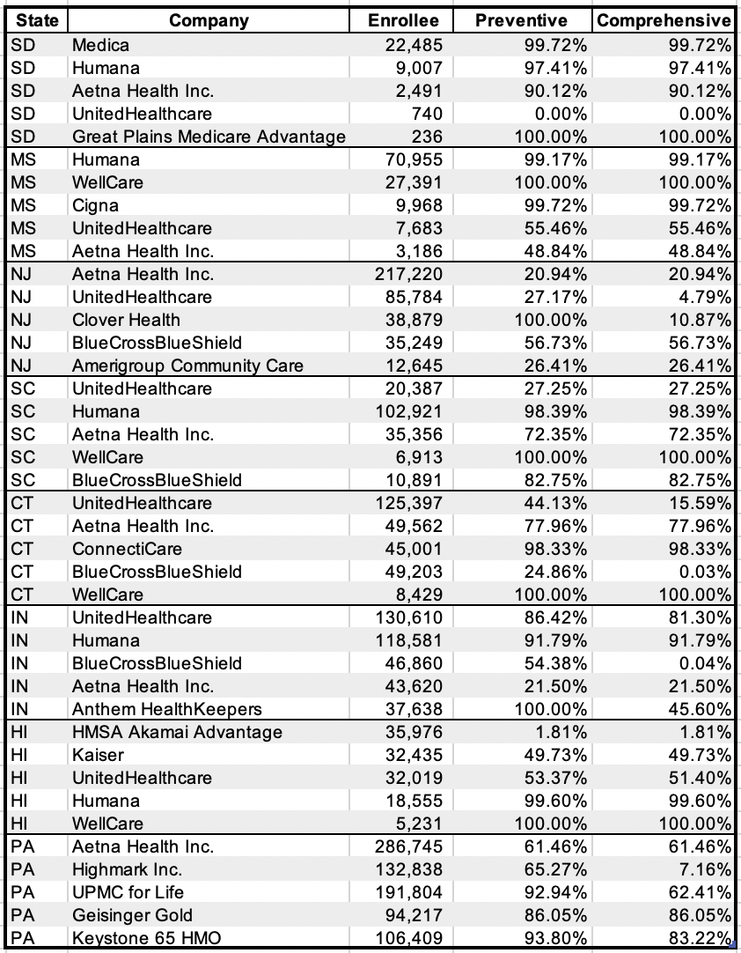

**Table 2.1** Percentage Enrollees Enjoy Preventative & Comprehensive(All given states)

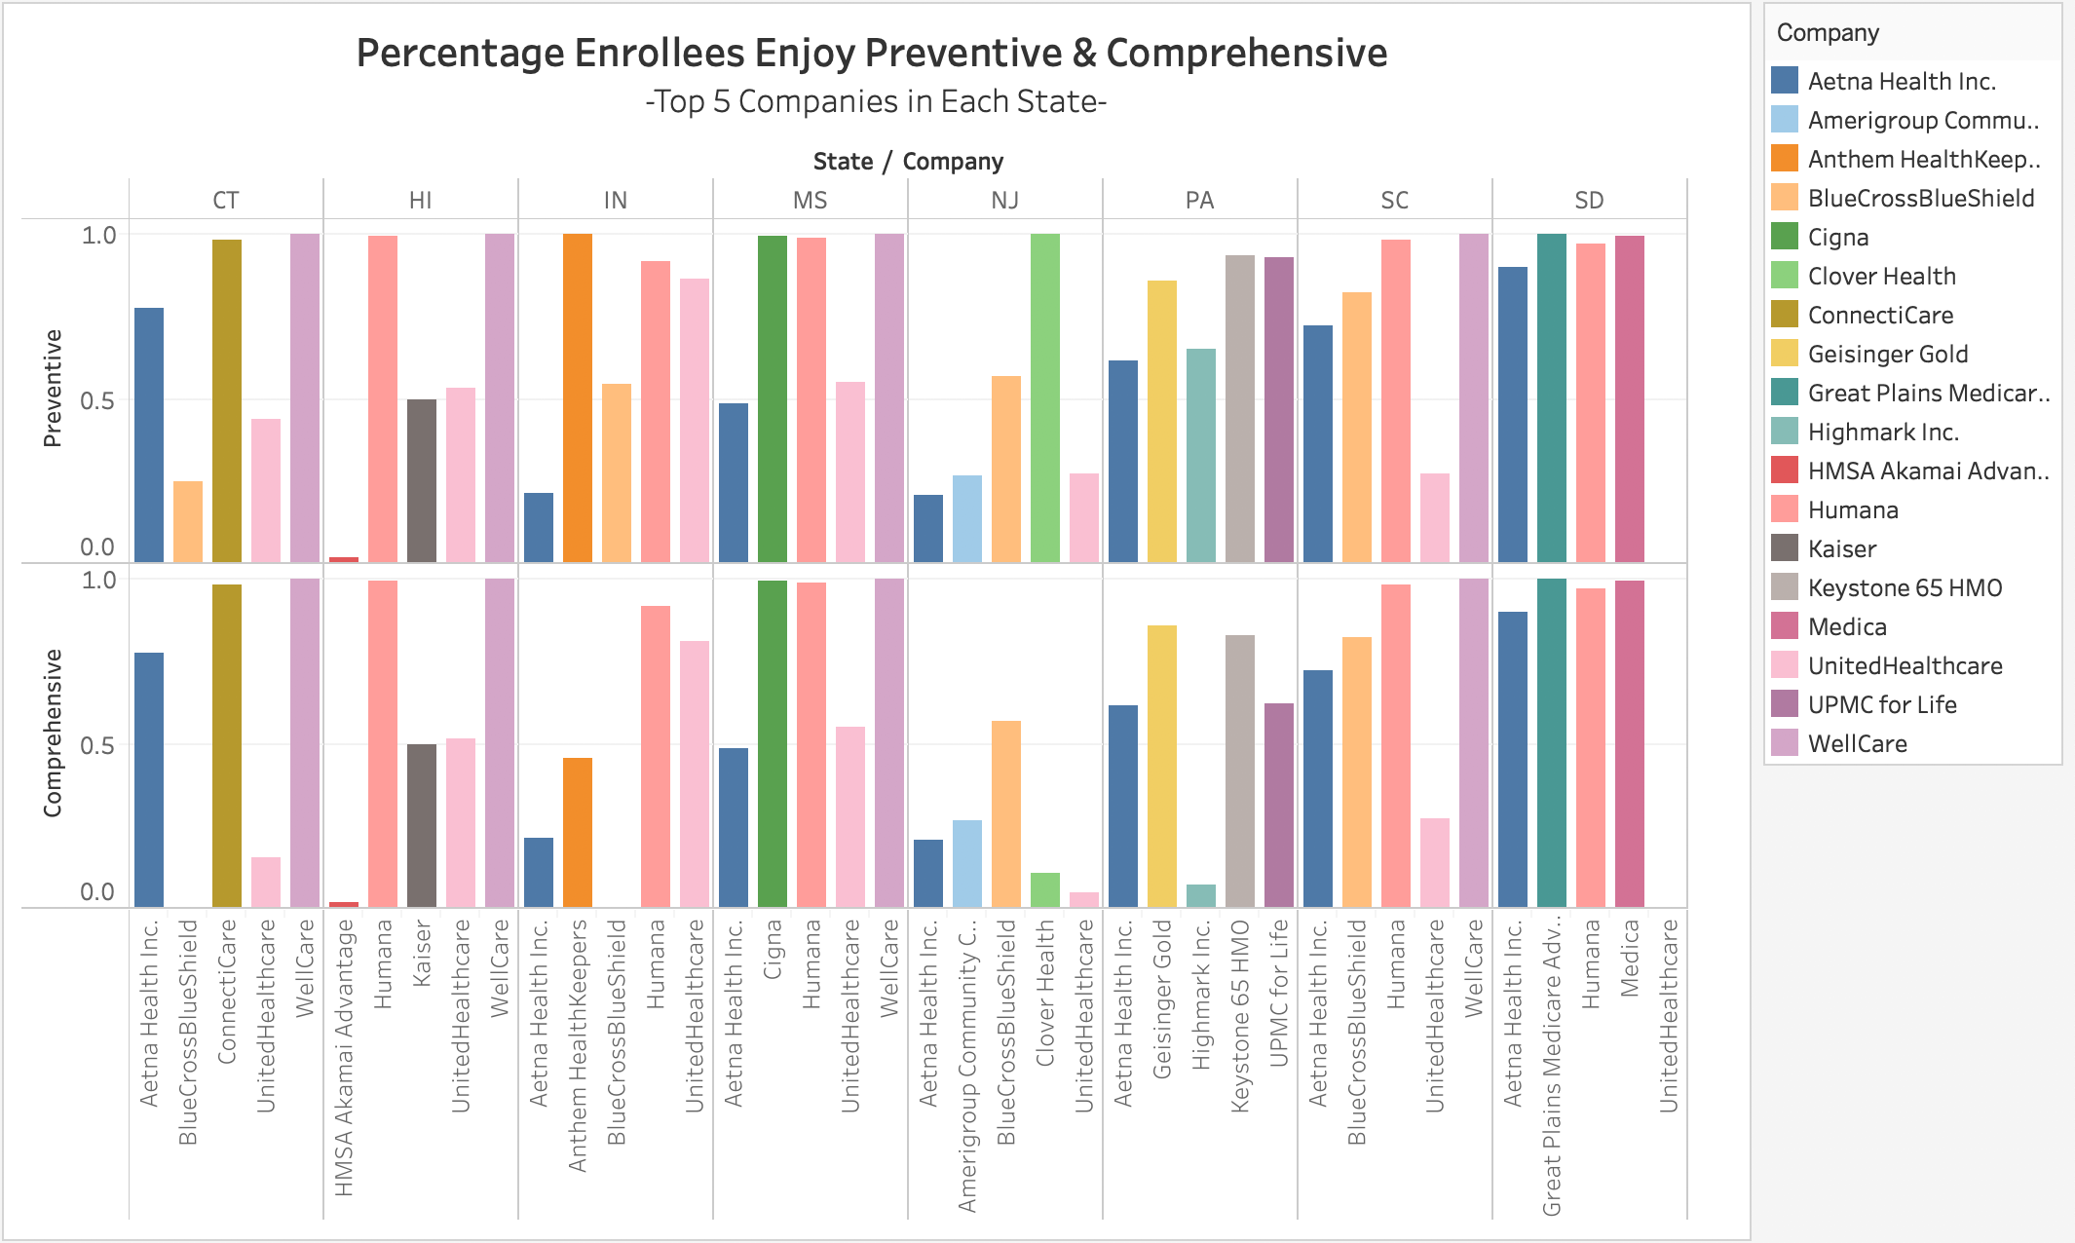

**Figure 2.1** Percentage Enrollees Enjoy Preventative & Comprehensive

After analyzing the percentage of enrollees with preventive and comprehensive dental items in the top-5 insurance companies in each state, we had several findings.

Firstly, many of these top companies in each state cover both preventive and comprehensive dental items in most of their plans. Great Plains Medicare Advantage and WellCare have all of their enrollees enjoy both preventive and comprehensive items. Humana also provides most enrollees (more than 90%) both preventive and comprehensive items in multiple states.

Secondly, most companies have the same percentage of preventive and comprehensive dental items, which means their plans cover preventive and comprehensive dental items at the same time. When there's a difference between preventive and comprehensive coverage, there is always more coverage for preventive items, which means some companies provide plans with only preventive items but not comprehensive items. Those companies include UnitedHealthcare, Clover Health, BlueCrossBlueShield, Anthem HealthKeepers, Highmark Inc., UPMC for Life and Keystone 65 HMO.

Lastly, we found that there can be geographical/regional differences in dental coverage. While some companies like WellCare provides 100% preventive and comprehensive dental items for enrollees in all states, a lot of identical companies provide very different percentages of preventive and comprehensive dental items in different states. For instance, UnitedHeathCare provides 80% dental coverage for enrollees in IN but 0% for enrollees in SD.

## 

## **Question 3: Quality of care and performance of the plans**

The opioid crisis is one of the major challenges facing the healthcare industry in the US. Prescription opioids are often used to treat chronic and acute pain and, when used appropriately, can be an important component of treatment. However, serious risks are associated with their use, and it is essential to carefully consider the risks of using prescription opioids alongside their benefits. These risks include misuse, opioid use disorder (addiction), overdoses, and death. In 2017, nearly two million nonelderly adults in the United States had an opioid use disorder (OUD), and of these adults, nearly four in ten were covered by Medicaid. There were over 476,600 opioid overdose deaths in the US alone in 2017.

CMS requires that all managed care organizations undergo an audit on Healthcare Effectiveness Data and Information Set (HEDIS) measures. HEDIS captures data related to the usage of opioid drugs among Part C members among other variables. For this analysis we focus on the “*Use of Opioids at High Dosage****”*** (UOD) variable. This variable reports the rate per 1,000 for members who are 18 years and older receiving prescription opioids for greater than or equal 15 days during the measurement year at a high dosage. A high dosage is defined as average Morphine Equivalent Dose (MED) greater than 120 mg. This data is reported at the contract level and a lower rate indicates better performance by the insurance provider.

The graph below shows the weighted average of the UOD rate based on the enrollment number of the company for each company across the four states with the highest HHI. The table afterwards shows the weighted average of the UOD rate across all the eight states. These results are limited to the top 10 insurance companies in each state only.

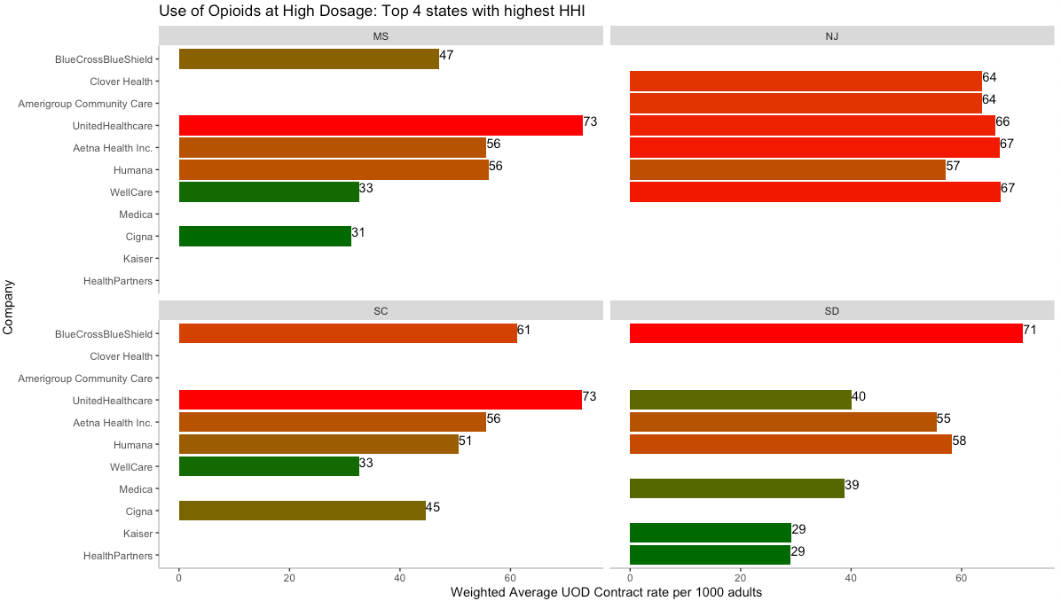

**Figure 2.1** Use of Opioids at High Dosage: Top 4 states with highest HHI

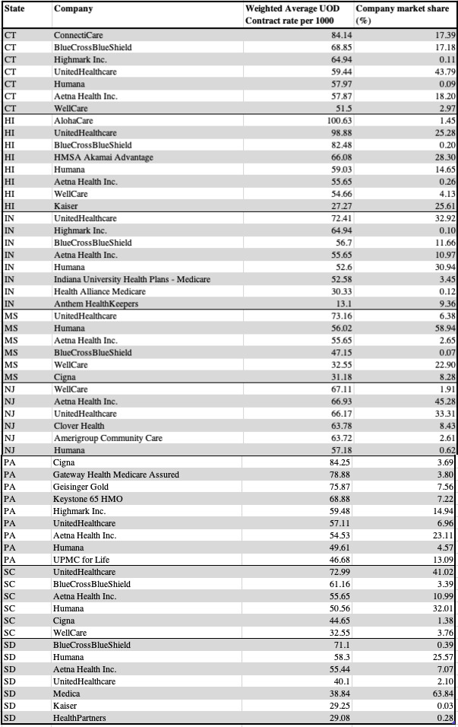

**Table 3.1:** Usage of Opioids at High Dosage: Top 10 Insurance Companies in each state[2]

We notice that there are significant differences in the UOD rate among the top 10 insurance companies in each state. Among the four states with the highest HHIs, *UnitedHealthCare* is the worst performer as it has the highest UOD rate of 73.11 and 72.99 in Minnesota and South Carolina respectively. The New Jersey market is saturated with the worst performers with all the major insurance companies having a UOD rate exceeding 55.0. This suggests that the likelihood of opioid overdose is higher in New Jersey as compared to the other three states with high HHIs.

In all states, UOD rates are highest for insurance companies in Hawaii with AlohaCare, *UnitedHealthaCare*, and *BlueCrosBlueShield* having rates of 100.63, 98.88, and 82.03 respectively. Among all the major insurance companies *BlueCrosBlueShield* appears to provide the highest rate. This company’s rate is in the top three in five of the six states in which its market share is in the top ten. *UnitedHealthaCare* also persistently has some of the highest UOD rates. The company’s rate tops the list in South Carolina and Mississippi. This is a cause for concern as these high UOD rates may only exacerbate the opioid crisis in the states in which *BlueCrosBlueShield* and *UnitedHealthaCare* are the major insurance providers. To make it worse *UnitedHealthaCare* is the largest health insurance company in the US, meaning that it covers more people thereby increasing the total number of people affected by opiods.

On the other extreme, insurance companies in South Dakota are providing the lowest UOD rates with *Kaiser* and *HealthPartners* having rates as low as 29.25 and 29.08 respectively. Conversely, this implies that the risk of opioid misuse is lower in this state in comparison to the other seven states. Across all eight states, *Kaiser* has one of the lowest UOD rates with 27.25 in Hawaii and 29.25 in South Dokota. The company has been very active in limiting opioid prescriptions overall, prescribing them only when it’s safe and appropriate. The volume of opioids prescribed by *Kaiser* has dropped by more than 40% between January 2011 and February 2017. In Hawaii, the number of high-dose opioid prescriptions has fallen by 47% within this period. The company’s prescription rate has also fallen by 47% across the Mid-Atlantic states where South Dokota is located.

# 

# **Conclusion**

After calculating the market shares for big name insurance companies in given states, we got top 4 states with relative higher market shares. We also discover that the top-4 states with the highest Herfindahl-Hirschman Index(HHI) among the 8 states assigned are South Dakota, Mississippi, New Jersey and South Carolina. In addition, we listed the company with the largest share for each of the four states. Based on this analysis, we can help the US Congress to select which companies are the best to partner with in given states. If a state is to be fixed, Congress should work with the insurance companies with the largest market share in that state. If in a few weeks, Congress should choose the insurance company with the largest market share among these states.

Based on the analysis of the percentage of enrollees enjoy preventive and comprehensive dental items, we concluded that the majority of big name insurances provide both preventive and comprehensive dental items in their benefit packages. Furthermore, the percentage of preventive and comprehensive dental items for top 5 big name insurance companies are almost the same. Thus, we make bold assumptions that most companies provide both preventive and comprehensive dental items but some companies provide plans with only preventive items but not comprehensive items.

As for analysis of quality of care and performance for some plans,we focused on the Use of Opioids at High Dosage (UOD) variable.We notice that there are significant differences in the UOD rate among the top 10 insurance companies in each state. *BlueCrosBlueShield* and *UnitedHealthaCare* have the highest UOD rates across all the eight states. In contrast, *Kaiser* and to a lesser extent *Humana* have lower UOD rates. These differences have significant ramifications on the members of these insurance contracts as high UOD rates are associated with increases in the risk of opioid overdose. We also notice that all the major insurance companies have very high UOD rates in New Jersey.

# 

# **Recommendation**

Congress needs to work with the big name insurance companies in each state based on market shares to ensure more enrollees in each plan. Meanwhile, small insurance companies can consider cooperating with large companies to share part of the insurance contracts and plans in order to survive.

We cannot ignore the fact that there can be geographical/regional differences in dental coverage. The same insurance company should try to provide similar insurance services in different states if possible.

The federal government should reward insurance companies in the Part C model such as *Kaiser,* *Humana*, and *Heathparneterswho* with low UOD rates. These companies have taken steps to ensure safe prescription of opioids and have initiated proper drug monitoring programs across their networks. These rewards can include tax rebates. This would incentivize insurance companies with high UOD rates to accelerate their efforts in reducing opioid prescriptions. In addition, CMS should consider excluding companies with high UOD rates such as *BlueCrosBlueShield* and *UnitedHealthaCare* from bidding in future Part C contracts awarded under Medicaid. The opioid overdose crisis is a major threat to the US healthcare system and the Federal government has to take more aggressive steps to prevent further loss of life. This proposal would incentivize insurance companies to reduce their UOD rates and undertake more training programs with their physicians and pharmacists to limit opioid prescription.

# 

# Reference

* [A proactive, proven approach to addressing the opioid epidemic](https://business.kaiserpermanente.org/kp-difference/cost-management/addressing-opioid-epidemic)
* [Opioid Overdose Deaths and Opioid Overdose Deaths as a Percent of All Drug Overdose Deaths](https://www.kff.org/other/state-indicator/opioid-overdose-deaths/?currentTimeframe=0&sortModel=%7B%22colId%22:%22Location%22,%22sort%22:%22asc%22%7D)

# Appendix

* [HW2_Q1_R_code](https://drive.google.com/file/d/18RQfBDwkoNW0THwE2K-aXPaLcpCcOPBY/view?usp=sharing)
* [HW2_Q1_python_code](https://drive.google.com/open?id=1lmcSxjM3Ses3Qc4YNezA3DFX9wkF0u4C)
* [HW2_Q2_sql_code](https://drive.google.com/drive/u/1/folders/1Q8G-MGzgTcnQPPcdHzYWoQewzwvKhiQt)
* [HW2_Q3_R_code](https://drive.google.com/open?id=1tKbL5-X2FNYmO3Mh-dMXNKyISB-AVm6Z)

END

1. A duopoly is a situation where two companies own all, or nearly all, of the market for a given product or service.
2. The “Company Market share” may not not necessarily add up to100% across each state since smaller insurance companies had missing UOD rates rates on some contracts. These relatively smaller companies do not appear in some states