ePTW v2 database redesign proposal
Technical design and migration proposal
Status | proposed baseline for implementation
Target database | PostgreSQL 16+
Source reviewed | Mongoose models, GraphQL queries/mutations, dashboard helpers, approval helpers, PDF history, and scheduled permit completion

Prepared for implementation planning and production migration assessment

Contents
1. Executive decision
2. Current database and behavior
3. Problems to remove
4. Target domain model
5. Tables and datatypes
6. Status and workflow mapping
7. Datatable and reporting design
8. Current feature coverage
9. Migration mapping
10. Migration and cutover plan
11. Implementation sequencing
12. Decisions required before build
13. Additional critical observation

1. Executive decision
Use PostgreSQL as the system of record. Keep dynamic form definitions and non-canonical answers in jsonb, but move all identifiers, relationships, workflow state, approval order, operational dates, and commonly filtered values into typed relational columns.
This design replaces four overlapping permit stores (permits, drafts, embedded permit.children, and childpermits) with one permits table. It replaces the reviewer arrays with explicit ordered workflow steps and replaces string logs/PDF document copies with structured events and immutable revisions.
The proposed schema has 27 application tables and three migration-control tables. It preserves the existing features while making server-side datatable filtering, sorting, counting, and dashboard aggregation predictable and indexable.
This is a code-level assessment. Before production migration, run the profiling and reconciliation steps in section 10 against a recent sanitized production snapshot; repository inspection cannot establish live row counts, null rates, orphaned references, or actual historical variants.

2. Current database and behavior
The application uses MongoDB through Mongoose. The active collections inferred from the models are:
Current collection | Purpose | Main problems
users | Accounts, role, company, site access | Company is free text; both site and sites; one group conflicts with group-owned membership
sites | Site master | Site code is not required/unique
templates | Dynamic form template and nested fields | No immutable versions; deployed edits can change the interpretation of old permits
permits | Parent permits plus embedded child forms | Large documents; untyped submission; duplicate child representation
drafts | Draft parent permits | Nearly duplicates permits
childpermits | Independently submitted child permits | Nearly duplicates permits; site can be absent and inferred from parent
mtgroups | Reviewer groups and member arrays | Membership duplicated in users and copied into every permit
disciplines | Discipline master | Duplicate string dates plus Mongoose timestamps; code not unique
permitnumbers | Global counter | String counter and read-then-write allocation can produce duplicate codes under concurrency
permitexpireds | Auto-close settings/counters | Singleton identified by a hard-coded ObjectId; mixes configuration and runtime counters
logpdfs | Full permit snapshots keyed by PDF filename | Duplicates most permit data; weak lookup key; not a true revision model
maps | Map name, site string, image URL | Site is not a foreign key; no timestamps
annoucements | Active UI announcements | Misspelled name; deployment date and type are untyped strings
changelogs | Release date and string entries | Not auditable or consistently typed
blockedwords | Leadership-name validation terms | Odd _word name; no uniqueness or normalization

admin.js is empty and is not an active collection. blockedwords is imported directly rather than from the model index, but it is active.

Current permit lifecycle
- A Micron submitter starts at PendingApproval; an external contractor starts at Pending for contractor-PM handling.
- Individual reviewers are processed in array order.
- Reviewer groups follow individual reviewers in array order; one member approval satisfies a group.
- The final reviewer changes the permit to Approved and approveAt is populated.
- Rejection stores one rejectedBy and one reason; recall removes the last item from approvedBy.
- Permits can move through pending closure/cancellation, completed, cancelled, and LSS-specific executed/completed states.
- A scheduled 02:00 job attempts automatic completion after an end-date threshold.
- Drafts can be edited, have child forms added, and be duplicated from an existing permit with signatures cleared.
- Reviewer users and groups can be added or removed after submission.

Current query/report behavior that must remain
- Role- and site-scoped permit lists: all, mine, pending closure/cancellation, awaiting my approval, final approval, approved by me, child permits, and drafts.
- Filters for permit/parent/child code, created date, planned start/end date, status, site, discipline, creator/applicant, host/system owner, child template/title, and free text.
- Parent and child template categories including general/tool-install and B1-B7/environmental/excavation/hazardous/traffic views.
- LSS impairment listing and execute/complete behavior.
- SIPP monthly reports.
- Dashboard counts by status, date/month/year, site, contractor, discipline, building level, parent/child permit type, and several template-specific answer values.
- User, site, group, discipline, template, map, blocked-term, announcement, and release-note administration.
- Local login, SSO login, verification/reset flows, file upload, email notifications, PDF retrieval/history, permit duplication, and automatic closure.

3. Problems to remove
1. Four permit shapes: fixes must be repeated across parent, draft, child, and PDF-log models.
2. Two child-permit stores: some children live inside permits.children; others live in childpermits, forcing every report to query and merge both.
3. Untyped operational data: dates are a mix of Mongo dates, locale strings, and YYYY-MM-DD strings under template-specific keys such as D03startDate and C11StartDate.
4. Implicit approval state: selectedUser, selectedMTGroupUsers, selectedMTGroup, and approvedBy overlap. Group membership changes can alter the meaning of an in-flight permit.
5. Unstructured history: human-readable log strings are not reliable audit facts and cannot be filtered safely.
6. Mutable templates: permits point to a template that can be edited or deleted; there is no version pinned to a submission.
7. Non-atomic numbering: the counter is read, incremented in application code, and written back. Child codes scan the latest document. Both race under concurrent requests.
8. Poor datatable access paths: query code contains many branches for combinations of filters, regexes site codes inside permit codes, and repeatedly populates large graphs.
9. Hard-coded business identifiers: dashboards depend on Mongo ObjectIds, exact titles, and form answer keys.
10. Weak integrity: most references and codes have no database uniqueness or deletion policy; malformed and orphaned documents are possible.
11. Status drift: model and GraphQL enums differ (DraftPermit), and the scheduled job uses test-only values (PendingClosure-test, CompletedTest).

4. Target domain model
organizations --< users >--< user_sites >-- sites --< site_maps
| |
| +--< review_groups --< review_group_members
|
form_templates --< form_template_versions --< permits >-- disciplines
|
+-- parent_permit_id --> permits
+--< permit_approval_steps
| +--< permit_approval_step_members
| +--< permit_approval_actions
+--< permit_events
+--< permit_revisions --< generated_documents
+--< permit_files >-- files
Key rules:
- A draft is a permit with status DRAFT, not a separate entity.
- A child is a permit with parent_permit_id, not an embedded object or separate collection.
- Each permit pins an immutable template version.
- Canonical operational fields are typed columns. Remaining dynamic answers stay in answers jsonb.
- Approval eligibility and order are snapshotted at submission. Later group membership changes do not rewrite an in-flight workflow.
- Events are append-only. A status update, approval action, reviewer edit, automatic completion, and revision creation occur in one database transaction.
- All timestamps are timestamptz in UTC. Each site has an IANA timezone for interpreting date/time-only form input.

5. Tables and datatypes
The executable reference DDL is in docs/postgresql-schema.sql. The list below describes why each table exists.

Identity and access

organizations
Column | Type | Rules
id | uuid | PK
name | text | required
normalized_name | text | required, unique; trimmed/lowercase migration key
kind | organization_kind | MICRON, CONTRACTOR, OTHER
is_active | boolean | default true
created_at, updated_at | timestamptz | required

This replaces user company strings and repeated submission.companyName for filtering. The original submitted company text remains in the permit snapshot.

users
Column | Type | Rules
id | uuid | PK
organization_id | uuid | FK organizations, nullable for pre-migration exceptions
email | citext | required, unique
full_name, phone, image_url | text | nullable
password_hash | text | nullable for SSO-only users
role | user_role | required
status | user_status | required
email_verified_at | timestamptz | nullable
sso_subject | text | nullable, unique when present
created_at, updated_at, deleted_at | timestamptz | soft deletion preserves audit references

user_sites
Column | Type | Rules
user_id, site_id | uuid | composite PK; FKs
is_default | boolean | one default site per user via partial unique index
created_at | timestamptz | required

This replaces both user.site and user.sites.

user_action_tokens
id uuid PK, user_id uuid, purpose text (VERIFY_EMAIL or RESET_PASSWORD), token_hash char(64) UNIQUE, expires_at timestamptz, consumed_at timestamptz, and created_at timestamptz. Store only a hash of the emailed token. This keeps verification and password-reset links one-time, expiring, and revocable while preserving the existing flows.

sites
Column | Type | Rules
id | uuid | PK
code | citext | required, unique
name | text | required
address | text | nullable
timezone | text | required, default Asia/Singapore
is_active | boolean | default true
created_at, updated_at | timestamptz | required

Site groupings such as F10NX should be API filter presets, not encoded into permit codes or duplicated database rows.

review_groups
Column | Type | Rules
id, site_id, created_by | uuid | PK/FKs
name | citext | unique per site
can_close_permit, is_active | boolean | required
created_at, updated_at | timestamptz | required

review_group_members
Column | Type | Rules
group_id, user_id | uuid | composite PK; FKs
joined_at, left_at | timestamptz | temporal membership; left_at null means active

This is the single source of group membership; remove users.group and group member arrays.
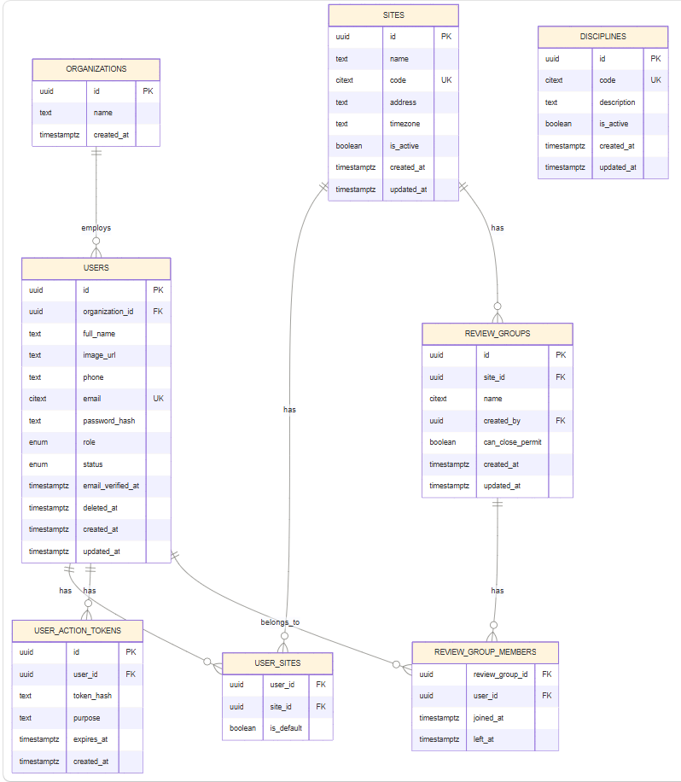

Master and configuration data

disciplines
id uuid PK, code citext UNIQUE NOT NULL, description text, is_active boolean, and created_at/updated_at timestamptz. Remove date_created and date_updated strings.

form_templates
id uuid PK, immutable code citext UNIQUE, title text, permit_kind permit_kind, child_category text, permit_color varchar(32), show_in_create boolean, is_active boolean, audit user IDs, and timestamps. Stable code replaces title/ObjectId dependencies in dashboards.

form_template_versions
Column | Type | Rules
id, template_id | uuid | PK/FK
version_no | integer | unique per template
status | template_version_status | draft/published/retired
schema_json | jsonb | complete ordered sections, fields, options, layout, validation, tooltips
field_map | jsonb | maps legacy/dynamic names to canonical meanings
checksum | text | detects accidental mutation
published_at, retired_at, created_at | timestamptz | lifecycle
created_by | uuid | FK user

Only one published version per template is allowed. Published rows are immutable. field_map defines mappings such as a template-specific start-date key to planned_start_at, avoiding hard-coded switch statements.

system_settings
key citext PK, value jsonb, description text, updated_by uuid, updated_at timestamptz. Appropriate values include automatic-close policy, notification flags, and the current permit-creation gate (stale_after_days, max_open_stale_permits, timer_count). Secrets do not belong here; keep them in a secrets manager.

permit_number_sequences
Column | Type | Rules
site_id | uuid | FK
period_start | date | monthly boundary
permit_kind | permit_kind | parent/child
last_value | bigint | updated atomically
updated_at | timestamptz | required

Composite PK is (site_id, period_start, permit_kind). Allocate with INSERT ... ON CONFLICT ... DO UPDATE SET last_value = ... RETURNING inside the permit transaction.
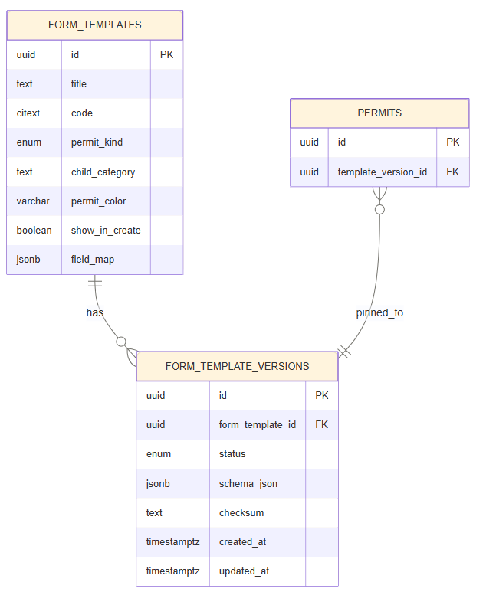

Permit aggregate

permits
Column | Type | Rules/use
id | uuid | PK
permit_number | text | unique when present; null while draft
kind | permit_kind | parent or child
parent_permit_id | uuid | self-FK; required for child, null for parent
template_version_id | uuid | immutable form version FK
site_id | uuid | FK, required
contractor_organization_id | uuid | FK; canonical contractor
submitted_by, host_owner_id | uuid | user FKs
discipline_id | uuid | FK
status | permit_status | required lifecycle state
status_reason | text | current rejection/cancellation reason only
answers | jsonb | flexible non-canonical form answers
work_description | text | indexed/searchable canonical answer
requester_name | text | submitted snapshot
contractor_name_snapshot | text | historical display value
location_text, building, level | text | searchable canonical location values
planned_start_at, planned_end_at | timestamptz | typed permit window
submitted_at, approved_at, executed_at, closed_at, cancelled_at | timestamptz | lifecycle facts
auto_close_due_at | timestamptz | computed when entering pending closure
created_at, updated_at, deleted_at | timestamptz | soft-delete/audit
lock_version | integer | optimistic concurrency

Canonical columns are the source of truth for common fields and are excluded from answers in v2 submissions. A compatibility serializer can merge them back into the old GraphQL response during transition. This avoids maintaining two writable copies.

permit_approval_steps
Column | Type | Rules/use
id, permit_id | uuid | PK/FK
sequence_no | smallint | unique within permit
target_type | approval_target_type | user, group, or organization role
target_user_id, target_group_id | uuid | exactly one where applicable
target_role | user_role | supports contractor-PM gate
quorum | smallint | default 1
status | approval_step_status | waiting/active/approved/rejected/skipped/cancelled
activated_at, completed_at | timestamptz | nullable
created_at | timestamptz | required

Individual steps are created first, then group steps. One active step gives constant-time “my next approval” queries.

permit_approval_step_members
step_id uuid, user_id uuid, is_eligible boolean, snapshotted_at timestamptz, composite PK. This freezes the eligible members of a group or role step at submission/reviewer-edit time.

permit_approval_actions
id uuid PK, step_id uuid, permit_id uuid, actor_user_id uuid, action approval_action, reason text, acted_at timestamptz, metadata jsonb. It preserves every approve/reject/recall action rather than one approvedBy array and one rejectedBy value.

permit_events
id uuid PK, permit_id uuid, event_type permit_event_type, actor_user_id uuid nullable, from_status permit_status, to_status permit_status, reason text, message text, metadata jsonb, occurred_at timestamptz, created_at timestamptz. Append-only audit history replaces logs: [String].

permit_revisions
id uuid PK, permit_id uuid, revision_no integer, change_type text, template_version_id uuid, snapshot jsonb, created_by uuid, created_at timestamptz, source_hash text; unique (permit_id, revision_no). This stores immutable snapshots only when a revision is needed and replaces duplicated logpdf permit-shaped rows.

Files and generated output

files
id uuid PK, storage_provider text, bucket text, object_key text, original_name text, content_type text, size_bytes bigint, sha256 char(64), uploaded_by uuid, created_at timestamptz, deleted_at timestamptz; unique (bucket, object_key).

permit_files
permit_id uuid, file_id uuid, field_name text, revision_id uuid nullable, created_at timestamptz; composite PK (permit_id, file_id, field_name). This associates form uploads/signatures with permits without storing URLs as uncontrolled answer values.

generated_documents
id uuid PK, permit_id uuid, revision_id uuid, file_id uuid, document_type text, display_name text, generated_by uuid, generated_at timestamptz; supports current PDF history/retrieval with exact permit and revision keys.

UI/reference content and delivery

site_maps
id uuid PK, site_id uuid, name text, file_id uuid, is_active boolean, created_at/updated_at timestamptz. This replaces map.site strings and mapImage URLs.

announcements
id uuid PK, title text, message text, kind text, color varchar(32), starts_at timestamptz, ends_at timestamptz, is_active boolean, created_by uuid, and timestamps.

release_notes
id uuid PK, version text UNIQUE, deployed_at timestamptz, title text, created_by uuid, created_at timestamptz.

release_note_items
id uuid PK, release_note_id uuid, sequence_no smallint, message text; unique (release_note_id, sequence_no). This preserves the current changelog list without an array column.

blocked_terms
id uuid PK, term citext UNIQUE, is_active boolean, created_by uuid, and timestamps.

notification_outbox
id uuid PK, optional permit_id/event_id, channel notification_channel, template_key text, recipient jsonb, payload jsonb, status notification_status, attempt_count integer, available_at/sent_at/created_at timestamptz, last_error text. Email becomes transactionally reliable and retryable instead of being coupled to the request.

Migration control

migration_runs
id uuid PK, source_name text, source_snapshot_at timestamptz, started_at/finished_at timestamptz, status text, statistics jsonb, code_version text.

legacy_id_map
source_collection text, legacy_id text, target_table text, target_id uuid, migration_run_id uuid, source_hash text, migrated_at timestamptz; PK (source_collection, legacy_id, target_table). This makes ETL idempotent and supports traceability.

migration_errors
id bigserial PK, migration_run_id uuid, source_collection text, legacy_id text, severity text, error_code text, message text, source_excerpt jsonb, created_at timestamptz.

6. Status and workflow mapping
Legacy value | V2 value | Notes
DraftPermit | DRAFT | Same permits table; no number required
Pending | PENDING_CONTRACTOR_APPROVAL | External-company submission/PM gate
PendingApproval | PENDING_REVIEW | Ordered user/group steps
Approved | APPROVED | Set approved_at
Rejected | REJECTED | Preserve reason and actor action/event
PendingClosure | PENDING_CLOSURE | Set automatic-close due time from policy
PendingCancel | PENDING_CANCELLATION | Explicit spelling
Cancelled | CANCELLED | Set cancelled_at
Executed | EXECUTED | LSS execution state
Completed | COMPLETED | Set closed_at
CompletedTest | quarantine or COMPLETED | Convert only after business confirmation
PendingClosure-test | quarantine or PENDING_CLOSURE | Convert only after business confirmation

Allowed transitions should be enforced in one service and tested as a state machine. The database event/status update must be transactional. Do not let generic API callers assign arbitrary statuses.
Recommended main transitions:
DRAFT -> PENDING_CONTRACTOR_APPROVAL -> PENDING_REVIEW -> APPROVED
\-------------------------------> PENDING_REVIEW -> REJECTED -> PENDING_REVIEW
APPROVED -> PENDING_CLOSURE -> COMPLETED
APPROVED -> PENDING_CANCELLATION -> CANCELLED
APPROVED -> PENDING_REVIEW (recall, with a recorded action)
APPROVED -> EXECUTED -> COMPLETED (LSS where applicable)

7. Datatable and reporting design
Use a single filter object and generate conjunctive SQL predicates. Avoid a resolver branch for every filter combination.
Recommended list API inputs:
- scope: all accessible, submitted by me, awaiting my action, approved by me, draft, pending closure/cancellation.
- kind and optional child category/template code.
- arrays for site, status, discipline, template, organization.
- created_from/to, planned_start_from/to, planned_end_from/to, approved_from/to.
- search for permit number, work description, requester, host, contractor, and parent number.
- whitelisted sort plus cursor (sort_value, id); retain offset only for short compatibility windows.
Core indexes are included in the DDL. Important access paths are site/status/date, parent-child, submitter/status, discipline/date, template/date, due automatic closures, active approval steps, and trigram search. Use COUNT(*) OVER() only for moderate result sets; for large tables return has_next_page and obtain exact totals separately/cached.
Create these database views/read models:
- permit_list_v: joins only small display columns (site, template, discipline, submitter, host, contractor, active approval step).
- lss_impairment_v: child rows filtered by stable template code/category, removing the current two-source merge.
- dashboard_daily_mv: daily counts by date basis (created, planned start, planned end, or approved), site, organization, discipline, template, permit kind, child category, and status.
- Optional future read model dashboard_answer_fact: extracted facts for dashboard dimensions that remain truly dynamic (for example hazardous flag or SIPP work type). It is not one of the baseline tables. Add it only if measurements show JSONB expression indexes are insufficient; populate only fields marked reportable in template field_map and do not create an unbounded EAV table for every answer.
Initially refresh the materialized summary concurrently on a short schedule. If production volume makes a full refresh too costly, replace it with an event-maintained summary table updated idempotently from permit events. The source of truth remains the normalized operational tables.

8. Current feature coverage
Current feature | V2 implementation
Parent, child, and draft permits | One permits table using status, kind, and parent_permit_id
Embedded and independent child forms | One child row per form submission
Dynamic template builder | Template master plus immutable JSONB versions
Template create/edit/activate/show-in-create | Draft a version, publish atomically, retire old version
Individual sequential review | Ordered user approval steps
Sequential MT-group review, any member approves | Ordered group step with snapshotted eligible members and quorum 1
Contractor-PM approval | Organization-role step
Add/remove reviewers | Version workflow steps; append events; never erase completed actions
Approval, rejection, recall, closure, cancellation | State machine, approval actions, and permit events
Host/system owner and discipline | Typed foreign keys
Permit duplication | Copy to DRAFT, clear signature/file associations by field metadata
PDF history | Revision plus generated-document/file relationship
Uploaded files and e-signatures | File metadata plus permit-field association
Auto-completion | Indexed auto_close_due_at worker with idempotent transaction/locking
Unclosed-permit count and creation gate | Typed planned_end_at query plus versioned policy in system_settings
Email notifications | Transactional outbox and retry worker
Role/site visibility | user_sites plus role authorization; optionally PostgreSQL row-level security
All datatable filters | Typed columns, full-text/trigram search, composable predicates, cursor pagination
Dashboards and monthly reports | Daily materialized view and selected reportable answer facts
LSS impairment and SIPP reports | Stable template codes/category, typed dates, child relationship
Maps | Site FK and file FK
Announcements, release notes, blocked terms | Dedicated typed tables
Permit numbering | Atomic scoped monthly sequence
Soft retention/audit | Soft-delete identity/master rows; append-only permit evidence

9. Migration mapping
Mongo source | PostgreSQL target | Transformation
sites | sites | Normalize/validate codes; assign timezone
distinct user/company/submission company strings | organizations | trim, collapse whitespace, case-fold; map Micron explicitly
users | users, user_sites | map company; merge site into sites; preserve password hash; generate UUID
mtgroups + users.group | review_groups, review_group_members | group array is authoritative; use user group only to repair/flag discrepancies
disciplines | disciplines | normalize code; discard redundant string dates after preservation in staging
templates | form_templates, form_template_versions | derive stable code; copy complete nested structure into version 1 JSONB; create field map
drafts | permits | status DRAFT; migrate children as child draft rows
permits | permits | extract canonical fields/dates; retain remaining answers JSONB
permits.children | child rows in permits | parent FK; inherit site/owner/discipline where absent; retain own form/submission/code
childpermits | child rows in permits | parent FK; derive site from parent if absent
reviewer arrays | approval steps/members/actions | direct users are selectedUser - selectedMTGroupUsers; then groups; map approvedBy
logs arrays | permit_events | preserve exact text; parse actor/type/time best-effort and flag uncertainty
logpdfs | permit_revisions, generated_documents | correlate primarily by permit code and timestamp, not filename regex alone
permitnumbers | permit_number_sequences | seed each scope from maximum parsed existing number
permitexpireds | system_settings | migrate policy only; do not migrate transient counts as configuration
maps | site_maps, files | resolve site string to site; treat unresolved values as migration errors
annoucements | announcements | parse deployment/start date; preserve raw value on parse failure
changelogs | release_notes, release_note_items | one ordered child row per log string
blockedwords | blocked_terms | rename, trim, case-insensitive de-duplicate

10. Migration and cutover plan

Phase 0: inventory and freeze semantics
1. Take a production snapshot and run read-only profiling.
2. Count every collection; count statuses and template IDs; find null/invalid dates, duplicate permit codes/emails/site/discipline codes, orphan ObjectIds, inconsistent group membership, and documents over expected size.
3. Inventory every submission key by template and data type. Confirm the canonical mapping for start/end, description, company, building, level, LSS, SIPP, and dashboard-specific dimensions.
4. Get business decisions for test statuses, duplicate child detection, group membership discrepancies, retention, and whether sequence scope is global or site/month/kind. The proposal defaults to site/month/kind.

Phase 1: build and rehearse
1. Deploy schema and migrations to an empty PostgreSQL database.
2. Use deterministic UUIDv5 values from source_collection + Mongo ObjectId, while also populating legacy_id_map.
3. Load reference data, organizations/users/sites, groups, templates, then permits and their dependent records.
4. Make each ETL stage restartable by comparing source hashes. Never update a target row silently when its source hash changed; record the difference.
5. Quarantine invalid records in migration_errors; do not drop them.
6. Rehearse until all critical reconciliation gates pass.

Phase 2: permit details
1. Extract canonical dates using each template version's field map. Interpret date/time-only strings using the permit site's timezone, then store UTC.
2. Remove extracted canonical keys from v2 answers; keep the unmodified legacy submission inside the first migration revision for evidence.
3. Migrate separate childpermits and embedded children. Deduplicate only on strong evidence: same legacy child ID, or same non-empty child code within a parent. Treat (parent, template, answer hash) as a review candidate, not an automatic merge.
4. For embedded child forms without lifecycle fields, inherit site, owner, discipline, requester, and status according to documented legacy behavior and tag metadata.migration_inherited = true in the migration event.
5. Convert signature-like answer fields to file relationships where resolvable; keep unresolved legacy values in the migration revision.

Phase 3: approval reconstruction
1. Direct reviewer order is the legacy selectedUser order after removing IDs listed in selectedMTGroupUsers.
2. Append legacy selectedMTGroup in order as quorum-one group steps.
3. Snapshot current group members. Historical membership cannot be recovered from the current schema; mark reconstructed snapshots in metadata.
4. Match each approvedBy user to its direct step or the earliest group step for which the user is eligible. Ambiguous matches become migration warnings and retain the raw arrays in the initial revision.
5. Create a synthetic legacy approval action/event for mapped approvals and rejection. Do not fabricate exact action timestamps when logs cannot prove them.

Phase 4: live synchronization and cutover
Preferred approach is a short controlled write freeze because workflow order and embedded arrays are difficult to dual-write safely.
1. Perform a full rehearsal from a recent snapshot and measure runtime.
2. Deploy v2 in shadow-read mode and compare representative list/detail/dashboard responses.
3. Announce maintenance; stop mutations and the automatic-close cron; record a source high-water timestamp.
4. Run final incremental ETL, then reconciliation.
5. Switch API reads/writes and background workers to PostgreSQL.
6. Keep MongoDB read-only for the agreed rollback/audit window. Do not immediately delete it.
7. Roll back by stopping v2 writes and returning traffic to the frozen Mongo deployment only if the cutover gate fails; after real v2 writes begin, rollback requires a reverse-change log and should be treated as a separate controlled operation.
For a zero-downtime requirement, introduce an application outbox/change log in v1 first and dual-write through one compatibility service. Raw Mongo change streams alone are insufficient to reconstruct the business transaction boundaries in the current multi-save mutations.

Reconciliation gates
- Source documents = migrated targets + explicitly quarantined documents, by collection and status.
- 100% of non-draft legacy permit codes preserved and unique.
- 100% of target foreign keys valid; zero unaccounted orphan references.
- Parent/child counts match after documented deduplication.
- Counts by status/site/template/month match, with approved exception report.
- Approval selected/approved/rejected users accounted for per permit.
- Every legacy log string exists in an event or initial revision.
- Every PDF log is linked or explicitly quarantined.
- Sampled permit detail/PDF output is byte- or field-equivalent where expected.
- Dashboard totals and datatable filter results match for agreed sample periods.
- Password hashes authenticate in a controlled test; SSO subject mappings are verified.

11. Implementation sequencing
1. Schema, migrations, fixtures, and repository layer.
2. Template versioning and canonical field-map tooling.
3. Unified permit aggregate and numbering transaction.
4. Approval state machine, audit events, and notification outbox.
5. Datatable query API and compatibility response adapter.
6. Child/LSS/SIPP operations.
7. PDF/revisions/files.
8. Dashboard read models.
9. ETL, reconciliation suite, shadow comparisons, and cutover.
Do not migrate the existing resolver logic line-for-line. Put lifecycle transitions and approval progression in domain services with database transactions, then expose them through the new API.

12. Decisions required before build
- Confirm PostgreSQL as the target and the required supported version.
- Confirm whether permit numbering is global monthly, per site monthly, or per site/type monthly. Existing parent and child behavior is inconsistent; the DDL uses per site/month/kind.
- Confirm official template codes/categories and retire all hard-coded Mongo ObjectIds/titles.
- Approve mappings for every operational/reportable form field.
- Decide treatment of test statuses and invalid historical documents.
- Define record/PDF/signature retention and privacy rules.
- Confirm whether an approval workflow is frozen at submission (recommended) or dynamically follows later group membership changes.
- Define datatable default sort, maximum page size, export limits, and exact-count expectations.

13. Additional critical observation
The repository README contains credential-like database and cloud examples. They should be treated as compromised: remove them from Git history where practical, rotate the values, and move all secrets to the deployment secret manager. This is separate from the schema migration but should be resolved before building v2.

