|  |
| --- |
|  |
| The Documentation |
| AirPick |
|  |
| **Qingyun Wang** |
| **9/5/2024** |

[Type the abstract of the document here. The abstract is typically a short summary of the contents of the document. Type the abstract of the document here. The abstract is typically a short summary of the contents of the document.]

Table of Contents

[To update the table of contents, right click the message below and select Update Field (F9 on PC, ⌥⌘U on Mac).]

**No table of contents entries found.**

1. Pages
   1. Page Tree

welcome page  
passenger  
driver

* 1. welcome page
     1. User Interface

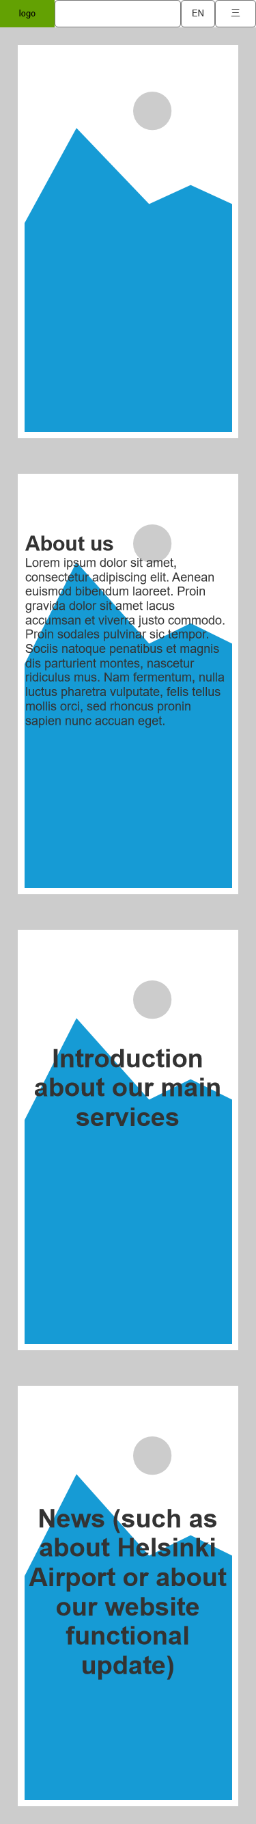

* + 1. logo
       1. State 1
       2. User Interface



* + 1. menu close
       1. close
       2. User Interface



* + 1. language
       1. english
       2. User Interface



* + - 1. finnish
      2. User Interface



* + - 1. chinese
      2. User Interface



* + 1. login box
       1. State 1
       2. User Interface

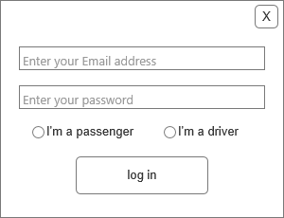

* + 1. sign up box
       1. State 1
       2. User Interface

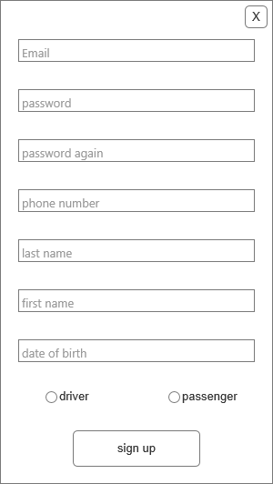

* + 1. Unnamed
       1. State 1
       2. User Interface



* + 1. menu open
       1. open
       2. User Interface

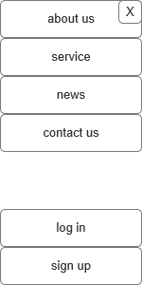

* 1. passenger
     1. User Interface

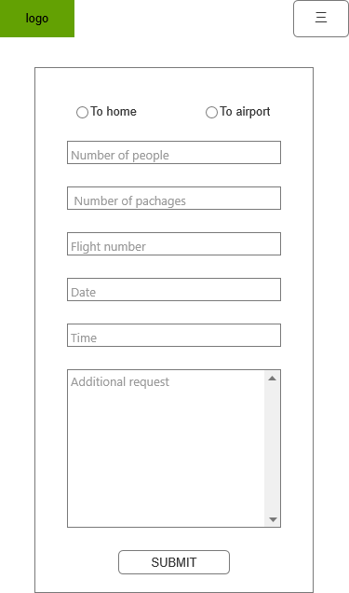

* + 1. main
       1. State 1
       2. User Interface

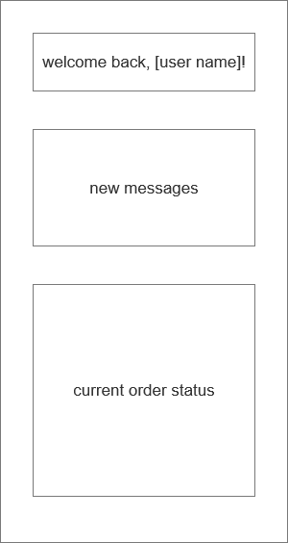

* + 1. notification
       1. State 1
       2. User Interface

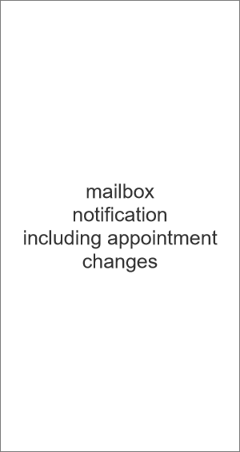

* + 1. new appointment
       1. State 1
       2. User Interface

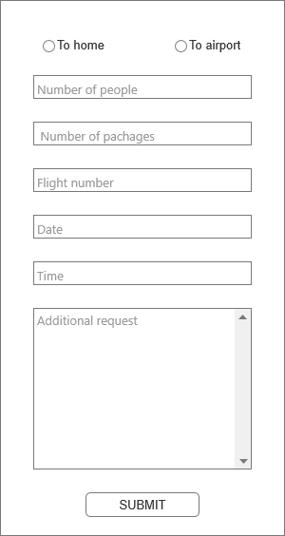

* + 1. profile
       1. State 1
       2. User Interface

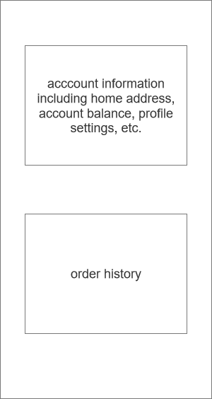

* + 1. menu open
       1. State 1
       2. User Interface

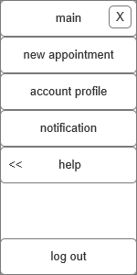

* + 1. help menu
       1. State 1
       2. User Interface

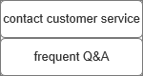

* + 1. log out box
       1. State 1
       2. User Interface

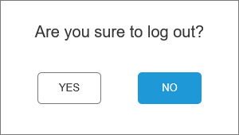

* 1. driver
     1. User Interface

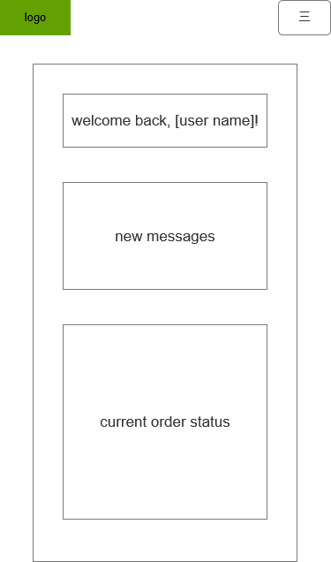

* + 1. main
       1. State 1
       2. User Interface



* + 1. notification
       1. State 1
       2. User Interface

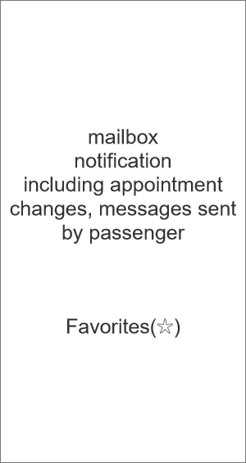

* + 1. profile
       1. State 1
       2. User Interface



* + 1. new mission
       1. State 1
       2. User Interface

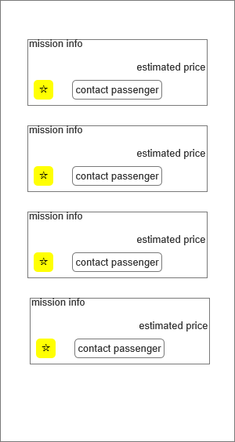

* + 1. chat box
       1. State 1
       2. User Interface

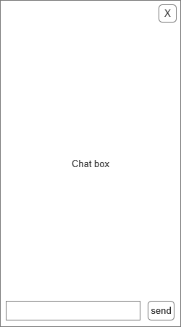

* + 1. menu open
       1. State 1
       2. User Interface

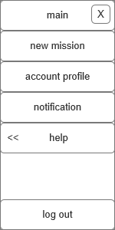

* + 1. help menu
       1. State 1
       2. User Interface



* + 1. log out box
       1. State 1
       2. User Interface

