Grommet Top
Most popular for contemporary spaces.
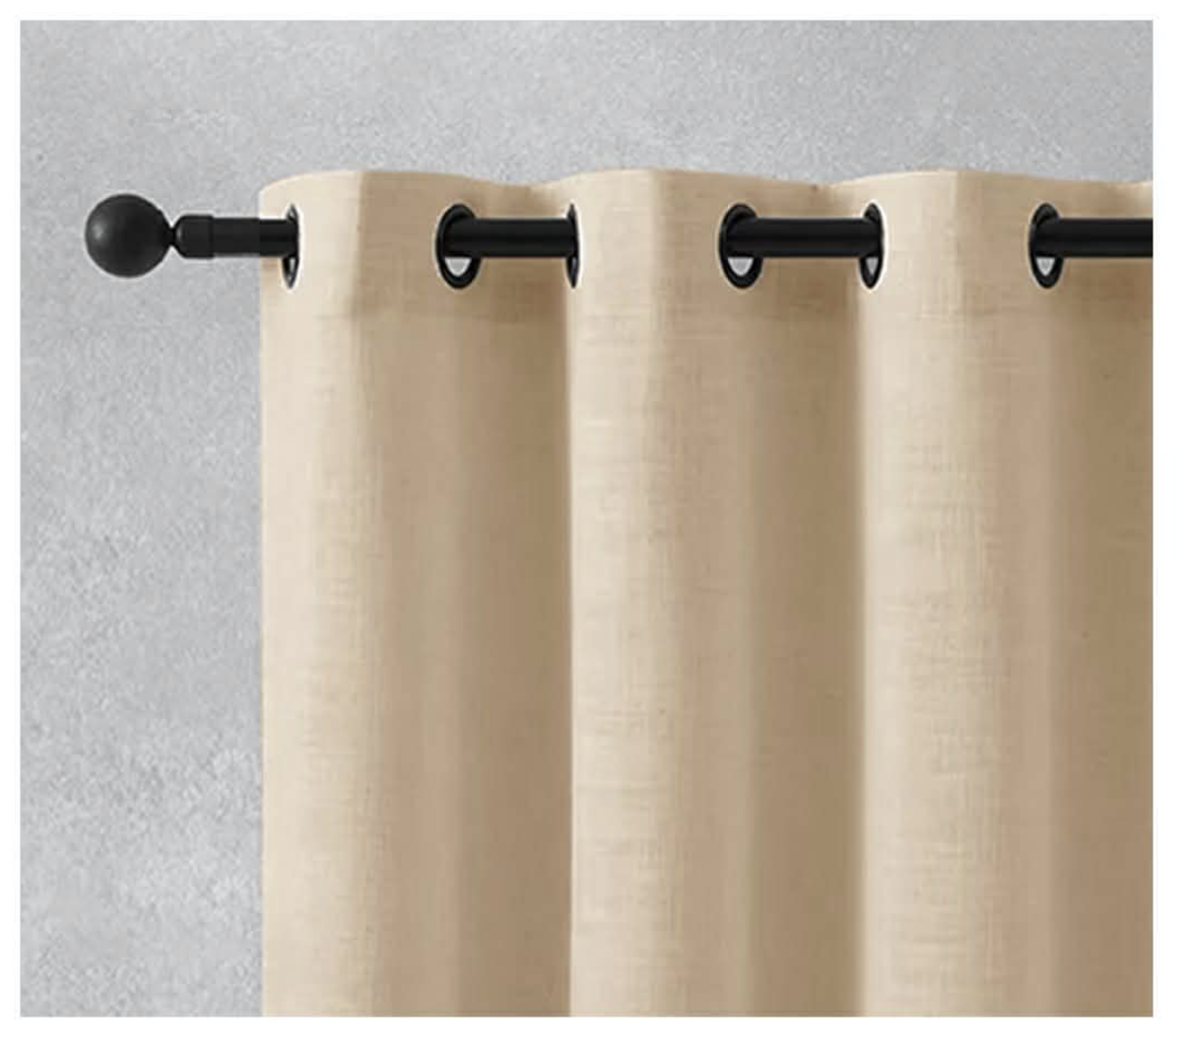

Rod Pocket
Lined top for a clean tailored look.
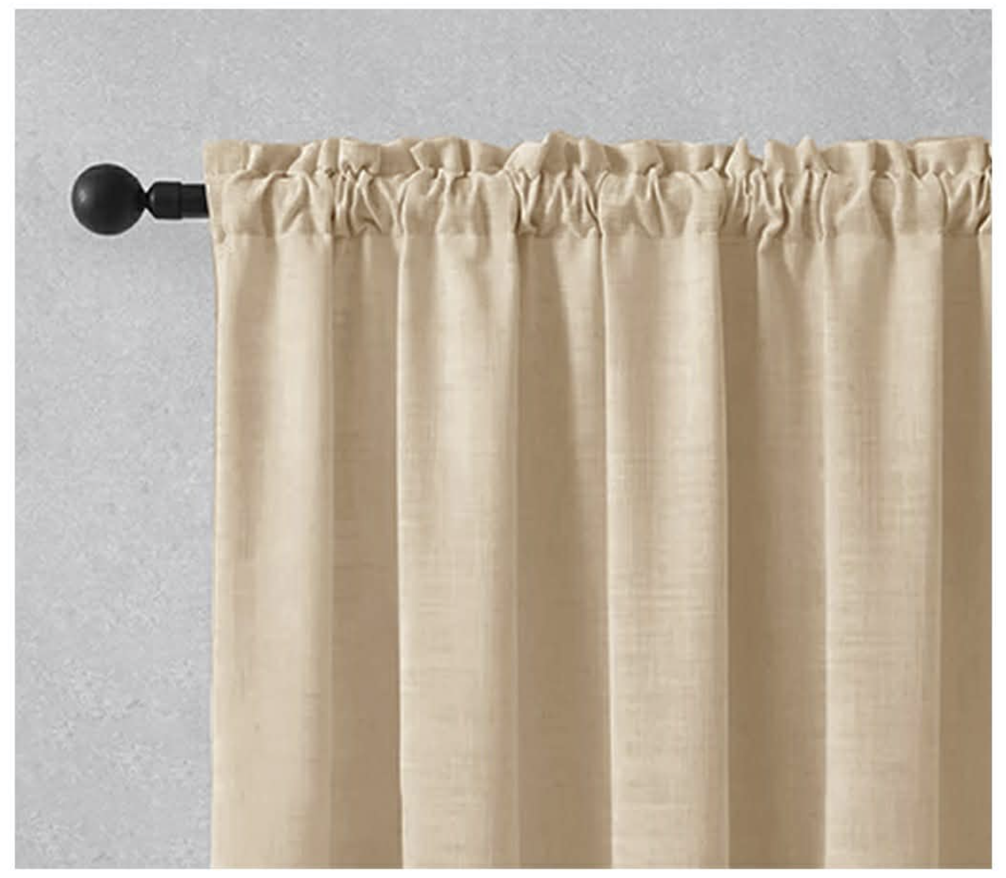

Pinch Pleat — Double
Formal and elegant.
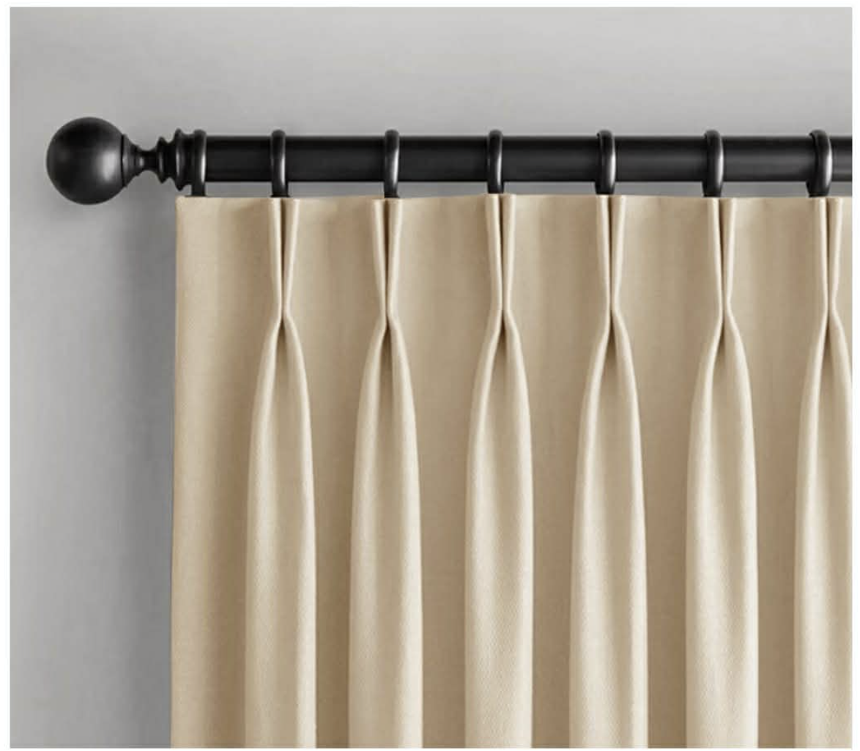
Back Tab
Soft, crisp touch with hidden tabs.
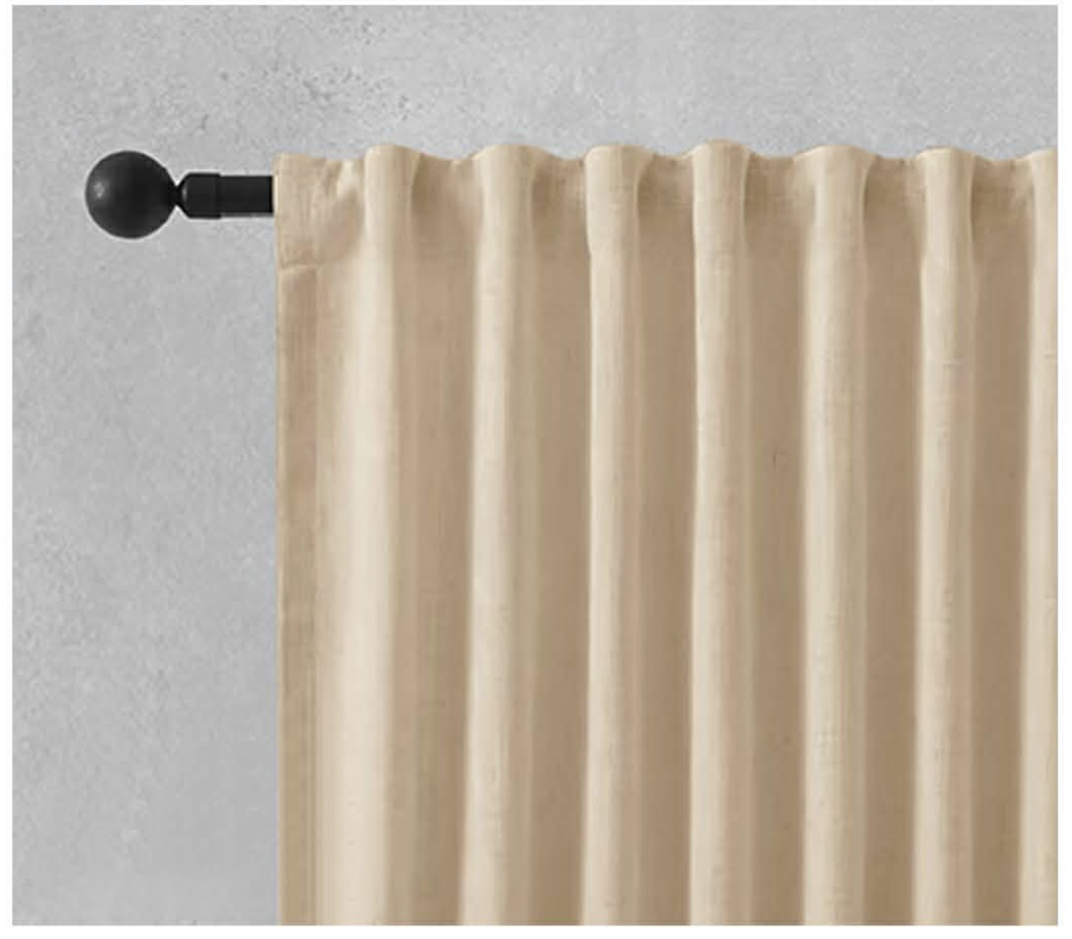
Tab Top
Informal, country / transitional decor.
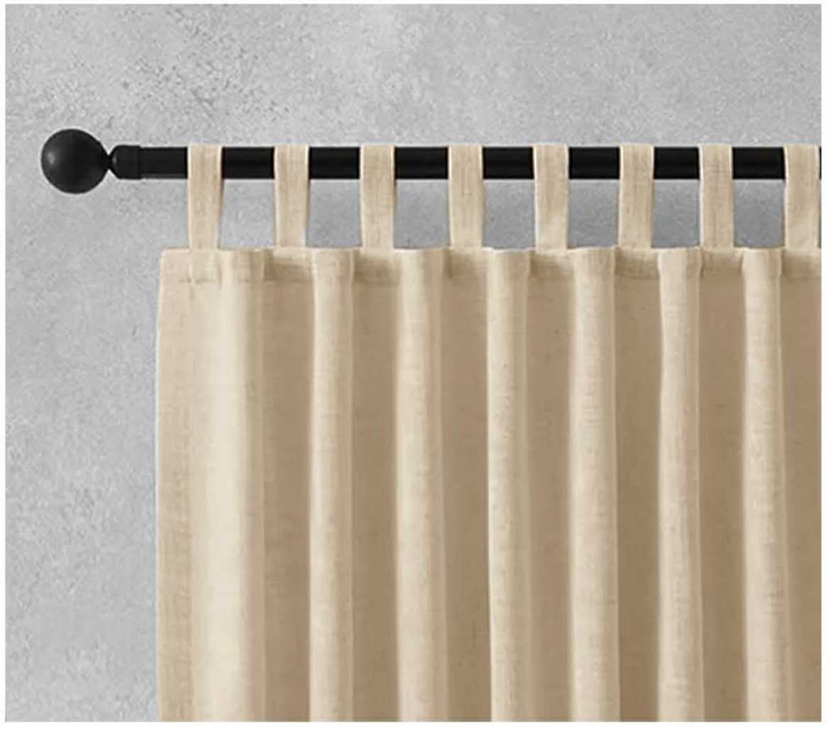
Flat Panel
Casual & modern. Uses 4-in-1 tape.
