Quantitively compute the maximum number of Clar’s sextet and radical sites distribution probabilities of a given open-shell structure.

There are two crucial properties as the focus of our studies, i.e., the maximum number of Clar’s sextet inside a given closed-shell or open-shell benzenoid structures and the probability of a radical appearing on a specific atom position for open-shell benzenoid structures.

The number of valid graphene structures (i.e., satisfying each carbon connecting with 4 bonds) for a large graphene skeleton such as the ones in our studies is extremely huge. Thus, it is impossible for humans to draw out the different structures and calculate the two crucial properties as mentioned above. A computer program based on constrained greedy-search and sampling is built to solve this challenge. A user-defined single bond connected skeleton structure is treated as the input (Details in supporting information XX). Based on the constraints from domain knowledges, including two benzene rings cannot appear next to each other, and there are alternating single and double bonds for all carbon atoms except those with radicals, double bonds will be added greedily (as much as possible) at different valid positions. After the enumeration of possible structures, the valid structures with the information on the positions of the radical sites and positions of the Clar’s sextet are recorded. Based on the results, the two crucial properties are calculated and reported. For structures with more than 50 atoms, the exact solution of greedy enumeration of all possible structures will be intractable thus a sampling-based approximation will be used to gain the two crucial properties. The details of the algorithm are provided in supporting information XX. In addition to the provision of a computational algorithm to calculate the crucial properties of general benzenoid structures, a proof of the specific rules in calculating maximum number of benzene rings for the magnetic topological graphene nanoribbons in our study (i.e., +5 for open-shell structure and +3 for closed-shell structure) is also provided in supporting information XX.

**Supporting Information**

**User input:**

A graphene structure will be treated as an undirected graph $G(V,E)$. Where *V* is the set of vertices (i.e., atoms in the graphene) and *E* is the set of bonds in the graph (i.e., bonds in the graphene). In terms of computational representation, an atom will be represented by an index such as 0,1, and 2 as shown in figure XX1 and bonds will be represented as a tuple of index such as (0,1), (1,2) as shown in figure XX1.

There are three user inputs needed for our algorithm to work: 1. the adjacent matrix of the graphene structure; 2. the information of valid double bond combination in each ring to form a Clar’s sextet; and 3. the information of the neighbor rings for each ring.

For the first input, the adjacent matrix describes the connectivity inside the graphene structure, where 1 indicates the two atoms are connected and 0 not. An adjacent matrix is as shown in figure XX1.

For the second input, it records for each ring what are the valid double bond combination for it to be a benzene ring as shown in figure XX1.

For the third input, it records the adjacent neighbors of each Clar’s sextet, including itself, to avoid two rings adjacent to each other being Clar’s sextet simultaneously.

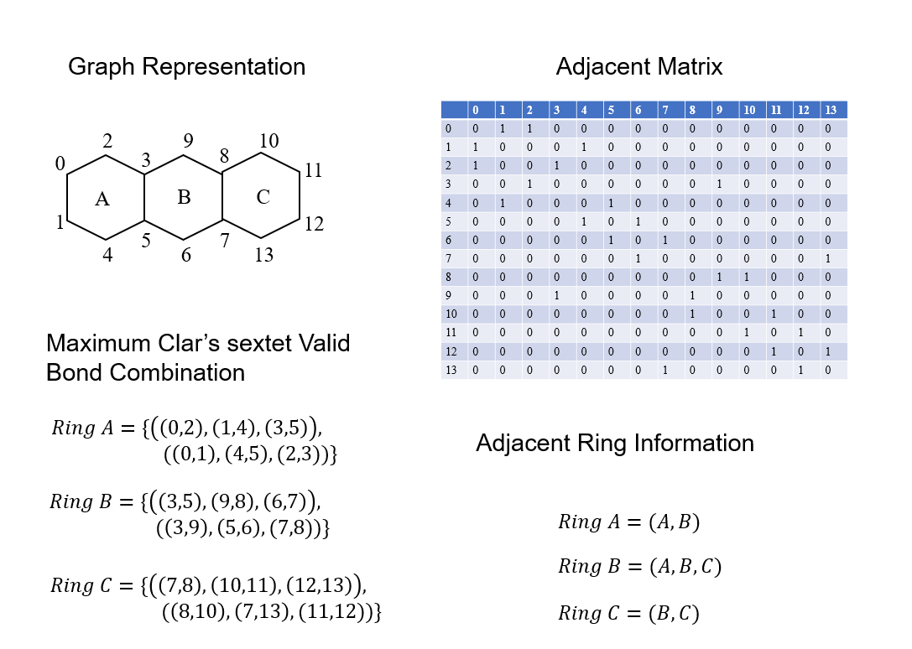

Figure XX1 (Figure effect will be further enhanced)

**Details of the auto-computing algorithm:**

Based on the connectivity information provided by the adjacent matrix, all the bonds are constructed and stored into a list data structure. Then an algorithm will enumerate over all the double bond combinations for a specific graphene structure. During the greedy enumeration process, several filters are applied to ensure that there are alternating single and double bonds according to the Clar rule. According to the provided information about the Clar’s sextet valid bond combinations, the corresponding Clar’s sextets can then be located. After getting the valid Clar’s sextets for this specific combination of bonds, the second constraint of non-adjacent Clar’s sextets will be applied according to the provided adjacent ring information. Since the double bond can appear either on the left or the right of a bond due to different drawing, all possible combinations of valid benzene rings for a specific double bond combination will be enumerated and the valid ones will be saved and reported. The whole process will be done for all bond combinations with a greedy approach.

Using the above algorithm, one can find the maximum number of Clar’s sextetof a given graphene structure with different radical numbers and the number of valid structures that can be generated given different radical combinations. From the first result, the crucial property of maximum number of benzene rings inside a given closed-shell or open-shell benzenoid structures can be calculated. Additionally, from the second result, it is possible to calculate the probability of a radical appearing on a specific atom position in open-shell benzenoid structures.

**Prove the rule to calculate the number of maximum benzene rings for the graphene structure (Where to include this proof? A box could be used? Or this paragraph can be simply used as the figure caption description)**

As shown in Figure XX2 (first column), for each structure in our study, the added structures GR are the same. Thus, one can use induction to formulate the maximum ring rule for our structures. From the second column of Figure XX2, through a large number of simulation experiments we find when there are no free radicals the benzene rings will never appear in the connected rings (i.e., the top three rings in GR) when the structure under study has maximum number of benzene rings (proved by enumerating all structures of G2). Thus, when there are no free radicals adding GR will be reduced to adding G1. Finally, the proof of max ring numbers in different structures is shown in the third column of figure XX2. When there are no free radicals to be added, a repeated structure will add 3 more benzene rings to the max ring number of the whole structure. While a repeated structure will add 5 more benzene rings to the overall max ring number, when there are free radicals to be added. This is aligned with the expert drawing results in figure XX.

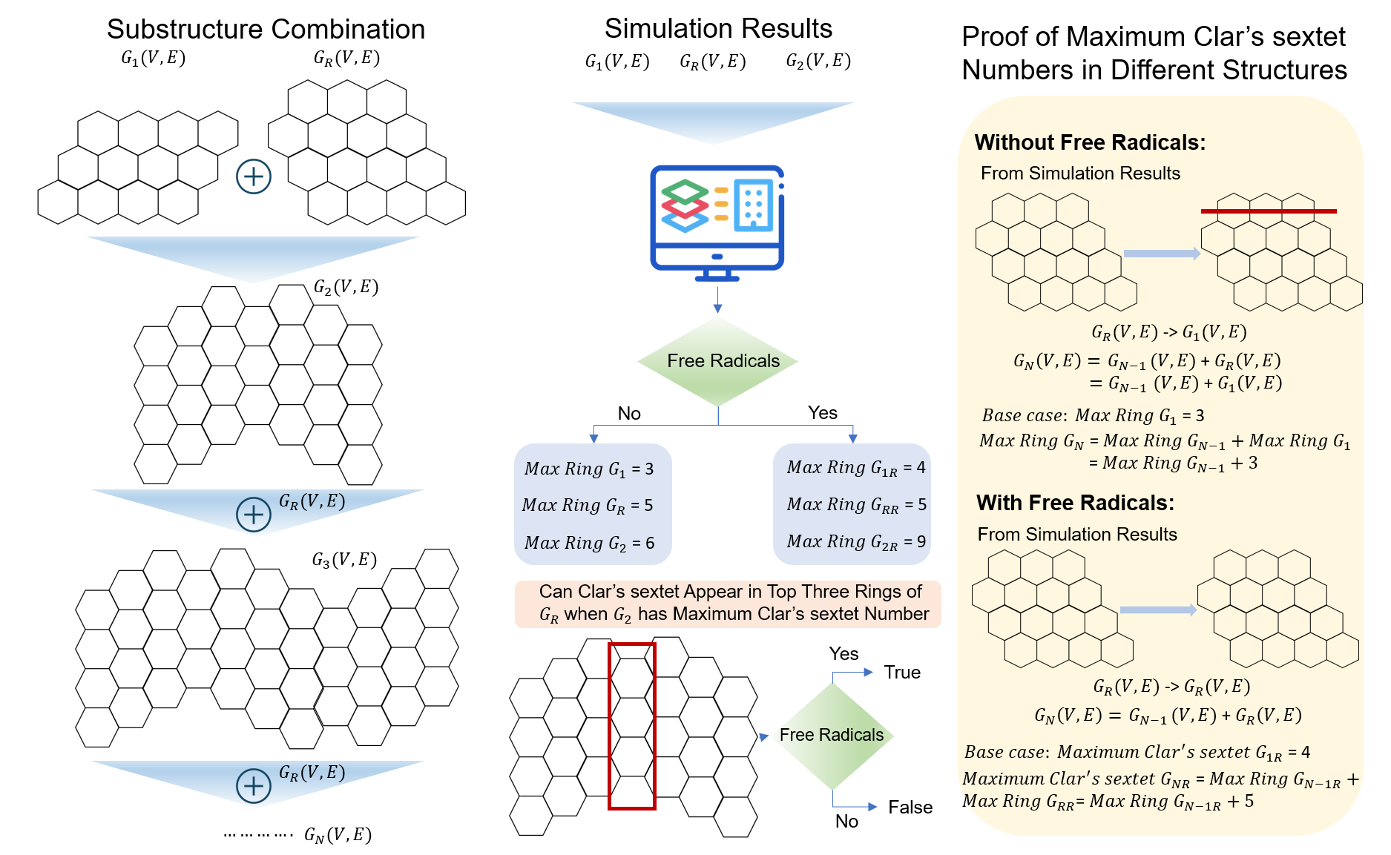

Figure XX2