Spatial Inequalities in Street-Tree Ecological Quality across New York City
Final Report
Urban Analytics | Track B (Advanced)
More Than Green
Di Li, Jialin Sun, Chunman Li, Xiaojing Jin
2026-05-07

1. Problem and Motivation
Urban street trees deliver a well-documented portfolio of ecosystem services: they mitigate the urban heat island effect, attenuate stormwater runoff, improve air quality, and contribute to residents' psychological well-being (Salmond et al., 2016; Berland et al., 2017). Despite growing consensus on their aggregate value, the spatial distribution of street-tree ecological quality is far from uniform. Evidence from North American cities consistently shows that lower-income, higher-density, and historically marginalized neighborhoods bear a disproportionate burden of degraded urban tree canopy (Wolf et al., 2020; Schwarz et al., 2015). New York City, with its extreme socioeconomic heterogeneity and dense built fabric, offers a compelling laboratory to examine these inequalities at fine spatial resolution.
This study pursues three interrelated research questions:
- RQ1: What spatial inequalities and clustering patterns characterize street-tree health, structural attributes, and species diversity across NYC?
- RQ2: How do street-tree ecological quality indicators associate with socioeconomic vulnerability, built-environment intensity (including 2D urban morphology and landscape configuration), and green infrastructure supply?
- RQ3: Where do multiple disadvantages overlap (low tree quality + high social vulnerability + high built density or fragmented greenery), and can we identify priority intervention areas?
Several key analytical constructs require explicit definition. The Tree Health Index is the mean of per-tree health scores (Good=3, Fair=2, Poor=1) aggregated to the Census Tract, providing a continuous proxy for overall structural condition. Shannon diversity (H') quantifies species richness weighted by evenness across the tract-level tree population. PLAND (proportion of landscape) expresses the percentage of a given land-cover class within each tract boundary, derived from the UrbanWatch 1m product. Landscape configuration is captured through a suite of FRAGSTATS metrics: Number of Patches (NP), Patch Density (PD), Largest Patch Index (LPI), Edge Density (ED), Aggregation Index (AI), Shannon Diversity Index (SHDI), and Contagion (CONTAG). Finally, co-burden mapping overlays multiple disadvantage layers to identify tracts simultaneously experiencing low tree quality, high social vulnerability, and high built density or fragmented greenery (Galle et al., 2021).
The primary stakeholders of this research include the NYC Department of Parks and Recreation (which administers the street-tree program), Community Boards seeking evidence for capital allocation, urban forestry practitioners managing planting and maintenance programs, and environmental justice advocates who require spatially explicit co-burden evidence to support policy interventions.
The Census Tract is adopted as the unit of analysis (n = 2,327 tracts covering all five boroughs). This choice is justified on three grounds: (1) it permits direct integration with American Community Survey socioeconomic data; (2) it constitutes the standard spatial unit for environmental justice analyses in U.S. urban research; and (3) it offers sufficient spatial resolution to capture meaningful intra-city variation without the statistical instability associated with smaller block-group geometries.
Variable Domains and Indicators
Domain | Indicators
Tree Ecological Quality | Health Index, mean DBH, tree density (trees/km2), Shannon diversity (H'), species count
Built Environment (3D) | Mean/max building height, building coverage ratio, building density
Built Environment (2D morphology) | 9-class PLAND from UrbanWatch 1m (building, road, parking, tree canopy, grass/shrub, water, agriculture, barren, other); impervious/pervious ratio
Landscape Configuration | SHDI, CONTAG (landscape-level); NP, PD, LPI, ED, AI for tree canopy and building classes
Green Infrastructure | Park area ratio, tree canopy PLAND
Socioeconomic | Median income, poverty rate, minority %, renter %, SVI composite (RPL_THEMES)
Table 1. Summary of analytical domains and indicators used in this study.
This framework draws on previous empirical work linking tree canopy cover to built-environment indicators (Berland et al., 2017), socioeconomic gradients (Wolf et al., 2020), and landscape configuration (Schwarz et al., 2015), while extending those foundations through the UrbanWatch high-resolution land-cover product (Zhang et al., 2022) and co-burden spatial methods (Galle et al., 2021).

2. Data Sources and Cleaning
Data Sources and Cleaning
Seven distinct datasets were assembled and harmonized to construct the tract-level analytical table. The following subsections describe each source's coverage, granularity, format, and provenance, followed by a record of cleaning and transformation decisions.

2.1 Trees Count! 2015 Street Tree Census
Source: NYC Open Data | Format: CSV with lat/lon | Coverage: City-wide, 2015-2016 |
Raw records: 683,788
The NYC Parks Department conducted its third decennial street tree census between 2015 and 2016, recording detailed information for each mapped street tree across the five boroughs. The dataset includes species, diameter at breast height (DBH), health condition, and geographic coordinates, totaling 683,788 records in CSV format.
Data cleaning procedures first removed all records with a status other than “Alive,” resulting in 652,173 valid tree observations. Coordinate fields were checked to ensure completeness, with no missing or zero values identified. Implausible DBH values exceeding 100 inches were capped at 100 to mitigate the impact of measurement errors. Tree health conditions were numerically encoded (Good = 3, Fair = 2, Poor = 1) to enable quantitative analysis.
Tree locations were then spatially joined to 2020 Census Tract boundaries (EPSG:4326), successfully matching 652,045 trees across 2,306 tracts. Aggregated tract-level indicators were computed, including total tree count, tree density (trees per square kilometer), mean DBH, a composite Tree Health Index, Shannon diversity index (H'), and species richness.
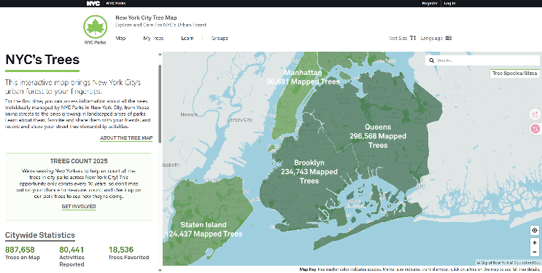
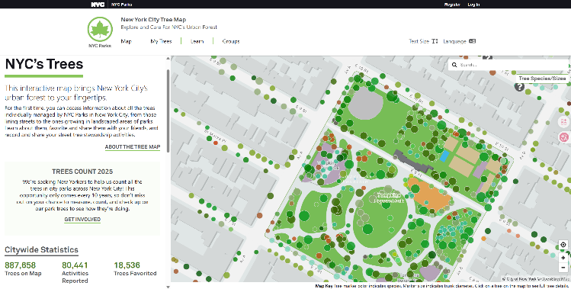

2.2 UrbanWatch 1m Land Cover
Source: University of Vermont / UNC Charlotte | Format: GeoTIFF (42,000 x 46,674 px) |
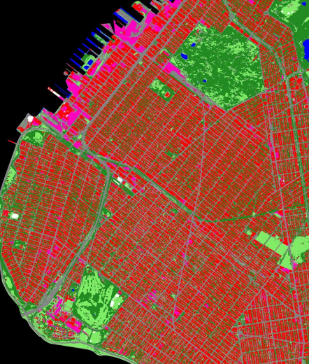
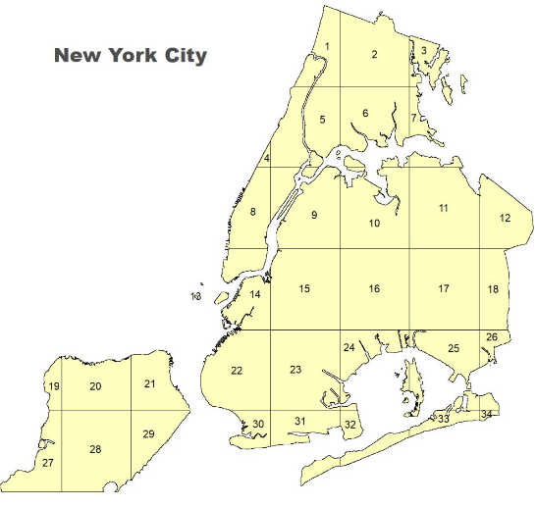
CRS: EPSG:26918 | Classes: 9

The UrbanWatch dataset provides a high-resolution (1-meter) land cover classification for the greater NYC area, derived from 2017 aerial imagery and validated at over 90% overall accuracy. The dataset is distributed as a three-band RGB GeoTIFF, where each RGB combination corresponds to one of nine land cover classes.
To enable analysis, the RGB raster was decoded into a single-band classified raster using the provided class-color lookup table, resulting in approximately 749 million valid pixels. Census Tract boundaries were reprojected to UTM Zone 18N (EPSG:26918) to align with the raster data. Zonal statistics were then computed to extract pixel counts per land cover class within each tract.
From these results, PLAND metrics were derived, representing the percentage of each land cover class relative to total tract area, yielding ten indicators per tract. In addition, landscape configuration metrics—including Number of Patches (NP), Patch Density (PD), Largest Patch Index (LPI), Edge Density (ED), Aggregation Index (AI), Shannon Diversity Index (SHDI), and Contagion Index (CONTAG)—were calculated using a FRAGSTATS-equivalent Python workflow at the tract level.
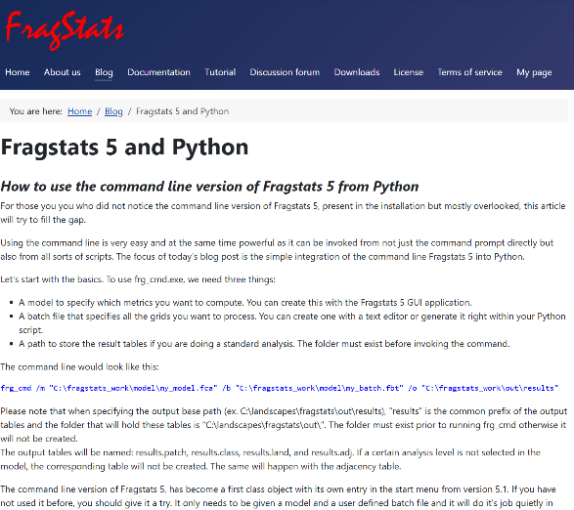
P.S. FRAGSTATS: FRAGSTATS is a landscape analysis tool used to quantify spatial patterns in categorical raster data. It identifies contiguous pixels of the same class as patches and computes metrics describing fragmentation, connectivity, edge complexity, and spatial heterogeneity. These metrics are widely applied in landscape ecology and urban studies to understand spatial structure.
In this study, FRAGSTATS-based metrics complement Python-based geospatial analysis. While Python is effective for calculating land-cover composition (e.g., PLAND), it does not provide a standardized framework for analyzing spatial configuration. FRAGSTATS offers a well-established set of patch-based metrics that ensure methodological consistency and comparability.

2.3 NYC Building Footprints
Source: NYC DoITT / NYC Open Data | Format: GeoPackage | Records: 1,082,289 |
CRS: EPSG:4326
The NYC Building Footprints dataset, provided by NYC DoITT, contains polygon geometries for all mapped buildings across the city, along with an attribute for roof height in feet. The dataset includes 1,082,289 records in GeoPackage format.
For processing, building geometries were reprojected to UTM Zone 18N to ensure accurate area calculations. The height_roof attribute was converted from feet to meters using a conversion factor of 0.3048. Representative centroid points were generated for each building and spatially joined to Census Tracts, resulting in a successful match rate of 99.98% (1,082,092 buildings).
Tract-level indicators derived from this dataset include total building count, mean, median, and maximum building height (in meters), building footprint coverage ratio (total footprint area divided by tract area), and building density (buildings per square kilometer). A small number of tracts corresponding to water bodies or major park interiors contained no buildings and were assigned missing values.

2.4 PLUTO v25.4
Source: NYC Department of City Planning | Format: CSV | Records: 858,644 tax lots
MapPLUTO v25.4, published by the NYC Department of City Planning, provides parcel-level land use and building attributes for 858,644 tax lots in CSV format. Key variables include floor area ratio (FAR), number of floors, year built, and land use classification.
To integrate this dataset, a consistent 11-digit Census Tract GEOID was constructed by concatenating the borough code (borocode) and tract identifier (bct2020). Parcel-level attributes were then aggregated to the tract level. Derived indicators include mean FAR, mean number of floors, median year built, and the modal land use class within each tract.

2.5 NYC Parks Properties
Source: NYC Parks / NYC Open Data | Format: CSV with WKT geometry | Records: 2,058
The NYC Parks Properties dataset enumerates all NYC Parks Department-managed properties, represented as multipolygon geometries stored in WKT format. The dataset includes 2,058 records.
WKT geometries were parsed using the Shapely library and intersected with Census Tract boundaries to compute the proportion of each tract occupied by parkland. This resulted in a park area ratio indicator for each tract. Of the 2,327 tracts, 1,354 contained at least partial park coverage, while the remaining 973 tracts were assigned a park_area_ratio of zero. These zero values were treated as structurally missing in terms of park presence rather than absent data.

2.6 American Community Survey (ACS) 5-Year Estimates (2019)
Source: U.S. Census Bureau API | Coverage: 2,167 NYC tracts | Tables: B19013, B17001, B02001, B25003
Socioeconomic variables were obtained from the U.S. Census Bureau’s American Community Survey (ACS) 2019 5-year estimates via the Census API, covering 2,167 NYC Census Tracts. Four tables were used: B19013 (median household income), B17001 (poverty status), B02001 (race), and B25003 (housing tenure).
From these tables, key indicators were computed, including poverty rate (percentage of population below the poverty line), minority percentage (non-white population share), and renter percentage (share of renter-occupied housing units). Sentinel values (-666666666) used by the Census Bureau to denote missing or suppressed data were recoded as NaN. Approximately 160 tracts (7%) had suppressed median income estimates, primarily corresponding to small or institutionalized populations.

2.7 CDC/ATSDR Social Vulnerability Index (SVI)
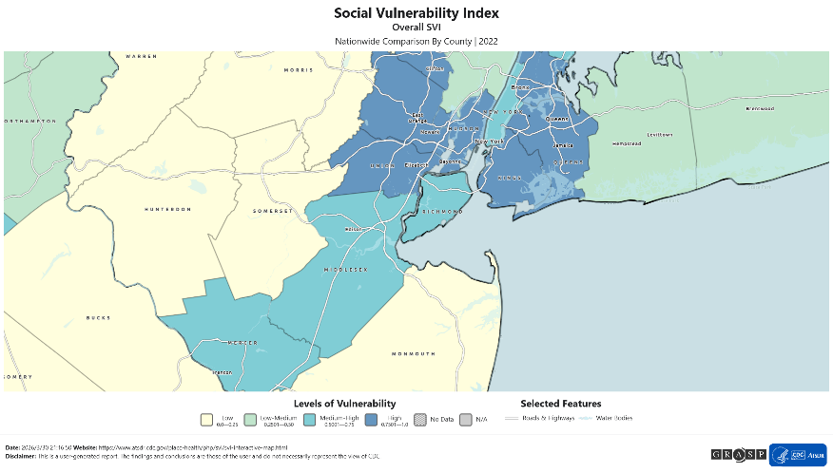
Source: CDC / ATSDR | Format: CSV | Coverage: All U.S. Census Tracts
The CDC/ATSDR Social Vulnerability Index (SVI) dataset provides a composite measure of social vulnerability at the Census Tract level across the United States. The primary indicator, RPL_THEMES, ranges from 0 to 1 and summarizes vulnerability across four dimensions: socioeconomic status, household composition, minority status and language, and housing type and transportation.
SVI data were matched to the analytical dataset using the 11-digit Census Tract GEOID. Sentinel values (-999) were recoded as NaN, affecting approximately 347 tracts (14.9%), which largely correspond to unpopulated areas such as water bodies, parks, or institutional zones identified by the CDC.

2.8 Final Data Integration
All seven datasets were integrated at the Census Tract level using the GEOID as a common key. The final analytical dataset consists of 2,327 Census Tracts and 73 variables, capturing a comprehensive range of environmental, spatial, and socioeconomic characteristics.
To ensure methodological consistency, all spatial operations—including reprojection, area calculation, and spatial joins—were conducted using a unified projected coordinate system, EPSG:26918 (UTM Zone 18N, NAD83). This standardization is critical for maintaining accuracy in distance- and area-based metrics across datasets with differing original coordinate systems.

3. Missing Data Analysis

3.1 Missing Data Identification
To evaluate data integrity, we systematically examined the distribution of missing values across the final tract-level dataset. Missingness was analyzed not only in terms of magnitude but also in terms of its structural and spatial context. We distinguished between structural absence and data gaps. This distinction is critical for applying the Dark Data framework, as it separates meaningful “known missing” values that reflect real-world conditions from missingness arising from data collection or reporting limitations.

3.2 Missing Data Identification
Missing data in the analytical table are structurally informative rather than random. Following the dark data taxonomy (Hand, 2020), each variable group is classified by missingness mechanism and handled accordingly.
Variable Group | Missing N (%) | Dark Data Type | Handling Strategy
Tree indicators (health, diversity) | 21 tracts (0.9%) | DD-Type 2 (Known missing) | tree_count = 0 assigned; diversity = NaN for tracts with < 5 trees
Building indicators | 5 tracts (0.2%) | DD-Type 2 (Known missing) | Retained as NaN (water / major park tracts)
Park area ratio | 973 tracts (41.8%) | DD-Type 2 (Known missing) | Filled with 0.0 (no parkland present)
Median income | ~160 tracts (~6.9%) | DD-Type 3 (Choosing not to record) | Retained as NaN; listwise deletion applied in regression models
SVI RPL_THEMES | ~347 tracts (~14.9%) | DD-Type 5 (Measurement issues) | Recoded -999 to NaN; excluded from SVI-dependent analyses
Landscape metrics | 7 tracts (0.3%) | DD-Type 4 (Self-selection / edge) | Retained as NaN (tracts at raster boundary)
Table 2. Missing data summary by variable group, mechanism classification, and handling strategy. The missing data matrix is shown in Figure 6.

3.3 Spatial and Structural Patterns of Missingness
Missing data are not randomly distributed but instead exhibit clear structural and spatial patterns.
Tree-related missingness is concentrated in tracts with very low tree counts, reflecting insufficient observations rather than data collection failure. Additionally, some apparent absence of tree-related indicators results from differences in data definitions rather than true ecological absence. The TreesCount dataset records only street trees and excludes trees located within parks or other non-street environments. Consequently, areas such as Central Park may appear to have zero tree counts despite substantial tree canopy, indicating a limitation of data scope rather than actual absence.
Park area ratio shows a high proportion of missing values (41.8%); however, this reflects a structural condition, as most tracts do not contain NYC Parks-managed land. These cases are therefore recoded as zero to accurately represent the absence of parkland.
Socioeconomic variables, particularly median income, exhibit missingness due to data suppression in low-population tracts, which are often associated with institutional land uses or minimal residential presence. Similarly, missingness in the Social Vulnerability Index (SVI) is primarily driven by a sentinel value (-999), which systematically excludes non-residential or institutional tracts.

3.4 Implications for Bias and Analysis
The structured nature of missing data has important implications for analysis.
Because SVI and income data are missing primarily in non-residential or low-population tracts, excluding these observations from regression models is analytically appropriate and unlikely to introduce systematic bias into comparisons across residential neighborhoods. However, such exclusion may slightly underrepresent areas with atypical land use characteristics.
The recoding of park area ratio to zero ensures that the absence of parkland is correctly represented rather than misinterpreted as missing data. For tree-related indicators, assigning tree_count = 0 while retaining undefined values (NaN) for diversity preserves the distinction between tracts with no trees and those with measurable ecological variation.
To further ensure robustness, a sensitivity analysis will be conducted by excluding tracts with suppressed income data from all income-based regressions.
Overall, although missingness is substantial in certain variables, its structured nature allows for analytically appropriate handling with limited risk of introducing bias into the main findings.

4. Initial Results and Visualizations

4.1 Descriptive Summary
After cleaning and merging, the analytical dataset captures 652,045 alive street trees distributed across 2,306 of 2,327 Census Tracts. Summary statistics for key indicators are presented below.
Indicator | Mean | Std. Dev. | Min | Max
Tree Health Index | 2.76 | 0.12 | 1.25 | 3.00
Tree Density (trees/km2) | 1,103 | 712 | 0 | 4,890
Mean DBH (inches) | 11.4 | 3.2 | 1.0 | 100.0
Shannon Diversity (H') | 1.82 | 0.44 | 0.00 | 2.89
Species Count per Tract | 28.3 | 14.1 | 1 | 82
Tree Canopy PLAND (%) | 27.4 | 13.5 | 0.3 | 71.2
Impervious PLAND (%) | 67.0 | 14.8 | 11.2 | 97.8
Mean Building Height (m) | 11.6 | 9.3 | 0.0 | 130.4
Park Area Ratio (%) | 7.3 | 14.2 | 0.0 | 98.4
Median Household Income ($) | 69,420 | 38,110 | 9,800 | 250,001
Poverty Rate (%) | 17.3 | 14.2 | 0.0 | 71.8
Minority % | 56.4 | 30.1 | 1.2 | 99.8
SVI RPL_THEMES | 0.51 | 0.28 | 0.00 | 1.00
Table 3. Descriptive statistics for key tract-level indicators (n = 2,306 tracts with tree data).
Health condition composition across all alive trees is: Good 81.1%, Fair 14.8%, Poor 4.1%. The top three street-tree species by count are London planetree (18.3%), honeylocust (9.9%), and Callery pear (9.0%), the latter raising long-term ecological concerns given its invasive potential. Native species constitute a small minority of the total inventory, concentrated in lower-ranked species by abundance.

4.2 Spatial Distribution of Tree Health Index
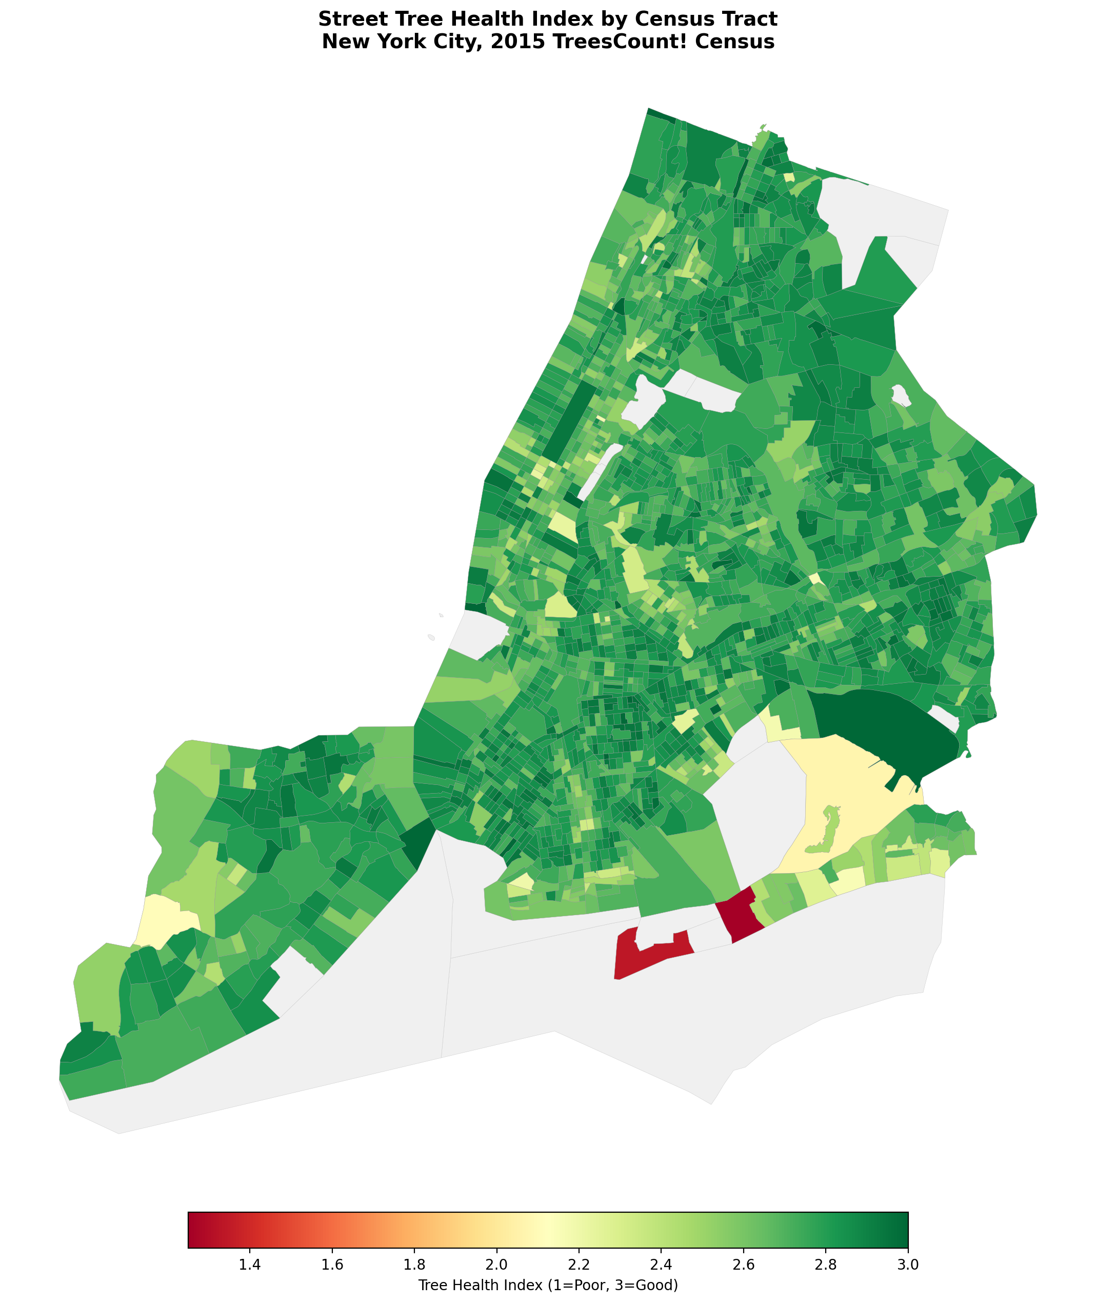
Figure 1. Choropleth Map of Street Tree Health Index by Census Tract New York City, 2015 TreeCount! Census
Figure 1 presents a choropleth map of the Tree Health Index across all 2,306 tracts. The citywide pattern reveals a predominantly green landscape with mean health near 2.76, consistent with a majority-Good distribution. However, pronounced low-health clusters are visible in lower Manhattan (Financial District, Lower East Side) and along the south Brooklyn and south Queens coastlines. These areas combine high building density, elevated impervious surface, and lower canopy coverage, suggesting built-environment constraints on tree vigor. Staten Island exhibits the highest health scores city-wide (see Figure 2).

4.3 Borough-Level Health Composition
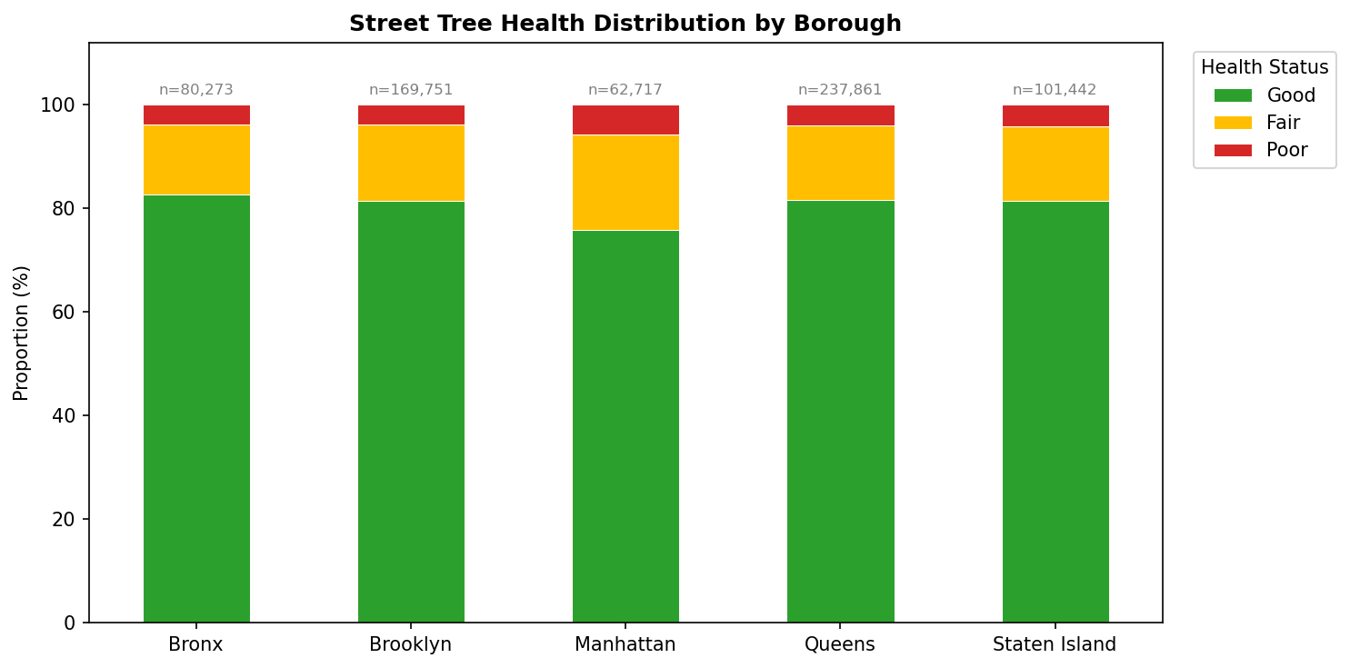
Figure 2. Stacked Bar Chart of Street Tree Health Distribution by Borough
Figure 2 disaggregates health composition by borough. Manhattan shows the lowest proportion of Good-rated trees (~76%) and the highest Poor proportion (~5%), despite having the highest median income among its resident populations. This apparent contradiction is consistent with the built-environment hypothesis: Manhattan's dense, impervious streetscape constrains root zones and moisture retention regardless of neighborhood wealth. Staten Island has the highest Good proportion and lowest Poor proportion, reflecting lower building density and greater canopy coverage.

4.4 Species Composition
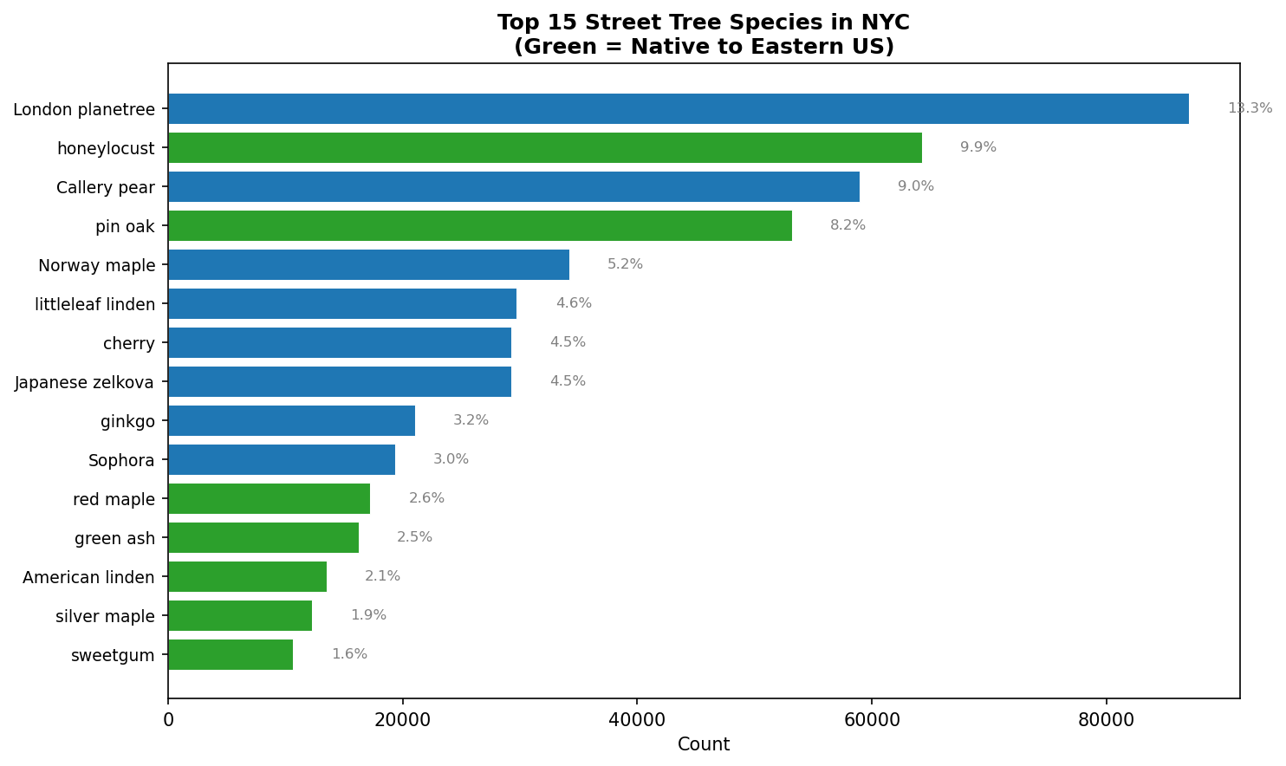
Figure 3. Horizontal Bar Chart of Top 15 Street Tree Species in NYC
Figure 3 displays the top 15 street-tree species by count. London planetree dominates, comprising nearly one-fifth of all alive trees — a legacy of mid-20th century mass planting driven by its pollution tolerance. The predominance of three non-native species in the top ranks (London planetree, honeylocust, Callery pear) underscores ongoing concerns about species homogeneity and its implications for ecological resilience under pest or climate pressures (Berland et al., 2017).

4.5 Socioeconomic Correlates
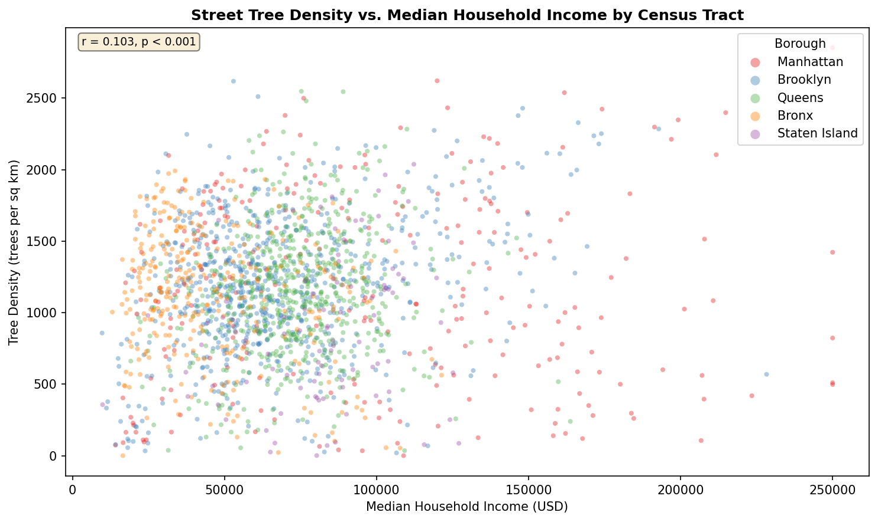
Figure 4. Scatter Plot of Street Tree Density vs. Median Household Income
Figure 4 examines the bivariate relationship between tree density and median household income. A statistically significant but weak positive correlation is observed (r = 0.102, p < 0.001), indicating that higher-income tracts tend to have marginally higher tree density. Manhattan tracts form a visually distinct cluster characterized by high income but anomalously low tree density, reflecting the borough's extreme built-environment intensity. This pattern suggests that income alone is insufficient to explain tree distribution; built-environment constraints must be considered jointly.

4.6 Land Cover Composition by Borough
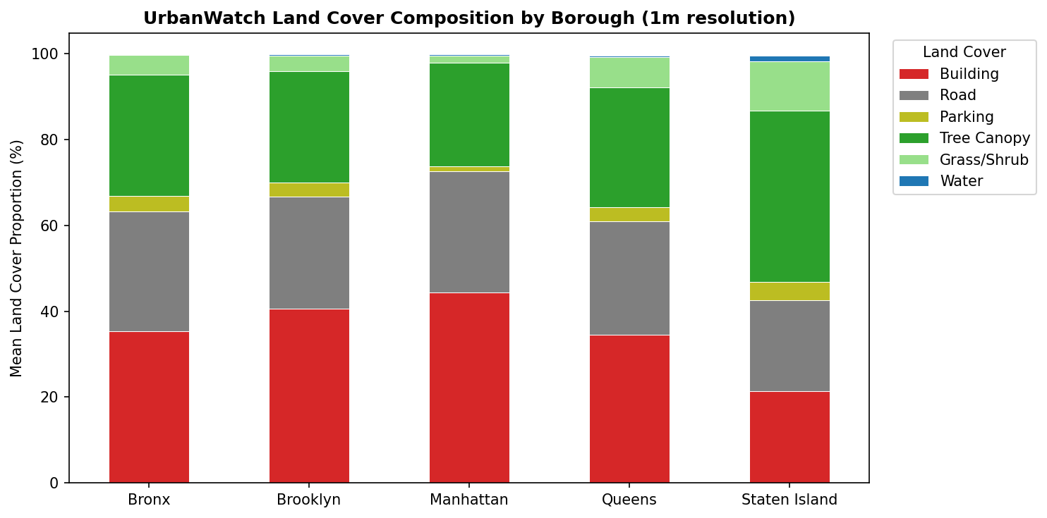
Figure 5. Grouped bar chart of Land Cover Composition by Borough(1m resolution)
Figure 5 presents land cover composition (PLAND by class) stratified by borough. Staten Island has the highest mean tree canopy PLAND (~40%) and lowest impervious surface (~52%), while Manhattan has the lowest tree canopy (~6%) and highest impervious cover (~93%). The Bronx and Brooklyn occupy intermediate positions, with Brooklyn showing notable variability across tracts. These borough-level patterns establish the structural context within which tree health and diversity outcomes are subsequently modeled.

4.7 Built Environment Intensity and Tree Health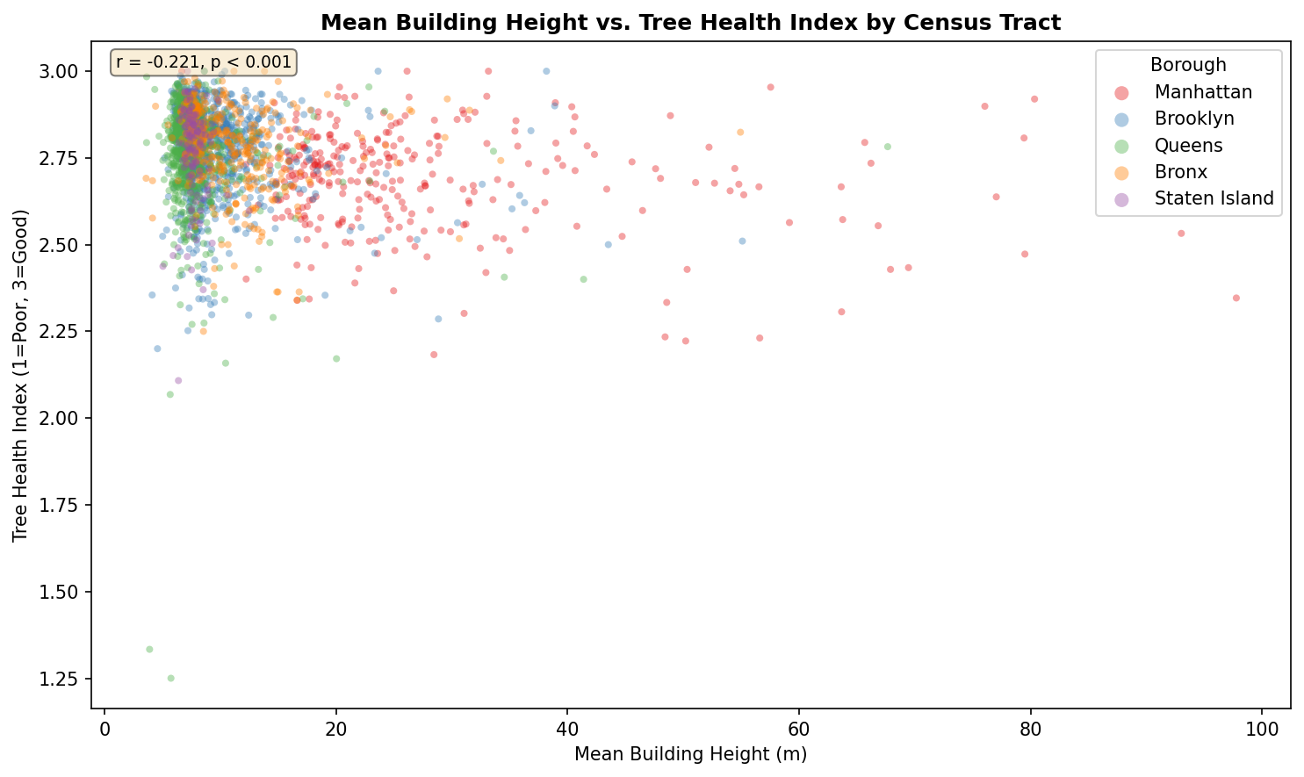
Figure 6. Scatter Plot of Mean Building Height vs. Tree Health Index
Figure 6 examines the relationship between mean building height and Tree Health Index at the tract level. A significant negative correlation is observed (r = -0.221, p < 0.001), indicating that tracts with taller buildings tend to exhibit lower tree health. This effect is consistent with the hypothesis that vertical densification reduces solar access, increases street-canyon wind effects, and compresses root-zone soil volumes available to street trees. The relationship is notably stronger in the Pearson correlation than the income-tree density relationship, suggesting that physical built-environment factors may be more proximal deter

5. Spatial Autocorrelation and LISA Clusters
在完成 tract-level 数据整合与描述性制图之后，本研究进一步使用空间自相关分析判断 Tree Health Index、Street Tree Density 和 Species Diversity 是否呈现非随机分布。具体而言，Global Moran’s I 用于检验整个纽约市尺度上的总体空间集聚趋势；Local Moran’s I / LISA 则用于识别局部空间类型，包括高值被高值邻近包围的 High-High clusters、低值被低值邻近包围的 Low-Low clusters，以及 High-Low 和 Low-High 两类空间离群区。所有空间自相关分析均采用 row-standardized k-nearest-neighbors 空间权重矩阵，k = 8。该设定可以避免纽约市岛屿、水体分隔和不连续 tract 带来的 disconnected-neighbor 问题，同时也保证 LISA 分析与后续的空间计量模型使用一致的空间邻近定义。显著性通过 999 次 permutation test 评估，并以 p < 0.05 作为局部空间聚类判定标准。结果显示，三个街道树生态指标均具有显著正向空间自相关，说明纽约市街道树生态质量并不是随机分散的，而是呈现出稳定的空间集聚结构。Tree Health Index 的 Moran’s I 为 0.313，表明树木健康状况存在中等强度的空间集聚；Street Tree Density 的 Moran’s I 为 0.361，是三个结果变量中空间集聚最强的指标，说明街道树供给不仅受单个 tract 内部条件影响，也高度受到相邻街区种植格局和城市形态连续性的影响；Species Diversity 的 Moran’s I 为 0.300，显示物种多样性同样具有明显的空间组织特征，可能反映了历史种植策略、道路等级、街区形态和维护制度的空间连续性。
Outcome | N | Moran's I | z-score | p-value
Tree Health Index | 2306 | 0.313 | 31.667 | 0.001
Street Tree Density | 2327 | 0.361 | 35.754 | 0.001
Species Diversity | 2306 | 0.300 | 29.498 | 0.001
Table 4. Global Moran's I results.
从 LISA 图的解释上，High-High clusters 可以被理解为街道树生态优势区，即指标本身较高、且周边 tract 同样较高的区域；Low-Low clusters 则代表连续性的生态弱势区，是后续 co-burden mapping 中最需要关注的空间单元。Tree Health Index 的 Low-Low clusters 指向街道树健康状况较弱并具有邻近延续性的区域；Street Tree Density 的 Low-Low clusters 指向街道树供给不足的连续片区；Species Diversity 的 Low-Low clusters 则提示物种组成单一、生态韧性较弱的空间集聚。相比之下，High-Low 和 Low-High outliers 具有更强的诊断意义：它们不是大片连续问题，而是局部异常点，对应特殊街道环境、公园边界、非典型土地使用、历史种植项目或数据定义差异。因此，纽约市街道树不平等并不只是 tract-level 单元之间的差异，而是具有明确的空间邻近效应。这个结果说明co-burden index 不应只看单个 tract 的数值排名，还应关注低质量、低供给或低多样性是否形成连续片区，因为连续性的 Low-Low clusters 更适合作为街道树维护、补植和树坑改造的优先治理单元。
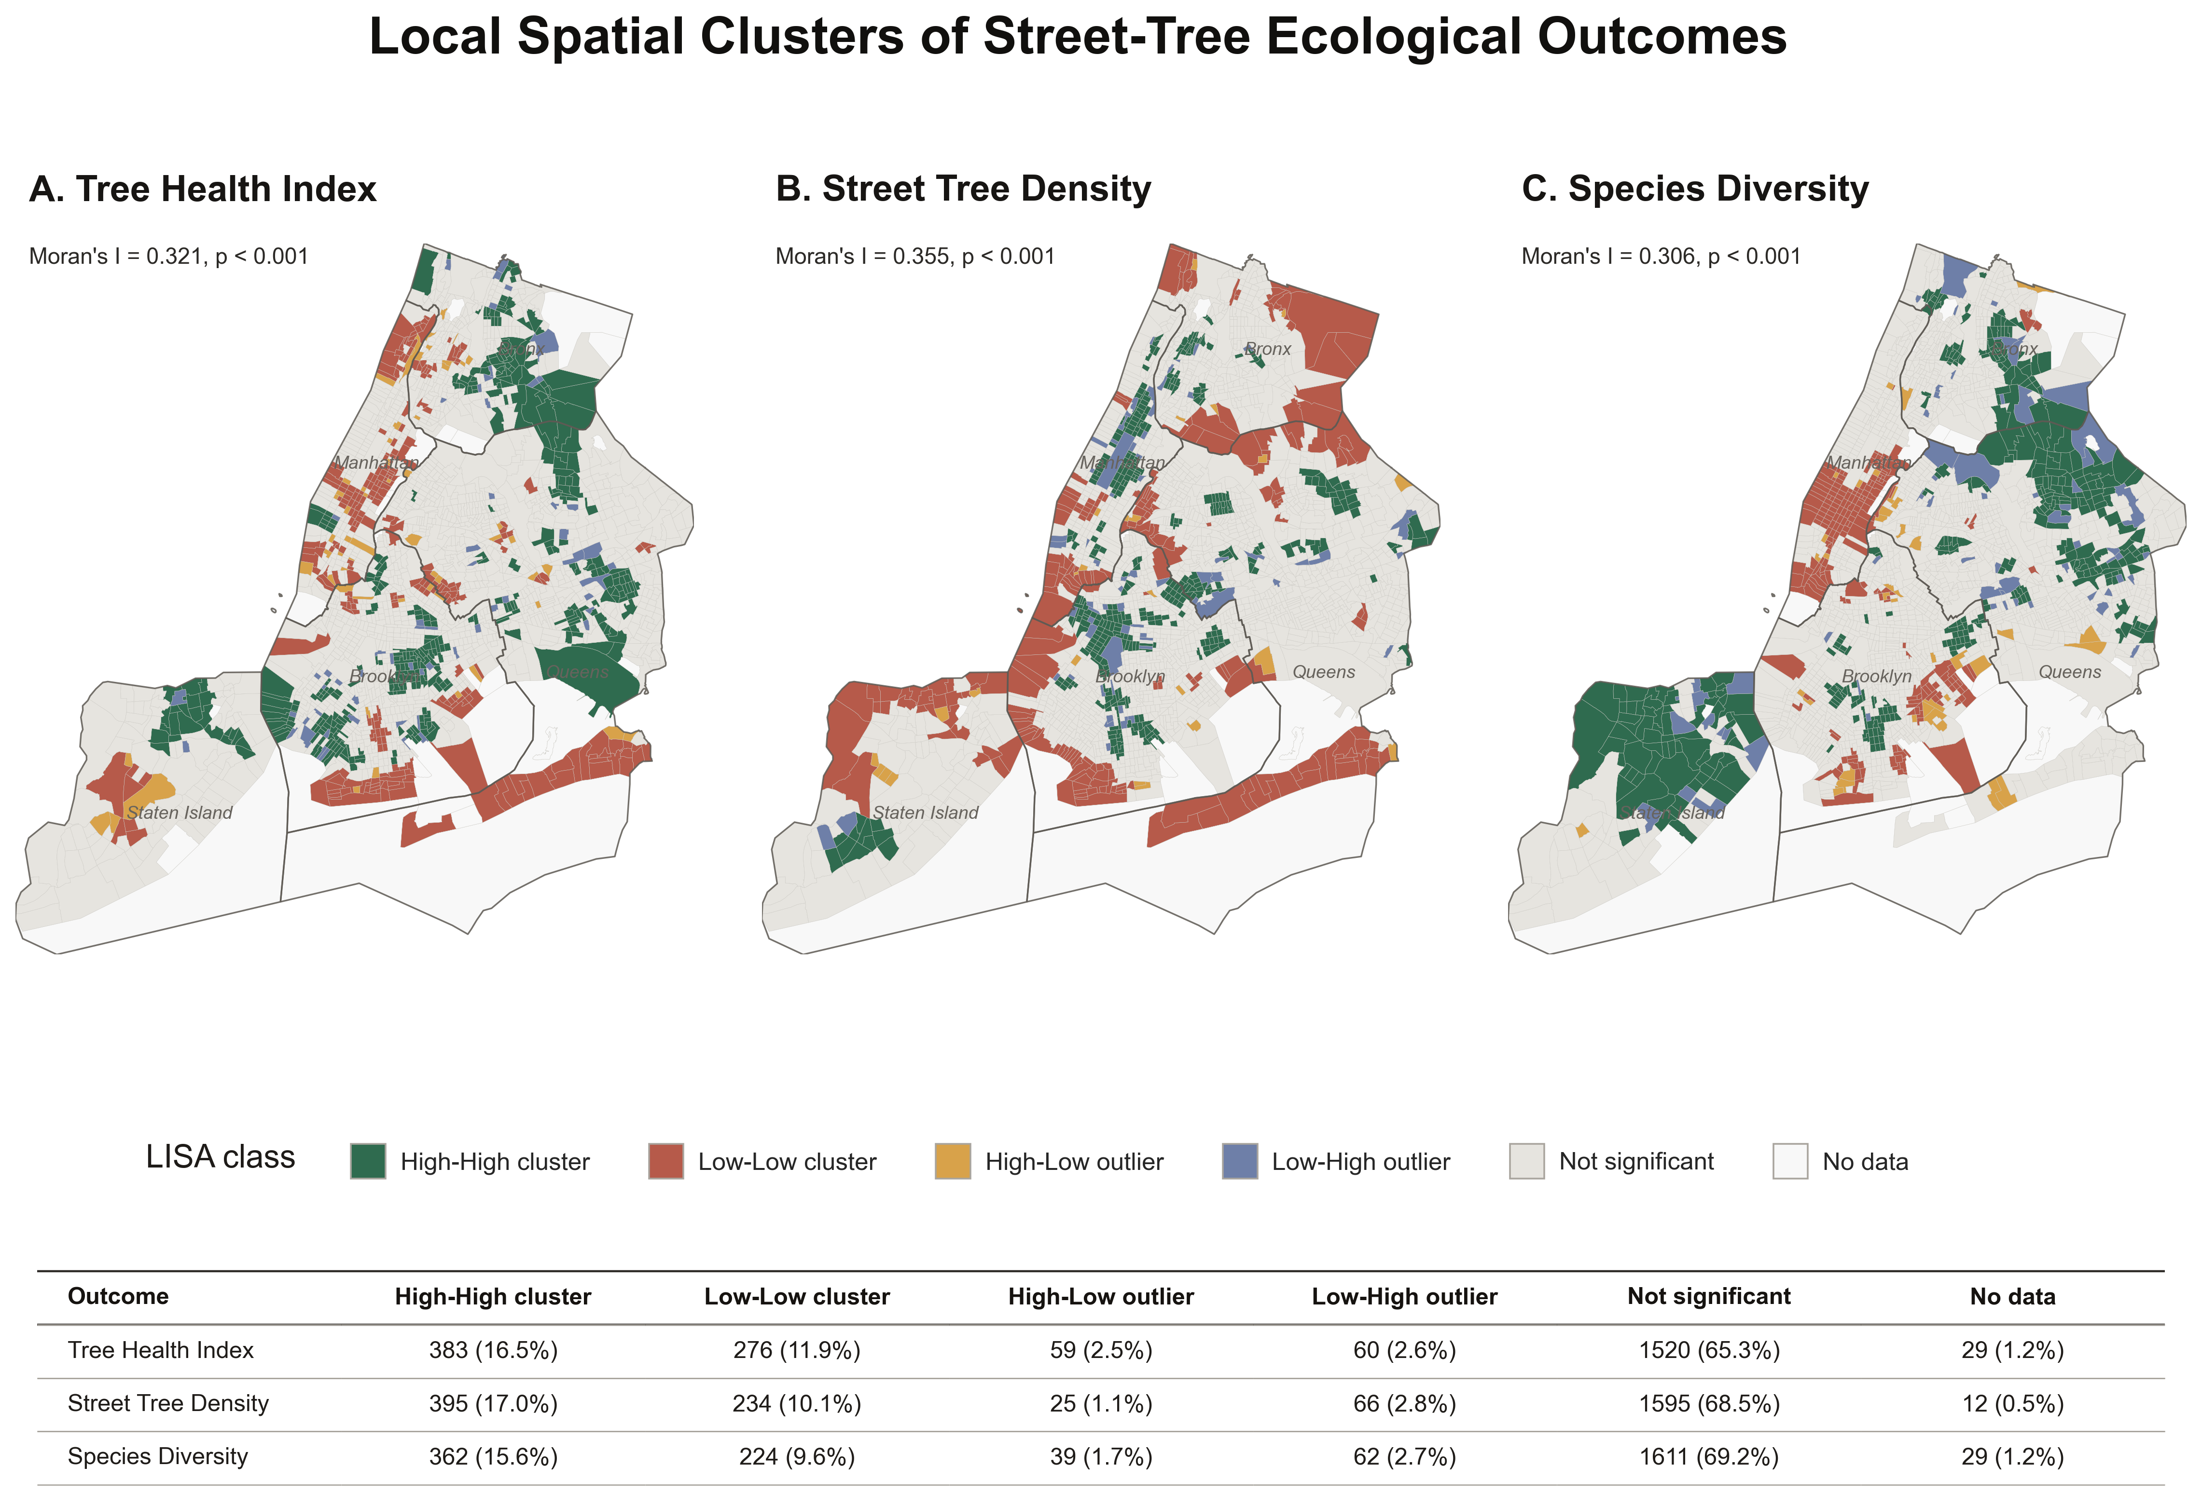Figure 7. Local spatial clusters of street-tree ecological outcomes across New York City Census Tracts.

6. Explanatory Baseline and Spatial Econometric Models

6.1 OLS baseline models
基于空间聚集结果，本部分进一步检验街道树生态质量与社会经济、建成环境、土地覆盖和景观格局变量之间的解释性关联。先前已经显示 Tree Health Index、Street Tree Density 和 Species Diversity 均存在显著正向空间自相关，本部分引用普通线性模型视为一个可解释的 baseline，用于判断不同变量组对三个街道树生态结果的基本解释能力。随后，引入空间计量模型，检验在考虑邻近 tract 的空间依赖后，模型解释是否得到改善，以及残差空间自相关是否被有效削弱。首先建立 OLS baseline models。三个因变量分别对应街道树生态质量的不同维度：Tree Health Index 表征街道树健康状态，Street Tree Density 表征街道树供给水平，Species Diversity 表征树种组成多样性和潜在生态韧性。所有预测变量在建模前进行标准化，并通过 VIF 筛选降低多重共线性影响。OLS 结果显示，三个因变量的解释力存在明显差异。Street Tree Density 的调整后 R² 最高，约为 0.609，说明街道树供给与 tract-level 的建成环境、土地覆盖和景观格局之间存在较强结构性关联。Species Diversity 的解释力居中，调整后 R² 约为 0.367，表明物种多样性部分受到城市形态和绿地格局影响，但也可能受到历史种植策略、苗木供应、街道等级和维护制度等未观测因素影响。相比之下，Tree Health Index 的调整后 R² 仅为 0.159，说明树木健康状态较难由 tract-level 变量解释。
Outcome | n | Adjusted R² | AIC | Residual Moran’s I | Residual p | Interpretation
Tree Health Index | 1,959 | 0.159 | −2,867.1 | 0.265 | 0.001 | Weak tract-level explanatory power; strong residual spatial structure
Street Tree Density | 1,961 | 0.609 | 2,168.7 | 0.186 | 0.001 | Strongest baseline fit; supply remains spatially structured
Species Diversity | 1,959 | 0.367 | 1,548.7 | 0.261 | 0.001 | Moderate fit; diversity retains strong spatial dependence
Table 5. OLS model results.

6.2 Spatial Lag and Spatial Error models
然而，OLS 模型的残差仍然存在显著空间自相关。三个因变量的 OLS residual Moran’s I 均显著，说明非空间模型没有完全吸收街道树生态结果中的邻近效应。换言之，街道树生态质量不是单个 tract 内部变量的独立结果，而具有明显的空间连续性和邻域依赖。这一发现直接支持后续空间计量模型的必要性。因此，研究进一步估计 Spatial Lag 和 Spatial Error 模型。Spatial Lag 模型假设相邻 tract 的因变量本身会影响当前 tract 的结果，适合描述街道树健康、密度或多样性在空间上连续扩散或共同组织的情形。Spatial Error 模型则假设空间依赖主要存在于未观测误差项中，代表遗漏变量或未观测空间过程的影响。两类模型共同用于判断空间依赖到底更接近 “outcome-level neighborhood dependence”，还是更接近 “unobserved spatial error”。模型比较显示，Spatial Lag 模型在 Tree Health Index 和 Species Diversity 上表现更稳定。对于 Tree Health Index，Spatial Lag 将 residual Moran’s I 从 OLS 的 0.265 降至接近 0 且不显著，说明树木健康的空间结构在很大程度上可以通过相邻 tract 的 health condition 解释。对于 Species Diversity，Spatial Lag 同样将残差空间自相关降至不显著，说明树种多样性存在明显的空间连续性。相比之下，Spatial Error fallback models 的残差 Moran’s I 仍然显著，说明它们没有充分消除空间依赖。因此，在正文中应将 Spatial Lag 作为主要空间模型，把 Spatial Error 放在补充材料或作为 robustness comparison。Street Tree Density 的情况更复杂。虽然 Spatial Lag 提高了模型表现，并降低了 residual Moran’s I，但残差空间自相关仍然显著。这意味着街道树密度不仅受到本 tract 内部的建成环境和土地覆盖影响，也可能受到更大尺度的街道网络、道路等级、种植政策、维护区划和历史街道绿化投资影响。这类过程未必能被 Census Tract 内部变量完全捕捉。
Outcome | Preferred spatial model | Spatial parameter ρ | Pseudo R² | AIC | Residual Moran’s I | Residual p | Main finding
Tree Health Index | Spatial Lag | 0.568 | 0.341 | −3,218.8 | −0.001 | 0.476 | Spatial dependence largely removed
Street Tree Density | Spatial Lag | 0.304 | 0.638 | 2,063.2 | 0.101 | 0.001 | Fit improves, but residual clustering remains
Species Diversity | Spatial Lag | 0.557 | 0.507 | 1,171.8 | 0.012 | 0.144 | Spatial dependence largely removed
Table 6. Spatial econometric model comparison.

7. Machine Learning Diagnosis
本部分中将机器学习作为非线性诊断层，用于检验社会经济、建成环境、土地覆盖和景观格局变量是否能够在非线性关系、变量交互和空间异质性存在的情况下预测街道树生态结果。与 OLS 和空间计量模型不同，机器学习模型不主要用于估计变量的线性方向和显著性，而是用于回答三个诊断性问题：第一，三个街道树生态指标在多变量条件下是否具有稳定的可预测性；第二，非线性模型是否显著提高预测表现；第三，哪些变量在预测过程中贡献最大，并是否表现出潜在阈值或异质性。

7.1 Model training and validation

本研究分别针对 Tree Health Index、Street Tree Density 和 Species Diversity 建立 Random Forest、CatBoost 和 XGBoost 模型。模型输入变量包括社会脆弱性、建成环境强度、土地覆盖组成、绿地供给和景观格局指标。为了避免空间数据中 random split 造成的过度乐观估计，本研究不仅使用 80/20 random train-test split，还使用 borough-based GroupKFold validation 进行更严格的空间泛化检验。后者将 borough 作为分组单元，用于测试模型是否能够从部分 borough 学到的关系推广到未参与训练的 borough。

7.2 Model performance comparison
结果显示，三个 outcome 的可预测性存在显著差异。Street Tree Density 在 random split 和 borough-based validation 下都表现稳定，CatBoost 在 borough GroupKFold 下仍达到较高 R²，说明街道树供给可以被 tract-level 的土地覆盖、建成环境和景观格局变量较好解释。这表明街道树密度更接近一种结构性供给结果，受规划历史、道路空间、绿地格局和建成强度共同塑造。Species Diversity 的预测表现处于中等水平。它在 random split 下表现较好，但在 borough-based validation 下明显下降，说明树种多样性的预测具有一定空间异质性。换言之，某些 borough 内部形成的树种配置规律未必可以直接推广到其他 borough。因此，species diversity 不能只被理解为土地覆盖或树木数量的函数，而应被视为历史规划和生态管理共同作用的结果。相比之下，Tree Health Index 的预测表现最弱。在 borough-based validation 中，Tree Health Index 的 R² 接近 0，个别模型甚至出现负值。这并不意味着模型计算错误，而是说明当前 tract-level 变量对跨 borough 的树木健康预测能力非常有限。由于 Tree Health Index 的数值分布本身较集中，且大多数街道树被评为 Good，模型可学习的差异空间较小；同时，树木健康更可能由树坑尺寸、土壤体积、根系空间、灌溉、修剪、病虫害、道路盐害、维护历史和微气候压力等细尺度因素决定。这些变量没有被当前 Census Tract 层级数据充分捕捉。
Outcome | Best model | Random split R² | Borough GroupKFold R² | RMSE | MAE | Interpretation
Tree Health Index | Random Forest | 0.140 | 0.035 | 0.133 | 0.100 | Weak borough-level transferability
Street Tree Density | CatBoost | 0.699 | 0.675 | 0.645 | 0.363 | Strong and stable predictability
Species Diversity | CatBoost | 0.466 | 0.266 | 0.410 | 0.315 | Moderate but spatially sensitive predictability
Table 9. Machine learning model performance.
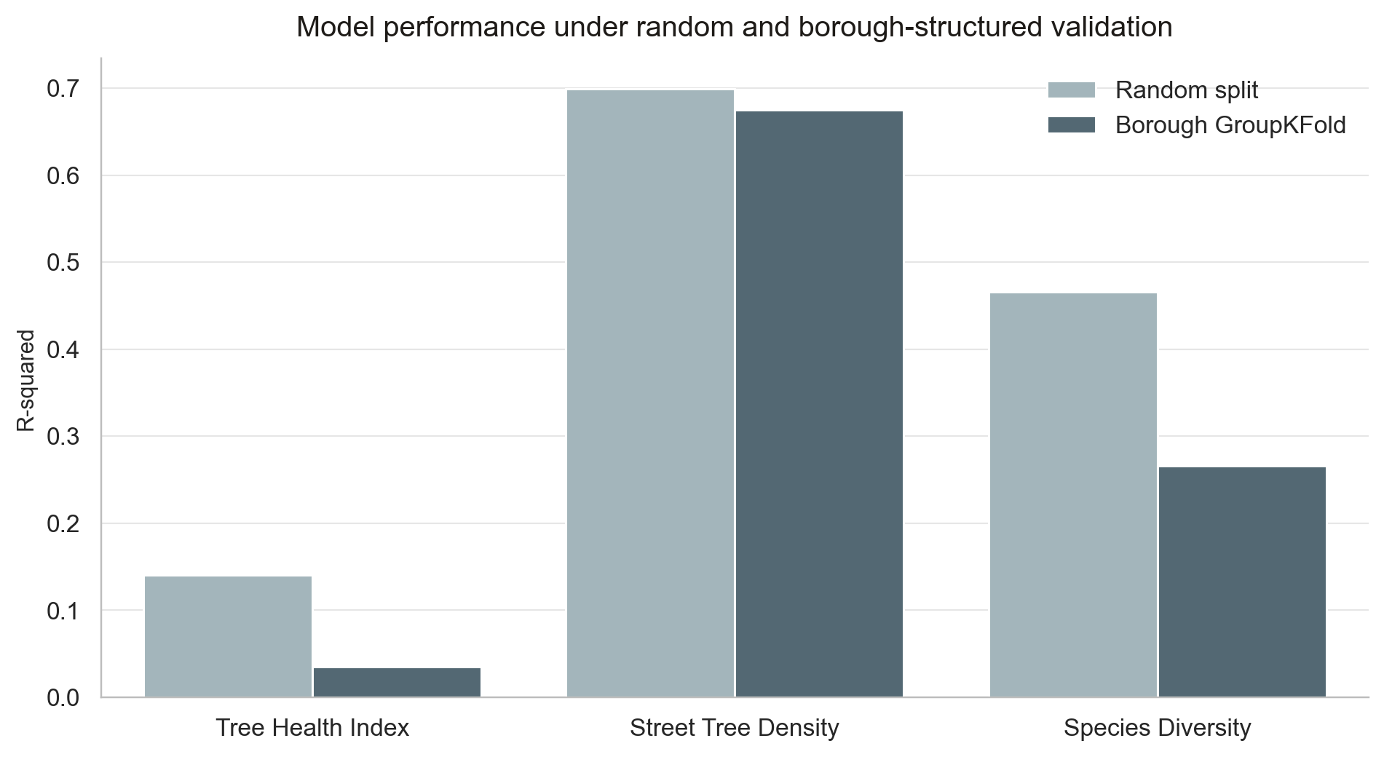
Figure 8. Machine learning performance under random and borough-structured validation.

7.3 Variable importance and SHAP
为了进一步理解机器学习模型如何形成预测，本研究结合 permutation importance 与 SHAP对最佳模型进行解释。需要强调的是，这些解释结果反映的是预测贡献，而不是严格意义上的因果效应，因此应被理解为机制诊断和假设生成工具，而非最终机制证明。从 permutation importance 来看，三个 outcome 的主导变量结构具有明显差异。对于 Tree Health Index，贡献较高的变量主要包括 mean floors、minority percentage、tree canopy ED、tree canopy PLAND 以及 landscape SHDI，说明树木健康的预测并不集中于单一形态变量，而是受到树冠边缘结构、街区建筑强度和景观异质性的共同影响。对于 Street Tree Density，最重要的变量明显集中在 built environment 与 green structure 两类指标上，尤其是 building density、building coverage、tree canopy ED 和 mean FAR，表明街道树供给主要受建成空间强度和树冠结构条件共同塑造。对于 Species Diversity，tree canopy NP、building density、mean floors、building NP 和 tree canopy PD 的重要性较高，说明树种多样性不仅与树木数量本身有关，也与绿地斑块数量、建成环境复杂度和街区形态结构密切相关。SHAP summary plots 进一步揭示了这些变量的方向性和非线性关系。对 Tree Health Index 而言，tree canopy ED、tree canopy PLAND 和 mean floors 是最值得关注的三个变量。SHAP dependence plots 显示，tree canopy ED 与树木健康总体呈正向关系：当 tree canopy ED 从较低水平升高至约 550–600 左右时，对健康指数的贡献由负转正，此后继续增加时正向影响逐渐增强。这说明在纽约街道树系统中，较高的树冠边缘密度可能对应更连续、更可达或更有效嵌入街道空间的树冠结构。与此同时，tree canopy PLAND 呈现明显阈值效应：在约 28%–30% 以下时，其对健康指数的贡献总体偏负，而超过这一范围后转为正值，说明一定程度的周边树冠覆盖是支持街道树健康状态的重要背景条件。相比之下，mean floors 呈现倒 U 型或阶段性负向关系：在低层到中低层建筑环境中，模型预测较为有利，但在约 4–5 层以上后，对 Tree Health Index 的贡献逐渐转负，提示更高的建筑强度可能通过遮阴、街谷效应、压缩根域空间等方式增加街道树生长压力。需要注意的是，由于 Tree Health Index 的整体预测能力较弱，这些模式更适合作为探索性线索，而不宜被过度因果化解释。对 Street Tree Density 而言，SHAP dependence plots 呈现出更清晰、也更稳定的结构关系。building density 的影响呈现快速上升后趋于平台的非线性模式：在很低建筑密度下，SHAP 值显著为负；随着 building density 增加，预测贡献迅速转正，并在中高密度范围保持稳定。这说明极低密度地区往往缺乏连续街道界面和街道树配置条件，而中高密度街区反而更容易形成系统化的街道树供给。building coverage 也显示出类似阈值型模式：当建筑覆盖率低于约 15%–20% 时，对街道树密度贡献偏负；超过这一范围后，影响迅速转正，并在 30% 左右以后进入平稳阶段，说明适度而连续的街道建成界面可能更有利于形成规则化的行道树种植系统。与此同时，tree canopy ED 呈现较强的单调正向关系，尤其在约 800 左右后正向贡献显著增强，进一步表明街道树供给与树冠边缘结构的连续性密切相关。整体而言，Street Tree Density 的 SHAP 图显示出最强的结构性和最清晰的阈值规律，这与其在机器学习验证中表现出最高、最稳定的可预测性是一致的。对 Species Diversity 而言，SHAP 结果揭示了一种更复杂的空间结构逻辑。首先，tree canopy NP 是最重要的变量之一，其 dependence plot 显示出典型的快速上升后趋于饱和的关系：在斑块数量较低时，SHAP 值明显为负；随着 tree canopy NP 提高至约 400–500 左右，正向贡献迅速增强，并在其后进入平台。这表明过少的树冠斑块往往对应单一、破碎或不足的绿地环境，而更丰富的树冠斑块结构有利于支持更高的树种多样性。其次，mean floors 呈现明显的倒 U 型关系：在约 2–4 层范围内，对物种多样性的贡献相对积极，但在 5–6 层以后迅速转负，并在高楼层区间持续下降。这说明中低层街区可能最有利于容纳多样化的树种配置，而高强度垂直开发环境则更可能压缩可种植空间并降低树种组合的复杂性。第三，building density 也表现出由负转正再趋于平台的非线性趋势：极低密度区对物种多样性不利，中等密度区最有利，而在极高密度范围内则可能出现轻微回落。这说明多样性并不是简单随密度增加而提高，而是受到街区结构、道路空间和种植制度共同塑造。综合来看，Species Diversity 的 SHAP 结果表明，物种多样性不仅取决于是否“有树”，更取决于树冠斑块结构、建成环境组织方式以及中低层街区尺度上的空间可容纳性。
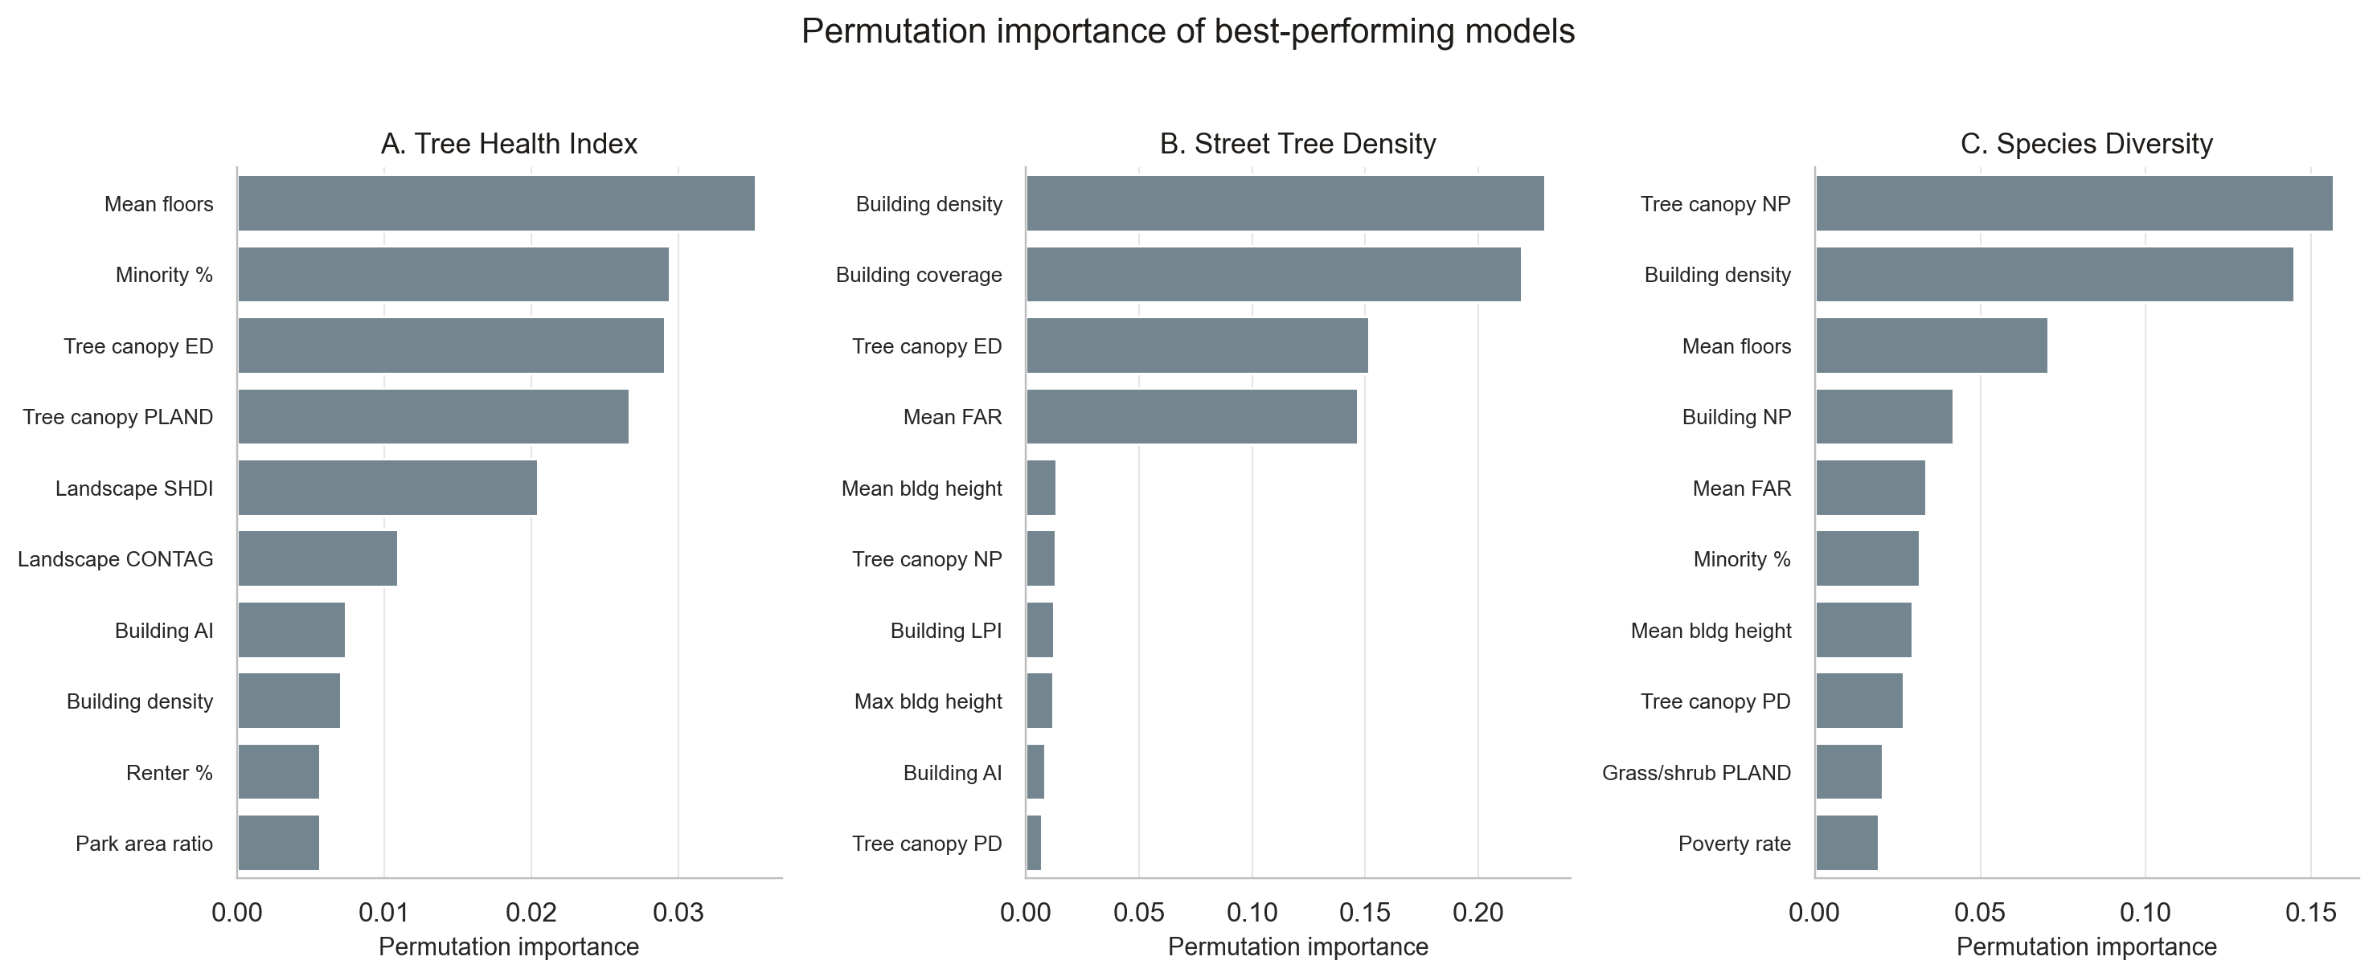
Figure 9. Permutation importance for the best-performing machine learning model for each outcome.
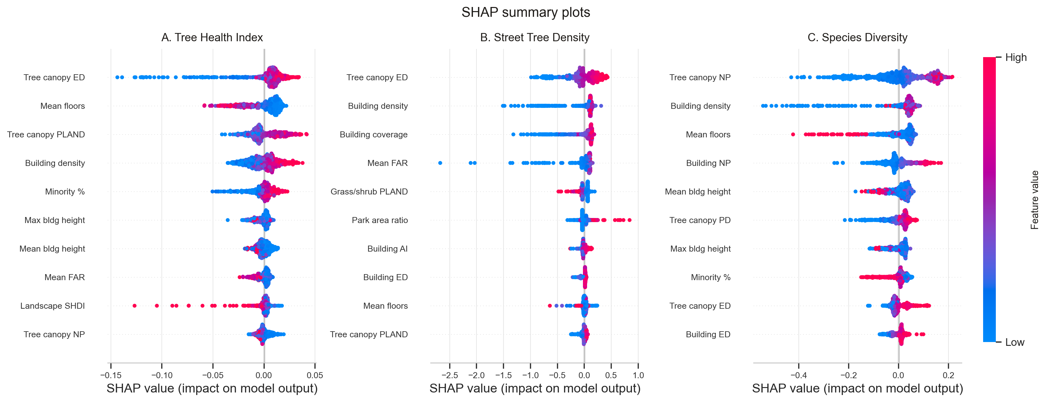
Figure 10. SHAP summary plot for Tree Health Index,Street Tree Density, Species Diversity.
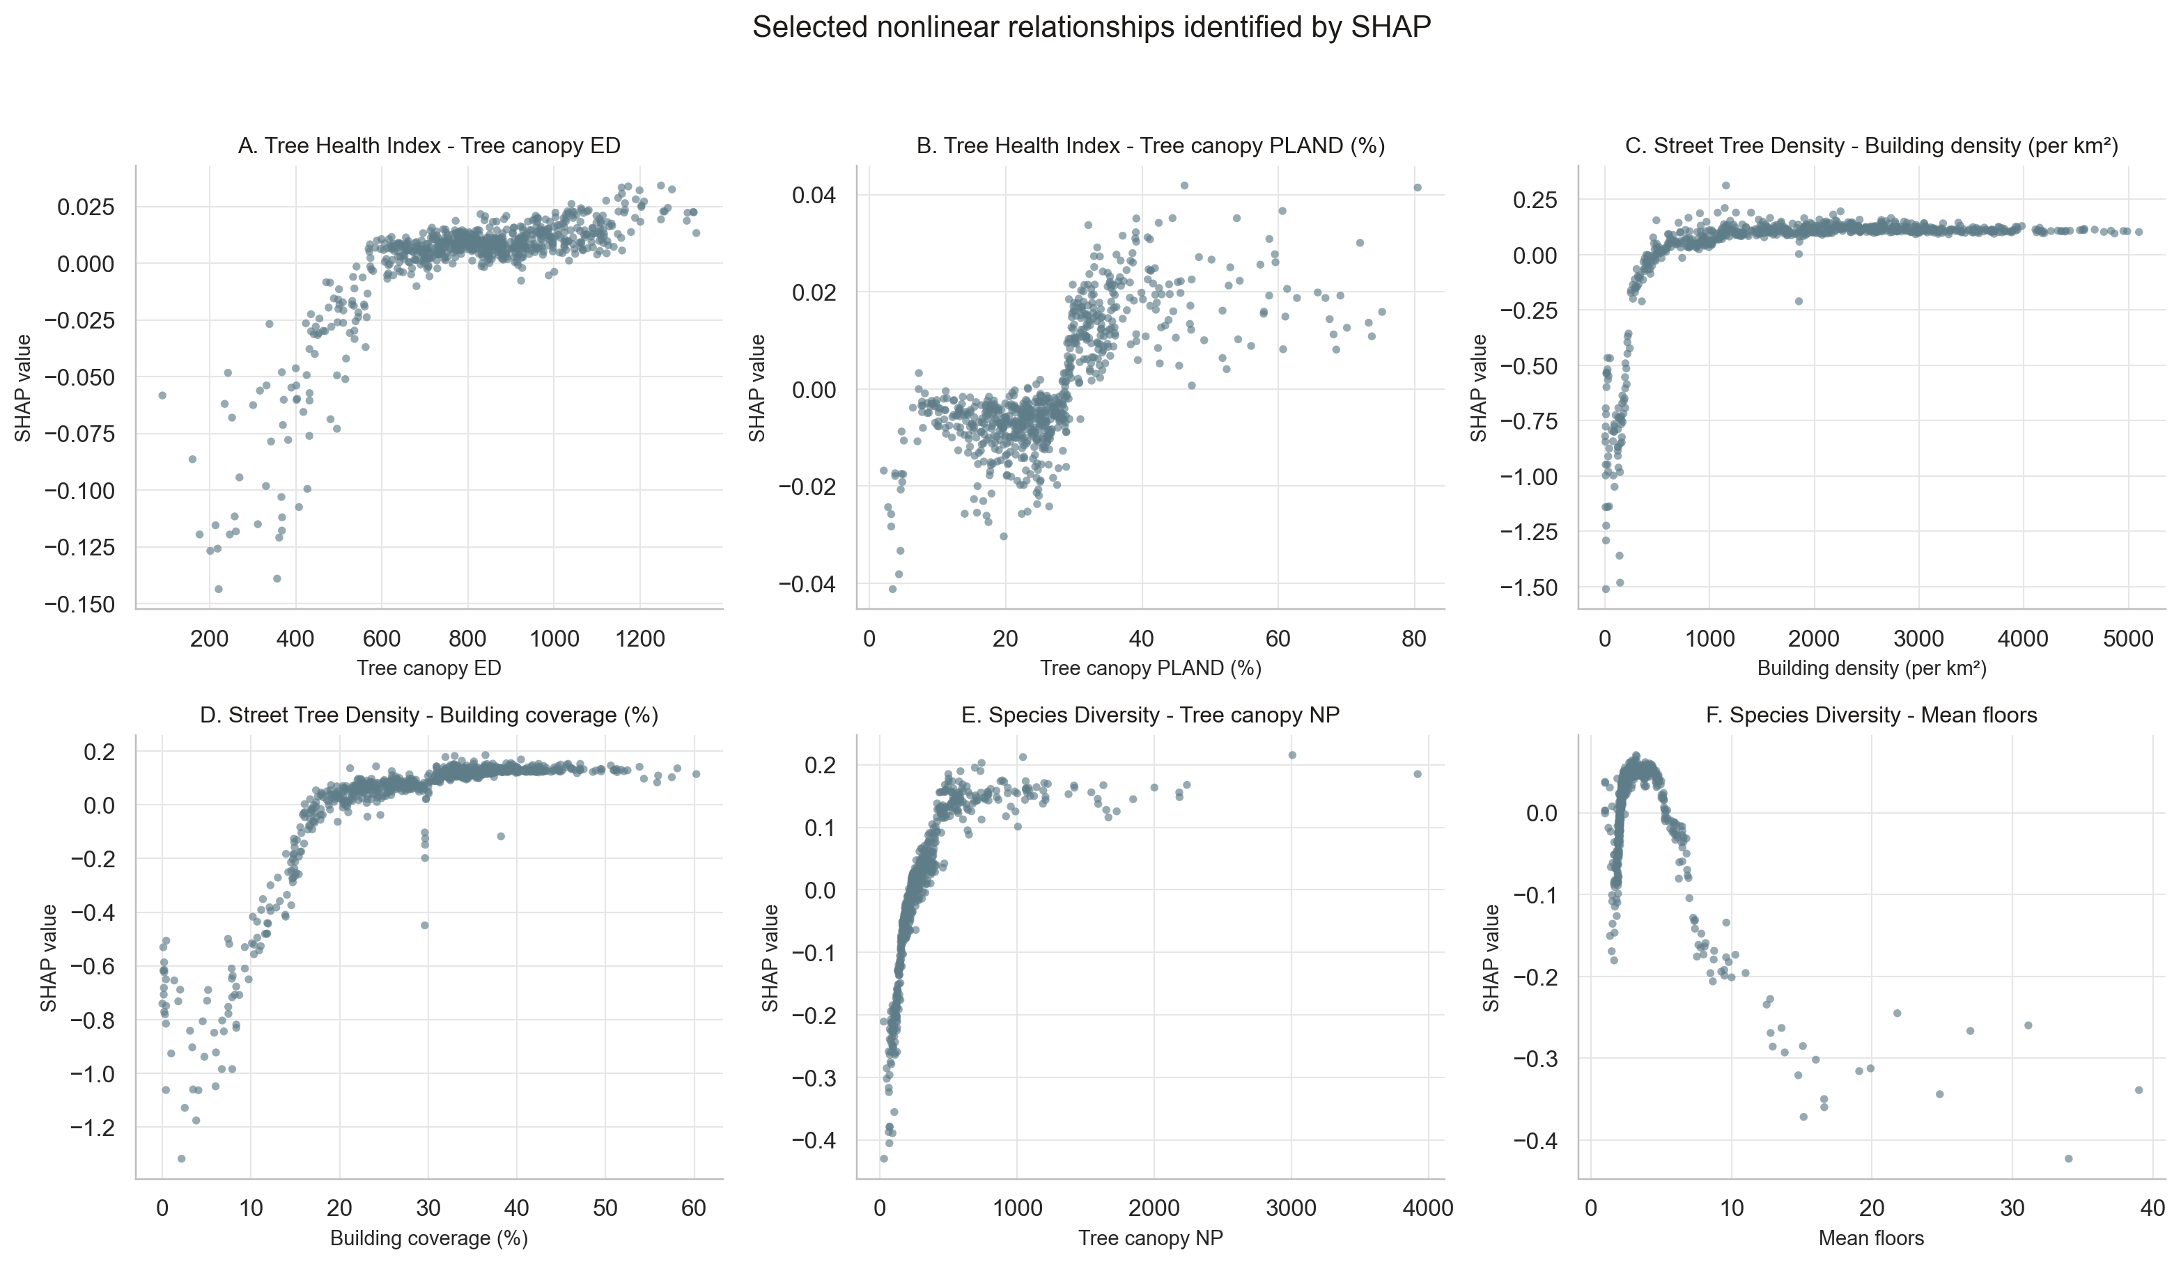
Figure 11. Selected SHAP dependence plots highlight nonlinearities and threshold-like behavior.

7.4 Machine learning synthesis
综合模型验证、变量重要性和 SHAP 解释结果可以看出，机器学习进一步揭示了三个街道树生态指标在可预测性、空间可迁移性与机制复杂度上的显著差异。首先，Street Tree Density 是最稳定、也是最可预测的 outcome。无论在 random split 还是 borough-based GroupKFold validation 下，它都保持了较高的 R²，说明街道树供给在较大程度上受 tract-level 的建成环境强度、土地覆盖结构和树冠空间格局所塑造。这意味着 street-tree density 更接近一种“结构性供给结果”：它不仅反映绿地资源分布，也反映长期街道规划、种植制度和道路空间条件的综合影响。对规划实践而言，这类结果最适合用于识别街道树供给不足区、比较 borough 之间的供给差异，并为后续 co-burden index 中的服务不足维度提供依据。其次，Species Diversity 具有中等水平的可预测性，但空间可迁移性明显弱于 tree density。其在 random split 下表现较好，但在 borough-based validation 中下降更明显，说明树种多样性的决定机制具有更强的地方性和历史性。这种地方性可能来自不同 borough 在树种选择、街道等级、维护制度、历史补植项目和苗木来源上的差异。第三，Tree Health Index 的预测能力最弱，而这一点恰恰是本研究非常重要的结论。即便引入非线性模型，Tree Health Index 在 borough-structured validation 下仍接近零，说明当前 tract-level 的社会经济、建成环境、土地覆盖和景观格局指标，并不足以稳定解释跨 borough 的树木健康差异。这一结果并不意味着分析失败，而是说明“树木健康”这一 outcome 与“树木数量”或“树种多样性”在本质上不同。它更多受微尺度条件支配，例如树坑大小、土壤体积、根域空间、灌溉与修剪、病虫害、道路盐害、维护频率以及街道微气候压力等，这些变量尚未被当前数据体系捕捉。因此，Tree Health Index 的低可预测性本身就构成了一个 substantive finding：如果后续研究和政策干预真正关心街道树健康，就必须补充现场调查、maintenance records 和 street-level habitat data，而不能仅依赖 tract-level 的城市形态代理变量。

8. Co-burden Index and Priority Intervention Areas
本节中进一步关注哪些 Census Tracts 同时承受多重不利条件，并因此更应被视为优先干预区域。为此，本研究构建了四个 single-burden indicators，并在此基础上形成 composite co-burden index，用于识别街道树生态弱势与社会—空间压力叠加最显著的 tract。

8.1 Single-burden indicators
在方法上，四个单项负担分别对应不同维度的不利条件。首先，low street-tree quality burden 用于识别街道树生态服务较弱或街道树健康状况较差的 tract。该指标并非简单地把无树 tract 都定义为高负担，而是引入 residential / built-up eligibility mask，仅在具有人口或街道建成环境条件的 tract 内识别街道树质量缺位问题，从而避免公园、水体和其他非适用 tract 被误判为高负担。其次，high social vulnerability burden 基于 SVI 百分位得分，反映社会经济脆弱性在空间上的集中程度。第三，high built-environment intensity burden 以 mean building height、building coverage 和 imperviousness 的百分位为基础构建，用于表示高楼、高覆盖和高不透水表面对街道树生长环境施加的综合物理压力。第四，high landscape fragmentation burden 基于 tree canopy PD、tree canopy ED、tree canopy LPI 和 tree canopy AI 构建，用于识别树冠格局更为破碎、边缘化和连通性较弱的区域。为保证不同 burden 之间具有可比性，所有单项指标均被标准化为 0–1 的 percentile score，数值越高表示负担越高。

8.2 Single-burden Maps

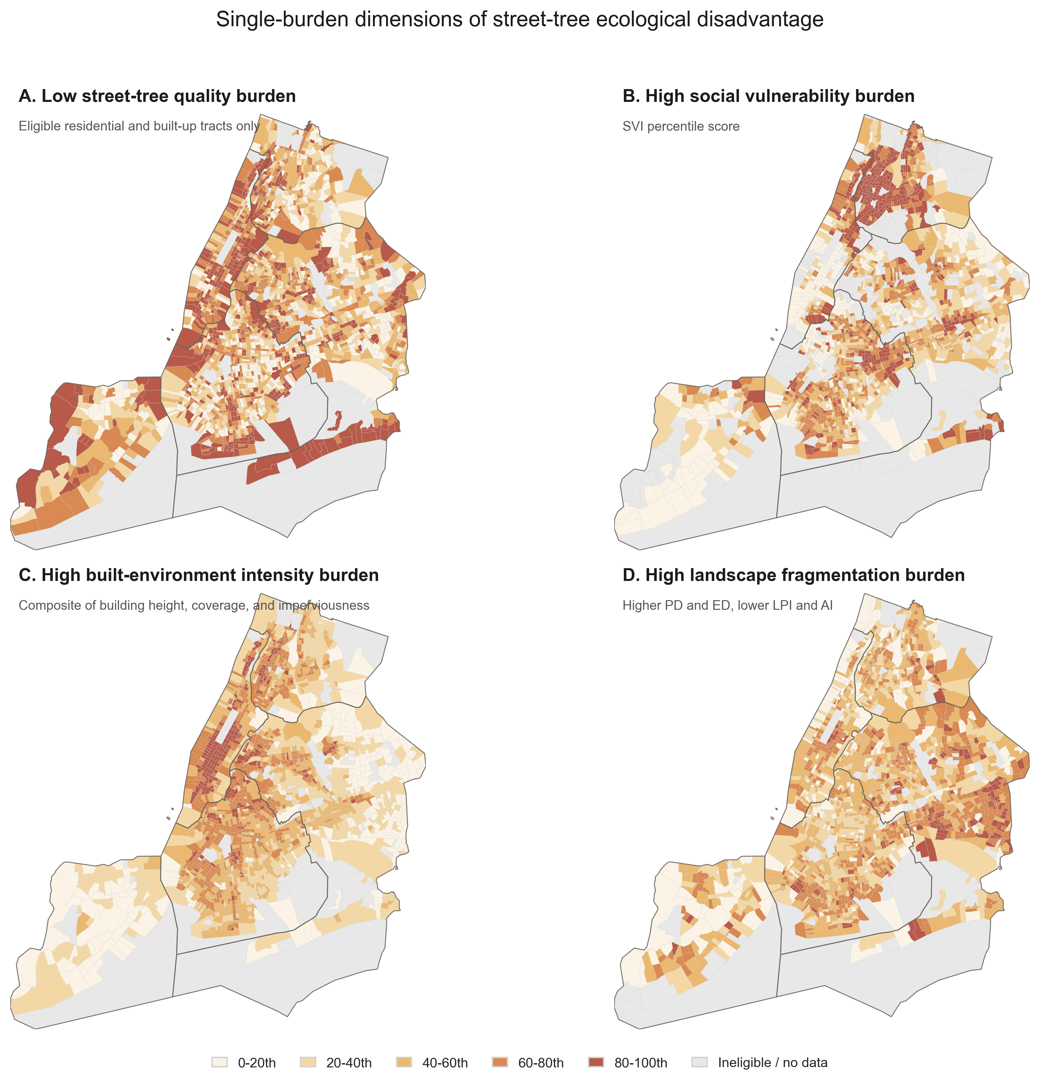
Figure 12. Single-burden maps: low street-tree quality, high social vulnerability, high built-environment intensity, and high landscape fragmentation.
从 single-burden maps 来看，四类负担在纽约市内部呈现出明显不同、但又相互交织的空间格局。首先，Low street-tree quality burden 主要刻画街道树系统本身的薄弱程度，而不是城市总树冠覆盖的简单反映。图 A 显示，高负担 tract 并非只集中在某一个 borough，而是在 Manhattan、Bronx、Brooklyn 以及 Staten Island 部分区域均有分布。这说明街道树质量或服务缺位具有较强的局地性，可能与街道树存量、道路空间条件、树坑环境、维护历史和街道界面连续性有关。换言之，低街道树质量负担并不等同于“树冠少”，而是更直接指向行道树系统在特定建成环境中的不足。其次，High social vulnerability burden 呈现出更明确的社会空间集中性。图 B 中高值区域在 Bronx、northern Manhattan、central Brooklyn 以及部分 Queens 较为突出，说明社会脆弱性并不是均匀分布的，而是在特定社区形成连续的高负担片区。这一结果为后续环境正义导向的街道树干预提供了关键依据：街道树生态改善不应只依据生态指标排序，也需要考虑哪些社区同时具有较高的社会脆弱性和较低的资源适应能力。第三，High built-environment intensity burden 主要反映高楼层、高建筑覆盖和高不透水环境共同形成的物理压力。图 C 显示，这一负担在 Manhattan 及部分高密度建成区更为突出，同时也在 Brooklyn 和 Queens 的若干连续街区中出现较高值。与 social vulnerability burden 不同，built-environment intensity 更强调街道树生长环境的物理约束，包括有限根域空间、较强的不透水覆盖、紧凑街谷环境以及潜在热压力。因此，它揭示的是街道树是否具备良好生长空间的问题，而不是社会条件本身。第四，High landscape fragmentation burden 反映的是树冠空间格局的破碎化程度。图 D 中高值区域分布较为分散，并不完全重合于社会脆弱性或建成强度最高的区域。这说明树冠破碎化不是单纯由社会经济弱势或高密度开发决定的，而与树冠斑块数量、边缘密度、最大斑块比例和空间聚合程度等景观格局特征有关。较高的 fragmentation burden 意味着树冠结构更边缘化、连通性更弱，也可能削弱连续遮阴、生态连通和热缓解功能。四类 burden 是分别从 street-tree service deficit、social vulnerability、built-environment pressure 和 landscape fragmentation 四个维度刻画街道树生态不平等。Figure12的差异性说明，某些地区可能主要面临街道树质量不足，某些地区则主要承受社会脆弱性或建成环境压力；而真正需要优先关注的是这些负担在空间上发生叠加的 tract。因此，single-burden maps 的作用不是直接给出最终干预名单，而是为后续 composite co-burden index 提供可解释的组成基础，帮助判断高优先级地区到底是由哪一种或哪几种不利条件共同驱动。

8.3 Sensitivity analysis
在此基础上，本研究构建 composite co-burden index，即对四个单项 burden 进行等权平均。该指数并不被视为因果模型，而是一种 decision-support screening tool，用于识别低街道树质量、高社会脆弱性、高建成环境压力与高景观破碎度空间重叠最明显的 tract。根据 composite index 的相对排名，得分前 20% 的 tract 被定义为 priority tracts，前 10% 被定义为 high-priority tracts。为检验这一结果是否过度依赖某一单项 burden 或特定权重假设，本研究进一步进行了 sensitivity analysis，包括 SVI-weighted version 以及分别剔除 fragmentation、built intensity 和 low street-tree quality 后的 leave-one-out comparison。结果显示，priority geography 在不同设定下总体保持稳定，表明 composite co-burden index 具有较好的稳健性。
Sensitivity Test | Top 10% Overlap with Main Index | Interpretation
Equal-weight index | 100.000 | Main reference index.
SVI-weighted index | 68.282 | Tests whether priority geography shifts toward socially vulnerable neighborhoods.
Excluding fragmentation | 74.449 | Tests dependence on landscape-configuration metrics.
Excluding built intensity | 73.128 | Tests dependence on built-environment pressure.
Excluding low street-tree quality | 59.031 | Tests whether priority areas are driven mainly by social and built factors.
Table 10. Co-burden sensitivity analysis.

8.4 Priority tracts
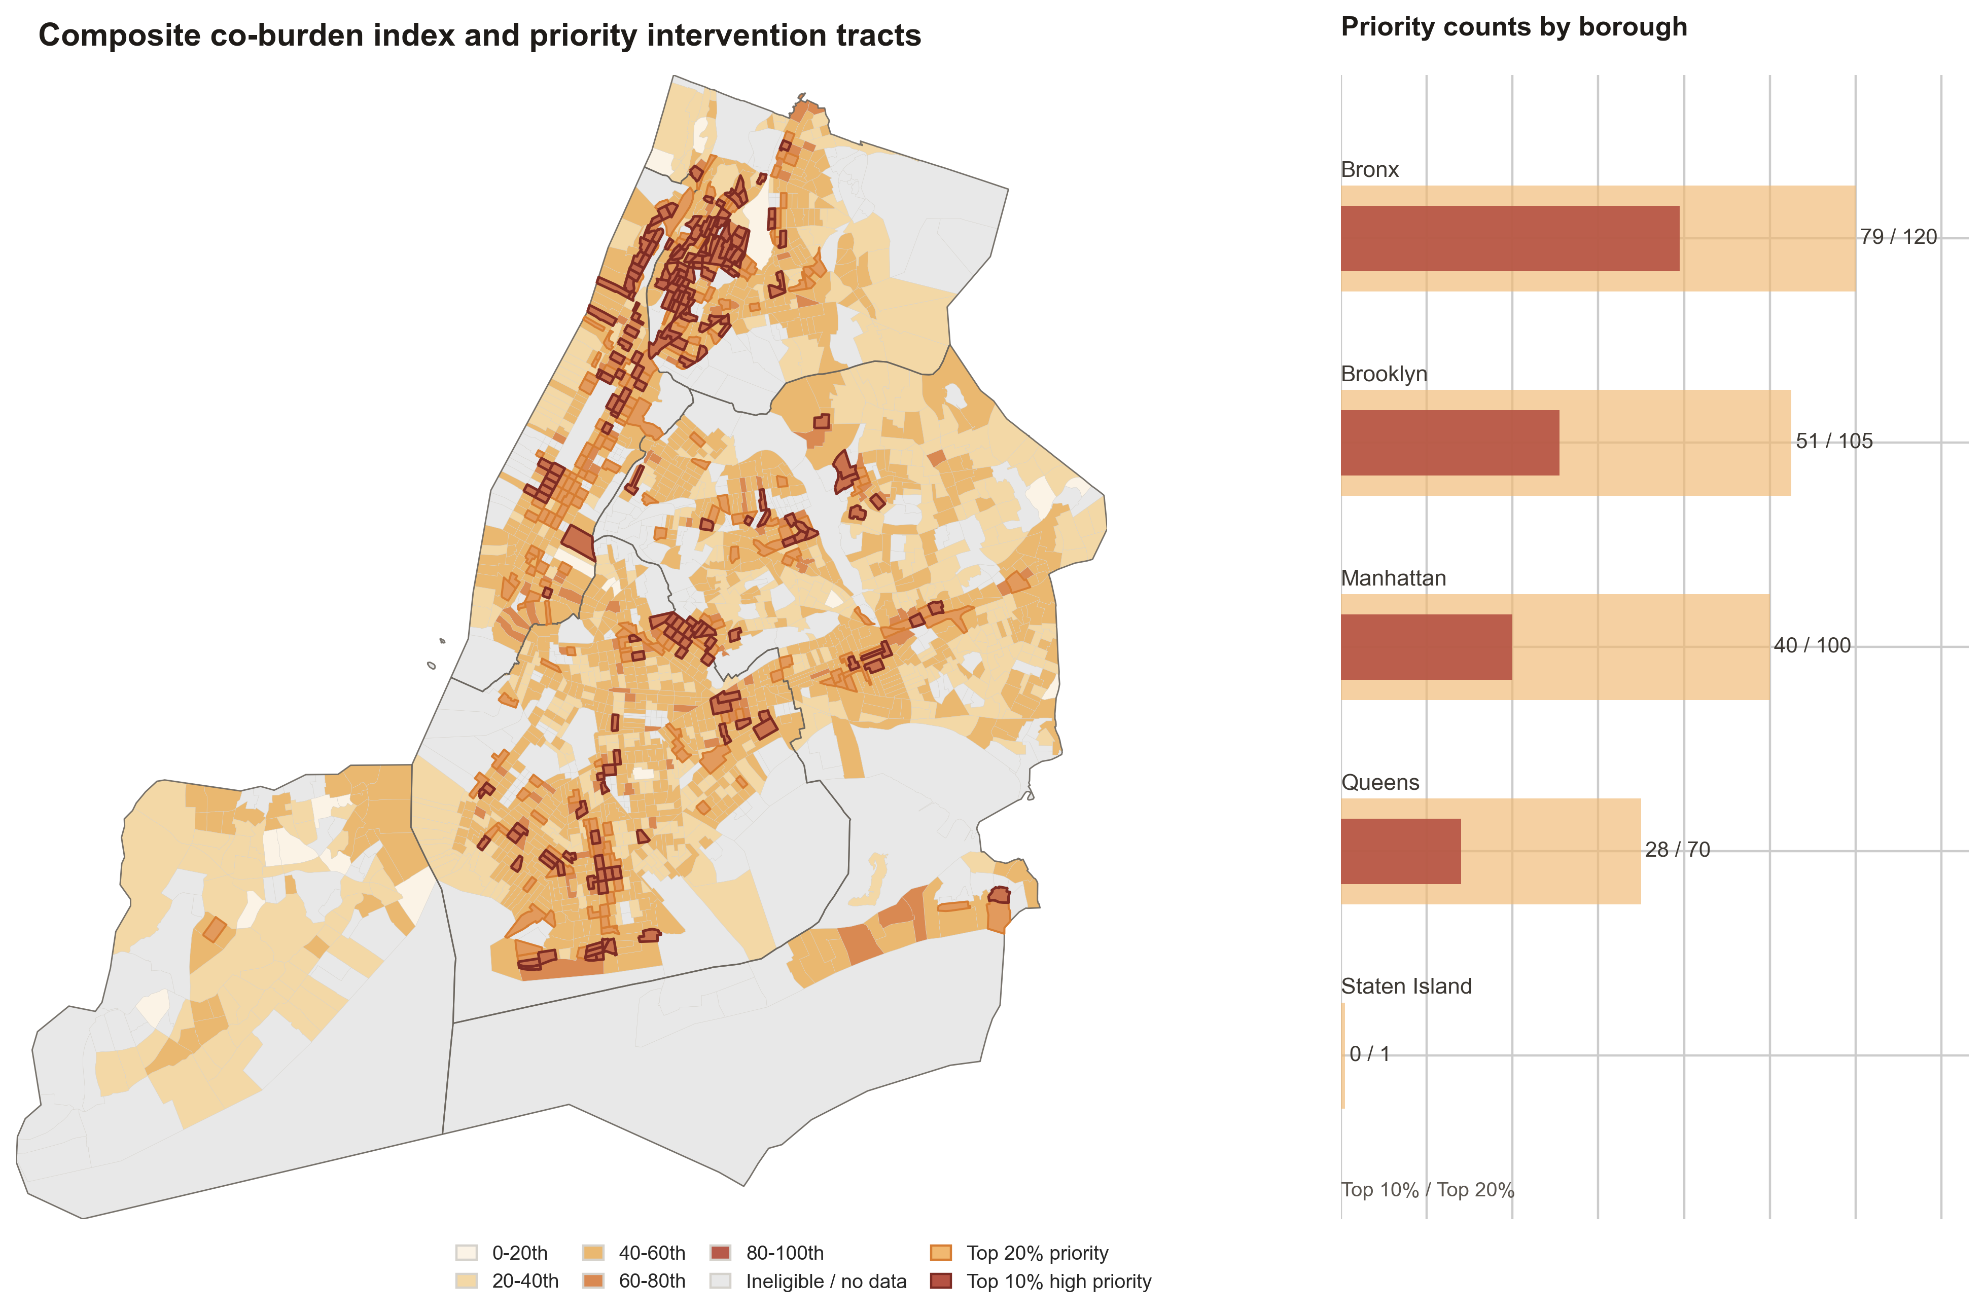
Figure 13. Composite co-burden index and priority tracts.
综合 co-burden index 进一步表明，纽约市街道树生态不平等并不是由单一指标驱动的，也不是在城市内部均匀分布的，而是在若干连续城区中形成了明显的多重负担集聚。图中的底图展示了 composite co-burden score 的百分位等级，深色区域表示低街道树质量、高社会脆弱性、高建成环境强度和高景观破碎度更强烈叠加；橙色边界标示 top 20% priority tracts，深红色边界则标示 top 10% high-priority tracts。与 single-burden maps 相比，composite map 的意义在于从多个维度同时识别空间劣势，而不是仅仅寻找某一个指标最高或最低的 tract。从空间分布来看，高优先级 tract 明显集中在 Bronx—northern Manhattan 一带，并沿 Manhattan 中北部、South Bronx 以及部分 central Brooklyn 形成连续片区。Queens 中也存在若干分散的 priority clusters，但总体强度和连续性弱于 Bronx、Manhattan 和 Brooklyn。Staten Island 几乎没有进入 high-priority category，说明其在本研究定义下较少同时承受四类高负担。右侧 borough summary 进一步强化了这一判断：Bronx 同时拥有最多的 top 10% 和 top 20% priority tracts，达到 79 / 120；Brooklyn 为 51 / 105；Manhattan 为 40 / 100；Queens 为 28 / 70；Staten Island 仅有 0 / 1。这说明 Bronx 不仅有局部高值，而且在全市尺度上形成了最显著的复合负担集中区。
GEOID | NAMELSAD | borough | co_burden_equal_weight | low_street_tree_quality_burden | high_social_vulnerability_burden | high_built_environment_intensity_burden | high_landscape_fragmentation_burden
36061026900 | Census Tract 269 | Manhattan | 0.863 | 0.858 | 0.984 | 0.897 | 0.712
36061010803 | Census Tract 108.03 | Manhattan | 0.860 | 0.798 | NA | 0.968 | 0.814
36047001502 | Census Tract 15.02 | Brooklyn | 0.851 | 0.954 | NA | 0.971 | 0.627
36005038500 | Census Tract 385 | Bronx | 0.846 | 0.971 | 0.974 | 0.691 | 0.749
36005023702 | Census Tract 237.02 | Bronx | 0.844 | 0.955 | 0.956 | 0.914 | 0.551
36061012601 | Census Tract 126.01 | Manhattan | 0.840 | 0.868 | NA | 0.856 | 0.797
36005017901 | Census Tract 179.01 | Bronx | 0.839 | 0.833 | 0.969 | 0.854 | 0.701
36005022102 | Census Tract 221.02 | Bronx | 0.839 | 0.815 | 0.989 | 0.882 | 0.671
36061013603 | Census Tract 136.03 | Manhattan | 0.839 | 0.955 | NA | 0.861 | 0.700
36005019900 | Census Tract 199 | Bronx | 0.834 | 0.927 | 0.948 | 0.755 | 0.706
36047044700 | Census Tract 447 | Brooklyn | 0.832 | 0.970 | 0.820 | 0.826 | 0.711
36005039902 | Census Tract 399.02 | Bronx | 0.832 | 0.890 | 0.944 | 0.877 | 0.615
36061012602 | Census Tract 126.02 | Manhattan | 0.830 | 0.881 | NA | 0.830 | 0.778
36061013201 | Census Tract 132.01 | Manhattan | 0.827 | 0.954 | NA | 0.704 | 0.822
36061028500 | Census Tract 285 | Manhattan | 0.826 | 0.907 | 0.880 | 0.887 | 0.632
36005037300 | Census Tract 373 | Bronx | 0.826 | 0.960 | 0.992 | 0.627 | 0.725
36005022101 | Census Tract 221.01 | Bronx | 0.826 | 0.857 | 0.873 | 0.900 | 0.673
36061026100 | Census Tract 261 | Manhattan | 0.823 | 0.847 | 0.922 | 0.895 | 0.629
36005018102 | Census Tract 181.02 | Bronx | 0.821 | 0.726 | 0.978 | 0.874 | 0.706
36061024500 | Census Tract 245 | Manhattan | 0.814 | 0.857 | 0.894 | 0.908 | 0.598
Table 11. Top high-priority intervention tracts.
borough | Other tracts | Top 10% high priority | Top 20% priority
Bronx | 227 | 78 | 45
Brooklyn | 671 | 52 | 66
Manhattan | 192 | 54 | 61
Queens | 605 | 43 | 54
Staten Island | 119 | 0 | 1
Table 12. Borough summary of priority tracts.
Top-ranked tract map 进一步揭示了高优先级区域的内部结构。排名前 15 的 tracts 高度集中于 Bronx 和 Manhattan，其中最高分 tract 为 Manhattan 的 CT 269，co-burden score 为 0.863；其后多为 Bronx tracts，如 CT 385、CT 237.02、CT 179.01、CT 221.02、CT 199、CT 399.02、CT 373、CT 221.01、CT 181.02、CT 233.02 等。Brooklyn 的 CT 447 也进入前 15。这种排名结构说明，高 co-burden 并不是随机散点，而是在若干社会—生态—形态压力共同叠加的地区形成了稳定的优先干预带。尤其是 Bronx 和 northern Manhattan 的连续高值，提示这些区域可能同时面临街道树质量不足、社会脆弱性较高、建成环境压力较强以及树冠格局破碎等复合问题。这一结果与前文分析形成了清晰衔接。第 5 节已经证明街道树健康、密度和物种多样性具有显著空间自相关，说明街道树生态质量具有空间集聚特征；第 6 节进一步显示，OLS 残差仍存在空间结构，而 Spatial Lag 模型能够更好地吸收部分空间依赖；第 7 节则通过机器学习表明，street-tree density 和 species diversity 与建成环境和树冠格局具有较强关系，而 tree health 更可能受到细尺度维护和生境条件影响。第 8 节的贡献在于把这些分散的统计和机制线索转化为空间决策框架。从规划和政策解释来看，high-priority tracts 不应被理解为只需要简单增加树木数量的区域，而应被视为需要差异化、综合性干预的复合压力区。对于同时具有高 built-environment intensity 和低 street-tree quality 的 tract，干预重点应放在树坑扩容、结构性土壤、透水铺装、根域空间改善和街道断面优化，而不仅是补植。对于 high social vulnerability 与 low street-tree quality 叠加的 tract，城市林业投资应与 heat-risk reduction、public health 和 environmental justice 目标结合，优先配置维护资源和长期管护资金。对于 high landscape fragmentation burden 较高的 tract，则应重点改善树冠斑块连通性，构建连续 shade corridors，并减少孤立、边缘化的树冠结构。
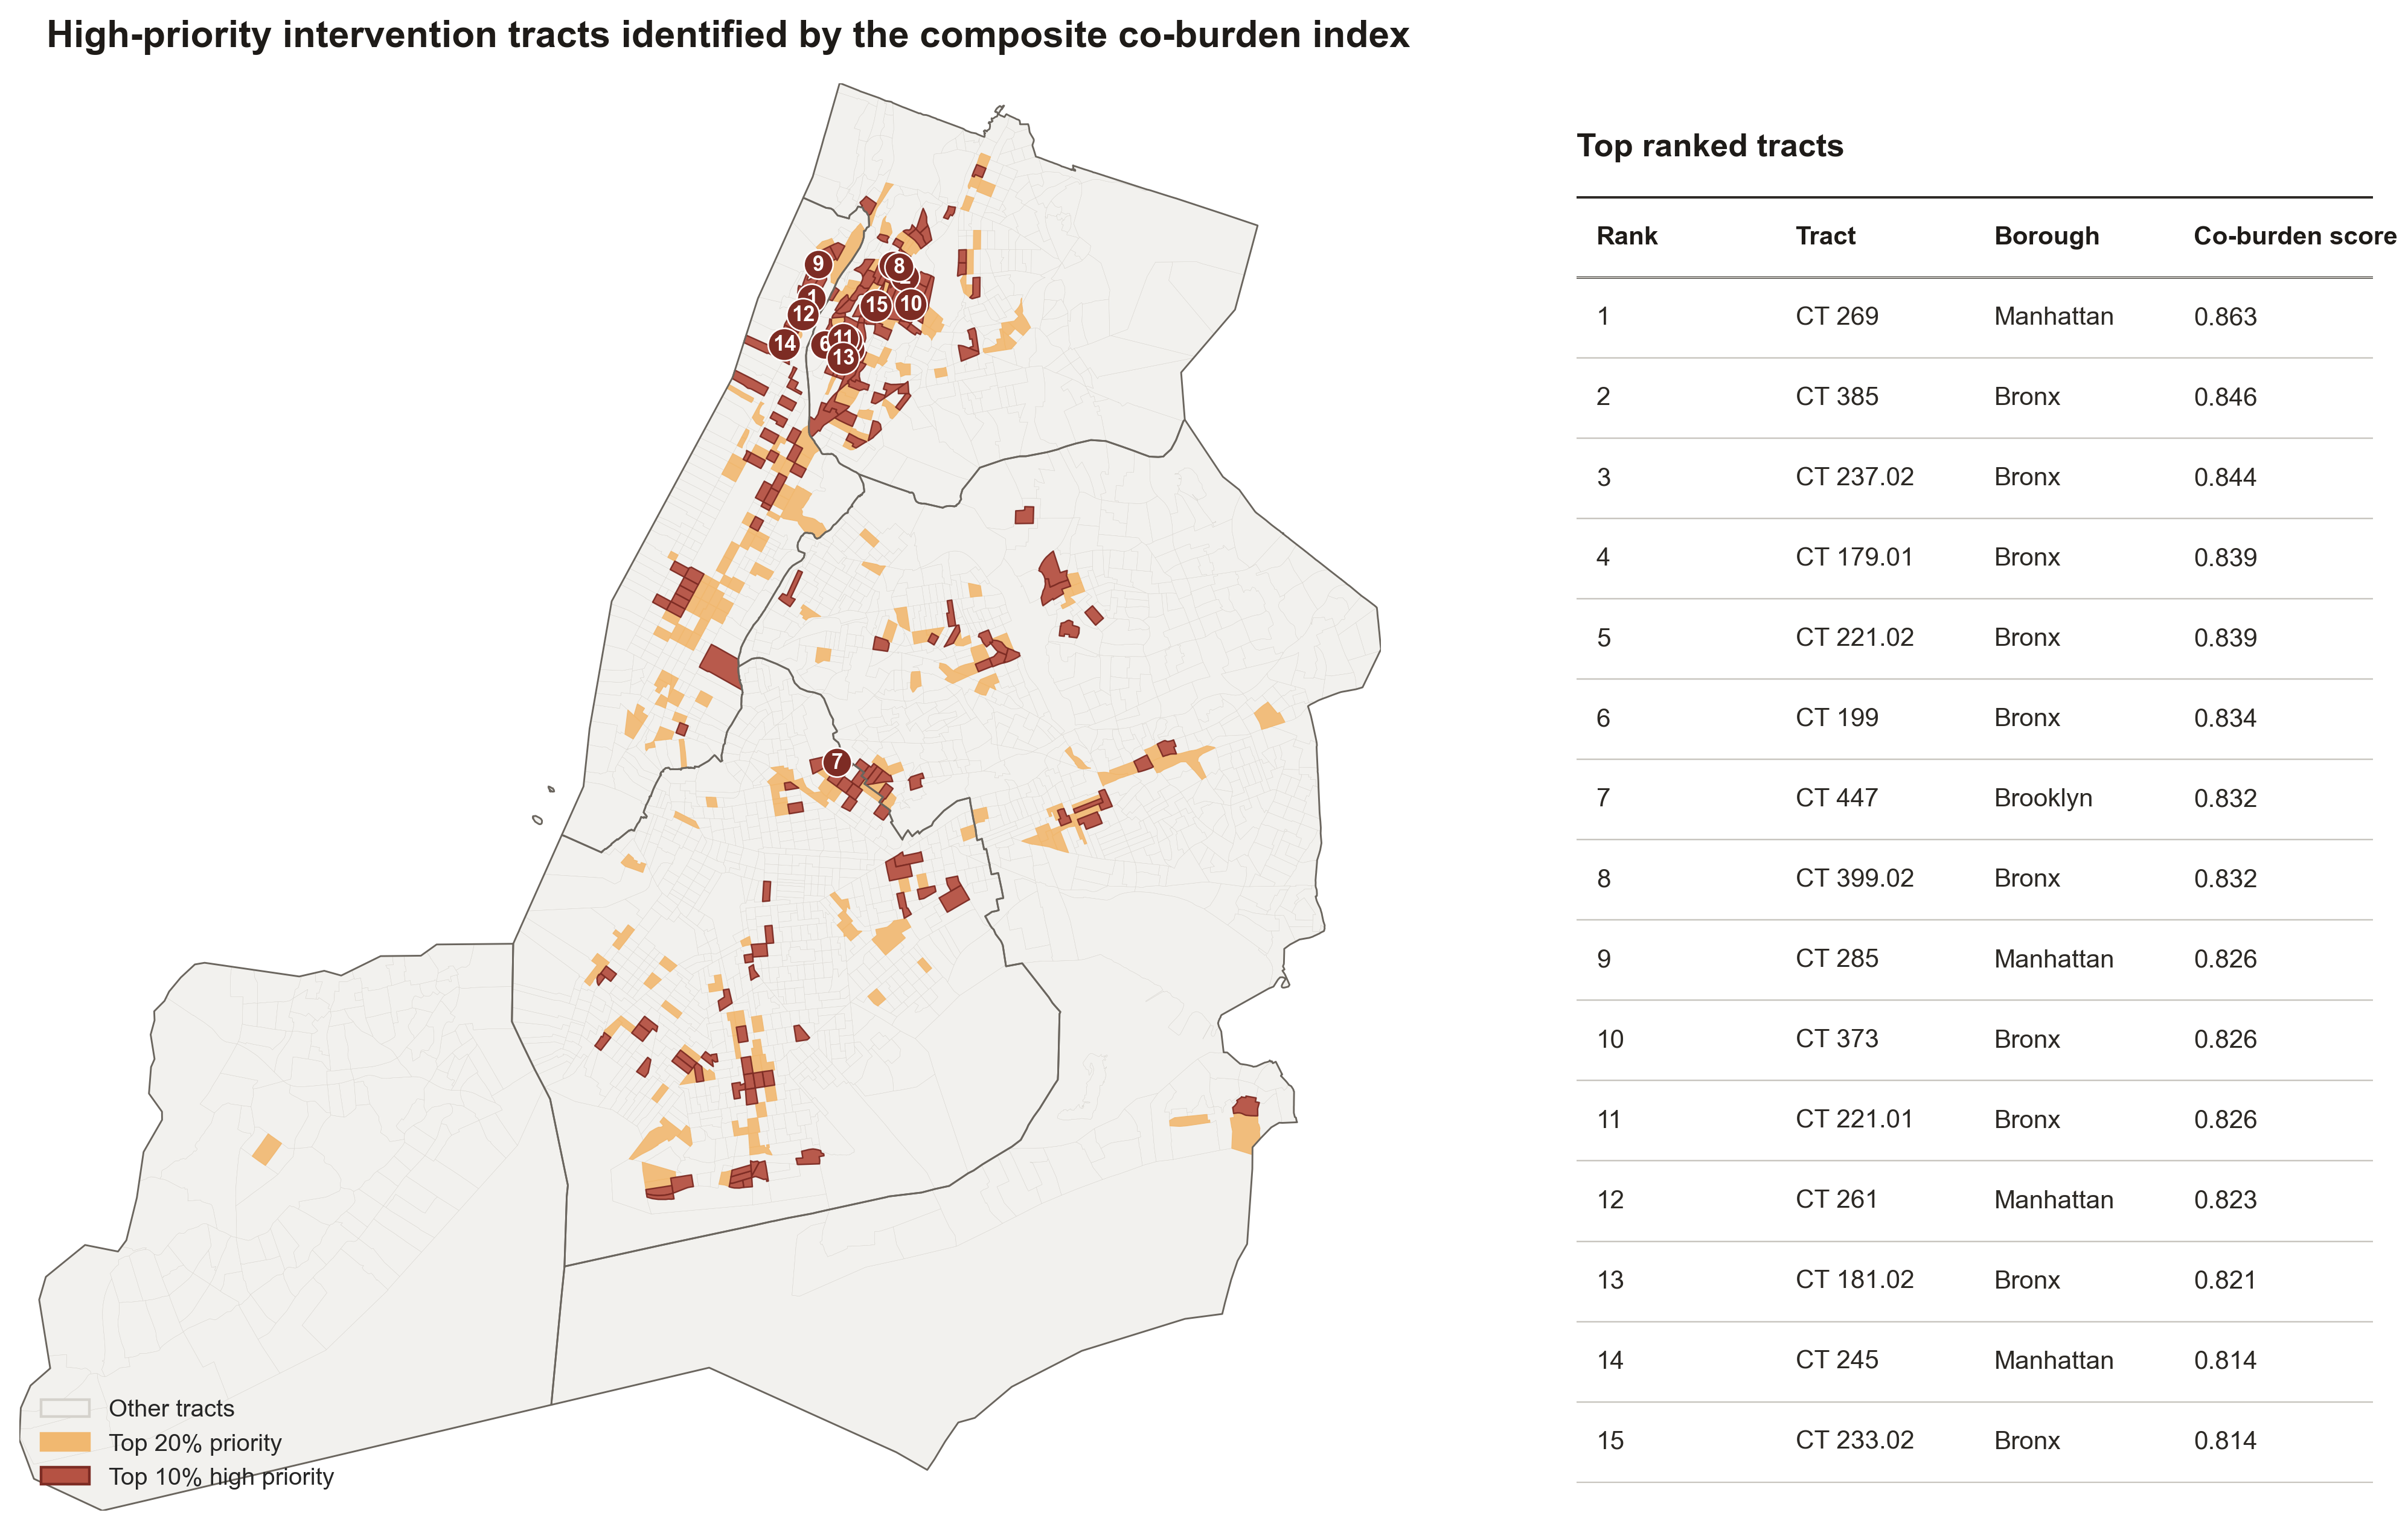
Figure 14. High-priority intervention tracts identified by the composite co-burden index. The map emphasizes the geography of the top 20% and top 10% tracts, while the ranked list supports tract-level planning and field verification.

9. Interactive Decision-Support Map and Policy Recommendations
The interactive map is not only a technical deliverable. It functions as a decision-support interface that allows users to switch between single burdens, the composite co-burden index, and LISA cluster outputs. The Deck.gl and MapLibre interface supports screening, field verification, and borough-level planning discussions.
Type A tracts combine high built intensity and low street-tree quality. These areas should prioritize structural soil, permeable pavement, tree pit expansion, and sidewalk redesign instead of simple replacement planting. Type B tracts combine high social vulnerability and low street-tree quality; they should be prioritized for environmental justice, public-health, and heat-risk reduction investments. Type C tracts combine fragmentation and weak canopy connectivity; they call for interventions that reconnect tree canopy patches and strengthen shade corridors. Type D tracts carry multiple high burdens simultaneously and should be treated as top priority zones for field verification, planting feasibility assessment, and integrated maintenance planning.
Limitations remain important. The study is cross-sectional and combines datasets from 2015 to 2020 rather than a single synchronized year. It addresses street-tree ecological quality rather than the full urban forest canopy. Results are sensitive to the modifiable areal unit problem because analysis is conducted at the Census Tract level. Finally, key determinants of tree health, such as maintenance schedules, root-zone condition, soil quality, and street-level stressors, remain unobserved.
The study shows that street-tree ecological inequality in New York City is multi-dimensional. Street-tree density and species diversity are relatively predictable from tract-level land cover, built environment, and landscape configuration, while tree health is much less predictable from these variables. This suggests that tree supply and diversity are strongly shaped by planning and urban form, whereas tree health likely depends on finer-scale maintenance, root-zone condition, soil environment, and street-level stressors. Therefore, priority intervention should not only increase tree numbers, but also improve growing conditions, reduce built-environment stress, and target socially vulnerable communities where ecological disadvantages overlap.

References
Berland, A., Shiflett, S. A., Shuster, W. D., Gall, A. M., Widder, C. R., & Herrmann, D. L. (2017). The role of trees in urban stormwater management. Landscape and Urban Planning, 162, 167-177. https://doi.org/10.1016/j.landurbplan.2017.02.017
Flanagan, B. E., Gregory, E. W., Hallisey, E. J., Heitgerd, J. L., & Lewis, B. (2011). A social vulnerability index for disaster management. Journal of Homeland Security and Emergency Management, 8(1).
Galle, N. J., Halpern, D., Nitoslawski, S. A., Duarte, F., Ratti, C., & Pilla, F. (2021). Fostering urban forests: A systematic review of expert perceptions, policy instruments, and governance frameworks. Urban Forestry and Urban Greening, 62, 127165. https://doi.org/10.1016/j.ufug.2021.127165
Hand, D. J. (2020). Dark data: Why what you don't know matters. Princeton University Press.
Schwarz, K., Fragkias, M., Boone, C. G., et al. (2015). Trees grow on money: Urban tree canopy cover and environmental justice. PLOS ONE, 10(4), e0122051. https://doi.org/10.1371/journal.pone.0122051
Wolf, K. L., Lam, S. T., McKeen, J. K., Richardson, G. R. A., van den Bosch, M., & Bardekjian, A. C. (2020). Urban trees and human health: A scoping review. International Journal of Environmental Research and Public Health, 17(12), 4371. https://doi.org/10.3390/ijerph17124371
Zhang, Y., Chen, G., Myint, S. W., Zhou, Y., Hay, G. J., Vukomanovic, J., & Meentemeyer, R. K. (2022). UrbanWatch: A 1-meter resolution land use and land cover dataset for 22 major cities in the United States. Remote Sensing of Environment, 278, 113106. https://doi.org/10.1016/j.rse.2022.113106

