Project Name: Digital Factory
Table of Contents
Objective 2
Digital Factory 2
Smart Factory 2
Implementation Plan 2
Phase 1: Static Website on a Local Server 2
Phase 2: Dynamic Web Application on an HTTP Server 2
Phase 3: Expansion Across Additional Departments 2
Phase 4: Smart Manufacturing — Leveraging Machine Learning for Precision Bidding and Scheduling 2
Step 1: Data Extraction & Feature Engineering (The "Foundation") 3
Step 2: Supervised Learning - Regression (The "Predictor") 3
Step 3: Optimization & Domain Knowledge (The "Refinement") 3
Step 4: System Integration (The "Delivery") 3
Current Status 3
Managing the Drawing Library 4
CustomizedProduct Management 4
StockPartLibrary Management 7
StandardProduct Management 10
Maintaining the HTML Index File 15
Example: Adding or Updating Project Information 15
Example: Updating the Index File for All Subfolders 16
System Requirements 16
Date Format: 16
Custom Property "notes": 17
Custom Property " ModelData": 18
Website File Structure 19

Objective

Digital Factory
Develop a centralized web platform that stores the entire manufacturing process data, streamlining workflows and fully eliminating paper-based documentation.

Smart Factory
Evolve from data storage → data intelligence through machine learning–powered prediction, automation, and continuous improvement.

Implementation Plan

Phase 1: Static Website on a Local Server
The transition to a Digital Factory starts by digitizing all engineering documents and establishing a centralized database for project parameters. The initial phase includes a static website hosted on a local server.

Phase 2: Dynamic Web Application on an HTTP Server
This phase introduces advanced search capabilities, allowing managers, sales teams, and engineers to retrieve historical project data efficiently. A role-based access control system will be implemented, ensuring appropriate access rights for users. All relevant data will be stored in an SQL database, facilitating job assignments and project tracking.

Phase 3: Expansion Across Additional Departments
Additional functionalities will be integrated to enable factory workers to log process start and end times. This will provide managers with real-time workflow insights and help analyze labor efficiency. Historical data will be leveraged to optimize project timelines and workforce planning.

Phase 4: Smart Manufacturing — Leveraging Machine Learning for Precision Bidding and Scheduling
The Vision: "The Digital Factory, powered by Machine Learning, will provide Halton with a cutting-edge Industry 4.0 environment, turning our engineering data into our greatest competitive asset."

Step 1: Data Extraction & Feature Engineering (The "Foundation")
The Task: ModelData is currently a string (e.g., "DL:14,DW:10,DH:6"). A Machine Learning model needs this in a table format.
Practice Project: Write a script to connect to the SQL database, parse the ModelData strings, and create a "Flat Table" where each feature (DL, DW, Bend Count) is its own column.

Step 2: Supervised Learning - Regression (The "Predictor")
The Task: Predict "Time" and "Cost".
Practice Project: Use the flat table to train a model. Input: Dimensions/Features. Output: CNCDate minus DesignDate or ShippedDate (Total Processing Time).

Step 3: Optimization & Domain Knowledge (The "Refinement")
The Task: Not all features are equal. A "Marvel" might add more assembly time than a "switch".
Practice Project: Create a "Difficulty Index." that represents how "hard" a part is to make. See if this improves the model's accuracy.

Step 4: System Integration (The "Delivery")
The Task: Bring the machine learning Python model back into the digital factory environment.
Practice Project: Build a "Quotation Simulator" page on the Digital Factory site. When a user enters project specs, the site sends the data to the machine learning Python script, which returns the predicted time and cost instantly.
Practice Project: Build a "Scheduling Simulator" page on the Digital Factory site. When a user enters project specs, the site sends the data to the machine learning Python script, which returns the predicted time slot available and manpower requirements instantly.
This journey may take years. We hope you’ll join us along the way and contribute ideas to further improve the system.

Current Status
We are currently in Phase 1 of the project.

Managing the Drawing Library
The website is designed for maintenance by engineers familiar with SolidWorks and my add-in application in SolidWorks. Engineering files are stored in the CustomizedProduct, StandardProduct, and StockPartLibrary subfolders.

CustomizedProduct Management
Customized product designs require frequent updates and daily maintenance. The manufacturing packages are saved in “DigitalFactory/Content/CustomizedProduct”. In Canada, we created a subfolder for each year under it. “_CAN_24” is the subfolder for the year 2024.
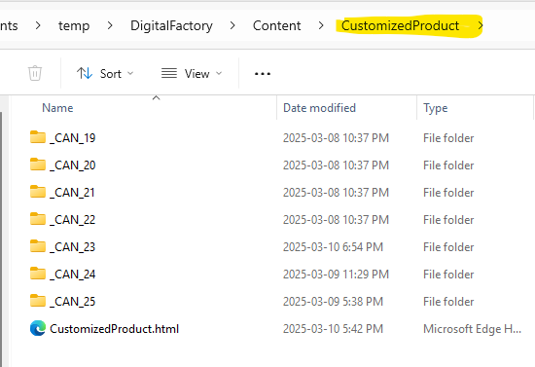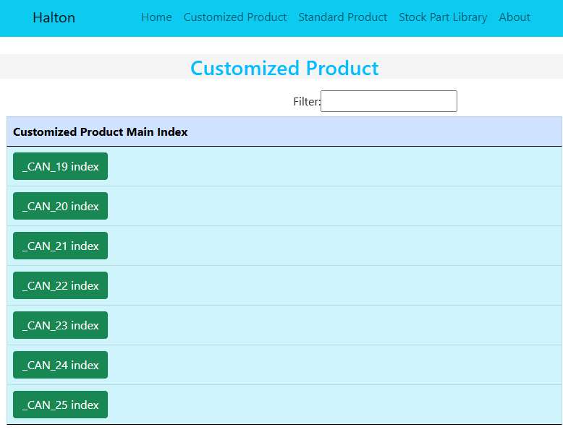

Example: Creating a Customized Manufacturing Package for Project C24101A
- Create a new project folder “C24101A” under the respective year (e.g., CustomizedProduct/ _CAN_24).
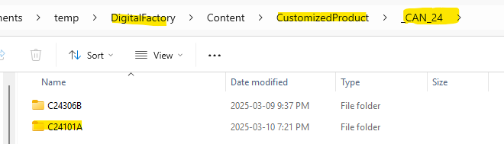
- Use JustinTool to generate the manufacturing package to the folder.
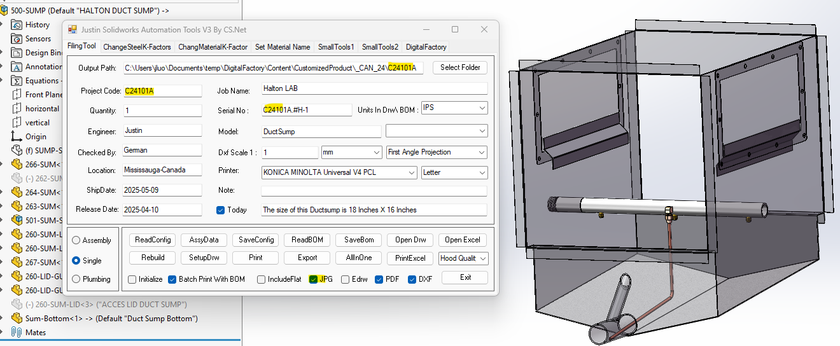

Keep the highlighted Textbox empty:
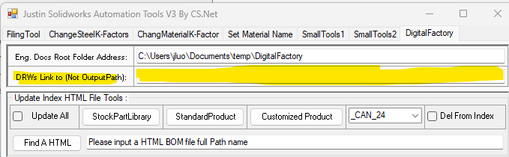
- The tool automatically updates the home page of the digital factory and the yearly project index file and integrates new BOM files.
In the job folder “C24101A”, there are 2 BOM files. One is for the duct sump sheet metal assembly, and the other is for the duct sump plumbing assembly.
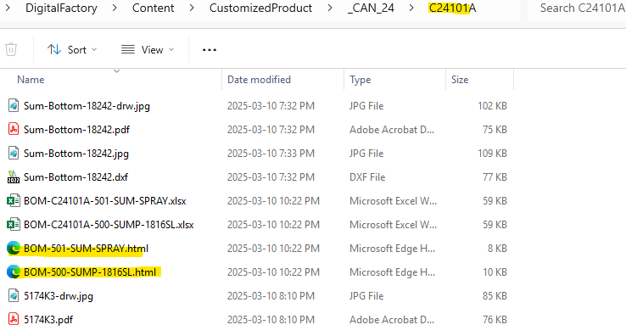
The two BOM files will also be uploaded to the CAN-24 index file automatically:
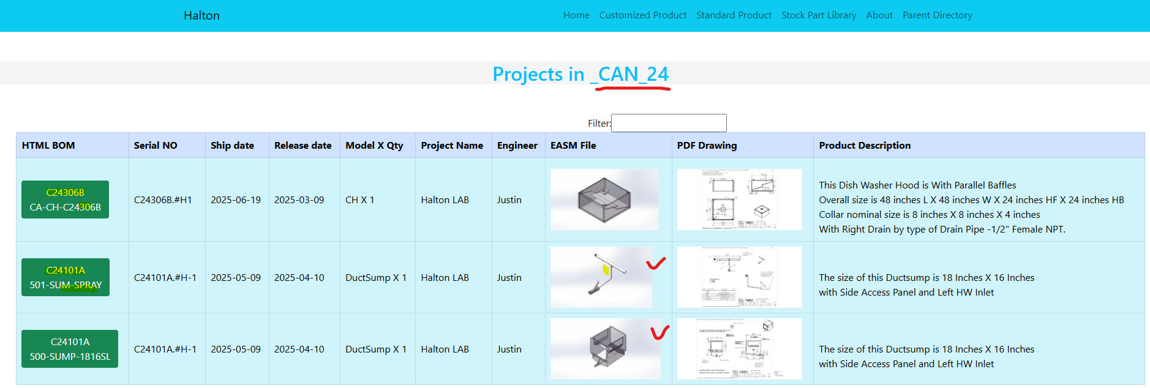
The home page lists all the recent projects. Engineers and workers normally only need to open this page for all the recent projects.
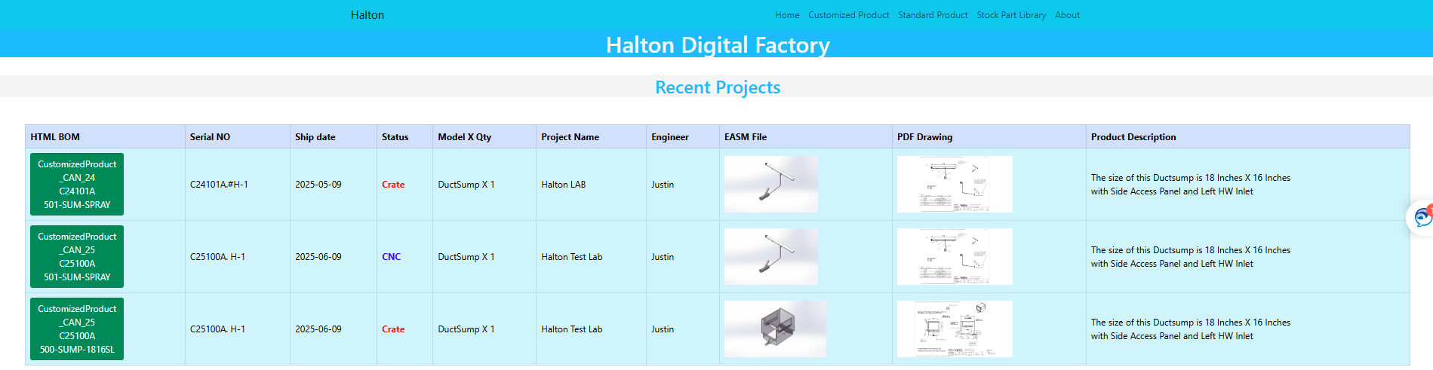

- Users can search and filter projects efficiently through the index file.
Additionally, project key parameters are stored in a JSON file for future data mining and search functionality.

StockPartLibrary Management

Example: Adding New Stock Parts to a stock part subfolder “StockPartHoodCommon”
- Open StockPartHoodCommon.sldasm in SolidWorks.
- Insert the new stock part assembly (e.g., RSB00.sldasm).
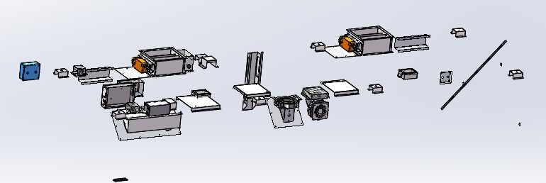
- Export PDF, DXF, and JPG files of stock parts (RSB01.sldprt, RSB02.sldprt) to the folder “StockPartHoodCommon”.
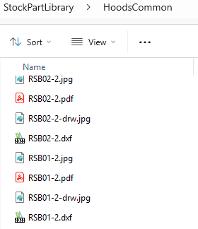
- Save the HTML BOM file for the updated assembly in the folder “StockPartHoodCommon”.
- The new stock parts will be reflected in StockPartHoodCommon.EASM and BOM-StockPartHoodCommon.html.
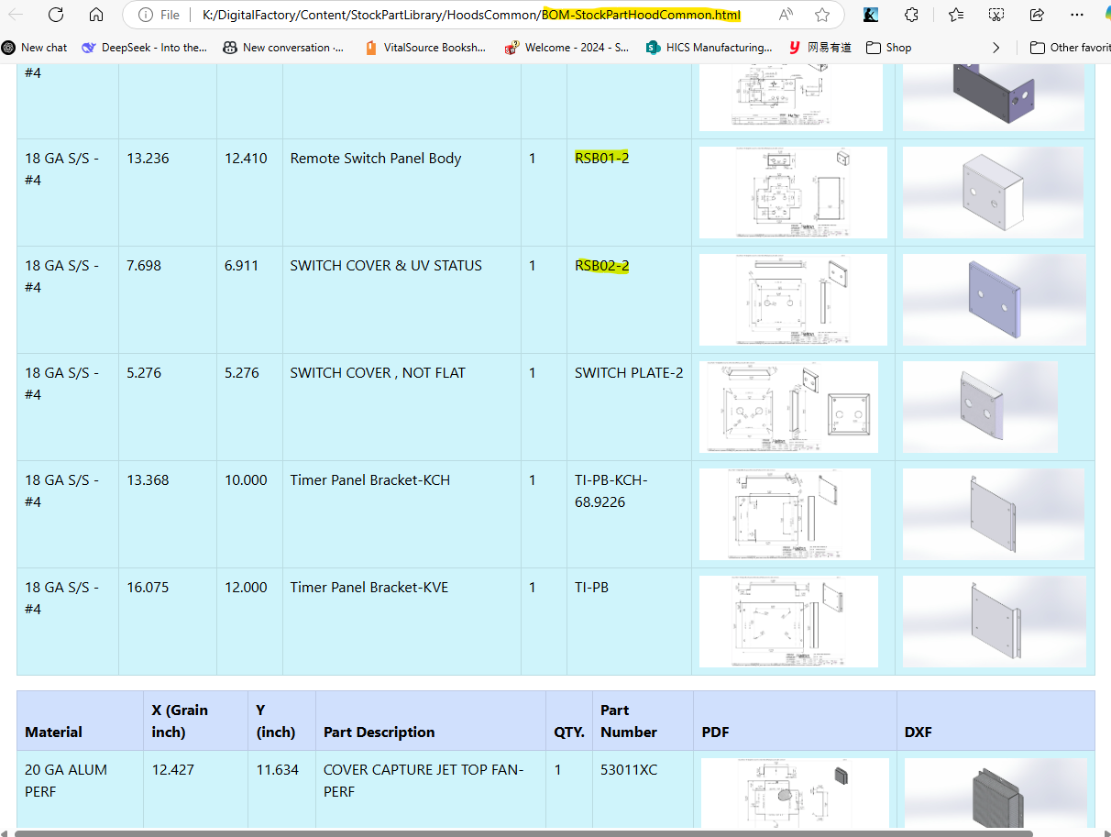

Example: Creating a New Stock Part Subfolder “KVE”
- Create a new folder (e.g., KVE) under DigitalFactory/Content/StockPartLibrary.
- Develop an assembly file (for example: StockPartKVE.sldasm) and set a custom property for notes.
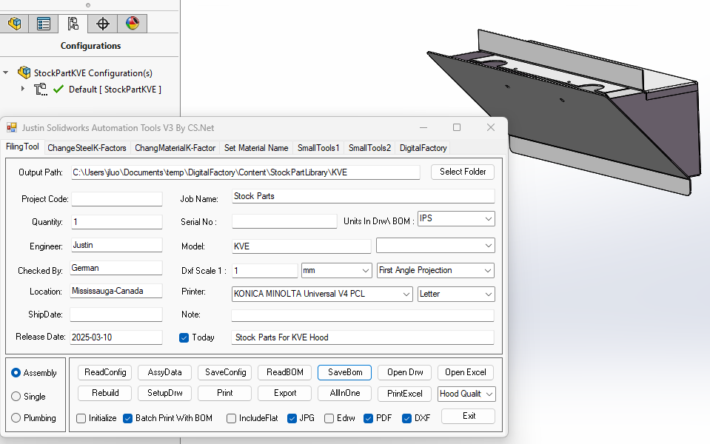
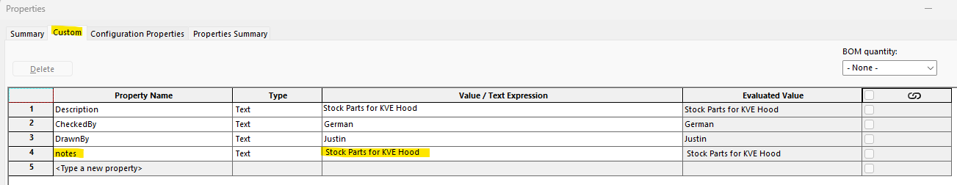
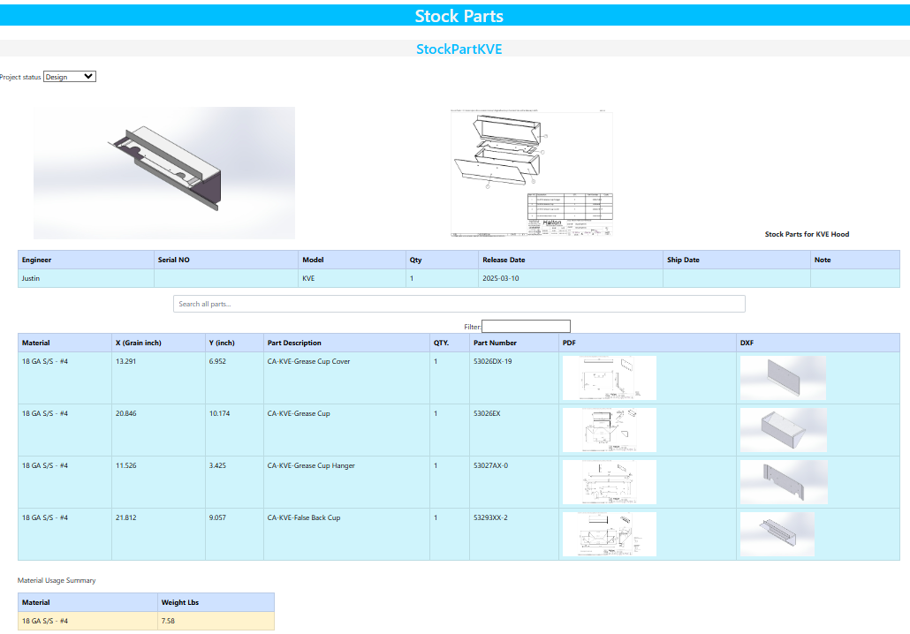
- Use JustinTool to generate a manufacturing package to the new folder, which will automatically update the stock part library index StockPartLibrary.html.
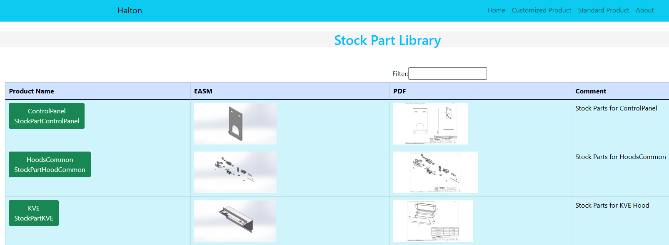

StandardProduct Management
For products like control panels that undergo minimal design changes, manufacturing packages are stored in “DigitalFactory/Content/StandardProduct”. When I release a package of this kind of product, I want a new BOM with current project information and drawings linked to the standard product library.

Example: Creating an A&W hood manufacturing package for project C25104A

Step 1: Prepare the Job Folder
- Create a job folder:
K:\DigitalFactory\Content\CustomizedProduct\_CAN_25\C25104A
- Copy the following files into the folder:
  - Submittal drawing: C25-104 - S1 (GL-L-38).dwg
  - Excel BOM for 38” A&W hood: BOM-GL-L-38C8104.5P

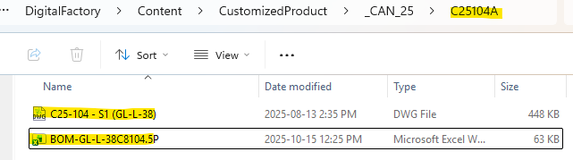

Step 2: Update Project Information in Excel BOM
Open the Excel BOM file in the job folder and update these fields:
- JOB NAME: Your job name
- SERIAL No: Your job serial number
- ENGINEER: Your name
- MODEL: GL-L
- QUANTITY: Number of units
- SHIP DATE: Required ship date
- NOTE: Any special notes for this job
These details will be used to update the HTML BOM file.
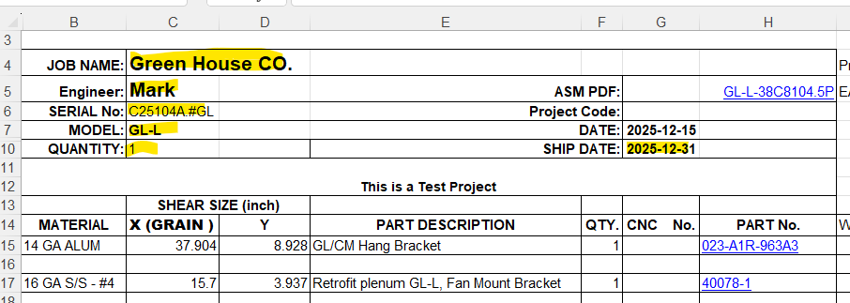

Step 3: Launch JustinToolsBasket
- Locate the Excel BOM file.
- Ensure the highlighted textbox is filled.
- Check the “Please” checkbox.
- Confirm the nested file name matches the BOM file name.
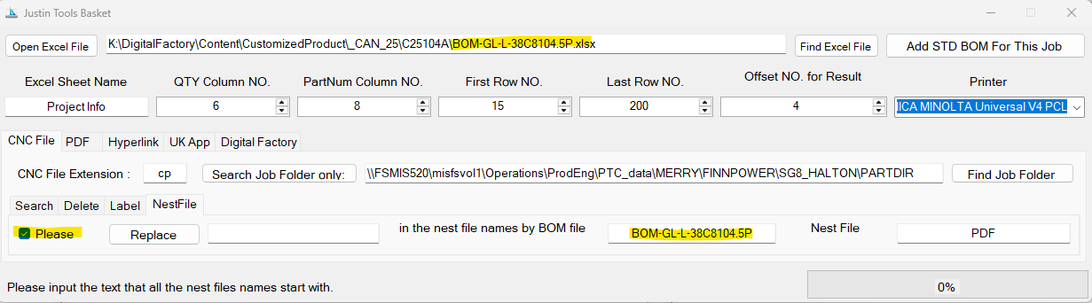

Step 4: Execute the Release Process
- Click “Add STD BOM For This Job”.
- Select the Standard Product Library Folder in the dialog:
Example: K:\DigitalFactory\Content\StandardProduct\A&W\GL-L-38\
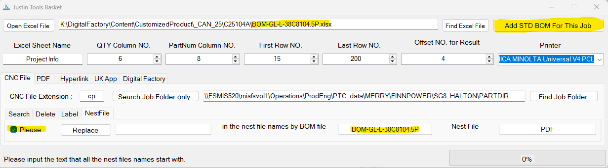

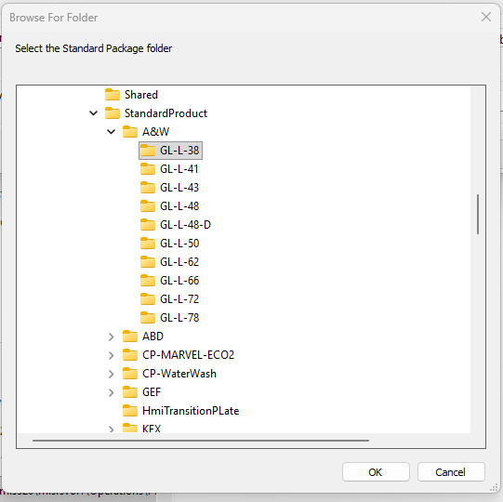
After clicking OK, the application will:

4.1 File Copying
- ✓ Copy HTML BOM file to the job folder
- ✓ Copy assembly files (.easm, .pdf, .jpg, -drw.jpg)
- ✓ Copy CNC nest files (numbered PDFs)

4.2 HTML BOM Updates
- Update <h1> title with job name
- Update engineer info table with project details
- Update all drawing links to point to the standard product library
- Update metadata tags for new folder structure
- Update red note section with special notes from Excel
- Add submittal DWG links to Sales DWGs column with colored buttons (while keeping old ones)

Step 5: Verify Results
Check the job folder for:
- Updated Excel BOM
- Updated HTML BOM
- Assembly files
- CNC nest files
- DWG submittal files
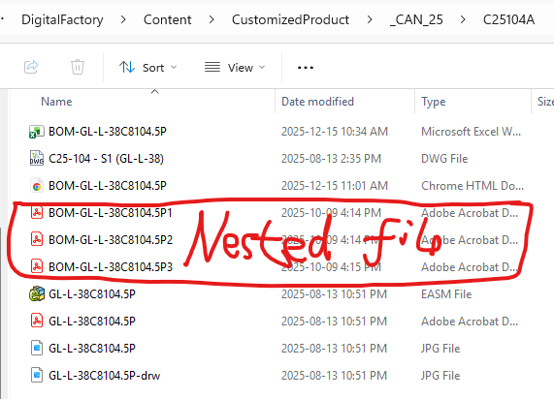
Open the HTML BOM in a browser and confirm:
- Title shows job name
- Engineer table displays project info
- All links work correctly
- DWG files appear as colored buttons
- Red note section shows special notes

Step 6: Complete the Release
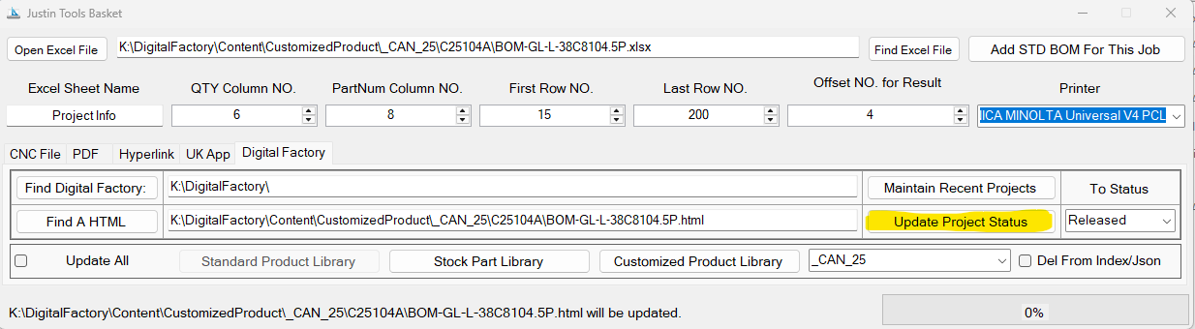
Click Update Project Status to:
- Add the HTML BOM to the Digital Factory homepage
- Set status as Released (use old nest files) or CNC (new nest files required)

Tip
If a job uses the same product as a previous job in the customized product folder:
- Treat the previous job folder as the standard product folder in Step 4.
- This creates a new HTML BOM linking to the previous job folder, which can also be added to the homepage.

Maintaining the HTML Index File

Example: Adding or Updating Project Information
- Locate the HTML BOM file of the project.
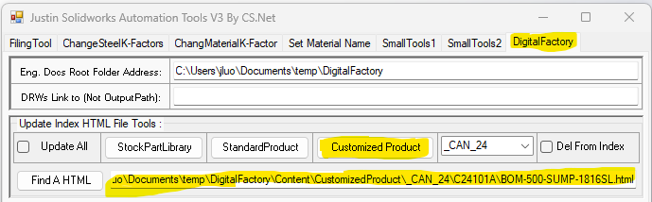
- If updating, uncheck the “Update All” option.
- To delete a project from the index, check "Del From Index"; otherwise, the software will check for existing projects and update information as needed.
- Click the appropriate update button based on the project’s location.

Example: Updating the Index File for All Subfolders
- Check the "Update All" option.
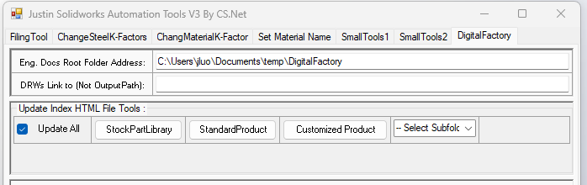
- Click the corresponding button to update the subfolder index files. If the combo box displays "-- Select Subfolder --", it will update “CustomizedProduct.html”, otherwise, it will update the yearly index (e.g., “_CAN_23.html”)

System Requirements
To optimize search functionality and standardize data entry, the following requirements must be met:

Date Format:
All dates should follow the YYYY-MM-DD format. Ensure Windows settings align accordingly.
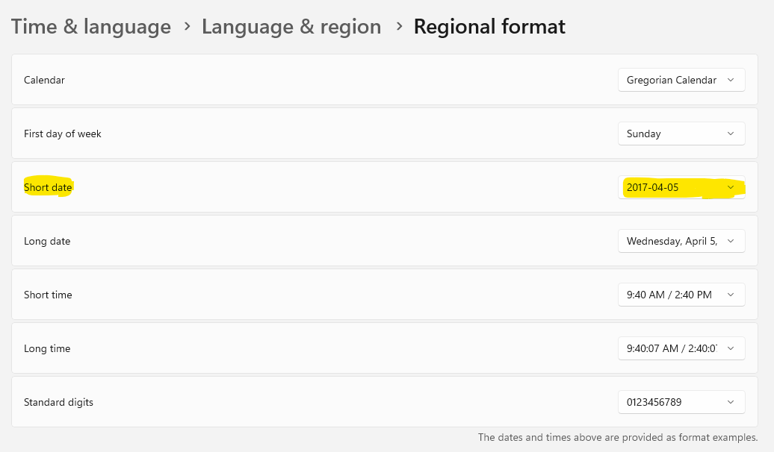

Custom Property "notes":
A detailed description must be added as custom property in SolidWorks assemblies. This will be extracted into HTML BOM files via JustinTool. Engineers can use Excel configurator to create the content of “notes” automatically.
- Add a row in ToSolidWorks sheet for notes:
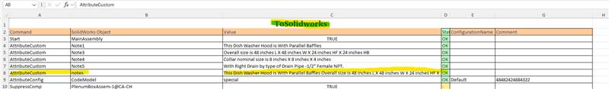
- Add formula to get the value of notes:
=TEXTJOIN(CHAR(10), TRUE, C4:C7) The old notes (note1 to note4) are saved in C4:C7
- Open assembly drawings to add the new notes:
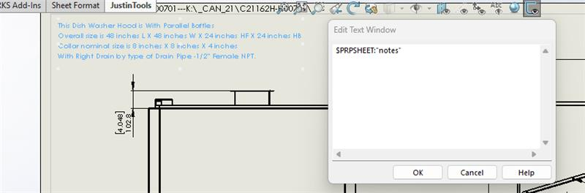
- The new BOM will include “notes” at the top of the page:
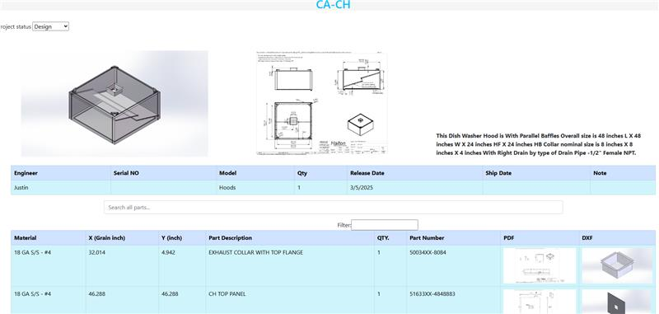

Custom Property " ModelData":
To ensure the software can correctly read the information from the ModelData sheet in Excel configurator, the table must follow a consistent format, as shown below. Column A starting with row 3 contain variable names, and Column B contains variable values in corresponding cells.
The table must follow a consistent format to ensure the software can correctly read the information from the ModelData sheet, as shown below.
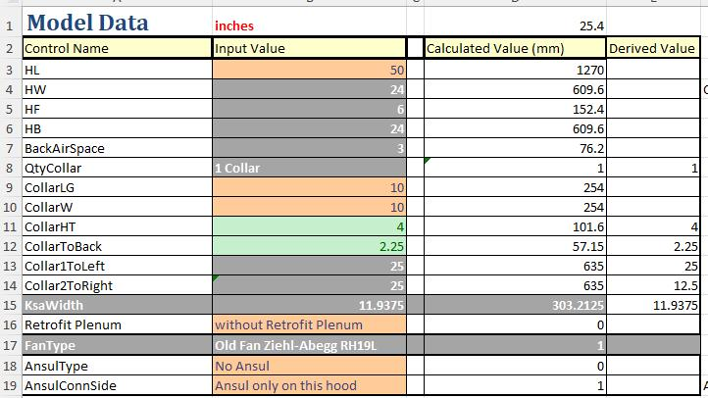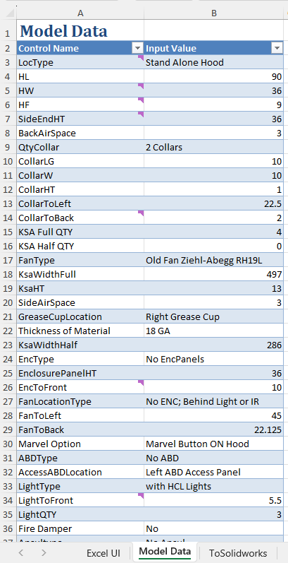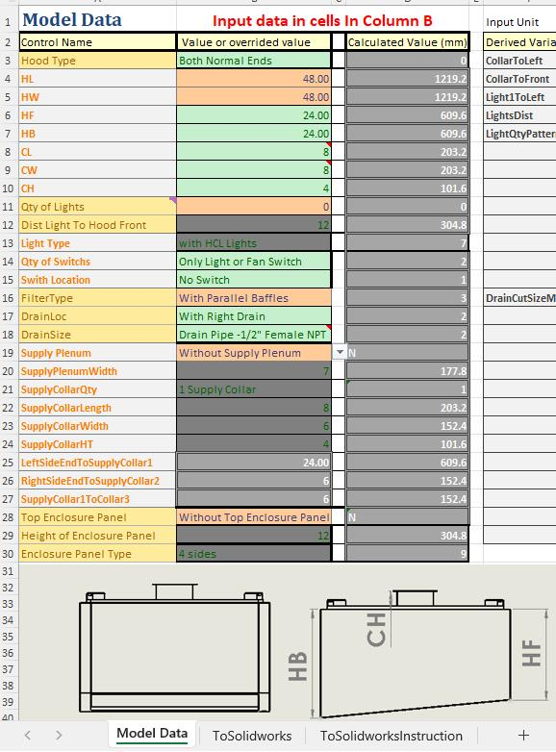

Website File Structure
DigitalFactory/ # Solution Root Directory
│
├── wwwroot/ # Static assets (CSS/JS/Images, no HTML)
│ ├── css/
│ ├── js/
│ ├── lib/ # Bootstrap/jQuery, etc.
│ └── images/
│
├── App/ # Server-side Code (Future Development)
│ ├── Controllers/
│ ├── Models/
│ ├── Views/
│ └── Services/
│
├── Content/ # HTML content repository
│ ├── CustomizedProduct/ # Manufacturing packages for customized products
│ ├── StandardProduct/ # Manufacturing packages for standard products
│ ├── StockPartLibrary/ # Drawings for stock parts
│ └── Shared/ # Reusable partial views
│ └── digitalfactory.html # entry point html file
│ └── DF-About.html #Help file
│
├── Database/ # SQL scripts/migrations
├── ClientApp/ # (Optional) Frontend framework
├── Docs/ # Documentation

The Digital Factory will evolve into a robust system capable of streamlining engineering workflows and improving operational efficiency.

