Royal Caribbean International
Revenue Management Strategy and Analytics - Data Analyst Case Study
PART 1: WTD (Week To Date) Expectations Presentation
For this part, you will be provided with information about the business. Please answer the questions and prepare a presentation that addresses each one. Feel free to use any tools or programs to complete this task.
Introduction To Track:
Track is a measurement of how we expect business to develop, enabling us to meet our forecasts. Specifically, it reflects the weekly passenger bookings (pax) required from the deployment date of a sailing up to the sailing date. This helps ensure we achieve our forecasted revenues. The business uses Track to make data-driven decisions and evaluate performance.
Below is a hypothetical example of a Track curve for a single sailing, represented as a line graph:
- X-axis: Calendar weeks, starting from the deployment date up to the sailing date.
- Y-axis: The number of pax needed each week to meet the forecast.
Example:
To meet the forecast for the week of June 24, 2024, we need to book 657 pax by that time.
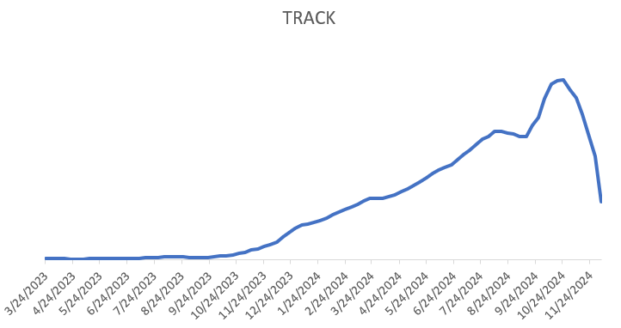
Calendar Week
Pax Ask
657

WTD (Week To Date) Expectations:
Now that you are familiar with weekly targets, we will take this a step further. To make informed daily pricing decisions, it is essential to understand how many of the expected pax should be booked each day within a given week. These daily targets are known as WTD (Week-To-Date) expectations.
- Using historical data, come up with what you think the WTD expectations should be at sail_year, sail_month, product level.
  - Your results should look like the table below.

  - Please explain your reasoning for each step of the task. Were there any abnormalities in the data? How did you handle the abnormalities?

  - Feel free to walk us through your EDA to help us better understand how you got your results.

- What are the implications of overestimating and under estimating WTD expectations and what does that mean in terms of revenue management?

- Present summary statistics and explain any reason why some products sell/book more on other days with respect to other products.

PART 2: SQL Questions
You will be given a series of SQL questions based on the data in a star schema. Please have your code at the end of your presentation.

