**UM-SJTU JOINT INSTITUTE**

**PHYSICS LABORATORY**

**(Vp141)**

**LABORATORY REPORT**

**EXERCISE 3**

**SIMPLE HARMONIC MOTION:**

**OSCILLATIONS in MECHANICAL SYSTEMS**

Kang Jiaming 518021911220 Group 18

Luo Chenhao 518370910038 Group 18

**1 Introduction**

The objective of this experiment is mainly to further the knowledge about simple harmonic oscillation, including measuring the spring constant, finding the relation between the period of the oscillation and the mass of the oscillator, examining whether the period is dependent on the amplitude of the oscillation and figuring out the relationship between the maximum speed and the amplitude.

Simple harmonic motion is the simplest kind of periodic motion, where the restoring force is proportional to the displacement from the equilibrium position. A typical example of simple harmonic motion is spring-mass system (Figure 11). According Hooke’s law1, “the force *Fx* needed to be applied in order to stretch or compress a spring by distance *x* is proportional to that distance”, *i.e.*,

$F_{x} = kx$, (1)

where *k* is the spring constant.

Also,

${△F}_{x} = k△x$. (2)

Therefore, by measuring the change of force acting on the spring ${△F}_{x}$ and the corresponding change of length of the spring $△x$ and then calculating the slope of the line ${ △F}_{x}$ vs. $△x$, the spring constant *k* can be obtained.

Apply Hooke’s law to the system shown in Figure 1, the equation of motion of this system is

$M\frac{ⅆ^{2}x}{ⅆt^{2}}+\left(k_{1}+k_{2}\right)x=0.$ (3)

The general solution to this equation is

$x\left(t\right)=Acos(ωt+φ$*)*, (4)

where $ω=\sqrt{({k_{1}+k_{2})}/M}$ is the angular frequency of the oscillation, A is the amplitude and $φ$ is the initial phase. The period of the oscillation $T$ is then

$T= \frac{2π}{ω}=2π\sqrt{\frac{M}{k_{1}+k_{2}}}$. (5)

It should be noticed that in the above derivation the mass of the spring has been neglected. However, the mass of the spring does affect the motion of the system. Taking that into account, the angular frequency of the system is corrected to be

$ω=\sqrt{\frac{k_{1}+k_{2}}{M+m_{0}}}$,

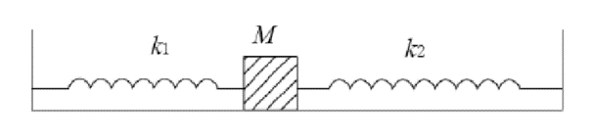where $m_{0}$ is the effective mass of the spring, which is one third of the mass of the spring.

Figure 1. Mass-Spring System

The total energy of the mass-spring system consists of potential energy $U= {kx^{2}}/2$ and kinetic energy $K={mv^{2}}/2$. At maximum displacement, the kinetic energy is $0$, and the potential energy reaches its maximum $U_{max}= {kA^{2}}/2$; at the equilibrium position, the potential energy becomes $0$, and the kinetic energy reaches its maximum $K_{max}= {m{v_{max}}^{2}}/2$. Then $U_{max}= K_{max}$, which implies

$\frac{m{v_{max}}^{2}}{A^{2}}=k$. (6)

Since $v=\lim_{△t→0}{\frac{△x}{△t}}$, the maximum of the speed can be approximately obtained by measuring the time spent $△$ t to cover a small distance $△$ x and by the equation

$v≈\frac{△x}{△t}$. (7)

U-shape shuttle is used to measure the maximum of the speed. In this case, the distance $△x$ is the distance between its two arms, and

$△x=\frac{1}{2}(x_{in}+x_{out})$, (8)

where $x_{in}$ is the inner distance between the two arms and $x_{out}$ is the outer distance.

**2 Experimental Setup**

The equipment used include the following: springs, masses, electronic balance, Jolly balance, air track, object(cart), photoelectric gates, electronic timer and caliper.

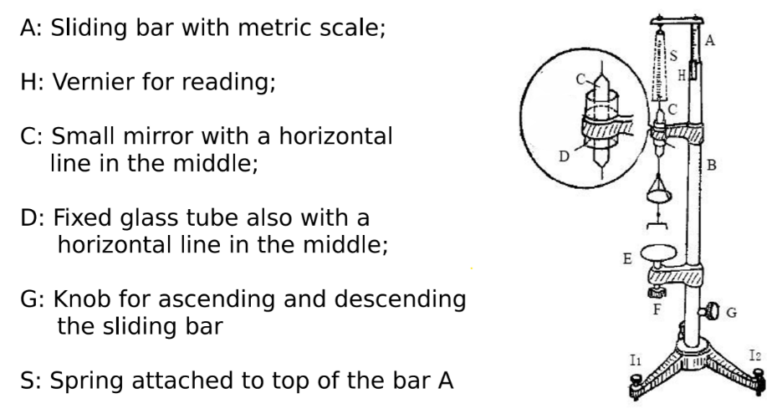The spring constant is measured with a Jolly balance (Figure 21), which can measure the change of length of the spring. When weights are added, adjust the knob G until the line on the mirror C, the line on the glass tube D and its reflection in the mirror coincide. The scale on the sliding bar then gives the length of the spring from the initial point, with maximum uncertainty 0.01cm.

Figure 2. Jolly Balance

The weights are measured by electronic balance, with maximum uncertainty 0.01g.

To avoid the friction of the oscillator with the surface, the object is put on an air track. The scale on the air track can measure the amplitude with maximum uncertainty 0.1cm.

The electronic timer is used to measure the period of oscillation and the maximum speed. When a shutter placed on the object passes the gate, the light is blocked and signal is sent to the timer to record the instant. The “T” mode and I-shaped shutter are applied to record 10 periods of oscillation with maximum uncertainty 0.1ms. The “S2” mode and U-shaped shutter are used to record the time interval $△t$ spent to cover the distance between the two arms of the shutter $△x$ with maximum uncertainty 0.01ms.

A caliper is used to measure $x_{in}$ and $x_{out}$ in equation 7 with maximum uncertainty 0.02mm.

The major facilities of measurements, the quantities each measure and their uncertainties are summarized in Table 1.

|  |  |  |
| --- | --- | --- |
| Device | Quantity measured | Uncertainty |
| Scaled sliding bar on the Jolly balance | Length of the spring | 0.01cm |
| Electronic balance | Mass | 0.01g |
| Scale on the air track | Amplitude | 0.1cm |
| “T” mode of the electronic timer | 10 Periods of oscillation | 0.1ms |
| “S2” mode of the electronic timer | Time interval $△t$ | 0.01ms |
| Caliper | Distance $x_{in}$ and $x_{out}$ | 0.02mm |

Table 1. Facilities of measurements

**3. Measurements**

**3.1 Spring Constant**

Caution: Do not stretch the spring over its elastic limit.

Before measurements, the elements of the Jolly balance were adjusted to the proper position:

1. Adjust the Jolly balance to be vertical by adjusting the knobs so that the mirror can move freely through the tube.

2. Adjust knob G and make the three lines in the tube coincide. Adjust the position of the tube to set the initial position L0 within 5.0 ∼ 10.0 cm.

Then, perform the measurements:

3. Record the reading L0 on the scale, add mass m1 and record L1.

4. Keep adding masses and take measurements for six diﬀerent positions.

5. Estimate the spring constant k1 using the least squares method.

6. Replace spring 1 with spring 2, repeat the measurements and calculate k2.

7. Remove the preload and repeat the measurement for springs 1 and 2 connected in series. Calculate k3 and compare it with the theoretical value.

**3.2 Relation Between the Oscillation Period T and the Mass of the Oscillator M**

Caution: Do not place anything on the air track when the air pump is off.

First, check if any of the holes on the air track are blocked and adjust the air track so that it is horizontal

Then the measurements proceed as follows:

For the horizontal air track:

1. Attach springs to the sides of the cart, and set up the I-shape shutter. Make sure that the photoelectric gate is at the equilibrium position.

2. Add weight m1. Let the cart oscillate about the photoelectric gate. The amplitude of oscillations should be about 5 cm. Release the cart with a caliper or a ruler. Set the timer into the ”T” mode. The timer in this mode will automatically record the time of 10 oscillation periods. Record the mass of the cart and the period.

3. Add weights to the object, repeat Step 2 and take measurements for 5 times.

4. Analyze the relation between M and T by plotting a graph.

For the inclined air track:

5. Place 3 plastic plates for the first time and 6 for the second time under the air track.

6. Repeat steps 1-4 each time.

**3.3 Relation Between the Oscillation Period T and the Amplitude A**

1. Keep the mass of the cart unchanged and set the amplitude as 5.0, 10.0, 15.0, 20.0, 25.0 and 30.0 cm.

2. Measure the period as said in step 2 in section 3.2.

3. Apply linear ﬁt to the data and comment on the relation between the oscillation period T and the amplitude A based on the correlation coeﬃcient γ.

**3.4 Relation Between the Maximum Speed and the Amplitude**

First, find out the distance to be covered $△x$ by measuring the outer distance xout and the inner distance xin of the U-shape shutter with a caliper and applying ∆x = (xout + xin)/2.

Next,

1. Change the shutter from I- to U-shape. Set the timer into the “S2” mode. Let the cart oscillate. Record the second readings of the time interval ∆t only if the two subsequent readings show the same digits to the left of the decimal point.

2. Set the amplitude as 5.0, 10.0, 15.0, 20.0, 25.0 and 30.0 cm.

3. Measure the maximum speed $v_{max}$ for diﬀerent values of the amplitude A. Obtain the spring constant from Eq. (6). Compare this result to that of the ﬁrst part.

**3.5 Mass Measurement**

1. Adjust the electronic balance every time before you use it. The level bubble should be in the center of the circle.

2. Add weights according to a ﬁxed order. Weigh the cart with the I-shape shutter and with the U-shape shutter. Measure the mass of spring 1 and spring 2.

3. Record the data only after the circular symbol on the scales display disappears.

**4 Results**

**4.1 Spring Constant**

The lengths of the springs are measured as described in 3.1 and the results are presented in Table 2. According to Equation (2), the spring constant can be found from the graph ${ △F}_{x}$ vs. $△x$. ${ △F}_{x}$ here is the weights of the series of masses, i.e. ${ △F}_{x}=mg$ where m is measured in section 4.5 and its value is shown in Table 12, and $△x$ is the deformation of the spring with respect to L0, i.e.,.

Take L1 of spring 1 as an example:

${△F}_{x}=mg=4.74×{10}^{-3}×9.79=(4.64±0.01) ×{10}^{-2}$ N,

$△x=△L=L_{1}-L_{0}=4.72-2.55=2.17±0.01$ cm

The ${ △F}_{x}$ and $△x$ of the springs are calculated in this way and the results, $mg$ and $△L$, are listed in Table 3.

|  |  |  |  |  |  |
| --- | --- | --- | --- | --- | --- |
| Spring 1 [cm] $±$ 0.01 [cm] | | Spring 2 [cm] $±$ 0.01 [cm] | | Series [cm] $±$ 0.01 [cm] | |
| L0 | 2.55 | L0 | 6.12 | L0 | 6.46 |
| L1 | 4.72 | L1 | 8.05 | L1 | 10.50 |
| L2 | 6.80 | L2 | 9.94 | L2 | 14.41 |
| L3 | 8.86 | L3 | 11.81 | L3 | 18.40 |
| L4 | 11.03 | L4 | 13.73 | L4 | 22.52 |
| L5 | 13.13 | L5 | 15.64 | L5 | 26.58 |
| L6 | 15.25 | L6 | 17.55 | L6 | 30.52 |

Table 2. Results of measurements of the lengths of the springs

|  |  |
| --- | --- |
| Spring 1 | |
| $mg$ [${10}^{-2}$ N] $± 0.01$ [${10}^{-2}$ N] | $△L$ [cm] $± 0.01$ [cm] |
| 4.64 | 2.17 |
| 9.26 | 4.25 |
| 13.9 | 6.31 |
| 18.7 | 8.48 |
| 23.4 | 10.58 |
| 28.1  Table 3(a). $mg$ and $△L$ of spring 1 | 12.70 |

|  |  |
| --- | --- |
| Spring 2 | |
| $mg$ [${10}^{-2}$ N] $± 0.01$ [${10}^{-2}$ N] | $△L$ [cm] $± 0.01$ [cm] |
| 4.64 | 1.93 |
| 9.26 | 3.82 |
| 13.9 | 5.69 |
| 18.7 | 7.61 |
| 23.4 | 9.52 |
| 28.1  Table 3(b). $mg$ and $△L$ of spring 2 | 11.43 |

|  |  |
| --- | --- |
| Series | |
| $mg$ [${10}^{-2}$ N] $± 0.01$ [${10}^{-2}$ N] | $△L$ [cm] $± 0.01$ [cm] |
| 4.64 | 4.04 |
| 9.26 | 7.95 |
| 13.9 | 11.94 |
| 18.7 | 16.06 |
| 23.4 | 20.12 |
| 28.1  Table 3(c). $mg$ and $△L$ of series | 24.06 |

The spring constant can be found from the slope of the graph $mg$ vs. $△L$. Apply linear fits to each of the 3 tables of data using Origin, the results are presented in the following (Figure 3 - 5). Reading off from the figures, it can be obtained that

The spring constant of spring 1

$k_{1}=2.229±0.006{{(10}^{-2}N}/{{10}^{-2}m)}=2.229±0.006$ N/M.

The spring constant of spring 2

$k_{2}=2.473±0.001{{(10}^{-2}N}/{{10}^{-2}m)}=2.473±0.001$ N/M.

Figure 4. Graph of $mg$ vs. $△L$ for spring 2

Figure 3. Graph of $mg$ vs. $△L$ for spring 1

The spring constant of spring 1 and spring 2 connected in series

$k_{series}=1.169±0.006{{(10}^{-2}N}/{{10}^{-2}m)}=1.169±0.006$ N/M

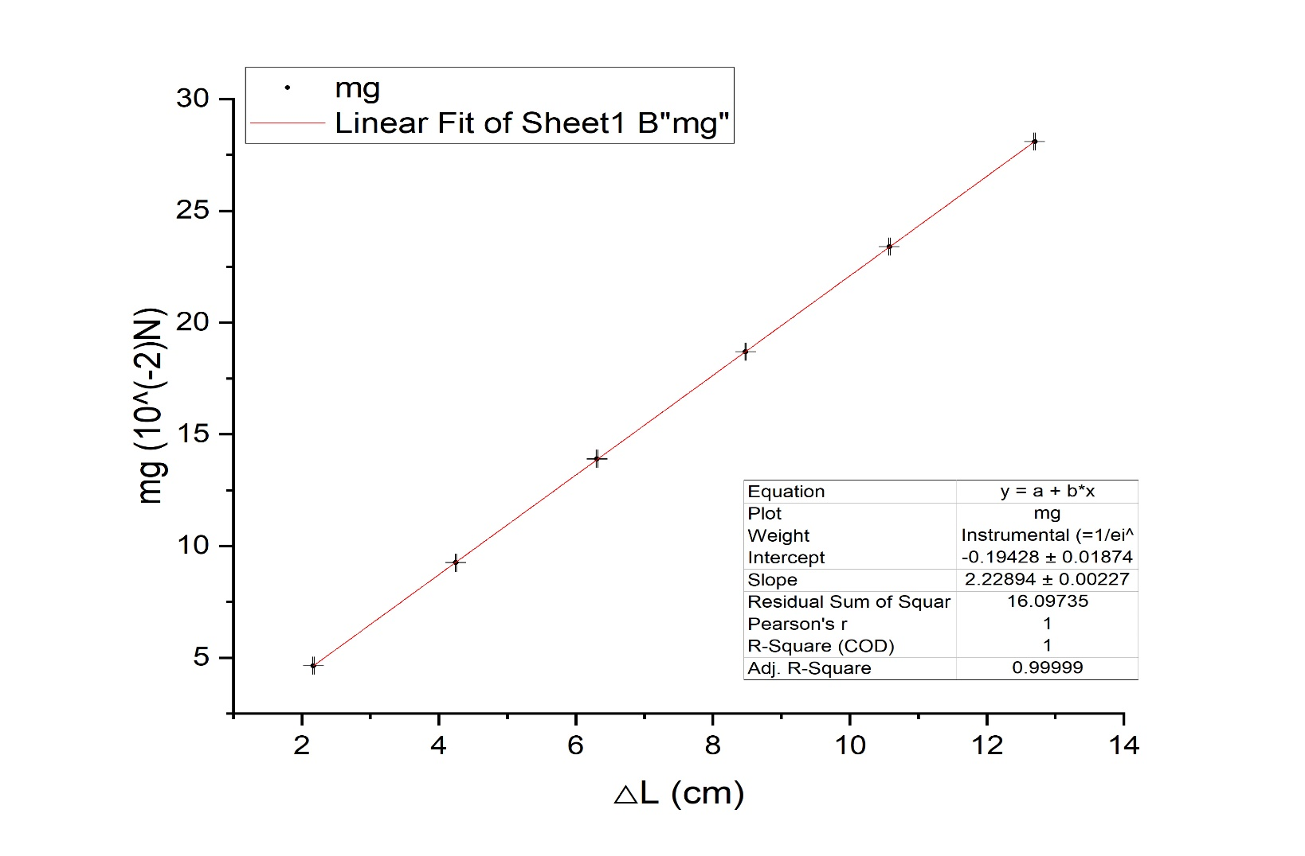

Figure 3. Graph of $mg$ vs. $△L$ for spring 1

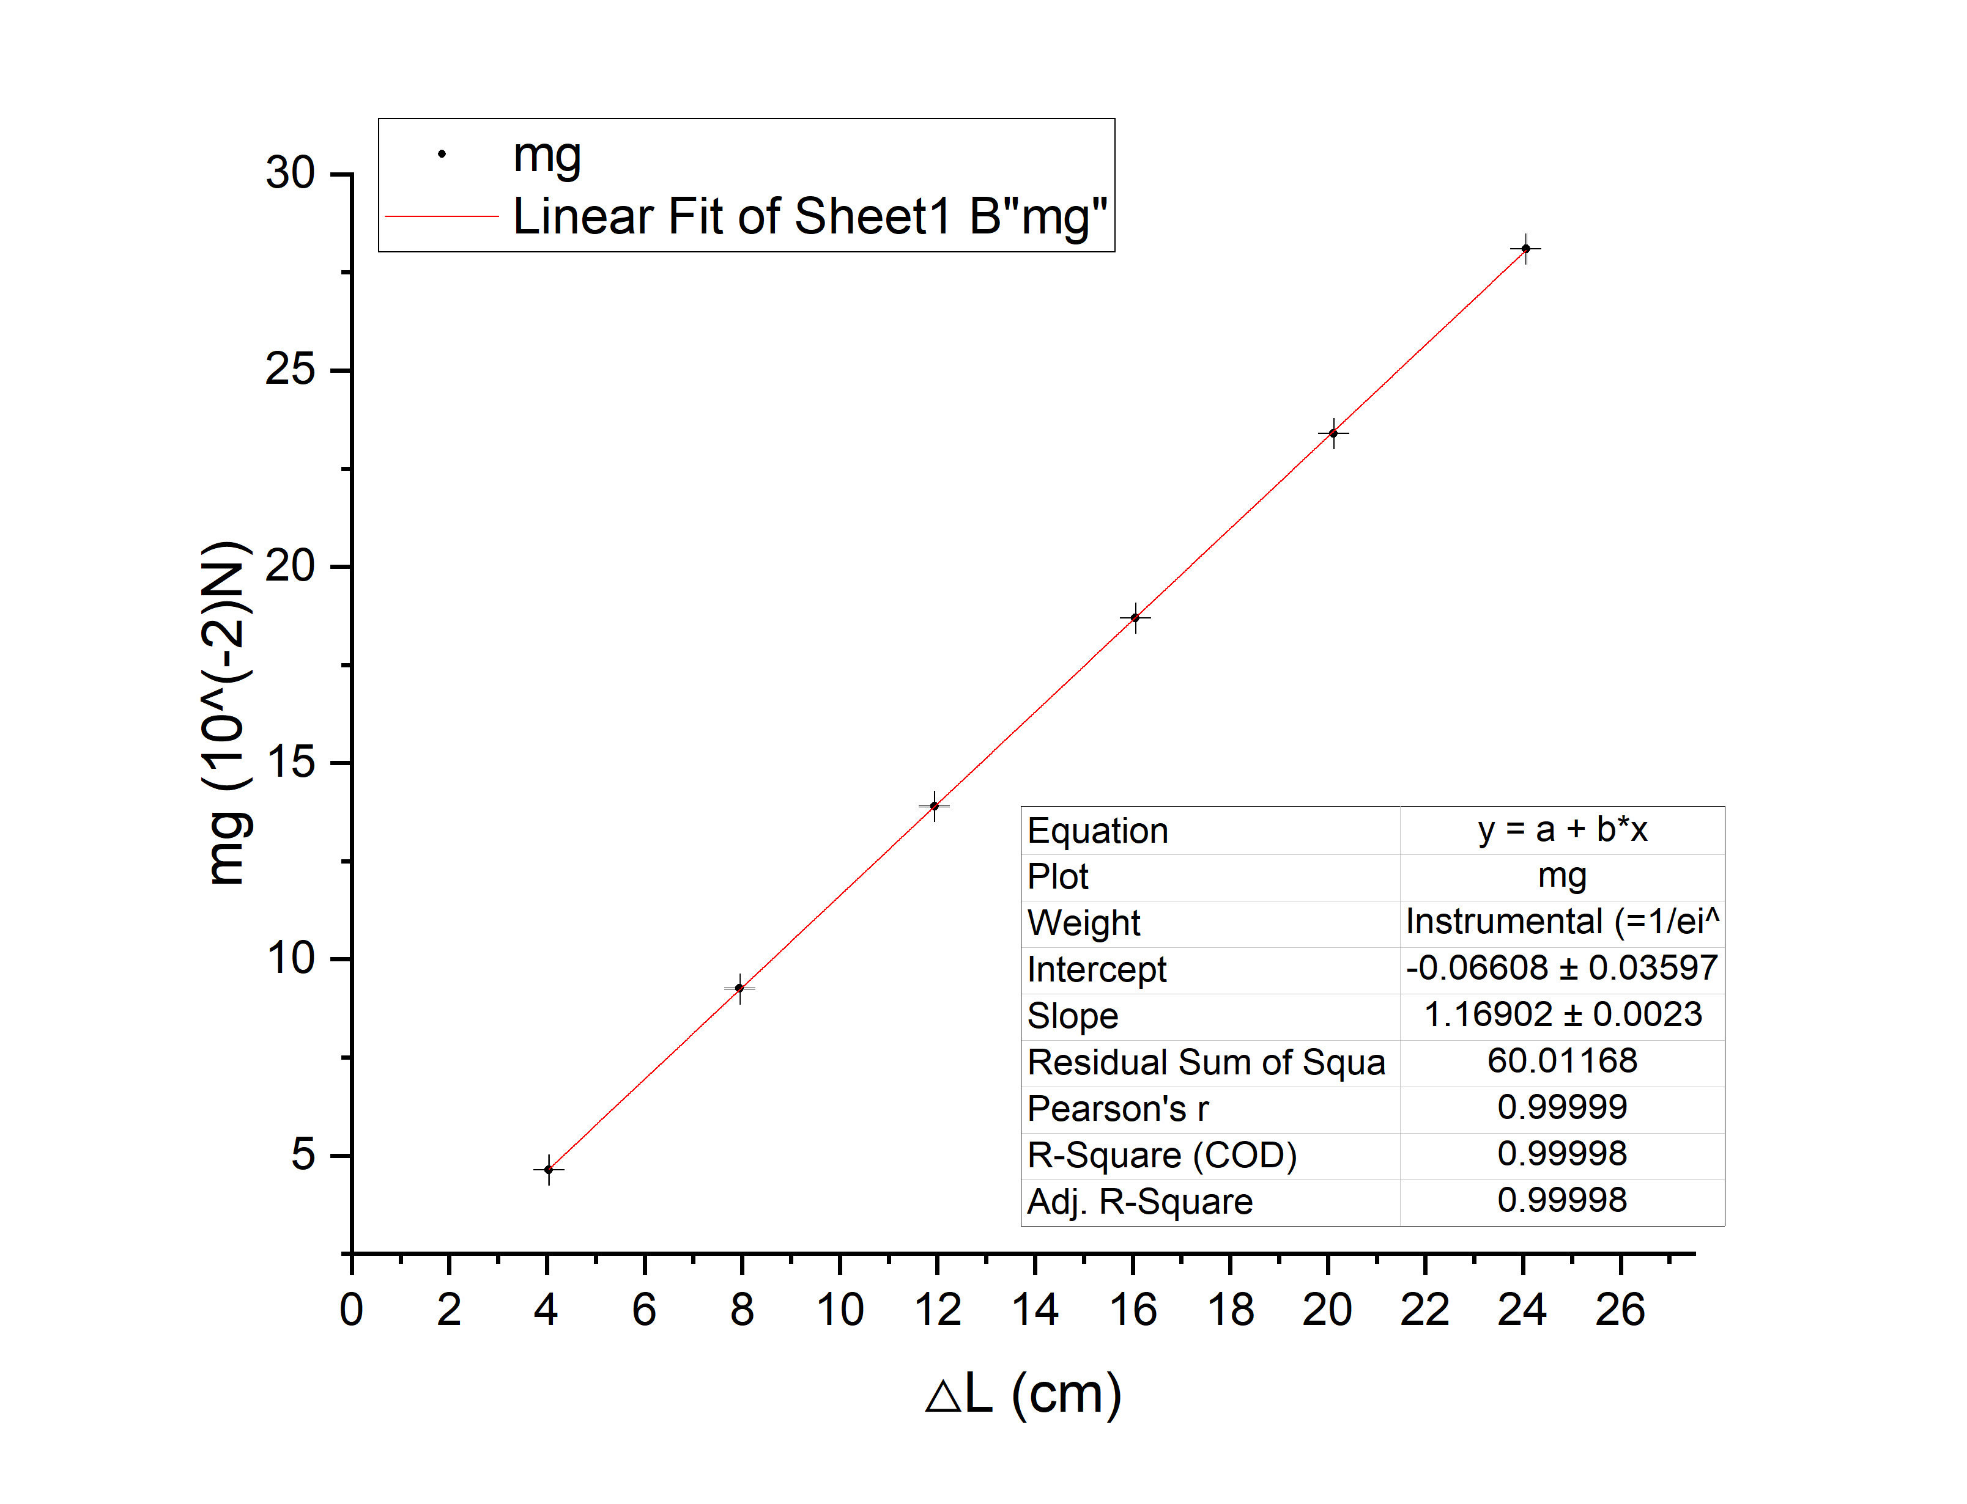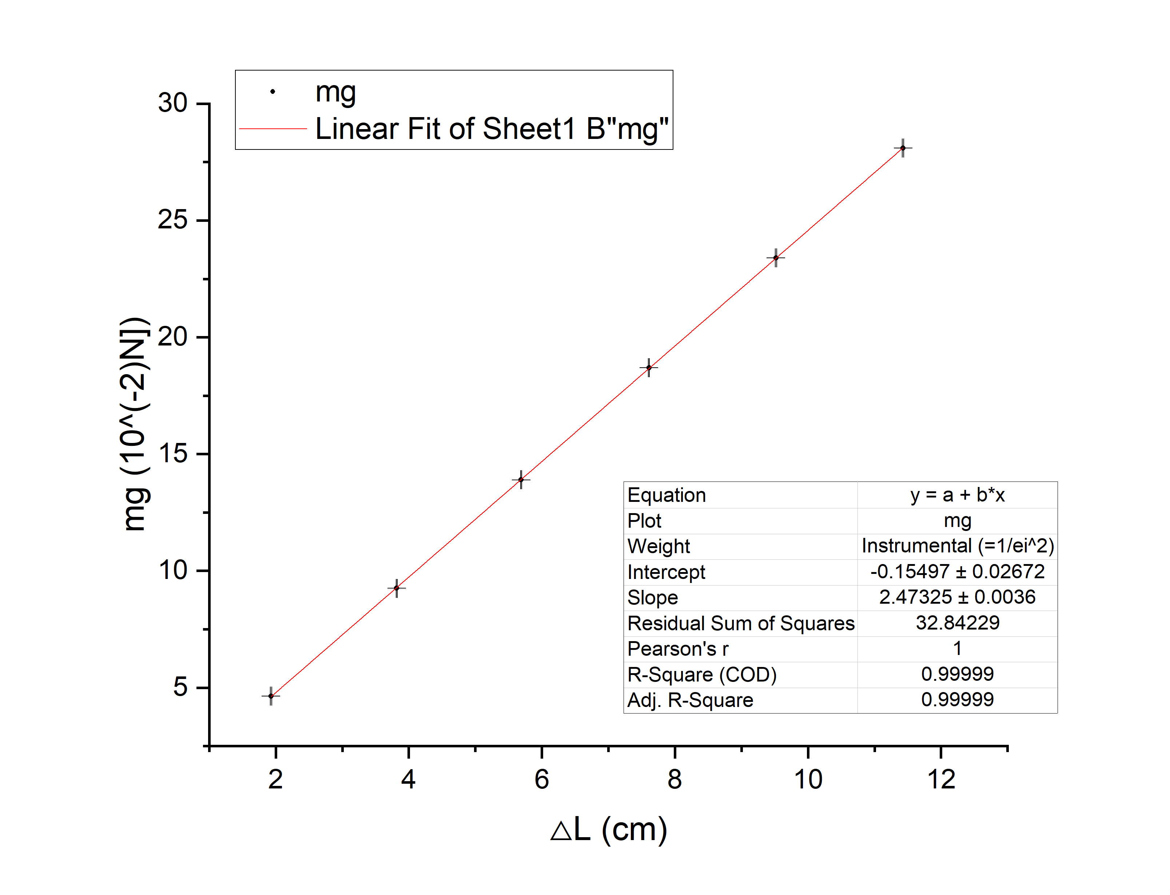

Figure 5. Graph of $mg$ vs. $△L$ for series

Figure 4. Graph of $mg$ vs. $△L$ for spring 2

**4.2 Relation Between the Oscillation Period T and the Mass of the Oscillator M**

The measurement results of ten periods are shown in Table 4. To find one period of oscillation, taking m1 of the horizontal trial as an example:

$T=\frac{t_{ten periods}}{10}=\frac{t_{ten periods}}{10}=\frac{12572.1}{10}=1257.21±0.01$ ms.

In this way, one single period of oscillation can be calculated and the results are presented in Table 5.

|  |  |  |  |  |  |
| --- | --- | --- | --- | --- | --- |
| Ten periods [ms] $±$ 0.1 [ms] | | | | | |
| Horizontal | | Incline 1 | | Incline 2 | |
| m1 | 12572.1 | m1 | 12559.8 | m1 | 12564.4 |
| m2 | 12719.0 | m2 | 12723.4 | m2 | 12713.5 |
| m3 | 12873.5 | m3 | 12877.6 | m3 | 12881.3 |
| m4 | 13041.9 | m4 | 13030.1 | m4 | 13033.5 |
| m5 | 13195.7 | m5 | 13189.4 | m5 | 13169.0 |
| m6 | 13340.7 | m6 | 13349.3 | m6 | 13325.0 |

Table 4. Results of measurements of ten periods of oscillation

|  |  |  |  |  |  |
| --- | --- | --- | --- | --- | --- |
| One period $T$ [ms] $±$ 0.01 [ms] | | | | | |
| Horizontal | | Incline 1 | | Incline 2 | |
| m1 | 1257.21 | m1 | 1255.98 | m1 | 1256.44 |
| m2 | 1271.90 | m2 | 1272.34 | m2 | 1271.35 |
| m3 | 1287.35 | m3 | 1287.76 | m3 | 1288.13 |
| m4 | 1304.19 | m4 | 1303.01 | m4 | 1303.35 |
| m5 | 1319.57 | m5 | 1318.94 | m5 | 1316.90 |
| m6 | 1334.07 | m6 | 1334.93 | m6 | 1332.50 |

Table 5. Results of calculation of one period of oscillation

To examine the relationship between period and mass, we plot $M$ vs. $T^{2}$ and applying linear fit using Origin, where M is the total mass of the oscillator, which is calculated in section 4.5. The value of $T^{2}$, is calculated as follows. Take m1 as an example:

$T^{2}={1257.21}^{2}=(1.58058±0.00003)×{10}^{6}$ ms.

The values of $T^{2}$ are shown in Table 6 and the graphs are shown in Figure 6-8.

Table 6. Results of calculation of

|  |  |  |  |  |  |
| --- | --- | --- | --- | --- | --- |
| [106ms] 0.00003 [106ms] | | | | | |
| Horizontal | | Incline 1 | | Incline 2 | |
| m1 | 1.58058 | m1 | 1.57749 | m1 | 1.57864 |
| m2 | 1.61773 | m2 | 1.61885 | m2 | 1.61633 |
| m3 | 1.65727 | m3 | 1.65833 | m3 | 1.65928 |
| m4 | 1.70091 | m4 | 1.69784 | m4 | 1.69872 |
| m5 | 1.74127 | m5 | 1.73960 | m5 | 1.73423 |
| m6 | 1.77974 | m6 | 1.78204 | m6 | 1.77556 |

A linear fit for the data of the horizontal trial yields the slope = (1.18 $±$ 0.05) $×{10}^{2}(g/{{10}^{6}ms)}$ and the intercept $-6±$ 3 $g$.

A linear fit for the data of the incline 1 trial yields the slope = (1.18 $±$ 0.03) $×{10}^{2}(g/{{10}^{6}ms)}$ and the intercept $-4±$ 2 $g$.

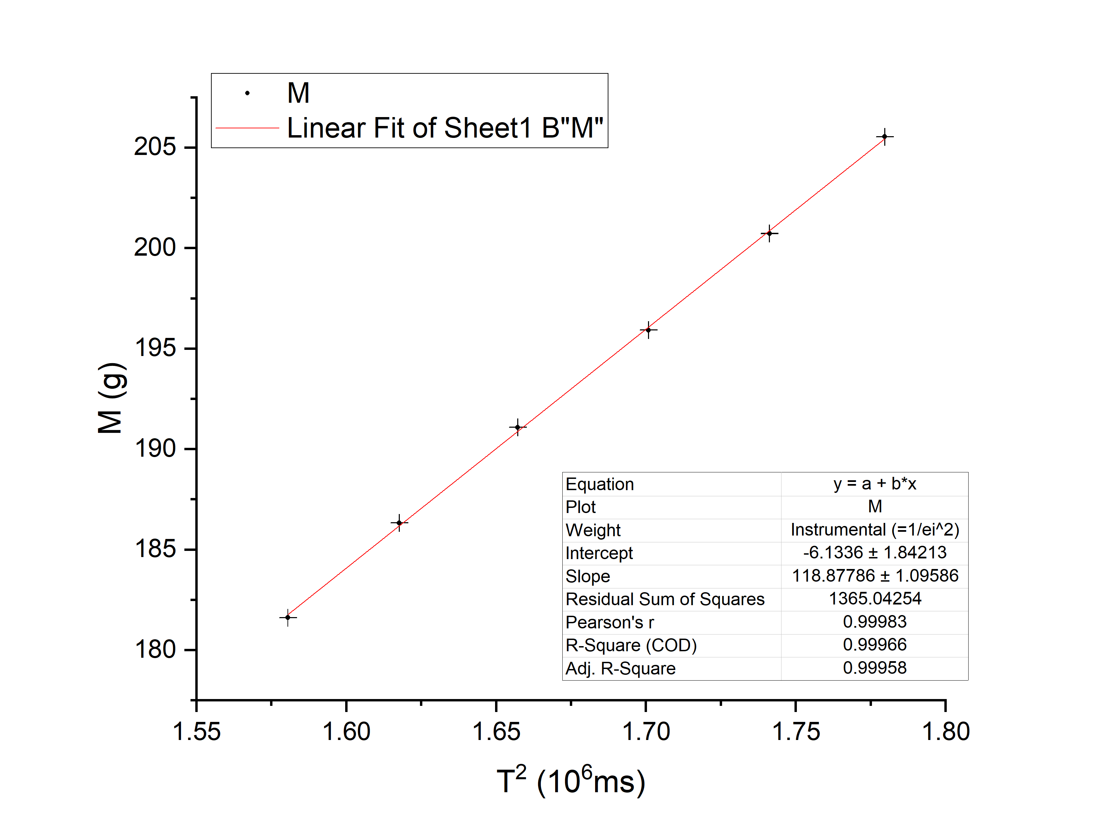 A linear fit for the data of the incline 2 trial yields the slope = (1.22 $±$ 0.07) $×{10}^{2}(g/{{10}^{6}ms)}$ and the intercept $-10±$ 4 $g$.

Figure 6. Graph of $M$ vs. $T^{2}$ for Horizontal

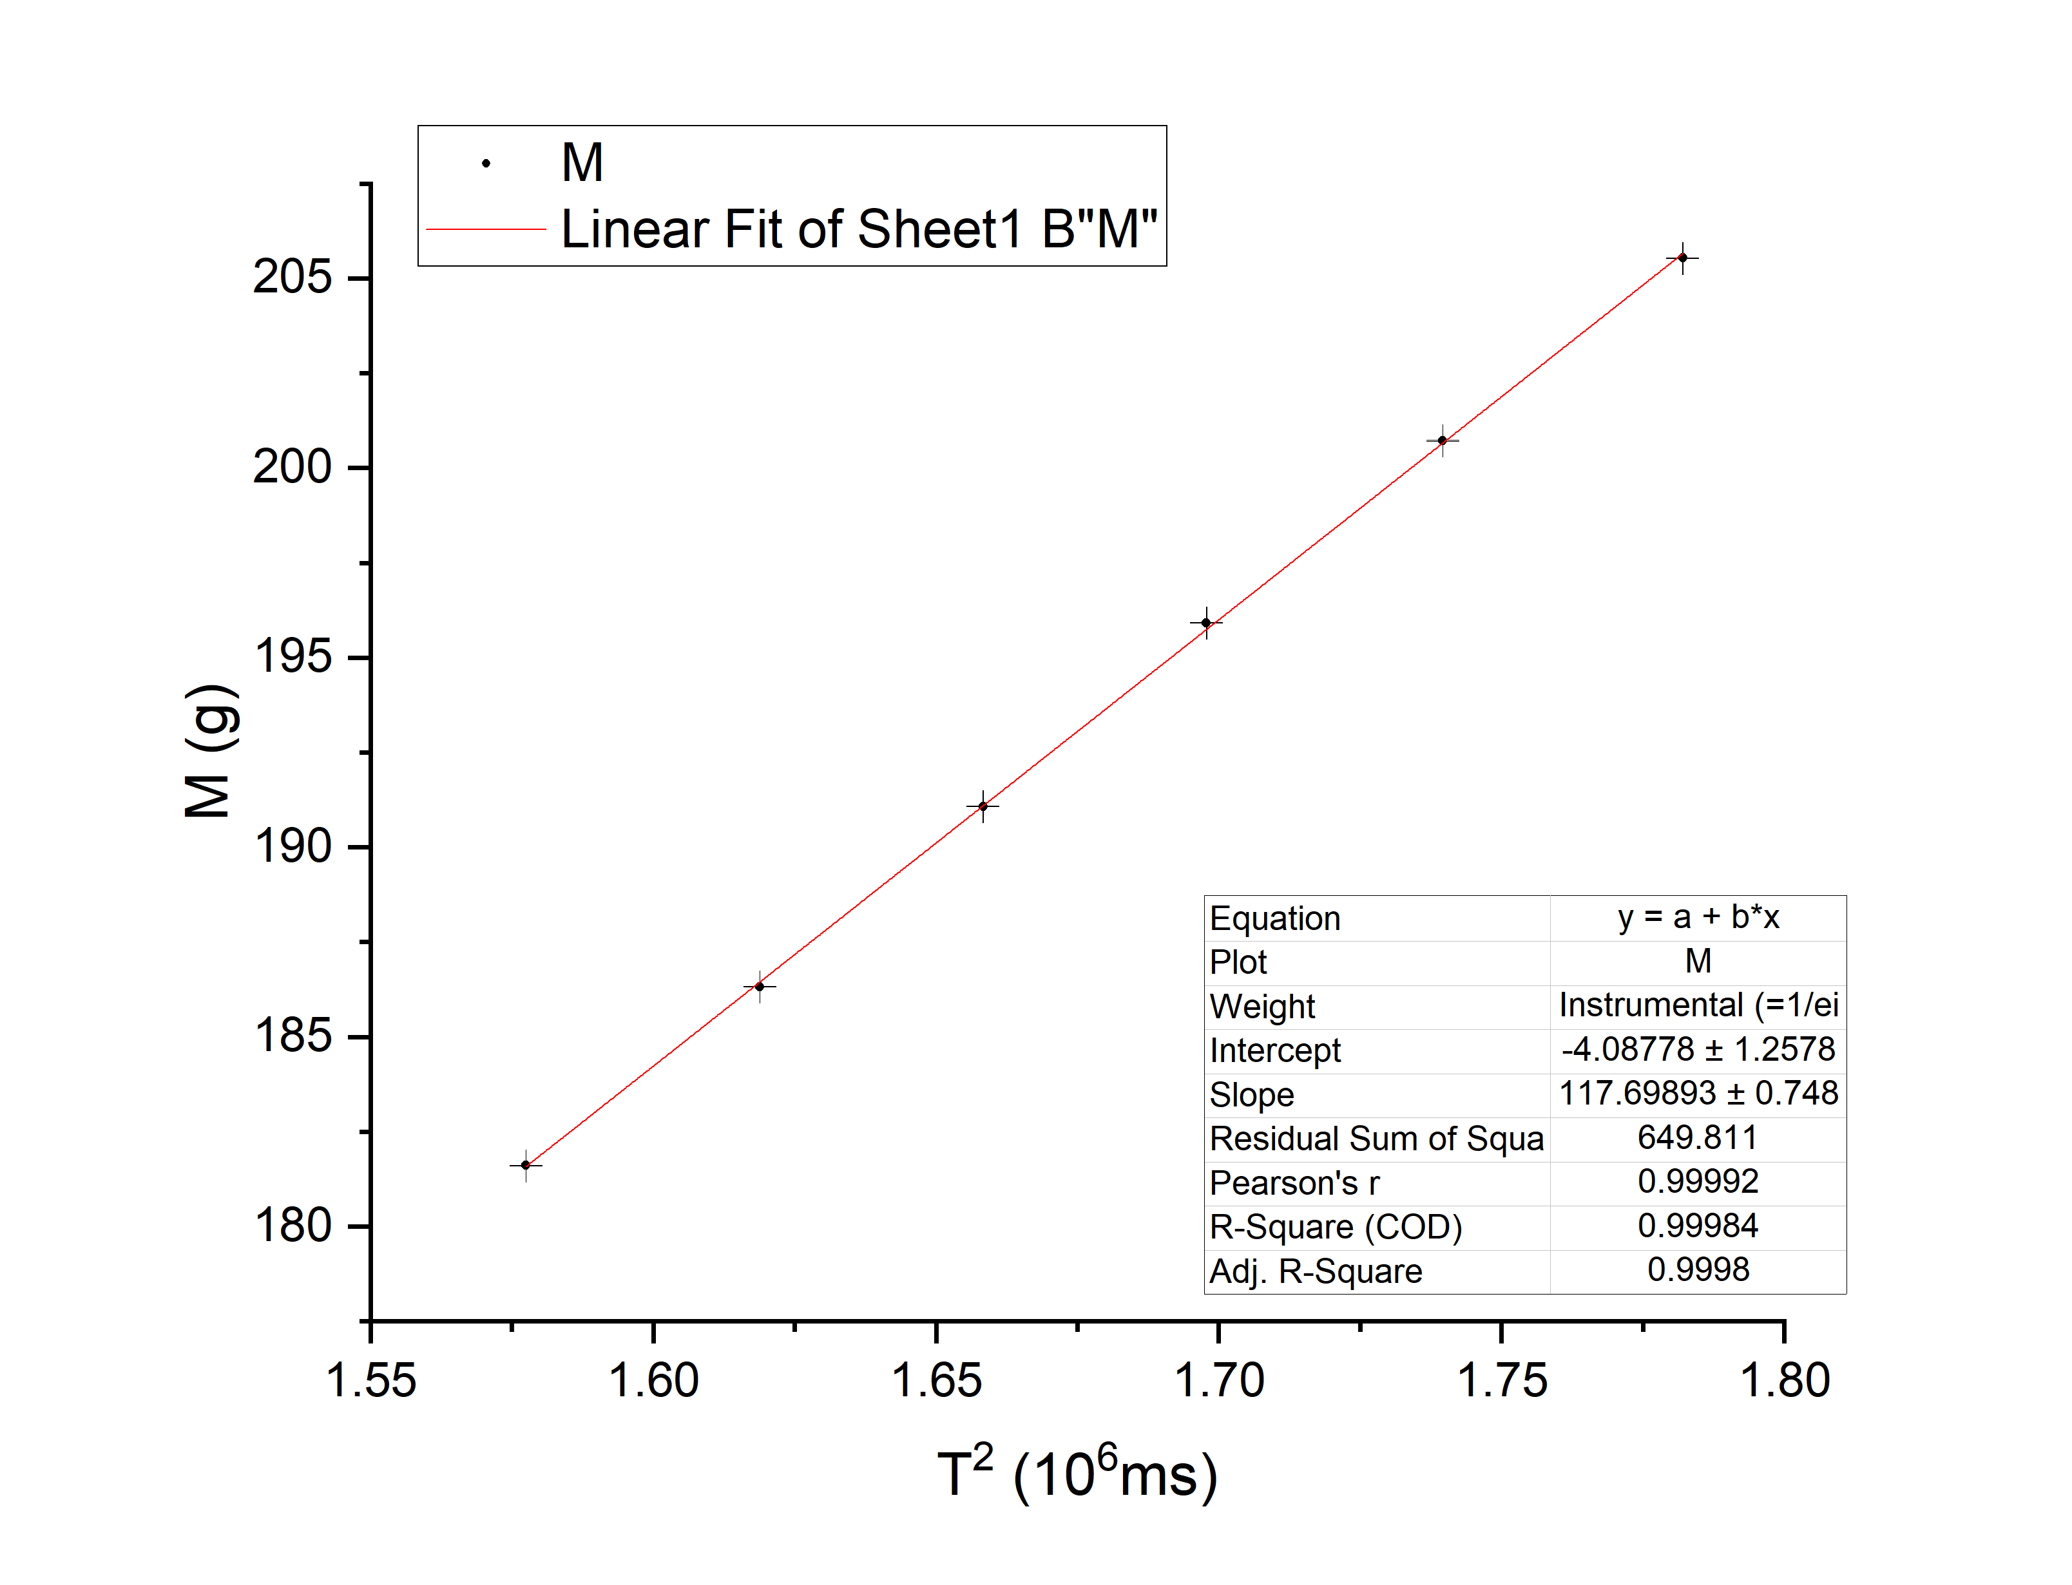

Figure 7. Graph of $M$ vs. $T^{2}$ for Incline 1

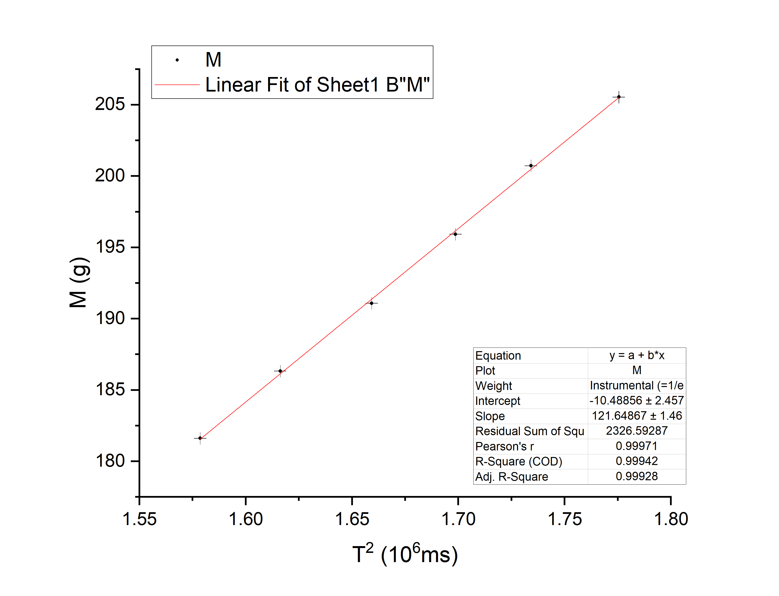

Figure 8. Graph of $M$ vs. $T^{2}$ for Incline 2

**4.3 Relation Between the Oscillation Period T and the Amplitude A**

The measured values of the period for each amplitude are presented in Table 7. By similar approach in section 4.2, the values of $T$ can be calculated and the results are shown in Table 8.

|  |  |  |
| --- | --- | --- |
|  | $A$ [cm] $±$ 0.1[cm] | Ten periods [ms] $±$ 0.1 [ms] |
| 1 | 5.0 | 12406.6 |
| 2 | 10.0 | 12399.5 |
| 3 | 15.0 | 12400.3 |
| 4 | 20.0 | 12412.3 |
| 5 | 25.0 | 12410.7 |
| 6 | 30.0 | 12411.7 |

Table 7. Results of measurements of ten periods of oscillation

|  |  |  |
| --- | --- | --- |
|  | $A$ [cm] $±$ 0.1[cm] | $T$ [ms] $±$ 0.01 [ms] |
| 1 | 5.0 | 1240.66 |
| 2 | 10.0 | 1239.95 |
| 3 | 15.0 | 1240.03 |
| 4 | 20.0 | 1241.23 |
| 5 | 25.0 | 1241.07 |
| 6 | 30.0 | 1241.17 |

Table 8. Results of calculation of one period of oscillation

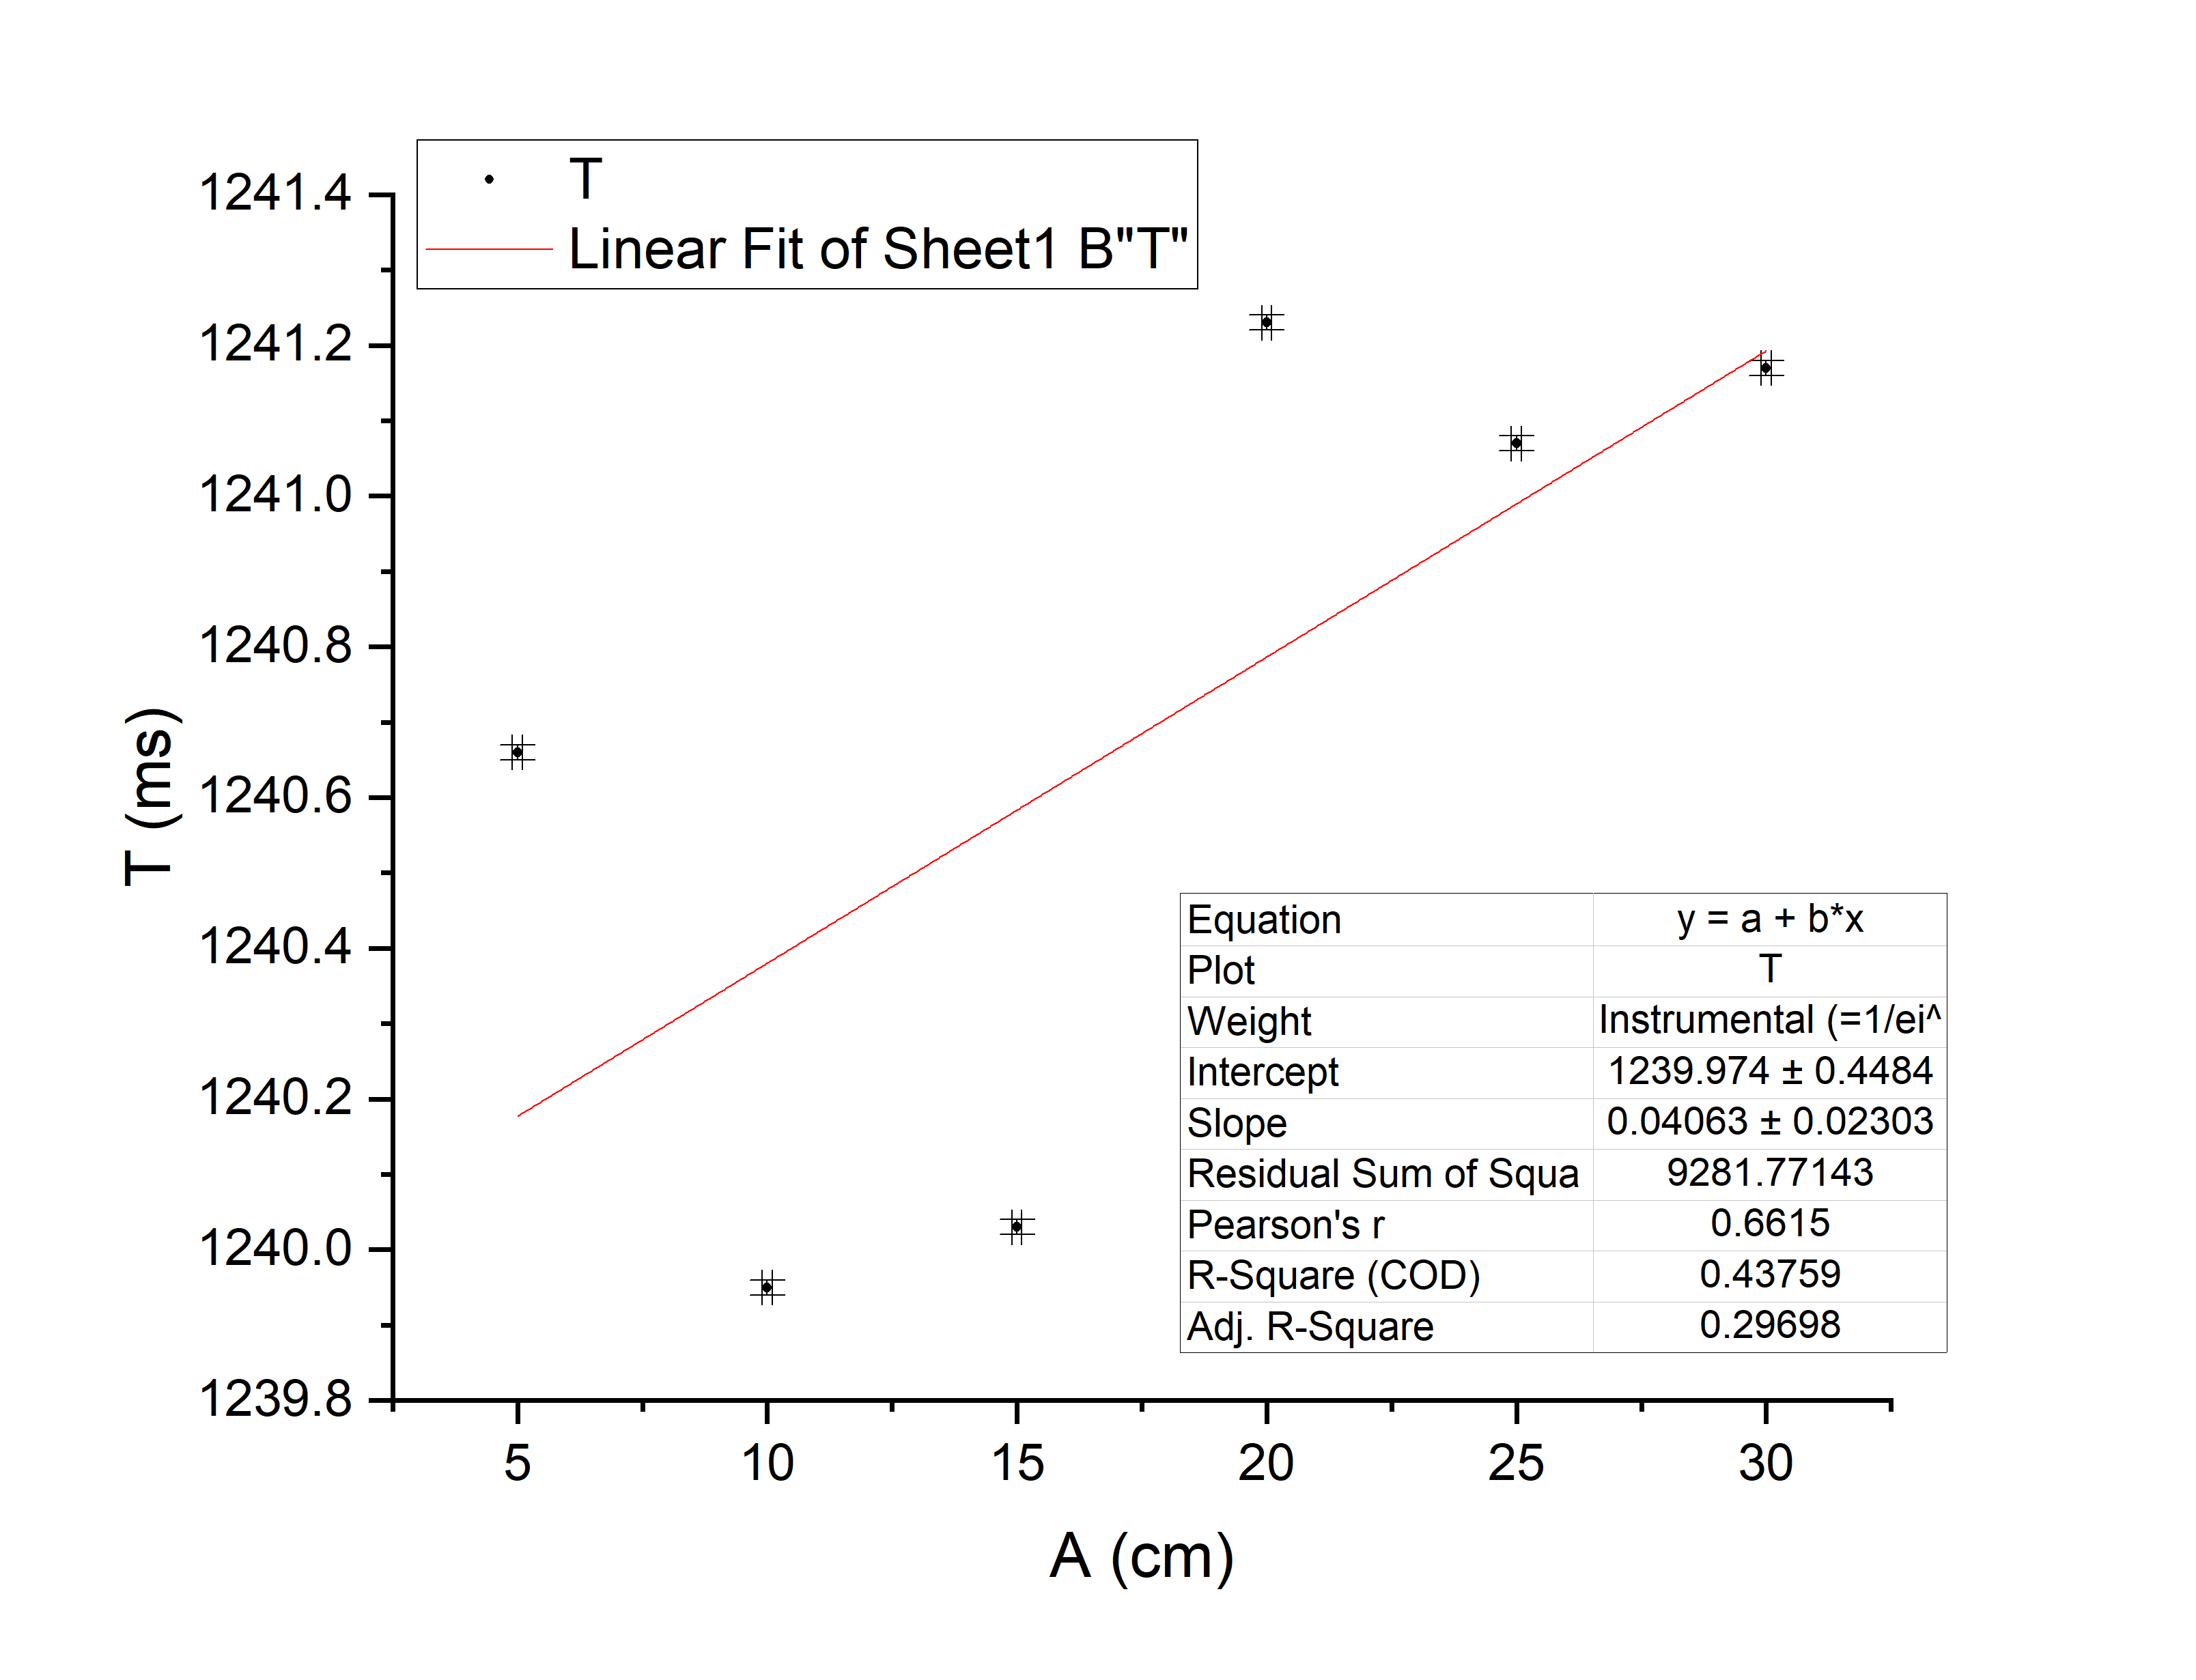

Figure 9. Graph of $T$ vs. $A$

To check whether the oscillation period depends on the amplitude, we plot the graph $T$ vs. $A$ and apply linear fit (Figure 9). We run a linear correlation test. The correlation coefficient $r(ρ_{TA})$ is calculated through Origin to be 0.6615, which suggests that we do not have much confidence to state that T is linear dependent on A. The linear fit yields the slope = (0.04 $±$ 0.06) $×{10}^{2}({ms}/{cm)}$ and the intercept $(1.240± 0.00$ 1 $) ×{10}^{3}ms$.

**4.4 Relation Between the Maximum Speed and the Amplitude**

The measured values of $x_{in}$ and $x_{out}$ are presented in Table 9 together with the corresponding $△x$ calculated from equation (8). A sample calculation using the first set of data is given below. The average value of $△x$ is

$\overline{Δx}=\frac{1}{3}\sum_{i=1}^{3}{Δx_{i}=10.04 ± 0.02}$ mm.

|  |  |  |
| --- | --- | --- |
| $x_{in}$ [mm] $±$ 0.02 [mm] | $x_{out}$ [mm] $±$ 0.02 [mm] | $△x$ [mm] $±$ 0.01 [mm] |
| 5.02 | 15.08 | 10.05 |
| 5.00 | 15.08 | 10.04 |
| 5.02 | 15.06 | 10.04 |

Table 9. Results of measurements of $x_{in}$ and $x_{out}$ and calculation of corresponding $△x$

Sample calculation:

$△x=\frac{1}{2}\left(x_{in}+x_{out}\right)=\frac{1}{2}\left(5.02+15.08\right)=10.05±0.01$ mm.

The measured $△t$ for each amplitude are presented in Table 10. Applying equation (7), ${{mv}_{max}}^{2}$ can be calculated where $m=m_{CU }=191.30±0.01$ g. The results are shown in Table 10 and a sample calculation is given below.

|  |  |  |  |  |
| --- | --- | --- | --- | --- |
|  | $A$ [cm] 0.1[cm] | A2 [cm2] | [ms] 0.01 [ms] | [10-2J] |
| 1 | 5.0 | 25 $±$ 1 | 40.85 | 1.158 $±$ 0.007 |
| 2 | 10.0 | 100 $±$ 2 | 20.86 | 4.44 $±$ 0.03 |
| 3 | 15.0 | 225 $±$ 3 | 13.92 | 9.97 $±$ 0.06 |
| 4 | 20.0 | 400 $±$ 4 | 10.46 | 17.7 $±$ 0.1 |
| 5 | 25.0 | 625 $±$ 5 | 8.38 | 27.5 $±$ 0.2 |
| 6 | 30.0 | 900 $±$ 6 | 7.13 | 38.0 $±$ 0.2 |

Table 10. Results of measurements of *A* and $△t$ and calculations of *A2* and corresponding ${{mv}_{max}}^{2}$

Sample calculation:

${{mv}_{max}}^{2}={m(\frac{△x}{△t})}^{2}=191.30×{10}^{-3}×{(\frac{10.05×{10}^{-3}}{40.85×{10}^{-3}})}^{2}=\left(1.158±0.007\right)×{10}^{-2}$ J.

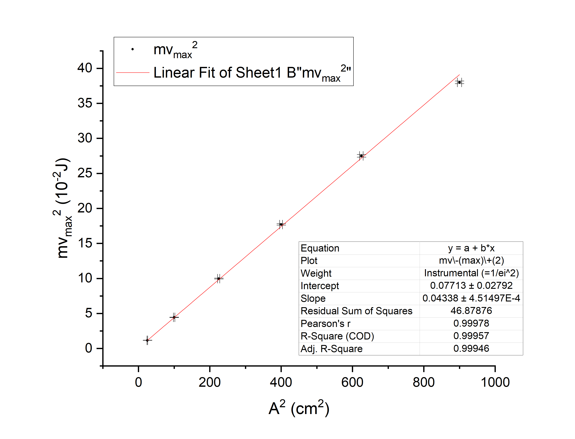 Then, plotting ${{mv}_{max}}^{2}$ vs. $A^{2}$ and applying linear fit yield the slope = (0.043 $±$ 0.001)10-2 J/cm2 and the intercept = (0.080.08)10-2 J.

Figure 10. Graph of ${{mv}_{max}}^{2}$ vs. $A^{2}$

**4.5 Mass Measurement**

The result of measurement of the mass of the series of weights, the cart with different shuttles and springs are shown in Table 11. The total mass of the oscillator in section 4.2 is equal to the sum of the mass of the weights and the mass of the Cart with I-shape shuttle, i.e.,

$M=m+m_{CI}$. (9)

Take $m_{1}$ as an example. $M=m_{1}+m_{CI}=4.74+176.87=181.61±0.01$ g. The total mass is calculated in this way and the results are presented in Table 12.

|  |  |  |
| --- | --- | --- |
|  | $m$ [g] $±$ 0.01 [g] | Cart with I-shape $m_{CI }$ [g] $±$ 0.01 [g] |
| 1 | 4.74 | 176.87 |
| 2 | 9.45 | Cart with U-shape $m_{CU }$ [g] $±$ 0.01 [g] |
| 3 | 14.21 | 191.30 |
| 4 | 19.05 | Mass of springs $m_{spr1\&2 }$ [g] $±$ 0.01 [g] |
| 5 | 23.85 | 21.32 |
| 6 | 28.67 |  |

Table 11. Results of mass measurements

|  |  |  |
| --- | --- | --- |
|  | $m$ [g] $±$ 0.01 [g] | $M$ [g] $±$ 0.01 [g] |
| 1 | 4.74 | 181.61 |
| 2 | 9.45 | 186.32 |
| 3 | 14.21 | 191.08 |
| 4 | 19.05 | 195.92 |
| 5 | 23.85 | 200.72 |
| 6 | 28.67 | 205.54 |

Table 12. Results of calculation of mass of oscillator

**5 Conclusions and Discussion**

According to Hooke’s Laws, $ΔF_{x}$ should be proportional to $Δx$. The results gained in section 4.1 shows that the Pearson’s r equals 1, 1, and 0.99999 respectively. According to the table of correlation coefficient2 we have more than 99.9% confidence to say that they are linearly dependent. However, they have intercept of 0.194, 0.155 and -0.066 respectively, which are not equal to 0. This may be because the spring may not strictly satisfy Hooke’s Law, especially when the deformation is small. $F_{x}$ may be also related to ${Δx}^{3}$. Besides, for spring 1, we had not set the initial position to be within 5.0 ~ 10.0 cm, which may also contribute to such results.

If we calculate $k_{series}$ from $k_{series}={k_{1}k_{2}}/{(k_{1}+k_{2})}$, we obtain $k_{series}= {2.229×2.473}/{(2.229+2.473)}=$ 1.172. Compare this with the measured value of $k_{series}$, the relative difference is ${(1.172-1.169)}/{1.169}=0.256$ 6%. The results are agreeable to each other.

**5.2 Relation Between the Oscillation Period T and the Mass of the Oscillator M**

According to equation (14.12) in *University Physics with Modern Physics*, Young and Freedman, 13th Edition,

$M={(k}/{4π^{2})} T^{2}$.

The results in section 4.2 shows that the Pearson’s r equals to 0.99983, 0.99992, 0.99971. According the table of correlation coefficient3, we have over 99.9% confidence to say that they are linearly dependent. However, the intercepts are still significantly different from 0. This may be because the error is hugely expanded when we extend the line towards the intercept. Also, there is still tiny friction between the object and the air track, which may lead to such a deviation too.

**5.3 Relation Between the Oscillation Period T and the Amplitude A**

The results in section 4.3 shows that the Person’s r equals to 0.6615, which is rather low. We do not have much confidence to say that T and A are linearly dependent. But still, the slope of the linear fit is not significantly different from 0, which implies that T and A are not related to each other, which accords with the conclusion in Chapter 14.2 of *University Physics with Modern Physics*, Young and Freedman, 13th Edition.

**5.4 Relation Between the Maximum Speed and the Amplitude**

The Pearson’s r is equal to 0.99978 and thus we have over 99.9% confidence to say that ${{mv}_{max}}^{2}$ is linearly dependent on $A^{2}$. Calculate k from equation (6),

$k=slope=\left(0.043 ± 0.001\right)×{10}^{-2}J/{{cm}^{2}}=4.3± 0.1 N/m$.

Compared with the result of section 4.1, the two ks measured are greatly different from each other. This may be because the timer is not placed exactly at the equilibrium position, which lead to error in measurement of $v_{max}$ and thus great deviation in the final result.

**6 References**

[1] Exercise 3 – lab manual, Figure. 1

[1, Figure. 2]

[2] Retrieved from

<https://image.baidu.com/search/detail?ct=503316480&z=0&ipn=d&word=%E7%9B%B8%E5%85%B3%E7%B3%BB%E6%95%B0%E8%A1%A8&step_word=&hs=0&pn=9&spn=0&di=40920&pi=0&rn=1&tn=baiduimagedetail&is=0%2C0&istype=0&ie=utf-8&oe=utf-8&in=&cl=2&lm=-1&st=undefined&cs=3959175027%2C2278839679&os=2521786237%2C3405637549&simid=0%2C0&adpicid=0&lpn=0&ln=761&fr=&fmq=1561946104958_R&fm=&ic=undefined&s=undefined&hd=undefined&latest=undefined&copyright=undefined&se=&sme=&tab=0&width=undefined&height=undefined&face=undefined&ist=&jit=&cg=&bdtype=0&oriquery=&objurl=http%3A%2F%2Fpic.chinawenben.com%2Fupload%2F1_aaxjjjjbbrqx7br8d7v8kxjj.jpg&fromurl=ippr_z2C%24qAzdH3FAzdH3Fooo_z%26e3Bvitgw141_z%26e3Bv54AzdH3FutsjAzdH3Fvmmj5x5zffprrnvmppmmm66v_8_z%26e3Bip4s&gsm=0&rpstart=0&rpnum=0&islist=&querylist=&force=undefined>

**A Measurement uncertainty analysis**

**A.1 Uncertainty of Mass Measurement**

Since mass is measured for only one single time, its uncertainty is $u_{m}=Δ_{m,B}=0.01$ g. For $M=m+m_{CI}$, its uncertainty $u_{M}=\sqrt{{u_{m}}^{2}+{u_{m_{CI}}}^{2}}=\sqrt{{0.01}^{2}+{0.01}^{2}}≈0.01$ g.

**A.2 Uncertainty of Measurements of ${ △F}_{x}$ (mg)**

$mg$ is measured indirectly by first measuring m and then multiplying it by g. By the propagation of uncertainty formula, the uncertainty of $mg$ is

$u_{mg}={g×u}_{m}=9.794×0.01×{10}^{-3}=9.79×{10}^{-5}=1×{10}^{-4}$ N.

**A.3 Uncertainty of Measurements of $ΔL$**

$ΔL$ is calculated from $L-L_{0}$. Applying uncertainty propagation formula, its uncertainty is

$u_{ΔL}=\sqrt{{u_{L}}^{2}+{u_{L_{0}}}^{2}}=\sqrt{{0.01}^{2}+{0.01}^{2}}≈0.01$ cm.

**A.4 Uncertainty of Measurements of Spring Constant**

Since the spring constant is read off from the slope of the figure directly, its uncertainty is exactly that of the slope, which is calculated by Origin.

**A.5 Uncertainty of Measurements of Period of Oscillation**

The uncertainty of ten periods of oscillation is $u_{ten periods}=Δ_{ten periods, B}=0.1$ ms. By applying the uncertainty propagation formula,

$u_{T}=\frac{1}{10}u_{ten periods}=0.01$ ms.

$u_{T^{2}}=2Tu_{T}≈30$ ms.

**A.6 Uncertainty of Linear fit of M vs. T2**

The uncertainty of the slope and intercept of linear fit of M vs. T2 is calculated in the fitting procedure using Origin.

**A.7 Uncertainty of Linear fit of T vs. A**

The uncertainty of the slope and intercept of linear fit of T vs. A is calculated in the fitting procedure using Origin.

**A.8 Uncertainty of Measurement of $Δx$**

$Δx$ is calculated from equation (7). Applying uncertainty propagation formula, its uncertainty is

$u_{Δx,B}=\frac{\sqrt{{u_{x_{in}}}^{2}+{u_{x_{out}}}^{2}}}{2}=\frac{\sqrt{{0.02}^{2}+{0.02}^{2}}}{2}≈0.0141$ mm.

$u_{Δx,A}=\sqrt{\frac{1}{n(n-1)}\sum_{i=1}^{n}{{({Δx}_{i}-\overline{Δx})}^{2}}}t_{0.95}=\frac{1}{300}×4.30≈0.0143$ mm (n = 3).

$u_{Δx}=\sqrt{{u_{Δx,A}}^{2}+{u_{Δx,B}}^{2}}≈0.02$ mm.

**A.9 Uncertainty of *A2***

Substitute the values of *A*, the uncertainty of *A2* is derived (Table 13).

|  |  |
| --- | --- |
| [cm] 0.1[cm] | [cm2] |
| 5.0 | 1 |
| 10.0 | 2 |
| 15.0 | 3 |
| 20.0 | 4 |
| 25.0 | 5 |
| 30.0 | 6 |

Table 13. Uncertainty of *A2*

**A.10 Uncertainty of Measurement of $m{v_{max}}^{2}$ ($m{(\frac{Δx}{Δt})}^{2}$)**

$$u_{{m\left(\frac{Δx}{Δt}\right)}^{2}}=\sqrt{{\left(\frac{∂{m\left(\frac{Δx}{Δt}\right)}^{2}}{∂m}\right)}^{2}{u_{m}}^{2}+{\left(\frac{∂{m\left(\frac{Δx}{Δt}\right)}^{2}}{∂Δx}\right)}^{2}{u_{Δx}}^{2}+{\left(\frac{∂{m\left(\frac{Δx}{Δt}\right)}^{2}}{∂Δt}\right)}^{2}{u_{Δt}}^{2}}=\sqrt{{\left(\frac{Δx}{Δt}\right)}^{4}{u_{m}}^{2}+{(\frac{2m}{{Δt}^{2}}Δx)}^{2}{u_{Δx}}^{2}+{(\frac{\left(-2\right)m{Δx}^{2}}{{Δt}^{3}})}^{2}{u_{Δt}}^{2}}$$

The uncertainty of each data is calculated using the above formula and the results rounded are presented in the following table (Table 14)

|  |  |
| --- | --- |
| $△t$ [ms] $±$ 0.01 [ms] | $u_{{m\left(\frac{Δx}{Δt}\right)}^{2}}$ [J] |
| 40.85 | 0.00007 |
| 20.86 | 0.0003 |
| 13.92 | 0.0006 |
| 10.46 | 0.001 |
| 8.38 | 0.002 |
| 7.13  Table 14. Uncertainty of ${m\left(\frac{Δx}{Δt}\right)}^{2}$ | 0.002 |

**B Datasheet**