Assessing the Economic Impacts of SNAP Policy Changes in Michigan Final Report
Holly Wang, David Ortega, Jiaming Zhang
Department of Agricultural, Food, and Resource Economics, Michigan State University
February 21, 2026
Executive Summary
This final report summarizes MAPPR-supported analysis of Michigan SNAP/FAP dynamics using a county-month panel (2014–2025) and policy-focused empirical designs. We separate three drivers of caseload and spending changes: (i) rules and compliance costs tied to ABAWD enforcement and waiver status, (ii) local need measured by county unemployment shocks, and (iii) benefit generosity, highlighted by Emergency Allotments (EA) termination.
Key findings (policy-relevant magnitudes):
• ABAWD enforcement reduces participation. In the main stacked event-study, participation falls by about -4.2% in months +1 to +3 (ATT = -0.0431 log points; 95% CI: -5.5% to -2.9%), and by about -6.5% over months +1 to +6 (ATT = -0.0674).
• Impacts are concentrated among adults. The adult–child gap is near zero before enforcement and reaches about -9.2% by month +6 (DDD = -0.0962 log points).
• Unemployment shocks increase SNAP participation. The cumulative 0–6 month response is approximately 0.56% for a 1 percentage-point YoY unemployment shock (cumulative log response ≈ 0.00559).
• EA termination produced a large benefit-intensity break. Average benefits per person drop by $111 in event month 0 and remain about $104 lower on average over months 0–12.
• 2026 OBBBA scenario implies a statewide contraction. The county-aggregated scenario projects baseline participants falling from 689,259 to 649,146 (Δ = -40,113, -5.82%). The largest absolute decreases occur in Wayne, Macomb, Oakland, Genesee, and Kent.
Forecasts are scenario-based (not point forecasts). Under the current scenario design, percent changes are similar across counties; county rankings primarily reflect baseline caseload scale.

1. Introduction
SNAP is Michigan’s primary nutrition safety-net program. Changes in caseload and spending can reflect (i) labor-market conditions, (ii) rule and enforcement environments, and (iii) benefit generosity. Because these forces often move together, simple trend interpretation can be misleading. This report uses a unified county-month framework to separate these channels and deliver policy-ready evidence for near-term planning, emphasizing heterogeneity across counties.

2. Policy Context (2015–2026)
Three milestones organize the empirical windows: (1) October 2021 Thrifty Food Plan (TFP) update (baseline benefit shift); (2) March 2023 EA termination (statewide generosity break); and (3) 2026 implementation assumptions used in the forecast module under OBBBA-related scenarios.

3. Data and Measures
The analysis uses Michigan county-month administrative SNAP/FAP data (2014–2025): cases, recipients, payments, and (where available) adult and child recipients. We construct recipients per case (composition proxy), payments per recipient (per-person intensity), and payments per case (per-case intensity). County unemployment (LAUS) and policy timing/exposure indicators are merged to support the channel analyses. A state-level descriptive series is constructed using full-coverage months (83 counties); months with partial county coverage are excluded from statewide level charts to avoid mechanical level artifacts.

4. Findings and Interpretation

4.1 Extensive margin: coverage and participation (cases/recipients)
ABAWD enforcement is associated with meaningful short-run participation declines. In months +1 to +3 after enforcement, the estimated average decline is about -4.2% (95% CI: -5.5% to -2.9%), with larger average declines over months +1 to +6 (about -6.5%). Separately, unemployment shocks increase participation both on impact and with delay; cumulatively, a 1pp YoY unemployment shock raises participation by about 0.56% over six months.

4.2 Composition: who adjusts (adult vs. child; recipients per case)
Reductions following ABAWD enforcement are concentrated more among adults than children. The adult–child difference is approximately flat in the pre-period and becomes increasingly negative after enforcement, reaching roughly -9.2% by month +6. This pattern is consistent with ABAWD-targeted mechanisms operating through adults most directly exposed to time limits. Recipients-per-case and related measures are used as supporting indicators of within-case composition adjustments.

4.3 Intensive margin: benefit intensity and spending
EA termination generates a clear, policy-driven break in benefit intensity. Average benefits per person fall immediately by about $111 and remain about $104 lower on average over the subsequent 12 months. Because the generosity shock is statewide, participation responses are interpreted cautiously in the main text and are presented as differential patterns (e.g., comparing higher- vs. lower-intensity counties) rather than a single-statewide causal level effect.

4.4 2026 scenario projections: where impacts are largest
To support planning, we translate estimated responses into scenario-based 2026 projections under OBBBA implementation assumptions. In the statewide aggregate, projected participants decline from 689,259 to 649,146 (Δ = -40,113, -5.82%). The largest absolute projected declines are in high-volume counties (Wayne, Macomb, Oakland, Genesee, Kent). Given the current scenario design applies a common percent shock across counties, rankings primarily reflect baseline scale and should be interpreted as an operations-volume prioritization tool.

5. Policy Implications
Immediate (0–6 months):
• Target outreach and recertification support toward working-age adults in counties experiencing ABAWD enforcement exposure changes.
• Scale Employment & Training (E&T) navigation capacity in high-volume counties to reduce procedural drop-offs and support compliance.
Planning for 2026 implementation:
• Use scenario projections to prioritize staffing and outreach in counties with the largest absolute projected caseload changes (beginning with Wayne, Macomb, Oakland, Genesee, and Kent).
• In budgeting, account for both extensive-margin changes (participants) and the sustained post-EA lower benefit intensity (payments per recipient).
• Maintain downturn contingency plans: unemployment still increases participation and can offset or compound rule-driven effects.

6. Limitations
County-month administrative data do not observe individual applications, entry/exit, or direct work-requirement compliance. EA termination is a statewide shock, limiting causal identification for participation level effects within Michigan; we therefore emphasize clean measurement of benefit-intensity changes and interpret participation responses cautiously. Forecasts are scenario-based and depend on OBBBA implementation assumptions; under the current scenario design, county rankings largely reflect baseline caseload scale.

Appendix A. Technical Notes (methods and detailed estimates)
A1. ABAWD event-study (stacked design): detailed estimates
Main stacked ATT, post months +1 to +3: -0.0431 (SE 0.00684; 95% CI [-0.0565, -0.0297]; p<0.001).
Main stacked ATT, post months +1 to +6: -0.0674 (SE 0.00692; p<0.001).
Wald pretrend test p-value (main): 0.151.
A2. Adult vs. child DDD event-study: selected post estimates
Event month 0: -0.0175 (SE 0.00303)
Month +3: -0.0415 (SE 0.00540)
Month +6: -0.0962 (SE 0.00829)
A3. Unemployment distributed lags (YoY shock): selected coefficients
Lag 0: 0.00275 (SE 0.000516; p<0.001)
Lag 4: 0.000626 (SE 0.000243; p=0.012)
Lag 6: 0.00180 (SE 0.000482; p<0.001)
Cumulative lag sum (0–6): 0.00559 (≈ 0.56% per 1pp YoY unemployment shock).
A4. EA benefit intensity event-study: selected estimates
Average benefit per person, event month 0: -110.54 (SE 0.95).
Average post (0–12) estimate: -104.48.
A5. Forecast scenario outputs: summary and validation
Baseline aggregate: 689,258.83; OBBBA scenario aggregate: 649,145.76; difference: -40,113.07 (-5.82%).
Backtest (log): RMSE 0.2097; MAE 0.2006; N=498.
Note: current scenario output applies a common log change across counties; percent changes are nearly uniform. County ranking mainly reflects baseline scale.

Figures
Figure 1. ABAWD main event-study.
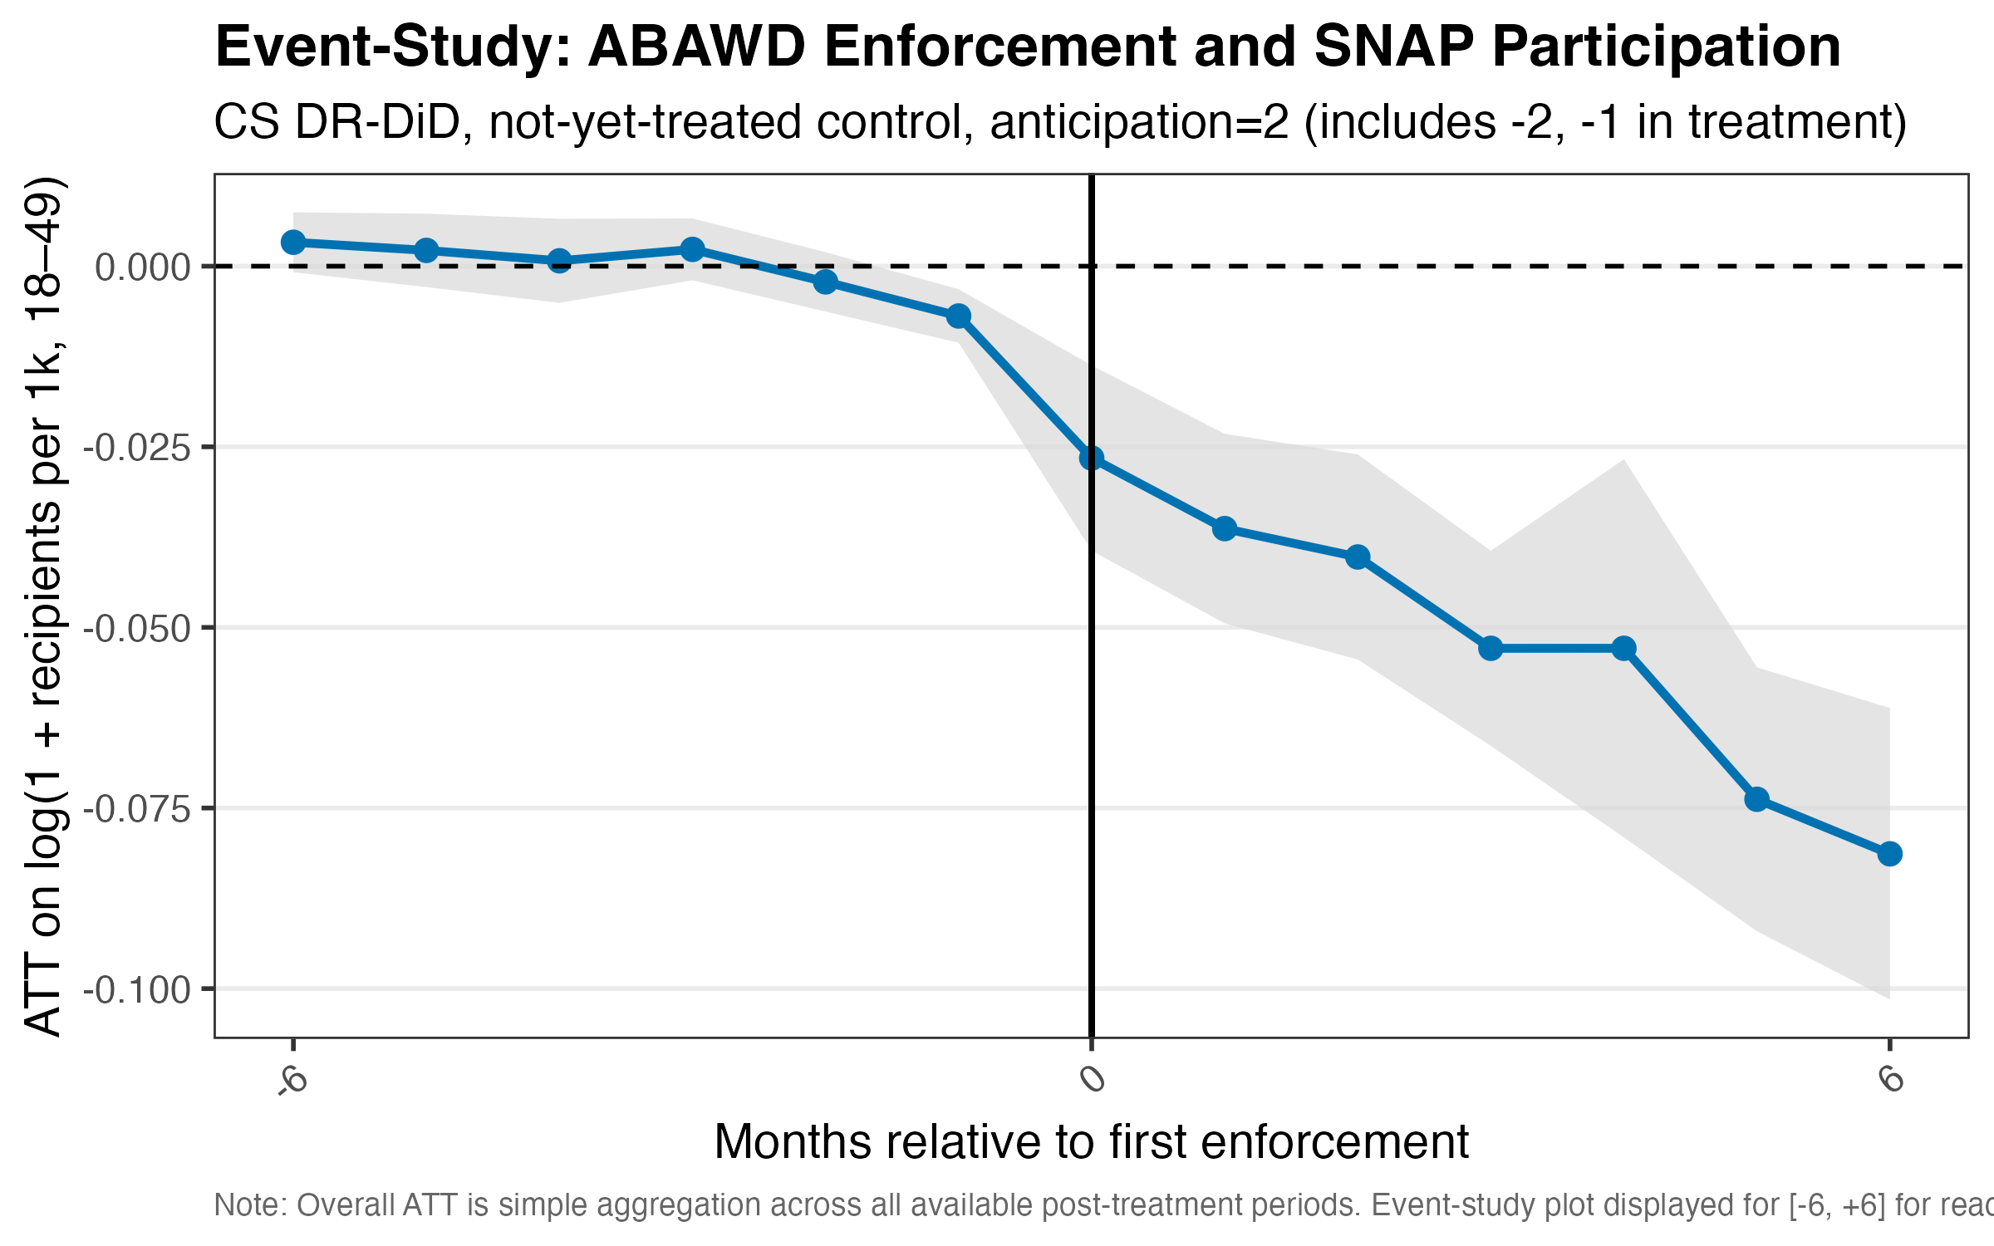
Figure 2. ABAWD DDD event-study (adult vs. child differential).
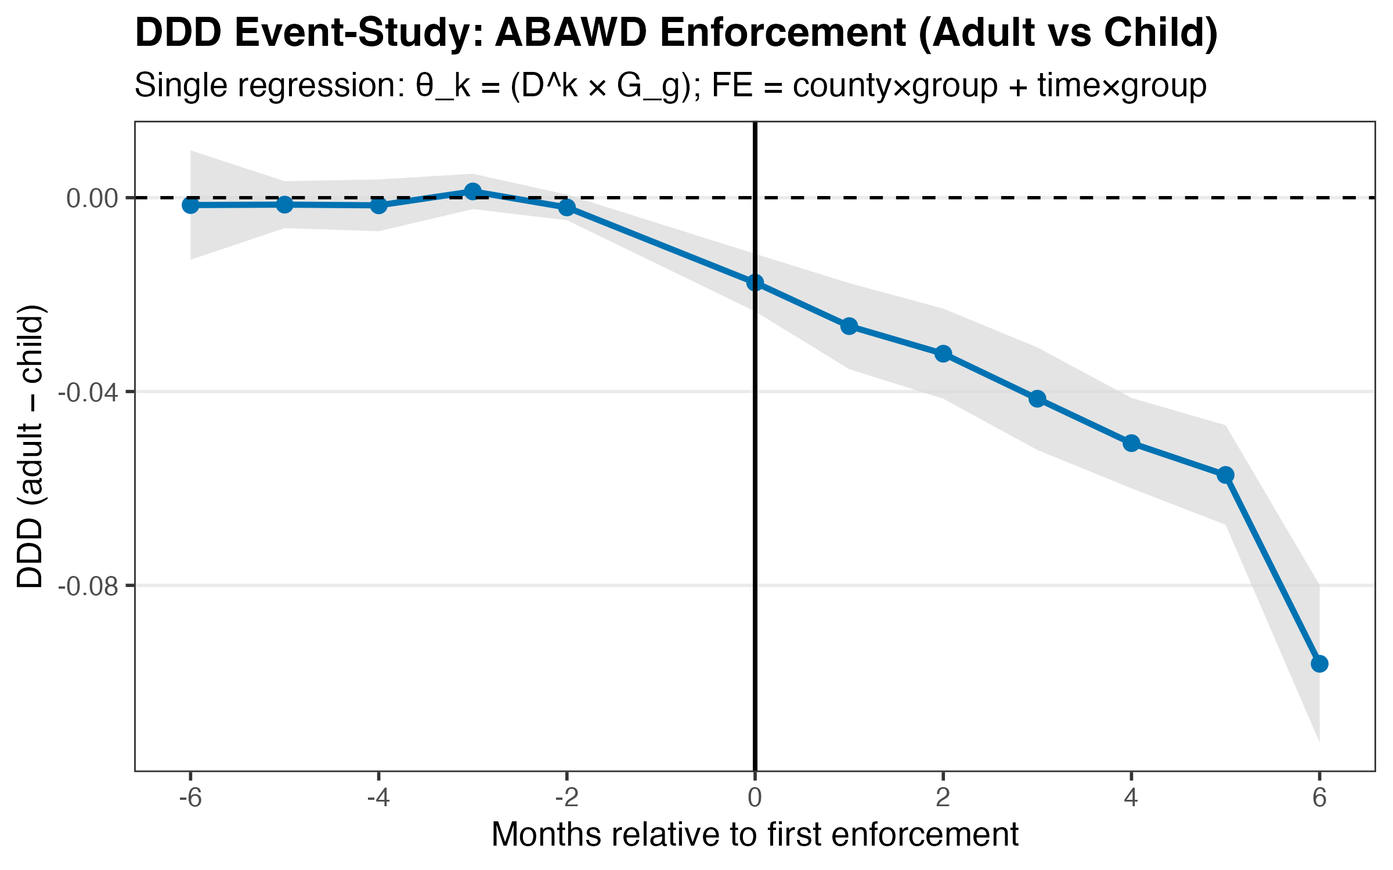
Figure 3. Distributed-lag unemployment response.
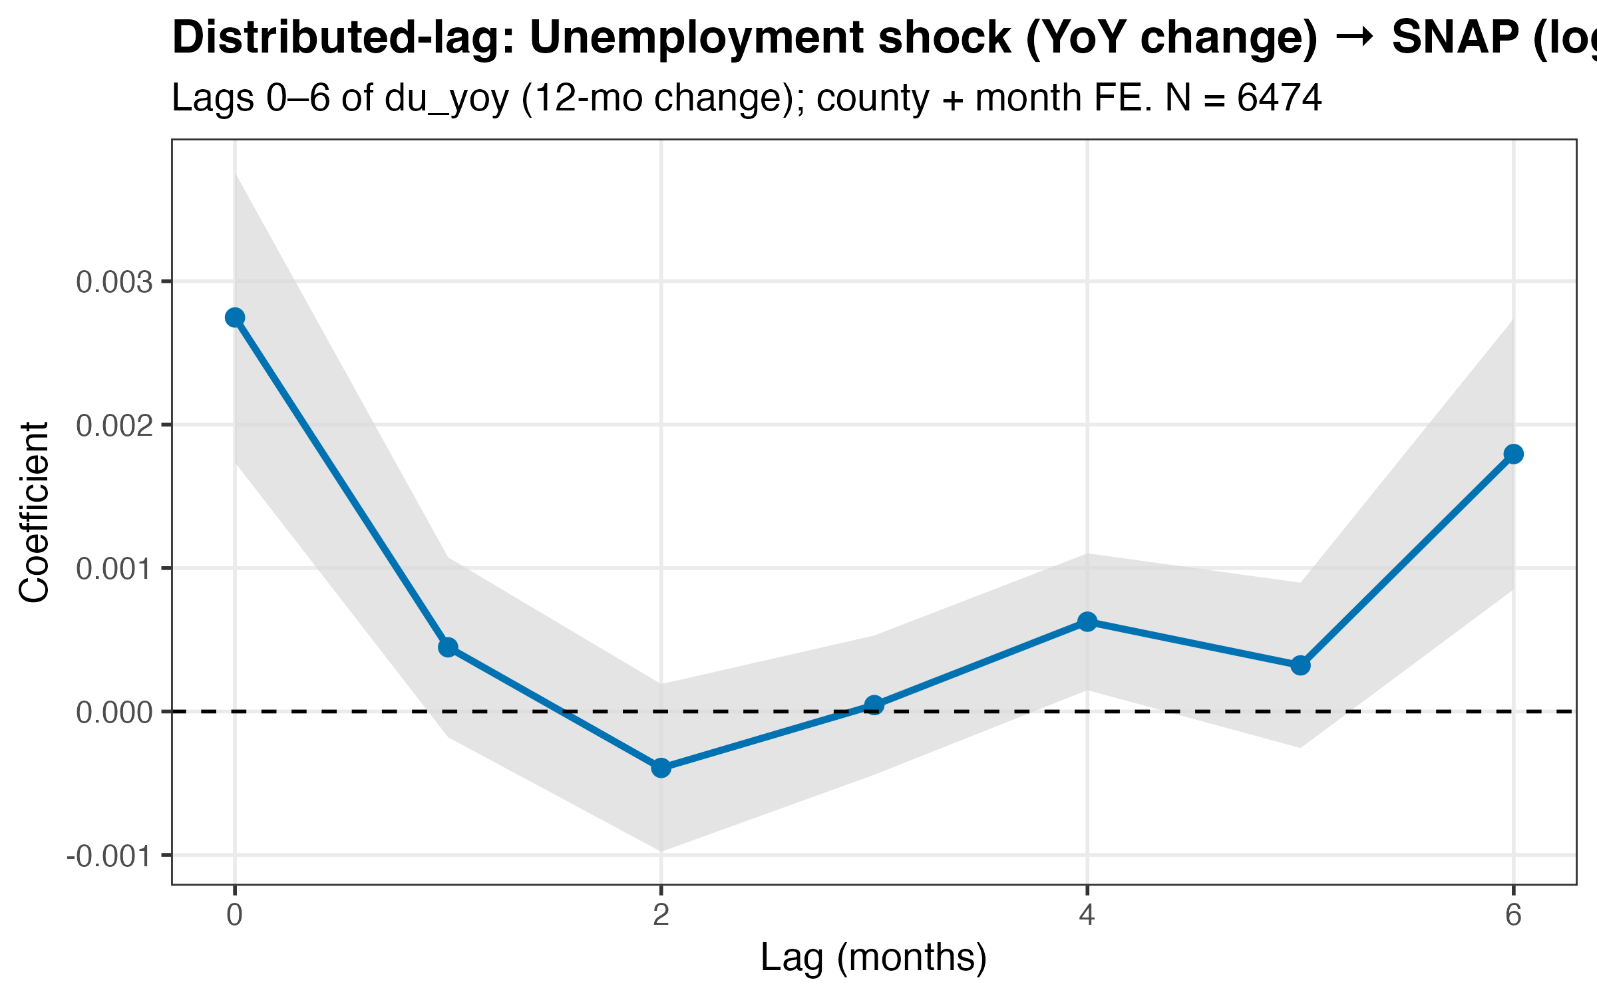
Figure 4. EA average benefit per person event-study.
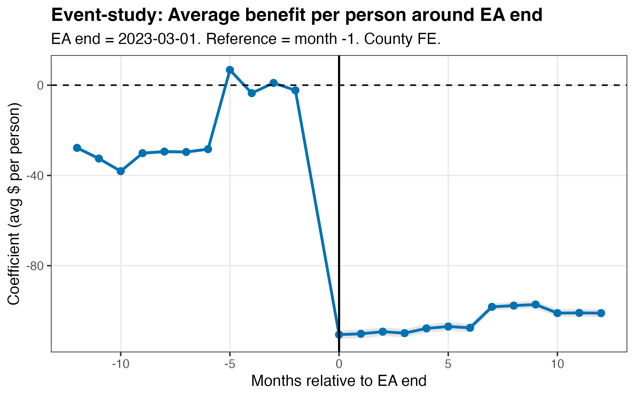
Figure 5. 2026 OBBBA scenario distribution.
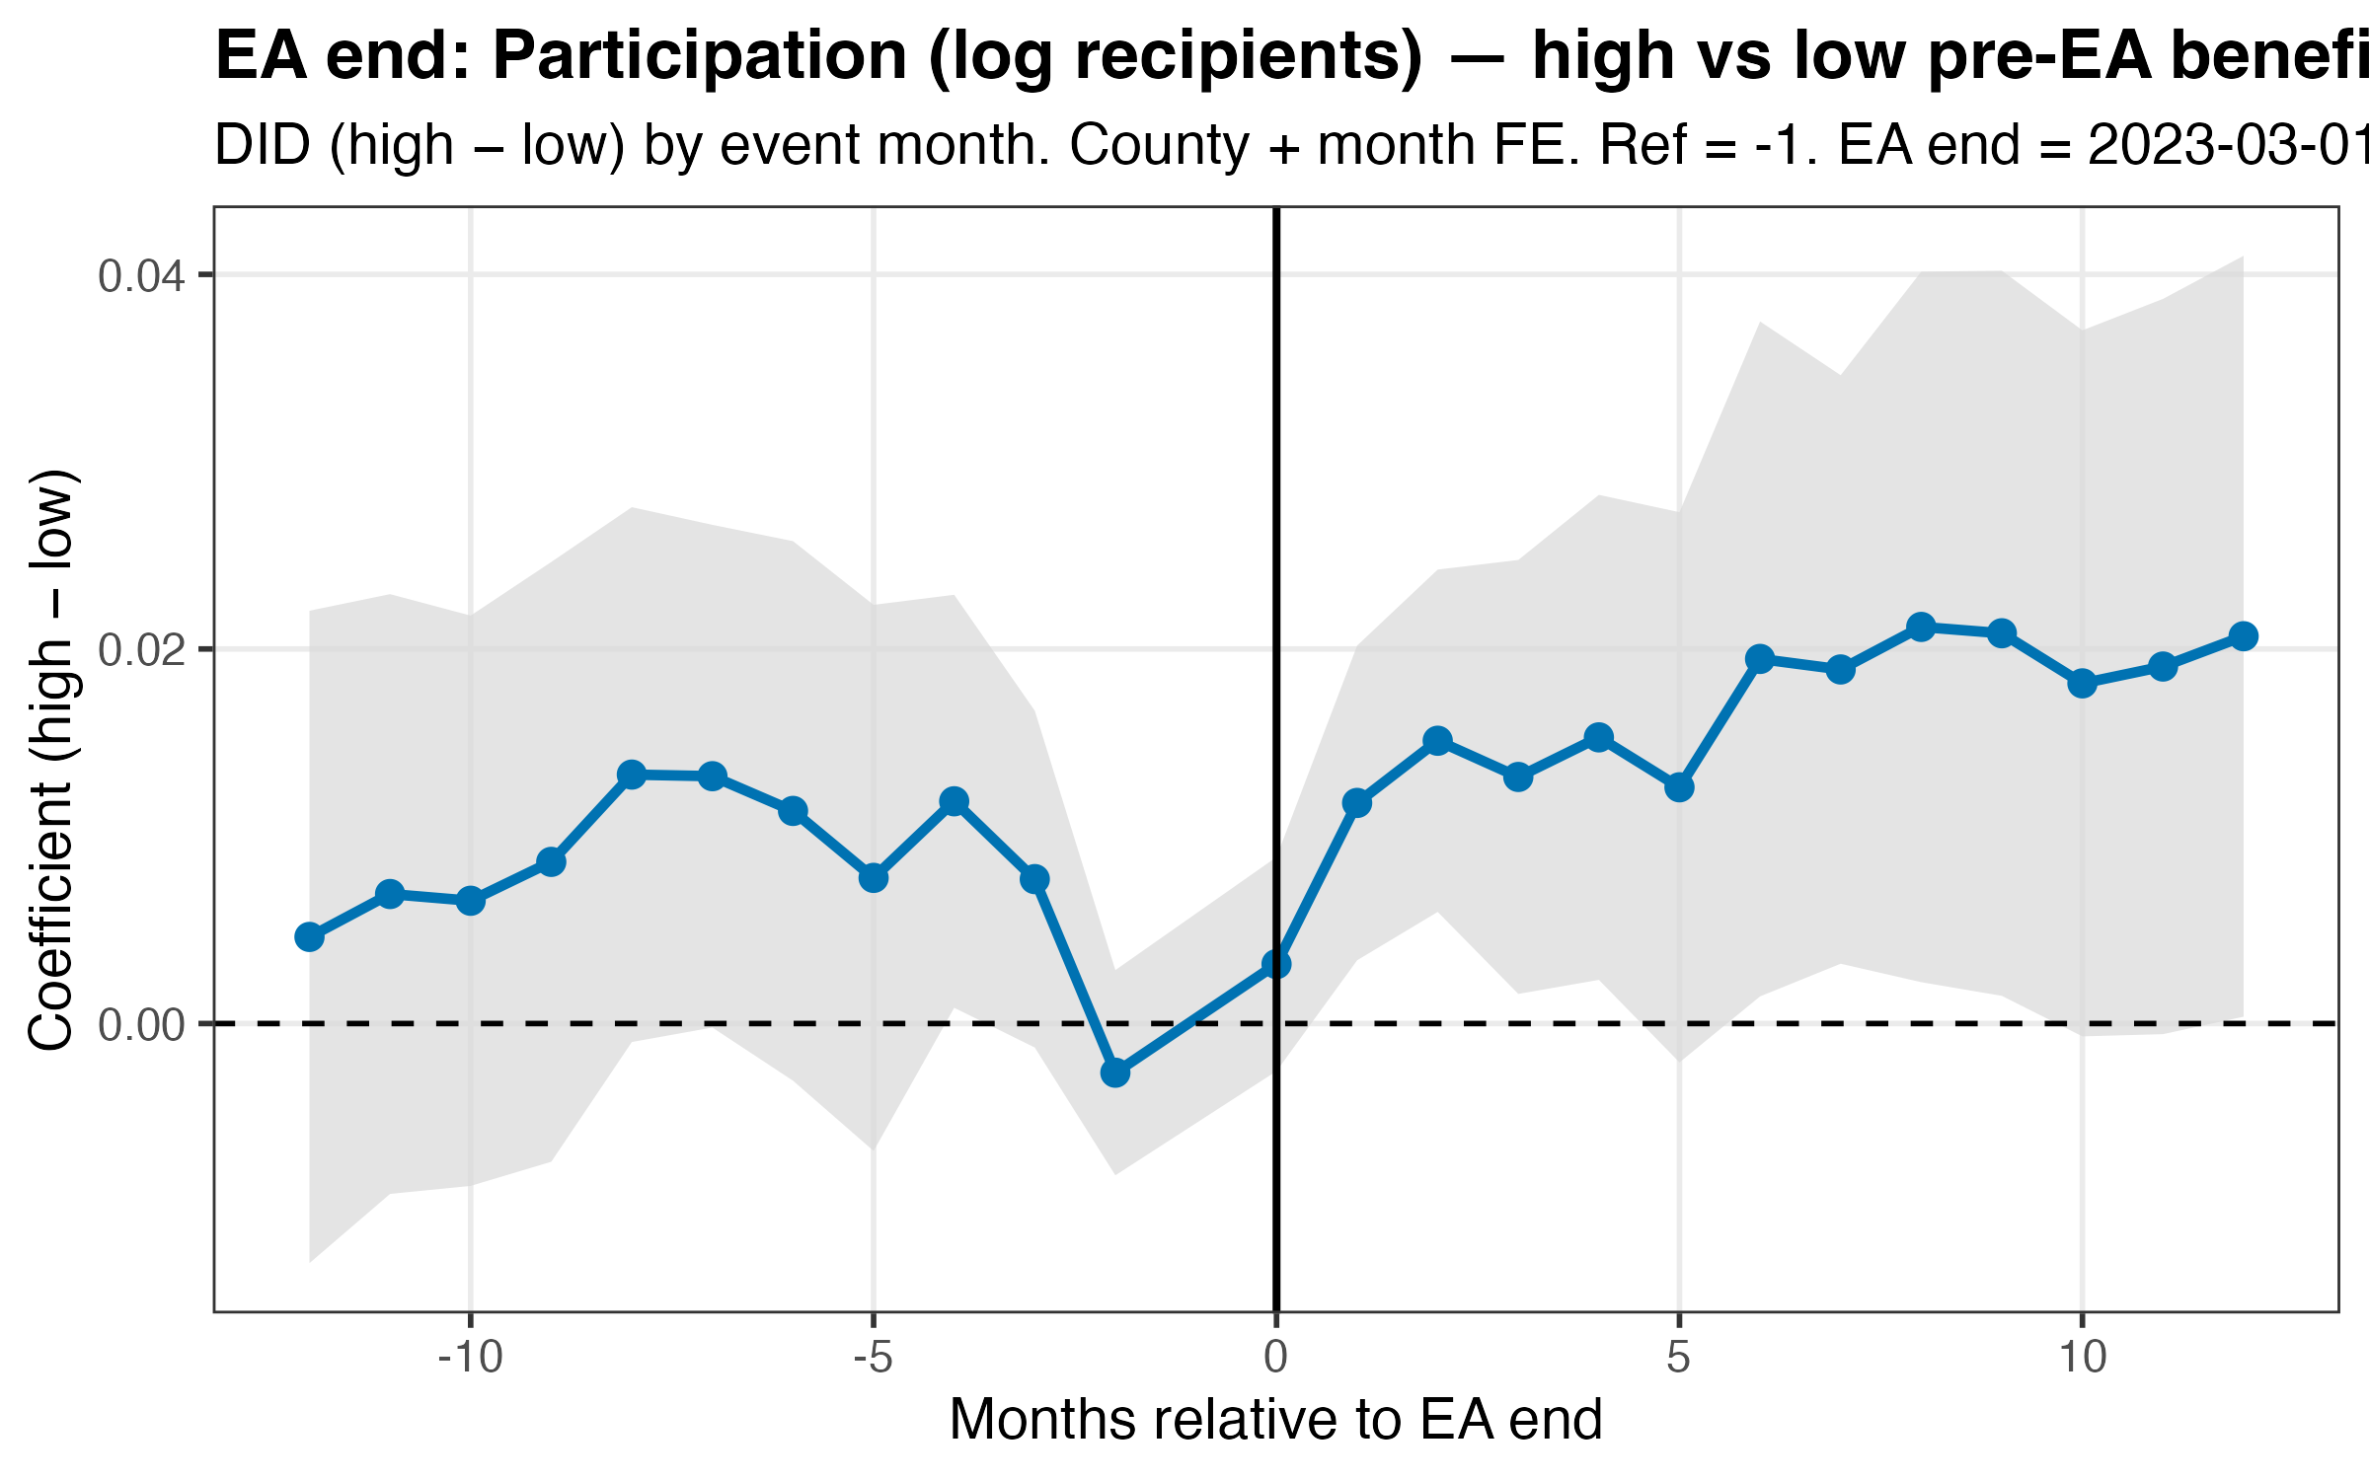

References
U.S. Department of Agriculture, Food and Nutrition Service. (2026, January 30). SNAP Data Tables (Participation, Households, Benefits, and Average Monthly Benefit per Person & Household).
U.S. Department of Agriculture. (2023, February 8). SNAP Emergency Allotments are Ending.
U.S. Department of Agriculture, Food and Nutrition Service. (2025, September 4). SNAP Provisions of the One Big Beautiful Bill Act of 2025 (Information / Implementation Memorandum landing page).
U.S. Department of Agriculture, Food and Nutrition Service. (2025, October 3). ABAWD Waivers — Implementation Memorandum (OBBBA / P.L. 119-21).
U.S. Department of Agriculture, Food and Nutrition Service. (2025, October 3). ABAWD Exceptions — Implementation Memorandum (OBBBA / P.L. 119-21).
U.S. Department of Agriculture, Food and Nutrition Service. (2025, December 9). One Big Beautiful Bill Act of 2025 (OBBBA) — Documents & Resources hub (Section 10102 SNAP Work Requirements and related memoranda).
U.S. Department of Agriculture, Food and Nutrition Service. (2025, July 9). SNAP Waiver Database (Certification Policy Waivers).
U.S. Department of Agriculture, Food and Nutrition Service. (2026). SNAP Food Restriction Waivers (Approved waivers and target implementation dates).
U.S. Bureau of Labor Statistics. (n.d.). Local Area Unemployment Statistics (LAUS).
U.S. Bureau of Labor Statistics. (n.d.). Consumer Price Index (CPI-U): Midwest Region overview tables.
U.S. House of Representatives, Committee on Rules. (2025, May 18). Rules Committee Print / legislative text for the One Big Beautiful Bill Act of 2025 (Subtitle A—Nutrition).

