Assessing the Economic Impacts of SNAP Policy Changes in Michigan
Final Report
Holly Wang, David Ortega, Jiaming Zhang
Department of Agricultural, Food, and Resource Economics, Michigan State University

Executive Summary
This final report is primarily an operational planning and prioritization document for Michigan SNAP/FAP in 2026. Using a county-month administrative panel (2014-2025), it first summarizes the main policy and economic channels behind recent changes in caseloads and spending and then translates those findings into county-level planning implications for implementation, outreach, staffing, and budget monitoring.
- ABAWD enforcement exposure (rules/compliance channel)
- County unemployment shocks (economic need channel)
- EA termination (benefit generosity channel)

Bottom-line findings
- Recent SNAP/FAP changes reflect multiple channels rather than a single trend, including rules/compliance exposure, local labor-market conditions, and benefit-policy changes.
- Adult participation appears more sensitive than child participation to enforcement-related transitions, which raises the importance of recertification and compliance support for adults.
- Local unemployment shocks remain a meaningful source of caseload pressure, so recession contingency capacity should remain part of county planning.
- EA termination sharply reduced benefit intensity, indicating that budgeting and client-support pressures can move even when participation adjusts more gradually.
- The 2026 scenario module indicates statewide contraction under the modeled assumptions, with the largest absolute operational volume impacts concentrated in high-volume counties.

Planning implications
- Focus implementation capacity where absolute volume risk is largest (starting with Wayne, Macomb, Oakland, Genesee, Kent).
- Plan staffing and budget across both margins: participation counts and per-recipient benefit intensity.
- Maintain recession contingency capacity; labor-market shocks remain material to caseload pressure.

1. Purpose and Policy Questions
This report supports state and county planning for SNAP/FAP operations under evolving federal policy and economic conditions. The goal is not only to estimate average effects, but also to identify which policy channels matter for different margins (participation, composition, and benefit intensity) and where implementation risk is likely to be largest in Michigan.
Primary questions:
- How much of recent SNAP movement is policy/enforcement versus economic need?
- How large and persistent is the EA-related benefit-intensity break?
- Where should 2026 implementation and outreach be prioritized?

2. Data, Measures, and Analytic Approach
This report uses a Michigan county-month SNAP/FAP administrative panel (2014-2025) covering cases, recipients, and payments, with adult and child recipient counts where available. From these data, the report tracks participation volume, recipient composition, and benefit intensity, and combines them with county unemployment (LAUS) and policy timing indicators.
The analysis separates three operational channels behind recent changes in caseloads and spending: ABAWD-related rules/compliance effects, labor-market need shocks, and the EA termination benefit-intensity break. Channel-specific empirical estimates are used as supporting evidence for the report’s main purpose: 2026 operational planning, county prioritization, and implementation risk management.

3. Context: Statewide Trend Evidence

3.1 Caseload and recipient trajectory
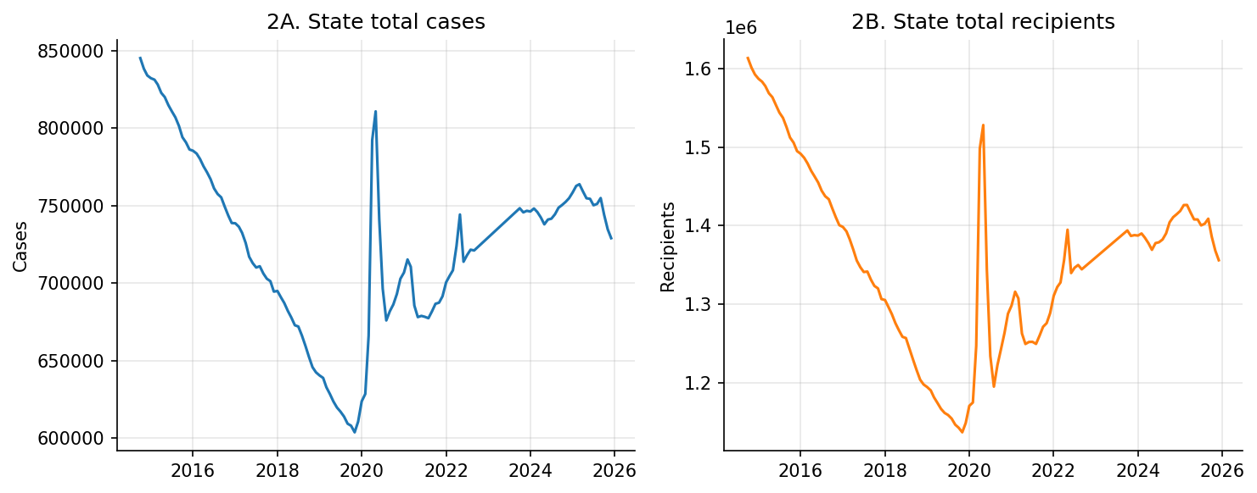
Figure 1. State total cases and recipients
Figure 1 shows the broad statewide caseload cycle. Total cases and recipients decline before 2020, rise sharply during the pandemic period, and remain above the 2019 trough even after partial normalization. The two series move closely but not perfectly, which suggests that household composition and recipients-per-case dynamics also matter. This statewide pattern provides the context for the channel-based analysis in later sections, where enforcement changes, macroeconomic need, and benefit-policy shifts are treated as distinct drivers of program outcomes.

3.2 Spending and per-case intensity
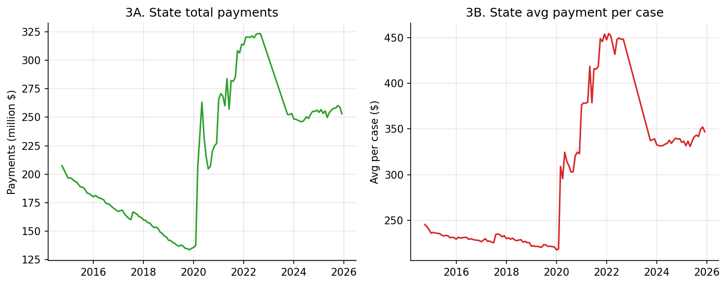
Figure 2. State total payments and average payment per case
Figure 2 shows that spending dynamics are not simply a mirror of caseload counts. Total payments and average payment per case both increase strongly during the emergency period and then partially normalize, but they do not move at the same pace throughout the period. This divergence indicates that operational workload and budget pressure should be monitored as related but distinct margins. It also motivates the report's separate treatment of participation effects and benefit-intensity effects in the findings section.

3.3 Scale-intensity decomposition (summary)
To keep the main report focused on decision-relevant findings, the scale-intensity decomposition is summarized in text rather than shown as a separate figure. Statewide payment changes reflect both caseload scale and benefit intensity, and the intensity component shifts sharply around the EA policy break. This supports the budgeting interpretation developed in the EA event-study section.

4. Summary of Recent Drivers (Evidence for Planning)
This section summarizes the empirical evidence used to inform the 2026 planning scenario. The goal is to identify which recent changes mainly affect participation volumes versus benefit intensity, and to translate those signals into operational planning implications. To keep the main report focused on planning, technical figures and estimation details are not presented in the main text.

4.1 Rules and compliance channel (ABAWD exposure)
Evidence from county exposure transitions indicates that ABAWD-related enforcement changes are associated with participation declines that build over several months rather than occurring only in the first month.
The pattern is concentrated in adult outcomes and is consistent with compliance, reporting, and recertification frictions. For planning purposes, this channel should be treated as an adult-focused implementation and outreach risk, especially in high-volume counties where avoidable exits can generate larger operational effects.

4.2 Economic need channel (county unemployment shocks)
Evidence from county labor-market variation indicates that unemployment shocks remain a meaningful driver of SNAP participation in Michigan. Participation pressure rises when local labor-market conditions deteriorate, with effects that can persist beyond the initial month.
For planning purposes, macroeconomic deterioration should be monitored as a separate demand channel rather than interpreted only through policy changes. This supports maintaining recession contingency capacity and monthly labor-market monitoring in county operations.

4.3 Benefit generosity channel (EA termination)
Evidence around the EA termination indicates a large and persistent reduction in average benefit per recipient. The strongest signal is on benefit intensity, which directly affects payment amounts and purchasing power.
For planning purposes, this channel matters primarily for budgeting and client-support pressure. Agencies should track benefit-intensity indicators alongside caseload counts because spending compression and workload changes may move on different timelines.

5. 2026 Planning Scenario and County Prioritization
This is the core forward-looking section of the report. It translates the summarized evidence on recent drivers into a 2026 operational planning scenario for prioritizing outreach, staffing, and implementation sequencing. The scenario should be used as a planning and prioritization tool rather than as a precise forecast of realized county outcomes.
Statewide summary:
- Baseline aggregate recipients: about 689,259
- Scenario aggregate recipients: about 649,146
- Net change: about -40,113 recipients (approximately -5.8%)
Largest absolute projected declines:
- Wayne (-12,665)
- Macomb (-3,166)
- Oakland (-2,672)
- Genesee (-2,478)
- Kent (-1,825)
The county ranking is intended for workload prioritization and implementation sequencing. Because the current scenario applies near-common proportional adjustments across counties, the largest absolute projected declines are concentrated in the largest baseline counties. Agencies should use this ranking to allocate capacity first, then refine county assumptions as new administrative and labor-market information becomes available.

6. Recommended Actions for Agencies

6.1 Immediate actions (0-6 months)
- Prioritize adult-focused recertification and compliance support in high-volume counties, especially Wayne, Macomb, Oakland, Genesee, and Kent.
- Expand E&T and case-navigation support capacity where participation declines are most likely to reflect administrative friction rather than underlying ineligibility.
- Use dual monitoring triggers for field operations by tracking both participation counts and benefit-intensity indicators, since workload pressure and payment compression may move on different timelines.

6.2 Near-term actions (6-18 months)
- Integrate county priority rankings into implementation planning for staff deployment, outreach sequencing, and local coordination.
- Establish monthly monitoring around three operational indicators: recipients, payments per recipient, and county unemployment conditions.
- Maintain downturn contingency protocols so agencies can absorb policy-driven and macroeconomic caseload pressure at the same time.

7. Limits and Risk Notes
- Administrative panel data do not directly measure individual application/compliance behavior.
- Because EA termination is a statewide policy break, the strongest interpretation in this report is on benefit intensity outcomes (especially average payment per recipient). Participation patterns around the EA end remain informative but may also reflect concurrent statewide factors.
- The 2026 scenario applies near-common proportional adjustments across counties and is intended for operational prioritization, not precise county-level prediction. Agencies should update local assumptions as new administrative and labor-market information arrives.

References
U.S. Department of Agriculture, Food and Nutrition Service. (2026, January 30). SNAP Data Tables (Participation, Households, Benefits, and Average Monthly Benefit per Person & Household).
U.S. Department of Agriculture. (2023, February 8). SNAP Emergency Allotments are Ending.
U.S. Department of Agriculture, Food and Nutrition Service. (2025, September 4). SNAP Provisions of the One Big Beautiful Bill Act of 2025 (Information / Implementation Memorandum landing page).
U.S. Department of Agriculture, Food and Nutrition Service. (2025, October 3). ABAWD Waivers — Implementation Memorandum (OBBBA / P.L. 119-21).
U.S. Department of Agriculture, Food and Nutrition Service. (2025, October 3). ABAWD Exceptions — Implementation Memorandum (OBBBA / P.L. 119-21).
U.S. Department of Agriculture, Food and Nutrition Service. (2025, December 9). One Big Beautiful Bill Act of 2025 (OBBBA) — Documents & Resources hub (Section 10102 SNAP Work Requirements and related memoranda).
U.S. Department of Agriculture, Food and Nutrition Service. (2025, July 9). SNAP Waiver Database (Certification Policy Waivers).
U.S. Department of Agriculture, Food and Nutrition Service. (2026). SNAP Food Restriction Waivers (Approved waivers and target implementation dates).
U.S. Bureau of Labor Statistics. (n.d.). Local Area Unemployment Statistics (LAUS).
U.S. Bureau of Labor Statistics. (n.d.). Consumer Price Index (CPI-U): Midwest Region overview tables.
U.S. House of Representatives, Committee on Rules. (2025, May 18). Rules Committee Print / legislative text for the One Big Beautiful Bill Act of 2025 (Subtitle A—Nutrition).

