  - COMPLETED SPATIAL REASSESSMENT • BIOLOGICAL REPORT

Changing fibroblast environments and cardiomyocyte development after birth
P0–P21 mouse-heart snRNA-seq and Xenium analysis

Central message
Fibroblast patterns change as the heart develops, and a Col8a1-associated component remains more often near arteries. These differences do not establish one general fibroblast effect on CM maturation. The refit instead identifies specific structural and metabolic settings to test, with the strongest corrected association concerning P14 Ankrd1 CMs near the endocardial environment.
The revised fibroblast assignments are now included in newly fitted CM-neighbor models. Whole-cell, inner-cell and deposited RNA, smaller neighborhoods and shared-boundary comparisons distinguish stronger observations from tentative candidates.
Six main figure plates, one supporting plate, source tables and detailed Methods are included. Cross-age neighborhood descriptions are updated; the original exact-transport and Wormhole matches are retained. One section per age limits developmental and causal conclusions.
Prepared 26 October 2026 • Earlier reports and original data are preserved.

Abstract
Fibroblasts help organize the tissue in which cardiomyocytes grow, but their changing locations do not by themselves establish how they influence muscle development. We reassessed this question in the P0, P7, P14 and P21 Heart Atlas using the revised fibroblast maps and directly measured gene patterns. Early Postn-associated expression declined, while Col8a1- and Gfpt2-associated patterns became more apparent later. These changes crossed subtype boundaries: individual genes could remain detectable after the corresponding early subtype was no longer represented in the same-age reference. At P14, broader Col8a1 candidates were more often near arterial structures than matched Gfpt2 candidates, although the contrast was smaller than in the earlier stringent subset. We then compared cardiomyocytes of the same subtype within local regions, accounting for vascular surroundings and RNA capture. No fibroblast subtype or program association passed correction across the full primary test set. The earlier P7 Postn–CM metabolic relationship weakened with broader assignments. A P0 elastic-matrix relationship remained a candidate for follow-up. The clearest corrected association was higher sarcomere-gene expression in P14 Ankrd1-associated cardiomyocytes near endocardial-like endothelial cells, although it depended on how CM RNA was assigned. Cross-age neighborhood matches also showed a P7-to-P14 shift from Postn-associated toward Col8a1-associated expression. Together, these results identify changing fibroblast environments and specific developmental comparisons to test, while separating tissue organization from evidence of local instruction or cell ancestry.

Introduction
After birth, cardiomyocytes grow and develop the machinery needed for sustained pumping. Their surroundings are changing at the same time. Coronary vessels expand, the ventricular wall is remodeled, and fibroblasts organize the extracellular matrix around muscle cells and vessels. These processes may support one another, but they need not progress at the same rate in every part of the heart.
The perinatal vascular study by Lu and colleagues provides a useful anatomical framework [2]. Existing coronary vessels expand particularly strongly into the inner ventricular muscle, toward the chamber cavity and its endocardial lining. By P7, vascular density there approaches that of the outer wall. This creates a specific question: as the blood supply expands, do different fibroblast environments accompany different steps in cardiomyocyte development?
Our earlier analysis identified candidate relationships but left an important task unfinished. Many late fibroblasts lacked a subtype under strict nuclear-confirmation rules, and the newer assignments had not been incorporated into the CM comparisons. Here, we complete that refit. We examine both the subtype a fibroblast resembles and the gene patterns it expresses, then ask whether either explains CM differences beyond shared anatomy and vascular proximity.

Results

Fibroblast identity and shared expression describe different parts of development
The revised maps recover substantial late Col8a1- and Lsamp-associated populations (Fig. 1). At P21, candidate identities are available for 7,992 of 10,867 eligible fibroblast profiles, or about 74%, compared with about 6% under the earlier stringent rules. This broadens coverage; it does not establish greater accuracy. The classifiers' reference thresholds were selected from the same predictions used to assess their apparent precision, so that precision is not an unbiased estimate of future performance.
Some families cannot be assessed at particular ages because they are absent from the same-age reference. We now mark those entries as “not assessable,” rather than presenting them as biological zeros. For example, the lack of a late Postn-family assignment does not mean that every late fibroblast has stopped expressing Postn. It means that the reference does not supply a separate late Postn family for the classifier to recognize.
The directly measured gene patterns provide complementary information (Fig. 2). The combined Postn/Ptn/Tnc/Col24a1 pattern was more prominent early and declined later, while Col8a1- and Gfpt2-associated patterns became more apparent. Individual Postn RNA can persist within later groups even as the broader early pattern weakens. At P21, 192 eligible fibroblast profiles met the descriptive Postn-pattern enrichment rule. This is different from identifying a persistent, distinct early Postn subtype.
Gfpt2 illustrates why both kinds of information matter. Only 85 P21 profiles received the broader candidate Gfpt2 identity, whereas 1,339 showed enrichment of the measured Gfpt2/Pi16/Adgrd1 pattern. Of these, 327 also showed the Col8a1-associated pattern. These are different measurements, not competing counts of one biological population. A fibroblast can resemble one subtype while sharing part of another group's expression pattern.

Broader Col8a1 maps retain an arterial-associated component
At P14, Col8a1 candidates were more often near identified arterial structures than matched Gfpt2 candidates (Fig. 6a,b). With the broader assignments, approximately 11% of Col8a1 profiles were within 50 µm of an arterial structure, compared with approximately 7% of matched Gfpt2 profiles. The smaller, crosschecked candidate subset gave a similar direction, approximately 11% versus 6%.
The earlier stringent comparison was approximately 19% versus 6%. Broadening the assignments therefore reduces the contrast while retaining its direction. Most Col8a1 candidates are farther than 50 µm from these structures. The result supports examining a vessel-associated component within a broadly distributed matrix-associated population, rather than treating Col8a1 fibroblasts as an exclusively peri-arterial subtype.
These fibroblasts may help organize matrix around vessels or between vessels and muscle. Their location alone does not establish that role. The matching accounts for RNA depth, cell area, nuclear fraction and local cell density, but does not establish an arterial signal or independent-heart replication. Many Col8a1 profiles were compared with reused Gfpt2 controls, so the number of matched pairs is not the number of independent biological comparisons.

The local CM comparisons do not establish a general fibroblast effect on maturation
We recalculated the CM relationships using the broader candidate identities, a more consistently supported subset, the earlier stringent labels and seven measured fibroblast patterns. We examined CM cell-cycle, energy-metabolism, sarcomere and excitation–contraction expression separately, alongside the overall 21-gene score (Fig. 3 and Fig. S1).
The main comparisons use CMs of the same subtype within local tissue regions. They account for vascular surroundings, cell composition, RNA capture and cell size. This matters because fibroblasts and CMs may both differ between regions without one directly instructing the other.
Across 925 primary comparisons, no fibroblast subtype or program association passed the stated multiple-testing correction. This does not show that fibroblasts have no developmental role. It means that these sections and this measured panel do not establish a reproducible local maturation effect of one named fibroblast population. Some patterns remain useful hypotheses, but their strength depends on CM identity, the RNA component measured and the definition of the neighborhood.
Several relationships also changed after anatomical adjustment or when comparisons were restricted to local regions. There was no single rule that fibroblast environments consistently raised or lowered all aspects of CM maturation. The developing matrix is therefore better viewed as a set of regional environments to investigate than as one uniformly promoting or inhibitory influence.

The earlier P7 Postn relationship weakens with broader assignments
In the earlier stringent analysis, cycling-associated CMs near Postn fibroblasts showed lower expression of genes involved in energy metabolism. The negative estimate became smaller and uncertain when we used the broader candidate identities or the crosschecked subset (Fig. 4a). This weakens the argument that a particular Postn fibroblast subtype suppresses CM metabolic development.
Examining the measured Postn-associated pattern gave negative estimates in several RNA views (Fig. 4b). However, when the same cycling-associated CMs were compared using a smaller, 30-µm neighborhood, the relationship was close to zero and uncertain (Fig. 4d). Shared-boundary comparisons also failed to provide consistent support. The observation remains a tentative association with a broader developmental environment, rather than evidence for a direct local effect.
The Gfpt2-associated pattern showed a possible contrasting relationship: at P7, cycling-associated CMs in Gfpt2-pattern-rich surroundings tended to show higher metabolic expression (Fig. 4c). This became less convincing when other fibroblast programs were considered together, and it did not pass correction across the primary comparisons. It suggests a comparison worth testing under controlled conditions, not evidence that Gfpt2 fibroblasts accelerate maturation.

A P0 elastic-matrix setting provides a specific follow-up hypothesis
At P0, working ventricular CMs surrounded by fibroblasts with a stronger Eln/Fbln1/Fbln2 pattern showed lower sarcomere-gene expression (Fig. 5c). The direction persisted when fibroblast RNA was measured in the inner part of the cell, in the deposited counts and after random RNA loss to a comparable depth. It also persisted in the smaller-neighborhood comparison using the same CMs, when other measured fibroblast programs were included together, and when CM genes were removed from the fibroblast scoring background.
This was the strongest fibroblast-program candidate in the primary analysis, but it did not pass correction across the full test set. The finding could reflect a local matrix environment accompanying structural development, or a regional feature that our anatomical proxies do not fully capture. The measured genes do not establish elastin deposition, tissue stiffness or an outflow-tract location.
A separate P21 pattern linked basement-matrix-associated fibroblast expression with higher sarcomere expression in Ankrd1 CMs (Fig. 5d). That estimate weakened when fibroblast RNA was restricted to the inner-cell region. It is a lower-confidence candidate and should first be checked with direct imaging of the relevant cell boundaries and matrix proteins.

The clearest corrected relationship concerns the endocardial environment of Ankrd1 CMs
At P14, Ankrd1-associated CMs near endocardial-like endothelial cells showed higher sarcomere-gene expression after adjustment for the new fibroblast identities (Fig. 5a). The relationship also remained when fibroblast gene programs were used instead. It was much smaller in working ventricular CMs, and the difference between the two CM groups was supported in the within-section comparison.
Removing Myl2 from the sarcomere measurement retained the positive relationship in Ankrd1 CMs. The overall 21-gene maturation score did not show a corresponding increase. The observation therefore concerns structural gene expression in a particular CM state, rather than greater overall maturity.
There is an important boundary-related qualification. The relationship was clear using CM RNA from the inner-cell region, but was uncertain using the deposited whole-cell CM counts (Fig. 5b). Smaller-neighborhood comparisons retained a positive direction when the same CMs were examined. Shared-boundary data did not provide an adequately supported corresponding estimate. This makes the result a priority for anatomical and RNA-imaging validation, rather than proof of direct endothelial contact signaling.
The endocardial lining differs from the coronary network that supplies the muscle. Cavity-facing anatomy, local loading and endothelial signals remain competing explanations. Published vascular growth provides the developmental setting, but it does not establish which of these mechanisms explains the P14 structural pattern.

Cross-age comparisons identify changing surroundings, not tracked cell transitions
We updated the fibroblast descriptions of the 96 previously selected neighborhoods while retaining the original exact-transport and Wormhole matches. The new fibroblast programs were not used to choose those matches.
Between P7 and P14, matched neighborhoods showed lower Postn-associated and higher Col8a1-associated expression in each of the four examined combinations of CM identity and distance from the chamber lining (Fig. 6c). This provides a consistent descriptive comparison to follow: similar muscle-associated environments can be surrounded by different fibroblast expression patterns at successive ages.
The sampling limits finer interpretation. Fifteen neighborhoods contained no eligible fibroblast among the sampled cells, and the median was only two fibroblasts per neighborhood (Fig. 6d). These comparisons cannot resolve detailed fibroblast transitions. They nominate tissue settings for denser sampling and intermediate-stage validation; neither optimal transport nor Wormhole follows an individual cell or establishes its descendants.

Discussion
The reassessment makes two parts of the story clearer. Fibroblast identities and matrix-associated patterns change across the postnatal sections, and a Col8a1-associated component remains more often near arteries than a matched Gfpt2 component. However, these spatial differences do not translate into one strong, general relationship with neighboring CM maturation. Broader maps improve coverage while also weakening some conclusions drawn from smaller selected subsets.
The P7 Postn result is an example. It remains plausible that an early growth-associated matrix environment accompanies relatively low metabolic expression in cycling-associated CMs. The current data do not establish that Postn fibroblasts cause that state. A controlled comparison should therefore test the matrix environment itself, while keeping starting CM state, oxygen and endothelial support similar.
The P0 elastic-matrix candidate gives a more specific structural question: do Eln/Fbln1/Fbln2-associated surroundings accompany less developed sarcomere organization in working CMs within comparable ventricular regions? The first experiment should combine membrane-resolved RNA imaging, matrix-protein staining and CM structural measurements. A mechanical effect should be proposed only after matrix organization and tissue properties are measured.
The P14 Ankrd1–endocardial relationship remains the clearest corrected association, but its sensitivity to CM transcript assignment changes the immediate priority. We should establish where these CMs lie, confirm sarcomere-marker expression within clearly outlined cells, and compare their structure under similar regional anatomy and loading. Endothelial contact signaling becomes a focused causal question if this association survives those checks.
The vascular findings provide a complementary developmental framework. Earlier analyses found that endothelial and CM cell-cycle activity occurred together at P0/P7, while capillary-adjacent CMs showed lower cell-cycle expression at P7 and higher metabolic-regulatory expression at P14/P21. Those earlier capillary comparisons are retained as context and were not rerun here. They suggest distinct questions about growth and subsequent vascular support, without establishing when a functional blood supply becomes sufficient or whether it drives the RNA changes.
Independent hearts at P3/P5 and around P10 would help order these processes. The most useful measurements would combine vascular perfusion and local oxygen conditions with fibroblast state, matrix organization and CM function in matched ventricular regions. Sarcomere organization, calcium handling, contraction and energy use should be measured directly. Cell-cycle RNA should be distinguished from completed division [4,5].
For cross-age analysis, denser fibroblast sampling should come before claims of fine niche transitions. The current transport comparisons identify a useful P7-to-P14 change in surrounding gene patterns, but their sparse fibroblast representation limits the biological detail. Intermediate stages and lineage tracing are needed to determine whether related states persist, change or contribute to later populations.
The next experiments should therefore be chosen from the observed relationships: validate the P14 structural setting, test the P0 matrix candidate, and examine early metabolic environments under controlled vascular conditions. This provides a practical route from spatial association to developmental mechanism while keeping the unanswered questions explicit.

Figure 1. Fibroblast identities and shared patterns give complementary maps
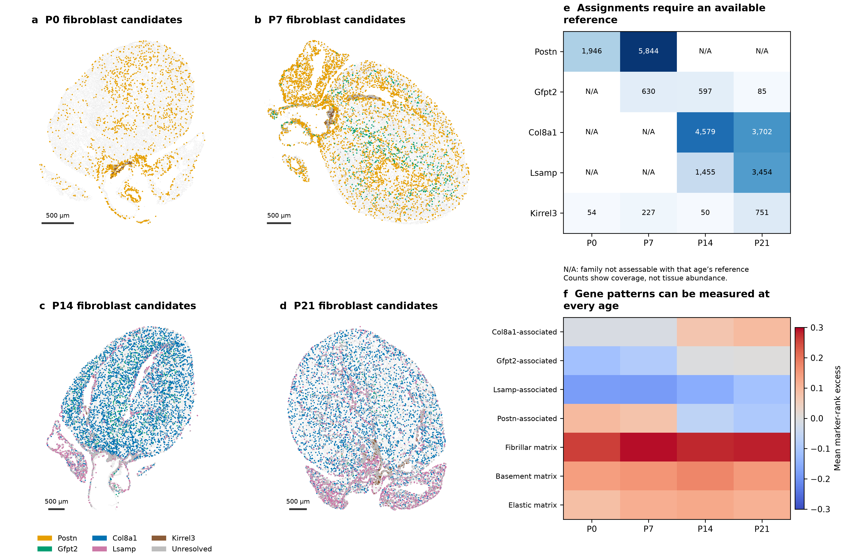
a–d, Broader candidate fibroblast identities on the original P0–P21 sections. Gray retains unassigned fibroblasts and tissue context; background cells may be subsampled for display only. e, Candidate counts, with unavailable same-age reference classes marked N/A. This does not mean the corresponding genes are absent. Counts measure assignment coverage, not accuracy or tissue abundance. f, Measured patterns can be scored independently of family availability. Values summarize each section relative to matched control genes; they do not measure matrix protein or function. Scale bars, 500 µm.

Figure 2. Early and late fibroblast patterns overlap without requiring a subtype label
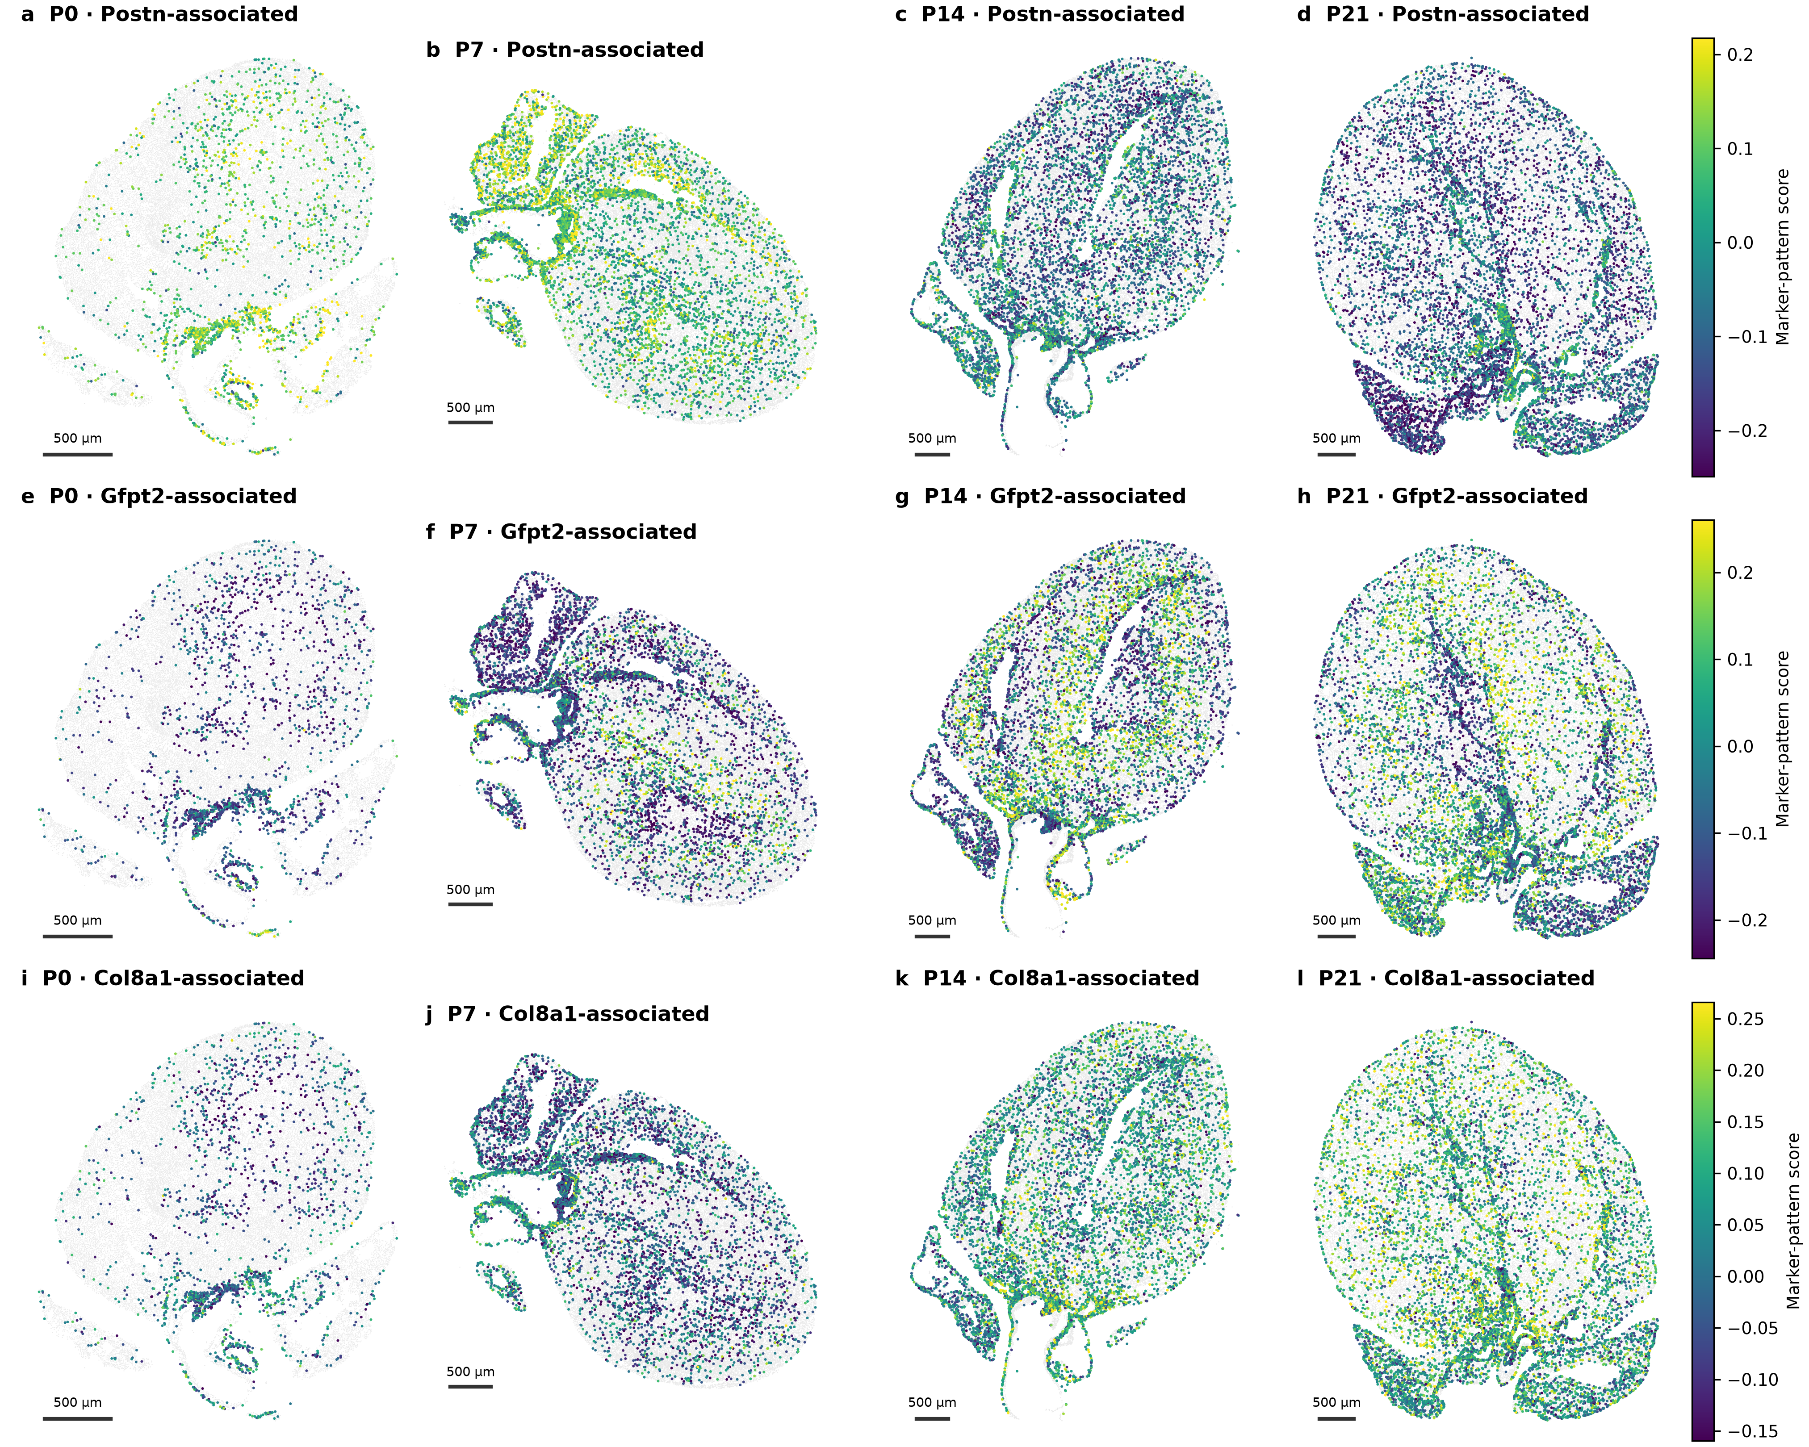
a–d, Postn/Ptn/Tnc/Col24a1 pattern. e–h, Gfpt2/Pi16/Adgrd1 pattern. i–l, Col8a1/Cmklr1/Col6a3/Htra3 pattern. Each row uses a common color scale across ages, showing eligible fibroblasts regardless of their candidate subtype. Negative scores mean expression ranks below matched controls, not negative RNA or biological absence. One pattern can occur across several subtype labels. Background tissue is shown in gray. Scale bars, 500 µm.

Figure 3. Local matrix relationships differ by CM state and outcome
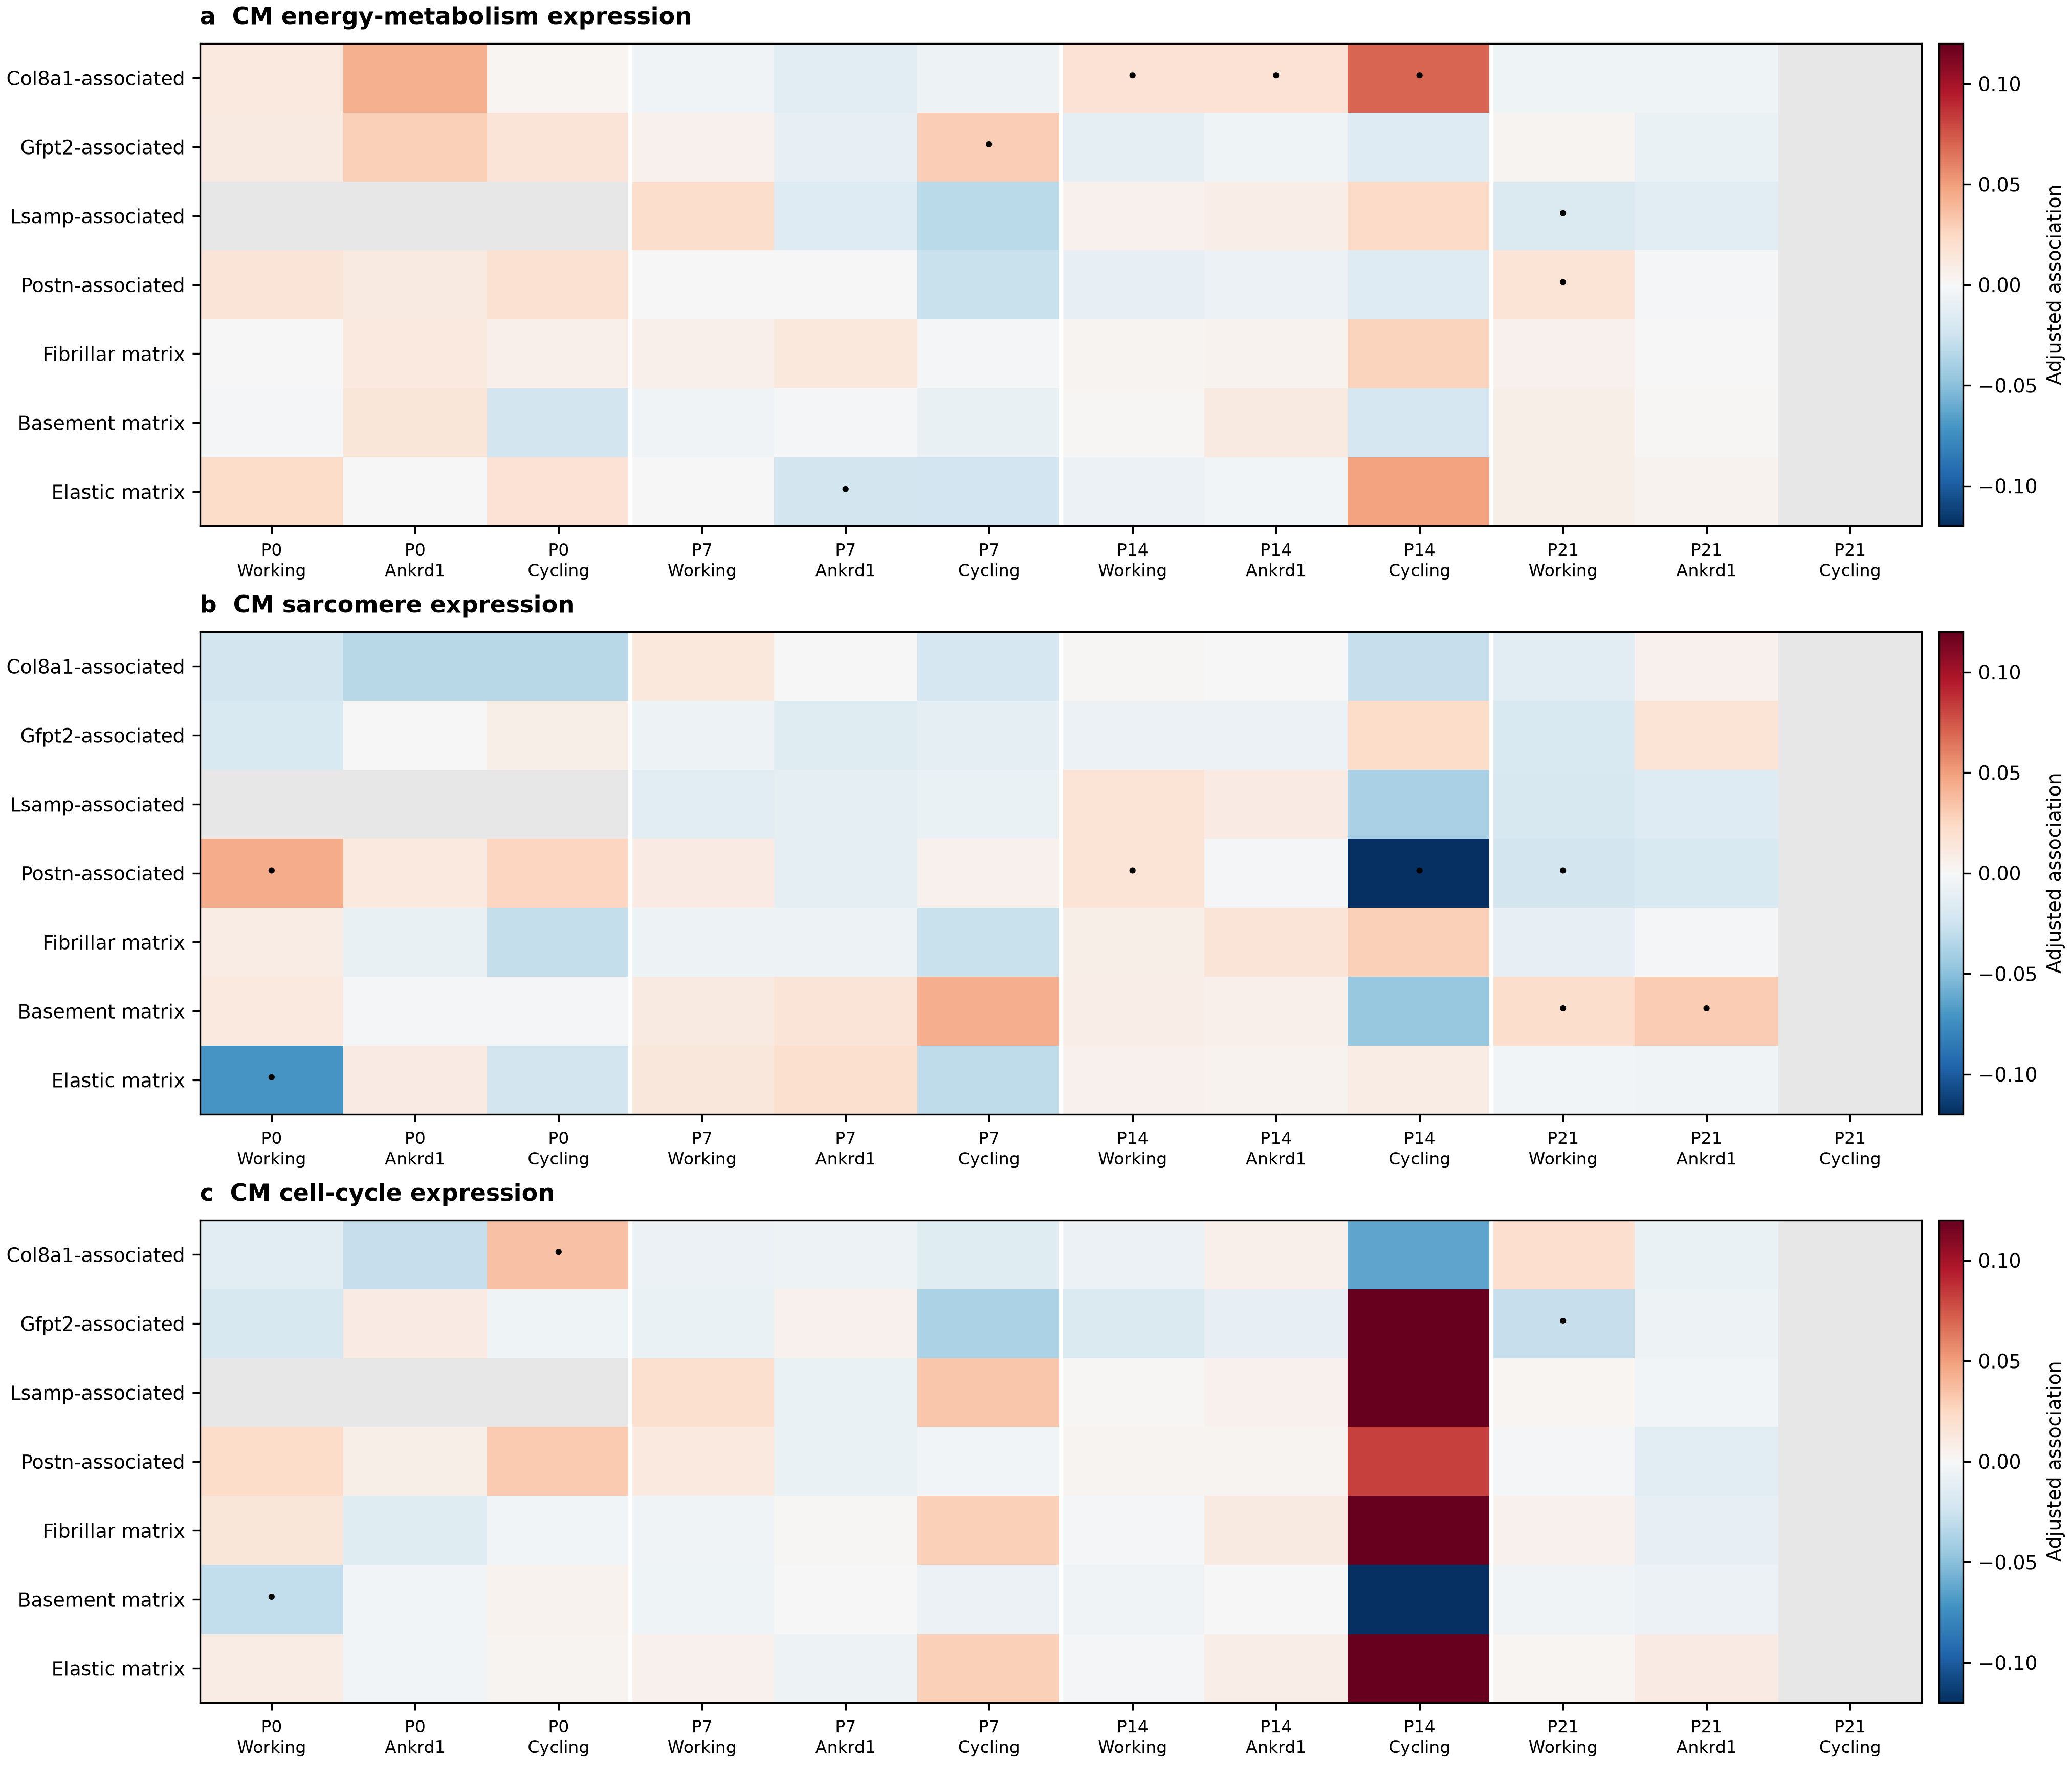
a–c, Within-region associations between neighboring fibroblast patterns and CM energy-metabolism, sarcomere or cell-cycle expression. Working, Ankrd1 and cycling-associated CMs are displayed; all eligible CM states enter the source tables and correction. Red and blue indicate positive and negative estimates. Dots mark intervals excluding zero before multiple-testing correction; none of these fibroblast-program associations passes the global primary correction. Gray indicates an unavailable or insufficiently supported comparison. The models account for vascular surroundings and capture. Each age has one section.

Figure 4. Early fibroblast environments suggest hypotheses without establishing metabolic instruction
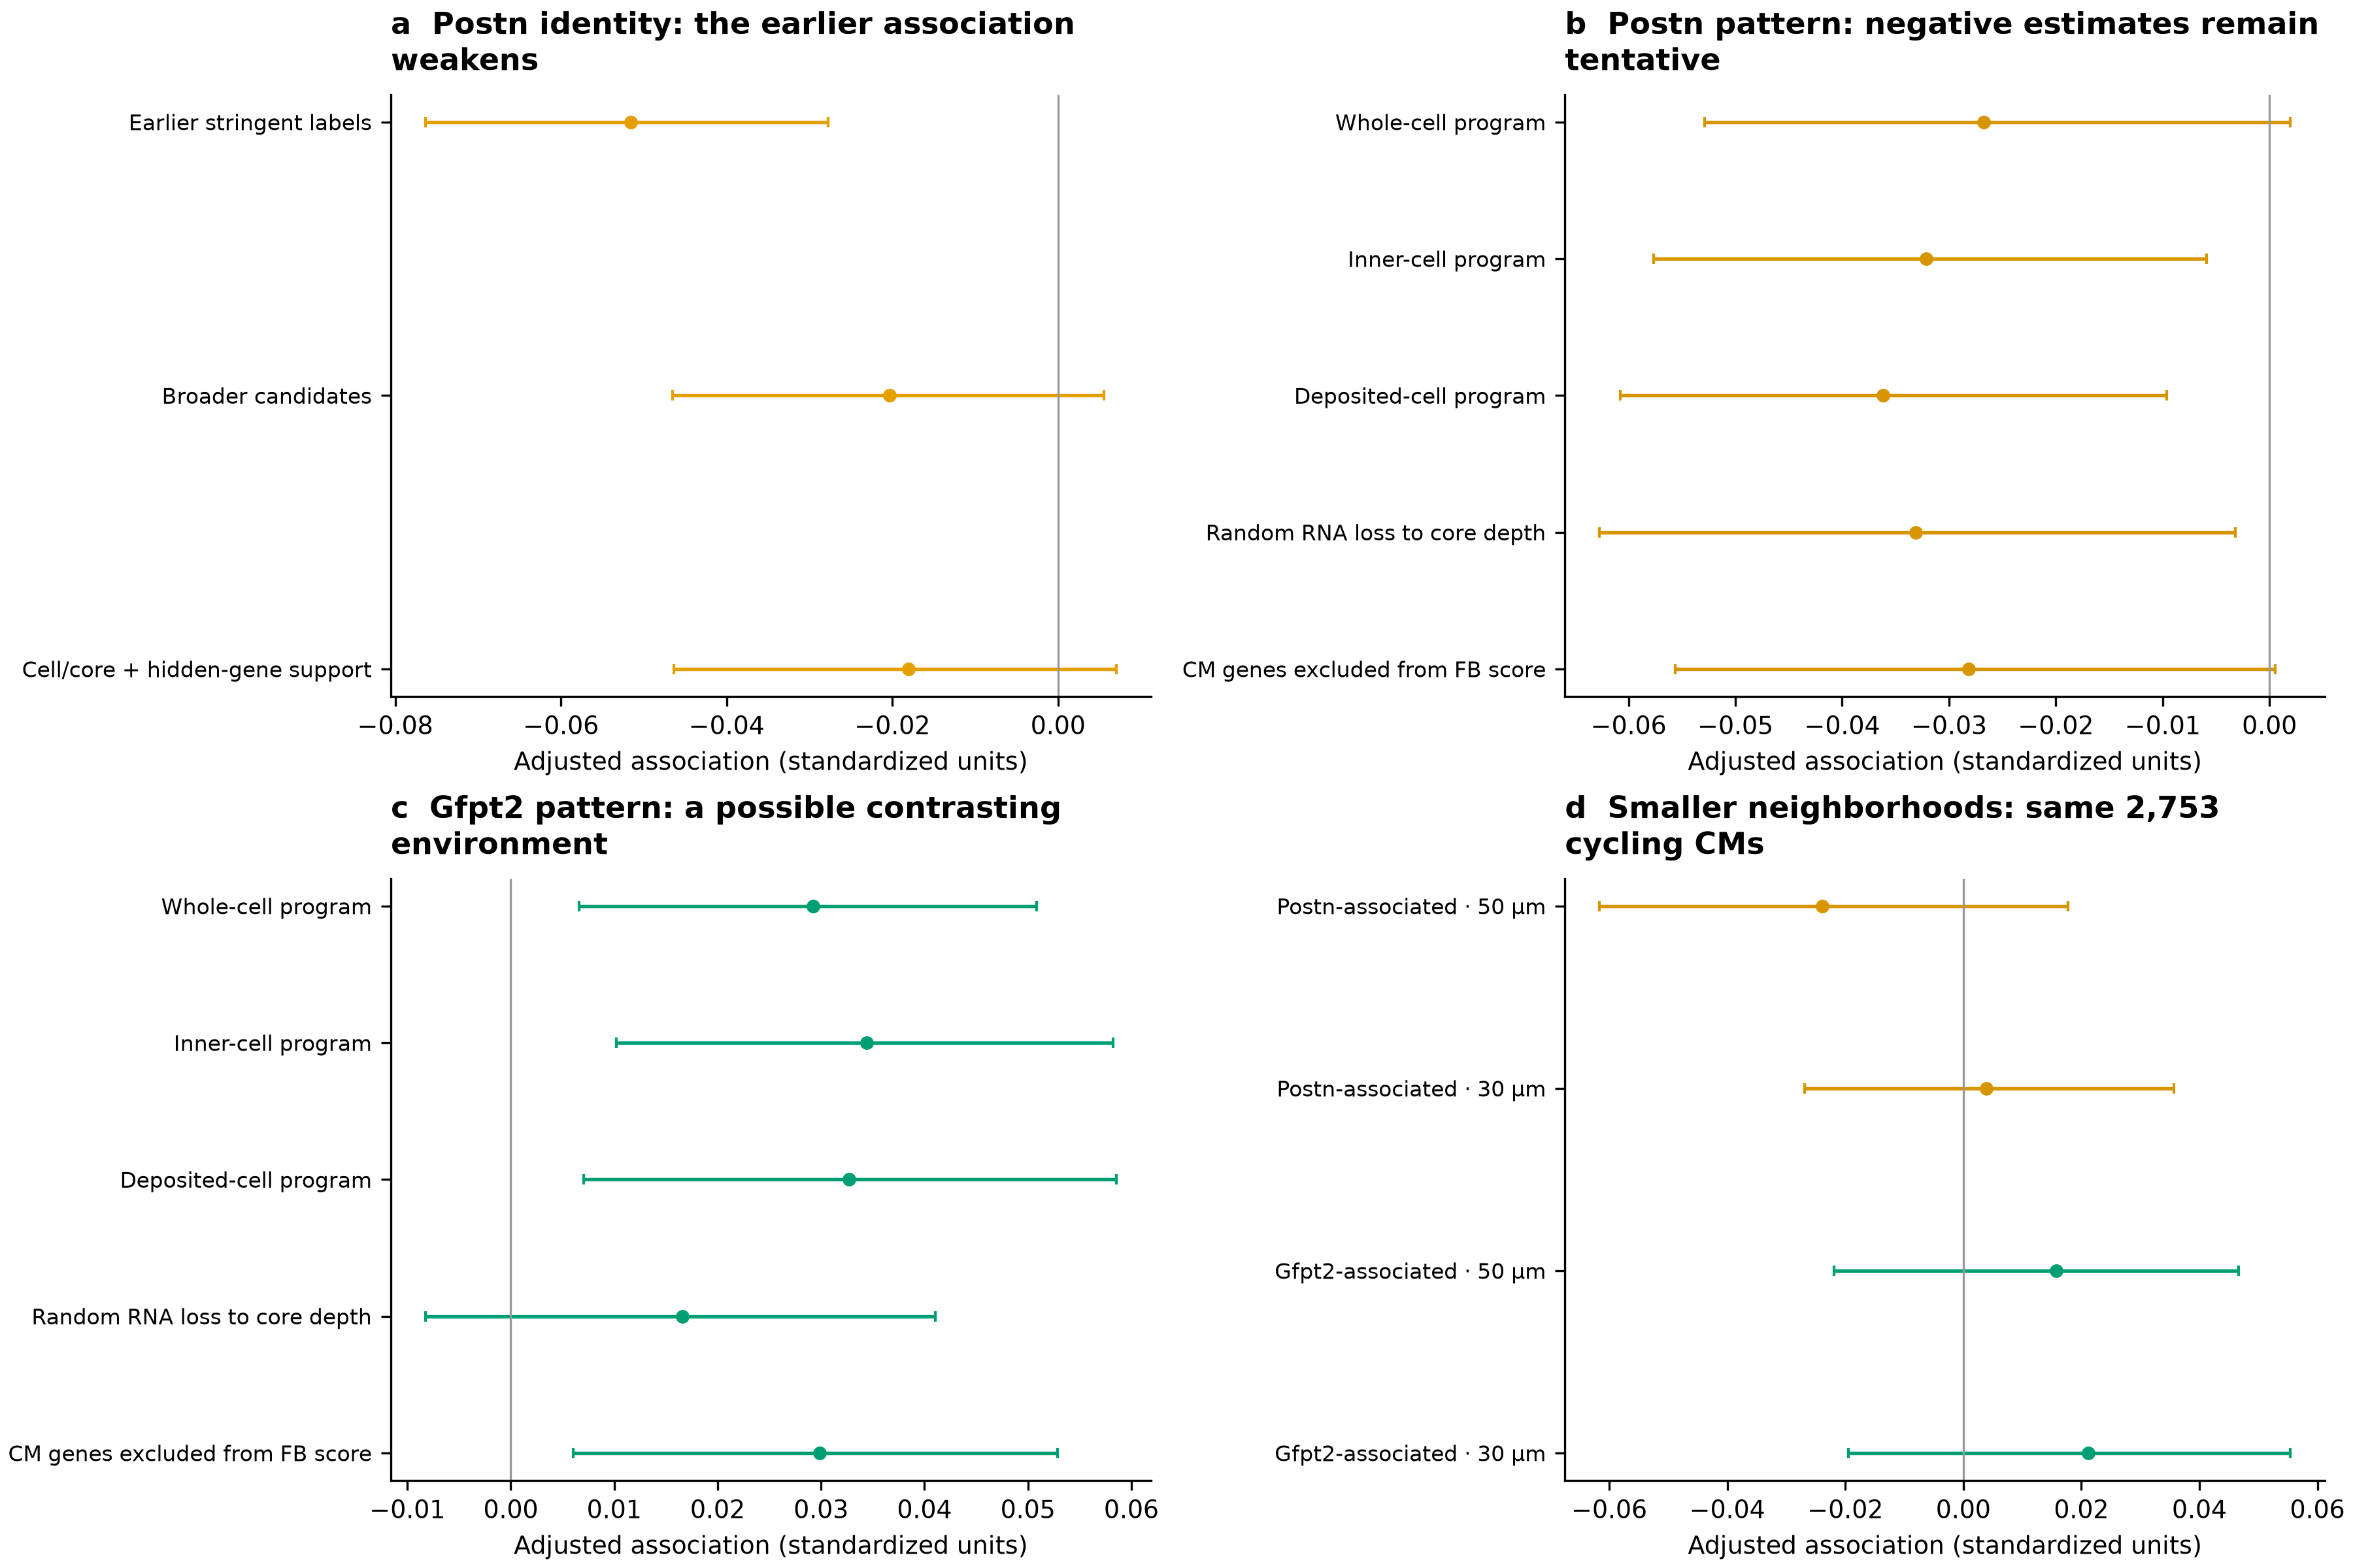
a, The P7 Postn-identity/metabolic relationship in cycling-associated CMs weakens with broader and crosschecked assignments. b,c, Postn- and Gfpt2-associated patterns in whole-cell, inner-cell, deposited and depth-matched fibroblast RNA, with an additional CM-gene-excluded scoring check. Negative and positive estimates suggest contrasting environments but do not establish opposing functions. d, The 50-/30-µm comparison uses the same 2,753 cycling-associated CMs. Smaller neighborhoods do not provide clear corresponding support. Points and intervals describe within-section estimates and 95% spatial-block intervals; they are not independent-heart replication.

Figure 5. Structural RNA relationships depend on CM identity and transcript ownership
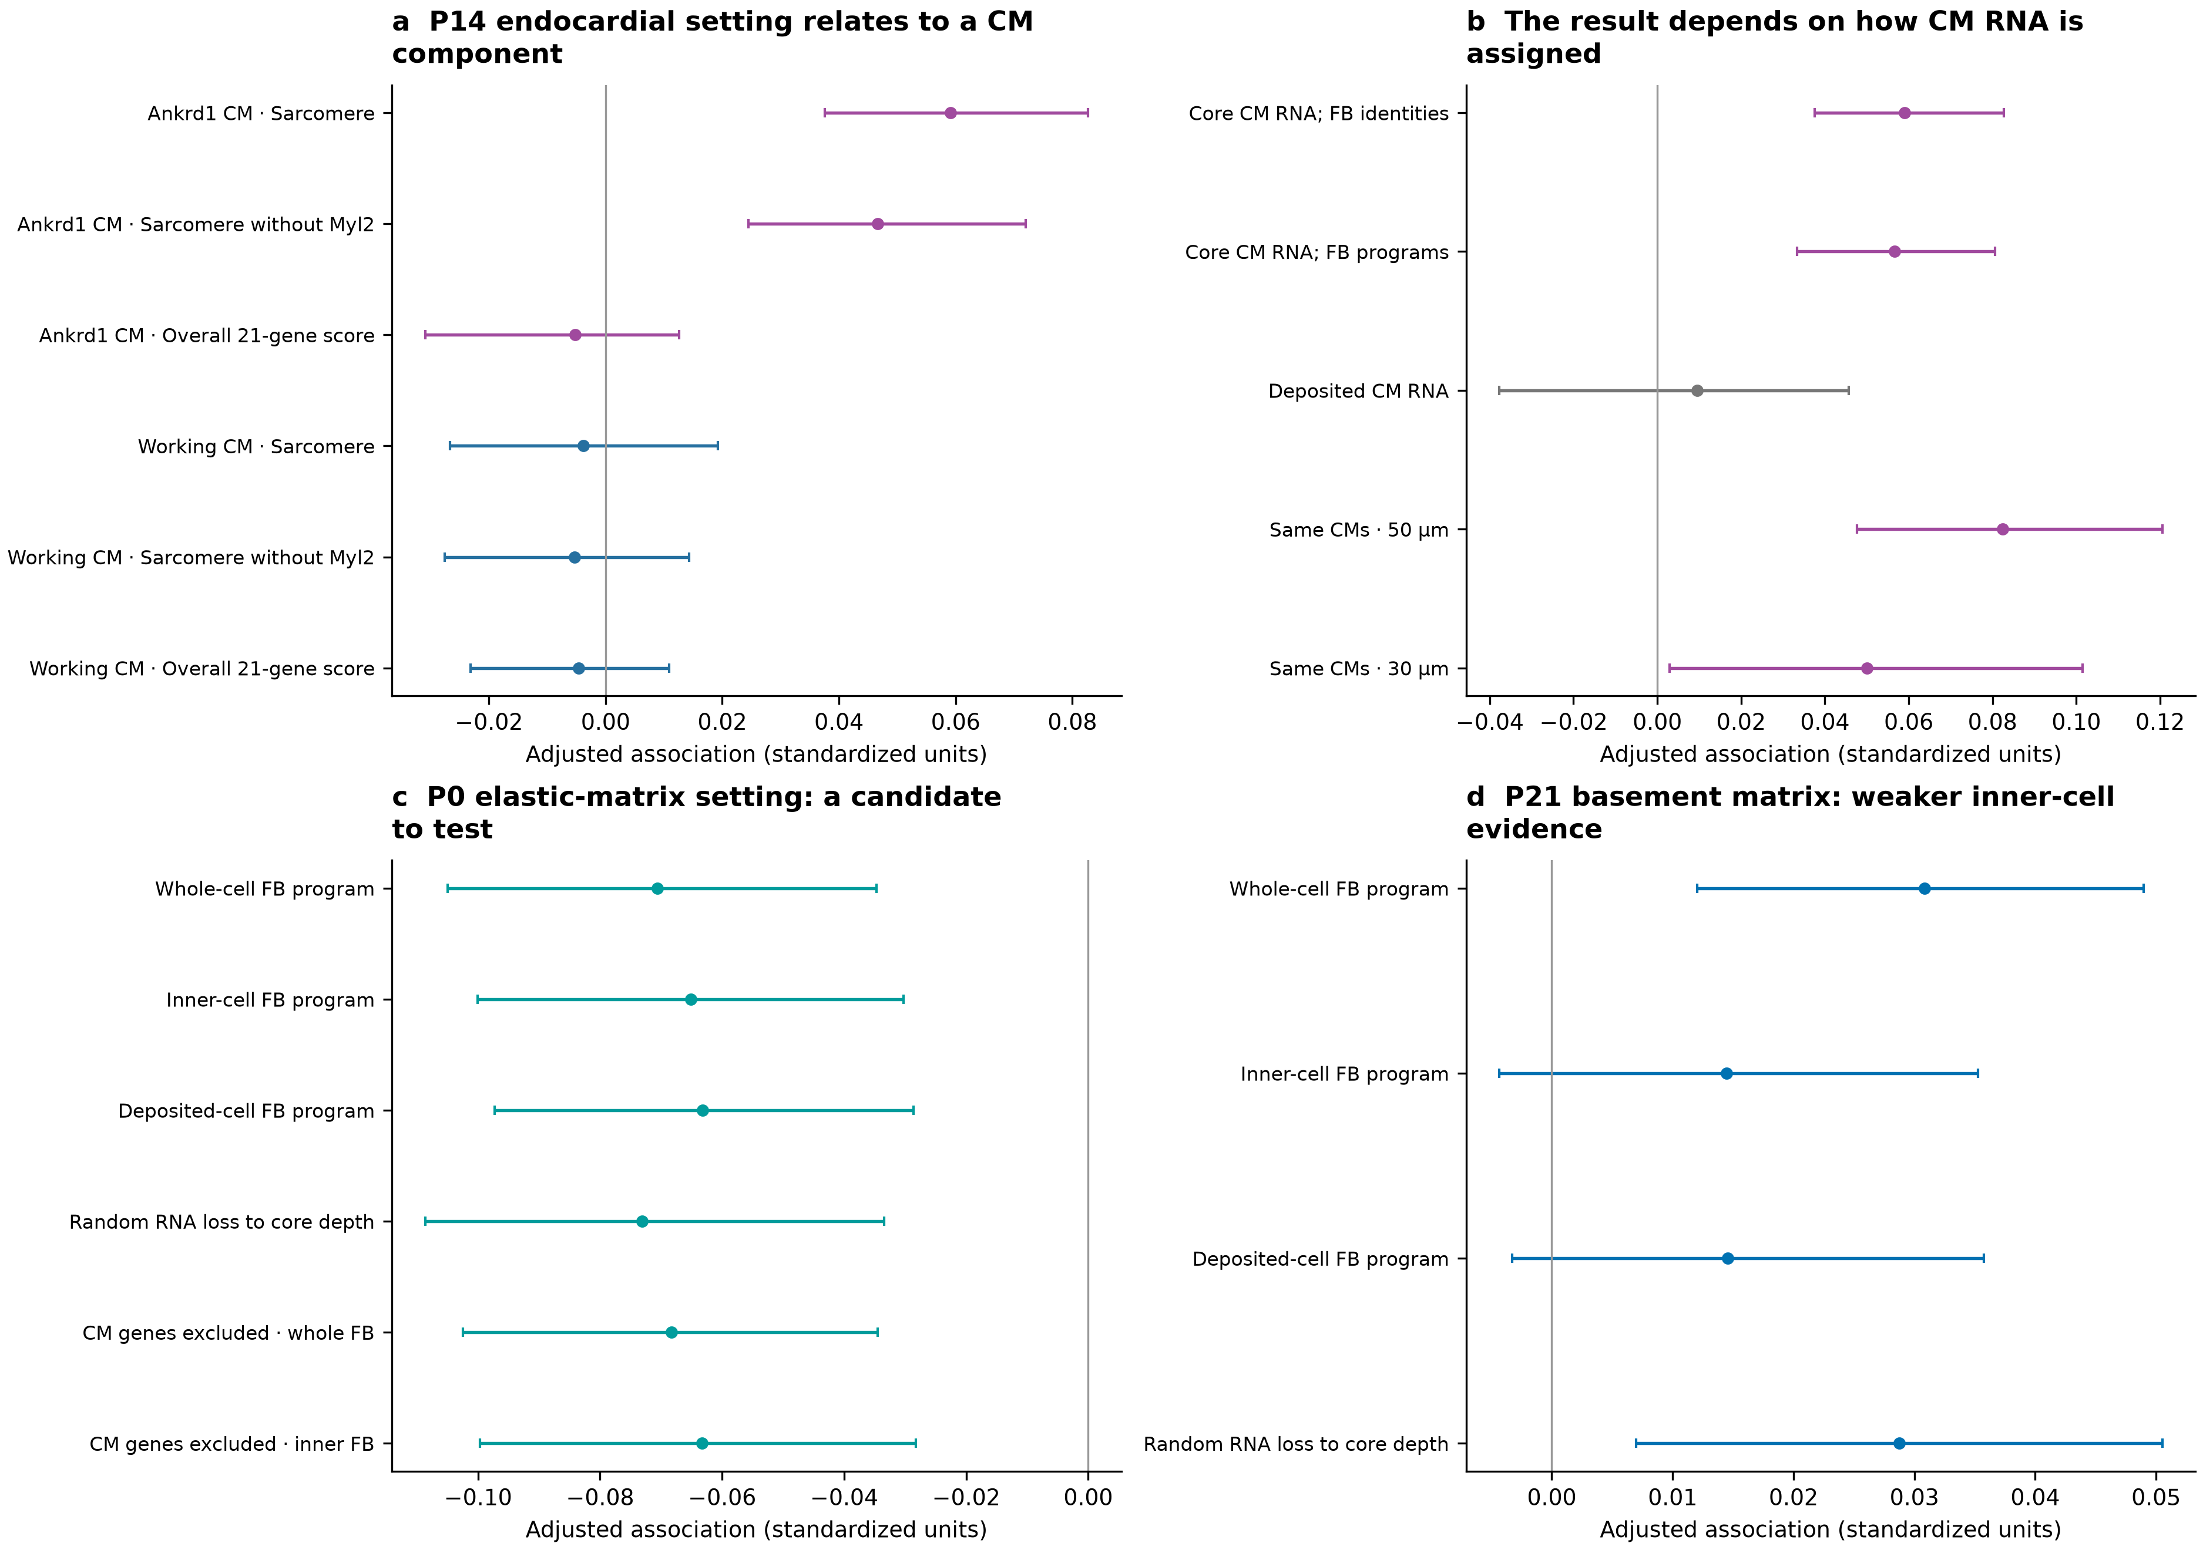
a, At P14, endocardial-like surroundings relate to higher sarcomere expression in Ankrd1 CMs, with a smaller relationship in working CMs. Removing Myl2 retains the direction; the overall score shows no corresponding increase. b, The relationship remains after adjustment for fibroblast programs but weakens in deposited CM RNA. The paired 50-/30-µm comparison uses the same 4,528 Ankrd1 CMs. c, A P0 elastic-matrix/sarcomere candidate retains its direction across fibroblast RNA views and CM-gene-excluded scoring, but does not pass the primary correction. d, The P21 basement-matrix estimate weakens with inner-cell fibroblast RNA. Intervals describe uncertainty within sections, conditional on the chosen count views.

Figure 6. Fibroblast position and changing surroundings guide specific developmental questions
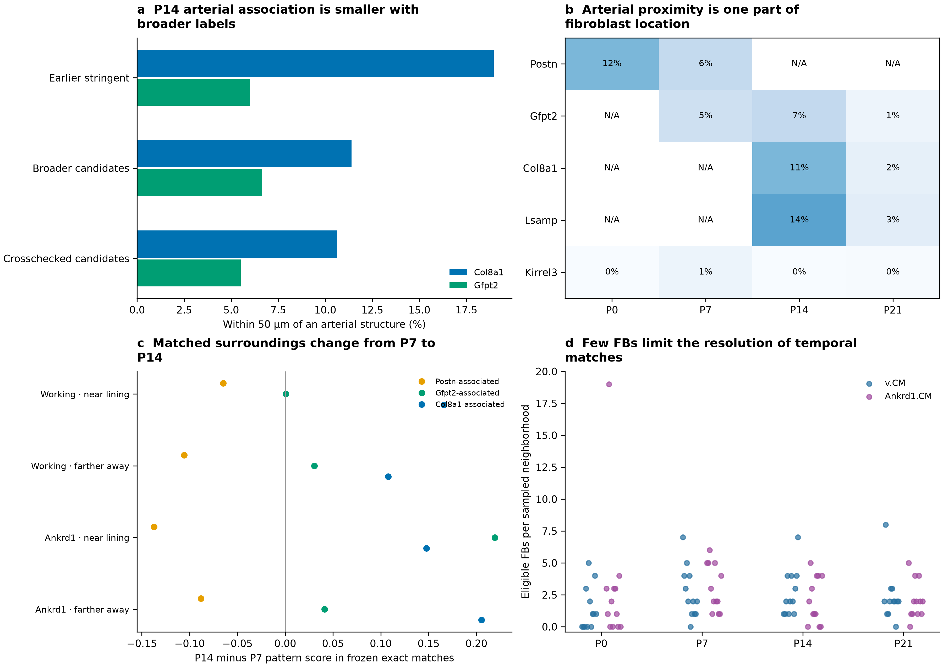
a, P14 Col8a1/Gfpt2 arterial proximity after the same technical matching design, using earlier stringent, broader and crosschecked identities. The contrast becomes smaller with broader assignments. Matching permits reused controls. b, Arterial proximity among candidate families; N/A marks unavailable families. Kirrel3 candidates are not assigned valve anatomy. c, Updated fibroblast patterns on frozen exact P7-to-P14 neighborhood matches, grouped by CM identity and endocardial distance. Only matching mass with informative fibroblasts at both ends contributes; supported mass is supplied. d, Eligible fibroblasts among the sampled sources: the median is two, and 15 of 96 neighborhoods have none. These comparisons do not trace cell transitions.

Methods

Data, inherited QC and scope
We used the deposited P0, P7, P14 and P21 snRNA-seq/Xenium data [1] and the frozen reviewed annotations, coordinates, CM cohorts and spatial graphs. There is one available spatial section per age. This analysis fits new CM-neighbor models with the revised fibroblast assignments and directly measured programs. It does not perform new segmentation, classifier training or spatial imputation.
Inherited snRNA-seq QC used per-library scDblFinder as the primary doublet screen; Scrublet was diagnostic. DecontX was fitted separately to singlet nuclei in eight libraries using called-nucleus clusters without empty droplets. Corrected counts informed the reviewed reference, with raw-reference sensitivity retained. Five residual CM/mural-program fibroblast groups were excluded from the fine reference. Earlier broad-fibroblast median estimated contamination fractions ranged approximately 0.05–0.12 across libraries; these are model estimates, not measured residual contamination after correction. Residual mixing remains possible.
The deposited Xenium matrices contain 403 gene targets plus 138 control/non-gene features. The shared RNA reference contains 381 measured genes. Controls do not enter biological scores. Missing nuclear area alone does not exclude a CM. The earlier multimodal segmentation, transcript reassignment and core/nuclear count layers are retained as sensitivity views, not independent ground truth.

Fibroblast identities and marker patterns
Identity layers are the newer recommended candidates, the subset supported by cell/core and naming-marker-withheld agreement, and the earlier stringent labels. Broad fibroblast eligibility is frozen. Supported nuclear alternatives remain review flags in the newer labels. Reference classes absent at an age are marked not assessable in the table; their programs can still be measured directly. Candidate counts measure operational coverage rather than tissue abundance. Thresholds selected from reference cross-validation predictions do not provide unbiased prospective spatial accuracy.
Seven measured patterns are analyzed: Postn, Gfpt2, Col8a1 and Lsamp marker sets, plus fibrillar, basement and elastic matrix sets. Exact genes are supplied in the program table and source files. Scores are mean within-cell gene ranks minus the average of 200 control sets matched to pooled clean RNA-reference abundance deciles. The four identity-marker scores reproduce the previous module files. A descriptive enrichment flag exceeds 90% of control sets and requires two detected markers; it is not a cell-type probability or single-cell significance test.
Each source view requires at least 20 shared-panel molecules and eight detected genes. Programs are averaged across all informative eligible fibroblast neighbors, including cells without a confident subtype or enrichment flag. A program is tested only if at least 30 informative fibroblasts detect two of its markers. Identity fractions use all eligible broad fibroblast neighbors, including unassigned cells. Fibroblast program genes do not overlap the CM maturation panel. A separate sensitivity removes CM maturation, lineage/response, cycling and sex genes from both the fibroblast rank background and control pool, then recomputes scores and fits; these excluded genes and retained counts are supplied.
Refined whole-cell, inner-cell core and native deposited counts are compared. Three binomial-thinning repetitions reduce refined counts toward each profile's core depth without changing its geometry; their mean score provides an information-loss control. Core and depth-matched comparisons use the same informative-source mask. These tests do not fully propagate boundary uncertainty.

Cardiomyocyte outcomes and cohorts
The frozen ventricular cohort retains ventricular-marker-supported profiles with compatible released v.CM, Ankrd1.CM, Slit2.CM, Ddc.CM or p.CM labels and the earlier morphology rule. CMs require at least 20 core-panel molecules and 20 molecules outside the outcome genes. The p.CM label denotes a cycling-associated state, not demonstrated completed cell division.
The measured 21-gene panel is Rxrg, Ppargc1a, Ppargc1b, Cebpa, Cebpb, Esrra, Esrrb, Esrrg, Mitf, Myh6, Tnni3, Myl2, Kcnq1, Jph1, Jph2, Bin1, Lpin1, Pln, Ppara, Ppard and Cpt1b. The frozen direct index is the mean gene-standardized log-normalized expression using the earlier pooled calibration. It is not an exact reproduction of the author's unrecovered AddModuleScore object.
Metabolic-regulatory genes are Ppargc1a, Ppargc1b, Esrra, Esrrg, Ppara, Ppard, Cpt1b and Lpin1. Sarcomere genes are Myh6, Tnni3 and Myl2. Excitation–contraction genes are Pln, Jph1, Jph2, Bin1 and Kcnq1. Cycling uses Mki67, Top2a and Cenpf, with higher values indicating higher cycling-associated RNA. Thus Lpin1 and Pln are grouped by their biological roles rather than reproducing the figure's category placement. Removing Myl2 yields a 20-gene index and a two-gene sarcomere sensitivity without changing ventricular selection. Native CM outcomes provide an additional transcript-ownership sensitivity.
Within each graph, source views use the same eligible CMs. The 50-µm cohorts contain 13,071 P0, 27,659 P7, 26,996 P14 and 27,053 P21 CMs before individual-state model eligibility. Paired 50-/30-µm and shared-boundary comparisons use their common CM cohorts. A fitted state requires at least 200 CMs, eight 400-µm blocks and sufficient residual exposure variation. Categorical exposures also require 50 positive CMs.

Association models and uncertainty
Primary fibroblast models test one identity fraction or program at a time. They adjust for CM capture outside the outcomes, area, nuclear missingness, neighbor counts, broad non-CM composition and FB/EC capture. Program models additionally adjust for informative-source coverage, depth and detected genes. Anatomical models add arterial/endocardial/large-void/outer-surface distance proxies, morphology class and nuclear-supported capillary/endocardial fractions. The primary comparison removes means within 200-µm regions, separately by CM state. These proxies are not independently reviewed LV/RV or compact/trabecular masks.
Targets and outcomes are standardized within each age/run before separating CM states. Rank-revealing QR removes redundant nuisance columns. Each point estimate is fitted by least squares. Shared 512-resample, 400-µm block bootstraps provide exploratory within-section intervals and CM-subtype slope comparisons. Technical, anatomical and within-region fits are retained separately. Joint-program fits examine specificity; single-program estimates are not assumed independent of other matrix patterns.
Vascular-target models adjust for the revised fibroblast fractions; a sensitivity replaces these fractions with all seven fibroblast programs. The primary family comprises 925 tests across all four ages, eligible CM states, candidate identities, refined programs, two vascular targets and five primary outcomes. One global BH correction is applied to this complete grid. Sensitivity outcomes and alternative definitions are supplied separately and are not used to declare additional corrected discoveries. Different detectability across ages is not treated as a demonstrated age interaction.

Fibroblast spatial comparisons and temporal descriptions
The P7 Gfpt2/Postn and P14 Col8a1/Gfpt2 comparisons repeat the earlier matching design with the new labels. Profiles need at least five resolved neighbors within 30 µm. Matching uses standardized log RNA molecules, log area, log 50-µm density and nuclear fraction; nearest reference matching permits replacement with a Euclidean caliper of two. Pair IDs, unique reference counts and covariate balance are supplied. Arterial distance is to the earlier operational structure, not a newly traced histological vessel wall. These are descriptive spatial contrasts.
The 96 frozen neighborhoods retain their selected cells, molecular representation, exact transport plans and saved Wormhole plans [3]. Updated fibroblast identities and programs are held-out descriptors. They may share underlying RNA information with the molecular representation, so this is not independent validation. Reported program changes condition on pairs with an informative fibroblast at both ends, and the supported matching mass is supplied. Fine labels do not retrain the encoder. Matching is not ancestry, expansion or a measured transition rate.

Validation and limitations
Independent checks reconstruct 8,064 neighborhood program means, compare 36 regression coefficients with a separate residualization calculation, verify assignment coverage and unavailable classes, recalculate the full primary BH correction and check design conditioning. Source IDs, source tables, count views and program definitions are retained. Source/artifact hashes and document/figure checks accompany the release.
The atlas's strict outline benchmark deteriorates at P21; its object-overlap score is not transcript-ownership accuracy. Core/native/thinned and shared-boundary checks expose some sensitivities but do not integrate uncertainty over plausible alternative boundaries. Neither computational agreement nor spatial-block intervals establish independent-heart replication. Blood flow, matrix mechanics, functional CM maturation and cell ancestry were not measured here.

References
1. Wang H et al. Spatially guided in vivo single-cell functional genomics of postnatal heart. Nature Cardiovascular Research (2026). https://doi.org/10.1038/s44161-026-00861-z
2. Lu P et al. Perinatal angiogenesis from pre-existing coronary vessels via DLL4–NOTCH1 signalling. Nature Cell Biology 23, 967–977 (2021). https://doi.org/10.1038/s41556-021-00747-1
3. Haviv A et al. Wasserstein Wormhole: Scalable Optimal Transport Distance with Transformers. ICML (2024). https://arxiv.org/abs/2404.09411
4. Puente BN et al. The oxygen-rich postnatal environment induces cardiomyocyte cell-cycle arrest through DNA damage response. Cell (2014). https://doi.org/10.1016/j.cell.2014.03.032
5. Mahmoud AI et al. Meis1 regulates postnatal cardiomyocyte cell cycle arrest. Nature (2013). https://doi.org/10.1038/nature12054

What changed after the refit?
Question | Updated observation | Biological interpretation
Does the P7 Postn relationship persist? | Negative metabolic estimate becomes smaller and uncertain with broader labels; smaller-neighborhood support is weak | A developing-matrix hypothesis remains; suppression by Postn fibroblasts is not established
Do late Col8a1 fibroblasts favor arteries? | About 11% near arteries versus 7% of matched Gfpt2 candidates; direction retained in the crosschecked subset | A vessel-associated component within a broader matrix population
Does one FB program predict general CM maturation? | No FB identity/program association passes the full primary correction | Different components and CM states require separate tests
Which FB candidate deserves focused imaging? | P0 elastic-matrix expression relates to lower working-CM sarcomere RNA across several sensitivity checks | Test matrix organization and CM structure; mechanism remains unknown
What is the clearest corrected relationship? | P14 endocardial-like surroundings and Ankrd1-CM sarcomere RNA; weaker in deposited CM counts | Validate anatomy and transcript ownership before testing contact or loading
What does the temporal comparison add? | P7-to-P14 matched surroundings lose Postn-associated and gain Col8a1-associated expression | A developmental comparison to sample more densely, not a tracked conversion

Fibroblast assignments and directly measured patterns
Candidate family | P0 | P7 | P14 | P21
Postn | 1,946 | 5,844 | Not assessable | Not assessable
Gfpt2 | Not assessable | 630 | 597 | 85
Col8a1 | Not assessable | Not assessable | 4,579 | 3,702
Lsamp | Not assessable | Not assessable | 1,455 | 3,454
Kirrel3 | 54 | 227 | 50 | 751
Not assessable means that this family is absent from the same-age reference. It is not a biological zero. Counts show assignment coverage among eligible fibroblasts, rather than tissue-wide abundance. Broader coverage is not independently established accuracy; apparent reference precision uses thresholds selected from the same reference predictions.
Pattern-enriched profiles | P0 | P7 | P14 | P21
Postn pattern | 535 | 1,591 | 166 | 192
Gfpt2 pattern | 19 | 312 | 1,232 | 1,339
Col8a1 pattern | 96 | 377 | 1,730 | 3,191
Lsamp pattern | 4 | 31 | 89 | 137
Fibrillar matrix | 1,496 | 6,186 | 6,604 | 8,844
Basement matrix | 1,325 | 5,180 | 6,392 | 7,414
Elastic matrix | 569 | 2,534 | 3,086 | 3,389
These descriptive flags require the measured multi-gene pattern to exceed matched controls and at least two markers to be detected. They are not subtype counts, functional activity or evidence of biological absence when low. Different patterns can occur in the same cell. Eligible broad FB denominators are 2,020, 7,365, 8,098 and 10,867.

Selected estimates and exact program definitions
Primary comparison | Estimate | 95% block interval | Global BH q
P7 · Postn identity → cycling-CM metabolic RNA | -0.020 | -0.047 to +0.006 | 0.758
P7 · Gfpt2 pattern → cycling-CM metabolic RNA | +0.029 | +0.007 to +0.051 | 0.546
P0 · Elastic matrix → working-CM sarcomere RNA | -0.071 | -0.105 to -0.035 | 0.0733
P21 · Basement matrix → Ankrd1 sarcomere RNA | +0.031 | +0.012 to +0.049 | 0.221
P14 · Endocardial context → Ankrd1 sarcomere RNA | +0.059 | +0.038 to +0.083 | 0.00104
Values are within-stage standardized associations, not measured functional effects. Intervals describe spatial variation conditional on the selected masks and model. The global correction covers all 925 primary tests. Sensitivity estimates are supplied separately and do not create extra corrected discoveries.
Measured pattern | Genes
Col8a1 pattern | Cmklr1, Col8a1, Col6a3, Htra3
Gfpt2 pattern | Gfpt2, Pi16, Adgrd1
Lsamp pattern | Col8a1, Itgbl1, Lsamp
Postn pattern | Col24a1, Ptn, Tnc, Postn
Fibrillar matrix | Col1a1, Col1a2, Col3a1
Basement matrix | Lama4, Lama5, Lamb1, Lamb2, Lamc1, Col4a1, Col4a2, Hspg2
Elastic matrix | Eln, Fbln1, Fbln2
Fibroblast genes do not overlap the CM maturation panel. Individual program models do not establish effects independent of the other patterns; joint-program sensitivities are supplied. Marker-pattern expression is not a measurement of matrix deposition or mechanics.

Figure S1. Subtype labels do not establish one uniform effect on neighboring CMs
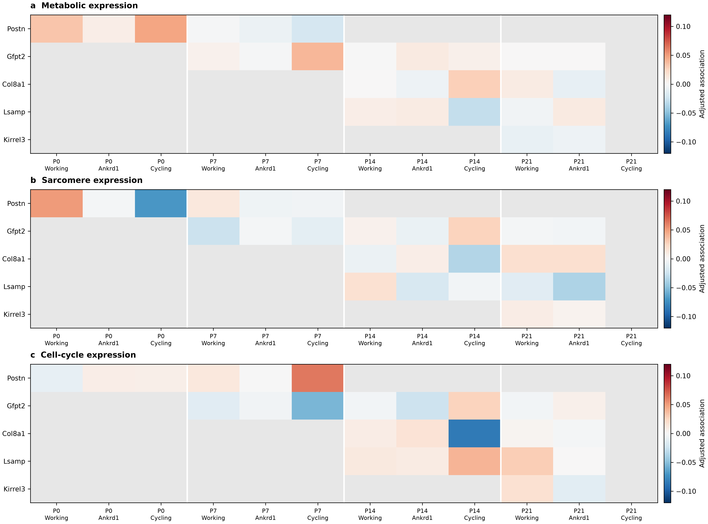
a–c, Candidate-family associations with CM metabolic, sarcomere and cell-cycle expression. The 50-µm models compare CMs within regions and account for vascular surroundings and capture. Gray marks unavailable or insufficiently supported comparisons. No fibroblast identity association passes the global primary correction. The full source tables also include other eligible CM states, the 21-gene and excitation–contraction outcomes, alternative label layers, smaller neighborhoods and transcript-ownership sensitivities.

Experiments suggested by the reassessment
Priority | Measurement | What it would distinguish
1. Validate the P14 structural setting | Clear membranes; Ankrd1 and sarcomere RNA/protein; endocardial identity; matched inner-wall anatomy | True within-CM structural variation versus transcript assignment or regional loading
2. Examine the P0 elastic-matrix candidate | Eln/Fbln1/Fbln2 RNA and matrix protein; CM sarcomere organization in comparable regions | A shared regional feature versus a local matrix-related structural relationship
3. Test early metabolic environments | Compare fibroblast/matrix conditions with the same starting CM state, oxygen and endothelial support | Matrix contribution independent of vascular support
4. Resolve developmental order | Independent P3/P5/P10 hearts with perfusion, oxygen, matrix and CM function measurements | Whether improved blood delivery, matrix organization or contact precedes each CM change
5. Follow cell states through time | Denser spatial neighborhoods and validated lineage tracing | Related expression states versus actual cell ancestry
One section per age cannot establish population-level developmental timing. Shared-boundary and core-RNA analyses do not prove functional contact, oxygen delivery or complete removal of mixed RNA. The experiments should measure contraction, calcium handling, energy use and completed division separately from RNA scores.

