  - INTEGRATED BIOLOGICAL REPORT • CLEAR-LANGUAGE REVISION

Muscle, matrix and vascular development in the postnatal heart
P0–P21 mouse-heart snRNA-seq and Xenium analysis

Central message
Muscle, matrix and blood vessels develop together, but different aspects of cardiomyocyte maturation emerge at different times. Early muscle and vessel growth may be coordinated; later, vascular support and the surrounding matrix may accompany metabolic and structural development. Fibroblast subtypes share some gene patterns while differing in others.
This report brings together the cardiomyocyte, vascular and fibroblast findings. Each section describes what was observed, what it may mean biologically and what remains uncertain. Seven main figure plates and two supporting plates are included; detailed analysis rules are collected in Methods.
The new fibroblast maps have not yet been used to recalculate the earlier CM-neighbor associations or cross-age transport results. One available section per age limits developmental and causal conclusions.
Prepared 26 October 2026 • Source results and earlier reports are retained for traceability.

Abstract
After birth, the heart must grow while becoming capable of sustained pumping. We examined how its muscle cells, fibroblasts and blood vessels develop together using the P0, P7, P14 and P21 Heart Atlas. Cardiomyocytes of the same subtype showed different levels of maturation-associated gene expression within the same section. Fibroblasts also changed with age: early Postn-associated states gave way to groups expressing different combinations of matrix genes. Reassessing their identities recovered broader spatial maps and showed that a Gfpt2-associated gene pattern is shared across several fibroblast groups. Published vascular work places these changes alongside expansion of the existing coronary network, particularly into the inner ventricular muscle. In our analysis, endothelial and cardiomyocyte cell-cycle activity tended to occur together at P0 and P7. Cardiomyocytes alongside capillaries showed lower cell-cycle gene expression at P7 and higher energy-metabolism gene expression at P14 and P21. At P14, Ankrd1-associated cardiomyocytes near endocardial-like cells showed higher sarcomere-gene expression. Together, these findings suggest that early tissue growth and later vascular support accompany different parts of cardiomyocyte development. Comparisons across ages identify cellular environments worth following, but do not establish cell ancestry. Independent hearts and measurements of blood flow, matrix properties and cardiomyocyte function are needed to determine how these environments contribute.

Introduction
The heart must meet increasing demands after birth. Its muscle grows, cardiomyocytes change how they use energy, and their contractile machinery develops. These changes take place while blood vessels expand and fibroblasts organize the extracellular matrix around and between cells. Cardiomyocyte development therefore depends on more than changes within the muscle cells themselves.
The Heart Atlas allows us to examine these processes in the same tissue [1]. We ask whether cardiac cell subtypes occupy different locations and relate differently to one another. Ankrd1-associated and working ventricular cardiomyocytes may respond differently to their surroundings. Fibroblasts expressing Postn-, Gfpt2-, Col8a1- or Lsamp-associated patterns may contribute different features of the developing matrix.
The vascular study by Lu and colleagues provides an important anatomical setting for these questions [2]. It showed that existing coronary vessels expand around birth, especially into the inner myocardium—the ventricular muscle toward the chamber cavity and its endocardial lining. We use this finding to ask how growing vessels, changing fibroblast states and cardiomyocyte development might coordinate within different parts of the ventricular wall.

Results

A cardiomyocyte subtype does not have one fixed level of maturity
At P0 and P7, both Ankrd1-associated and working ventricular cardiomyocytes showed a wide range of maturation-associated gene expression within the same section (Fig. 1). Two cardiomyocytes with the same subtype label could therefore differ in their expression of genes involved in energy metabolism and contraction. Subtype identity and developmental state describe different features of a cell.
We measured these differences using a panel of 21 genes and examined the metabolic, structural and cell-cycle patterns separately. A higher panel score means stronger expression of the measured maturation-associated genes. It does not tell us directly how strongly a cell contracts or how efficiently it produces energy. Separating these measurements matters because a cardiomyocyte can retain cell-cycle activity while developing other aspects of its function.
The subtypes also occupied different parts of the tissue. Slit2-associated cardiomyocytes were more often found toward the chamber lining in the released maps. Ankrd1 expression was enriched near identified arterial structures, particularly at P7 and P14, but many Ankrd1-associated cardiomyocytes were elsewhere. Because Ankrd1 can accompany adaptation to mechanical loading, this pattern raises the possibility that local forces or matrix organization contribute to the state of these cells. It does not establish an exclusively artery-associated subtype or indicate disease in the developing heart.

Fibroblasts acquire different matrix-associated features as the heart develops
Early fibroblasts prominently expressed a Postn-associated pattern. At later ages, Col8a1-, Gfpt2- and Lsamp-associated groups became more apparent in the RNA data (Fig. 2). Postn expression fell substantially by P21, although some transcripts remained detectable. This early Postn pattern is consistent with normal tissue growth and remodeling; its presence does not imply pathological fibrosis.
The later fibroblast groups differed in the matrix genes they expressed. At P14 and P21, Col8a1-associated fibroblasts showed higher expression of genes associated with basement-matrix organization than Gfpt2 fibroblasts. This difference was seen in both RNA libraries. Lsamp-associated groups included elastic-matrix and collagen-IV-associated patterns. Within the Col8a1 group, Svep1- and Hmcn2-associated subgroups differed in adhesion and matrix-organization genes. These findings suggest that later fibroblasts may contribute different properties to the tissue around muscle cells and vessels. We have not yet measured the matrix proteins they deposit or the mechanical properties that result.
Their locations offer a possible clue to these roles. In an earlier P14 comparison, about 19% of Col8a1 fibroblasts were within 50 µm of an identified arterial structure, compared with about 6% of matched Gfpt2 fibroblasts. Most Col8a1 fibroblasts were farther away. The finding therefore suggests a broadly distributed matrix-associated population with a subset more often found near arteries. That subset may help organize the tissue around vessels or where vessels meet muscle. This comparison used the earlier conservative fibroblast labels and has not been repeated with the newest assignments.

Broader fibroblast maps reveal cells missed by the original strict rules
Many late-stage fibroblasts could not be assigned a subtype under rules requiring agreement between whole-cell and nuclear RNA. A nucleus may contain too few informative transcripts even when the rest of the cell supports an identity.
We reassessed these cells using three classifiers, the paper's measured marker combinations and RNA from different parts of each cell. We also asked whether assignments persisted when the naming genes were hidden from the classifiers. At P21, the combined approach recovered candidate identities for 7,992 of 10,867 eligible fibroblast profiles, or about 74%, compared with about 6% under the earlier stringent rules (Fig. 3). The broader maps recover substantial Col8a1- and Lsamp-associated populations. They show where additional fibroblast states may occur, while retaining cells whose identity remains uncertain.
Recovering more labels does not by itself make the labels more accurate. Some methods identified more Gfpt2 reference nuclei but also incorrectly assigned other fibroblasts to that group (Fig. S1). We therefore retain agreement and disagreement between methods, and check whether a label changes when boundary transcripts are excluded. This allows us to distinguish a consistently supported subset from a broader set of plausible candidates.

A Gfpt2-associated gene pattern is shared across fibroblast groups
The small number of narrowly assigned Gfpt2 fibroblasts does not mean that Gfpt2-associated biology is rare at P21. When we examined the measured Gfpt2, Pi16 and Adgrd1 genes together, 1,339 eligible fibroblast profiles showed enrichment of this pattern. Of these, 327 also showed a Col8a1-associated pattern (Fig. 4). Among the 2,716 eligible profiles carrying the paper's Gfpt2 label, 1,058 showed the Gfpt2-pattern flag. The public label therefore includes cells with varied levels of support from the measured markers.
There is also evidence for a more distinguishable Gfpt2 subset. After the naming genes were hidden from the classifiers, 280 P21 profiles still received a majority Gfpt2 assignment. When we inspected the hidden genes afterward, Gfpt2 was detected in about 84% and Pi16 in about 91% of these cells (Fig. S2). A smaller subset of 75 profiles retained agreement across the whole-cell, inner-cell and naming-gene tests. These numbers describe different levels of evidence; they are not competing estimates of the total biological population.
The RNA reference helps explain the overlap. Gfpt2 was detected in about two-thirds of nuclei in the Col8a1/Hmcn2 group, although the distinct Gfpt2 group expressed the combined Gfpt2/Pi16/Adgrd1 pattern more strongly. Col8a1 also appears among the paper's Lsamp-family markers. A single naming gene therefore cannot reliably separate all these groups.
For the biological questions, we should keep both pieces of information: the subtype a fibroblast most resembles and the gene patterns it expresses. A Col8a1-like fibroblast may also express part of a Gfpt2-associated program. Such overlap may reflect related fibroblast states or shared functions, although some RNA mixing across cell boundaries remains possible. It does not establish that one subtype is turning into another.

Coronary growth changes the environment of the inner ventricular muscle
Lu and colleagues showed that the coronary network expands from existing vessels around birth, with especially strong growth toward the inner ventricular wall [2]. This begins before birth and extends into developing trabecular muscle. The expansion occurs alongside regional hypoxia and growth of the ventricular wall. By P7, vessel density in the inner myocardium approaches that of the outer wall, and the early angiogenic activity appears to decline between P7 and P14 (Fig. 5a).
This sequence suggests that different parts of the ventricular wall experience vascular growth at different times. Some regions may still be expanding their vessel network while others have more established vascular coverage. These differences could help explain why cardiomyocytes within the same section show different developmental states. Vessel coverage alone, however, does not tell us whether those vessels are delivering sufficient blood or oxygen.
The coronary network must also be distinguished from the endocardium, which lines the heart chamber. In the vascular study, cells labeled in the endocardium around birth did not generate the expanding postnatal coronary network. A cardiomyocyte near the chamber lining therefore has a different vascular and mechanical environment from one alongside a coronary capillary. These settings should be examined separately even though both contain endothelial cells.

Vascular growth and later vascular support accompany different steps in CM development
At P0 and P7, regions with more cell-cycle activity in endothelial cells also tended to show more cell-cycle activity in cardiomyocytes. This is consistent with coordinated growth of the muscle and its blood supply. Cardiomyocytes in these regions can still express genes involved in energy metabolism and contraction: cell-cycle activity and maturation are not opposite ends of a single developmental scale.
Cardiomyocytes positioned alongside capillary endothelial cells showed a changing pattern with age. At P7, they showed lower expression of cell-cycle genes. At P14 and P21, they showed higher expression of genes involved in energy metabolism (Fig. 5d). Together, these observations suggest that early vascular growth and later vascular support may accompany different steps in cardiomyocyte development. We have not yet established whether these relationships depend on blood flow, oxygen delivery or signals from neighboring cells.
The fibroblast relationship is less certain. At P7, cycling cardiomyocytes near Postn-associated fibroblasts showed lower expression of genes involved in energy metabolism. However, this relationship weakened when we changed how fibroblasts and their neighborhoods were identified (Fig. 5b). It remains a tentative link between the developing extracellular matrix and cardiomyocyte metabolism.
At P14, Ankrd1-associated cardiomyocytes near endocardial-like endothelial cells showed higher expression of genes involved in building sarcomeres—the structures that generate contraction. This relationship persisted across the earlier alternative fibroblast assignments and was much weaker in working ventricular cardiomyocytes (Fig. 5c). It suggests that the endocardial environment may relate to structural development differently across CM subtypes. The pattern could reflect local signals, regional anatomy or mechanical forces; it does not establish greater overall maturity.
These relationships come from the earlier analyses. The newest fibroblast maps in Figures 3 and 4 have not yet been used to recalculate them. The updated assignments broaden the fibroblast populations we can investigate, but do not provide a new test of their relationship with cardiomyocyte maturation.

Comparisons across ages identify developmental relationships worth following
We next asked whether cardiomyocytes have similar cellular surroundings at successive ages. Optimal transport compares the mixtures of cells and their RNA profiles around each cardiomyocyte, then identifies the environments that most closely resemble one another. We restricted these comparisons to the same CM subtype and a comparable position relative to the chamber lining. The maturation score was not used to choose the matches.
In one comparison, environments around Ankrd1 cardiomyocytes farther from the chamber lining at P7 resembled P14 environments whose cardiomyocytes occupied a similar relative maturation rank. Arbitrarily paired environments showed less agreement. The corresponding comparison near the chamber lining did not show the same improvement (Fig. 6). This raises the possibility that some regional differences in CM development persist while the surrounding cells change. The finding was not consistent across all regions and ages.
Wormhole estimates neighborhood similarities faster than exact optimal-transport calculations, but agreement varied, particularly for the closest matches. We therefore use it to identify developmental comparisons worth examining. It cannot follow individual cells, establish their descendants or reconstruct the unobserved days between samples.

Discussion
The findings suggest that muscle, matrix and blood vessels develop together, but different aspects of cardiomyocyte maturation emerge at different times. At P0 and P7, local cell-cycle activity in endothelial cells and cardiomyocytes tended to occur together. Later, CMs alongside capillaries showed higher expression of energy-metabolism genes. Near the chamber lining, the structural RNA pattern differed between CM subtypes. These observations favor examining several parts of development separately rather than placing every cell on one scale from proliferating to mature.
The inner ventricular wall provides a specific place to test this idea. Published vascular work shows pronounced coronary expansion there during the first postnatal week. A useful next question is whether increased blood delivery precedes changes in cardiomyocyte energy metabolism, or whether matrix organization and local endothelial interactions better explain the differences. Regional anatomy must be considered first: nearby cells can share a developmental environment without one directly instructing the other.
The fibroblast reassessment also changes what we should compare. Strict subtype labels missed many plausible late-stage fibroblasts, while Gfpt2-associated expression extended across more than one group. Future analyses should therefore ask both which fibroblasts surround a CM and which matrix-associated patterns those fibroblasts express. This may be more informative than asking whether one narrowly defined subtype is present or absent. The P7 Postn relationship remains tentative, and the newest fibroblast assignments still need to be incorporated into those CM comparisons.
Three experimental questions follow from these findings (Fig. 7). First, does improved blood supply precede metabolic development? This requires measuring perfusion and local oxygen conditions together with CM energy use. Second, does the matrix explain differences between CMs with similar vascular access? This requires measuring matrix composition and organization, then testing defined fibroblast or matrix environments under comparable oxygen conditions. Third, does endothelial contact contribute independently? This requires changing contact or local signaling while keeping oxygen and matrix conditions similar. More than one mechanism may contribute, but these experiments would distinguish their roles.
Independent hearts at P3/P5 and around P10 would help establish the order of events between the current samples. The most informative measurements would compare matched ventricular regions and combine vessel imaging, actual blood delivery, fibroblast state and CM phenotype. Sarcomere organization, calcium handling, contraction and energy use would show whether the RNA changes accompany functional development. Completed cell division should be measured separately from cell-cycle gene expression [4,5].
For fibroblasts, imaging Gfpt2/Pi16/Adgrd1 together with Col8a1/Htra3 and Lsamp/Itgbl1 in clearly outlined cells would test whether the overlapping patterns occur within the same cells or across neighboring boundaries. Lineage tracing would answer a different question: whether early fibroblast states contribute to the later groups. Similarity of their RNA profiles alone cannot answer that question.
There is one available spatial section per age, and neither vascular function nor CM function was measured directly in this analysis. The current findings therefore identify where development differs, which neighboring cell states accompany those differences, and which explanations are most useful to test. They do not yet establish that a particular vessel or fibroblast subtype causes cardiomyocyte maturation.

Figure 1. CMs of the same subtype show different maturation-associated RNA patterns
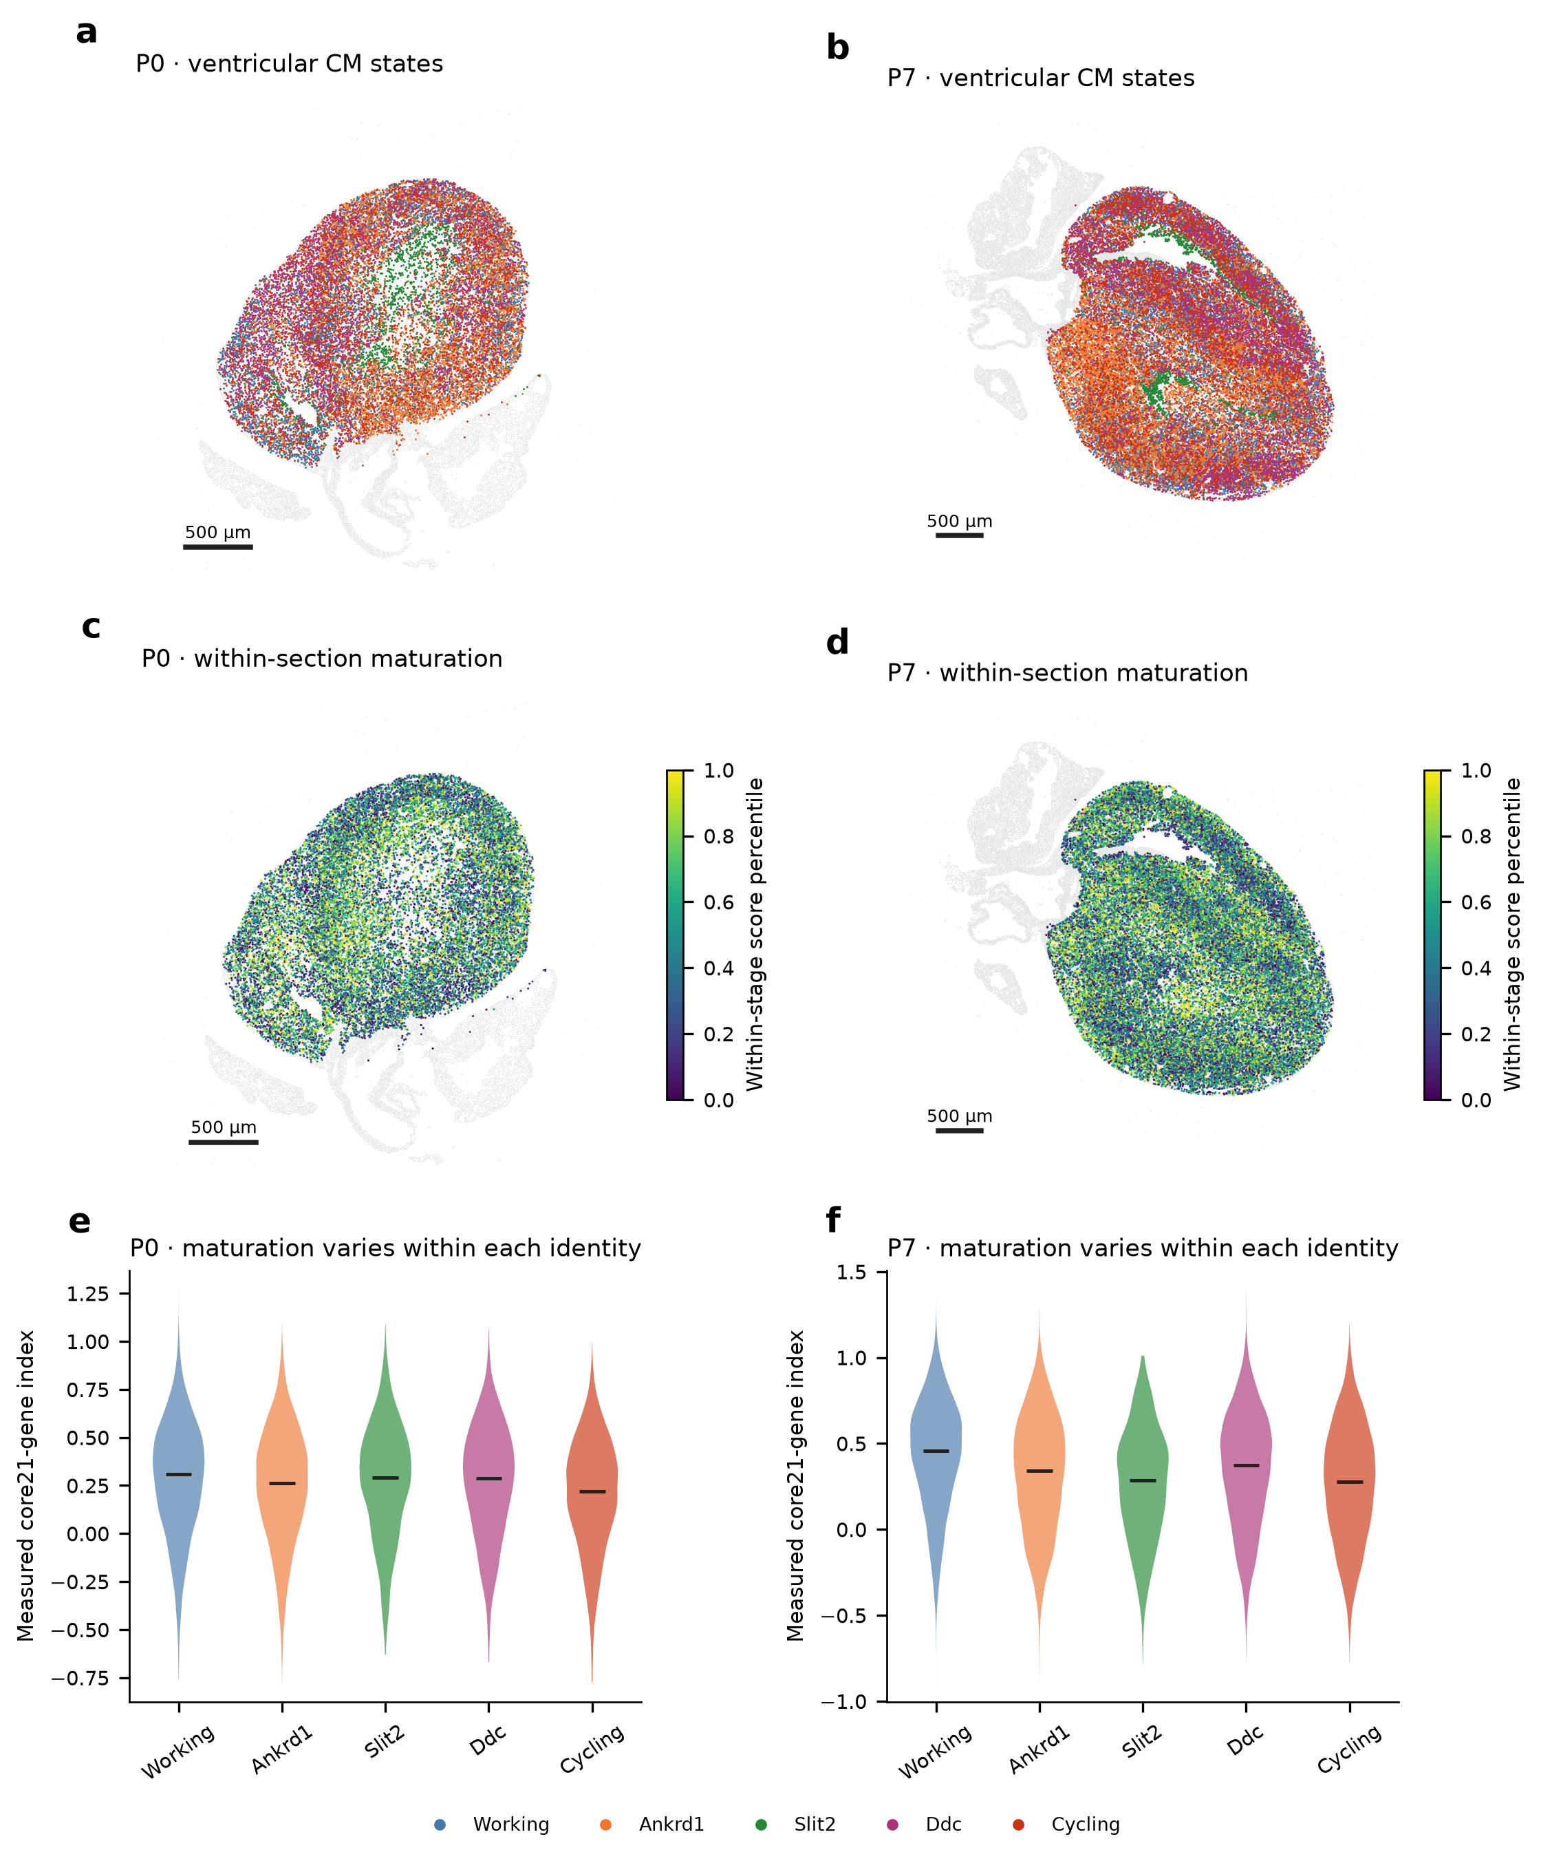
a,b, Ventricular CM subtypes at P0 and P7. c,d, Relative maturation scores in the same sections, measured using the 21-gene panel. e,f, Scores within each subtype. Cells with the same subtype label can differ in maturation-associated gene expression. A higher score does not directly measure stronger contraction or greater energy production. The labels, scores and positions are unchanged from the earlier analysis. Scale bars, 500 µm.

Figure 2. Fibroblasts develop different matrix-associated features
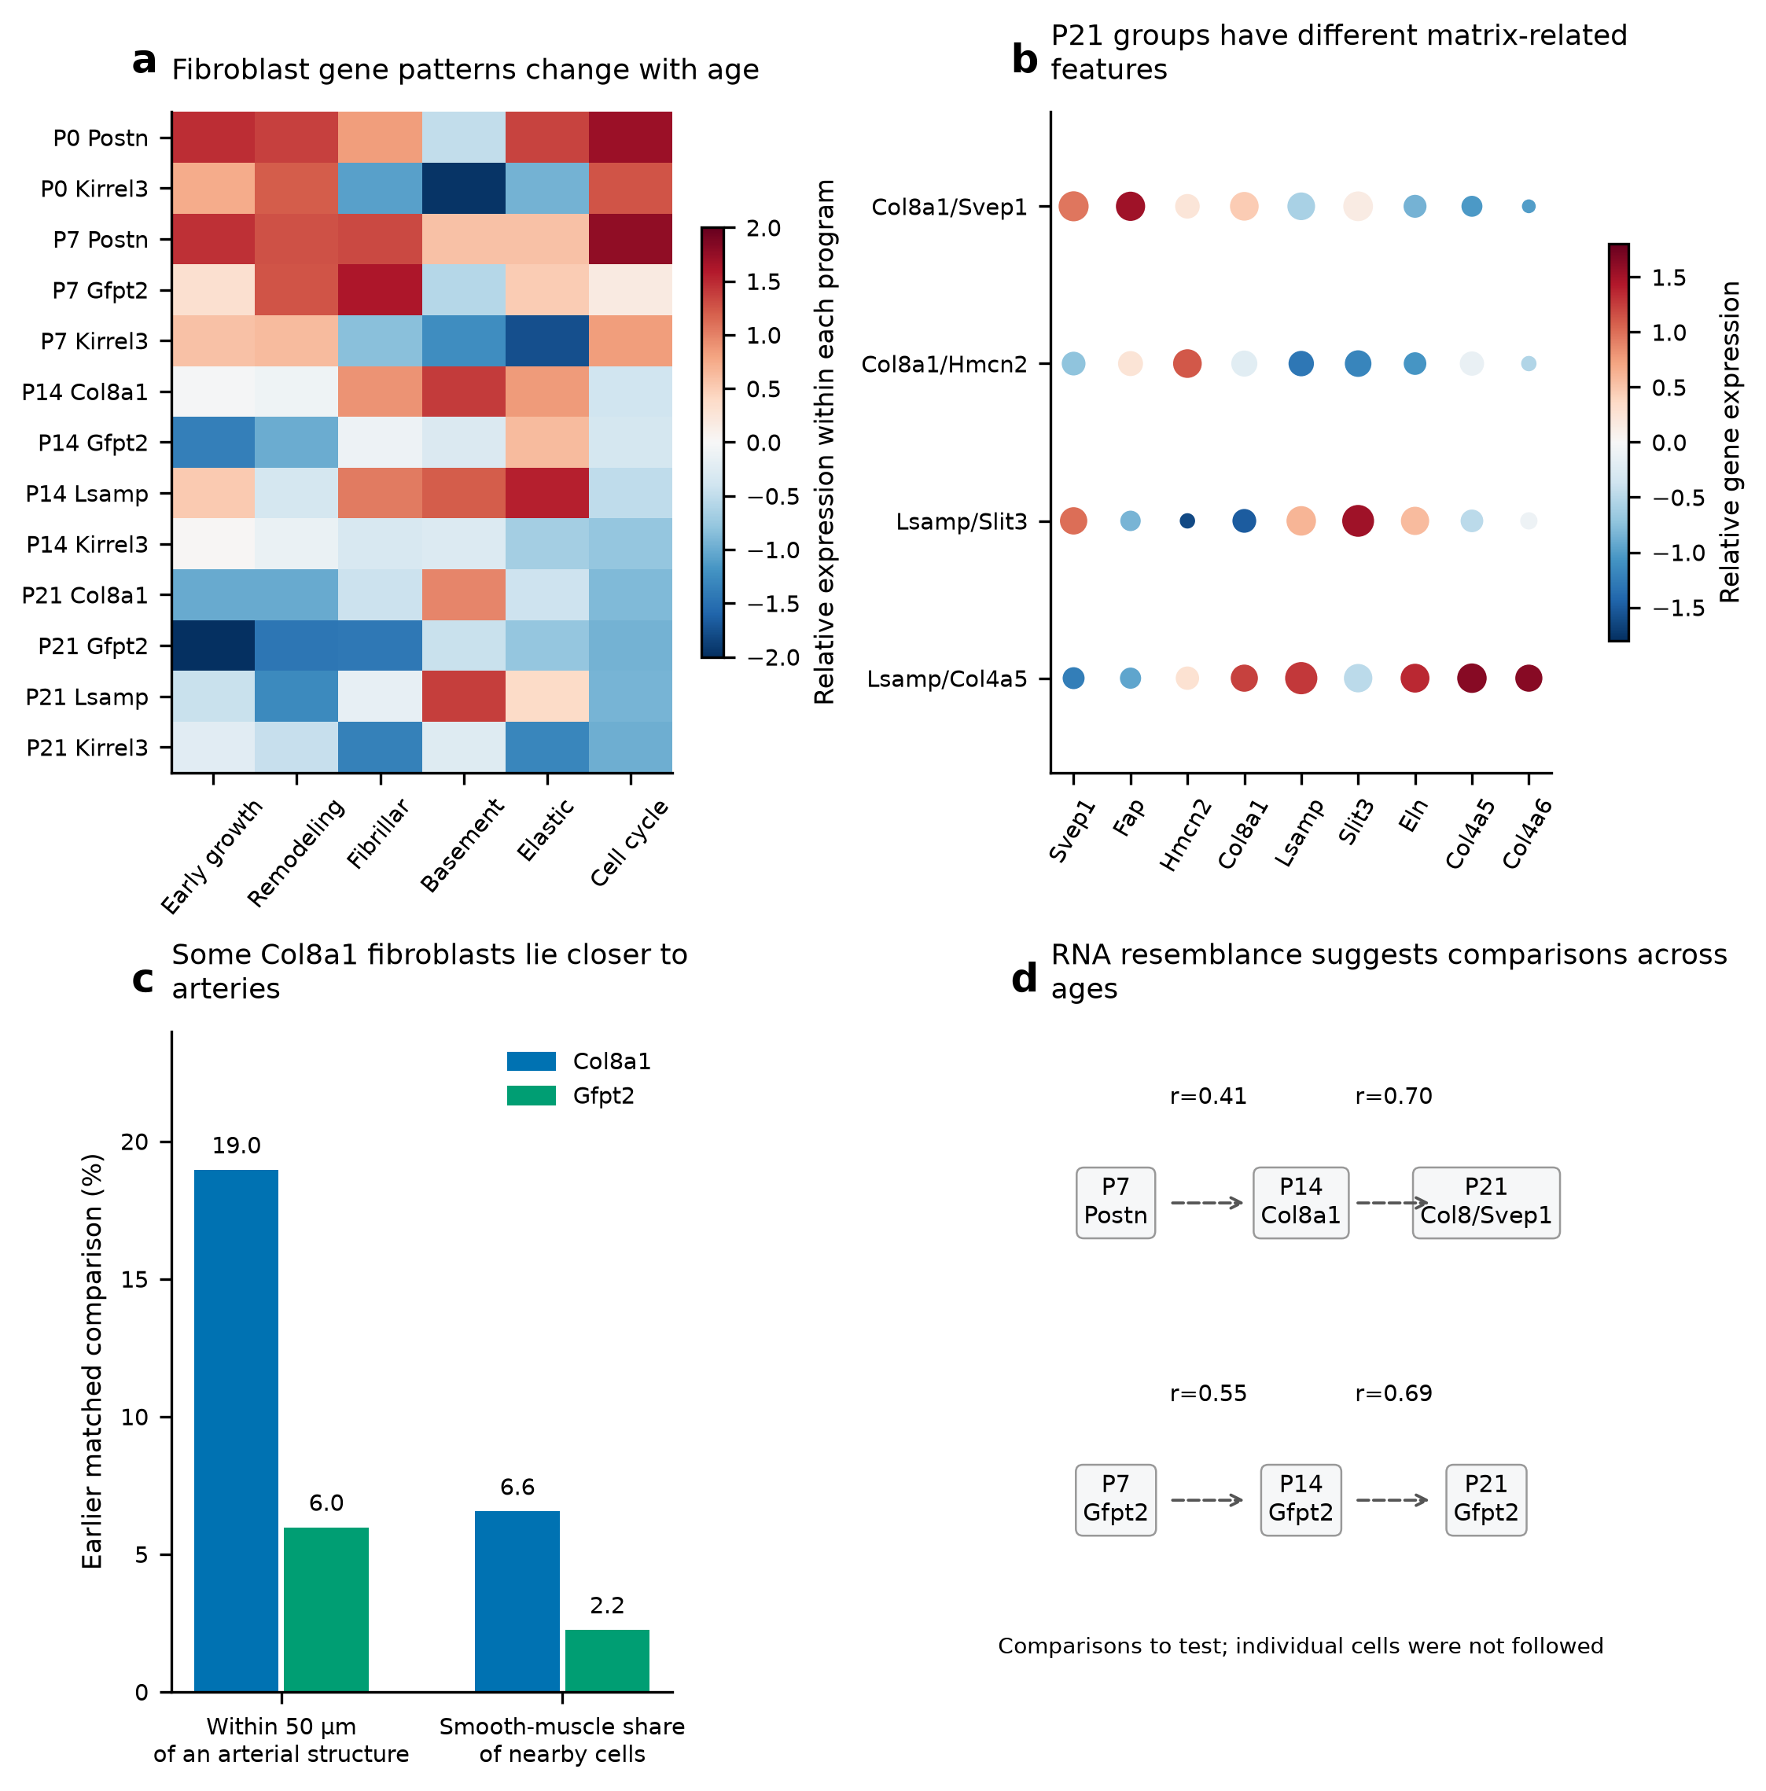
a, Matrix-associated gene expression across ages and fibroblast groups, averaged across the two RNA libraries and shown relative to the other groups. b, Marker expression in named P21 subgroups; larger dots indicate detection in more nuclei, and color shows relative expression. c, Col8a1 fibroblasts were more often near arterial structures and smooth-muscle cells than matched Gfpt2 fibroblasts in the earlier P14 comparison. This panel retains the earlier conservative labels. d, Selected early and later RNA groups resemble one another even when interpreted markers are withheld. Dashed arrows identify comparisons to follow; they do not show one group becoming another.

Figure 3. Alternative methods recover broader fibroblast candidate maps
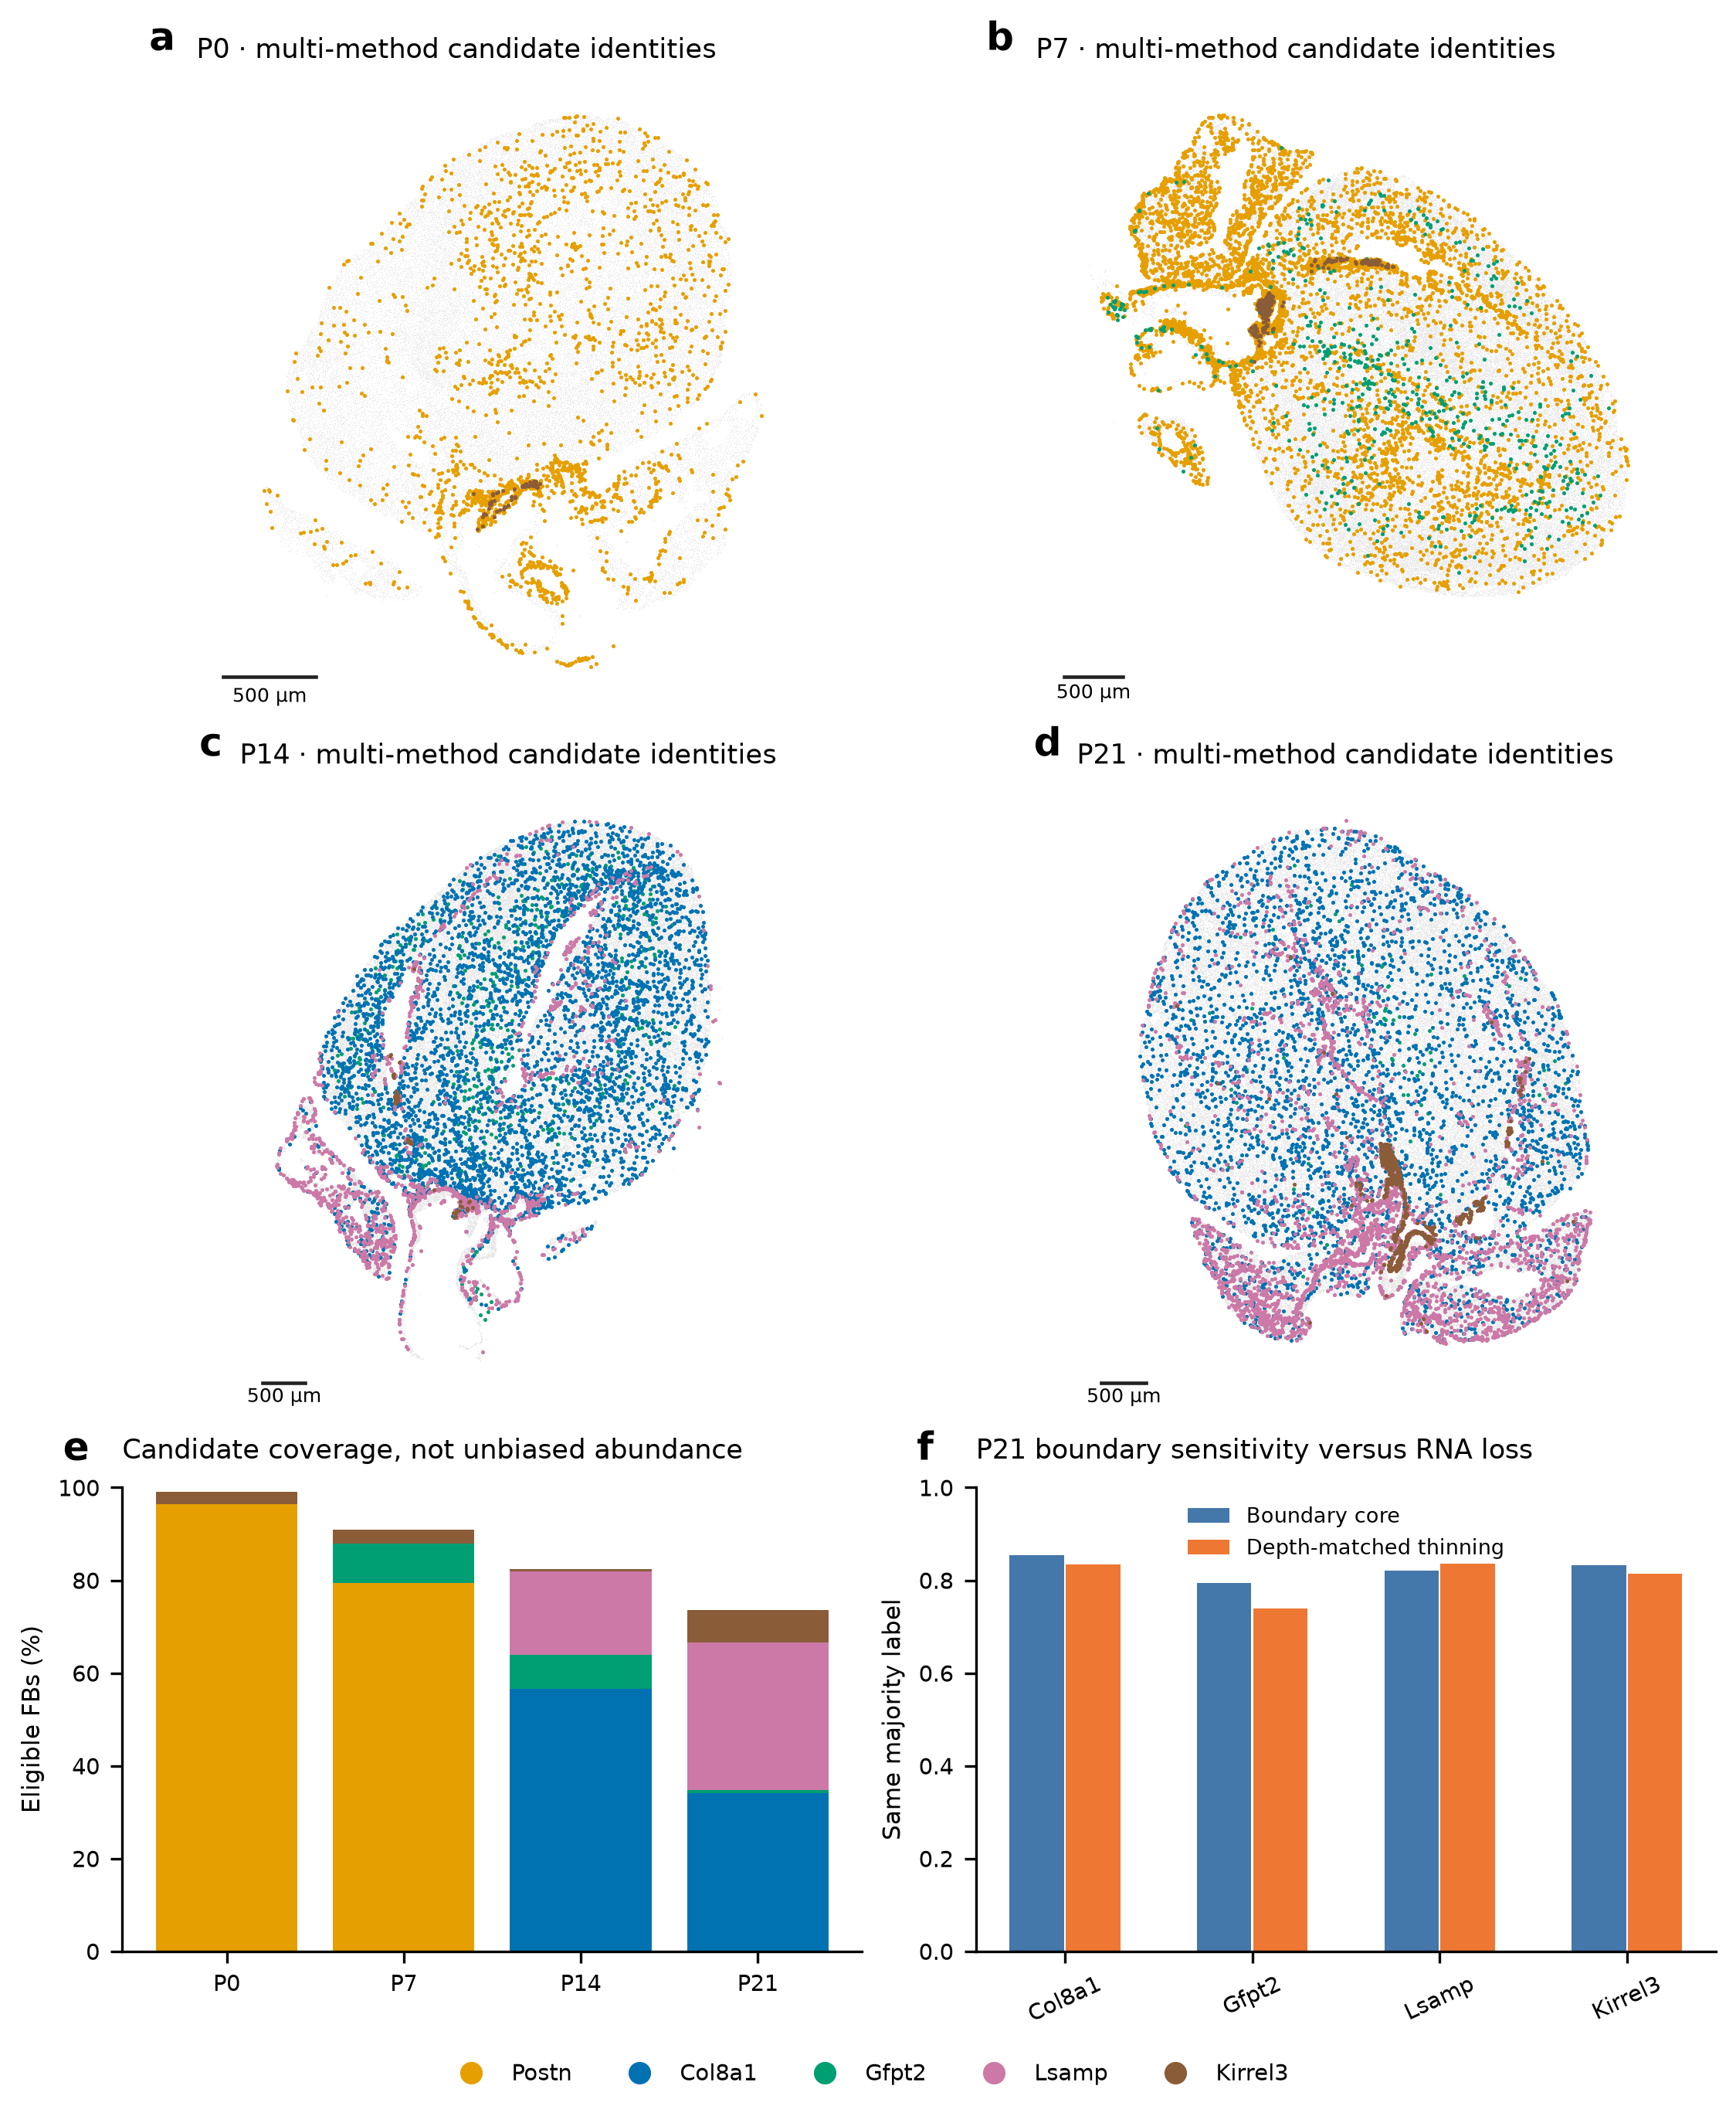
a–d, Candidate fibroblast subtypes at P0, P7, P14 and P21. e, The fraction of eligible fibroblasts receiving a candidate identity. More labels give a broader map, but do not by themselves establish greater accuracy or tissue-wide abundance. f, Agreement between whole-cell and inner-cell assignments at P21. Randomly reducing whole-cell RNA to a similar depth helps test whether disagreement reflects fewer transcripts or their position within the cell. Supported alternative nuclear identities remain flagged for review. Gray shows profiles without a confident candidate. Scale bars, 500 µm.

Figure 4. A Gfpt2-associated pattern extends beyond the narrow subtype
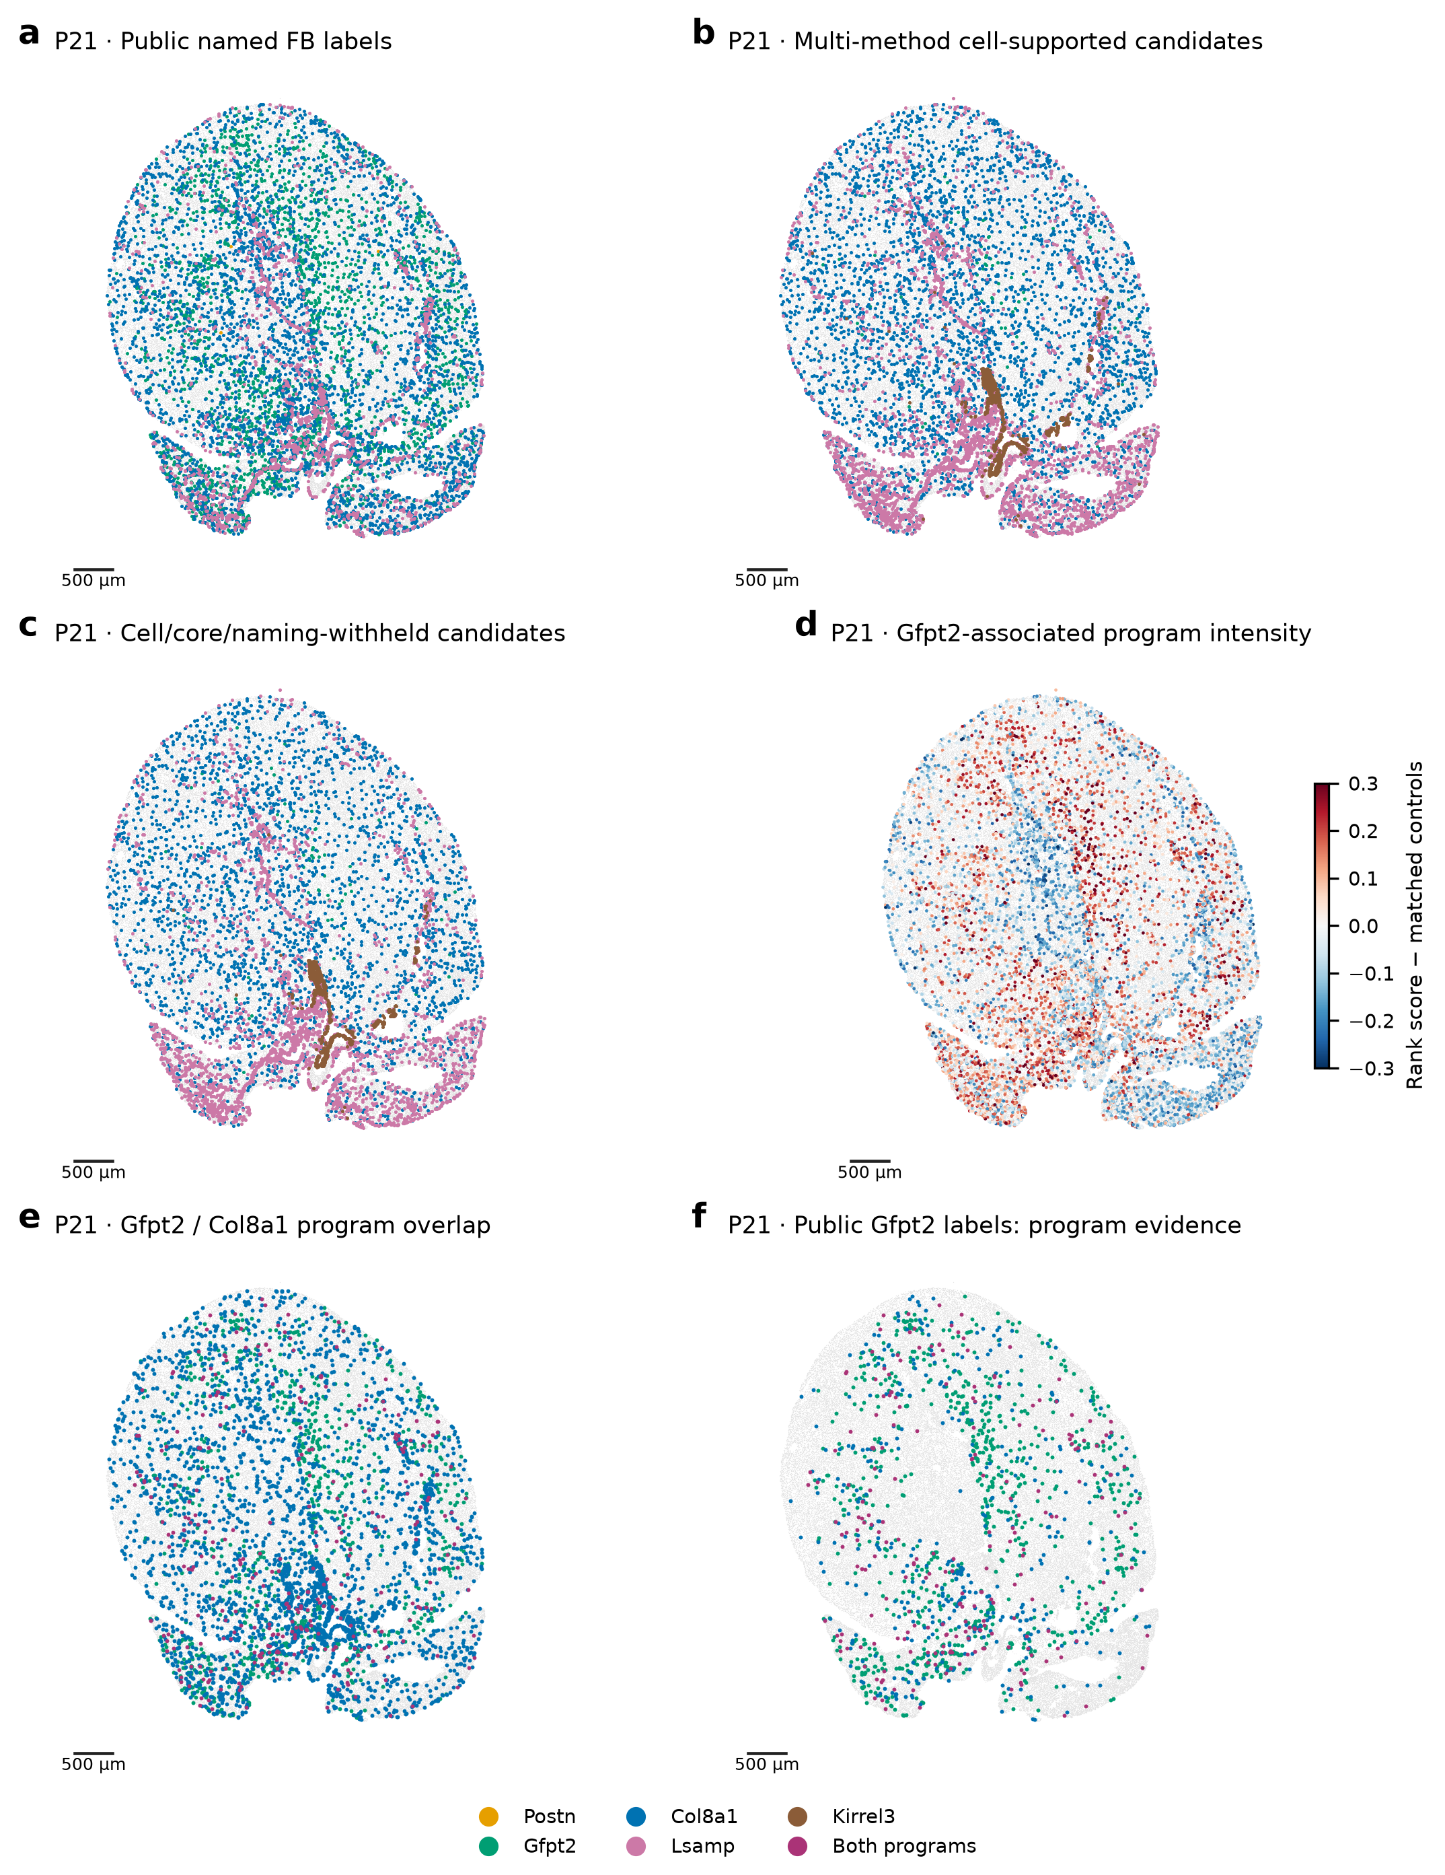
a, The paper’s fibroblast labels among eligible P21 profiles. b, Candidate identities from agreement between classifiers. c, A smaller subset also supported by inner-cell RNA and by tests that hide the naming genes. d, Expression of the measured Gfpt2/Pi16/Adgrd1 pattern relative to control genes. e,f, Cells expressing Gfpt2-associated, Col8a1-associated or overlapping patterns, across all eligible fibroblasts and within the paper’s Gfpt2 group. A shared gene pattern can cross subtype boundaries. Kirrel3 candidates are not assumed to occupy valves. Gray profiles and review flags retain uncertainty. Scale bars, 500 µm.

Figure 5. Vascular growth and CM maturation have different relationships over time
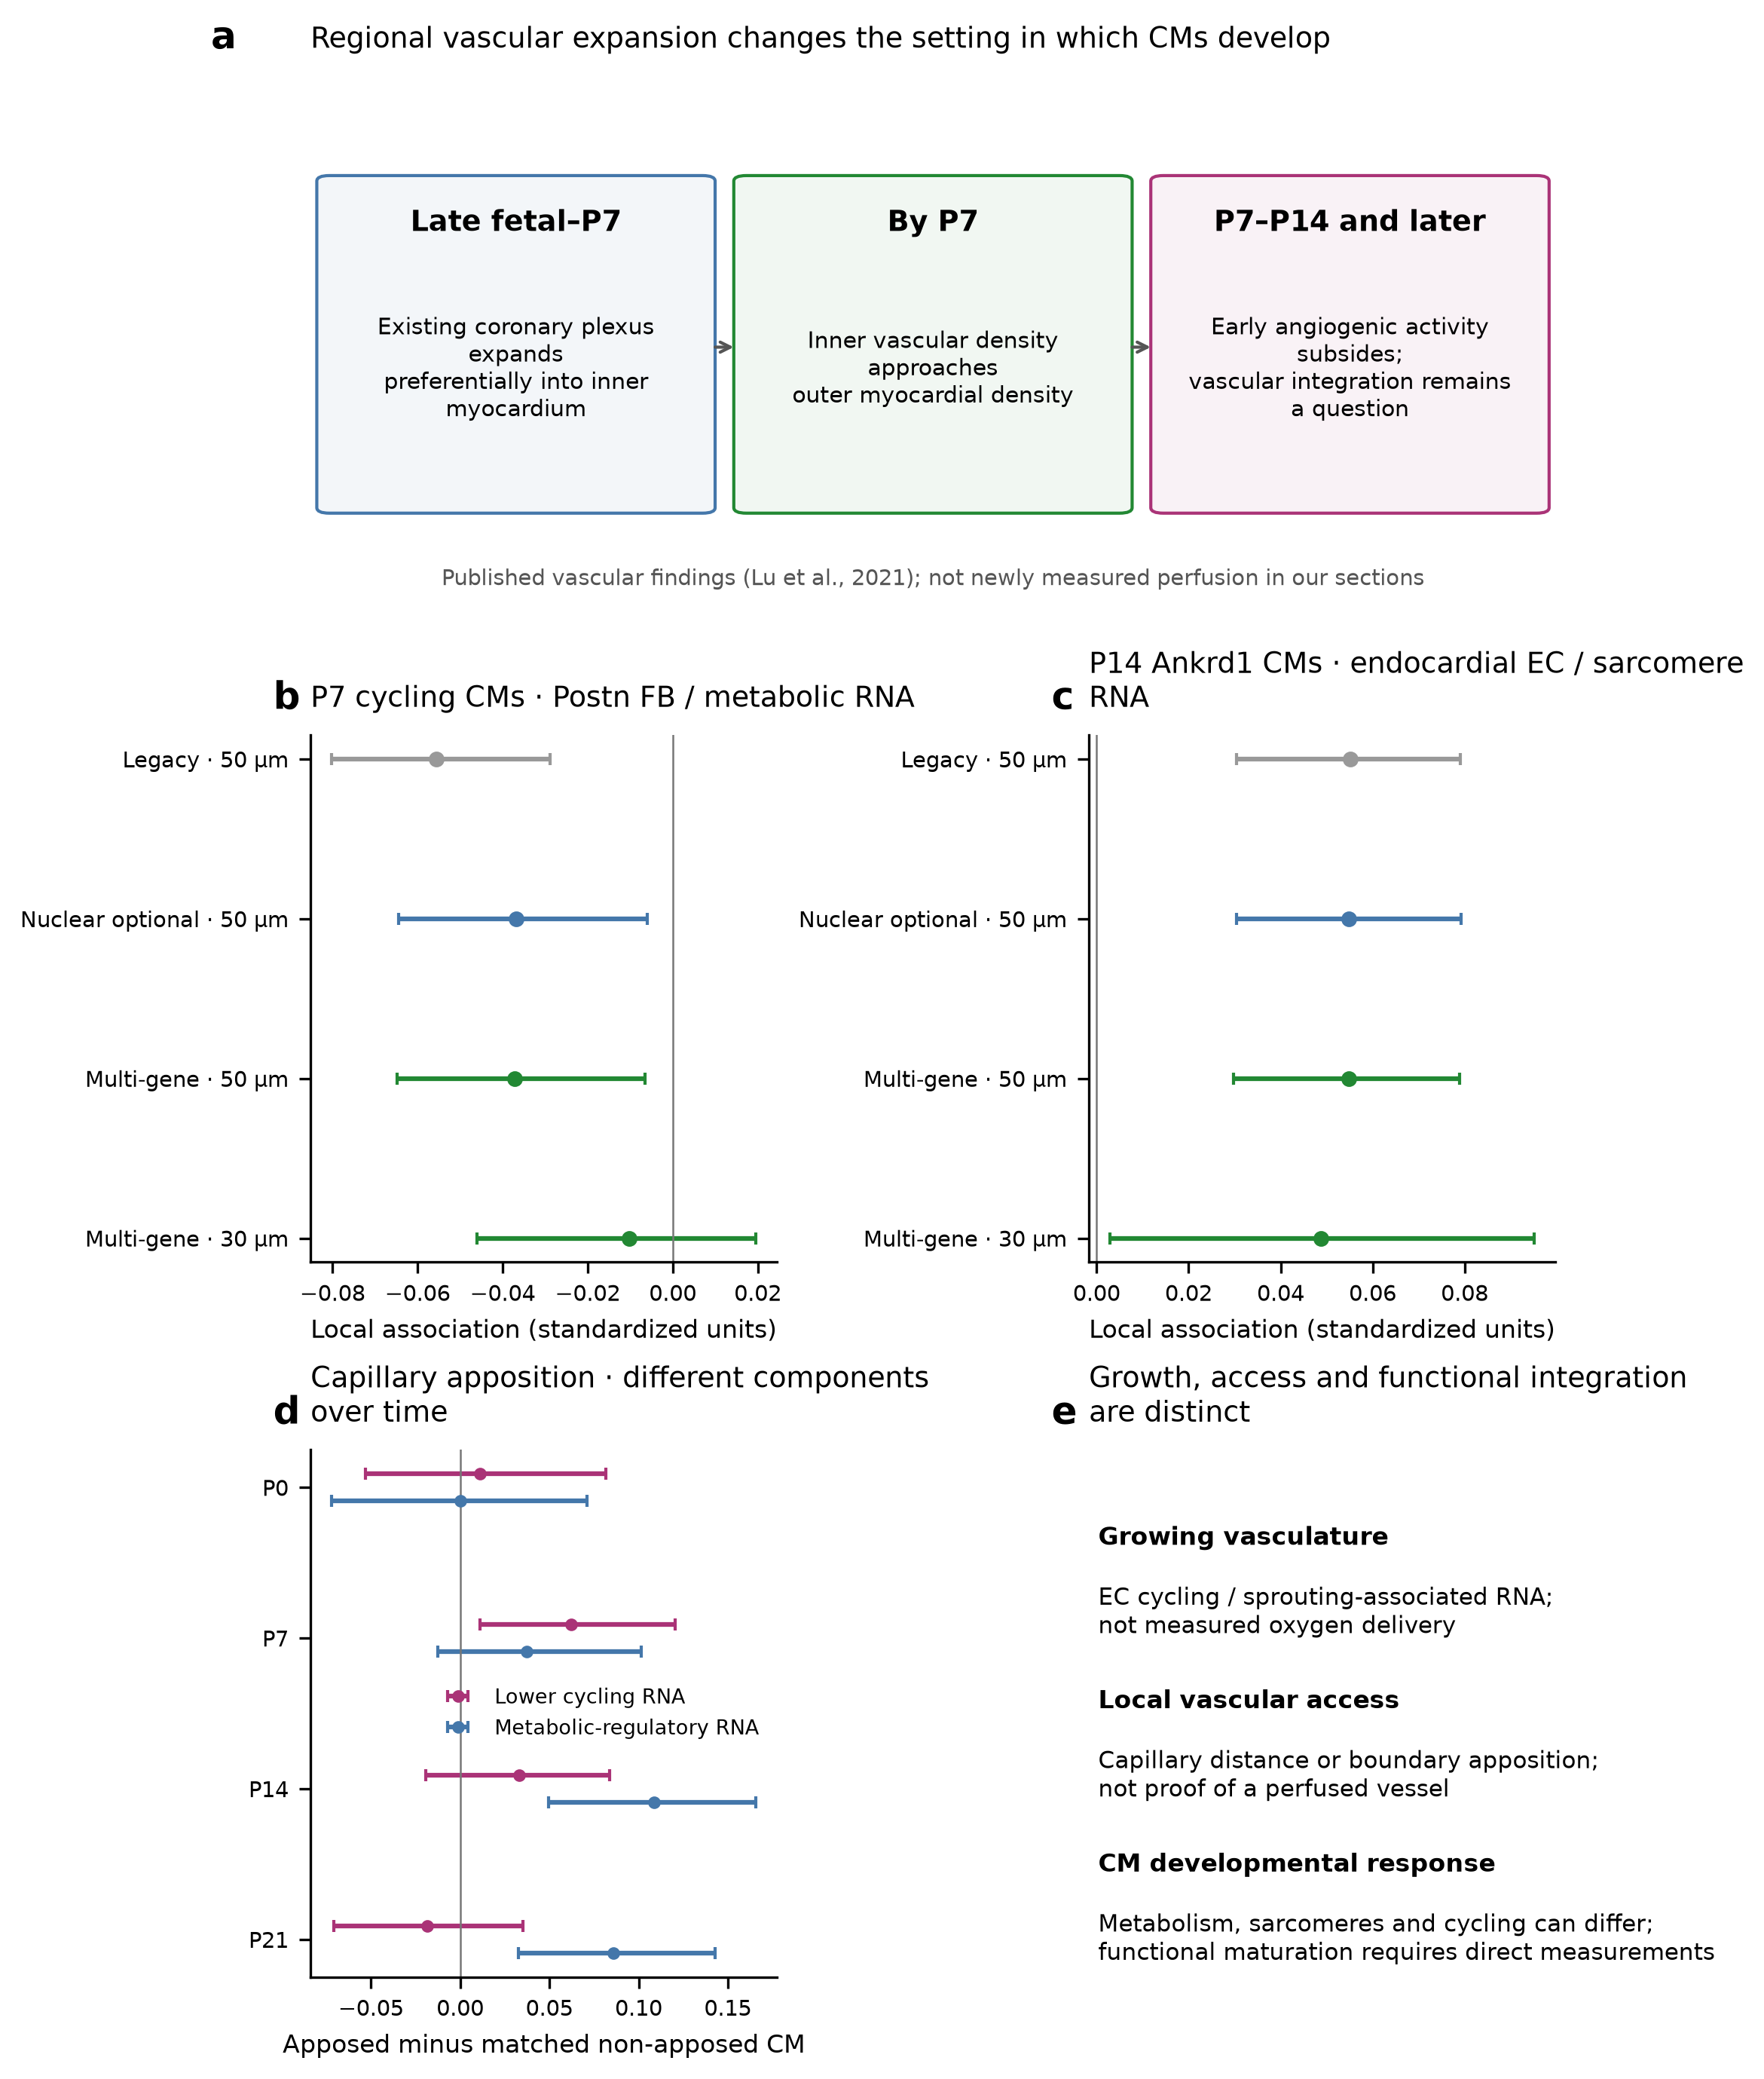
a, Coronary growth described by Lu et al. (2021); blood flow was not newly measured here. b, At P7, cycling CMs near Postn-associated fibroblasts showed lower energy-metabolism gene expression, but the relationship weakened with alternative fibroblast and neighborhood definitions. c, At P14, Ankrd1-associated CMs near endocardial-like cells showed higher sarcomere-gene expression. Intervals describe uncertainty within a section. d, Comparable CMs alongside capillary cells showed lower cell-cycle gene expression at P7 and higher energy-metabolism gene expression at P14/P21. This analysis uses a broader CM cohort. e, Growing vessels, being near a vessel and receiving a functioning blood supply are different observations. These earlier estimates have not been refitted with the newest fibroblast labels.

Figure 6. Some cellular environments resemble one another across ages
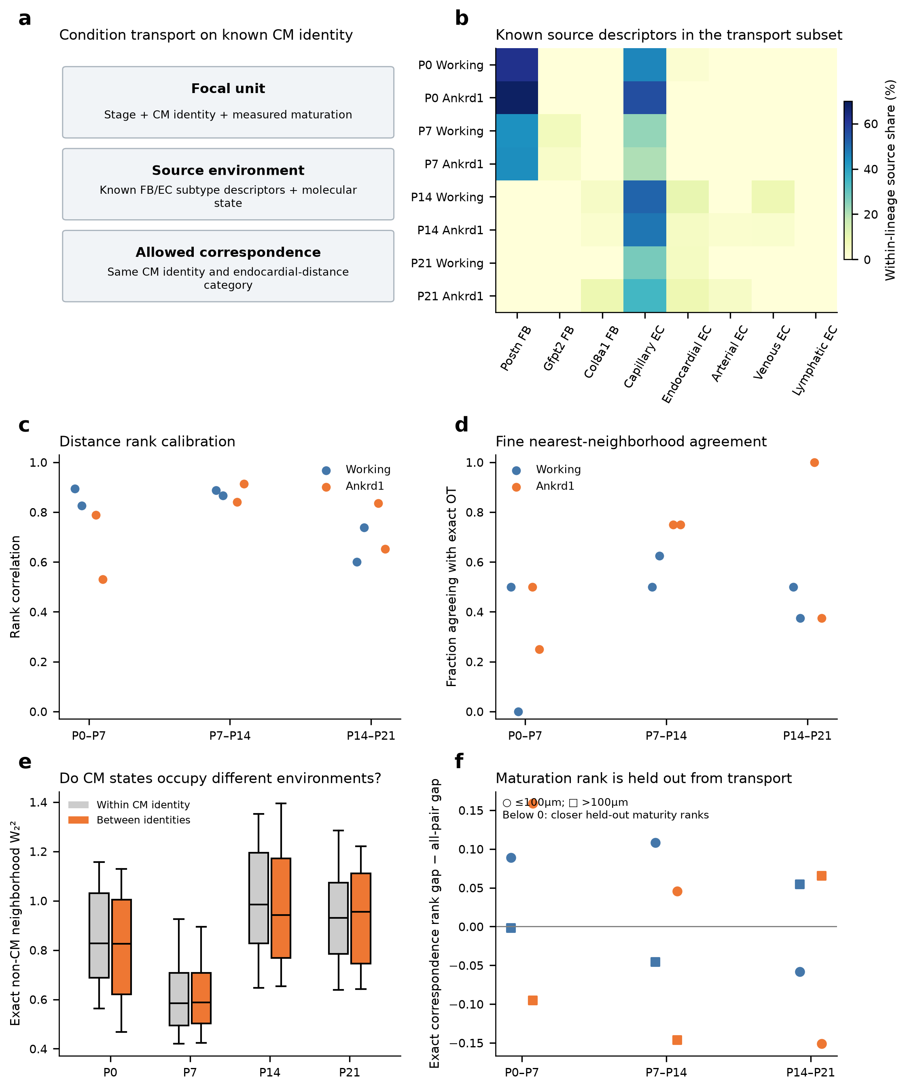
a, Neighborhoods are compared around the same CM subtype and at a similar distance from the chamber lining. b, Fibroblast and endothelial composition in 96 observed neighborhoods, using the earlier strict assignments. c,d, Agreement between Wormhole and exact calculations of neighborhood similarity. e, Similarity of environments around the same or different CM subtypes within an age. f, Maturation ranks are compared after matching; they were not used to select the matches. Some matched environments contain CMs with similar relative maturation, but this varies by age and region. No individual cells were followed. The newest fibroblast labels have not been incorporated into these comparisons.

Figure 7. Experiments can separate blood supply, matrix and contact effects
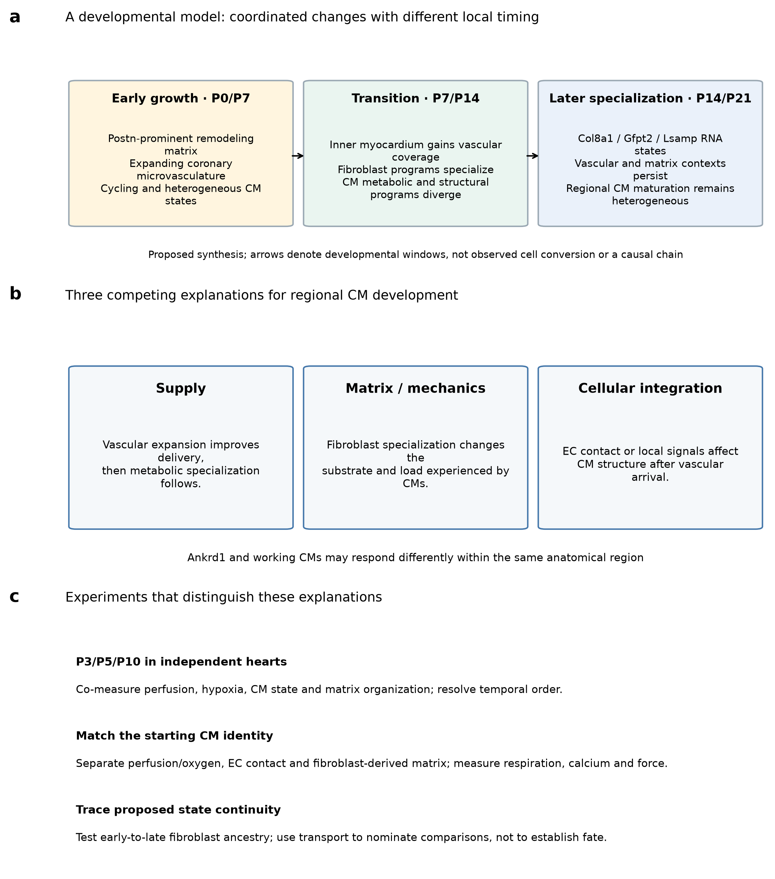
a, A proposed sequence linking early tissue growth with later muscle specialization. Arrows indicate developmental periods, not observed cell conversion. b, Blood delivery, matrix organization and endothelial contact may each contribute to CM development. c, Intermediate-stage hearts and controlled experiments can test whether these contributions occur in a particular order or act together. Measurements should include blood flow, CM energy use, calcium handling and contraction. Lineage tracing addresses cell ancestry. These are experimental predictions, not demonstrated causal relationships.

Methods

Data and scope of this revision
We integrated the deposited P0, P7, P14 and P21 heart data [1] with the earlier reviewed spatial analyses and the alternative fibroblast reassessment. Original spatial coordinates, broad cell identities and count matrices were retained. Earlier snRNA-seq QC included doublet screening and ambient-RNA correction. There is one available spatial section per age.
This revision changes the report's presentation. The newest fibroblast classifiers update identity maps and marker analyses, but have not been used to refit the earlier CM-neighbor associations, matched vascular comparisons or transport plans. In particular, the P14 19%-versus-6% arterial comparison and the estimates in Figure 5 retain their earlier source definitions.

Cardiomyocyte selection and maturation measurements
The ventricular cohort includes profiles with compatible released labels—v.CM, Ankrd1.CM, Slit2.CM, Ddc.CM and the ventricular-supported part of p.CM—and supporting ventricular markers. Profiles also meet the earlier morphology rule, contain at least 20 core-panel molecules and have at least 20 molecules outside the outcome genes. Missing nuclear area alone does not exclude a cardiomyocyte. These rules select an analytical cohort; they do not independently verify anatomical or functional identity.
The frozen 21-gene panel provides the overall maturation index. Metabolic-regulatory, sarcomere, excitation/contraction and lower-cycling measurements are examined separately. Relative low/high groups are defined by quartiles within each age and CM subtype. A high-ranked P0 cell is therefore not assumed to be as physiologically mature as a high-ranked P21 cell. Myl2 contributes both to the panel and partly to ventricular selection.

Fibroblast reference and classifiers
The clean RNA reference contains 14,328 fibroblast nuclei. We excluded 35 with unresolved programs from named-family training. Primary classifiers use families present in the same-age reference; a missing reference class does not establish biological absence. The shared RNA matrix contains 381 of the 403 Xenium targets. Identity training excludes CM maturation/response genes, CM lineage markers, cycling genes and sex genes. Training features must be detected in at least five cells or 0.5% of the training cohort, whichever is larger.
We compared three ways of recognizing a family. Balanced multinomial logistic regression learns combinations of normalized gene expression. It uses log1p counts per 10,000 retained-feature molecules, training-reference means and SDs, an SD floor of 0.25, clipping to ±5, C=0.3 and balanced class weights. Rank-centroid classification compares within-cell gene-expression ranks with library-balanced family templates, using centered-rank cosine scores and a temperature of 0.02. The negative-binomial model compares observed counts with library-balanced family templates while accounting for query depth and training-derived dispersion, clipped to 0.5–100. Class log likelihoods are divided by the square root of query depth. The resulting weights are not calibrated probabilities of Xenium identity.
Each RNA library is predicted using the other library for training. Sensitivity analyses reduce RNA information by Poisson thinning toward 60 molecules or by 15% random gene dropout. Other comparisons use raw RNA, empirical RNA priors and a pooled P14/P21 reference. Pooled tests hold out the same replicate-number group across both ages. The naming-gene test excludes Postn, Tnc, Gfpt2, Pi16, Col8a1, Lsamp and Kirrel3 from both classification and query normalization. These checks test recovery of reviewed RNA labels, rather than independently verified spatial identities.

Candidate identities and shared marker patterns
Candidate assignments retain the existing broad-fibroblast QC mask. At least two classifiers must agree after passing family-specific reference screens, and a profile must contain at least 20 retained-feature molecules and eight detected genes. Each screen uses the lowest tested score threshold giving at least 20 reference predictions, representation from both held-out libraries and pooled apparent precision of at least 0.8. Because thresholds are selected from these same predictions, they are not unbiased estimates of future accuracy.
We compare whole-cell assignments with transcripts in the inner-cell core and nucleus. A supported alternative core identity triggers review. The cell/core subset requires matching supported labels in both views. The crosschecked subset also requires the same refined-cell majority when naming genes are hidden. Nuclear support is optional; a supported nuclear alternative remains an explicit review flag, even for a crosschecked candidate. These views share evidence and are not independent anatomical validation. Classifiers do not separately recenter query genes or force spatial populations into target proportions.
Published marker sets are taken from Supplementary Table 3, retaining shared measured genes with positive log2 fold change and adjusted P<0.05. At least three genes are needed for a module. The Gfpt2 set contains Gfpt2/Pi16/Adgrd1; the Col8a1 set contains Col8a1/Cmklr1/Col6a3/Htra3; and the Lsamp set contains Lsamp/Itgbl1/Col8a1. Mean within-cell marker rank is compared with 200 control sets matched to RNA-reference abundance deciles. A descriptive enrichment flag requires a score above 90% of control sets and at least two detected markers. It is neither a cell-type probability nor a single-cell significance test.
Native, refined whole-cell, boundary-core and nuclear-only counts are analyzed separately. Three random-thinning repetitions reduce refined counts to the expected core depth without changing cell geometry. Hidden naming genes are inspected only after groups are formed without them. RNA summaries retain both libraries and raw/corrected views. Assignment coverage is calculated among eligible broad fibroblasts; it is not an estimate of tissue-wide subtype abundance.

Earlier matrix and spatial comparisons
Matrix programs and named RNA subgroups are summarized by library and family using full-RNA pseudobulks, with raw/corrected sensitivity and duplicate gene symbols summed. Programs are means of gene log1p CPM values. The P14 Col8a1/Gfpt2 comparison uses the earlier conservative labels, matched for RNA depth, cell area, nuclear fraction and neighbor density. Arterial distance is measured to an operationally identified structure, rather than a histologically traced vessel wall. Cross-age RNA similarities are calculated with interpreted markers withheld and are not conversion rates.
The primary neighborhood graph uses tissue-screened 50-µm proximity. Graphs based on 30-µm distance or shared boundaries provide sensitivity checks. Fibroblast and endothelial fractions use all eligible neighbors of the corresponding lineage as their denominator, including neighbors without a subtype. CM models require at least five resolved neighbors and at least one eligible fibroblast and endothelial neighbor. A tested subtype requires at least 30 source profiles and at least 50 CMs with positive exposure.
Joint models include eligible subtype fractions, capture, cell area, nuclear missingness, neighbor density/counts, source capture, broad non-CM composition and anatomical distance proxies. Fits compare CMs within 200-µm regions, separately by CM subtype. Uncertainty is estimated from 512 shared resamples of 400-µm blocks. Approximate tests use bootstrap standard errors, with BH correction across the full state/source/outcome grid within each age, graph and source definition. These intervals describe variation within sections, not replication across independent hearts.
The capillary comparison matches CMs in the same region and state while controlling for capture, area, perimeter and capillary area. It uses a broader CM cohort than the subtype-specific models. Some effects weaken with stricter nuclear-supported capillary labels. Shared-boundary tests and smaller neighborhoods were less conclusive. The results therefore distinguish proximity from evidence of a direct contact mechanism.

Comparing cellular environments across ages
The frozen transport analysis contains 96 observed neighborhoods: 12 per age and CM identity, using v.CM and Ankrd1.CM. Four in each group lie within 100 µm of the endocardial proxy and eight farther away. Selection does not depend on membership in a broad niche cluster. Up to 32 observed non-CM profiles per neighborhood enter a representation of 16 molecular PCs and six lineage features. Exact squared Wasserstein costs are compared with the saved Wormhole approximation [3].
Matches are restricted to the same CM identity and endocardial-distance category. CM maturation is withheld from matching and examined afterward. Subtype descriptions retain the earlier stringent fibroblast definitions; the newest classifiers do not change the representation or plans. Matching mass does not measure survival, proliferation, ancestry or transition rates. Similar relative maturation ranks do not establish an absolute developmental clock.

Cell boundaries and validation
The atlas uses nuclear, membrane and cell-interior staining. Automatic boundaries were compared with manual outlines in five P0 and five P21 fields. The reported score is TP/(TP+FP+FN) at a 90% overlap threshold. Approximate readings are 45–50% at P0 and around 10% at P21; raw benchmark values were not recovered. This object score does not give the proportion of correctly assigned transcripts. The exact overlap normalization and relevant software version/parameters are not fully specified in the cited Methods sections. Image fields do not establish independent-heart replication.
A valid section through a large CM may contain no visible nucleus. Conversely, a boundary error can introduce CM RNA into a neighboring fibroblast or endothelial profile. We retain whole-cell, core and nuclear views rather than treating one segmentation as ground truth. Original anatomical masks, score objects and neighbor-level inputs were not recovered for exact replication of the paper's Figure 4e.
Earlier validation reconstructed neighbor measurements, checked reference-label recovery and hidden-gene exclusions, refitted selected coefficients and verified transport calculations. This revision retains those numerical results and checks its claims against the source tables. Figure data, source checksums and analysis scripts accompany the report. The matrix plate rearranges existing results; no new biological model or replicate is added.

References
1. Wang H et al. Spatially guided in vivo single-cell functional genomics of postnatal heart. Nature Cardiovascular Research (2026). https://doi.org/10.1038/s44161-026-00861-z
2. Lu P et al. Perinatal angiogenesis from pre-existing coronary vessels via DLL4–NOTCH1 signalling. Nature Cell Biology 23, 967–977 (2021). https://doi.org/10.1038/s41556-021-00747-1
3. Haviv A et al. Wasserstein Wormhole: Scalable Optimal Transport Distance with Transformers. ICML (2024). https://arxiv.org/abs/2404.09411
4. Puente BN et al. The oxygen-rich postnatal environment induces cardiomyocyte cell-cycle arrest through DNA damage response. Cell (2014). https://doi.org/10.1016/j.cell.2014.03.032
5. Mahmoud AI et al. Meis1 regulates postnatal cardiomyocyte cell cycle arrest. Nature (2013). https://doi.org/10.1038/nature12054

What the evidence supports
Biological observation | What it suggests | What remains to test
CMs of the same subtype differ in maturation-associated expression | A subtype can contain several developmental states | Energy use, calcium handling and contraction
Later fibroblast groups express different matrix genes | They may help organize different tissue properties | Deposited matrix proteins and tissue mechanics
Gfpt2-associated expression occurs across several groups | A shared pattern need not define one subtype | Several markers imaged within clear cell boundaries
EC and CM cell-cycle activity occur together at P0/P7 | Muscle and blood vessels may grow together locally | Completed division and the order of events
Capillary-adjacent CMs differ in cell-cycle expression at P7 and metabolism at P14/P21 | Early growth and later vascular support may accompany different steps | Blood flow, oxygen delivery and contact signals
P14 Ankrd1 CMs near endocardial-like cells express more sarcomere RNA | The structural relationship may differ between CM subtypes | Anatomy, mechanical loading and local signals
Some cellular surroundings resemble one another across ages | Specific regions and states are worth following | Independent intermediate-stage hearts and lineage tracing

Fibroblast identities and programs: reading the numbers
Candidate family | P0 | P7 | P14 | P21
Postn | 1,946 | 5,844 | 0 | 0
Gfpt2 | 0 | 630 | 597 | 85
Col8a1 | 0 | 0 | 4,579 | 3,702
Lsamp | 0 | 0 | 1,455 | 3,454
Kirrel3 | 54 | 227 | 50 | 751
Counts refer to candidate assignments among eligible broad fibroblasts. A zero means no candidates under that reference and rule; it is not proof that every cell or marker of that kind is absent. These are not tissue-wide abundance estimates. Kirrel3 candidates are not assigned valve anatomy from their name.
P21 Gfpt2 evidence | Profiles | Meaning
Marker-pattern enrichment | 1,339 | Broader measured Gfpt2/Pi16/Adgrd1 signal under the module rule
Also enriched for Col8a1 pattern | 327 | Overlapping RNA patterns; not proof of transition
Public Gfpt2 profiles with Gfpt2-pattern flag | 1,058 of 2,716 | The public-labelled population contains varied marker evidence
Naming-marker-hidden majority label | 280 | Candidate grouping made without the seven naming/anchor genes
Cell-supported candidate | 85 | Reference-screened model agreement without a supported core conflict
Cell/core and naming-marker consistency | 75 | A narrower supported subset; not the total biological population

Which results include the new fibroblast labels?
Result | Status in this revision
Fibroblast identity and marker-pattern maps | Updated alternative classifiers and direct programs included
CM-neighbor association estimates | Earlier models retained; not refitted with the newest classifiers
P14 arterial-proximity comparison | Earlier conservative matched subset retained
Cross-age neighborhood matching | Earlier representation and plans retained

Figure S1. The reference tests show why more labels need not mean better assignments
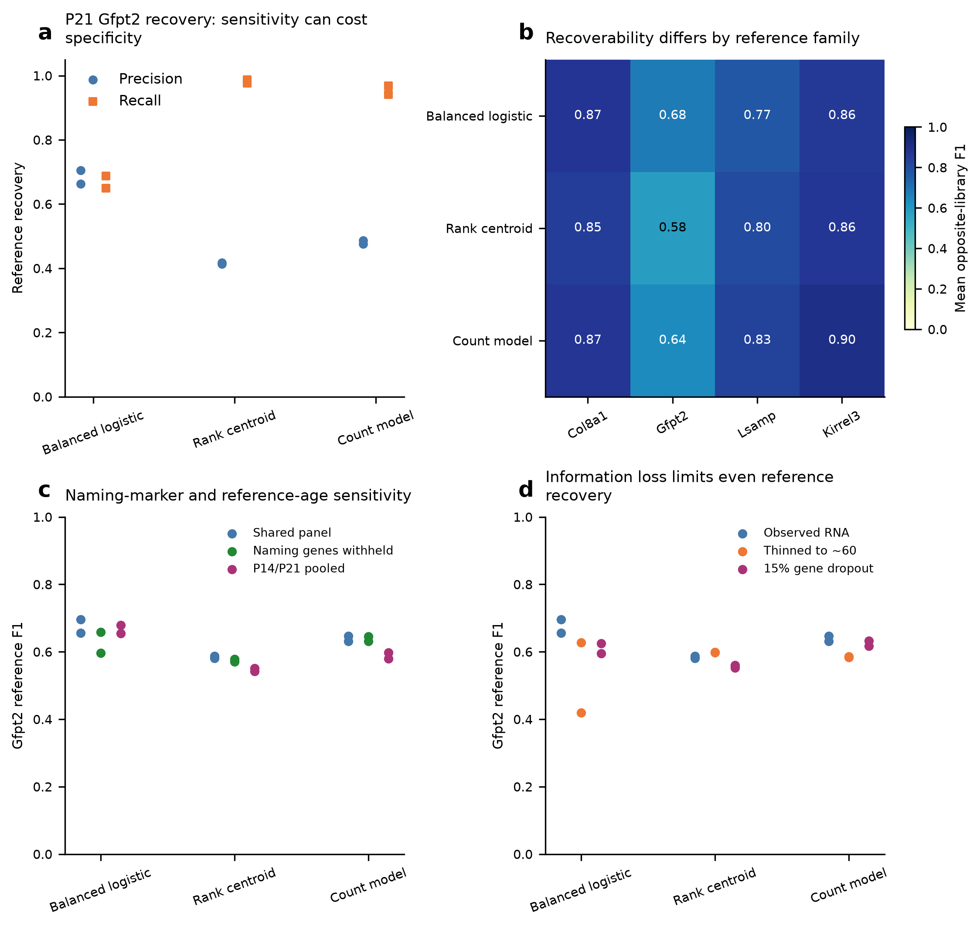
a, P21 Gfpt2 reference tests: recall measures how many Gfpt2 nuclei are recovered, while precision measures how many predicted Gfpt2 nuclei carry that reviewed label. Each point represents one held-out library. b, Recovery of the reviewed families by each method. c, Changes when naming genes are hidden or late-age references are pooled. d, Changes when less RNA information is available. A method can recover more Gfpt2 nuclei while also mislabeling other families. These tests assess the RNA definitions, not independently verified Xenium identities.

Figure S2. Hidden genes help check assignments, while marker patterns can overlap
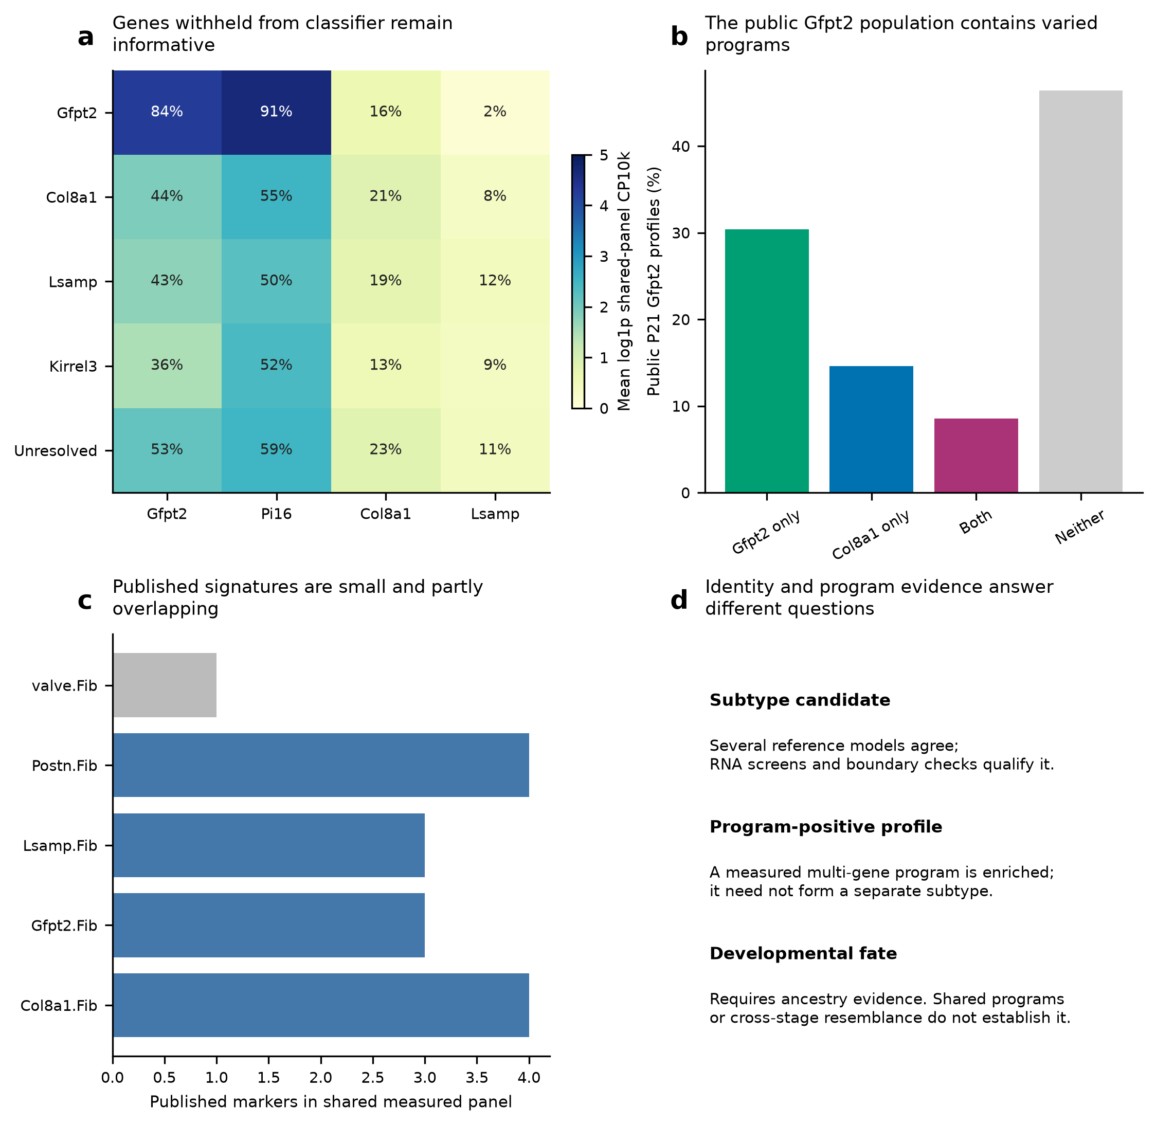
a, Expression of P21 naming genes after cells were grouped without allowing classifiers to use those genes. Printed values give detection percentages. b, Gfpt2- and Col8a1-associated patterns can overlap among cells carrying the paper’s Gfpt2 label. c, The number of published markers measured in the shared panel. Too few valve markers are measured to score a multi-gene pattern. d, A proposed subtype, a shared gene pattern and a cell’s developmental fate answer different questions.

How to read the cell-boundary results
To place a cell subtype on the map, we first need to know which RNA belongs to that cell. The atlas combines membrane, cell-interior and nuclear stains to identify cell outlines. This is especially useful for large cardiomyocytes, whose full shape cannot be determined by drawing a fixed area around the nucleus.
The authors compared the automatic outlines with expert drawings in five P0 and five P21 image fields. Their combined-stain method performed better than nucleus expansion. Agreement was poorer at P21: approximate scores were 45–50% at P0 and around 10% at P21 under a demanding 90% overlap rule. These values describe agreement between cell outlines, not the percentage of RNA assigned correctly. A cell can fail the strict outline test while still retaining many correctly assigned interior transcripts.
This matters for fibroblasts and endothelial cells beside RNA-rich cardiomyocytes. A small boundary error can introduce neighboring muscle RNA and change a subtype assignment. Conversely, a section through a large CM may contain no visible nucleus. Removing every profile without a nucleus would discard some valid muscle-cell information.
We therefore compare whole-cell RNA with RNA from the inner part of the cell and the nucleus. Agreement strengthens an assignment. Sparse nuclear RNA does not by itself disprove the whole-cell label, but nuclear evidence for another cell identity requires review. Each view provides useful information; none proves the true boundary on its own.
The next step is direct imaging of selected cell interfaces, using clear membrane outlines and several subtype markers in the same cells. This would help determine whether overlapping fibroblast patterns occur within individual cells or result from RNA assigned across a boundary. The detailed earlier assessment and the atlas Methods and Supplementary Figure 1 are linked in the source record.
Sources: Wang et al. (2026), segmentation Methods and Supplementary Figure 1; the earlier detailed segmentation assessment accompanies the source record.

