  - UNIFIED BIOLOGICAL REPORT • CURRENT INTEGRATED RESULTS

Muscle, matrix and vascular development in the postnatal heart
P0–P21 mouse-heart snRNA-seq and Xenium analysis

Central message
The postnatal heart contains changing muscle, matrix and vascular environments. Early EC and CM cell-cycle activity occurs together, while later vascular proximity accompanies selected metabolic or structural RNA patterns. Fibroblast programs change and overlap, but the latest refit does not establish one general fibroblast effect on CM maturation. Specific structural settings now provide focused hypotheses to validate.
This single report integrates the CM states, five endothelial categories, alternative fibroblast identities, full-RNA matrix features, latest spatial refit, calibrated cross-age comparisons and experimental roadmap. Nine main figure plates, four supporting plates and consolidated tables are included. Explanations lead with biology; reproducible definitions are collected in Methods.
The newest fibroblast labels are incorporated into the CM-neighbor and matched fibroblast spatial analyses. Earlier capillary-adjacency estimates retain their original cohorts. Cross-age fibroblast descriptions are updated; exact/Wormhole matching plans remain frozen. One available section per age limits developmental and causal inference.
Prepared 27 October 2026 • Earlier reports and source data remain available.

Abstract
After birth, the heart must grow while becoming capable of sustained pumping. We integrated the P0, P7, P14 and P21 Heart Atlas analyses to examine how cardiomyocyte states, fibroblast environments and vascular development relate across tissue regions. Cardiomyocytes of the same subtype differed in maturation-associated expression within a section. Fibroblasts also expressed changing combinations of matrix genes, and broader assignments recovered late populations missed by strict nuclear-confirmation rules. At P14, approximately 11% of Col8a1 candidates were near arterial structures, compared with 7% of matched Gfpt2 candidates. Early endothelial and CM cell-cycle activity tended to occur together; earlier matched capillary comparisons associated proximity with lower cell-cycle expression at P7 and higher metabolic-regulatory expression at P14/P21. The latest CM-neighbor refit, however, did not establish a general fibroblast effect on maturation: no fibroblast identity or program association passed correction across the full primary test set. A P0 elastic-matrix relationship remains a follow-up candidate. The clearest corrected association was P14 endocardial-like surroundings with Ankrd1-CM sarcomere expression, although it depended on transcript assignment. Updated descriptions of cross-age matches showed a P7-to-P14 shift from Postn-associated toward Col8a1-associated expression, without establishing cell ancestry. Together, the analyses identify specific regional environments and developmental comparisons to test with independent hearts, direct boundary validation and measurements of vascular and CM function.

Introduction
The heart must meet increasing demands after birth. Its muscle grows, cardiomyocytes change how they use energy, and their contractile machinery develops. These changes take place while blood vessels expand and fibroblasts organize the extracellular matrix around and between cells. Cardiomyocyte development therefore depends on more than changes within the muscle cells themselves.
The Heart Atlas allows us to examine these processes in the same tissue [1]. We ask whether cardiac cell subtypes occupy different locations and relate differently to one another. Ankrd1-associated and working ventricular cardiomyocytes may respond differently to their surroundings. Fibroblasts expressing Postn-, Gfpt2-, Col8a1- or Lsamp-associated patterns may contribute different features of the developing matrix.
The vascular study by Lu and colleagues provides an important anatomical setting for these questions [2]. It showed that existing coronary vessels expand around birth, especially into the inner myocardium—the ventricular muscle toward the chamber cavity and its endocardial lining. We use this finding to ask how growing vessels, changing fibroblast states and cardiomyocyte development might coordinate within different parts of the ventricular wall.
The latest fibroblast reassessment is incorporated throughout this report. We distinguish which fibroblasts occupy a region from whether their identities or shared expression patterns explain differences between neighboring CMs. This brings tissue organization, local associations and developmental comparisons into one account without treating them as equivalent evidence for a mechanism.

Results

The major cardiac populations define different tissue settings
The atlas places the major cardiac populations in a common spatial setting: muscle cells, endothelial cells, fibroblasts, pericytes, smooth-muscle cells, immune cells and epicardial cells (Fig. 1a–d). Their distributions provide the tissue context for more specific subtype comparisons. A concentration of smooth-muscle cells, for example, helps identify a vascular setting, while surface-associated cells and chamber-facing structures define different environments from the surrounding muscle. These broad maps do not establish communication between neighboring cells.
We retain five practical endothelial categories: capillary-like, endocardial-like, arterial-like, venous-like and lymphatic-like (Fig. 1e–h). The maps show the supported subset, with unassigned endothelial profiles kept visible. A sparse subtype map does not prove that the corresponding vessels are absent. Capillary and endocardial environments are examined separately because a cell lining the chamber and a cell belonging to the coronary network have different anatomical roles.
Cycling or sprouting-associated expression describes an endothelial state that can occur within a vascular category. It should not be treated as a separate vessel identity or as proof that a vessel is delivering blood. Similarly, a lymphatic assignment requires endothelial identity and a broader lymphatic marker pattern; Lyve1 alone is insufficient.

A cardiomyocyte subtype does not have one fixed level of maturity
At P0 and P7, both Ankrd1-associated and working ventricular cardiomyocytes showed a wide range of maturation-associated gene expression within the same section (Fig. 2). Two cardiomyocytes with the same subtype label could therefore differ in their expression of genes involved in energy metabolism and contraction. Subtype identity and developmental state describe different features of a cell.
We measured these differences using a panel of 21 genes and examined the metabolic, structural and cell-cycle patterns separately. A higher panel score means stronger expression of the measured maturation-associated genes. It does not tell us directly how strongly a cell contracts or how efficiently it produces energy. Separating these measurements matters because a cardiomyocyte can retain cell-cycle activity while developing other aspects of its function.
The subtypes also occupied different parts of the tissue. Slit2-associated cardiomyocytes were more often found toward the chamber lining in the released maps. Ankrd1 expression was enriched near identified arterial structures, particularly at P7 and P14, but many Ankrd1-associated cardiomyocytes were elsewhere. Because Ankrd1 can accompany adaptation to mechanical loading, this pattern raises the possibility that local forces or matrix organization contribute to the state of these cells. It does not establish an exclusively artery-associated subtype or indicate disease in the developing heart. The native Slit2 and Ankrd1 maps provide additional regional context (Fig. S4). Kcnd2 and Irx5 are not measured in the deposited 403-gene panel, so those genes cannot directly locate a proposed transmural subtype in Xenium.

Fibroblasts acquire different matrix-associated features
Early fibroblasts prominently expressed a Postn-associated pattern. At later ages, Col8a1-, Gfpt2- and Lsamp-associated groups became more apparent in the RNA data (Fig. 3). Postn expression fell substantially by P21, although some transcripts remained detectable. This early Postn pattern is consistent with normal tissue growth and remodeling; its presence does not imply pathological fibrosis.
The later fibroblast groups differed in the matrix genes they expressed. At P14 and P21, Col8a1-associated fibroblasts showed higher expression of genes associated with basement-matrix organization than Gfpt2 fibroblasts. This difference was seen in both RNA libraries. Lsamp-associated groups included elastic-matrix and collagen-IV-associated patterns. Within the Col8a1 group, Svep1- and Hmcn2-associated subgroups differed in adhesion and matrix-organization genes. These findings suggest that later fibroblasts may contribute different properties to the tissue around muscle cells and vessels. We have not yet measured the matrix proteins they deposit or the mechanical properties that result.
The named P21 RNA groups provide more detail: Col8a1/Svep1, Col8a1/Hmcn2, Lsamp/Slit3 and Lsamp/Col4a5 fibroblasts differ in their matrix-related expression. Those names replace the F-number labels. Their finer positions are not established at the same resolution in Xenium. Similarities between selected early and later RNA groups nominate comparisons for lineage tracing; they do not show that an early fibroblast becomes a particular late subtype.

Fibroblast identity and shared expression describe different parts of development
The revised maps recover substantial late Col8a1- and Lsamp-associated populations (Fig. 4). At P21, candidate identities are available for 7,992 of 10,867 eligible fibroblast profiles, or about 74%, compared with about 6% under the earlier stringent rules. This broadens coverage; it does not establish greater accuracy. The classifiers' reference thresholds were selected from the same predictions used to assess their apparent precision, so that precision is not an unbiased estimate of future performance.
Some families cannot be assessed at particular ages because they are absent from the same-age reference. We now mark those entries as “not assessable,” rather than presenting them as biological zeros. For example, the lack of a late Postn-family assignment does not mean that every late fibroblast has stopped expressing Postn. It means that the reference does not supply a separate late Postn family for the classifier to recognize.
The directly measured gene patterns provide complementary information (Fig. S1). The combined Postn/Ptn/Tnc/Col24a1 pattern was more prominent early and declined later, while Col8a1- and Gfpt2-associated patterns became more apparent. Individual Postn RNA can persist within later groups even as the broader early pattern weakens. At P21, 192 eligible fibroblast profiles met the descriptive Postn-pattern enrichment rule. This is different from identifying a persistent, distinct early Postn subtype.
Gfpt2 illustrates why both kinds of information matter. Only 85 P21 profiles received the broader candidate Gfpt2 identity, whereas 1,339 showed enrichment of the measured Gfpt2/Pi16/Adgrd1 pattern. Of these, 327 also showed the Col8a1-associated pattern. These are different measurements, not competing counts of one biological population. A fibroblast can resemble one subtype while sharing part of another group's expression pattern.

A Gfpt2-associated pattern extends beyond a narrow subtype
The reference tests show why choosing the method that assigns the most Gfpt2 cells would be misleading: some methods recover more Gfpt2 reference nuclei while also assigning other fibroblasts incorrectly. We therefore retain the narrow candidate identity and the broader measured Gfpt2-associated pattern separately (Fig. 5).
After the naming genes were hidden from the classifiers, 280 P21 profiles still received a majority Gfpt2 assignment. When the hidden genes were inspected afterward, Gfpt2 was detected in about 84% and Pi16 in about 91% of these profiles. A smaller subset of 75 retained whole-cell, inner-cell and naming-gene support. These numbers describe different evidence levels, not competing estimates of one population.
The RNA reference also shows overlap: Gfpt2 was detected in about two-thirds of nuclei in the Col8a1/Hmcn2 group, whereas the distinct Gfpt2 group more strongly expressed the combined Gfpt2/Pi16/Adgrd1 pattern. Col8a1 also appears among the paper's Lsamp markers. These genes are informative but not exclusive identifiers. Overlap may reflect related states, shared functions or residual RNA mixing; it does not establish a transition.

Coronary growth changes the environment of the inner ventricular muscle
Lu and colleagues showed that the coronary network expands from existing vessels around birth, with especially strong growth toward the inner ventricular wall [2]. This begins before birth and extends into developing trabecular muscle. The expansion occurs alongside regional hypoxia and growth of the ventricular wall. By P7, vessel density in the inner myocardium approaches that of the outer wall, and the early angiogenic activity appears to decline between P7 and P14 (Fig. 6a).
This sequence suggests that different parts of the ventricular wall experience vascular growth at different times. Some regions may still be expanding their vessel network while others have more established vascular coverage. These differences could help explain why cardiomyocytes within the same section show different developmental states. Vessel coverage alone, however, does not tell us whether those vessels are delivering sufficient blood or oxygen.
The coronary network must also be distinguished from the endocardium, which lines the heart chamber. In the vascular study, cells labeled in the endocardium around birth did not generate the expanding postnatal coronary network. A cardiomyocyte near the chamber lining therefore has a different vascular and mechanical environment from one alongside a coronary capillary. These settings should be examined separately even though both contain endothelial cells.

Vascular growth and later support accompany different steps in CM development
At P0 and P7, regions with more cell-cycle activity in endothelial cells also tended to show more cell-cycle activity in cardiomyocytes (Fig. 6b). This is consistent with coordinated growth of the muscle and its blood supply. Cardiomyocytes in these regions can still express genes involved in energy metabolism and contraction: cell-cycle activity and maturation are not opposite ends of a single developmental scale.
Cardiomyocytes positioned alongside capillary endothelial cells showed a changing pattern with age. At P7, they showed lower expression of cell-cycle genes. At P14 and P21, they showed higher expression of genes involved in energy metabolism (Fig. 6c). Together, these observations suggest that early vascular growth and later vascular support may accompany different steps in cardiomyocyte development. We have not yet established whether these relationships depend on blood flow, oxygen delivery or signals from neighboring cells.
These earlier matched capillary comparisons use a broader CM cohort than the subtype-specific refit below. They were not rerun for this document. Some effects weakened under stricter capillary definitions, and the data do not establish that a metabolic relationship begins at one particular age. Different detectability across stages is not a demonstrated developmental switch.

Broader Col8a1 maps retain an arterial-associated component
At P14, Col8a1 candidates were more often near identified arterial structures than matched Gfpt2 candidates (Fig. 9a,b). With the broader assignments, approximately 11% of Col8a1 profiles were within 50 µm of an arterial structure, compared with approximately 7% of matched Gfpt2 profiles. The smaller, crosschecked candidate subset gave a similar direction, approximately 11% versus 6%.
The earlier stringent comparison was approximately 19% versus 6%. Broadening the assignments therefore reduces the contrast while retaining its direction. Most Col8a1 candidates are farther than 50 µm from these structures. The result supports examining a vessel-associated component within a broadly distributed matrix-associated population, rather than treating Col8a1 fibroblasts as an exclusively peri-arterial subtype.
These fibroblasts may help organize matrix around vessels or between vessels and muscle. Their location alone does not establish that role. The matching accounts for RNA depth, cell area, nuclear fraction and local cell density, but does not establish an arterial signal or independent-heart replication. Many Col8a1 profiles were compared with reused Gfpt2 controls, so the number of matched pairs is not the number of independent biological comparisons.

The local comparisons do not establish a general fibroblast effect on maturation
We recalculated the CM relationships using the broader candidate identities, a more consistently supported subset, the earlier stringent labels and seven measured fibroblast patterns. We examined CM cell-cycle, energy-metabolism, sarcomere and excitation–contraction expression separately, alongside the overall 21-gene score (Fig. S2; full identity results in the source tables).
The main comparisons use CMs of the same subtype within local tissue regions. They account for vascular surroundings, cell composition, RNA capture and cell size. This matters because fibroblasts and CMs may both differ between regions without one directly instructing the other.
Across 925 primary comparisons, no fibroblast subtype or program association passed the stated multiple-testing correction. This does not show that fibroblasts have no developmental role. It means that these sections and this measured panel do not establish a reproducible local maturation effect of one named fibroblast population. Some patterns remain useful hypotheses, but their strength depends on CM identity, the RNA component measured and the definition of the neighborhood.
Several relationships also changed after anatomical adjustment or when comparisons were restricted to local regions. There was no single rule that fibroblast environments consistently raised or lowered all aspects of CM maturation. The developing matrix is therefore better viewed as a set of regional environments to investigate than as one uniformly promoting or inhibitory influence.

The earlier P7 Postn relationship weakens with broader assignments
In the earlier stringent analysis, cycling-associated CMs near Postn fibroblasts showed lower expression of genes involved in energy metabolism. The negative estimate became smaller and uncertain when we used the broader candidate identities or the crosschecked subset (Fig. 7a). This weakens the argument that a particular Postn fibroblast subtype suppresses CM metabolic development.
Examining the measured Postn-associated pattern gave negative estimates in several RNA views (Fig. 7b). However, when the same cycling-associated CMs were compared using a smaller, 30-µm neighborhood, the relationship was close to zero and uncertain (Fig. 7d). Shared-boundary comparisons also failed to provide consistent support. The observation remains a tentative association with a broader developmental environment, rather than evidence for a direct local effect.
The Gfpt2-associated pattern showed a possible contrasting relationship: at P7, cycling-associated CMs in Gfpt2-pattern-rich surroundings tended to show higher metabolic expression (Fig. 7c). This became less convincing when other fibroblast programs were considered together, and it did not pass correction across the primary comparisons. It suggests a comparison worth testing under controlled conditions, not evidence that Gfpt2 fibroblasts accelerate maturation.

A P0 elastic-matrix setting provides a specific follow-up hypothesis
At P0, working ventricular CMs surrounded by fibroblasts with a stronger Eln/Fbln1/Fbln2 pattern showed lower sarcomere-gene expression (Fig. 8c). The direction persisted when fibroblast RNA was measured in the inner part of the cell, in the deposited counts and after random RNA loss to a comparable depth. It also persisted in the smaller-neighborhood comparison using the same CMs, when other measured fibroblast programs were included together, and when CM genes were removed from the fibroblast scoring background.
This was the strongest fibroblast-program candidate in the primary analysis, but it did not pass correction across the full test set. The finding could reflect a local matrix environment accompanying structural development, or a regional feature that our anatomical proxies do not fully capture. The measured genes do not establish elastin deposition, tissue stiffness or an outflow-tract location.
A separate P21 pattern linked basement-matrix-associated fibroblast expression with higher sarcomere expression in Ankrd1 CMs (Fig. 8d). That estimate weakened when fibroblast RNA was restricted to the inner-cell region. It is a lower-confidence candidate and should first be checked with direct imaging of the relevant cell boundaries and matrix proteins.

The clearest corrected relationship concerns the endocardial environment of Ankrd1 CMs
At P14, Ankrd1-associated CMs near endocardial-like endothelial cells showed higher sarcomere-gene expression after adjustment for the new fibroblast identities (Fig. 8a). The relationship also remained when fibroblast gene programs were used instead. It was much smaller in working ventricular CMs, and the difference between the two CM groups was supported in the within-section comparison.
Removing Myl2 from the sarcomere measurement retained the positive relationship in Ankrd1 CMs. The overall 21-gene maturation score did not show a corresponding increase. The observation therefore concerns structural gene expression in a particular CM state, rather than greater overall maturity.
There is an important boundary-related qualification. The relationship was clear using CM RNA from the inner-cell region, but was uncertain using the deposited whole-cell CM counts (Fig. 8b). Smaller-neighborhood comparisons retained a positive direction when the same CMs were examined. Shared-boundary data did not provide an adequately supported corresponding estimate. This makes the result a priority for anatomical and RNA-imaging validation, rather than proof of direct endothelial contact signaling.
The endocardial lining differs from the coronary network that supplies the muscle. Cavity-facing anatomy, local loading and endothelial signals remain competing explanations. Published vascular growth provides the developmental setting, but it does not establish which of these mechanisms explains the P14 structural pattern.

Cross-age comparisons identify changing surroundings, not tracked transitions
We updated the fibroblast descriptions of the 96 previously selected neighborhoods while retaining the original exact-transport and Wormhole matches. The new fibroblast programs were not used to choose those matches.
Between P7 and P14, matched neighborhoods showed lower Postn-associated and higher Col8a1-associated expression in each of the four examined combinations of CM identity and distance from the chamber lining (Fig. 9c). This provides a consistent descriptive comparison to follow: similar muscle-associated environments can be surrounded by different fibroblast expression patterns at successive ages.
The sampling limits finer interpretation. Fifteen neighborhoods contained no eligible fibroblast among the sampled cells, and the median was only two fibroblasts per neighborhood (Fig. 9d). These comparisons cannot resolve detailed fibroblast transitions. They nominate tissue settings for denser sampling and intermediate-stage validation; neither optimal transport nor Wormhole follows an individual cell or establishes its descendants.
The original calibration explains how much confidence to place in fine matches (Fig. S3). Wormhole's agreement with exact neighborhood distances varies, and the closest matches are less stable. Some exact matches also preserve relative CM maturation ordering—for example, an Ankrd1 comparison farther from the chamber lining between P7 and P14—but this is not consistent across all regions. The useful output is a set of developmental environments to sample more closely, rather than a reconstructed cell history.

Discussion
The combined findings suggest that muscle, matrix and vessels develop together, while different components of CM development relate differently to their surroundings. Early EC and CM cell-cycle activity can occur together. Later capillary proximity accompanies selected metabolic-regulatory patterns, while the endocardial relationship concerns structural expression in a particular CM state. None of these observations places every cell on a single scale from proliferating to mature.
Published coronary expansion gives these findings an anatomical setting. The inner ventricular muscle undergoes pronounced vascular growth around birth. A useful experimental question is whether improved blood delivery precedes changes in CM energy use, whether the matrix explains differences between regions with similar vascular access, or whether local endothelial contact contributes independently. Regional anatomy must be tested first because neighboring cells can share a developmental environment without one directly instructing the other.
The fibroblast refit narrows the claims we can make. Broader assignments retain a Col8a1-associated component near arteries while reducing the apparent contrast with Gfpt2 cells. They also weaken the earlier P7 Postn–CM metabolic relationship. Shared patterns cross subtype boundaries, so future comparisons should retain both the cells' proposed identities and the programs they express. The current evidence does not establish one fibroblast subtype as a general promoter or suppressor of CM maturation.
Two structural settings deserve focused validation. At P0, working CMs in Eln/Fbln1/Fbln2-associated surroundings show lower sarcomere expression across several sensitivity checks, although the candidate does not pass the full primary correction. At P14, Ankrd1 CMs near endocardial-like cells show higher sarcomere expression in core RNA, with a weaker relationship in deposited whole-cell counts. Clear membrane outlines, same-cell RNA/protein measurements and matched ventricular anatomy should precede a mechanistic claim about either setting.
Experiments can then separate the competing explanations. Perfusion and local oxygen measurements would test the blood-supply hypothesis. Defined fibroblast or matrix environments under comparable oxygen conditions would test matrix contributions. Altering endothelial contact or local signals while holding oxygen and matrix conditions similar would test contact-related effects. CM measurements should include sarcomere organization, calcium handling, contraction and energy use, with completed division assessed separately from cell-cycle RNA [4,5].
Independent hearts at P3/P5 and around P10 would help establish the order of events. Denser spatial sampling would also strengthen the cross-age comparison, whose sampled neighborhoods currently contain a median of only two eligible fibroblasts. RNA resemblance and optimal-transport correspondence can nominate where to look; lineage tracing is needed to establish which cells contribute to later populations.
One available spatial section per age, incomplete marker resolution and uncertain transcript ownership remain important limits. The integrated story is therefore a set of observed spatial patterns and increasingly specific biological hypotheses. Its next step is direct anatomical and functional validation, followed by a causal experiment chosen from those results.

Figure 1. Cardiac identities and endothelial subtypes define different tissue settings
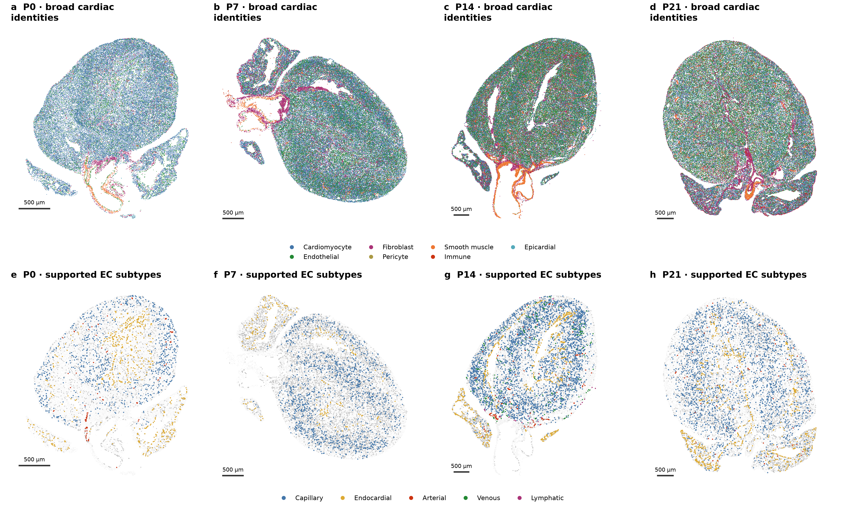
a–d, Broad cardiac identities at P0, P7, P14 and P21 on the original coordinates. Dense populations may be subsampled for display; calculations retain the full cohorts. e–h, Supported capillary-, endocardial-, arterial-, venous- and lymphatic-like endothelial sources. Unassigned eligible ECs and background tissue remain gray. Sparse calls do not establish absence of a vessel type. These maps retain the reviewed broad/EC definitions and do not newly classify cells. Scale bars, 500 µm.

Figure 2. CMs of the same subtype can differ in developmental state
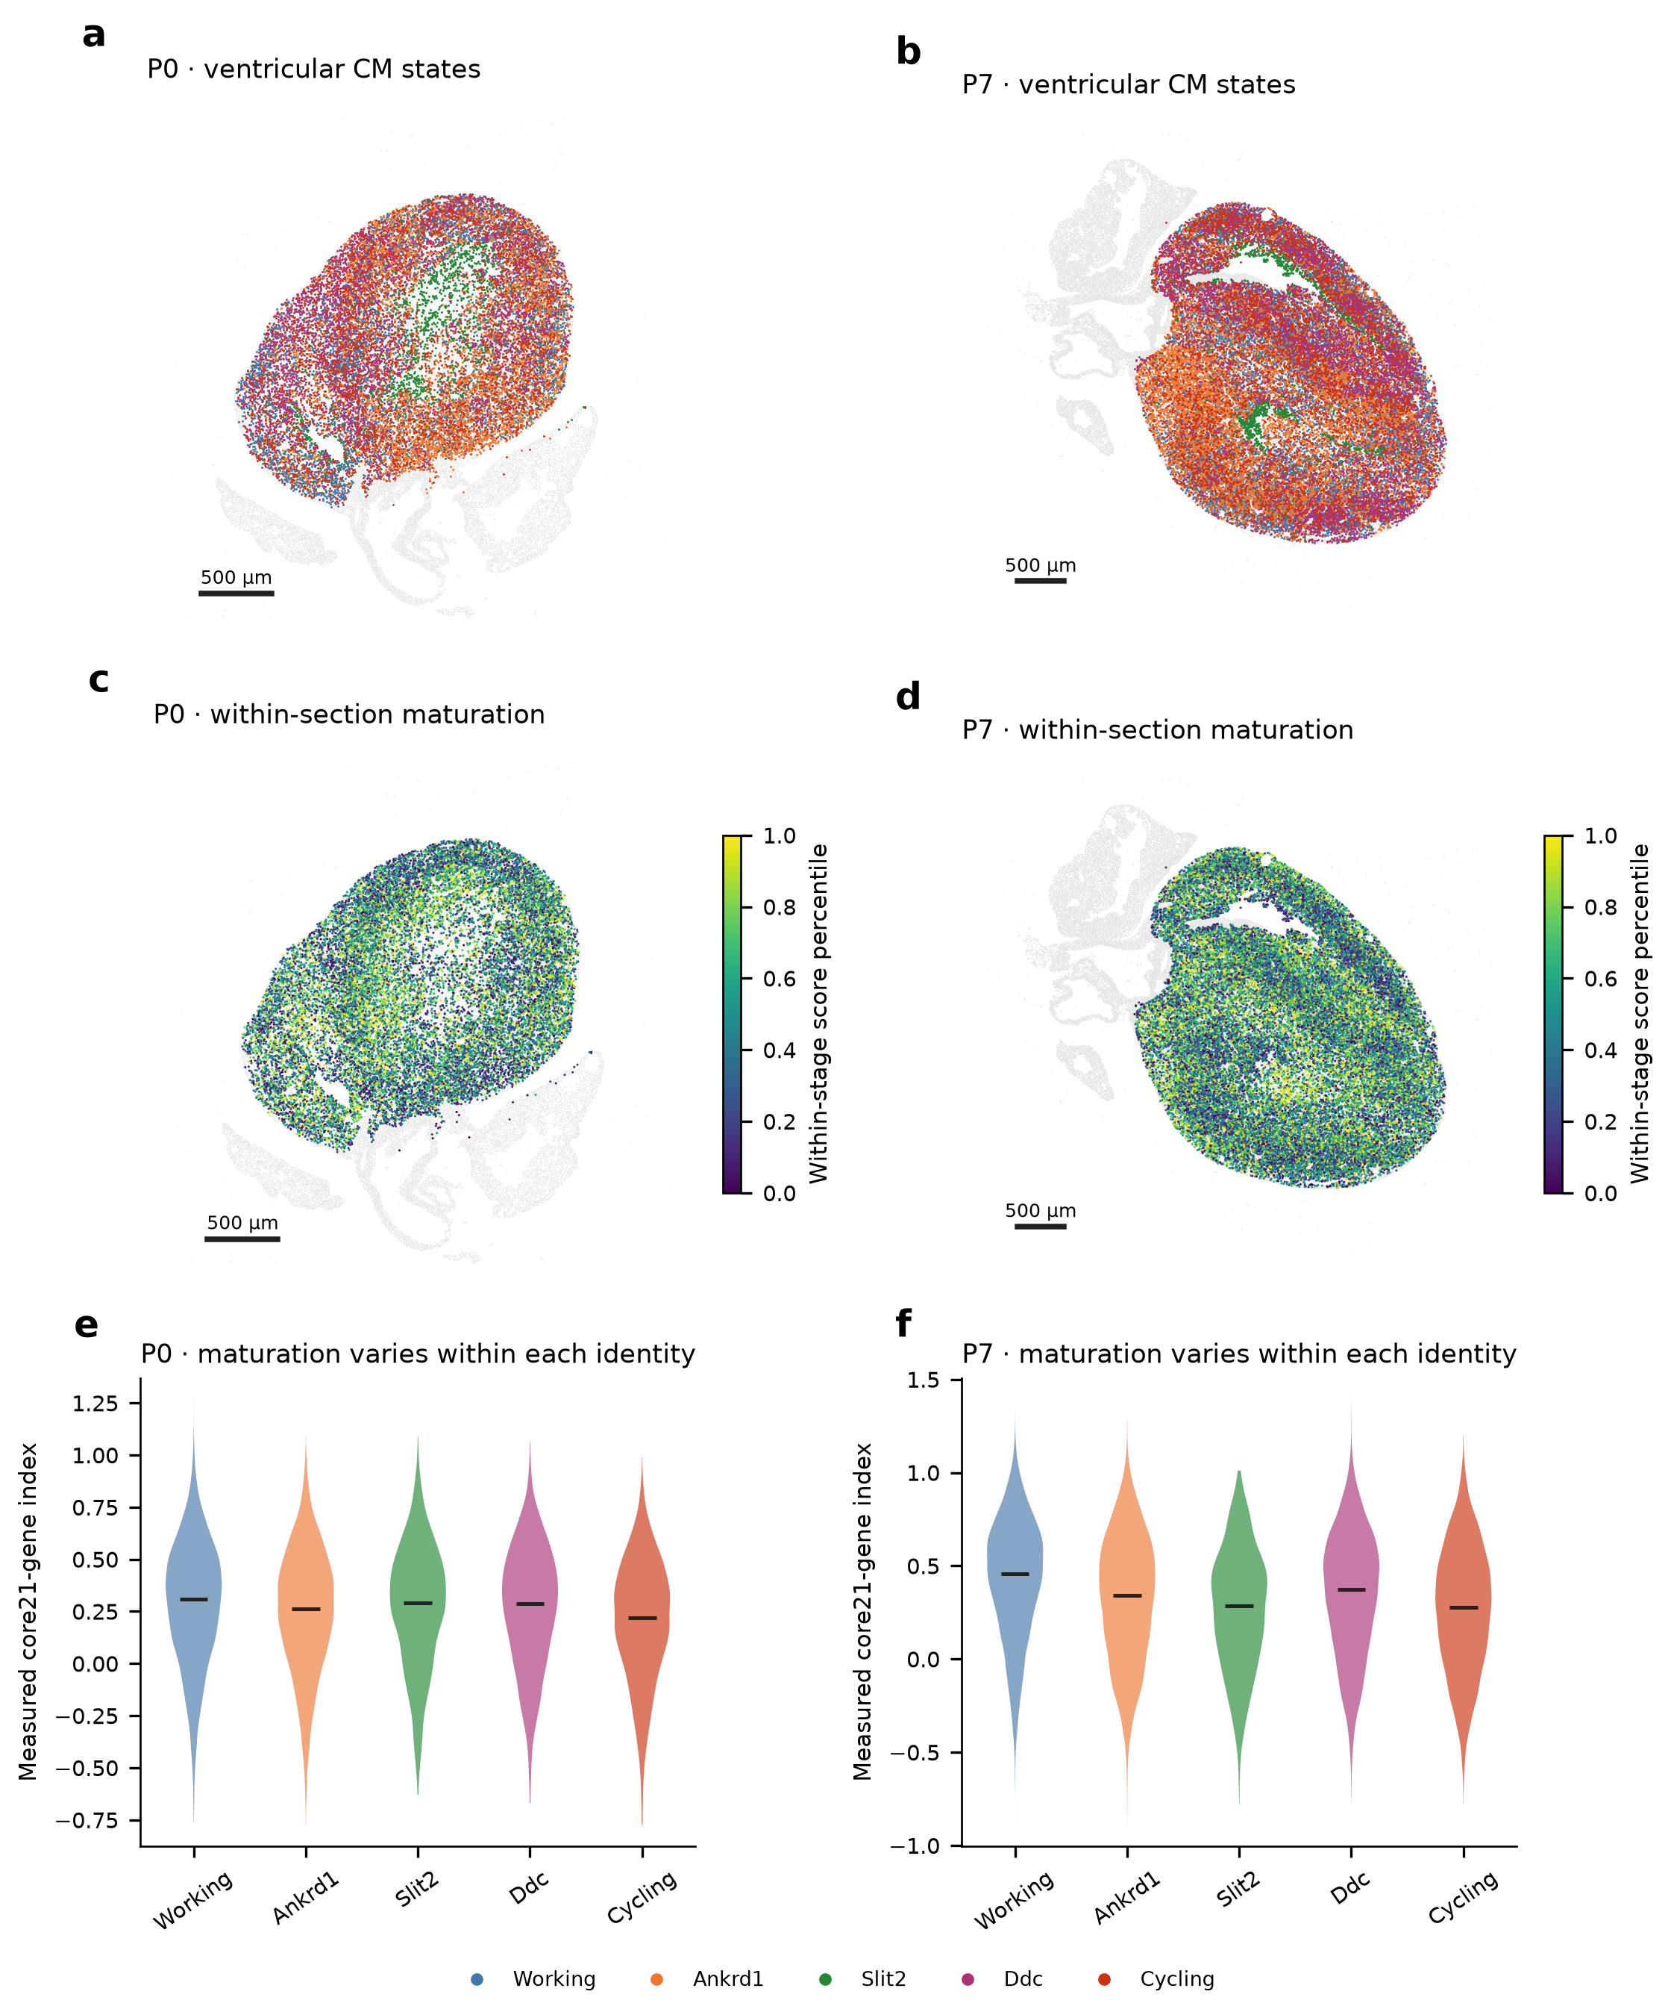
a,b, Ventricular-associated CM identities at P0 and P7. c,d, Relative position in each section’s measured 21-gene score distribution. e,f, Scores within the named CM groups. Higher scores indicate stronger expression of the measured panel, rather than a direct measurement of contraction or energy use. Subtype and developmental state are complementary descriptions. The underlying labels, scores and coordinates are unchanged. Scale bars, 500 µm.

Figure 3. Fibroblast RNA states differ in matrix-related features
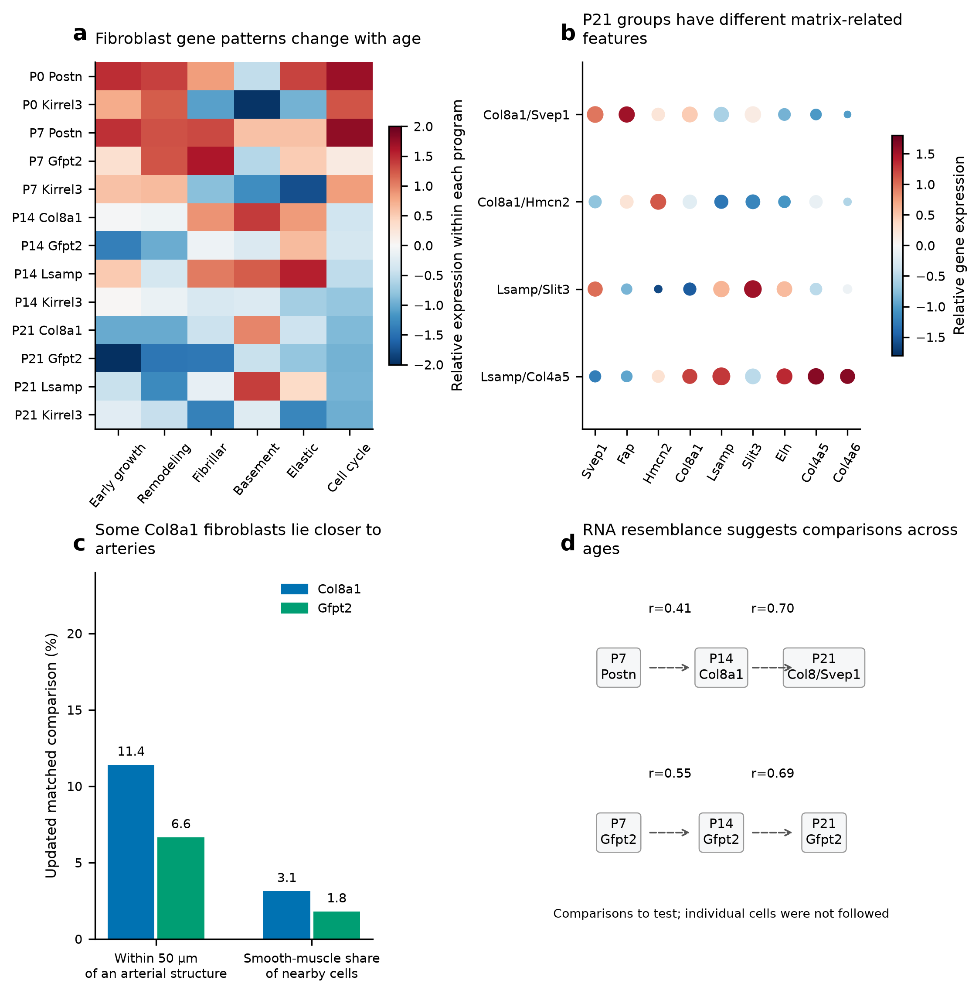
a, Full-RNA matrix programs across age and family, averaged over the two libraries and shown relative to the displayed groups. b, P21 marker patterns in named Col8a1/Svep1, Col8a1/Hmcn2, Lsamp/Slit3 and Lsamp/Col4a5 groups; dot size gives detection and color gives relative expression. c, Latest broader-candidate P14 Col8a1/Gfpt2 technical-matched comparison, replacing the earlier stringent estimate. Arterial proximity and smooth-muscle-neighbor share are separate measures. d, Selected early/late RNA similarities with interpreted markers withheld. Dashed arrows nominate comparisons for tracing, not observed cell conversion.

Figure 4. Fibroblast identities and shared patterns give complementary maps
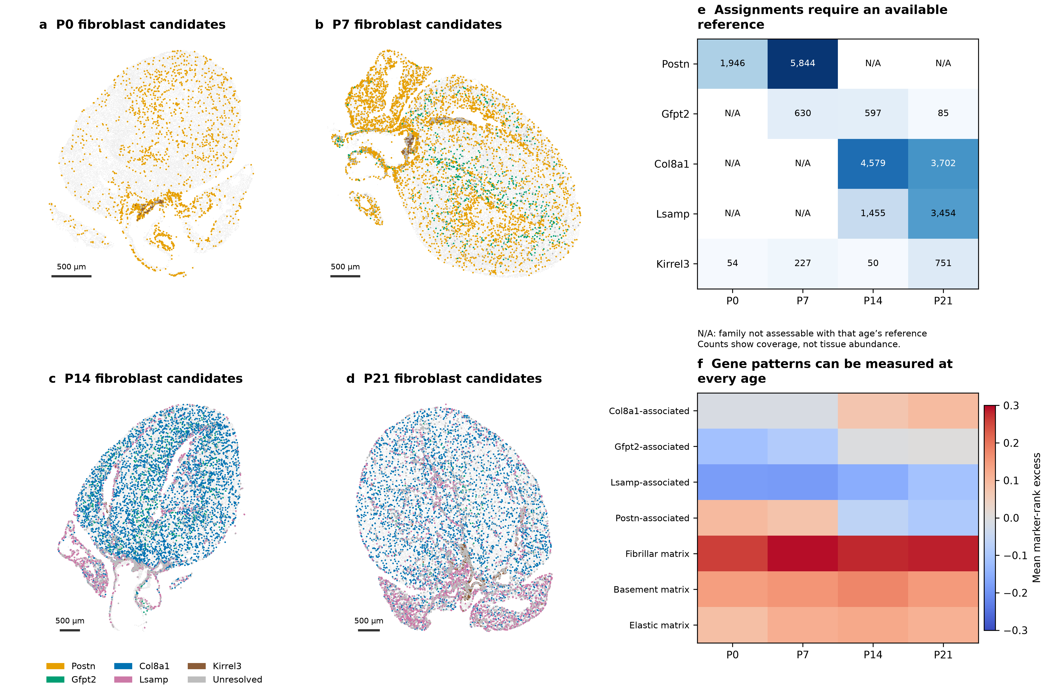
a–d, Broader candidate fibroblast identities on the original P0–P21 sections. Gray retains unassigned fibroblasts and tissue context; background cells may be subsampled for display only. e, Candidate counts, with unavailable same-age reference classes marked N/A. This does not mean the corresponding genes are absent. Counts measure assignment coverage, not accuracy or tissue abundance. f, Measured patterns can be scored independently of family availability. Values summarize each section relative to matched control genes; they do not measure matrix protein or function. Scale bars, 500 µm.

Figure 5. A Gfpt2-associated pattern extends beyond the narrow candidate subtype
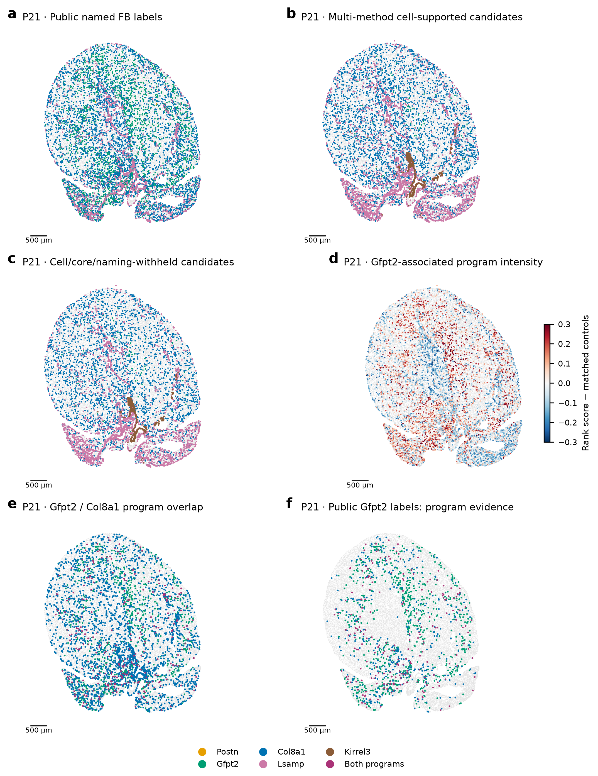
a, The paper’s fibroblast labels within the eligible P21 cohort. b, Candidate identities from agreement between classifiers. c, A smaller subset supported in the cell core and after naming genes are hidden. d, The measured Gfpt2/Pi16/Adgrd1 pattern relative to matched controls. e,f, Gfpt2- and Col8a1-associated patterns can overlap across all eligible fibroblasts and within the public Gfpt2 group. Shared expression does not establish one exclusive subtype or lineage transition. Kirrel3 candidates are not assigned valve anatomy. Scale bars, 500 µm.

Figure 6. Vascular growth and proximity relate to different parts of CM development
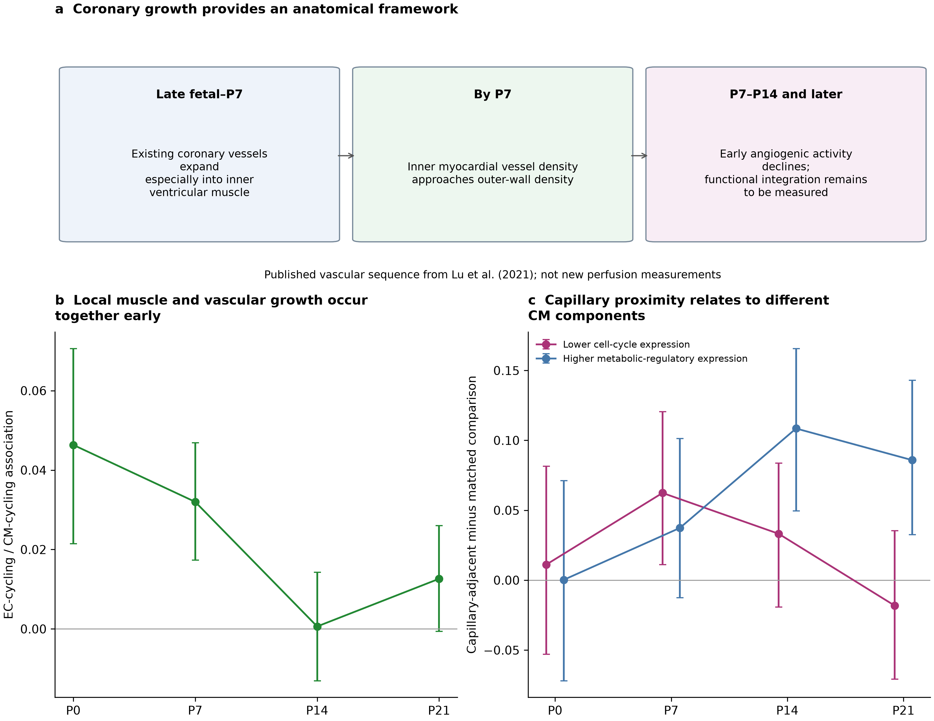
a, The regional coronary sequence described by Lu et al. (2021); perfusion was not newly measured here. b, Earlier nuclear-QC EC/CM cell-cycle associations within 50 µm are positive at P0/P7. c, Earlier locally matched capillary-adjacency comparisons show lower CM cycling-associated RNA at P7 and higher metabolic-regulatory RNA at P14/P21. These estimates use their original cohorts and uncertainty definitions and were not rerun with the fibroblast refit. Intervals are within-section spatial-block intervals, not independent-heart replication. Vessel proximity does not establish oxygen delivery or a contact mechanism.

Figure 7. Early fibroblast environments suggest hypotheses without establishing metabolic instruction
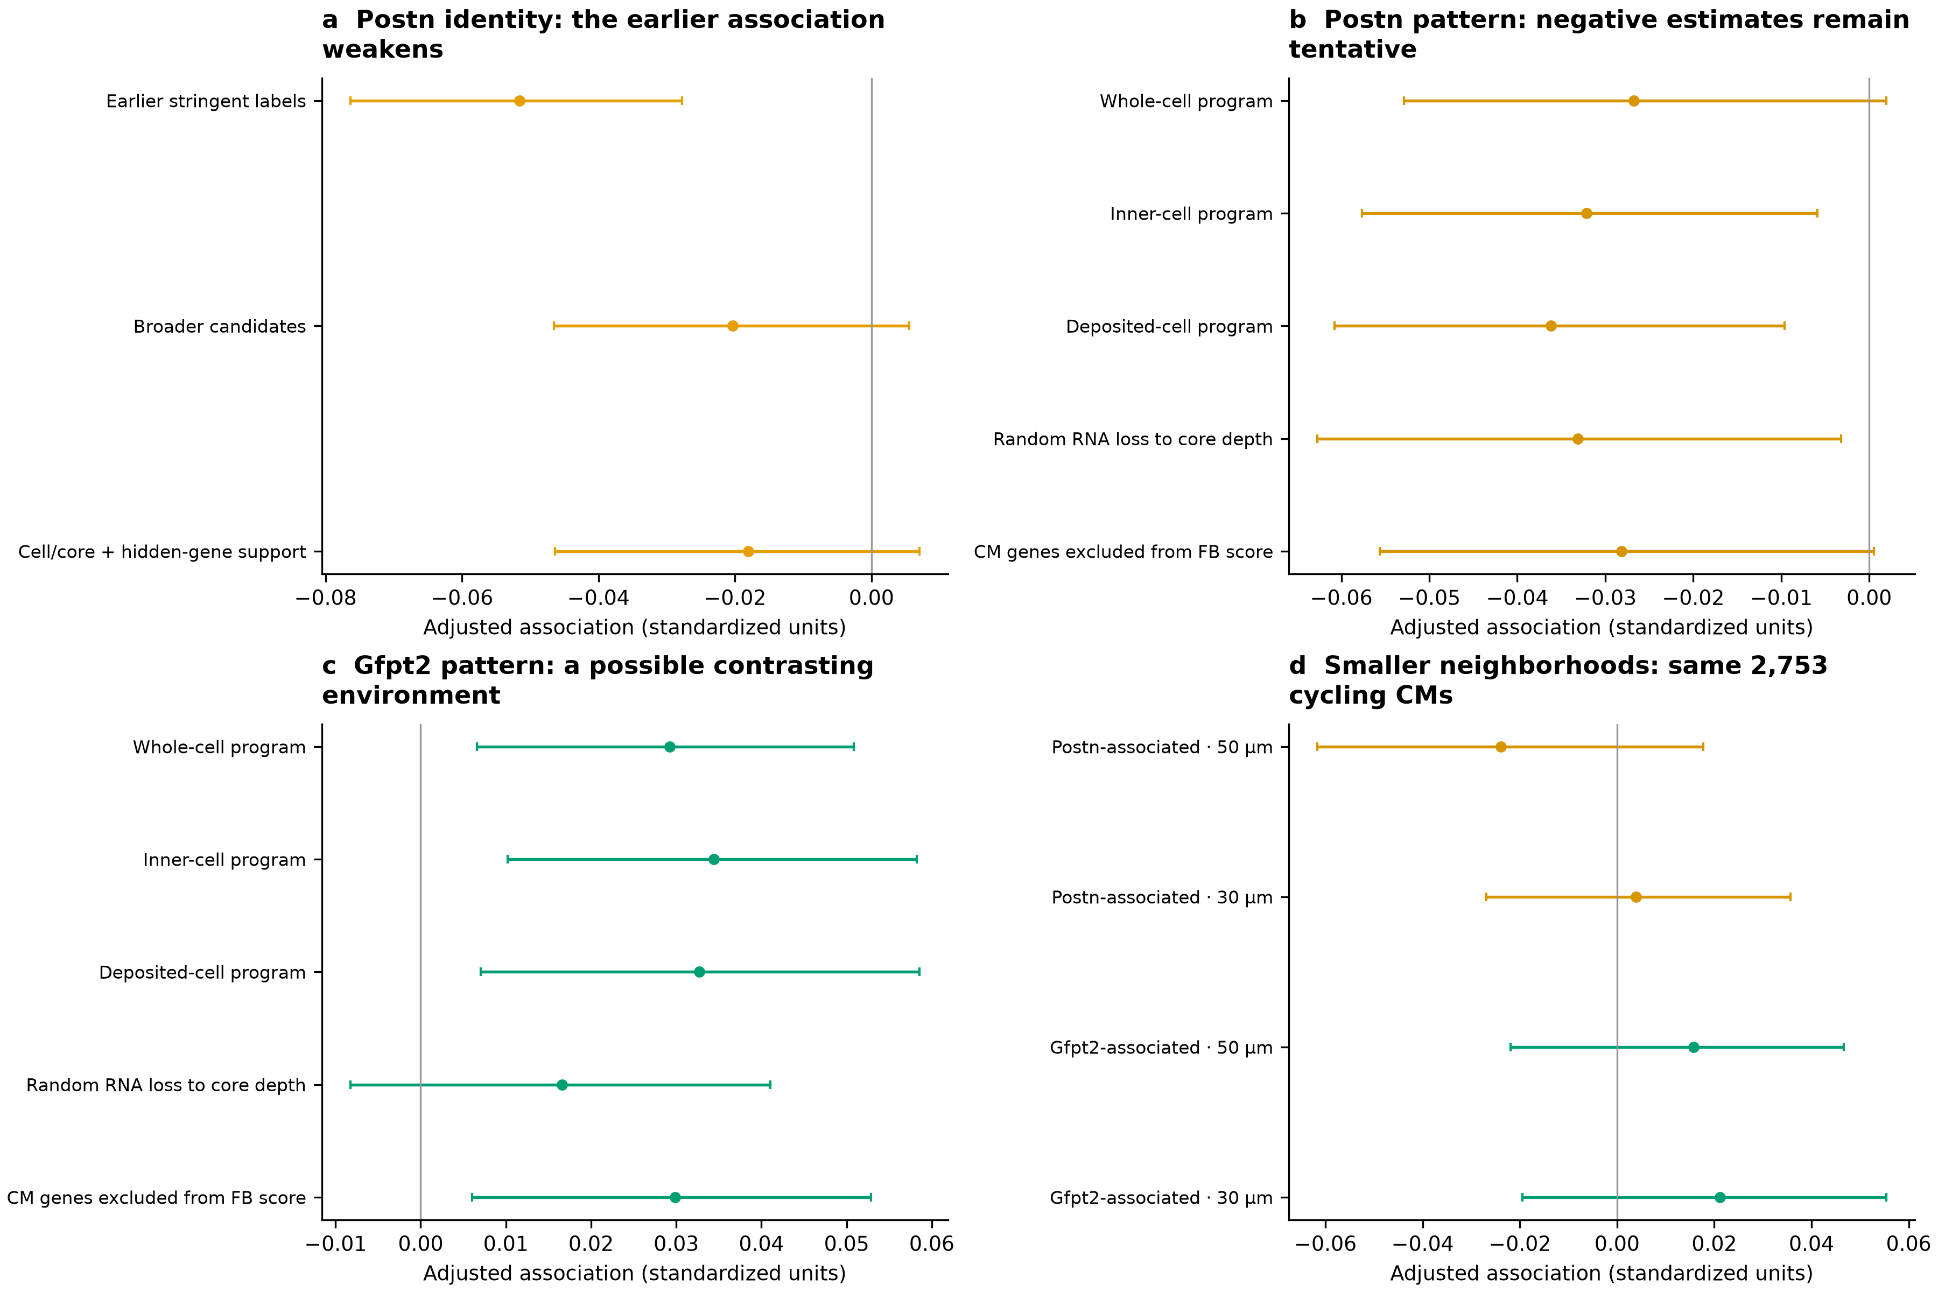
a, The P7 Postn-identity/metabolic relationship in cycling-associated CMs weakens with broader and crosschecked assignments. b,c, Postn- and Gfpt2-associated patterns in whole-cell, inner-cell, deposited and depth-matched fibroblast RNA, with an additional CM-gene-excluded scoring check. Negative and positive estimates suggest contrasting environments but do not establish opposing functions. d, The 50-/30-µm comparison uses the same 2,753 cycling-associated CMs. Smaller neighborhoods do not provide clear corresponding support. Points and intervals describe within-section estimates and 95% spatial-block intervals; they are not independent-heart replication.

Figure 8. Structural RNA relationships depend on CM identity and transcript ownership
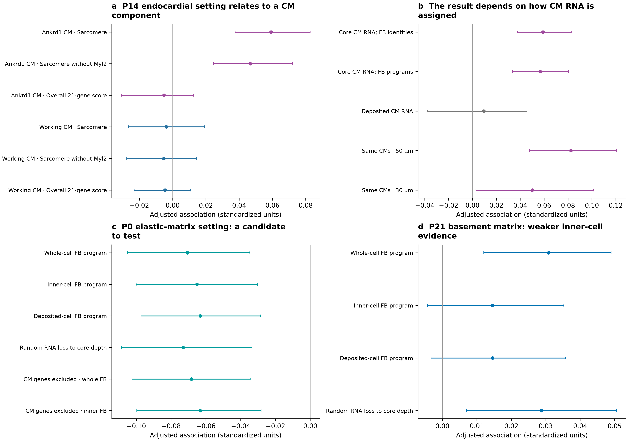
a, At P14, endocardial-like surroundings relate to higher sarcomere expression in Ankrd1 CMs, with a smaller relationship in working CMs. Removing Myl2 retains the direction; the overall score shows no corresponding increase. b, The relationship remains after adjustment for fibroblast programs but weakens in deposited CM RNA. The paired 50-/30-µm comparison uses the same 4,528 Ankrd1 CMs. c, A P0 elastic-matrix/sarcomere candidate retains its direction across fibroblast RNA views and CM-gene-excluded scoring, but does not pass the primary correction. d, The P21 basement-matrix estimate weakens with inner-cell fibroblast RNA. Intervals describe uncertainty within sections, conditional on the chosen count views.

Figure 9. Fibroblast position and changing surroundings guide specific developmental questions
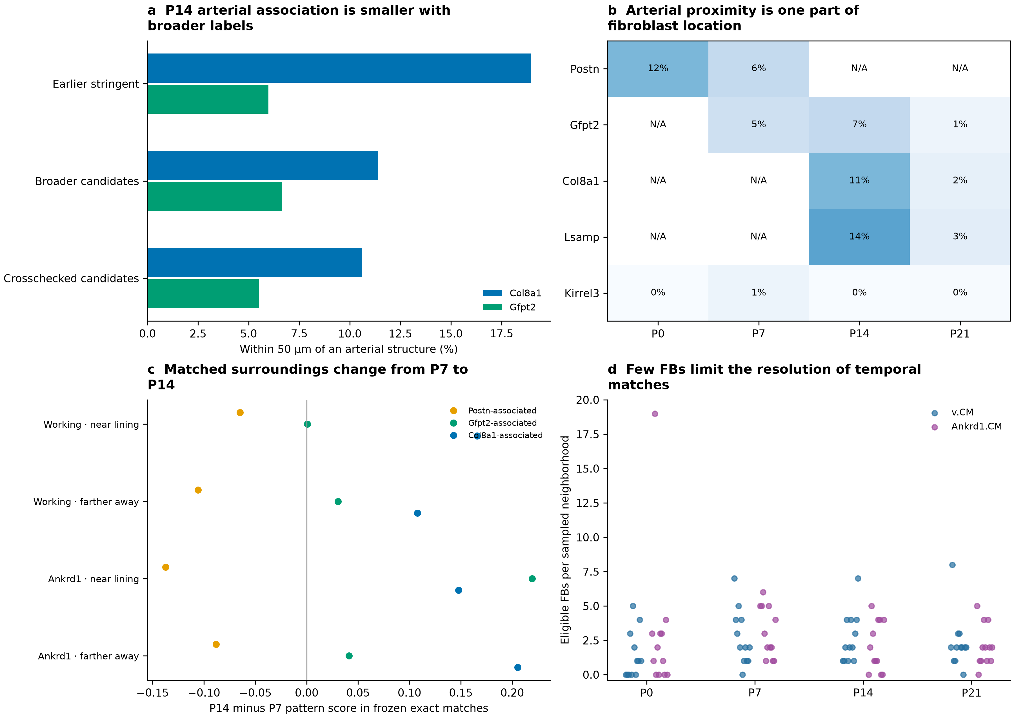
a, P14 Col8a1/Gfpt2 arterial proximity after the same technical matching design, using earlier stringent, broader and crosschecked identities. The contrast becomes smaller with broader assignments. Matching permits reused controls. b, Arterial proximity among candidate families; N/A marks unavailable families. Kirrel3 candidates are not assigned valve anatomy. c, Updated fibroblast patterns on frozen exact P7-to-P14 neighborhood matches, grouped by CM identity and endocardial distance. Only matching mass with informative fibroblasts at both ends contributes; supported mass is supplied. d, Eligible fibroblasts among the sampled sources: the median is two, and 15 of 96 neighborhoods have none. These comparisons do not trace cell transitions.

Methods

Data, inherited QC and scope
We used the deposited P0, P7, P14 and P21 snRNA-seq/Xenium data [1] and the frozen reviewed annotations, coordinates, CM cohorts and spatial graphs. There is one available spatial section per age. The latest incorporated analysis fitted CM-neighbor models with the revised fibroblast assignments and directly measured programs. This unified document adds no new biological model or replicate. It does not perform new segmentation, classifier training or spatial imputation.
Inherited snRNA-seq QC used per-library scDblFinder as the primary doublet screen; Scrublet was diagnostic. DecontX was fitted separately to singlet nuclei in eight libraries using called-nucleus clusters without empty droplets. Corrected counts informed the reviewed reference, with raw-reference sensitivity retained. Five residual CM/mural-program fibroblast groups were excluded from the fine reference. Earlier broad-fibroblast median estimated contamination fractions ranged approximately 0.05–0.12 across libraries; these are model estimates, not measured residual contamination after correction. Residual mixing remains possible.
The deposited Xenium matrices contain 403 gene targets plus 138 control/non-gene features. The shared RNA reference contains 381 measured genes. Controls do not enter biological scores. Missing nuclear area alone does not exclude a CM. The earlier multimodal segmentation, transcript reassignment and core/nuclear count layers are retained as sensitivity views, not independent ground truth.

Fibroblast identities and marker patterns
Identity layers are the newer recommended candidates, the subset supported by cell/core and naming-marker-withheld agreement, and the earlier stringent labels. Broad fibroblast eligibility is frozen. Supported nuclear alternatives remain review flags in the newer labels. Reference classes absent at an age are marked not assessable in the table; their programs can still be measured directly. Candidate counts measure operational coverage rather than tissue abundance. Thresholds selected from reference cross-validation predictions do not provide unbiased prospective spatial accuracy.
Seven measured patterns are analyzed: Postn, Gfpt2, Col8a1 and Lsamp marker sets, plus fibrillar, basement and elastic matrix sets. Exact genes are supplied in the program table and source files. Scores are mean within-cell gene ranks minus the average of 200 control sets matched to pooled clean RNA-reference abundance deciles. The four identity-marker scores reproduce the previous module files. A descriptive enrichment flag exceeds 90% of control sets and requires two detected markers; it is not a cell-type probability or single-cell significance test.
Each source view requires at least 20 shared-panel molecules and eight detected genes. Programs are averaged across all informative eligible fibroblast neighbors, including cells without a confident subtype or enrichment flag. A program is tested only if at least 30 informative fibroblasts detect two of its markers. Identity fractions use all eligible broad fibroblast neighbors, including unassigned cells. Fibroblast program genes do not overlap the CM maturation panel. A separate sensitivity removes CM maturation, lineage/response, cycling and sex genes from both the fibroblast rank background and control pool, then recomputes scores and fits; these excluded genes and retained counts are supplied.
Refined whole-cell, inner-cell core and native deposited counts are compared. Three binomial-thinning repetitions reduce refined counts toward each profile's core depth without changing its geometry; their mean score provides an information-loss control. Core and depth-matched comparisons use the same informative-source mask. These tests do not fully propagate boundary uncertainty.

Cardiomyocyte outcomes and cohorts
The frozen ventricular cohort retains ventricular-marker-supported profiles with compatible released v.CM, Ankrd1.CM, Slit2.CM, Ddc.CM or p.CM labels and the earlier morphology rule. CMs require at least 20 core-panel molecules and 20 molecules outside the outcome genes. The p.CM label denotes a cycling-associated state, not demonstrated completed cell division.
The measured 21-gene panel is Rxrg, Ppargc1a, Ppargc1b, Cebpa, Cebpb, Esrra, Esrrb, Esrrg, Mitf, Myh6, Tnni3, Myl2, Kcnq1, Jph1, Jph2, Bin1, Lpin1, Pln, Ppara, Ppard and Cpt1b. The frozen direct index is the mean gene-standardized log-normalized expression using the earlier pooled calibration. It is not an exact reproduction of the author's unrecovered AddModuleScore object.
Metabolic-regulatory genes are Ppargc1a, Ppargc1b, Esrra, Esrrg, Ppara, Ppard, Cpt1b and Lpin1. Sarcomere genes are Myh6, Tnni3 and Myl2. Excitation–contraction genes are Pln, Jph1, Jph2, Bin1 and Kcnq1. Cycling uses Mki67, Top2a and Cenpf, with higher values indicating higher cycling-associated RNA. Thus Lpin1 and Pln are grouped by their biological roles rather than reproducing the figure's category placement. Removing Myl2 yields a 20-gene index and a two-gene sarcomere sensitivity without changing ventricular selection. Native CM outcomes provide an additional transcript-ownership sensitivity.
Within each graph, source views use the same eligible CMs. The 50-µm cohorts contain 13,071 P0, 27,659 P7, 26,996 P14 and 27,053 P21 CMs before individual-state model eligibility. Paired 50-/30-µm and shared-boundary comparisons use their common CM cohorts. A fitted state requires at least 200 CMs, eight 400-µm blocks and sufficient residual exposure variation. Categorical exposures also require 50 positive CMs.

Association models and uncertainty
Primary fibroblast models test one identity fraction or program at a time. They adjust for CM capture outside the outcomes, area, nuclear missingness, neighbor counts, broad non-CM composition and FB/EC capture. Program models additionally adjust for informative-source coverage, depth and detected genes. Anatomical models add arterial/endocardial/large-void/outer-surface distance proxies, morphology class and nuclear-supported capillary/endocardial fractions. The primary comparison removes means within 200-µm regions, separately by CM state. These proxies are not independently reviewed LV/RV or compact/trabecular masks.
Targets and outcomes are standardized within each age/run before separating CM states. Rank-revealing QR removes redundant nuisance columns. Each point estimate is fitted by least squares. Shared 512-resample, 400-µm block bootstraps provide exploratory within-section intervals and CM-subtype slope comparisons. Technical, anatomical and within-region fits are retained separately. Joint-program fits examine specificity; single-program estimates are not assumed independent of other matrix patterns.
Vascular-target models adjust for the revised fibroblast fractions; a sensitivity replaces these fractions with all seven fibroblast programs. The primary family comprises 925 tests across all four ages, eligible CM states, candidate identities, refined programs, two vascular targets and five primary outcomes. One global BH correction is applied to this complete grid. Sensitivity outcomes and alternative definitions are supplied separately and are not used to declare additional corrected discoveries. Different detectability across ages is not treated as a demonstrated age interaction.

Fibroblast spatial comparisons and temporal descriptions
The P7 Gfpt2/Postn and P14 Col8a1/Gfpt2 comparisons repeat the earlier matching design with the new labels. Profiles need at least five resolved neighbors within 30 µm. Matching uses standardized log RNA molecules, log area, log 50-µm density and nuclear fraction; nearest reference matching permits replacement with a Euclidean caliper of two. Pair IDs, unique reference counts and covariate balance are supplied. Arterial distance is to the earlier operational structure, not a newly traced histological vessel wall. These are descriptive spatial contrasts.
The 96 frozen neighborhoods retain their selected cells, molecular representation, exact transport plans and saved Wormhole plans [3]. Updated fibroblast identities and programs are held-out descriptors. They may share underlying RNA information with the molecular representation, so this is not independent validation. Reported program changes condition on pairs with an informative fibroblast at both ends, and the supported matching mass is supplied. Fine labels do not retrain the encoder. Matching is not ancestry, expansion or a measured transition rate.

Validation and limitations
Independent checks reconstruct 8,064 neighborhood program means, compare 36 regression coefficients with a separate residualization calculation, verify assignment coverage and unavailable classes, recalculate the full primary BH correction and check design conditioning. Source IDs, source tables, count views and program definitions are retained. Source/artifact hashes and document/figure checks accompany the release.
The atlas's strict outline benchmark deteriorates at P21; its object-overlap score is not transcript-ownership accuracy. Core/native/thinned and shared-boundary checks expose some sensitivities but do not integrate uncertainty over plausible alternative boundaries. Neither computational agreement nor spatial-block intervals establish independent-heart replication. Blood flow, matrix mechanics, functional CM maturation and cell ancestry were not measured here.

Reference classification and finer RNA states
The clean fibroblast RNA reference contains 14,328 nuclei, with 35 unresolved profiles excluded from named-family training. Three classifiers use the shared panel: balanced multinomial logistic regression, within-cell rank centroids and a negative-binomial count model. Training excludes CM maturation/response, lineage, cycling and sex genes. Opposite-library prediction, naming-gene withholding, raw-reference and pooled late-reference comparisons test sensitivity to the RNA definition. They do not establish independent Xenium truth.
Candidate labels require agreement between at least two reference-screened classifiers and adequate RNA information. Supported core alternatives trigger review. The crosschecked subset also retains core agreement and the same majority assignment after naming genes are hidden. Supported nuclear alternatives remain flags. Reference score screens target apparent precision of at least 0.8 with at least 20 predictions and both libraries represented; thresholds are selected on those same predictions. Full parameters and per-view evidence remain in the alternative-identity release.
Full-RNA matrix comparisons use library-by-family pseudobulks, independently normalized raw/corrected views and summed duplicate gene symbols. Program scores are means of gene log1p CPM. P21 subgroup names retain the reviewed Col8a1/Svep1, Col8a1/Hmcn2, Lsamp/Slit3 and Lsamp/Col4a5 hierarchy. Their finer spatial positions remain unverified. Selected early/late RNA correlations with interpreted markers withheld are candidate similarities, not transition rates.

Broad cardiac and endothelial maps
Broad cardiac identities and nuclear-supported EC categories retain the earlier atlas/source-QC definitions. The display can subsample dense broad-cell backgrounds, but all calculations retain the recorded cohorts. Endothelial maps show supported capillary-, endocardial-, arterial-, venous- and lymphatic-like sources, with unassigned EC profiles retained in gray. These categories and activity programs do not establish perfusion or lineage fate. Relative CM low/high groups use within-age, within-state ranks, rather than a shared physiological maturity scale.

Earlier vascular comparisons and transport calibration
The earlier EC/CM cycling analysis uses nuclear-QC sources within 50 µm, with a 30–50-µm shell sensitivity. It measures coordinated RNA expression rather than completed proliferation. The earlier capillary comparison matches CMs within the same 200-µm region and CM state, controlling for capture, area, perimeter and nearby capillary area. It uses a broader cohort than the new subtype-specific models. These earlier estimates and their own uncertainty definitions are retained; they are not added to the 925-test family or refitted in this document.
The 96 transport neighborhoods include 12 per age and CM identity, with four within 100 µm of the endocardial proxy and eight farther away. Up to 32 observed non-CM profiles contribute 16 molecular PCs and six lineage features. Exact distances and saved Wormhole distances are restricted to the same CM identity/distance category. CM maturation is withheld from matching and examined afterward. Approximation and nearest-match agreement remain separate from the updated fibroblast descriptions.

Original segmentation benchmark
The atlas combines nuclear, membrane and cell-interior staining. Automatic outlines were compared with expert outlines in five P0 and five P21 fields, using TP/(TP+FP+FN) at a demanding 90% overlap threshold. Approximate visual scores are 45–50% at P0 and around 10% at P21; raw values were not recovered. These object scores do not measure the fraction of correctly assigned transcripts. Field counts do not establish independent-heart replication, and relevant overlap/software details remain incompletely specified. A section through a large CM can legitimately lack a visible nucleus. The report therefore retains whole-cell, inner-cell and nuclear evidence without treating one view as ground truth.

References
1. Wang H et al. Spatially guided in vivo single-cell functional genomics of postnatal heart. Nature Cardiovascular Research (2026). https://doi.org/10.1038/s44161-026-00861-z
2. Lu P et al. Perinatal angiogenesis from pre-existing coronary vessels via DLL4–NOTCH1 signalling. Nature Cell Biology 23, 967–977 (2021). https://doi.org/10.1038/s41556-021-00747-1
3. Haviv A et al. Wasserstein Wormhole: Scalable Optimal Transport Distance with Transformers. ICML (2024). https://arxiv.org/abs/2404.09411
4. Puente BN et al. The oxygen-rich postnatal environment induces cardiomyocyte cell-cycle arrest through DNA damage response. Cell (2014). https://doi.org/10.1016/j.cell.2014.03.032
5. Mahmoud AI et al. Meis1 regulates postnatal cardiomyocyte cell cycle arrest. Nature (2013). https://doi.org/10.1038/nature12054

Cell identities and the biological questions they support
CM state | Interpretation to investigate | Important limit
Working ventricular | Contractile ventricular reference across stages | One label can contain different maturation-associated states
Ankrd1-associated | Regional structural or loading-related adaptation | Not exclusively peri-arterial or proof of disease
Slit2-associated | Chamber-facing regional specialization | Requires anatomical validation; Kcnd2/Irx5 unmeasured
Cycling-associated | Early growth-related CM state | Cell-cycle RNA does not establish completed division
Ddc-associated | Distinct measured RNA state | Specific tissue function remains unresolved
EC subtype | Tissue role to examine | Important limit
Capillary-like | Coronary exchange network and muscle support | Proximity is not measured perfusion
Endocardial-like | Chamber-lining environment and local structural relationships | Distinct from coronary capillaries
Arterial-like | Supply-vessel environment and mural context | RNA label does not trace a vessel wall
Venous-like | Venous vascular setting | Sparse calls do not establish absence
Lymphatic-like | Lymphatic vascular setting | Requires multi-marker endothelial/lymphatic support
The proposed roles guide comparisons. They are not new functional validation or a complete anatomical lineage map. Broad and fine assignments retain their source confidence and boundary-review fields.

What changed after the refit?
Question | Updated observation | Biological interpretation
Does the P7 Postn relationship persist? | Negative metabolic estimate becomes smaller and uncertain with broader labels; smaller-neighborhood support is weak | A developing-matrix hypothesis remains; suppression by Postn fibroblasts is not established
Do late Col8a1 fibroblasts favor arteries? | About 11% near arteries versus 7% of matched Gfpt2 candidates; direction retained in the crosschecked subset | A vessel-associated component within a broader matrix population
Does one FB program predict general CM maturation? | No FB identity/program association passes the full primary correction | Different components and CM states require separate tests
Which FB candidate deserves focused imaging? | P0 elastic-matrix expression relates to lower working-CM sarcomere RNA across several sensitivity checks | Test matrix organization and CM structure; mechanism remains unknown
What is the clearest corrected relationship? | P14 endocardial-like surroundings and Ankrd1-CM sarcomere RNA; weaker in deposited CM counts | Validate anatomy and transcript ownership before testing contact or loading
What does the temporal comparison add? | P7-to-P14 matched surroundings lose Postn-associated and gain Col8a1-associated expression | A developmental comparison to sample more densely, not a tracked conversion

Fibroblast assignments and directly measured patterns
Candidate family | P0 | P7 | P14 | P21
Postn | 1,946 | 5,844 | Not assessable | Not assessable
Gfpt2 | Not assessable | 630 | 597 | 85
Col8a1 | Not assessable | Not assessable | 4,579 | 3,702
Lsamp | Not assessable | Not assessable | 1,455 | 3,454
Kirrel3 | 54 | 227 | 50 | 751
Not assessable means that this family is absent from the same-age reference. It is not a biological zero. Counts show assignment coverage among eligible fibroblasts, rather than tissue-wide abundance. Broader coverage is not independently established accuracy; apparent reference precision uses thresholds selected from the same reference predictions.
Pattern-enriched profiles | P0 | P7 | P14 | P21
Postn pattern | 535 | 1,591 | 166 | 192
Gfpt2 pattern | 19 | 312 | 1,232 | 1,339
Col8a1 pattern | 96 | 377 | 1,730 | 3,191
Lsamp pattern | 4 | 31 | 89 | 137
Fibrillar matrix | 1,496 | 6,186 | 6,604 | 8,844
Basement matrix | 1,325 | 5,180 | 6,392 | 7,414
Elastic matrix | 569 | 2,534 | 3,086 | 3,389
These descriptive flags require the measured multi-gene pattern to exceed matched controls and at least two markers to be detected. They are not subtype counts, functional activity or evidence of biological absence when low. Different patterns can occur in the same cell. Eligible broad FB denominators are 2,020, 7,365, 8,098 and 10,867.

Selected estimates and exact program definitions
Primary comparison | Estimate | 95% block interval | Global BH q
P7 · Postn identity → cycling-CM metabolic RNA | -0.020 | -0.047 to +0.006 | 0.758
P7 · Gfpt2 pattern → cycling-CM metabolic RNA | +0.029 | +0.007 to +0.051 | 0.546
P0 · Elastic matrix → working-CM sarcomere RNA | -0.071 | -0.105 to -0.035 | 0.0733
P21 · Basement matrix → Ankrd1 sarcomere RNA | +0.031 | +0.012 to +0.049 | 0.221
P14 · Endocardial context → Ankrd1 sarcomere RNA | +0.059 | +0.038 to +0.083 | 0.00104
Values are within-stage standardized associations, not measured functional effects. Intervals describe spatial variation conditional on the selected masks and model. The global correction covers all 925 primary tests. Sensitivity estimates are supplied separately and do not create extra corrected discoveries.
Measured pattern | Genes
Col8a1 pattern | Cmklr1, Col8a1, Col6a3, Htra3
Gfpt2 pattern | Gfpt2, Pi16, Adgrd1
Lsamp pattern | Col8a1, Itgbl1, Lsamp
Postn pattern | Col24a1, Ptn, Tnc, Postn
Fibrillar matrix | Col1a1, Col1a2, Col3a1
Basement matrix | Lama4, Lama5, Lamb1, Lamb2, Lamc1, Col4a1, Col4a2, Hspg2
Elastic matrix | Eln, Fbln1, Fbln2
Fibroblast genes do not overlap the CM maturation panel. Individual program models do not establish effects independent of the other patterns; joint-program sensitivities are supplied. Marker-pattern expression is not a measurement of matrix deposition or mechanics.

Gfpt2 identity: evidence levels and reference checks
P21 evidence | Profiles or measurement | Meaning
Measured Gfpt2/Pi16/Adgrd1 pattern | 1,339 | Broader shared expression
Also enriched for Col8a1 pattern | 327 | Overlap, not demonstrated transition
Public Gfpt2 group with pattern flag | 1,058 of 2,716 | Mixed support within a public label
Naming-gene-hidden majority | 280 | Grouping formed without the naming genes
Hidden Gfpt2/Pi16 subsequently detected | About 84% / 91% | Consistent marker evidence in that selected subset
Broader candidate / crosschecked subset | 85 / 75 | Different confidence layers, not total abundance
Opposite-library tests show that recovering more Gfpt2 reference nuclei can also increase incorrect assignments of other families. A missing family in a same-age reference is not a biological zero. Candidate identity, a measured marker pattern and developmental fate remain separate questions.

Which analyses are current in this combined report?
Analysis | Status
Broad cardiac/EC maps and CM subtype/maturity maps | Reviewed existing definitions retained
Alternative fibroblast candidate/program maps | Current assignments and measured programs included
CM–FB and endocardial/capillary fraction models | Latest refit with current FB labels/programs
P14 matched Col8a1/Gfpt2 arterial comparison | Updated to broader/crosschecked labels
Earlier matched capillary-adjacency and nuclear cycling comparisons | Earlier validated cohorts/estimates retained, not rerun
Cross-age FB descriptions | Updated on the 96 frozen neighborhoods
Exact/Wormhole matching plans and encoder | Frozen; no retraining or cell tracking
This unified document | Presentation synthesis; no additional biological model fitted

Figure S1. Early and late fibroblast patterns overlap without requiring a subtype label
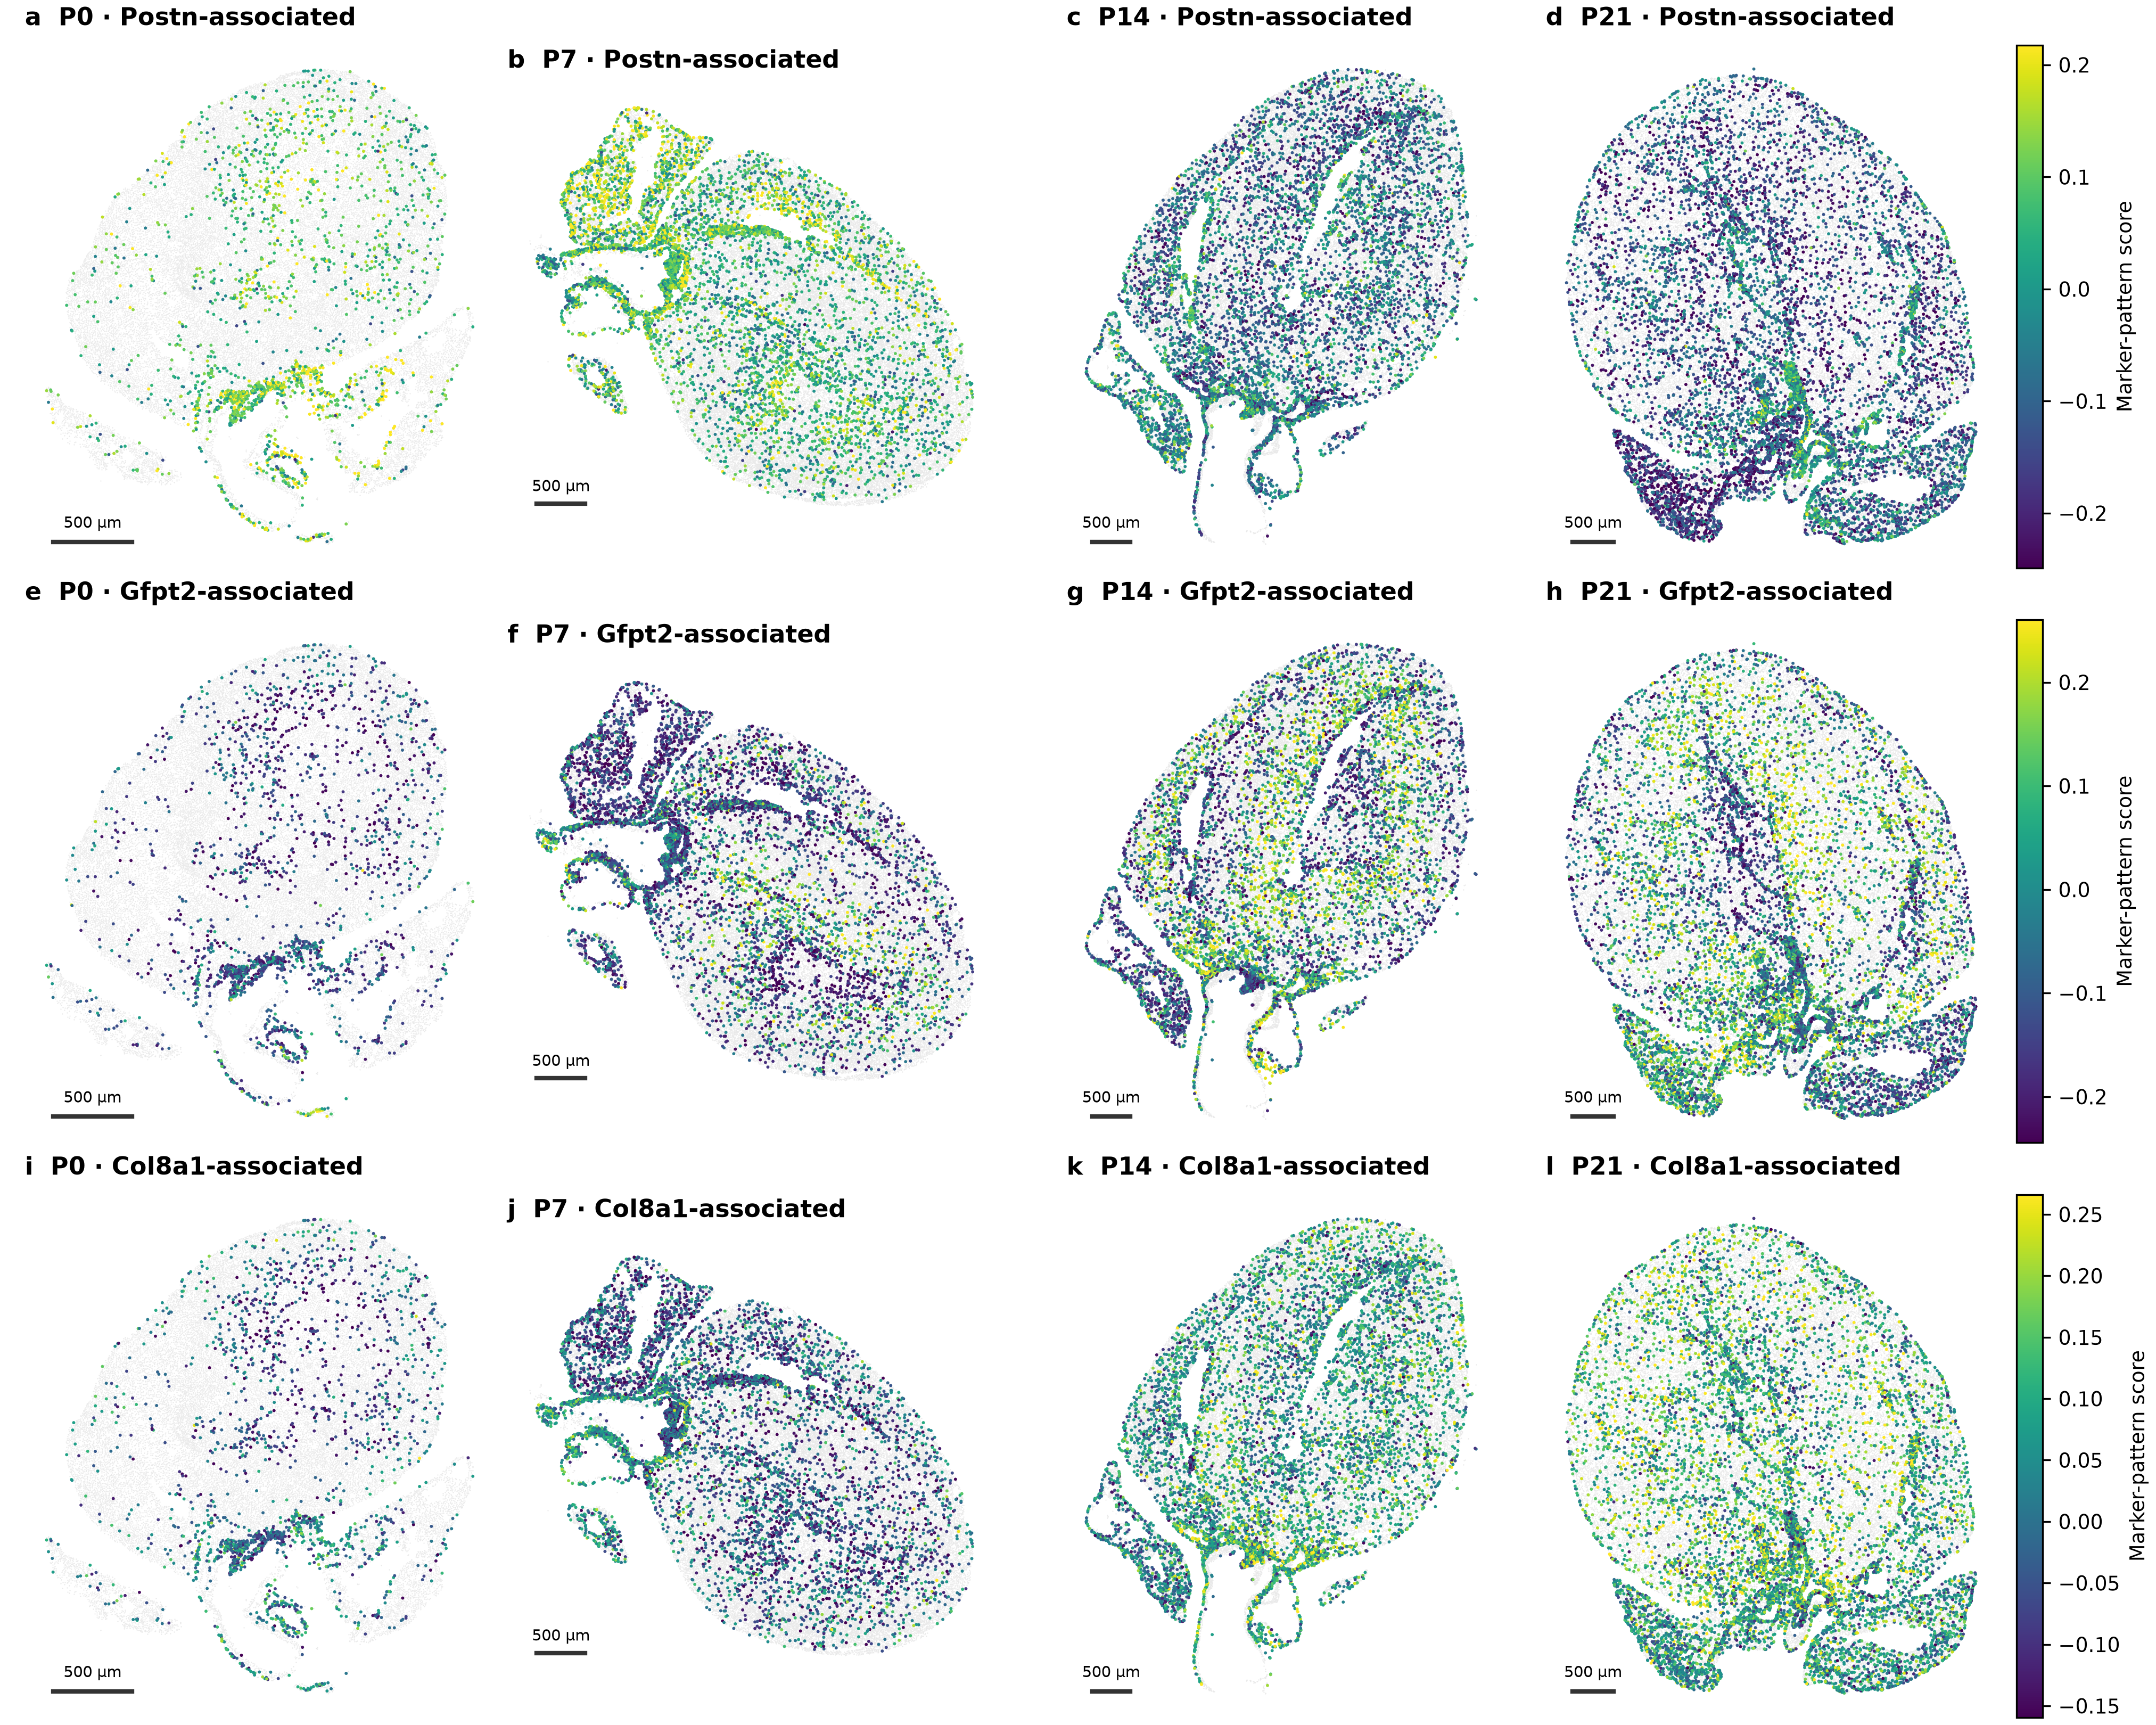
a–d, Postn/Ptn/Tnc/Col24a1 pattern. e–h, Gfpt2/Pi16/Adgrd1 pattern. i–l, Col8a1/Cmklr1/Col6a3/Htra3 pattern. Each row uses a common color scale across ages, showing eligible fibroblasts regardless of their candidate subtype. Negative scores mean expression ranks below matched controls, not negative RNA or biological absence. One pattern can occur across several subtype labels. Background tissue is shown in gray. Scale bars, 500 µm.

Figure S2. Local matrix relationships differ by CM state and outcome
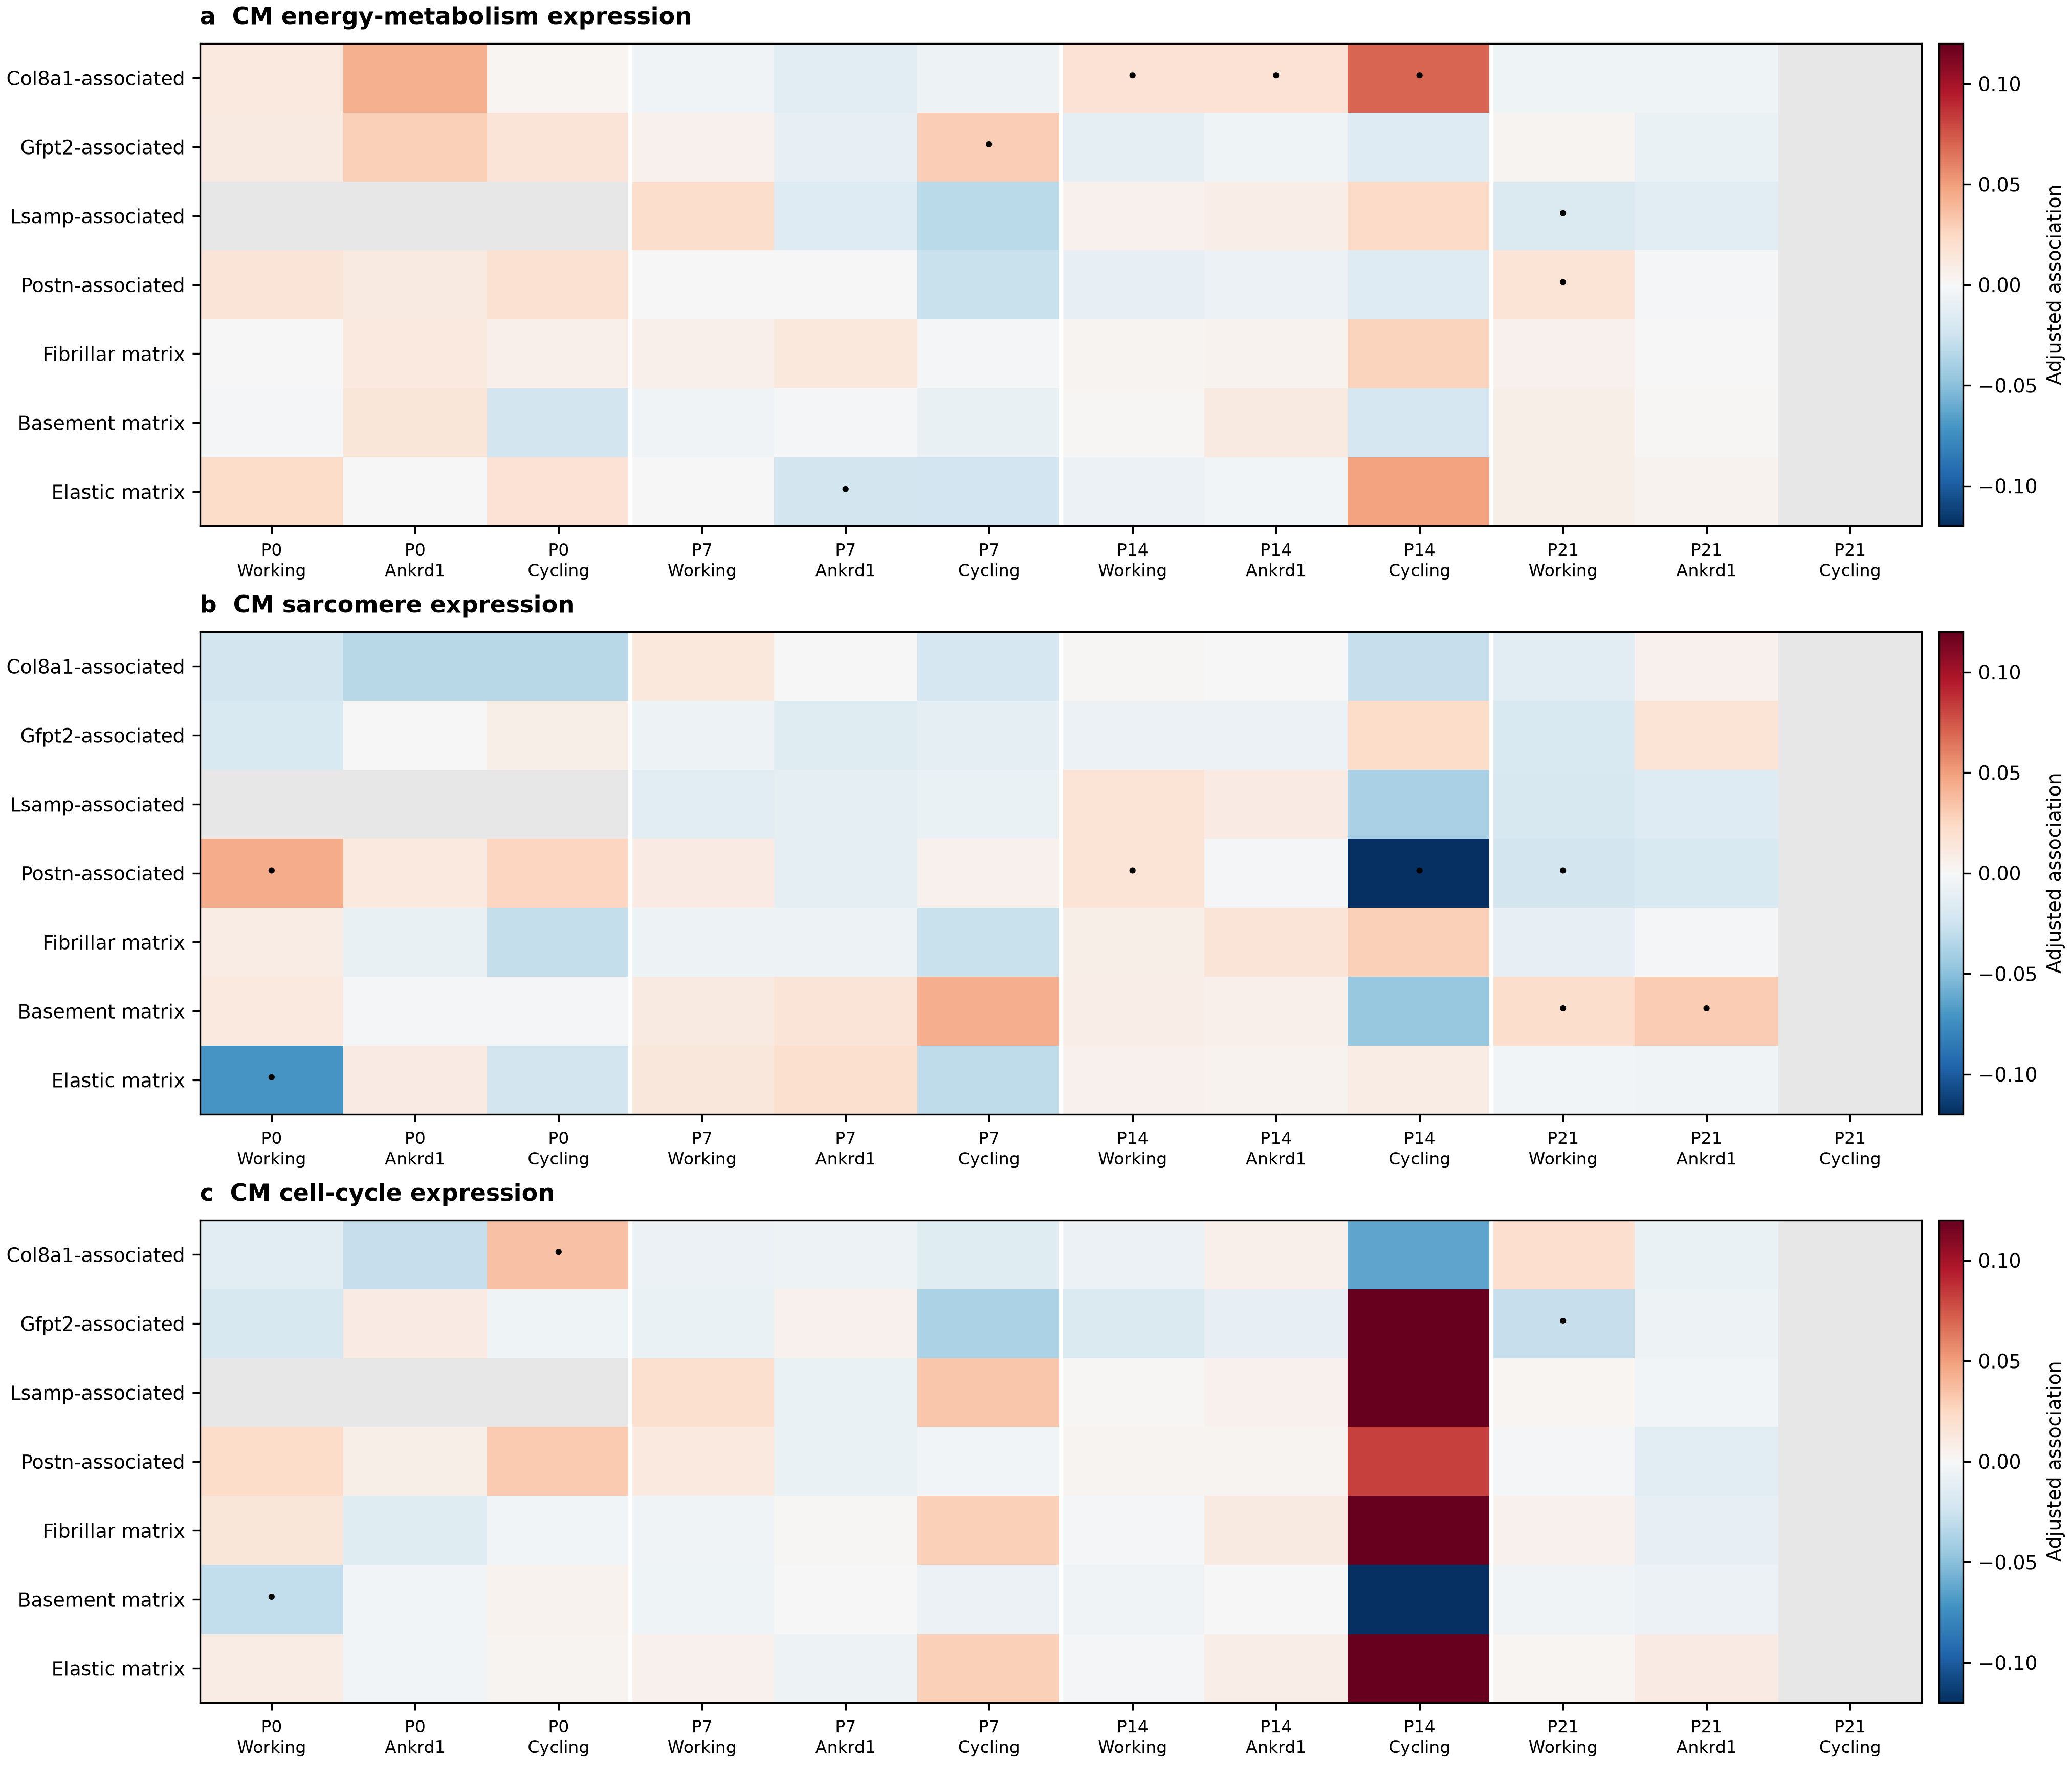
a–c, Within-region associations between neighboring fibroblast patterns and CM energy-metabolism, sarcomere or cell-cycle expression. Working, Ankrd1 and cycling-associated CMs are displayed; all eligible CM states enter the source tables and correction. Red and blue indicate positive and negative estimates. Dots mark intervals excluding zero before multiple-testing correction; none of these fibroblast-program associations passes the global primary correction. Gray indicates an unavailable or insufficiently supported comparison. The models account for vascular surroundings and capture. Each age has one section.

Figure S3. Cross-age neighborhood matches have useful but limited resolution
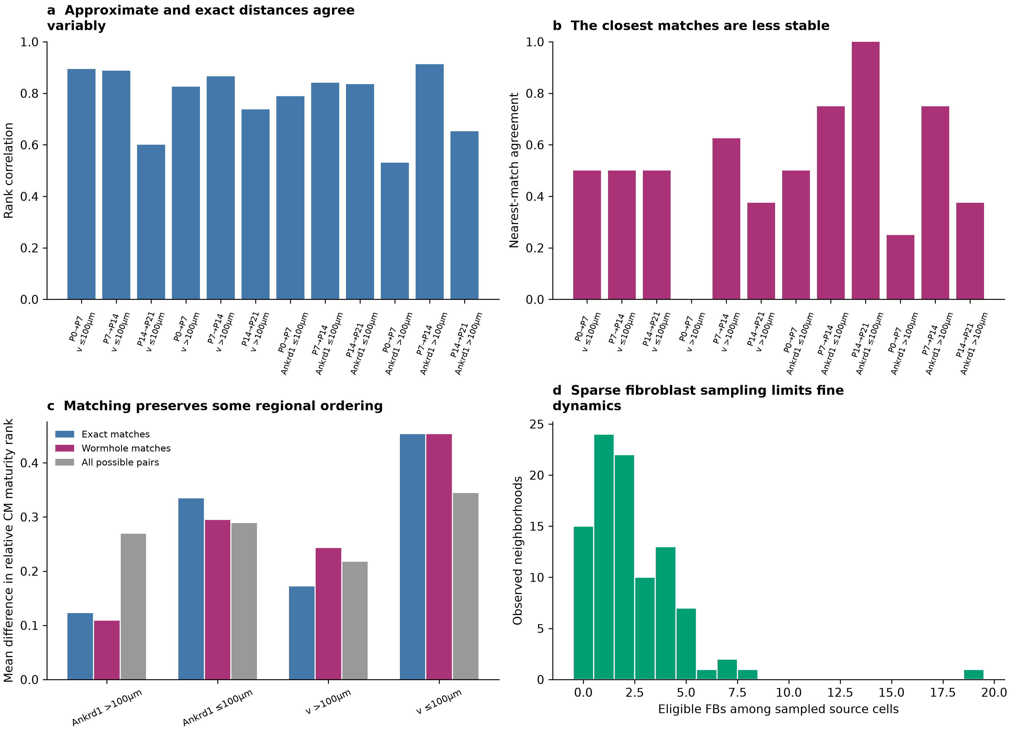
a, Agreement between frozen Wormhole and exact distance rankings in each CM/anatomical comparison. b, Agreement on the nearest match is a separate, less stable quantity. c, P7-to-P14 relative CM maturation-rank gaps for exact matches, Wormhole matches and all possible pairs; maturation was not used to choose matches. Selected regions show closer ranks, but this is not universal or a developmental clock. d, Eligible FB counts in the 96 sampled neighborhoods show why fine fibroblast dynamics remain uncertain. The updated descriptions do not retrain the encoder or establish ancestry.

Figure S4. Measured CM regional patterns give anatomical comparisons to follow
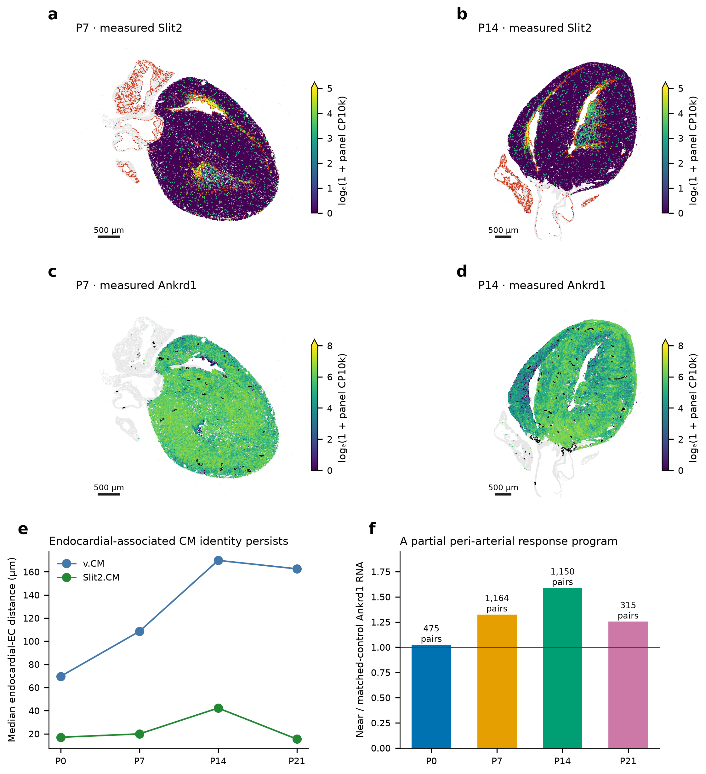
a,b, Native Slit2 expression at P7/P14, with reference endocardial cells shown in red. c,d, Native Ankrd1 expression at P7/P14, with operational arterial structures outlined. e, Released Slit2-CM and working-CM labels differ in distance to endocardial ECs; this is not independent anatomical validation. f, Earlier locally matched near-artery/control Ankrd1 RNA ratios at all four ages. These are partial spatial associations, not proof of vascular lineage or mechanical function. Kcnd2/Irx5 were not measured by the deposited Xenium panel. Coordinates and earlier estimates are retained.

How to read the cell-boundary results
To place a cell subtype on the map, we first need to know which RNA belongs to that cell. The atlas combines membrane, cell-interior and nuclear stains to identify cell outlines. This is especially useful for large cardiomyocytes, whose full shape cannot be determined by drawing a fixed area around the nucleus.
The authors compared the automatic outlines with expert drawings in five P0 and five P21 image fields. Their combined-stain method performed better than nucleus expansion. Agreement was poorer at P21: approximate scores were 45–50% at P0 and around 10% at P21 under a demanding 90% overlap rule. These values describe agreement between cell outlines, not the percentage of RNA assigned correctly. A cell can fail the strict outline test while still retaining many correctly assigned interior transcripts.
This matters for fibroblasts and endothelial cells beside RNA-rich cardiomyocytes. A small boundary error can introduce neighboring muscle RNA and change a subtype assignment. Conversely, a section through a large CM may contain no visible nucleus. Removing every profile without a nucleus would discard some valid muscle-cell information.
We therefore compare whole-cell RNA with RNA from the inner part of the cell and the nucleus. Agreement strengthens an assignment. Sparse nuclear RNA does not by itself disprove the whole-cell label, but nuclear evidence for another cell identity requires review. Each view provides useful information; none proves the true boundary on its own.
The next step is direct imaging of selected cell interfaces, using clear membrane outlines and several subtype markers in the same cells. This would help determine whether overlapping fibroblast patterns occur within individual cells or result from RNA assigned across a boundary. The detailed earlier assessment and the atlas Methods and Supplementary Figure 1 are linked in the source record.
The P14 structural association is stronger in core CM RNA than deposited whole-cell counts. The report retains that sensitivity rather than treating either view as a verified boundary. Block intervals do not integrate all segmentation uncertainty.

Experiments that distinguish the developmental explanations
Question | Measurement | What it would resolve
Does vascular delivery precede metabolic change? | Independent intermediate-stage hearts; perfusion, local oxygen and CM energy use in matched ventricular regions | Blood-supply support versus shared regional development
Is the P14 endocardial structural setting real? | Clear membranes, CM sarcomere RNA/protein, endocardial identity and comparable loading/anatomy | Within-CM structural variation versus transcript ownership or regional mechanics
Does the P0 matrix candidate affect structure? | Eln/Fbln1/Fbln2 RNA and matrix protein, followed by controlled matrix/CM experiments | A regional marker pattern versus a matrix-related structural contribution
Can early FB environments alter metabolism? | Same starting CM state, oxygen and endothelial support across defined FB/matrix conditions | A matrix contribution independent of vascular support
Do early states contribute to later groups? | Denser spatial sampling, P3/P5/P10 hearts and validated lineage tracing | Related RNA states versus actual cell ancestry
Functional CM measurements should include sarcomere organization, calcium handling, contraction and energy use. Completed division is a separate outcome from cell-cycle RNA. Exact transport and Wormhole nominate developmental comparisons; they do not replace these measurements.

