Low Glucose Analysis – Figure Legends

Figure E: OFF-Cell Population Time Course (High to Low vs Normal to Low Glucose)
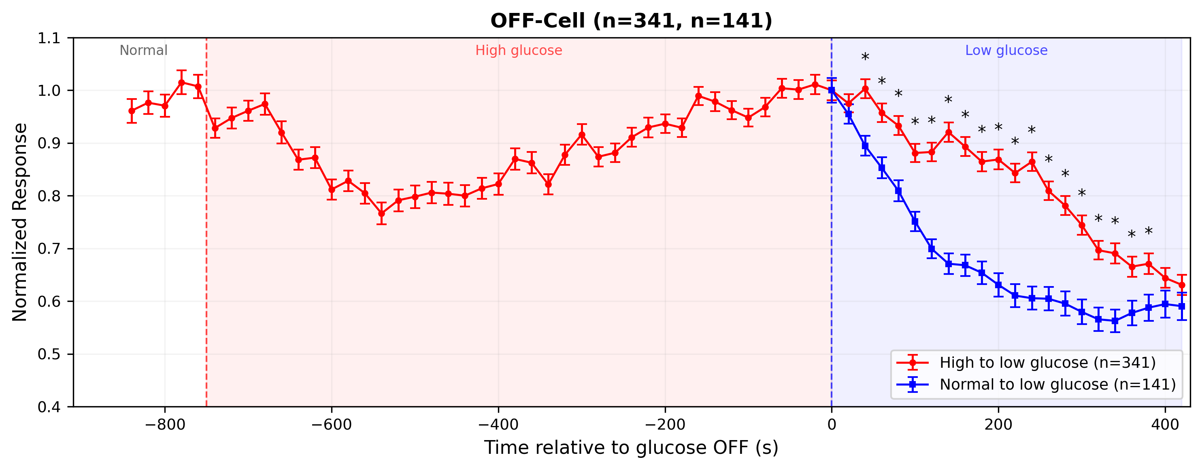
Figure Y-E2
Figure E. Population time course of OFF-cell light response amplitude across the full recording, with the low glucose alone control aligned at the end of high glucose (t=0). Red trace (circles): high to low glucose – retinas exposed to normal glucose, then high glucose, then low glucose (n=341 units from 5 recordings). Blue trace (squares): normal to low glucose – retinas switched directly from normal to low glucose without prior high glucose exposure (n=141 units from 4 recording pairs), scaled to match the red trace at t=0. Data points show mean +/- SEM of the normalized response amplitude (max-min range), plotted trial-by-trial. Each unit’s response was first normalized to its own maximum, then the population was normalized to the mean of the last 5 baseline trials before high glucose onset. Vertical dashed lines indicate solution switch times (red: high glucose onset; blue: low glucose onset / high glucose offset at t=0). Background shading denotes solution phases: white = normal glucose, red = high glucose, blue = low glucose. Black asterisks mark time points where the two groups differ significantly (Welch’s t-test, p < 0.05). In the low glucose phase, both traces decline but the high-to-low glucose group (red) declines more slowly than the normal-to-low glucose group (blue), suggesting prior high glucose exposure partially protects against the low glucose effect on OFF-cells.

Figure F: ON-Cell Population Time Course (High to Low vs Normal to Low Glucose)
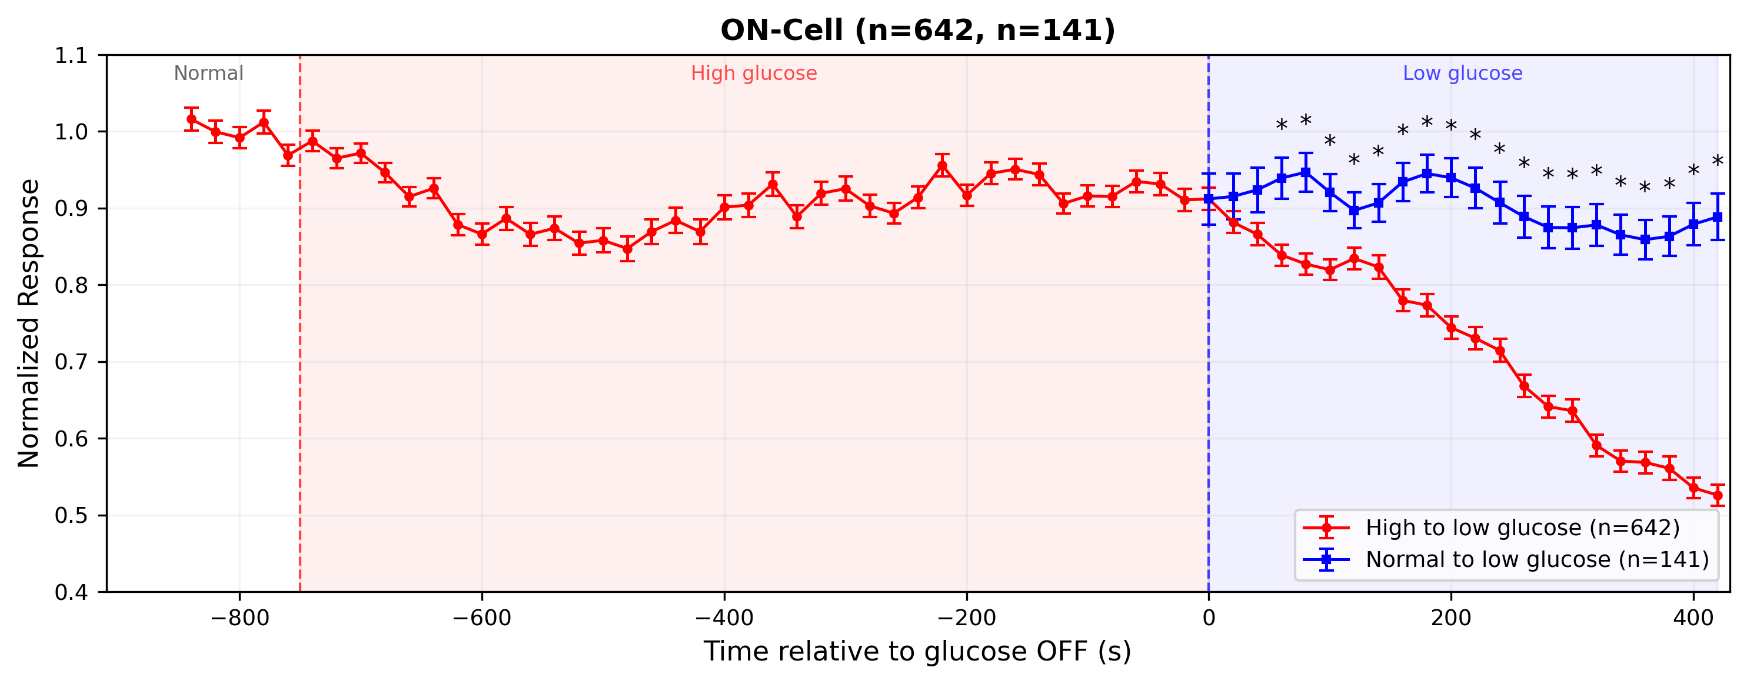
Figure Y-F2
Figure F. Population time course of ON-cell light response amplitude, with conventions as in Figure E. Red trace: high to low glucose (n=642 units). Blue trace: normal to low glucose (n=141 units), scaled to match the red trace at t=0. ON-cells show a similar pattern: the high-to-low glucose group (red) exhibits a more pronounced decline in the low glucose phase compared to the normal-to-low glucose group (blue), which maintains relatively stable responses. This indicates that prior high glucose exposure sensitizes ON-cells to subsequent low glucose.

Figure S: OFF-Cell Low Glucose Phase Comparison
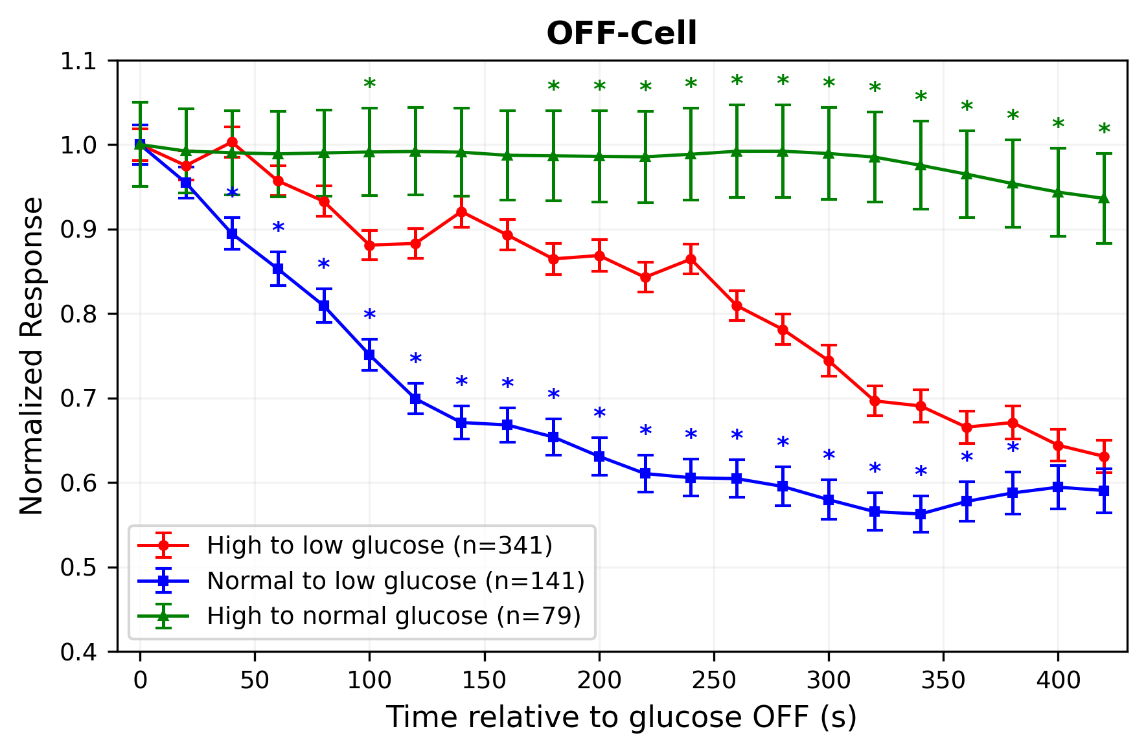
Figure Y-S
Figure S. Comparison of OFF-cell light response amplitude during the low glucose phase across three experimental conditions, aligned at the offset of high glucose (t=0). Red trace (circles): high to low glucose – cells exposed to high glucose before switching to low glucose (n=341 units). Blue trace (squares): normal to low glucose – cells switched directly from normal to low glucose without prior high glucose exposure (n=141 units). Green trace (triangles): high to normal glucose – cells returned to normal glucose after high glucose treatment (n=79 units). All traces are normalized to their respective values at t=0 for direct comparison. Data points show mean +/- SEM. Colored asterisks indicate time points where the blue or green trace differs significantly from the red trace (Welch’s t-test, p < 0.05). Both low glucose conditions (red, blue) show a progressive decline in response amplitude, while the normal glucose recovery (green) remains near baseline, confirming that the response reduction is specifically caused by low glucose rather than time-dependent rundown. Notably, the decline is slower in the high-to-low glucose group (red) compared to the normal-to-low glucose group (blue), suggesting that prior high glucose exposure partially protects against the low glucose effect.

Figure T: ON-Cell Low Glucose Phase Comparison
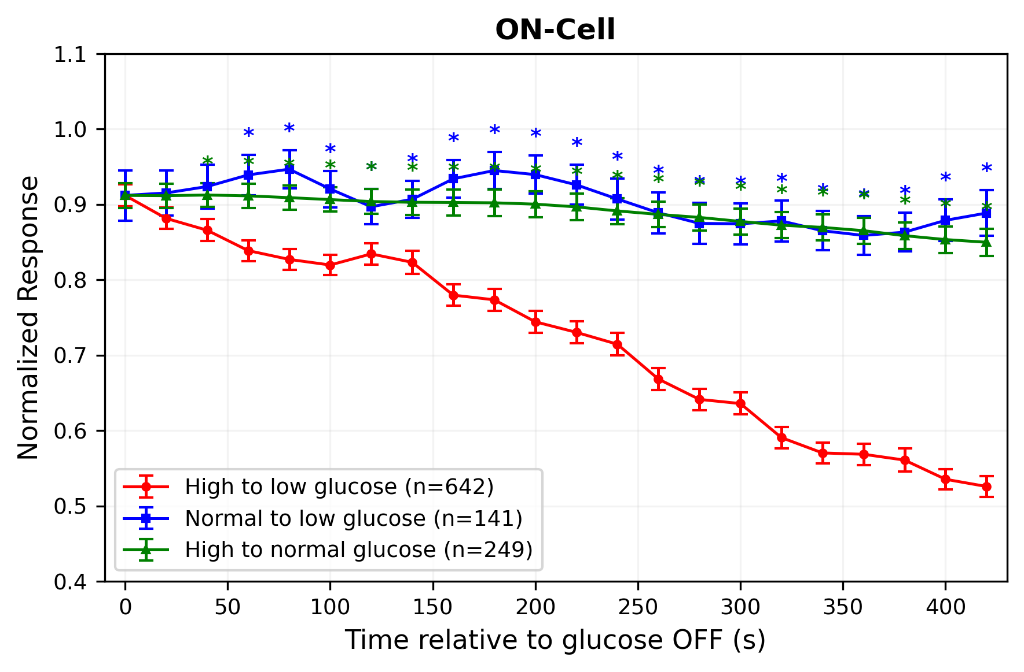
Figure Y-T
Figure T. Comparison of ON-cell light response amplitude during the low glucose phase across the same three conditions as Figure S. Red trace: high to low glucose (n=642 units). Blue trace: normal to low glucose (n=141 units). Green trace: high to normal glucose (n=249 units). Conventions as in Figure S. ON-cells show a similar pattern: both low glucose conditions produce a decline in response amplitude relative to the normal glucose recovery control (green), and the high-to-low glucose group (red) declines more slowly than the normal-to-low glucose group (blue) in the early phase but ultimately reaches a lower amplitude by the end of the recording.

