**1.下载miniconda，下载地址如下**

<https://rep>o.anaconda.com/miniconda/Miniconda3-latest-Linux-x86_64.sh

可使用wget下载

wget <https://rep>o.anaconda.com/miniconda/Miniconda3-latest-Linux-x86_64.sh

--no-check-certificate

1. **安装miniconda**

安装软件：安装过程中根据提示输入enter或yes

bash Miniconda3-py38_4.8.3-Linux-x86_64.sh

1. 验证安装

conda -V

## **4. 创建虚拟环境**

conda create -n py39 python=3.9

## **5. 激活虚拟环境**

conda activate py39

## **进入代码目录执行**

pip install -r requirements.txt

## **执行代码**

gene_exp_infomap.py --moduleNum 4 --geneNum 300 --filterWeight 0.4

--dataFile ./data/ku50\(1\).txt

## **查看帮助**

gene_exp_infomap.py -h

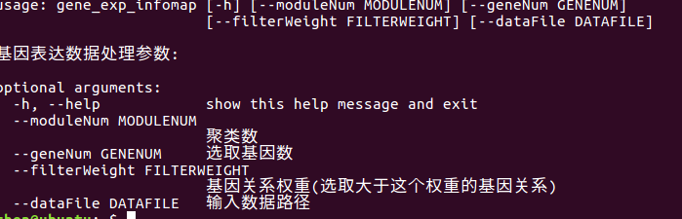

1. 打包代码

pyinstaller -F gene_exp_infomap.py --hidden-import="sklearn.metrics._pairwise_distances_reduction._datasets_pair" --hidden-import="sklearn.metrics._pairwise_distances_reduction._middle_term_computer" --hidden-import="PIL._tkinter_finder"